به نام خدا

CA3_Operating Systems

Multithreading

فاطمه شاه حسینی

25/آذر/1401

Time costs in SERIAL form:

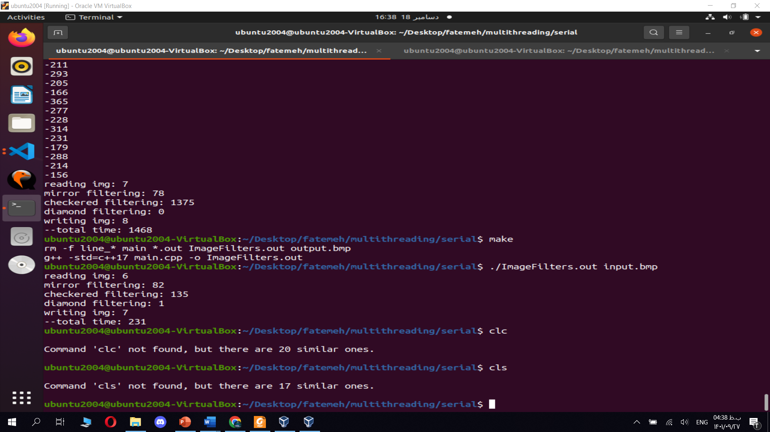

Hot spots:

* Checkered filter
* Horizontal mirror filtering
* Reading the image and store in memory
* Write the filtered image in output

Time costs in PARALLEL form:

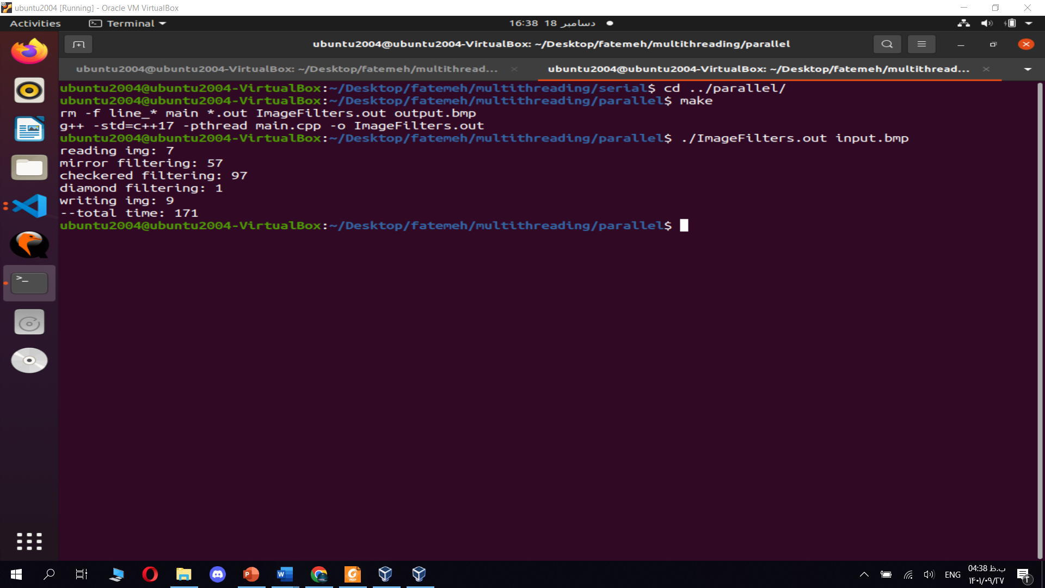

Input: Output:

 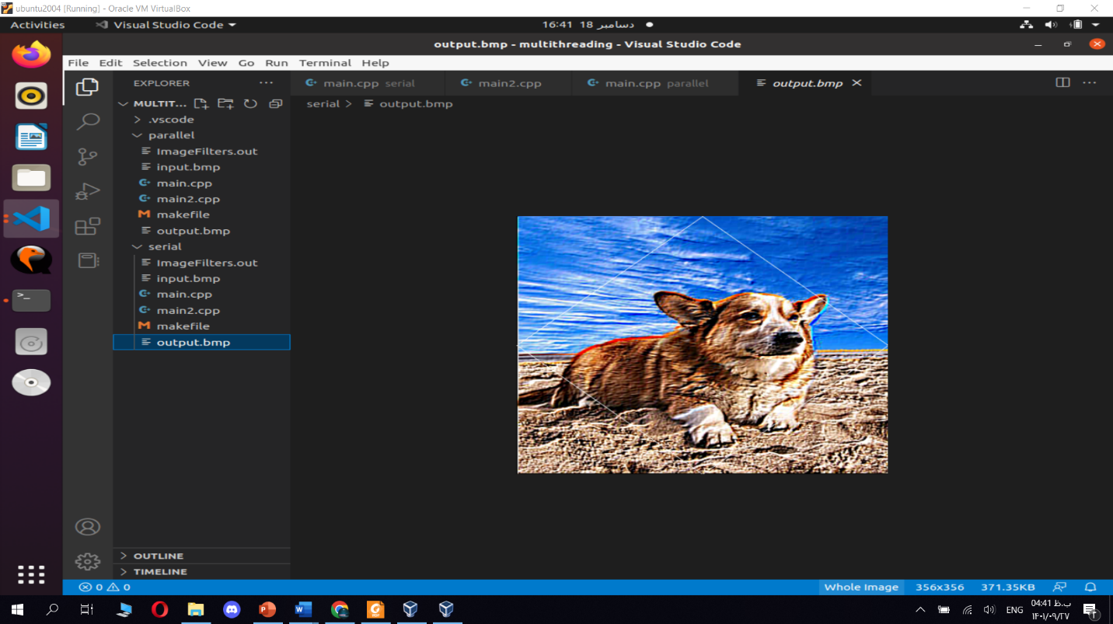

Speed up = 231 / 171 = 1.3