**REPORT CREATE VUFORIA PROJECT**

**I. Create new project from Vuforia sample**

**1. Create new android application**

**a. Step 1 – Create new project**

_ Select Minimum require SDK: API 16 because some functions in Vuforia requires at least the SDK version for working.

_ Write the demand package path.

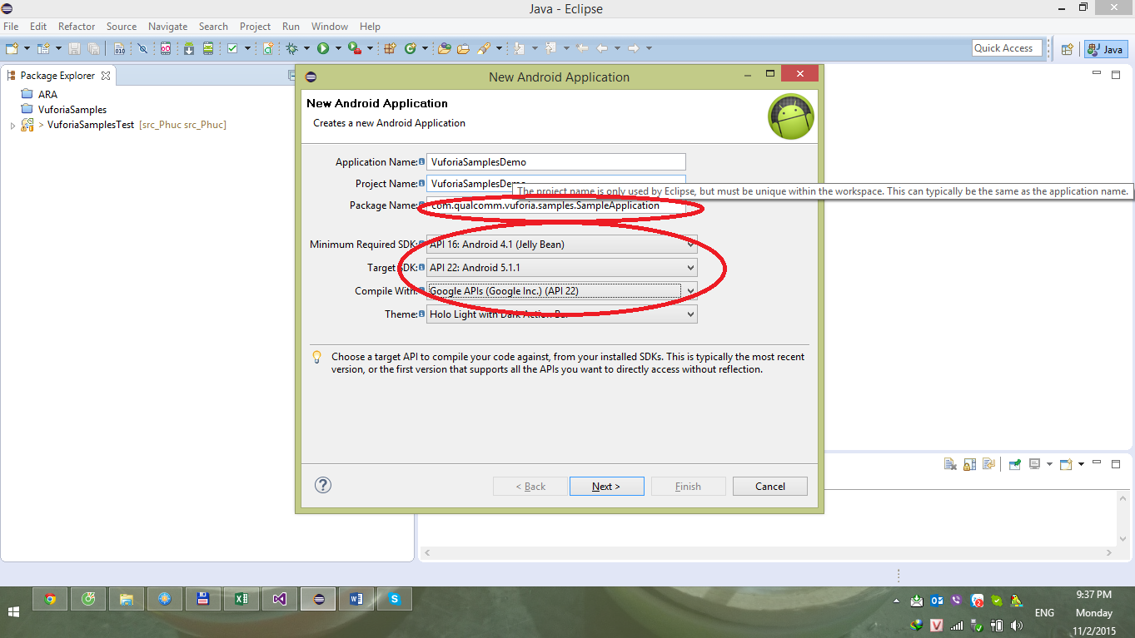

**b. Step 2 – Add Vuforia builder**

_ Step 2.1: Create 1 xml file storing the absolute path of Vuforia library

_ Step 2.2: Add Vuforia Root SDK folder to libraries of WORKSPACE

_ Step 2.3: Active Vuforia root SDK for building the project

_ Step 2.4: Create Vuforia builder with type **Ant builder**

_ Step 2.5: Build the project

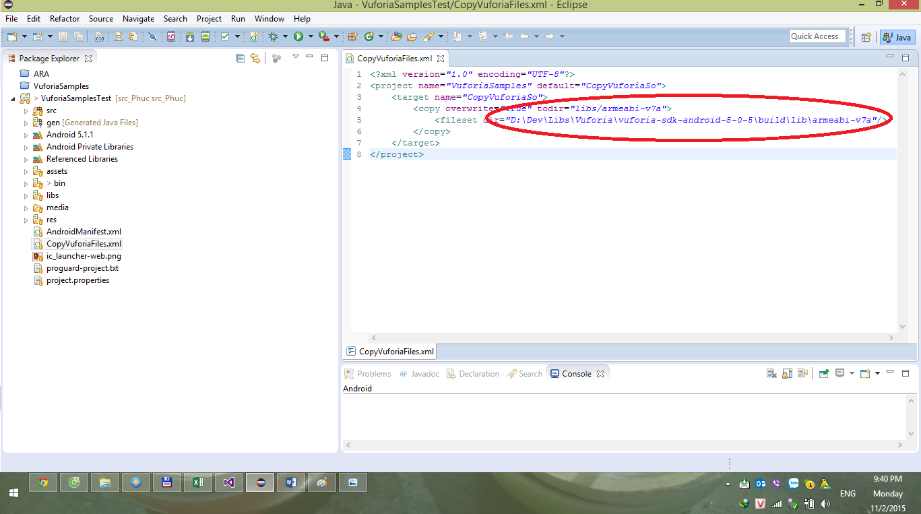

Step 2.1

Create 1 xml file storing the absolute path of Vuforia library

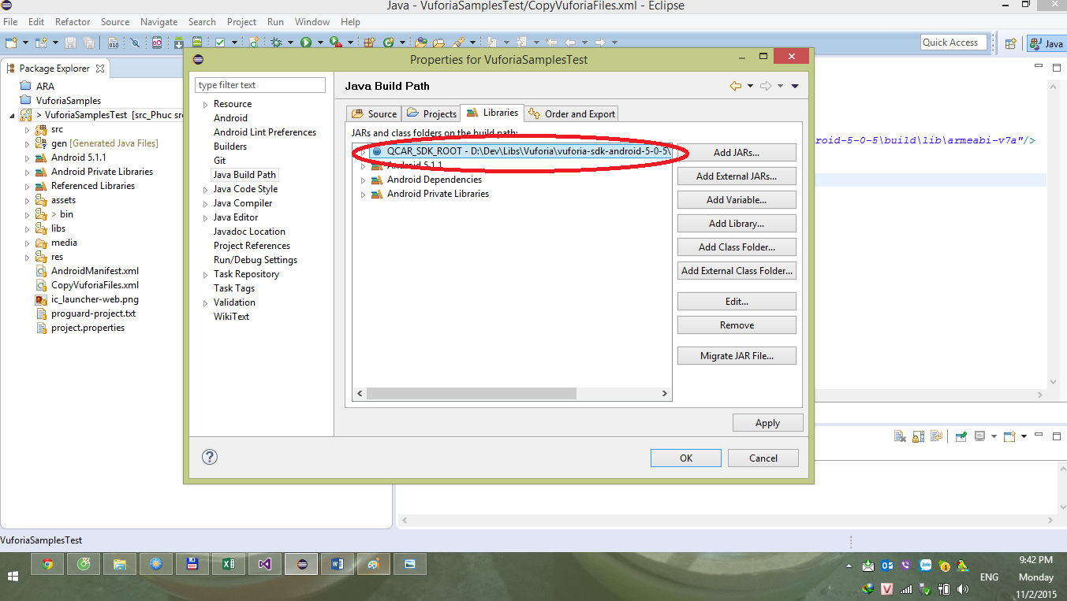

Step 2. 2

Add Vuforia Root SDK folder to libraries of WORKSPACE

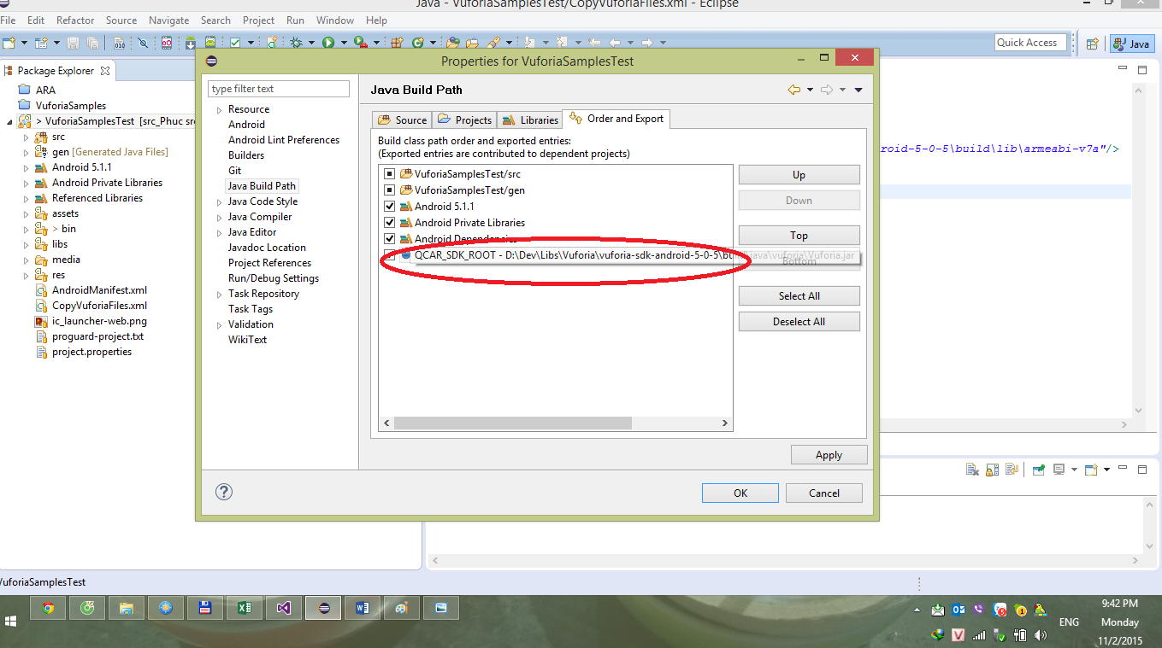

Step 2.3

Active Vuforia root SDK for building the project

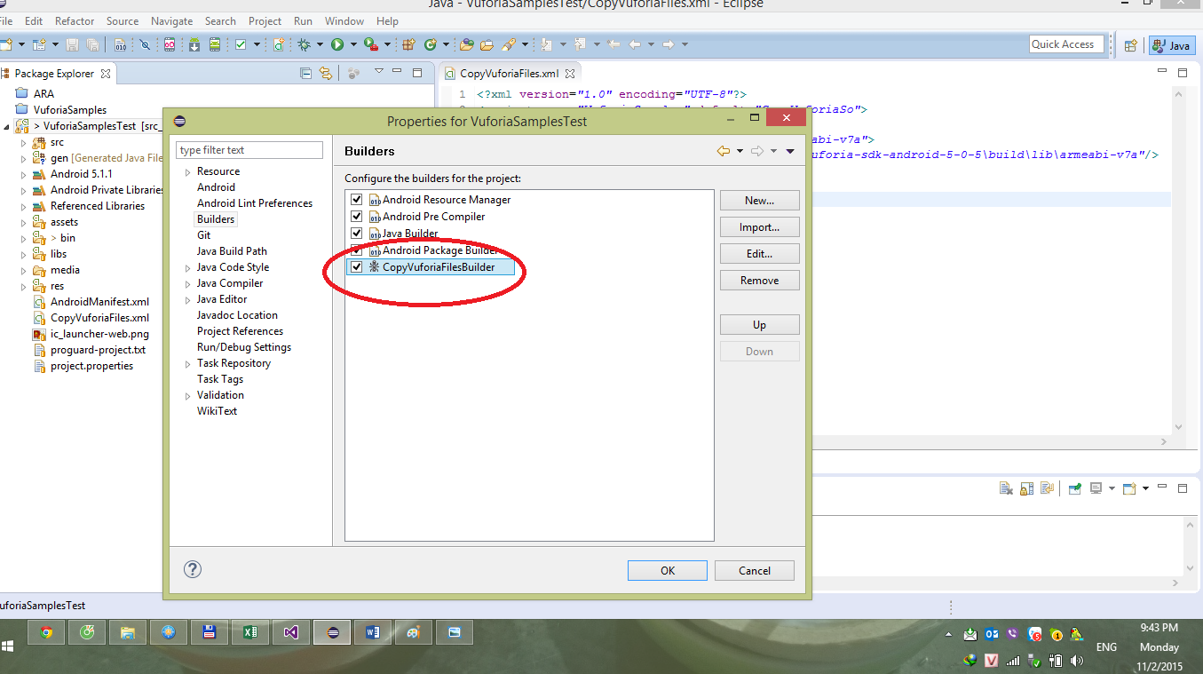

Step 2.4

Create Vuforia builder with type **Ant builder**

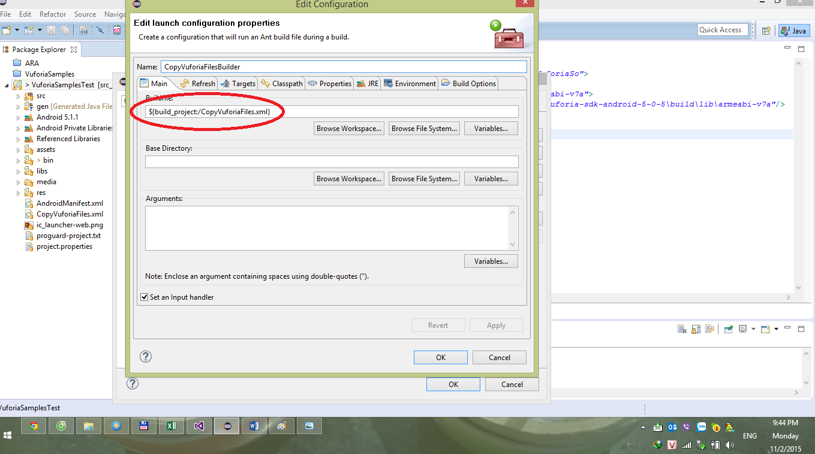

* It will create .external tool builder to root of project folder.

**2. Create user-feature and permission in android manifest**

**a. Create user-permission**

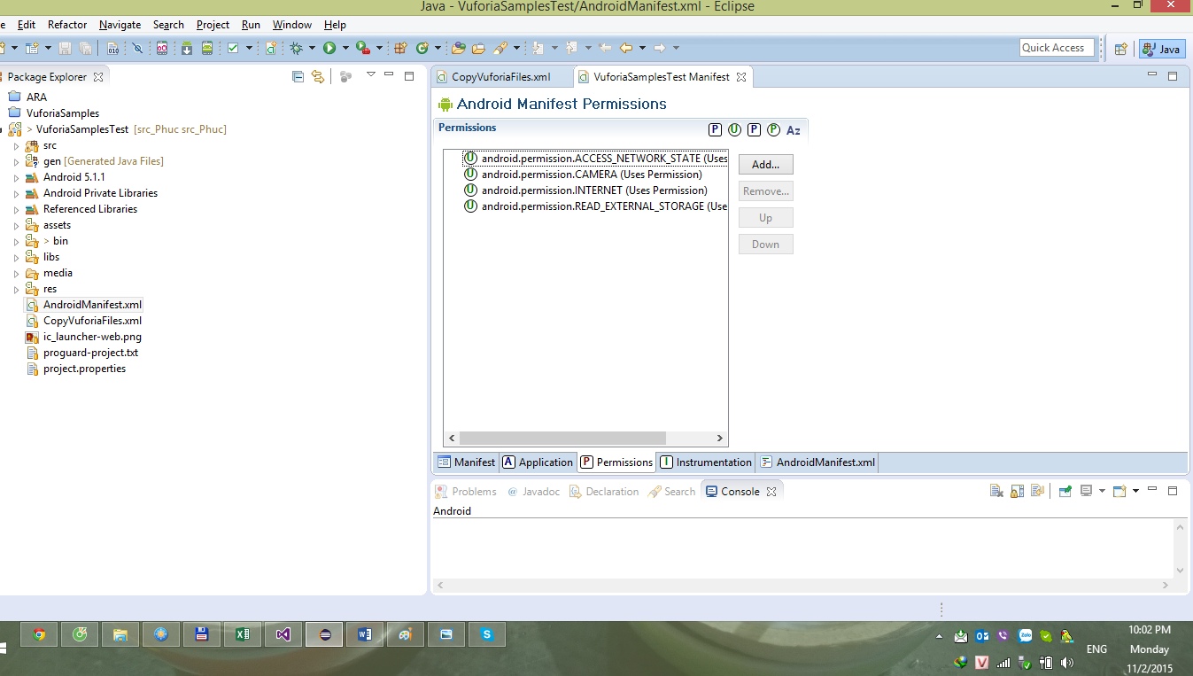

**b. Create user-feature**

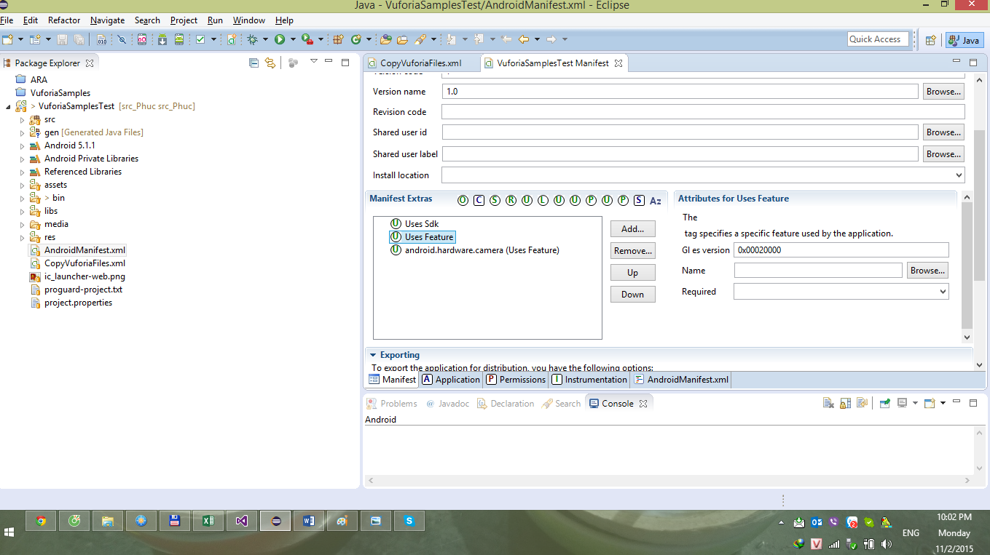

Set OpenGL version.

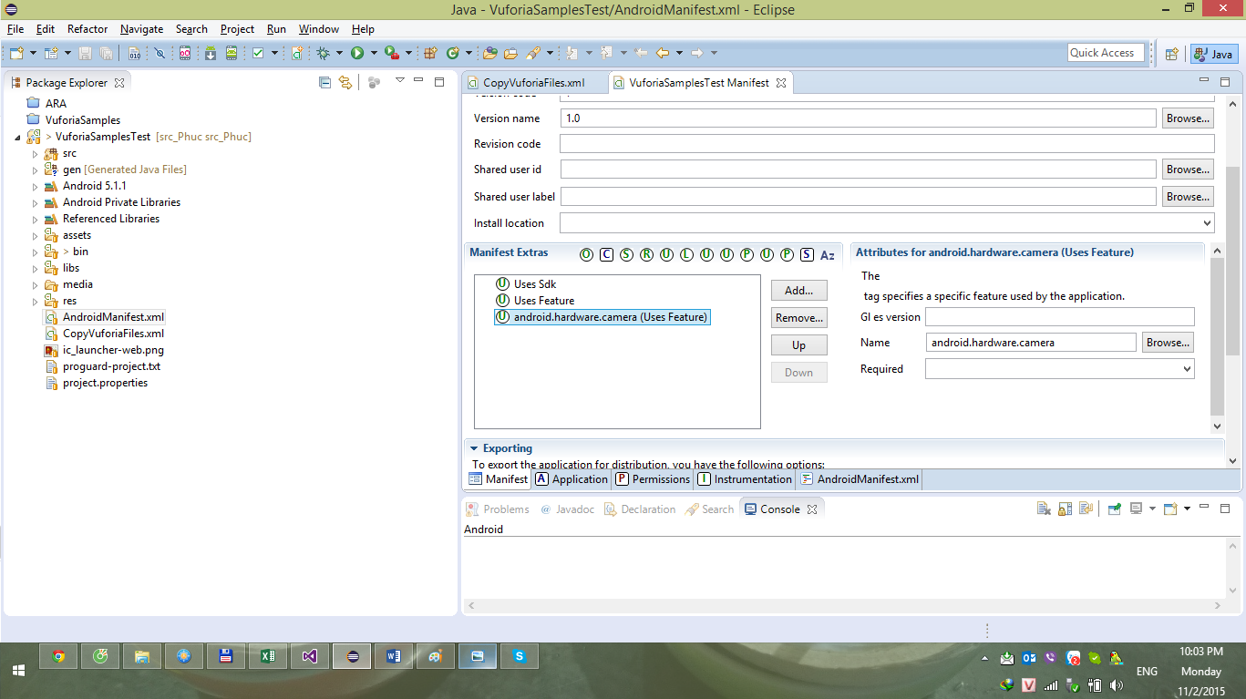

Set android.hardware.camera (in API14 until now, android use android.hardware.camera2 but android.hardware.camera is still working)

3. Migrate source code, assest, media, drawable from sample project to new demo project.

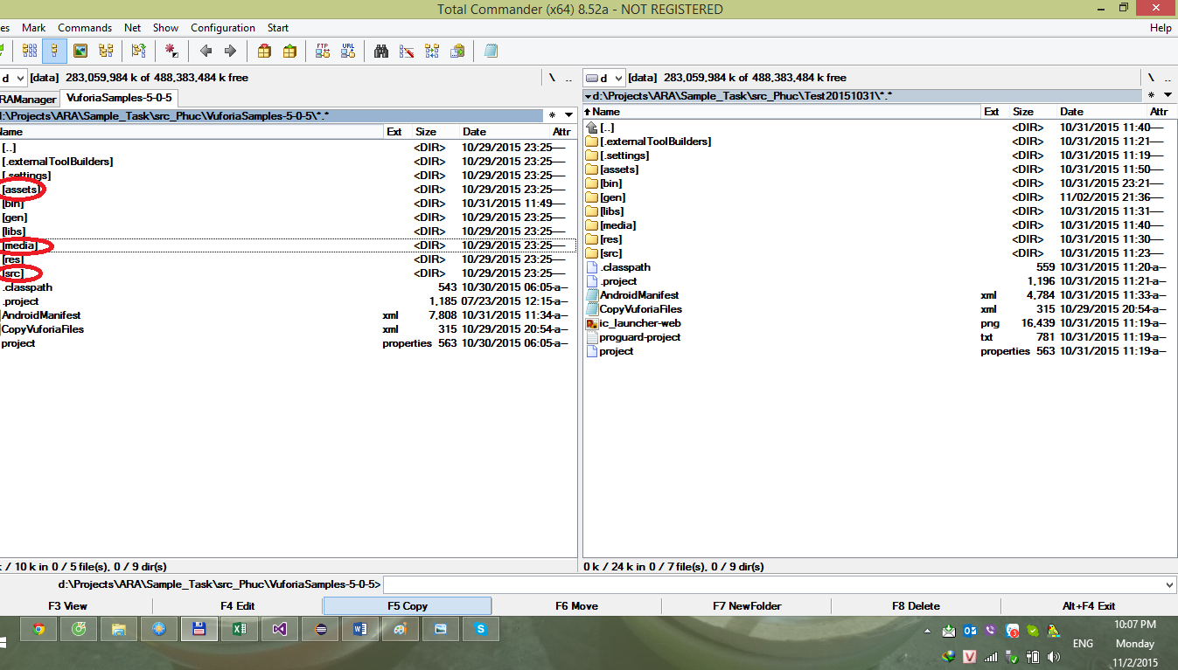

_ the media folder can be excluded from the project because it is not for working. This stores the test data.

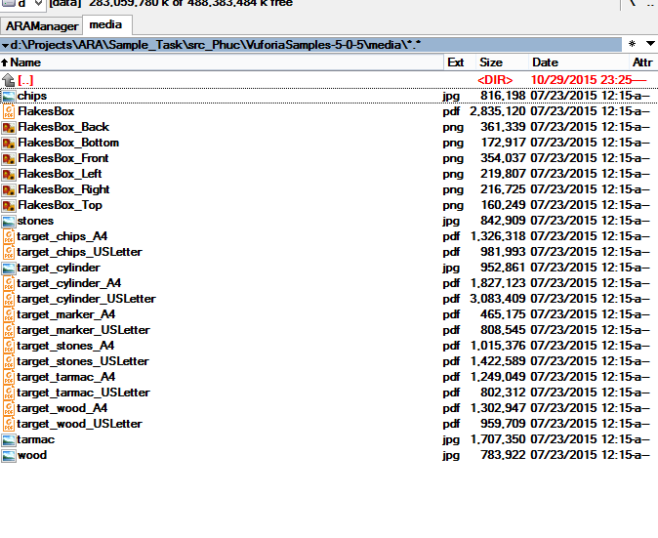

_ Note that the drawable folder is stored in res folder. It is just resource for layout in android application.

_ Asset folder store local recognition target of the application in xml file.

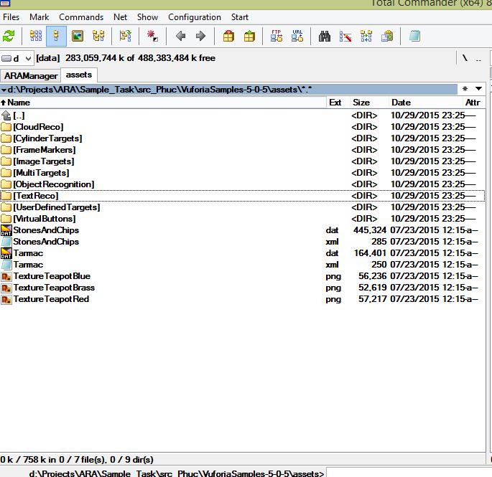

_ Check application nodes in Android Manifest

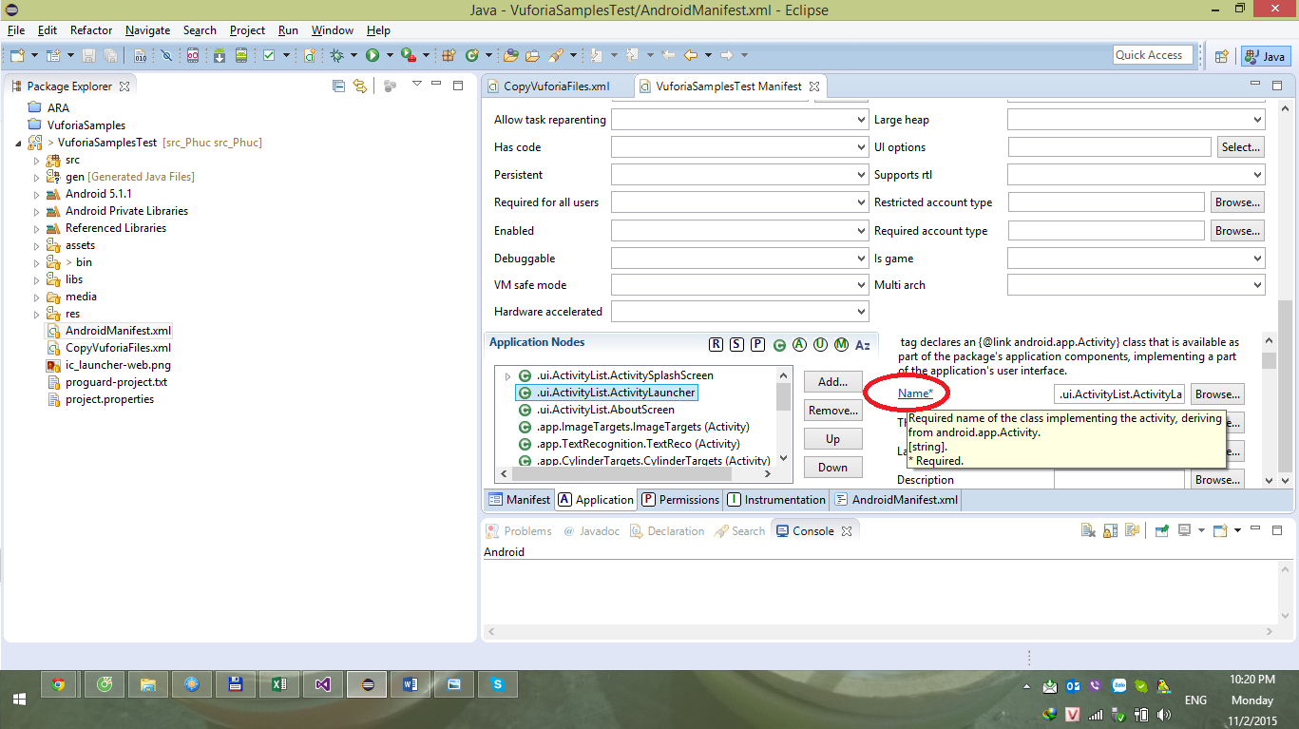

Click on the button name to set the application node to correct path if necessary. Then build the project.

In conclusion, the new project is working smooth after migration because the package path (same as namespace in Visual Studio) is completely the same as Vuforia samples project.

If there is any different, we just need to change path in Application nodes in Android manifest.

**II. Error in old self project**

* Do not know how to create .external tool builder correctly.
* Path of application nodes in wrong when doing migration source code

**III. Vuforia topics:**

**Create License key and create Cloud Vuforia Database associate with the license key**

1. **How to create Vuforia target**
2. **Manually**

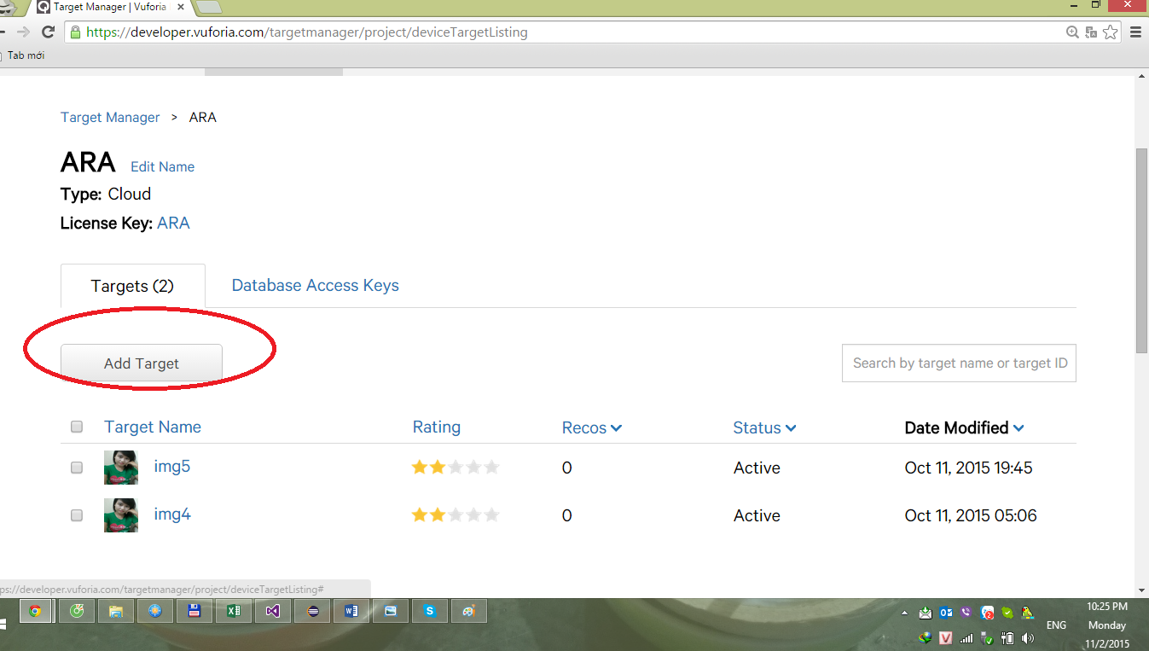

1. **Vuforia web services (VWS)**

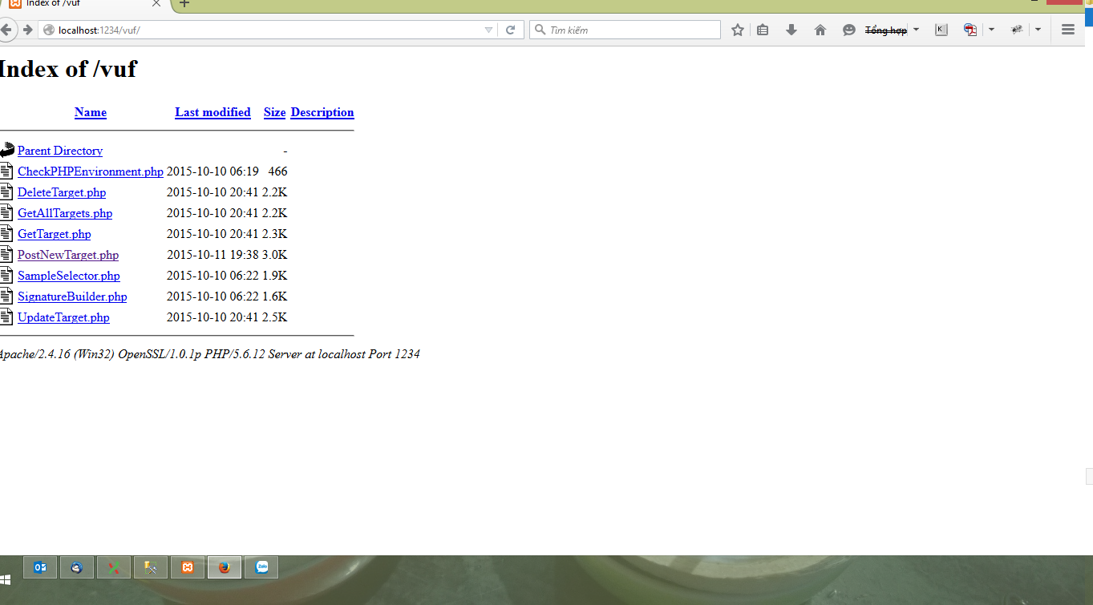

(PhP code)

1. **Access Vuforia target**

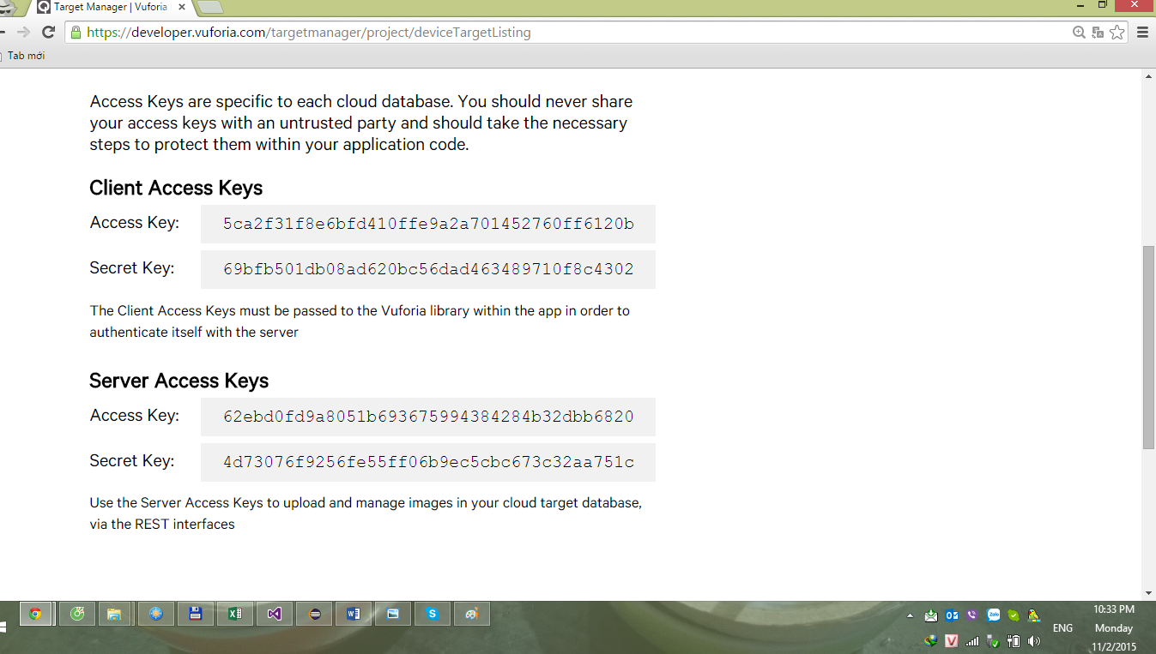

_ Client Access keys: for android application (in just the case of this project)

_ Server Access keys: for manager application

1. Researched samples: Image targets, Multi targets, Cloud Recognition, Text Recognition