**VIETNAM NATIONAL UNIVERSITY HOCHIMINH CITY**

**UNIVERSITY OF INFORMATION TECHNOLOGY**

**ADVANCED PROGRAM IN INFORMATION SYSTEMS**

**PHUNG QUOC VUONG-LE HOANG LAM**

**IMPLEMENT AN ECOMMERCE SYSTEM IN THE WEBSITE**

**ENGINEERING OF SCIENCE IN INFORMATION SYSTEMS**

**HO CHI MINH CITY, 20****15**

**NATIONAL UNIVERSITY HOCHIMINH CITY**

**UNIVERSITY OF INFORMATION TECHNOLOGY**

**ADVANCED PROGRAM IN INFORMATION SYSTEMS**

**PHUNG QUOC VUONG – 10520517**

**LE HOANG LAM – 10520474**

**IMPLEMENT AN ECOMMERCE SYSTEM IN THE WEBSITE**

**ENGINEERING OF SCIENCE IN INFORMATION SYSTEMS**

**THESIS ADVISOR**

**Dr. HO BAO QUOC**

**HO CHI MINH CITY, 2015**

**ACKNOWLEDGMENTS**

The author wishes to express sincere appreciation to Dr.Ho Bao Quoc for his assistance in the preparation of this dissertation.

I would like to express my gratitude to my teachers: Ph.D. NGUYEN DINH THUAN, M.S. NGUYEN THI KIM PHUNG and Ms LE BAO UYEN for your help and your suggestions.

Thanks also to the members of the school council for their valuable input.

Finally, we would like to express our greatest gratitude towards our families for always believe and support us.

**COMMENT OF ADVISOR**

**COMMENT OF JUDGE**

**TABLE OF CONTENTS**

🙢🕮🙠

ACKNOWLEDGMENTS i

LIST OF FIGURES vi

LIST OF TABLES vii

ABSTRACT viii

Chapter 1 i

Introduction i

1.1 Problem statement i

1.2 Scope of the thesis i

1.3 Structure of the thesis i

Chapter 2 ii

Fundamental theories ii

2.1 E-commerce ii

2.2 Advantages of E-commerce for customers iii

2.3 Advantages of E-commerce for businesses v

2.4 Disadvantages of E-commerce vii

Chapter 3 xii

E-commerce status and solution xii

3.1 E-commerce status xii

3.1.1 E-commerce in Vietnam xii

3.1.2 Challenges in technology for Vietnamese enterprise xiv

3.2 System requirement xiv

3.2.1 The ecommerce in thesis analysis xiv

3.3 Solution xvii

3.3.1 Magento frameworks xvii

3.3.2 Magento vesus Wordpress xxv

3.3.3 Recommendation System on E-commerce xxviii

Chapter 4 xxxiv

System implementation xxxiv

4.1 The commerce xxxiv

4.2 Online store implementation xxxiv

4.2 Recommendation system implementation xxxv

4.3 Integration online store with recommendation system. xxxvi

Chapter 5: xli

Result and Future development xli

5.1 Conclusion xli

5.2 Future development xli

REFERENCES xliii

APPENDICES xliv

# LIST OF FIGURES

🙢🕮🙠

Figure 1: Database solution xv

Figure 2: The interface of Magento xx

Figure 3: Magento features xxiii

Figure 4: Magento vesus WordPress xxv

Figure 5: Easyrec architecture xxxii

Figure 6: The Easyrec user interface xxxiii

Figure 7: Magento product category page xxxv

Figure 8: Easyrec summary page xxxvi

Figure 9: The Easyrec about describe xl

**LIST OF TABLES**

🙢🕮🙠

Table 1: Example database with 4 items and 5 transactions xxx

**ABSTRACT**

E-commerce is growing fast and become the trend in the 21st century. E-commerce replaces traditional ecommerce by change the way how human do business activities. For the businesses, they must be aware about this trend and be familiar with E-commerce. However, there are two main problems for a business to launch an E-commerce system: system implement and system operation. Frist system implementation relates to the how to choose technologies to build the system that must be suitable for the business‘s resource and need. After that, operating an E-commerce system is to run the system and find out way to make and increase profit for the business. The two works are important and must be plan carefully before start an E-commerce project. In this paper we introduce the way to for business to start an E-commerce from implementing to operation in Vietnam.

# Chapter 1

# Introduction

## Problem statement

By the end of 2012, there are currently 31.3 million Internet users across Internet Viet Nam, which accounts for 35.26% of the population (an increase by more than 15 times compared to the year 2000) [1]. With large number of people using Internet, Vietnam is a potential place for investment in E-commerce area. Though the potential is good and numbers are growing. E-commerce in Vietnam is facing challenges such as lack of modern payment and competition from oversea famous businesses like Amazon.com, Lazada.com. One important thing is that in Vietnam 95% of the number of business are small and medium. It looks like Vietnamese businesses are behind in the E-commerce race. In this thesis, we introduce the cheap and effective way that can help Vietnamese businesses can start an E-commerce.

## Scope of the thesis

E-commerce is a huge area and we can not cover all. However, as we stated above, we focus on providing a solution for Vietnamese business can launch an E-commerce quickly and effectively. There are two main works for us: study how to implement an online shop quickly base on new technologies then study how to improve the profit of the online shop.

These two works are important but we aimed to gain more knowledge and skills in the second work because it is the most concerned of many businesses today.

## Structure of the thesis

To achieve the two goals, there is knowledge that we should study

Frist, we need to understand more about E-commerce, and it is a large are so we focus on its concept, type, advantages and disadvantages

Second, we need to study about how E-commerce system such as an online store can be implemented. We focus on the technologies used E-commerce systems and compare them to find the most suitable for Vietnamese businesses. When find out the best one, we need to learn how to implement an E-commerce system using the technology we choose and implement it.

Finally, we need to study solutions used in E-commerce systems to improve the profit such as marketing strategy to attract more customers. After finding the one, we will try to improve it to be suitable for the system we implement.

# Chapter 2

# Fundamental theories



## E-commerce

Electronic commerce (E-commerce) is the process of conducting commercial transactions electronically over the Internet [2]. The most popular example of an E-commerce system is online store where people can sit at home and access the store site to buy and selling product. Nowadays, E-commerce involves in every aspect of the economy such as finance, merchant. E-commerce system can variant in scale from very big system such as E-banking to small one such as online store. The classification bellow is adopted by in the book of Turban, King, Lee, & Viehland [3].

* Business to business E-commerce (B2B): companies doing business with others business entities without involving customers. In this type, transaction is often internationally and transaction amount are very huge due to the characteristics of participants involving in the transactions. For example: a car manufacture which is a business selling its products to a car retailer entity which also a business.
* Business to consumers E-commerce (B2C): a business selling products to the community. It is the most popular types and online stores are good examples of this type. Customers access the website of a retail store to buys or products.
* Consumers to consumers E-commerce (C2C): customers sell their products to other customers but often the business operates the sites. There are many sites offering free classifieds, auctions, and forums where individuals can buy and sell by online payment systems like PayPal where people can send and receive money online with ease. eBay’s auction service is a great example of where person-to-person transactions take place every day since 1995.
* Consumer to business e-commerce (C2B): a consumer posts his project with a set budget online and within hours companies review the consumer's requirements and bid on the project. The consumer reviews the bids and selects the company that meets his price expectation to complete the project. Elance site empowers consumers around the world by providing the meeting ground and platform for such transactions.
* Mobile Commerce (M-commerce): E-commerce transactions and activities that happen in Wireless Network environment. The weakness of wireless technology decreases the reliable of M-commerce transactions. Smartphones and tablets with wireless capability are most popular devices used to access Internet in M-commerce.
* Intra business E-commerce: Includes all internal organizational activities that involve the exchange of goods, services, or information among various units [4].
* Business-to-Employees (B2E): an E-commerce system that operates intra-business that deliver services, information and products to users who are mainly business’s employees. Example of B2E E-commerce is Online supply request system.

E-commerce transactions are performed through the Internet media so advantages of E-commerce come from the way it exploits the Internet media and with help of computer, transaction can be performed more quickly and accurately than one made by human. However, Internet also has security holes which affect E-commerce. E-commerce is motivation that t also speeds up the growing of Internet infrastructure.

## Advantages of E-commerce for customers

With E-commerce, transaction is perform through the Internet so advantages of E-commerce come from the way it exploits the Internet media and with help of machine, transaction can be perform quickly and accurately. In addition, E-commerce growing fast also speeds up the growing of Internet. We can list some advantage of E-commerce bellow:

**Convenience**

It is a true convenience to do what we want in front of a computer. Wherever you are, in just a few clicks o, you can already do shopping, banking and download media files.

Moreover, E-Commerce offers retailers an opportunity to provide customer convenience. With so much competition for their dollars, many customers expect access to products and services around the clock. For business buyers, the ability to make electronic purchases and manage inventory replenishment electronically is cost effective and efficient. This enables companies to get supplies and product inventory more quickly than they might be able to using traditional means.

**Time Efficient**

Doing E-Commerce transactions can be much faster than in paper. Just hit the on button and the result acquired can be the same with long working time by traditional method.

**Wider Range of Choices**

With e-commerce, the consumers have a wider range of choices for the needed products from the variety of sellers. This possibly happen because at present, many sellers use Internet sites as shop fronts so that “the consumer can browse and buy from many different sellers, making it easier to find exactly what they are looking for.

**Products or Services Can Be Purchased from Remote Areas**

E-commerce gives the remote consumer an option to shop somewhere else therefore driving prices down and quality of goods up in the local region.

With e-commerce, a local company has no longer hold monopoly with pricing in a region even other competitors are remote from them, so that, the quality and price of goods will be the decisive factor for the company to success.

**Give Greater Control to Consumer**

E-commerce gives greater control to consumer by providing easy-to-use ordering systems that allow customers to choose and order products according to their personal and unique specifications. Dell. Inc gives us the best example about the concept of easy-to-use ordering system.

**Price Comparisons**

E-commerce enables consumers to perform price comparison, so that they can make more appropriate purchasing decisions. E-commerce makes information on products and the market as a whole readily available and accessible, and increases price transparency, which enable customers to make more appropriate purchasing decisions.

**Save Time**

With e-commerce, consumers can save their time because they can have access to their money from home through Internet and work all from a desktop computer. Transactions can be handled over the Internet instantaneously without high response times, most of the times much faster than offline systems.

## Advantages of E-commerce for businesses

For businesses, improving the profit is the always goal, E-commerce is nothing if it cannot reward back to the business invest on it. There are some tangible benefits that are listed below:

**Global market acquisition**

Global market acquisition: using E-Commerce, business can extend their market from local to national and international markets without increasing the sale force. An organization can easily to contact with potential customers, best suppliers and suitable business partners across the globe. For an online store, its customers are all people who can access the Internet; Amazon.com, a UK Retailer E-commerce business can easily serves a Vietnamese customer without opening store in Vietnam.

**Operation costs reduction**

Labor cost, construction cost, advertisement code can be reduced when establish a web-based business. Labor cost is reduced because the E-commerce business requires less sale force to expand the market and reduce the number of labors to operation, manage the store. Construction cost is reduced because of unnecessary physical store. Advertising cost is reduced because advertisement software or service can be easy to apply can site and effect better than traditional advertisement means. Google Adwords advertisement service helps site appears on the top of the search result so customer can be easy to recognize the site.

**Automation of processes improvement**

E-commerce replaces the manual business processes and paper work with their automated electronic equivalents to accelerate ordering, delivery and payment procedures. Automated processes are performed by computer so the accuracy is absolutely and avoid human fraud.

**Accounting process enhancement**

Transactions are automated and logged in database. Data can be retrieved any time for account purpose without paper work and human calculation. Accounting program can be integrated to the system and help to save much effort. Number of accountant staffs is reduced help save labor cost.

**Decision making enhancement**

New function can be implemented in the site to capture user behavior effectively. Customer data can be used for knowledge discovering process by using data mining techniques to find out pattern and rule that help manager make decision. Rules and patterns can be used to improve user experience such as improve searching feature. For example, marketer manager bases on rules and patterns of buying before Christmas day to prepare marketing campaign.

**Business efficiency improvement**

Business need to be changed to adapt which new model when it transforms to E-commerce business. E-commerce promotes structure change in the business to be light and effective because manual and paper processes are replace by automated one. Cost is saved due to structure lighten and business reengineering project help employees’ productivity, knowledge and skill increase so they can make more value for the business.

For E-commerce also bring to the business intangible profit such as build customer loyalty and is a competitive advantage.

## Disadvantages of E-commerce

E-commerce has big advantages over traditional commerce because it exploits the advantages of the Internet media. However, Internet also has some disadvantages and affects the E-commerce reliability. There are some bad sides of the Internet because in the beginning Internet was invented for study purpose and now it is used for commercial purpose. There are many bad guys who always try to exploit security weakness of the Internet to attack E-commerce system. For the E-commerce system, if it is attacked by bad guy the effect can be very huge because they relate to commercial activities. Two most popular things that are often stolen when use E-commerce are personal data and money because to access to an E-commerce system, the customer need to register and must input some personal data.

E-commerce system itself also has some disadvantages because of performing transaction through long distance:

**Time for delivery of physical products**

It is possible to visit a local music store and walk out with a compact disc, or a bookstore and leave with a book. E-commerce is often used to buy goods that are not available locally from businesses all over the world, meaning that physical goods need to be delivered, which takes time and costs money. In some cases there are ways around this, for example, with electronic files of the music or books being accessed across the Internet, but then these are not physical goods [5]

**Physical product, supplier & delivery uncertainty**

When you walk out of a shop with an item, it's yours. You have it; you know what it is, where it is and how it looks. In some respects e-commerce purchases are made on trust. This is because, firstly, not having had physical access to the product, a purchase is made on an expectation of what that product is and its condition. Secondly, because supplying businesses can be conducted across the world, it can be uncertain whether or not they are legitimate businesses and are not just going to take your money. It's pretty hard to knock on their door to complain or seek legal recourse! Thirdly, even if the item is sent, it is easy to start wondering whether or not it will ever arrive. [6]

**Security**

Many issues arise - privacy of information, security of that information and payment details, whether or not payment details (e.g. credit card details) will be misused, identity theft, contract, and, whether we have one or not, what laws and legal jurisdiction apply.

* Privacy: has become a major concern for consumers with the rise of identity theft and impersonation, and any concern for consumers must be treated as a major concern for E-commerce providers. According to Consumer Reports Money Adviser the US Attorney General has announced multiple indictments relating to a massive international security breach involving nine major retailers and more than 40 million credit- and debit-card numbers. US attorneys think that this may be the largest hacking and identity-theft case ever prosecuted by the justice department. Both EU and US legislation at both the federal and state levels mandates certain organizations to inform customers about information uses and disclosures. Such disclosures are typically accomplished through privacy policies, both online and offline .In a study by Lauer and Deng (2008) [7], a model is presented linking privacy policy, through trustworthiness, to online trust, and then to customers’ loyalty and their willingness to provide truthful information. The model was tested using a sample of 269 responses. The findings suggested that consumers’ trust in a company is closely linked with the perception of the company’s respect for customer privacy. Trust in turn is linked to increased customer loyalty that can be manifested through increased purchases, openness to trying new products, and willingness to participate in programs that use additional personal information. Privacy now forms an integral part of any e-commerce strategy and investment in privacy protection has been shown to increase consumer’s spend, trustworthiness and loyalty.
* Integrity, Authentication & Non-Repudiation: in any E-commerce system the factors of data integrity, customer & client authentication and non-repudiation are critical to the success of any online business. Data integrity is the assurance that data transmitted is consistent and correct, that is, it has not been tampered or altered in any way during transmission. Authentication is a means by which both parties in an online transaction can be confident that they are who they say they are and non-repudiation is the idea that no party can dispute that an actual event online took place. Proof of data integrity is typically the easiest of these factors to successfully accomplish. A data hash or checksum, such as MD5 or CRC, is usually sufficient to establish that the likelihood of data being undetectably changed is extremely low. Notwithstanding these security measures, it is still possible to compromise data in transit through techniques such as phishing or man-in- the-middle attacks. These flaws have led to the need for the development of strong verification and security measurements such as digital signatures and public key infrastructures (PKI). One of the key developments in e-commerce security and one which has led to the widespread growth of e-commerce is the introduction of digital signatures as a means of verification of data integrity and authentication. In 1995, Utah became the first jurisdiction in the world to enact an electronic signature law. An electronic signature may be defined as “any letters, characters, or symbols manifested by electronic or similar means and executed or adopted by a party with the intent to authenticate a writing” . In order for a digital signature to attain the same legal status as an ink-on-paper signature, asymmetric key cryptology must have been employed in its production such a system employs double keys; one key is used to encrypt the message by the sender, and a different, albeit mathematically related, key is used by the recipient to decrypt the message. This is a very good system for electronic transactions, since two stranger-parties, perhaps living far apart, can confirm each other’s identity and thereby reduce the likelihood of fraud in the transaction. Non-repudiation techniques prevent the sender of a message from subsequently denying that they sent the message. Digital Signatures using public-key cryptography and hash functions are the generally accepted means of providing non-repudiation of communications
* Technical Attacks: technical attacks are one of the most challenging types of security compromise an e-commerce provider must face. Perpetrators of technical attacks, and in particular Denial-of-Service attacks, typically target sites or services hosted on high-profile web servers such as banks, credit card payment gateways, large online retailers and popular social networking sites:

1. Denial of Service (DoS) attacks consist of overwhelming a server, a network or a website in order to paralyze its normal activity . Defending against DoS attacks is one of the most challenging security problems on the Internet today. A major difficulty in thwarting these attacks is to trace the source of the attack, as they often use incorrect or spoofed IP source addresses to disguise the true origin of the attack.
2. Distributed Denial of Service (DDoS) attacks are one of the greatest security fear for IT managers. In a matter of minutes, thousands of vulnerable computers can flood the victim website by choking legitimate traffic (Tariq et al., 2006). A distributed denial of service attack (DDoS) occurs when multiple compromised systems flood the bandwidth or resources of a targeted system, usually one or more web servers. The most famous DDoS attacks occurred in February 2000 where websites including Yahoo, Buy.com, eBay, Amazon and CNN were attacked and left unreachable for several hours each.
3. Brute Force Attacks – A brute force attack is a method of defeating a cryptographic scheme by trying a large number of possibilities; for example, a large number of the possible keys in a key space in order to decrypt a message. Brute Force Attacks, although perceived to be low-tech in nature are not a thing of the past. In May 2007 the internet infrastructure in Estonia was crippled by multiple sustained brute force attacks against government and commercial institutions in the country. The attacks followed the relocation of a Soviet World War II memorial in Tallinn in late April made news around the world.

* Non-Technical Attacks

1. Phishing is the criminally fraudulent process of attempting to acquire sensitive information such as usernames, passwords and credit card details, by masquerading as a trustworthy entity in an electronic communication. Phishing scams generally are carried out by emailing the victim with a ‘fraudulent’ email from what purports to be a legitimate organization requesting sensitive information. When the victim follows the link embedded within the email they are brought to an elaborate and sophisticated duplicate of the legitimate organizations website. Phishing attacks generally target bank customers, online auction sites (such as eBay), online retailers (such as amazon) and services providers. According to community banker, in more recent times cybercriminals have got more sophisticated in the timing of their attacks with them posing as charities in times of natural disaster.
2. Social engineering is the art of manipulating people into performing actions or divulging confidential information. Social engineering techniques include pretexting (where the fraudster creates an invented scenario to get the victim to divulge information), Interactive voice recording (IVR) or phone phishing (where the fraudster gets the victim to divulge sensitive information over the phone) and baiting with Trojans horses (where the fraudster ‘baits’ the victim to load malware unto a system). Social engineering has become a serious threat to e-commerce security since it is difficult to detect and to combat as it involves ‘human’ factors which cannot be patched akin to hardware or software, albeit staff training and education can somewhat thwart the attack.

# Chapter 3

# E-commerce status and solution



## E-commerce status

### E-commerce in Vietnam

According to Vietnam’s E-commerce and Information Technology Agency (VECITA) [8], by 2015, B2C e-commerce sales will amount to more than US$4 billion. Current sales are estimated to be around US$2.2 billion, with an average spending of US$120 per capita. The strong growth that has been predicted is primarily due to the fast increasing number of internet users.

In 2013, Vietnam’s online population reached a total of 32.6 million users; this represents 35.6 percent of the total population. The majority of these current users tend to be quite young, with 73 percent under 35 years old. Of current online shoppers, 59 percent are women and 41 percent are men. According to recent surveys, 92 percent of internet users go online every day. Most importantly, in terms of e-commerce, 61 percent of the country’s internet users have bought at least one item online.

VECITA believes that by 2015, 40-50 percent of the country’s population will be online and will spend around US$150 per capita on e-commerce purchases [9].

There were over 30 million Internet users in Vietnam last year, reaching over a third of the population. In the large cities of the country over half of Internet uses shop online. Though the potential is good and numbers are growing, major remaining challenges to development of B2C E-Commerce are the lack of modern payment systems and logistics and delivery services. Credit card penetration is low in Vietnam, so cash is predominantly used to settle retail payments and B2C E-Commerce is dominated by cash on delivery. Logistics is also underdeveloped, though in a better condition than in India and Indonesia, according to an international rank. Both factors are gradually improving, benefitting B2C E-Commerce growth potential.

E-Commerce in Vietnam is governed by specific laws and special decrees, which are frequently updated. E-Commerce marketplaces are required to apply for registration, while independent B2C E-Commerce sellers can notify the relevant authorities about establishing a website. Non-compliance with the decrees is punished by fines, introduced in 2013.

A trend toward mobile commerce in Vietnam is supported by increasing smartphone penetration, as over a quarter of consumers in 2013 had such devices. A high double digit percentage share of smartphone owners buy via mobile and almost all of them research products and services through their smartphone.

Social commerce is another important trend in Vietnam. The majority of Internet users there visit social networks, with Facebook and ZingMe being the two most popular ones. Consumers in Vietnam often join social networks with the main purpose of finding reviews on products and joining E-Commerce groups, with 3 of the top 5 brands in Facebook being E-Commerce companies. Social media was the major factor influencing the purchase decision of one fifth of online shoppers.

Group buying sites are very popular in Vietnam, including leaders such as Hotdeal.vn, Muachung.vn, Cucre.vn, Cungmua.com and Mhommua.com. Group buying websites sell not only coupons for services, but also physical goods, with leaders reporting as much as 70% of sales being generated by products [9].

The product categories most purchased by online shoppers in Vietnam in 2013 were clothing and electronics. The most popular model in E-Commerce in Vietnam is the online marketplace, including B2C and C2C players such as Vatgia.com, Enbac.vn, 5giay.vn. In pure B2C E-Commerce the leaders are Lazada.vn and Tiki.vn. Of the E-Commerce sites specializing on one product category, the most popular are online fashion and beauty retailer Sendo.vn and online fashion retailer Zalora.vn. Store-based retailers also have online channels, especially electronics and appliances merchants such as Thegioididong.com, Dienmay.com and Nguyenkim.com.

### Challenges in technology for Vietnamese enterprise

For small and medium enterprise with lack of resource launching an E-commerce project can become a big investment if it is not plan carefully. The first investment is biggest for a an if built from beginning an online website have cost for license of software, development cost, testing code and deployment code. However, development project involve a lot of risk and may come to failure if not managed. Business always aware about this fact and lack of confidence to start it own E-commerce project.

Second, if the business has success in development, they also need to consider how to operate the system and make profit from it. Maketing campaign can cost and not the best solution. Data mining and knowledge discovering are used widely and successfully. But for business, they may lack of knowledge to apply them.

Finally, mobile area is growing fast and if business not considered. Now mobile can be used to accessed the Internet and can use for shopping. If a website can not interact with mobile users, it may lose a lot of potential buyer.

## System requirement

### The ecommerce in thesis analysis

The database is recommend because it is response about problem thesis release



Figure 1: Database solution

Typical Functions Of An E-Commerce System to recommend

**Registration**

In order to make a purchase, users must register with the site, providing all the information needed for shipping and billing.

The data will be stored on a database and will be available from the back office.

**Basket**

The basket is a tool that, like a shopping basket, allows users to select the products they want and then go to the checkout for payment.

Managing the basket means:

* Summarising user requests within the possibilities offered by the catalogue
* Checking the basket and possibly cancel/modify the items placed in it
* Starting the payment process for the selected products

**Payment**

The payment system is a mechanism that facilitates dialogue between the parties involved in financial transactions: the bank, the store and you with your credit card.

After filling in the order, the customer enters his/her credit card number that travels along a channel solely accessible to the bank. The bank checks the customer’s account and decides whether or not to authorise the payment.

The operation takes a few moments. If approved, the bank performs the transaction and transfers the payment to the account. If denied the user is notified that the transaction cannot be completed and his order is cancelled.

**Product management**

This is the main part of the e-commerce system and provides all the features required for product placement, order fulfilment, etc.., key to the management of online sales.

In detail the feature in system are:

*Product management*: this makes it possible to define a product via a set of standard fields:

* Product code
* Category
* Subcategory
* Product name
* Description
* Image, zoom
* Sizes available
* Price in usds

The products can be searched by category and subcategory.

The back-office feature that allows you to associate related products to further stimulate online sales is very useful.

*Order management*: the order is the card that summarises all the delivery and order information to enable correct delivery. It includes:

* List of products purchased
* User information
* Details of place of delivery
* Delivery time information
* Payment information

Managing the order means crossing the information on the registration database, the data in the basket, the delivery information and verification data relating to the payment credit rating.

All this information is summarised in a form identified by a number or reference code (order number).

**Listing orders and customer details**

From the back office of the site you can search and sort orders by:

* Customer
* Order status
* Date
* Payment

Orders may be printed for attachment to the shipment (packing list).

Product Recommendations for E-Commerce Platform is feature necessary to ecommerce page the group research or implement web service to receive behavior of customer after that user the rule of datamining to predict recommendations to every customer.

## Solution

### Magento frameworks

#### Popular E-commerce frameworks

**Apache OFBiz**

Apache open for business(Apache OFBiz) is an open source enterprise resource planning (ERP) system. It provides a suite of enterprise applications that integrate and automate many of the business processes of an enterprise.

Apache OFBiz is framework that provides a common data model and a rich set of business process. All application are built around a common architecture using common data, logic and process components. Beyond the framework itself, apache OFBiz

**Presta Shop**

Presta Shop is open source e-commerce solution; it supports payment gateways such as DirecPay, Google Checkout, Authorize.Net, Skrill, PayPal, PayPal Payments Pro (Direct) and EBANX Checkout via their respective APIs. Further payment modules are offered commercially.

**PrestaShop**

PrestaShop is available under the Open Software License and officially launched in August 2007. The software, which is written in PHP and based on the Smarty template engine, is currently used by 165,000 shops worldwide. MySQL is the default database engine.

**Jigoshop**

Jigosho**p** is an open-source content management system for eCommerce websites based on WordPress.

Jigoshop was initially developed as a free eCommerce software solution for small and medium enterprises with WordPress websites. In its early stages, Jigoshop and competing plugin WP-E-commerce were the dominant WordPress ecommerce plugins.

**osCommerce**

osCommerce is absolutely free under the GNU General Public License and caters very well to most people’s needs. Unsurprisingly, considering how easy it is to set up and run, it’s extremely popular, powering over 228,700 online stores. Such popularity does come with a significant downside however- it makes it harder for you to differentiate your store from the thousands of others out there. If you want to stand out from the crowd, you’re going to need to use some of the 5,800 add-ons available, some of which cost money.

**Opencart**

Not only does OpenCart look great, it’s extremely scalable. You can create an unlimited number of categories, sell an unlimited number of products, accept multiple currencies, use multiple languages, and choose from over 20 payment and 8 shipping methods. It’s user-friendly and search-engine-friendly too, so will help your prominence in Google. Customers can even review and rate the items you sell. It’s not as popular as osCommerce, so help and guidance is not so freely available, but it’s a darn sight better looking.

**Spree commerce**

Spree is an open-source ecommerce platform for Ruby on Rails. Using Spree’s extension system, you’ll be able to customize your store and mark yourself out from your competitors. Useful features include support for over 50 payment gateways, single page checkout and custom tax logic, which can save merchants lots of time and effort. It also comes with Google Analytics built in.

#### About Magento

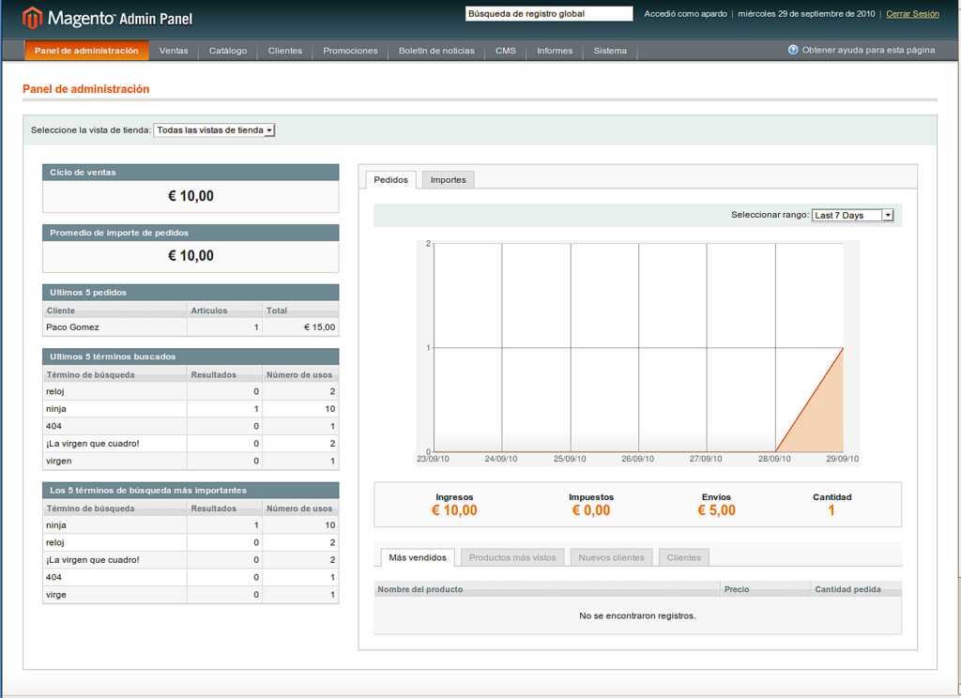

Figure 2: The interface of Magento

**History**

Magento officially started development in early 2007. Seven months later, on August 31, 2007, the first public beta version was released.

Varien, the company owning Magento, formerly worked with osCommerce. It had originally planned to fork osCommerce but later decided to rewrite it as Bento. Due in part to a naming conflict with FileMaker Inc. who had already trademarked the name Bento, Varien and osCommerce renamed Bento to Magento, a mix of Bento and Mage. The term Mage is said to pay homage to the Mage or Wizard of traditional Dungeons & Dragons style role playing games.

In February 2011, eBay announced it had made an investment in Magento in 2010, worth a 49% ownership share of the company.

As of June 6, 2011 eBay owns 100% of Magento. eBay announced that Magento would join eBay's new X.Commerce initiative. Magento's CEO and co-founder Roy Rubin wrote on the Magento blog that "Magento will continue to operate out of Los Angeles, with Yoav Kutner and me as its leaders.".

Yoav Kutner left Magento in April 2012 citing the vision for Magento having changed since the time of acquisition due to high level staff changes. Magento has since been moved to eBay Enterprise.

Magento provides three distinct platforms, Magento Community Edition, Magento Enterprise Edition, and Magento Go.

Magento community Edition

Magento Community Edition is an open-source content-management system. Anyone can modify the core system. Developers can implement the core files and extend its functionality by adding new plug-in modules provided by other developers. Since the first public beta version was released in 2007, Community Edition has been developed and customized in order to provide a basic eCommerce platform. The latest version is 1.9.1.0 which was released on Nov 24, 2014.

Magento enterprise Edition

Magento Enterprise Edition is derived from the Magento Community Edition and has the same core files. Unlike Community Edition, this is not free, but has more features and functionality. This edition is designed for large businesses that require technical support with installation, usage, configuration, and troubleshooting. Although Magento Enterprise has annual maintenance fees, neither Community nor Enterprise Editions include hosting. The Magento team develops Enterprise Edition by cooperating with users and third parties. The latest version is 1.14.0.1 which was released on May 13, 2014.

Magento Go is a cloud-based eCommerce solution, which also includes web hosting by Magento Inc. This was launched in February 2011 in order to support small businesses as it has no need for software installation. Magento Go still has many built-in modules and can add Magento extensions for more functionality, but is also the least customizable platform. The latest version is 1.1.2.3 which was released on March 28, 2014.[14] On July 1, 2014, Magento Inc. announced that they would be shutting down the Magento Go platform on February 1, 2015.

**Magento Features**

Magento supports a Web template system which generates multiple similar-looking pages and customizes them.

Themes

Magento provides a basic theme which sets up an ecommerce website. The theme is designed for customizing all pages by adding or editing the PHP, HTML and CSS. Magento users may install themes which change the display of the website or its functionality. Without loss of content or layout of pages, themes are interchangeable with Magento installations. Themes are installed by uploading theme folders via FTP or SSH and applying them using the backend admin system.

**Modules**

Magento developers have created Magento plugins which extend its basic built-in functionality. Magento users can install modules by downloading them, and uploading them to their server, or applying a module's Extension Key through Magento Connect Manager.

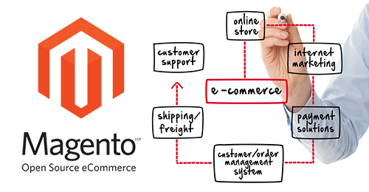

Figure 3: Magento features

The Magento was developer by language PHP with web application framework Zend Framework and database host is MySQL.

#### Magento advantages

There are many reasons for Magento become the best choice for implementing a online store. The purpose is to find a way to implement an online store quickly and effectively. Below are identified advantages that make Magento meet the two criteria:

* Offers the best total cost of ownership compared to any other system in the world. No other system of this caliber in the world comes close when it comes to features versus cost. License fees are based on the number of production servers utilized not number of users/seats, etc. This means that you can run multiple independent Magento sites from the same server without incurring any additional costs. This allows the cost of licensing to increase in line with website growth and success. So if another production server license is required due to website growth (requiring another operational service to run the eCommerce store) it will generally be as a direct result of increase sales and revenue.
* Magento is eCommerce feature rich and contains hundreds of essential and value added functions to help merchants operate a successful eCommerce store.
* Magento has multi-store capabilities making it possible run multiple websites and website views from one instance /Magento setup. This is one of the main defining factors and reasons why so many merchants globally have chosen Magento as their preferred eCommerce platform.
* Magento is 100% SEO friendly.
* Magento is 100% open source. This means there is no proprietary lock in or code restrictions or limitations. This is a huge advantage and will help ensure that your website system is not limited by a single company’s development road map.
* Magento is highly extensible and can be customized to address any eCommerce requirement.  There are now over 5,000 extensions available that can be used to extend the functionality of the store or to address specific requirements. This is unparalleled by any other eCommerce system. This is also supported by a sophisticated extension market place that enables you to search for the extension required. Normally when a requirement is identified for a Magento eCommerce store the first step is to search for the appropriate extension. If the extension is identified it can either  be purchased and used verbatim, purchased and customized to suite the need, or if the extension is not available it can be custom developed to suite the requirements.
* Magento is highly scalable and can be deployed to handle very large scale website. Being 100% web based it can be quickly scaled to handle any level of traffic, orders and customers.
* Magento has demonstrated that it is a quality eCommerce solution that can be relied upon to run the eCommerce operations of some of the world’s largest eCommerce websites and leading brands.
* Magento is owned and backed by eBay, which is a company that not only has vast resources but is committed to the growth and momentum of eCommerce.
* Magento is an innovative and modern eCommerce application that has been developed from the outset to meet the latest Internet standards. The web services API makes it possible to integrate Magento to third-party applications.
* Magento is supported by a very large range of 3rd party software vendors making it possible to integrate Magento with popular and best of breed 3rd party systems that business are already using or desire to use. These range ranging from email marketing, inventory management, shipping and logistics, market places, website analytics, payment options, website security, CRM, ERP, accounting, social media, search, etc.
* Magento is very intuitive and easy to use. There are also many resources available to learn how to use and understand Magento.
* No single vendor or partner locking in. Magento’s business model is based on a global partner network. This is made up of both solution and technology partners so the merchants have the flexibility and liberty to choose who they prefer to work with.
* Magento supports mobile commerce – HTML 5 so that the store can be developed so that it is optimized for mobile devices.

### Magento vesus Wordpress

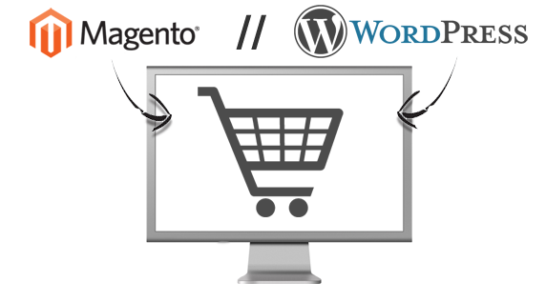

Figure 4: Magento vesus WordPress

If you use WordPress as a publishing platform with which to operate your website and find yourself with the need to incorporate some eCommerce functionality in order to support or enable your business’ growth, you may be asking yourself which solution is better for you and your business? Will you use WordPress or Magento?

Magento’s complexity in comparison may be somewhat intimidating. In this entry to our ecommerce blog, we highlight why Magento is the preferred eCommerce solution for your business and provide some tips.

#### What is your site’s purpose?

While both platforms are content management systems, it is clear that Magento was developed specifically for eCommerce. Its functionality overall is tailored towards a business structure and selling online. If your goal is to sell products, then using Magento is highly recommended. If the purpose of your website is primarily to post content or blog, and you don’t expect to offer for sale more than twenty different products, then WordPress may be an acceptable choice. However, the functionality that is provided by WordPress’ eCommerce plugins is limited. Maybe you want to support different shipping options or multiple payment methods; WordPress would not be tailored for this purpose. Just by navigating through the Magento Admin Panel, you’ll notice that an overwhelming majority of it is devoted to eCommerce capabilities like shipping options, payment integration, inventory, price management, gift cards, or order fulfilment. Magento is also more secure than using WordPress third party plugins. [10]

If your business is growing, or if you want to support its growth, then Magento should be your platform of choice. Magento is the WordPress of eCommerce.

#### Development Differences

The differences also become clear, between WordPress and Magento, as you begin development. Magento is a complicated platform to learn, especially if you are previously familiar with WordPress due to differences in terminology and thinking. However, as both platforms are content management systems, learning Magento may be easier if you try to recognize where the platforms are similar.

WordPress is made up of a series of editable Posts and Pages. When developing template files, Loops and function tags are used to call the Page or Post content. Custom template files can also be added and applied on a per-page basis. Magento features CMS Pages and they largely function the same way as a WordPress Page. However, as is often the case in Magento, something that can be accomplished through WordPress in a few quick clicks is done in a more programmatic fashion by following Magento best practices. For instance, to set up additional CMS Page templates you do not simply create a new template file; in Magento you must also create a new module that updates the list of templates available to it. The equivalent content call within these templates is performed through a PHP method as follows:

WordPress Magento

<?php the_content(); ?> <?php echo $this->getChildHtml('content') ?>

CMS Static Blocks in Magento act somewhat like a combination of Posts and Widgets in WordPress. CMS Static Blocks are good for placing images and/or text on a CMS Page or in a template file. They can be a useful way to separate content from markup or feature a list of editable links. They act similarly to Widgets in WordPress, which control design, and structural elements in a theme. It should be noted that Magento does offer true Widget functionality as well, which provides a greater level of functionality than using Static Blocks. In WordPress, you must first register a “widgetized” sidebar as well as the widget itself in the functions.php file in order to be editable through the CMS front end. In Magento, a CMS Static Block can be created in the front end, but before it can be used in a template file it must be registered as a block in the theme’s local.xml file. For a Widget to be used within a Page’s content in WordPress, some code must first be added to the functions.php file to enable the use of a shortcode in the front end. With Magento, such shortcodes are active by default: {{block type="cms/block" block_id="your_block_id"}}.[10]

The greatest difference between the two is that WordPress has its programming contained within a set of sequenced PHP scripts while Magento is object-oriented and spread across a great number of files and folders. Further, whereas WordPress has relatively unique naming conventions for template files, and those files are largely contained within a single theme directory, Magento has several folders and files that share the same name. In WordPress, a theme is contained to one folder. With Magento, there are a series of nested folders. Template files and skin files are also located in separate directories. Lastly, unlike WordPress where themes are independent of one another, Magento features fall-back logic and relies upon its default theme.

### Recommendation System on E-commerce

#### Recommendation system

Recommendation System or Recommender systems are used by E-commerce sites to suggest products to their customers and to provide consumers with information to help them decide which products to purchase. [11]. There are some criteria can be used to provide recommendation for user such as the sale number of a product on the site, customer demographic, based on customer behavior to point out the similarities or predict the future buying behavior. By using recommendation system, the site can be more adaptable to each customer. Let imagine a site with millions of products so browse through options to find the product she wants is very challenging. Recommendation system help arrange products that she likes like to buy in a way that convenient to find. Recommendation system helps to improve the E-commerce business by:

**Improving customer experience**: Recommendation System help personalize the site so that she can easy find what she wants

**Increasing the Cross-sell:** by suggesting the additional product for the customer to buy, the order size can be increased.

**Building Loyalty:** build the customer loyalty is as important as attract new one in the time that competition is cut throat. Recommendation system can improve customer satisfaction when buying and customer also help the recommendation system become more correctly because customer perform action exactly what they want. These customers also recommend for others they know and site can also attract new customers without marking campaign.

**Providing use full information for marketer and supply change manager:** recommendation provided by the recommendation engine can be help full for them to make decision. Marketer can use provided recommends to make a marketing campaign because the product recommend maybe interested by many customer and supply change manager should prepare the stock for the recommended products because they can be hot sell soon.

#### Recommendation base on association rule

Association rule is famous algorithms in knowledge discovering. The Association Rule Miner (ARM) is a shopping cart analyzer (association rule learner) searching for recommendations of the form users who bought/viewed item X also bought/viewed item Y based on the Apriori algorithm of R. Agrawal 1994. The purpose of association rule is finding the relation between two set of product in transactions so that which the occurrence of one set the second set will likely present. With association rule, the value of confidence and support will be the threshold for choosing the most likely rules. Association rule can be used to provide recommendations like who bought/viewed item X also bought/viewed item Y.

Following the original definition by Agrawal [12] the problem of association rule mining is defined as: Let I=\{i_1, i_2,\ldots,i_n\} be a set of n binary attributes called items. Let D = \{t_1, t_2, \ldots, t_m\} be a set of transactions called the database. Each transaction in D has a unique transaction ID and contains a subset of the items in I. A rule is defined as an implication of the form X \Rightarrow Y where X, Y \subseteq I and X \cap Y = \emptyset. The sets of items (for short itemsets) X and Y are called antecedent (left-hand-side or LHS) and consequent (right-hand-side or RHS) of the rule respectively.

To illustrate the concepts, we use a small example from the supermarket domain. The set of items is I= \{\mathrm{milk, bread, butter, beer}\} and a small database containing the items (1 codes presence and 0 absence of an item in a transaction) is shown in the table to the right. An example rule for the supermarket could be \{\mathrm{butter, bread}\} \Rightarrow \{\mathrm{milk}\} meaning that if butter and bread are bought, customers also buy milk.

|  |  |  |  |  |
| --- | --- | --- | --- | --- |
| **transaction ID** | **milk** | **bread** | **butter** | **beer** |
| 1 | 1 | 1 | 0 | 0 |
| 2 | 0 | 0 | 1 | 0 |
| 3 | 0 | 0 | 0 | 1 |
| 4 | 1 | 1 | 1 | 0 |
| 5 | 0 | 1 | 0 | 0 |

Table 1: Example database with 4 items and 5 transactions

* The *support*  supp(X)  of an itemset X is defined as the proportion of transactions in the data set which contain the itemset. In the example database, itemset {milk, break, butter}  has a support of 1/5=0.2 since it occurs in 20% of all transactions (1 out of 5 transactions).
* The *confidence* of a rule is defined conf(X=>Y)= sup(X∪Y)/sup(X).For example, the rule {butter, break}=>{milk} has a confidence of 0.2/0.2=1.0 in the database, which means that for 100% of the transactions containing butter and bread the rule is correct (100% of the times a customer buys butter and bread, milk is bought as well). Be careful when reading the expression: here supp(X∪Y) means "*support for occurrences of transactions where****X and Y both appear***", not "*support for occurrences of transactions where****either X or Y appears***", the latter interpretation arising because set union is equivalent to [logical disjunction](http://en.wikipedia.org/wiki/Logical_disjunction). The argument of  supp(X) is a set of preconditions, and thus becomes more restrictive as it grows (instead of more inclusive).

#### Easyrec recommendation system

**Introduction**

Easyrec is an open source Web application that provides personalized recommendations using RESTful Web services to be integrated into Web enabled applications. It is distributed under the GNU General Public License by the Studio Smart Agent Technologies and hosted at SourceForge.

It is written in Java, uses a MySQL database and comes with an administration tool.

**History**

The development of Easyrec, an implementation of the Adaptive Personalization approach, started in the course of several research and development project conducted by the Studio Smart Agent Technologies in close cooperation with international companies. During the year of 2008 the core functionality of Easyrec was developed forming the basis of research prototypes focusing on the music domain. In June 2009 a beta version of Easyrec, containing basic administration features, was integrated into a movie streaming portal for evaluation purposes. Furthermore, in September 2009 Easyrec was awarded a special recognition in the category “Award for Innovations – IT Innovations for an economic upswing” by the jury of the Austrian state prize for multimedia and e-business. After a comprehensive refactoring phase and the integration of the evaluation results Easyrec was published on SourceForge on 18 February 2010. In course of the CeBIT tradeshow 2011 in Hanover Easyrec has been awarded the German “INNOVATIONSPREIS-IT 2011”.

**Features**

A major feature of Easyrec is a set of usage statistics and other business relevant information presented via an administration and management interface. Furthermore, the Easyrec administrator is supported by a variety of administration and configuration functions including the manual import or adaptation of business rules. Integrators or developers benefit from the lightweight Web service APIs (REST and SOAP) as well as from the guided installation wizard.

Concerning personalization functionality Easyrec is providing the following services impersonalized recommendations of the form "other users also bought/viewed/...", etc.

Personalized recommendation depending on individual preferences

Rankings such as "most bought items", "most viewed...", etc.

Additionally, as an integration showcase, a MediaWiki extension was developed and is bundled with the application.

Currently additional features like further recommender algorithms and a plugin-system are evaluated and prepared for integration into the Easyrec system.

**Architecture**

The underlying architecture of Easyrec is designed to be robust and scalable—separating time-consuming computations from the task of online assembling of recommendations.

Easyrec is designed as a multi-layer system consisting of

* a database layer as storage of user actions and pre-calculated business rules
* an application layer for hosting online and offline recommendation services and
* an API layer for various Web service interfaces.
* Moreover the generator server contains different item association generators which create business rules that define a relation between two items. [13]

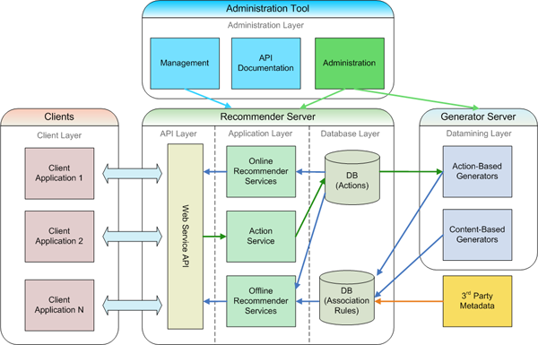

Figure 5: Easyrec architecture

**How Easyrec works**

* User Actions are sent to the Easyrec using the REST API. Possible actions are viewing, buying or rating an item.
* These user actions are stored in the database of the Recommendation Engine.
* The provided Analyzers periodically analyze all recorded data for identifying patterns to generate recommendations.
* These Recommendations can be accessed through calls to the Easyrec web service API and presented to a user.

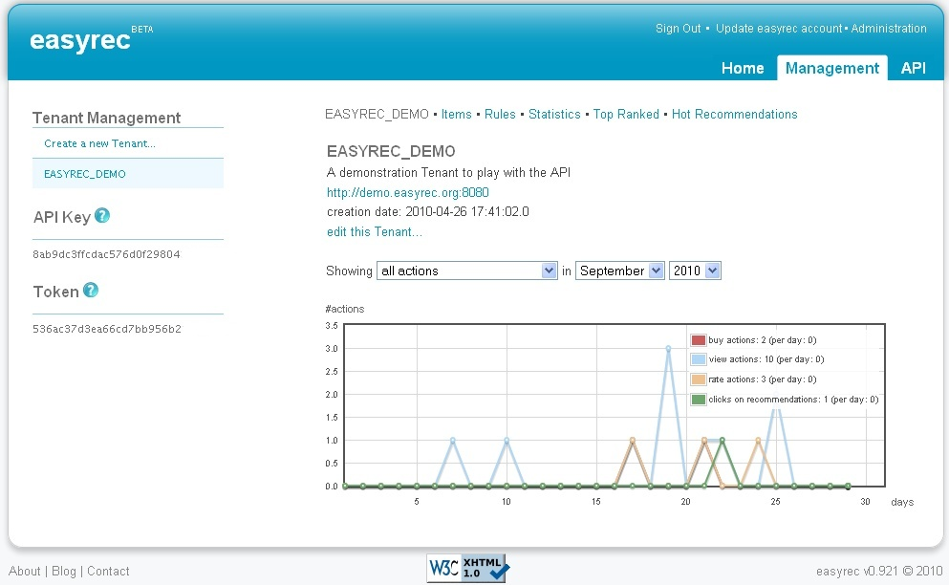

Figure 6: The Easyrec user interface

#### Easyrec recommendation system advantages

The following five primary goals guided the development of Easyrec:

* ready-to-use application, not another algorithmic framework
* easy to use, concerning installation, integration and administration
* be robust and scalable for serving real world applications
* free of charge, so that anyone can profit from personalization features

# 

# Chapter 4

# System implementation



## The commerce

## Online store implementation

Implement an online store is very easy and can be done quickly because today there are many frameworks that support to do this work. Magento framework provides a rich featured E-commerce system that can help to quickly start an E-Shop. Magento provides an open source package to the public so everyone use and modify without any free. With Magento, an online store can be built by installing the package and customizing. The install steps consist of two main steps:

Database management system preparation: Magneto supports many database management systems. But in case of the thesis, MySQL is the best choose because it is free and the number of users is small.

Magento deployment: Magento can be deployed to a web server that support PHP website. WAMP server which is free and famous web server is a properly choice in the scope of the thesis .During the deployment process, there most important step is database setup. In this step the MySQL server prepared in step one is used to store shop’s database. Magento autos create tables in database and sample database need to be import to have sample product on the store. After deployment, the online store is ready with important feature such as showing products, online order and payment and administration.

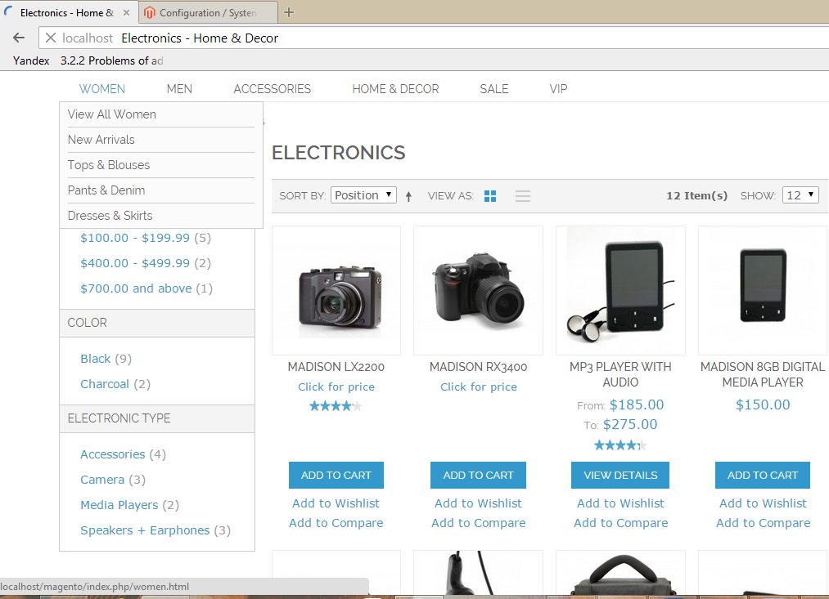

Figure 7: Magento product category page



## Recommendation system implementation

Similarly to Magento, Easyrec also provides ready-to-use package to deploy to a web server. Install Easyrec is similar to Magento: database management system preparation and deployment. For database management system preparation, the database management system or online store can be reused to contain database for Easyrec. And Tomcat server is the best choose for Easyrec because it is written in Java.

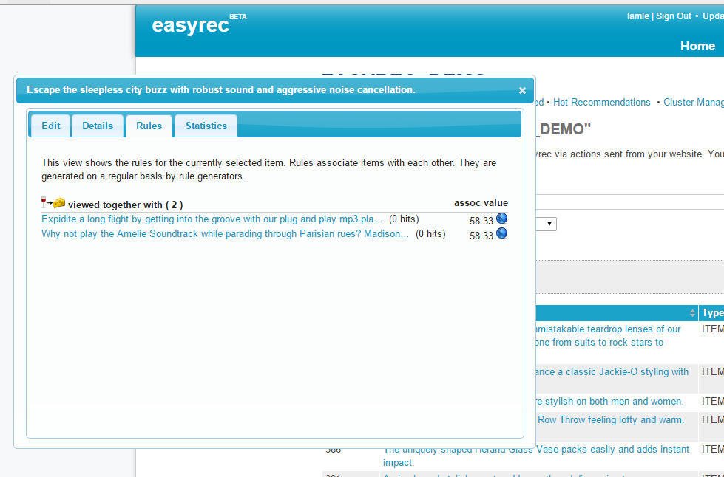

Figure 8: Easyrec summary page

## Integration online store with recommendation system.

This is the main work in the thesis. Online store and Easyrec need to collaborate to produce recommendation rules for user. To build data for mining recommendation rule basing on user action and showing the recommended product to the user. There are three main works that need to be implemented: track the user action and send it to Easyrec

To track the user action: the easy way is find buttons or links which user will click on to view or buy the product, at this time user profile and product profile are retrieved to build a REST request and send to EasyRec. User profile and product profile in Magento page can be retrieved by using PHP scripts. For example the PHP script below is used to retrieve user and product information.

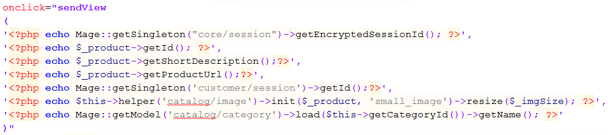

After obtaining parameters. To build and send REST request from Magento store to Easyrec, JavaScript can be exploited. The parameters sent to to JavaScript function to build request and sent to Easyrec system. For example the Java Script function which is used to send REST request:

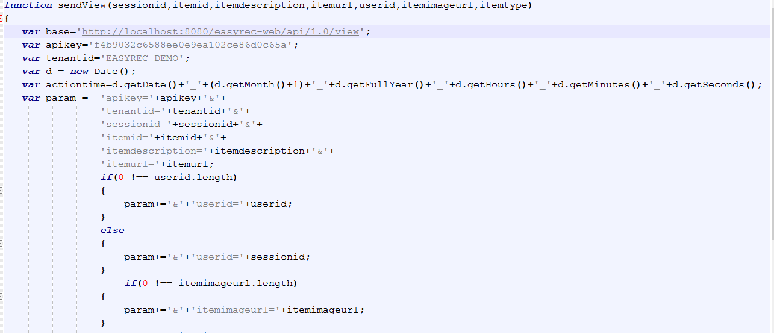

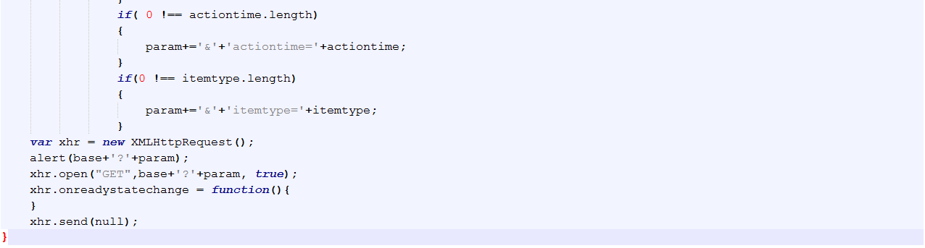

If a request is sent successfully, the action summary can be seen in EasyRec summary page. Easyrec also sends a response back to online store to acknowledge the request. The bellows are the “view action “ REST request which is built and sent to Easyrec and the repose from Easyrec

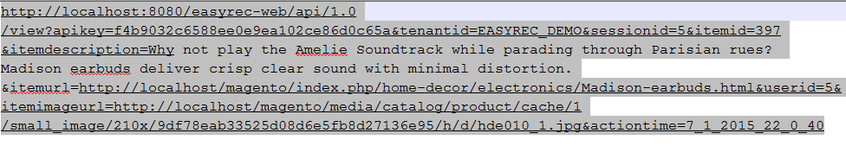

XML response sends from Easyrec

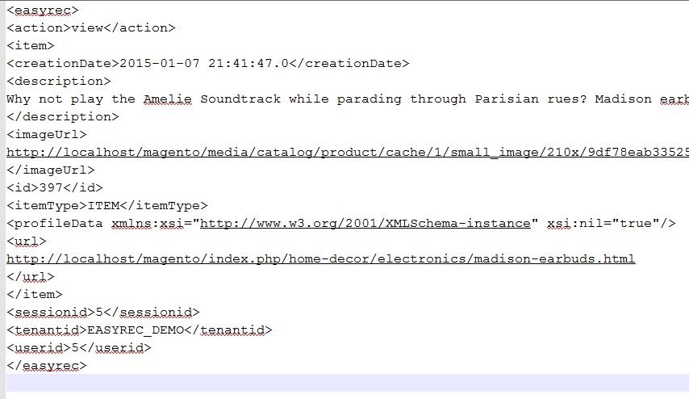

With this method, user action is track to build data for the Rule Mining Engine of Easyrec. This method help the Recommendations become more active, not static. This means data for mining is updated day by day and it is real data from the online store so the recommendations will is more reliable because they reflect exactly what happen on the store.

Easyrec will run the Rule mining engine every day base on the schedule with is configurable. When the Rule mining engine is run, it will output recommendation rules base on Association Rule Mining algorithm. After having recommendation rules, the next work is to retrieve these rules to show for the current user. PHP script and JavaScript are used to build and send request to ask for recommendations for the current user. For example, the “other users also viewed” request retrieves the products that others user also viewed when they viewed the current product for the current user when they view the base product. Bellows are the sample “other also view” REST request and the XML response.

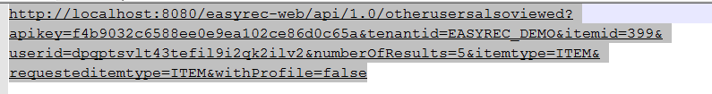

The response recommendation response from Easyrec

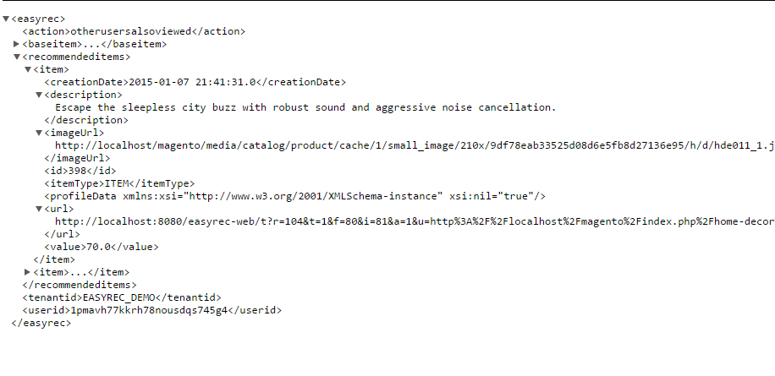

In the response, the most valuable information contain in the node <recommendeditem>.The child nodes of this node will contain recommendation products. The information in item nodes is the profile of the recommended product. In Magento page when the response is received. New block need to be implemented to show the recommended product. With the MVC architect, the view is rendered from .phtm file. To show the recommended product we define new .phtml file and insert to the current page. Use PHP script to extract the item node in the response and render info of the products contained in the node such as product url and product image url.

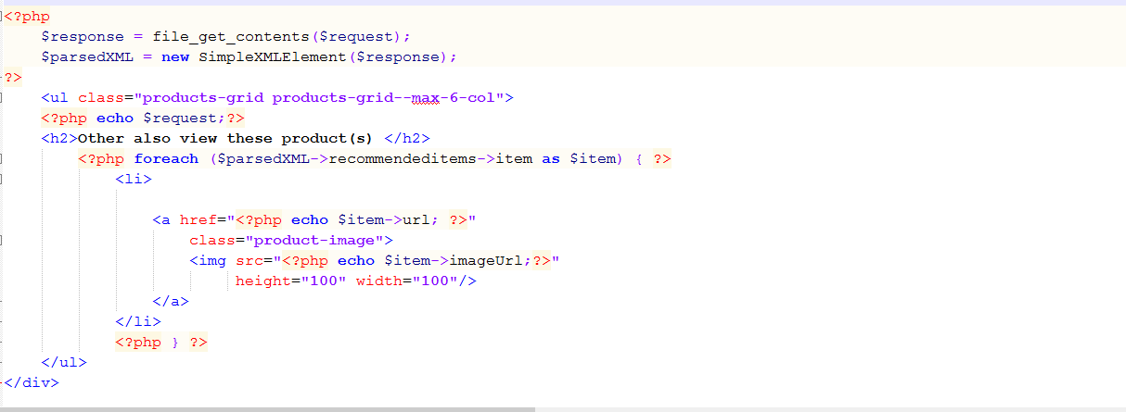

The recommend product is showing below the product detail page. The recommended product is showing with an image that when user click in will direct user the detail page of the recommended product.

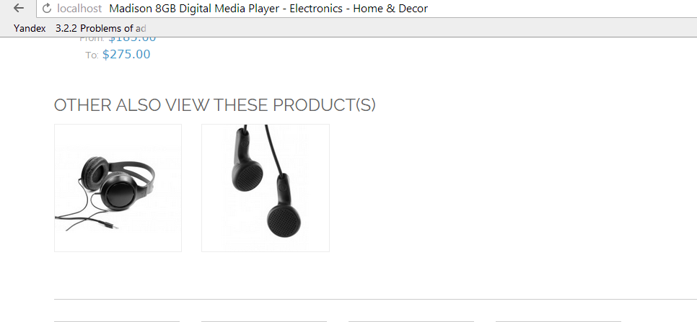

Figure 9: The Easyrec about describe

The solution to integrate Magento and Recommendation system has some advantage: easy and can be implemented quickly however it the big disadvantages is there is some hard code and need to be when the host server changed.

# Chapter 5:

# Result and Future development



## Conclusion

In this thesis we have gained

* + We have proposed the solution about the best framework to implement an E-commerce system and proven it is the suitable on for business in Vietnam. We have provide my own argument and real experience when implement an online store with Magento.
  + We point out that recommendation system can enhance an E-commerce. Recommendation system can help to increase the profit by improving customer experience, increasing order size, and attracting more customers. Then we try to finding way to implement a recommendation system for the online shop. We have researched to find the suitable solution and came up with Easyrec. The solution is implement and working as expected.
  + During the process, we also update our knowledge that related the work such as E-commerce, Association Rule.
  + We have improved knowledge about Magento and how to implement new feature in Magento. In addition, we have practiced PHP programming language and JavaScript.
  + We also improve English skill, problem solving skill, time management skill and teamwork when do the thesis.

## Future development

There are some things that we have not done as we planned at the beginning and we plan to implement them in the future

* Mobile is a new trend, we recognize that an E-commerce need to consider mobile users, however we have not addressed the mobile case. So in the future we will research about mobile trend and implement our system to work on mobile.
* The our integration solution is simple and easy but it is not configurable because there a some hard code value, so in the we will try to improve the solution and build it become an extension for Magento and public to the community.
* Easyrec also have others recommendation type such as “other user also bought” and they are great to implement these recommendation to the online store
* There are many new recommendation algorithms but Easyrec only have association rule, we plan to implement new recommendation base on new algorithms to provide more options.

**REFERENCES**

|  |  |
| --- | --- |
| [1] | "Information and Data on Information and Communication Technology Viet Nam 2013," Ha No, Infomation and Communication Pulishing House, 2014, p. 35. |
| [2] | "Payment Processing Systems and Security for E-Commerce: A Literature Review," *International Journal of Emerging Research in Management &Technology,* vol. 2, no. 5, May 2014. |
| [3] | K. L. &. V. Turban, Electronic Commerce: A Managerial Perspective, Upper Saddle River, NJ: Pearson Prentice Hall, 2004. |
| [4] | A. P. Shemi, "Factors Affecting E-commerce Adoption in Small and Medium Enterprises: An Interpretive Study of Botswana," Salford, 2012. |
| [5] | N. M, *nternational Journal of Advanced Research in Computer and Communication Engineering,* vol. 2, no. 6, p. 4, June 2013. |
| [6] | "International Journal of Advanced Research in Computer Science and Software Engineering," *A Study of Ethical and Social Issues in E - Commerce,* vol. 2, no. 7, p. 4, July 2012. |
| [7] | D. M. Panagiota Papadopoulou, "TRUST IN E-COMMERCE: CONCEPTUALIZATION AND OPERATIONALIZATION ISSUES," Athen. |
| [8] | April 2014. [Online]. Available: http://www.vietnam-briefing.com/news/vietnam-online-understanding-vietnams-e-commerce-market.html/. |
| [9] | VECITA, December 2104. [Online]. Available: http://www.vecita.gov.vn/tinbai/882/Circular-No-47-stipulating-on-the-management-e-commerce-websites/en. |
| [10] | "www.demacmedia.com," [Online]. Available: http://www.demacmedia.com/magento-commerce/working-with-magento-vs-wordpress-for-ecommerce/. |
| [11] | "E-Commerce Recommendation Applications," Minneapolis. |
| [12] | "Mining association rules between sets of items in large databases," in *Proceedings of the 1993 ACM SIGMOD international conference on Management of data - SIGMOD*, 1993. |
| [13] | [Online]. Available: http://en.wikipedia.org/wiki/Easyrec. |
| [14] | "Analysis of E-Commerce and M-Commerce: Advantages, Limitations and Security issues," *nternational Journal of Advanced Research in Computer and Communication Engineering,* vol. 2, no. 6, June 2013. |

**APPENDICES**