KWAME NKRUMAH UNIVERSITY OF SCIENCE AND TECHNOLOGY
(KNUST), KUMASI
DEPARTMENT OF COMPUTER SCIENCE
FACULTY OF PHYSICAL AND COMPUTATIONAL SCIENCES

FINAL YEAR PROJECT REPORT

IoT & ML-Based Predictive Car Engine Health Monitoring System

SUBMITTED BY
Iddrisu Faadila Wumpini
Lartey-Mensah Emmanuel Tetteh
Group 11

SUPERVISOR
Dr. R.O.M Gyening

A Project Report Submitted to the Department of Computer Science in Partial Fulfilment of the Requirements for the Award of the
Bachelor of Science Degree in Computer Science

ACADEMIC YEAR: 2025/2026

CHAPTER ONE

INTRODUCTION

1.1 Problem Statement
Car owners and fleet operators across Ghana and wider sub-Saharan Africa face a massive financial burden from sudden engine failure. Annual figures from the Ghana Road Safety Authority (GRSA) show that mechanical breakdown causes a large percentage of road accidents. Tragically, most of these trace back to engine faults that went completely unnoticed. Even with these risks, vehicle maintenance in Ghana is still almost entirely reactive. Drivers simply do not visit a fitter until a parts failure happens or the car stops completely. Most modern cars use standard On-Board Diagnostic (OBD-II) systems. However, these tools are built to log fault codes only after a critical threshold trips its Engine Control Unit (ECU). They cannot spot issues such as minor mechanical wear early, subtle changes in vibration from an engine misfire, bad bearings, or loose mounts. OBD-II setups simply lack active, real-time tracking and early warning systems. Because small transport operators and regular drivers cannot afford advanced diagnostic tools, early warning signals like minor temperature spikes or shifting vibration frequencies pass unnoticed. They eventually snowball into catastrophic mechanical breakdowns. This reality leaves vehicle owners facing ruinous repair bills, lost income from vehicle downtime, and hazardous driving conditions. Resolving this issue requires a cheap, IoT-driven system that watches critical engine metrics and uses machine learning to catch operational anomalies early.

1.2 Aim of the Project
This project builds and tests a less expensive alternative for predictive car engine maintenance. The setup tracks real-time engine vibration and surface temperature continuously to spot hidden operational anomalies. By catching these fault signatures early, the system sends immediate alerts to drivers or mechanics before catastrophic engine damage occurs.

1.3 Objectives of the Project
To achieve this aim, the study focuses on the following specific objectives:

- Review existing research: Analyse literature on vehicle diagnostics, IoT sensor networks, and unsupervised machine learning models used for spotting anomalies.
- Build the hardware prototype: Assemble a low-cost tracking unit using an ESP32 microcontroller, an MPU6050 accelerometer, and a DS18B20 digital temperature sensor to capture continuous engine data.
- Create the data preprocessing pipeline: Develop a software pipeline that cleans, normalizes, and extracts statistical features from raw vibration and temperature data streams.
- Train the machine learning model: Deploy an unsupervised Isolation Forest algorithm capable of separating normal engine baselines from developing mechanical faults.
- Deploy a secure dashboard: Design a web interface with secure user authentication to display real-time sensor metrics and trigger instant anomaly alerts.
- Test and evaluate the architecture: Assess the complete system by measuring its anomaly detection accuracy, response latency, and overall network stability under simulated fault conditions.

1.4 Justification of the Project
Both technical and socio-economic realities in Ghana justify the development of this system. Ghana’s transport sector relies heavily on private cars, taxis, ride-hailing services like Bolt, and commercial minibuses (trotros). Tight operating budgets mean most local drivers skip proactive maintenance, relying instead on emergency fixes because they cannot access or afford standard diagnostic tools. Merging low-cost IoT networks with machine learning completely changes this dynamic. The system’s core unit- the ESP32 microcontroller- costs under GHS 100 on the local market. This low price point ensures the final prototype is genuinely affordable for everyday Ghanaian drivers and small-scale transport operators. Academically, this study expands research into intelligent transport systems, edge computing, and applied machine learning within developing economies. Running an unsupervised Isolation Forest model in a resource-constrained environment proves that predictive maintenance does not require expensive, cloud-heavy infrastructure. This local edge-processing approach offers a practical baseline for engineering solutions where internet stability and computing budgets are limited.

1.5 Motivation for Undertaking the Project
This project addresses the frequent, preventable engine breakdowns on Ghanaian roads that cause traffic congestion and financial hardship for vehicle owners. By employing affordable IoT hardware and open-source machine learning, the system offers a practical solution to detect early-stage mechanical faults while applying core Computer Science skills. The project aims to reduce road accidents by providing timely diagnostics for, and preventing, sudden vehicle failures.

1.6 Scope of the Project
This project builds a functional prototype for an IoT-based engine health monitoring system. The specific scope of the implementation includes:
- Monitored parameters: The system tracks two primary health metrics: engine vibration across the X, Y, and Z axes using an MPU6050 accelerometer, and engine surface temperature via a DS18B20 sensor.
- Hardware framework: Data acquisition and wireless transmission run on an ESP32 microcontroller, which pushes data packets over Wi-Fi using the lightweight MQTT protocol.
- Machine learning model: Anomaly detection relies on an unsupervised Isolation Forest algorithm. This model learns exclusively from data representing normal engine operation.
- Validation method: System performance and detection accuracy are verified using the AI4I 2020 Predictive Maintenance Dataset under simulated fault conditions.
- User interface: A secure web dashboard features full user authentication—supporting both standard email/password logins and Google OAuth—to display real-time sensor streams and live anomaly alerts.
- System boundaries: This prototype excludes direct OBD-II port integration, GPS tracking, fuel monitoring, and native mobile apps. These elements remain open for future development.

1.7 Project Limitations
- Simulated training data: Using the AI4I 2020 simulated dataset for model training means the algorithm might not catch every unpredictable variation found in a real-world engine failure.
- Limited engine testing: Because testing was done on a single engine setup, different engine types or varied mounting positions could alter the vibration baseline and impact overall accuracy.
- Network dependence: The prototype requires stable Wi-Fi to push data in real time. Remote tracking drops completely if the vehicle enters an area with poor internet coverage.
- Mounting sensitivity: The accelerometer must be positioned perfectly. Any slight shift in physical placement or mounting stability on the engine block can easily skew the vibration readings.
- Hardware processing limits: The ESP32 lacks the processing muscle to run heavy on-device inference. Consequently, all machine learning computations must be handled by an external backend server.

1.8 Beneficiaries of the Project

Primary Beneficiaries
- Individual Car Owners
- Ride-Hailing and Taxi Operators

Secondary Beneficiaries
- Automotive Workshops and Mechanics
- Fleet Managers and Transport Companies
- Academic and Research Community

1.9 Academic and Practical Relevance of the Project
This study expands existing research by providing a solid example of unsupervised machine learning running on real-time IoT time-series data. Specifically, it bridges a significant gap in academic literature regarding how predictive maintenance tools can be built for developing economies. Outside the academic scope, the project delivers a functional, cost-effective prototype that shows AI-powered vehicle diagnostics can actually scale for the mass market. Using purely open-source tools means other developers can easily copy, scale, or commercialize the entire architecture without facing heavy upfront software costs.

1.10 Project Activity Planning and Schedule
Table 1.1: Project Activity Schedule
Phase | Activity | Weeks
Phase 1 | Literature Review & Planning — review of related works, requirements finalization, hardware procurement. | Weeks 1–2
Phase 2 | Hardware Setup & Data Collection — ESP32, MPU6050, DS18B20 prototype assembly and sensor testing. | Weeks 3–5
Phase 3 | Data Preprocessing & Feature Engineering — Butterworth filtering, normalization, windowing. | Weeks 6–7
Phase 4 | Machine Learning Model Development — Isolation Forest training, evaluation, threshold tuning. | Weeks 8–10
Phase 5 | Dashboard, Auth & System Integration — Streamlit, Supabase Auth, Google OAuth, MQTT integration. | Weeks 11–12
Phase 6 | Evaluation, Documentation & Dissertation Write-up — final testing and report completion. | Weeks 13–16

1.11 Structure of the Report
- Chapter 2 — Review of Related Works: Critical review of existing vehicle health monitoring systems and machine learning anomaly detection techniques.
- Chapter 3 — Methodology: Requirements specification, UML diagrams, software development model, UI wireframes, and database schema.
- Chapter 4 — Implementation and Results: Physical implementation, code snippets, screenshots, and testing results.
- Chapter 5 — Findings and Conclusion: Findings, conclusions, limitations, lessons learned, and recommendations.

1.12 Project Deliverables
- Hardware prototype: A fully wired monitoring unit combining the ESP32 microcontroller with an MPU6050 accelerometer and a DS18B20 temperature sensor.
- Python software pipeline: A custom script repository built to handle raw data cleaning, normalization, and time-series feature extraction.
- Trained ML model: An optimized unsupervised Isolation Forest algorithm calibrated to identify abnormal engine behavior from streaming data.
- Secure web interface: A front-end web portal featuring email/password and Google OAuth authentication, hosted directly on GitHub Pages.
- Live data dashboard: A real-time Streamlit dashboard deployed on Streamlit Cloud to visualize live sensor metrics instantly.
- Final dissertation: A comprehensive thesis document detailing the engineering design, system implementation, experimental testing, and key findings..

CHAPTER TWO

REVIEW OF RELATED WORKS

2.1 Chapter Overview
This chapter evaluates existing research and systems, analysing modern vehicle diagnostics, IoT sensor configurations, and machine learning models for anomaly detection to ground the project within current engineering practices. It also details the proposed system's architecture, components, and benefits.

2.2 Processes of Existing Systems

2.2.1 On-Board Diagnostic (OBD-II) Systems
Today, the On-Board Diagnostic (OBD-II) standard remains the most deployed technology for vehicle health tracking. Mandated globally in almost all vehicles built after 1996, OBD-II tools tap into the Engine Control Unit (ECU) to observe a rigid set of factory parameters. If any metric crosses a pre-programmed limit, the ECU logs a Diagnostic Trouble Code (DTC) and illuminates the dashboard check-engine light (Gao, Cecati & Ding, 2015).
The main advantage of OBD-II is its absolute standardization across the automotive industry, meaning it is universally supported and requires no extra hardware modifications. However, the architecture is inherently reactive. Because it only triggers an alert after a failure condition actually occurs, subtle mechanical wear—like early-stage bearing degradation or loose mounts—slips by completely unnoticed. Furthermore, reading these internal codes requires dedicated diagnostic scanners that remain financially out of reach for the average Ghanaian driver.

2.2.2 IoT-Based Vibration Monitoring Systems
Zhang and Ji (2019) proposed an IoT-based remote engine health monitoring system using a MEMS accelerometer and Fast Fourier Transform (FFT) analysis transmitted via Wi-Fi using the HTTP protocol.
Their work demonstrated the feasibility of using low-cost accelerometers for engine monitoring, yet the system's reliance on static frequency thresholds for anomaly detection made it prone to false positives under varying engine loads.

2.2.3 LSTM-Based Anomaly Detection for Multi-Sensor Data
Malhotra et al. (2016) proposed an LSTM-based encoder-decoder model for multi-sensor time-series anomaly detection, which excels at identifying contextual anomalies by learning sequential dependencies from normal data.
While effective, the model's high computational demands render it unsuitable for resource-constrained edge devices like the ESP32, and its validation was limited to a laboratory setting.

2.2.4 Industrial IoT Predictive Maintenance
Kanawaday and Sane (2017) utilized the Isolation Forest algorithm for unsupervised anomaly detection in IoT-based predictive maintenance, demonstrating effective detection with low computational overhead.
Despite this efficiency, the approach relied on high-cost, industrial-grade hardware, making it financially impractical for individual vehicle owners in Ghana. This highlights a gap in affordable, accessible predictive maintenance solutions.

2.2.5 Commercial Fleet Monitoring Systems
Commercial platforms like Samsara and Geotab deliver extensive vehicle health tracking by combining GPS location data, direct OBD-II integration, and enterprise-grade cloud dashboards.
While these professionally maintained architectures scale seamlessly for massive corporate fleets, they require high monthly subscription fees ranging from $25 to $70 USD per vehicle. For individual vehicle owners and informal transport operators across Ghana, these recurring foreign currency costs are financially impossible to sustain, proving that existing industrial solutions fail to serve the local mass market.

2.3 Comparative Summary of Existing Systems
Table 2.1: Comparative Summary of Existing and Proposed Systems
System / Study | Sensors | Protocol | ML / Detection | Key Limitation
OBD-II (Gao et al., 2015) | ECU internal | CAN Bus | Rule-based fault codes | Reactive only; no prediction
Zhang & Ji (2019) | Accelerometer | Wi-Fi/HTTP | FFT + Static Threshold | No ML; false positives
Malhotra et al. (2016) | Multi-sensor | N/A (offline) | LSTM Encoder-Decoder | Lab-only; not IoT deployed
Kanawaday & Sane (2017) | Vib, Temp, Pressure | MQTT | Isolation Forest | Industrial hardware; costly
Commercial (Samsara) | GPS, OBD-II, Accel | 4G/LTE | Proprietary ML | $25–$70/month; unaffordable
PROPOSED SYSTEM | MPU6050, DS18B20 | MQTT/Wi-Fi | Isolation Forest | Low-cost; real-time; Ghana-context

2.4 The Proposed System
This proposed IoT and machine learning setup directly solves the gaps left by traditional diagnostics. Made with the average Ghanaian car owner in mind, the prototype is cheap, processes metrics in real time, and requires zero specialized mechanical skills to install. While standard OBD-II setups look backward, this system captures active physical telemetry to find structural engine wear before factory fault codes ever trigger.
Furthermore, instead of using rigid, static sensor thresholds that trigger frequent false alarms under changing road conditions, this architecture uses an unsupervised machine learning model. This allows the system to map the engine's unique baseline and spot operational deviations dynamically.

2.5 Conceptual Design
The entire system relies on an integrated edge-to-cloud IoT architecture. At the edge, an ESP32 microcontroller interfaces directly with the hardware sensors, sampling the MPU6050 accelerometer at 50Hz and the DS18B20 temperature probe at 1Hz. This raw telemetry streams immediately over Wi-Fi to a dedicated processing server via the MQTT protocol. The backend server handles all signal preprocessing and machine learning inference. Whenever the system flags an operational anomaly, it pushes the alert event to a cloud database and updates the web-based monitoring dashboard simultaneously. To secure this data, dashboard access is restricted by a Supabase Auth gateway, which handles user sign-ups through mandatory verification emails as well as standard Google OAuth logins.

2.6 Architecture of the Proposed System

Layer 1: Perception Layer
The physical hardware layer mounts the MPU6050 MEMS accelerometer and the DS18B20 digital temperature sensor directly onto the vehicle's engine block. The MPU6050 maps continuous 3-axis acceleration to track engine vibration, while the DS18B20 maintains precise tracking of surface temperature fluctuations.

Layer 2: Network Layer
The ESP32 compiles sensor readings and transmits them to a processing server using MQTT over Wi-Fi. The ESP32 acts as an MQTT publisher, sending JSON-formatted sensor payloads to designated topic channels on a Mosquitto MQTT broker.

Layer 3: Processing Layer
The central backend server processes the raw telemetry in three distinct stages. First, it sanitizes the data stream using a digital Butterworth filter, normalizes the values, and splits the time-series data into discrete windows. Second, it extracts 22 statistical features—including mean, standard deviation, RMS, kurtosis, skewness, range, and peak-to-peak metrics. Finally, it runs machine learning inference on these features to generate real-time anomaly scores using the trained Isolation Forest model.

Layer 4: Application Layer
The user interface features a live Streamlit web dashboard that charts real-time time-series plots, displays the active anomaly score indicator, and catalogs historical event logs. Users access this monitoring interface via the project landing page at https://faadila-wumpini.github.io/Engine_monitor, which requires full credentials authentication before unlocking the live sensor streams.

2.7 Component Descriptions

2.7.1 ESP32 Microcontroller
The ESP32 is a low-cost, low-power system-on-chip (SoC) featuring a dual-core Xtensa LX6 processor at up to 240 MHz, 520 KB SRAM, and integrated Wi-Fi. In the proposed system it serves as the central edge device for sensor interfacing, data acquisition, and wireless MQTT transmission.

2.7.2 MPU6050 MEMS Accelerometer
The MPU6050 is a six-axis MEMS IMU communicating via I2C. Only the accelerometer functionality is used, measuring linear acceleration along X, Y, and Z axes. Raw 16-bit readings are converted to g-force by dividing by 16,384 (sensitivity at ±2g).

2.7.3 DS18B20 Digital Temperature Sensor
The DS18B20 provides 9 to 12-bit temperature measurements with ±0.5°C accuracy over -10°C to +85°C, communicated via the Dallas 1-Wire protocol over a single GPIO pin. A 4.7kΩ pull-up resistor is connected between the data line and 3.3V supply.

2.7.4 MQTT Protocol and Mosquitto Broker
MQTT (Message Queuing Telemetry Transport) is a lightweight publish-subscribe messaging protocol designed for IoT data transmission with minimal bandwidth. The ESP32 publishes JSON sensor payloads to the topic engine/sensors on a Mosquitto MQTT broker running on the processing server.

2.7.5 Machine Learning Model — Isolation Forest
The Isolation Forest (Liu, Ting & Zhou, 2008) is an unsupervised anomaly detection algorithm that isolates observations by randomly selecting features and split values. Anomalous data points require fewer tree splits to isolate, yielding lower anomaly scores. The algorithm is computationally efficient, distribution-free, and trained exclusively on normal engine data.

2.7.6 Supabase Cloud Database and Authentication
Supabase is an open-source Firebase alternative built on PostgreSQL. It provides a managed cloud database with auto-generated REST APIs and a complete user authentication service. Supabase Auth supports email/password authentication with email confirmation, Google OAuth 2.0, and JWT-based session management. In the proposed system, Supabase Auth secures the project website — users must register and confirm their email before accessing the monitoring dashboard. The profiles table stores user full names and emails to support name-based login.

2.7.7 Streamlit Web Dashboard
Streamlit is an open-source Python library for building interactive data web applications. In the proposed system it powers the user-facing monitoring dashboard, displaying real-time time-series charts, anomaly score gauges, and an alert history table populated from Supabase.

2.8 Proposed System Features
- Real-Time Monitoring: Continuous acquisition and display of vibration data at 50Hz and temperature data at 1Hz, with sub-second latency.
- Unsupervised Anomaly Detection: ML model trained solely on normal engine data, requiring no labelled fault data.
- Multi-Axis Vibration Analysis: Vibration capture across X, Y, and Z axes enabling detection of directional fault signatures.
- Historical Anomaly Logging: Persistent storage of all detected anomaly events via Supabase cloud database.
- User Authentication: The project website is secured with Supabase Auth. Users must register and confirm their email before accessing the dashboard. Google OAuth is provided as an alternative sign-in method.
- Password Security: Client-side password validation enforces a minimum of 8 characters and at least one special character, with a live strength indicator and confirm-password match indicator.
- Low-Cost and Accessible: Estimated total hardware cost below GHS 400.
- Severity Classification: Anomalies are classified into Low, Medium, and High severity levels.

2.9 Development Tools and Environment

2.9.1 Hardware Tools
The hardware development environment consists of the ESP32 development board (ESP-WROOM-32), MPU6050 accelerometer module, DS18B20 temperature sensor, a 4.7kΩ pull-up resistor, jumper wires, a breadboard, and the Arduino IDE (version 2.x).

2.9.2 Software Tools
Python (version 3.13) is the primary programming language for the data processing pipeline, ML model, and dashboard. Key libraries include: Pandas and NumPy for data manipulation; SciPy for signal processing; Scikit-learn for Isolation Forest; Paho-MQTT for MQTT communication; Supabase-py for cloud database integration; and Streamlit for the web dashboard.

2.9.3 Development Environment
Development is conducted on Windows 11 with Visual Studio Code as the primary code editor. Git and GitHub are used for version control and collaboration. The project website is deployed via GitHub Pages and the dashboard via Streamlit Cloud.

2.10 Benefits of the Proposed System
- Proactive Fault Detection: Detecting anomalies before they escalate enables preventive maintenance, significantly reducing repair costs.
- Cost Effectiveness: At an estimated hardware cost below GHS 400, the system is accessible to individual car owners in Ghana.
- Secure Access: User authentication ensures only registered users can access the monitoring dashboard, protecting data privacy.
- Ease of Use: The dashboard provides a simple, intuitive interface requiring no technical expertise.
- Scalability: The MQTT-based architecture allows scaling from a single vehicle to a fleet.

2.11 Chapter Summary
This chapter provided a comprehensive review of existing vehicle health monitoring systems and related works. Critical gaps were identified — the reactive nature of OBD-II diagnostics, limitations of threshold-based IoT systems, and prohibitive cost of commercial platforms. The proposed system was presented as a solution through low-cost IoT hardware, MQTT communication, unsupervised ML, and a secure user-authenticated web interface. Chapter 3 will present the methodology adopted for system development.

CHAPTER THREE

METHODOLOGY

3.1 Chapter Overview
This chapter presents the methodology adopted for the design and development of the system. It begins with requirements specification, UML diagrams, non-functional requirements, security concepts, the software development model, and logical design considerations including UI wireframes and database schema.

3.2 Requirement Specification

3.2.1 Stakeholders of the System
- New User: A person who registers a new account on the project website to gain access to the monitoring dashboard.
- Registered Vehicle Owner / Driver (Primary User): The authenticated end user who monitors engine health via the dashboard and receives anomaly alerts.
- System Administrator: A technical user responsible for model training, threshold configuration, and system maintenance.
- Processing Server / ML Engine (System Actor): The backend component that subscribes to sensor data, executes preprocessing, and runs anomaly detection inference.
- ESP32 Sensor Node (System Actor): The embedded hardware device that collects raw sensor data and publishes it to the MQTT broker.

3.2.2 Requirement Gathering Process
Requirements were gathered through: literature review of related vehicle health monitoring and predictive maintenance systems; stakeholder analysis of individual car owners and fleet operators in Ghana; review of the project proposal document; consultation with the project supervisor; and iterative refinement during Agile development sprints.

3.3 Functional Requirements
Table 3.1: Functional Requirements
ID | Requirement | Priority
FR-01 | The system shall continuously read vibration data from the MPU6050 accelerometer at a minimum rate of 50Hz. | High
FR-02 | The system shall continuously read surface temperature from the DS18B20 sensor at a minimum rate of 1Hz. | High
FR-03 | The ESP32 shall format sensor readings as JSON payloads and publish them to the MQTT broker in real-time. | High
FR-04 | The processing server shall subscribe to the MQTT broker and receive sensor data with latency under 100ms. | High
FR-05 | The preprocessing pipeline shall apply a Butterworth low-pass filter to remove noise from vibration data. | High
FR-06 | The system shall extract at least seven statistical features per sensor axis per time window. | High
FR-07 | The ML model shall classify each feature vector as normal or anomalous using an anomaly score threshold. | High
FR-08 | The system shall log all detected anomaly events to a Supabase database with timestamp and severity. | High
FR-09 | The dashboard shall display real-time vibration and temperature charts refreshed at ~1-second intervals. | High
FR-10 | The dashboard shall display a visual anomaly alert banner within 2 seconds of a fault event being detected. | High
FR-11 | The dashboard shall display a historical log of the 50 most recent anomaly events from the database. | Medium
FR-12 | An administrator panel shall allow authorised users to log in and adjust the anomaly score threshold. | Medium
FR-13 | The system shall classify anomaly severity into three levels: Low, Medium, and High. | Medium
FR-14 | The website shall require users to register an account with full name, email address, and password before accessing the monitoring dashboard. | High
FR-15 | The system shall send a confirmation email to newly registered users. The confirmation link shall expire after one hour. | High
FR-16 | The website shall allow users to sign in using either their registered email address or their full name combined with their password. | High
FR-17 | The system shall provide a 'Continue with Google' OAuth option on both Sign In and Create Account screens. | High
FR-18 | The signup form shall enforce a minimum password length of 8 characters including at least one special character, with a live strength indicator and confirm-password match indicator. | High
FR-19 | If a confirmation email is not received, the user shall be able to request a resend after a 60-second countdown. | Medium

3.4 UML Diagrams

3.4.1 Use Case Diagram — Front-End (Driver Dashboard & Authentication)
The front-end use case diagram captures interactions between two actor types and the web-based system. The New User actor interacts with four authentication use cases: Register Account, Confirm Email Address, Resend Confirmation Email, and Sign In with Google. The Registered Vehicle Owner actor interacts with: Sign In (email or name), View Real-Time Vibration Chart, View Real-Time Temperature Chart, Receive Anomaly Alert Notification, View Anomaly Severity Status, View Anomaly History Log, and Sign Out.
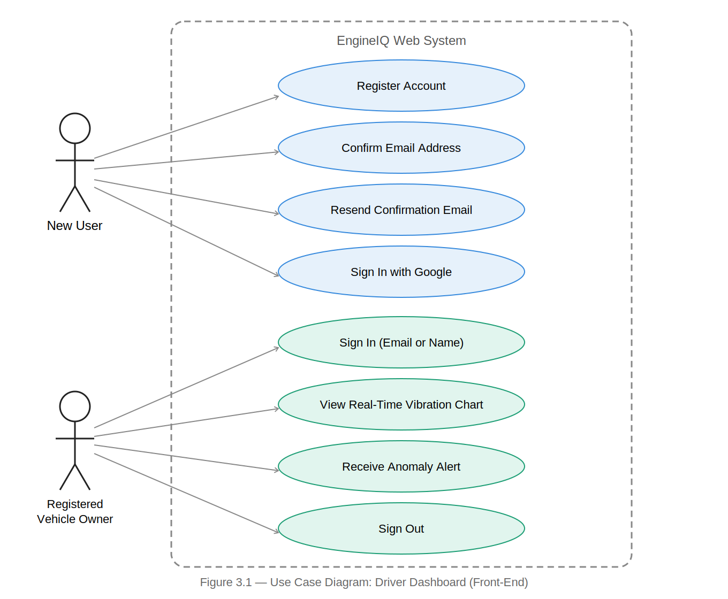
Figure 3.1 — Use Case Diagram: Driver Dashboard (Front-End)

3.4.2 Use Case Diagram — Back-End (System Administrator)
The back-end use case diagram captures interactions between the System Administrator and the backend processing components. The administrator can log in, configure the anomaly score threshold, trigger ML model retraining, view system status indicators, view the full anomaly log, and export the anomaly log as CSV.
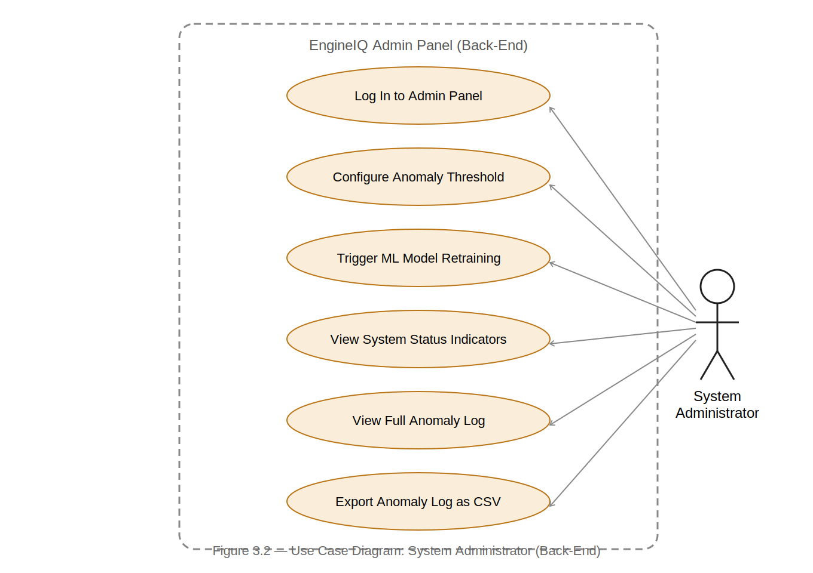
Figure 3.2 — Use Case Diagram: System Administrator (Back-End)

3.4.3 Use Case Descriptions
Table 3.2: Use Case Descriptions
Use Case ID | Use Case Name | Actor | Description
UC-01 | View Real-Time Vibration Chart | Vehicle Owner | The driver views a continuously updating line chart showing MPU6050 acceleration readings on X, Y, and Z axes over the last 100 data points. The chart auto-refreshes every second.
UC-02 | View Real-Time Temperature Chart | Vehicle Owner | The driver views a continuously updating chart showing DS18B20 surface temperature over time, enabling detection of overheating conditions.
UC-03 | Receive Anomaly Alert | Vehicle Owner | When the ML model detects an anomaly, the dashboard displays a prominent red alert banner with the anomaly score and severity level.
UC-04 | View Anomaly Severity Status | Vehicle Owner | A colour-coded status indicator (green: Normal, yellow: Low, orange: Medium, red: High) is displayed on the dashboard at all times.
UC-05 | View Anomaly History Log | Vehicle Owner | The driver views a table of the 50 most recent anomaly events retrieved from the Supabase database, including timestamp, severity, and anomaly score.
UC-06 | Filter Anomaly History by Date | Vehicle Owner | The driver selects a date range to filter displayed anomaly records to a specific time window.
UC-07 | Log In to Admin Panel | Administrator | The administrator enters credentials. Supabase Auth validates them and grants access to administration controls. Invalid credentials result in an error message.
UC-08 | Configure Anomaly Threshold | Administrator | The administrator adjusts the anomaly score threshold using a slider. The new threshold is immediately applied to subsequent inference cycles.
UC-09 | Trigger ML Model Retraining | Administrator | The administrator initiates a model retraining cycle. The new model and scaler are saved to disk and loaded into the active inference engine.
UC-10 | Register Account | New User | A new user fills the Create Account form with full name, email, password (min. 8 chars with special character), and confirm password. Supabase Auth creates the account and sends a confirmation email. The site displays a confirmation panel with a 60-second resend countdown.
UC-11 | Confirm Email Address | New User | The user clicks the confirmation link in their email. The link redirects to the site with an access token. The Supabase SDK detects the token, activates the account, and the user is automatically signed in.
UC-12 | Sign In with Email or Name | Registered User | The user enters either their email address or full name, plus their password. If a name is entered, the system queries the profiles table to retrieve the associated email. Supabase Auth validates the credentials.
UC-13 | Sign In with Google | New / Registered User | The user clicks Continue with Google. The browser redirects to Google's OAuth consent screen. After approval, Supabase creates or retrieves the account, issues a JWT session, and redirects the user to the dashboard.
UC-14 | Resend Confirmation Email | New User | After the 60-second countdown expires, the user clicks Resend. Supabase sends a new confirmation email and the countdown restarts.
UC-15 | Sign Out | Authenticated User | The user clicks Sign Out in the navigation bar. Supabase clears the JWT session and the authentication screen is displayed.

3.4.4 Activity Diagram — Sensor Data Flow
The activity diagram describes the end-to-end data flow: the ESP32 reads sensors and publishes JSON via MQTT; the inference engine receives data and appends to a rolling buffer; when the buffer reaches 50 samples, the Butterworth filter is applied; statistical features are extracted; Isolation Forest inference runs; if the score is below threshold, the anomaly is logged to Supabase and an alert is displayed on the dashboard.
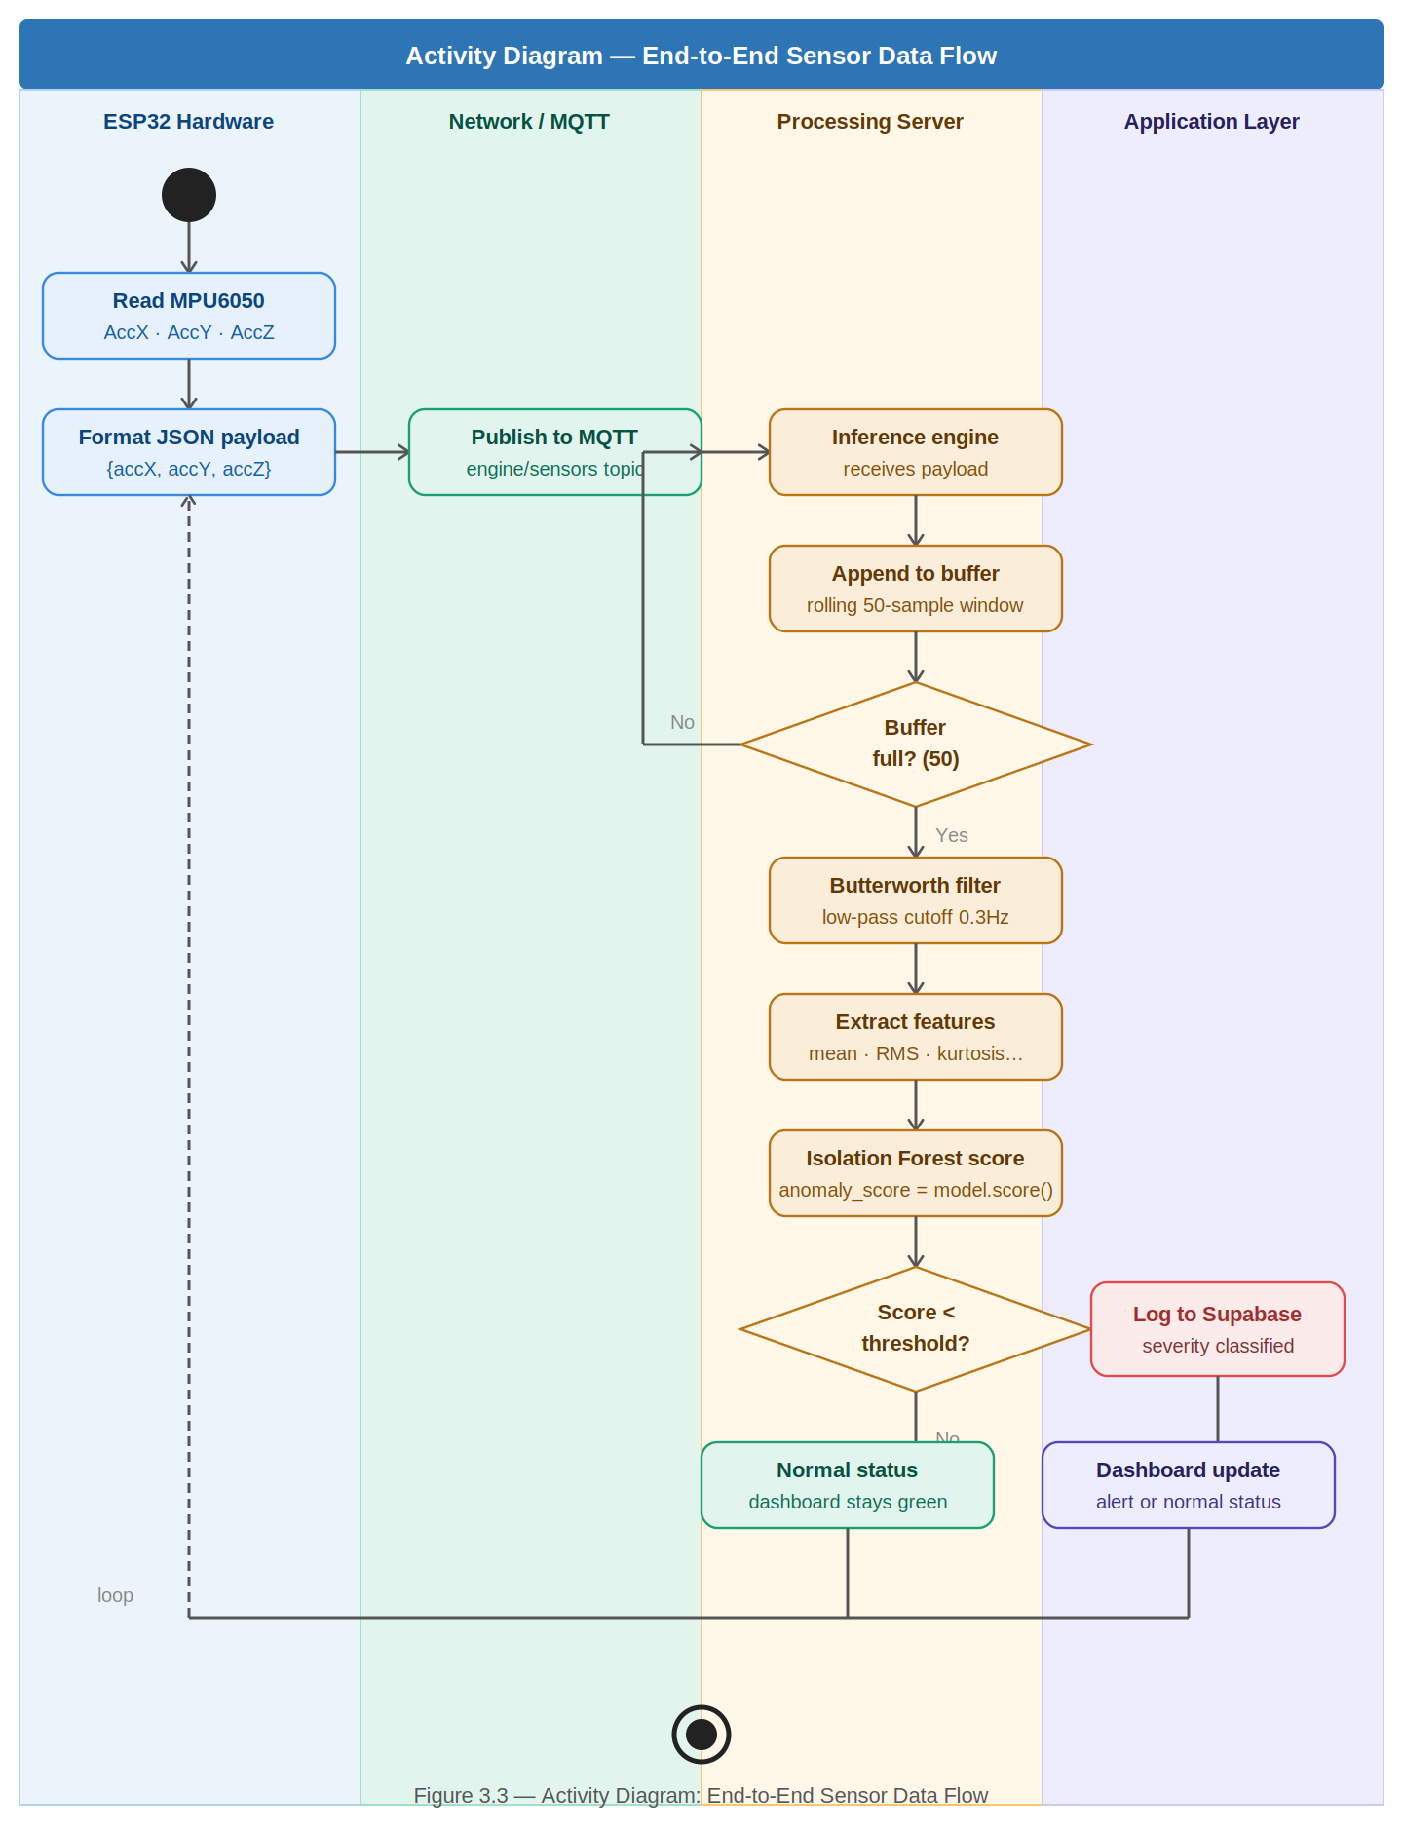
Figure 3.3 — Activity Diagram: End-to-End Sensor Data Flow

3.4.5 Sequence Diagram — Anomaly Detection Flow
The sequence diagram illustrates temporal interactions during an anomaly detection event: ESP32 publishes to MQTT broker; broker forwards to inference engine; inference engine preprocesses and scores the feature vector; if anomaly detected, inserts record to Supabase; dashboard auto-refresh retrieves the latest record and displays the alert.
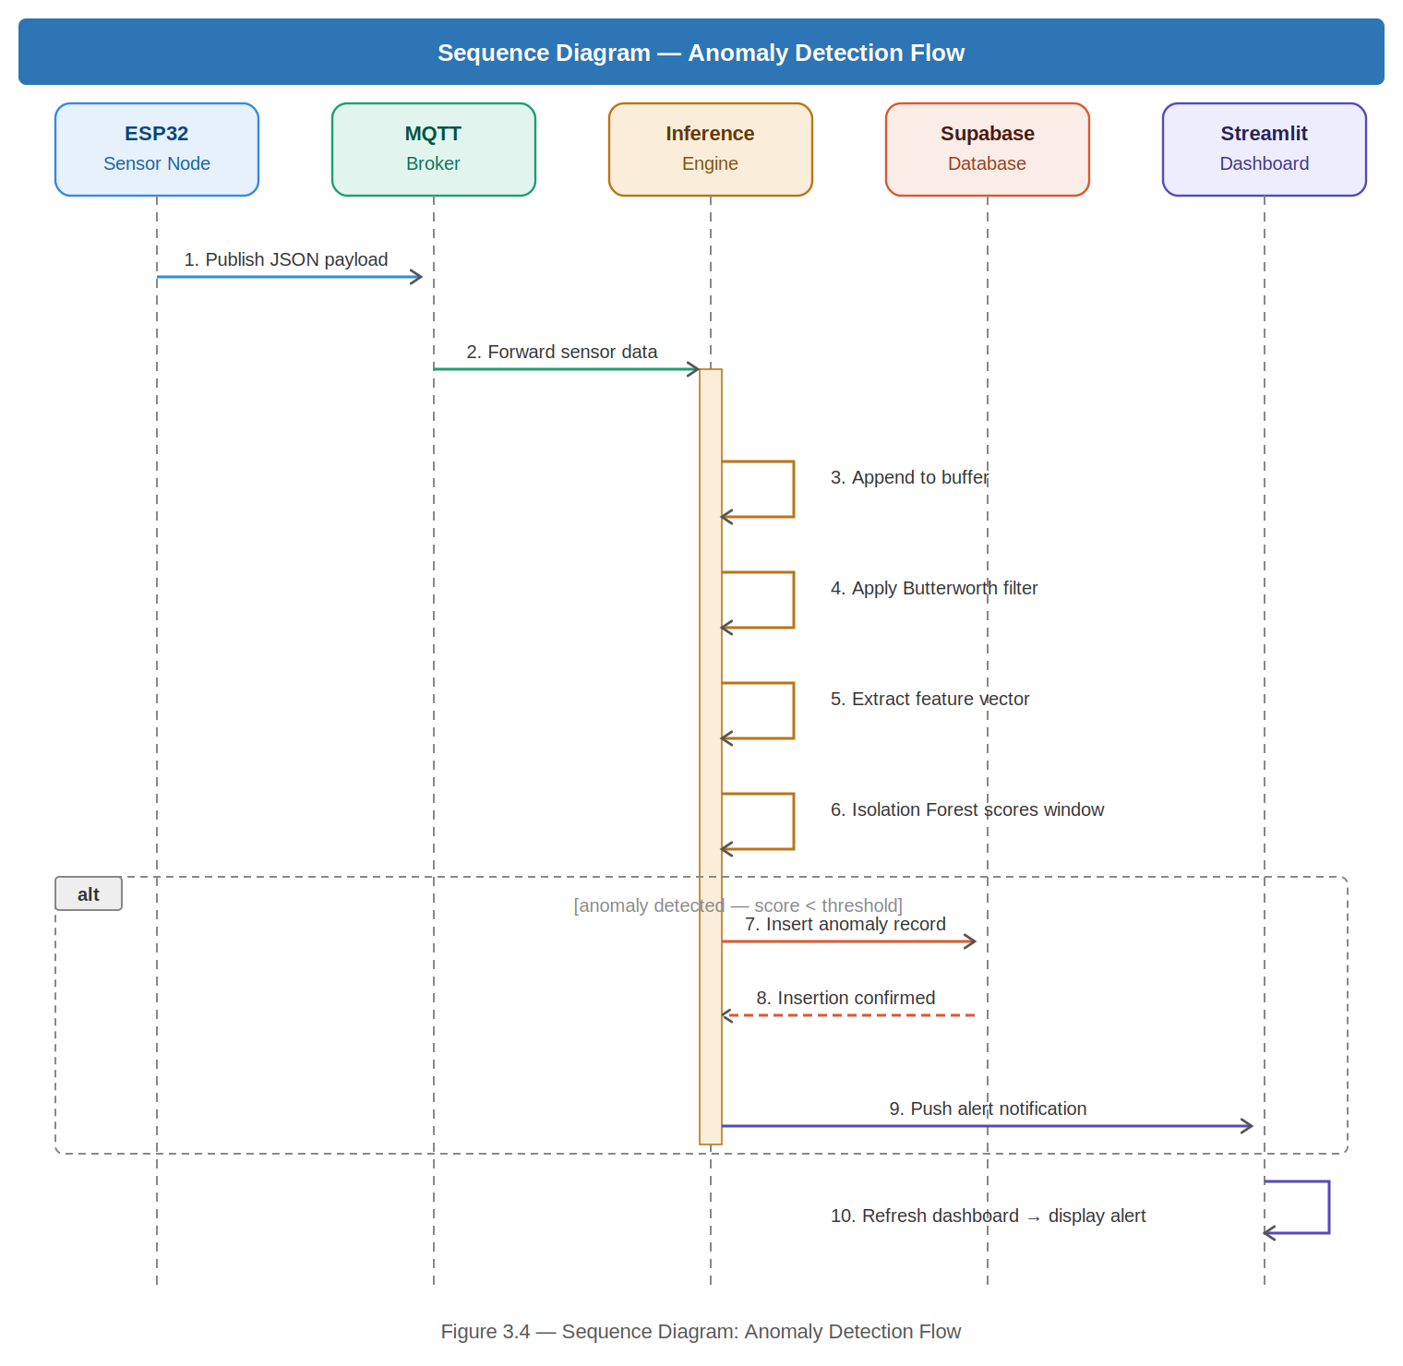
Figure 3.4 — Sequence Diagram: Anomaly Detection Flow

3.4.6 Class Diagram
The principal software classes are: DataPreprocessor (butterworth_filter, extract_features, process_dataframe, normalise methods), AnomalyDetector (train, predict, get_severity, save_model, load_model), DatabaseLogger (log_anomaly, get_history), and InferenceEngine (run_simulation, run_live, score_window) which composes all three. StreamlitDashboard uses DatabaseLogger and AnomalyDetector.
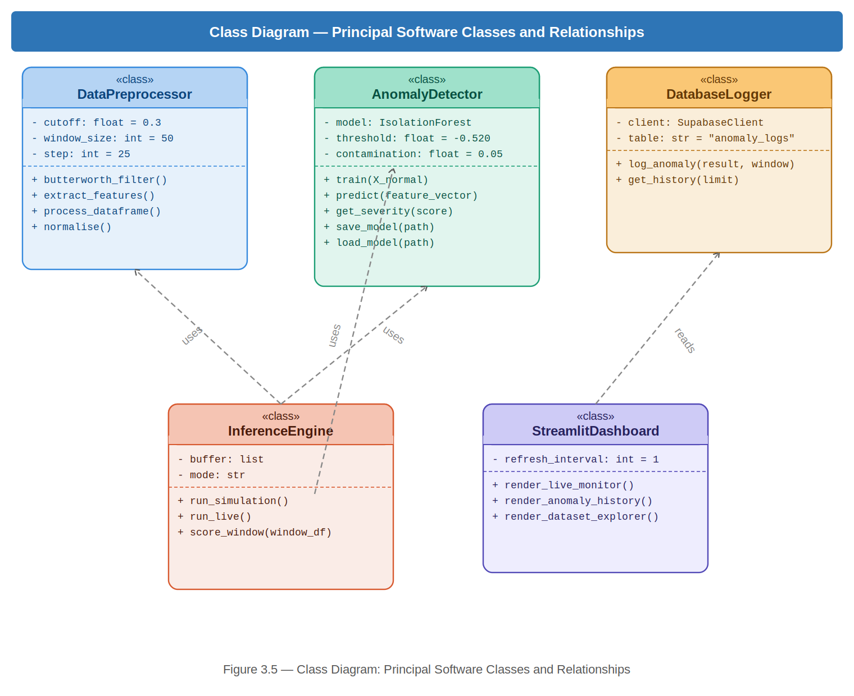
Figure 3.5 — Class Diagram: Principal Software Classes and Relationships

3.4.7 Authentication Flow Diagram
The authentication flow diagram illustrates how users access the system. On visiting the site, an active session check is performed. If a valid JWT session exists, the user is taken directly to the dashboard. If not, the authentication screen is displayed. The user may choose email/password (new user signs up and confirms email; returning user signs in by email or full name) or Google OAuth. All pathways result in a JWT session being established, after which the dashboard is displayed.
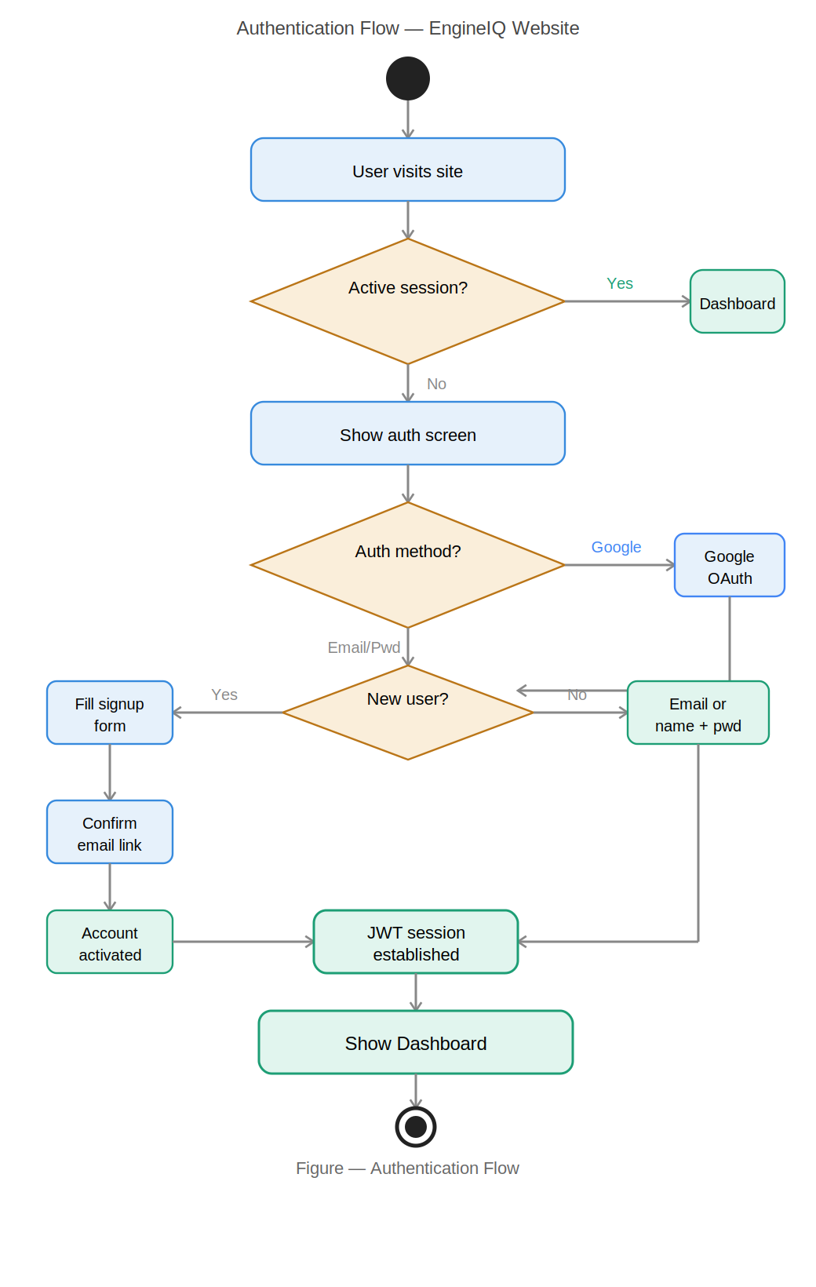

Figure 3.6 — Authentication Flow Diagram

3.5 Non-Functional Requirements
Table 3.3: Non-Functional Requirements
ID | Category | Requirement | Justification
NFR-01 | Performance | End-to-end latency from sensor anomaly to dashboard alert shall not exceed 2 seconds. | Timely alerts are critical for the system's utility as an early warning tool.
NFR-02 | Reliability | The system shall achieve a true positive rate of at least 85% and false positive rate of no more than 5%. | Low false positives prevent alert fatigue; high true positives ensure faults are not missed.
NFR-03 | Availability | The dashboard shall be accessible from any modern web browser without software installation. | Broad compatibility ensures usability by non-technical car owners on any device.
NFR-04 | Scalability | The MQTT architecture shall support up to 10 additional ESP32 sensor nodes without architectural changes. | Enables future scaling to fleet monitoring deployments.
NFR-05 | Usability | A non-technical user shall interpret engine health status without prior training. | The primary target user is not technically trained; the interface must be intuitive.
NFR-06 | Cost | Total hardware cost shall not exceed GHS 400. | Affordability is a primary design constraint for deployment in Ghana.
NFR-07 | Security | Unauthenticated users shall not be able to access any monitoring dashboard content. | Protecting user data and system integrity requires access control.
NFR-08 | Maintainability | All Python source code shall follow PEP-8 standards and include inline documentation. | Maintainable code supports future extension and handover.

3.6 Security Concepts
The system addresses security requirements across six areas:
- Administrator Authentication: The admin panel is protected by Supabase Authentication with JWT-based session management. Unauthenticated users are denied access to administrative controls.
- MQTT Broker Authentication: The Mosquitto MQTT broker is configured with username/password authentication to prevent unauthorised clients from publishing to the engine/sensors topic.
- Database Row-Level Security: Supabase Row-Level Security (RLS) policies are configured on the anomaly_logs table. The profiles table has policies restricting read access and allowing users to only insert and update their own records.
- Data Transmission Security: In production deployment, TLS encryption over MQTT (MQTTS, port 8883) is recommended to protect data in transit between the ESP32 and the MQTT broker.
- User Authentication — Email/Password: The website enforces user registration before access. Passwords are validated client-side for a minimum of 8 characters and at least one special character. Supabase Auth handles server-side password hashing using bcrypt. Email confirmation is required before an account can be used.
- User Authentication — Google OAuth: The system integrates Google OAuth 2.0. Google verifies the user's identity and issues an authorisation code to the Supabase callback endpoint. Supabase exchanges this for a JWT session token. No password is required or stored for Google-authenticated users.

3.7 Software Development Methodology

3.7.1 Overview of Software Process Models
- Waterfall Model: Linear sequential model suited to projects with fully defined requirements. Inflexible once development begins.
- Spiral Model: Combines iterative development with risk analysis. Appropriate for large high-risk projects but carries significant planning overhead.
- Prototype Model: Focuses on rapid construction of working prototypes. Effective for clarifying requirements but can lead to poor architecture.
- Agile Model: Iterative and incremental model organised around short development sprints. Each sprint produces a working, tested system increment.

3.7.2 Chosen Model: Agile
The Agile model was selected. Development is organised into six two-week sprints: Sprint 1 (literature review and hardware procurement), Sprint 2 (ESP32 firmware and sensor integration), Sprint 3 (data preprocessing pipeline), Sprint 4 (ML model training and evaluation), Sprint 5 (dashboard, authentication, and Supabase integration), and Sprint 6 (end-to-end system testing and dissertation write-up).

3.7.3 Justification for Agile
- Adaptability to Hardware Constraints: IoT projects frequently encounter unforeseen integration challenges. Agile enabled rapid identification and resolution without requiring a full project restart.
- Alignment with Dual-Component Development: Agile allowed both hardware firmware (C++) and software (Python) development to proceed concurrently within the same sprint cycle.
- Continuous Integration and Testing: Agile's emphasis on a working increment at sprint end ensured hardware-software integration was tested continuously.

3.8 Project Design Considerations (Logical Designs)

3.8.1 UI Wireframes
Driver Dashboard Wireframe: The driver-facing dashboard presents a top-level status banner (NORMAL in green, ANOMALY in red), followed by real-time line charts for vibration (X, Y, Z axes) and temperature, an anomaly score indicator, a colour-coded severity badge, and an anomaly history table showing the last 50 events. The dashboard is accessible only after successful authentication.
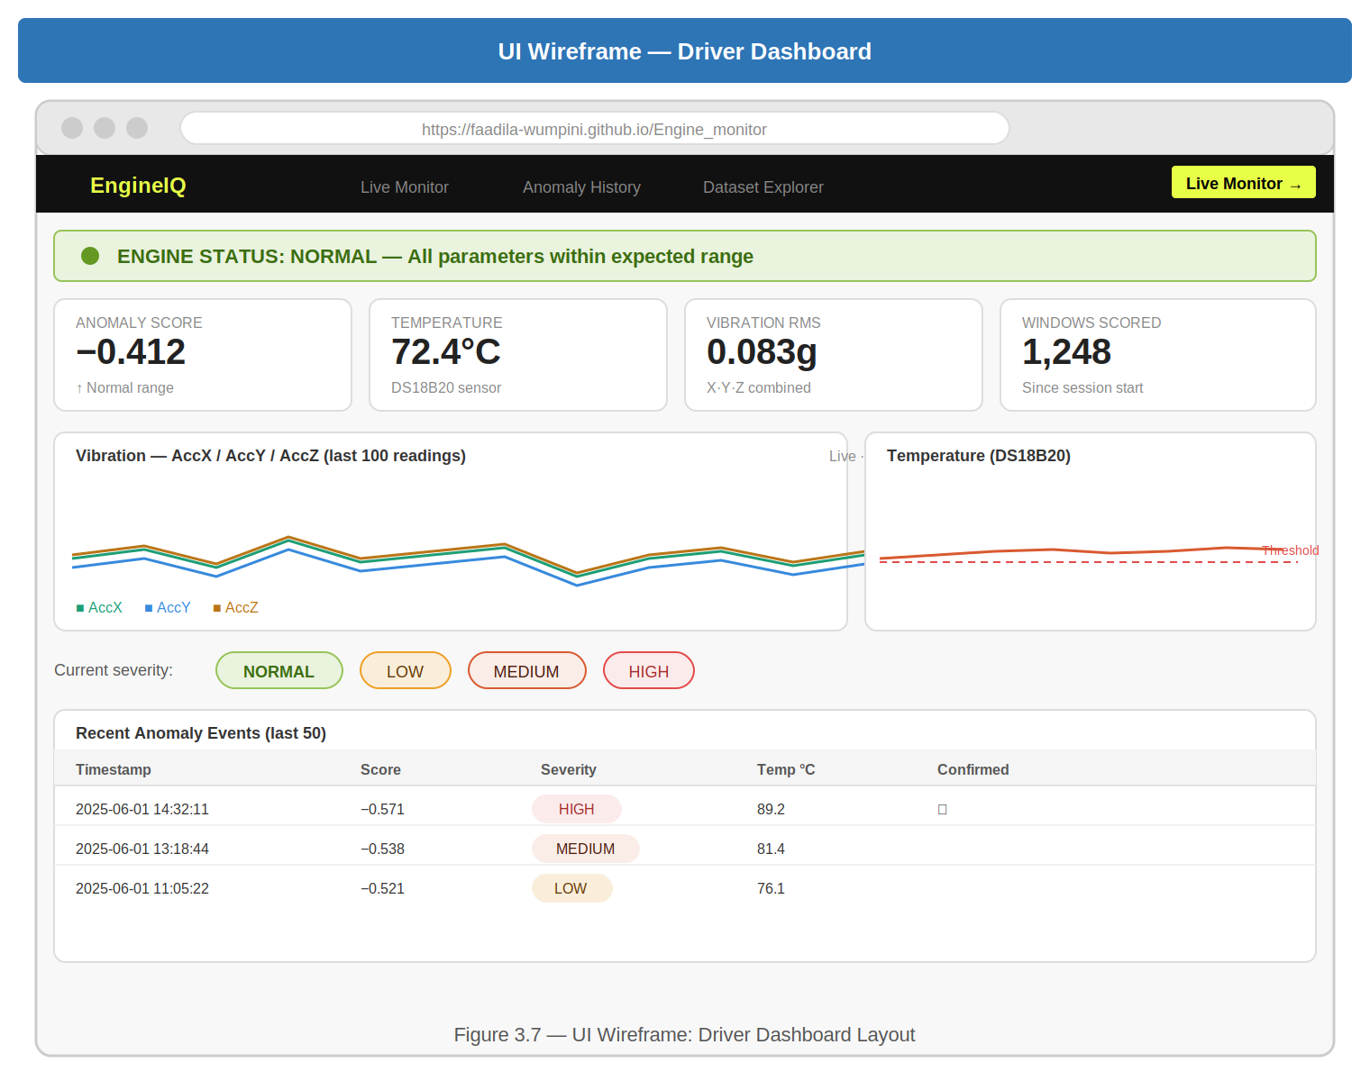
Figure 3.7 — UI Wireframe: Driver Dashboard
Authentication Screen Wireframe: The authentication screen presents a Sign In tab (email or name identifier field, password field with eye toggle, Continue with Google button) and a Create Account tab (full name, email, password with strength bar, confirm password with match indicator, Continue with Google button). After successful signup, the form is replaced by a confirmation panel showing the destination email, a 1-hour expiry warning, and a resend button with 60-second countdown.
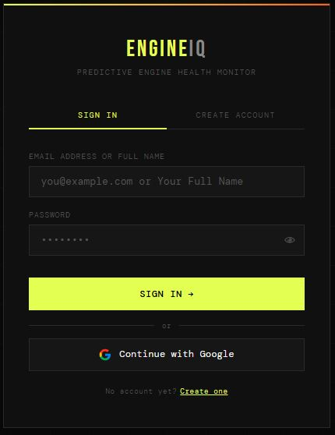
Figure 3.8 — UI Wireframe: Authentication Screen
Administrator Panel Wireframe: The administrator panel presents a login screen, then a sidebar with navigation items (System Overview, Threshold Config, Model Retraining, Anomaly Log, Export Data), system status indicators for MQTT, Inference Engine, and Supabase, an anomaly threshold slider, a retrain button, and a full anomaly log table.
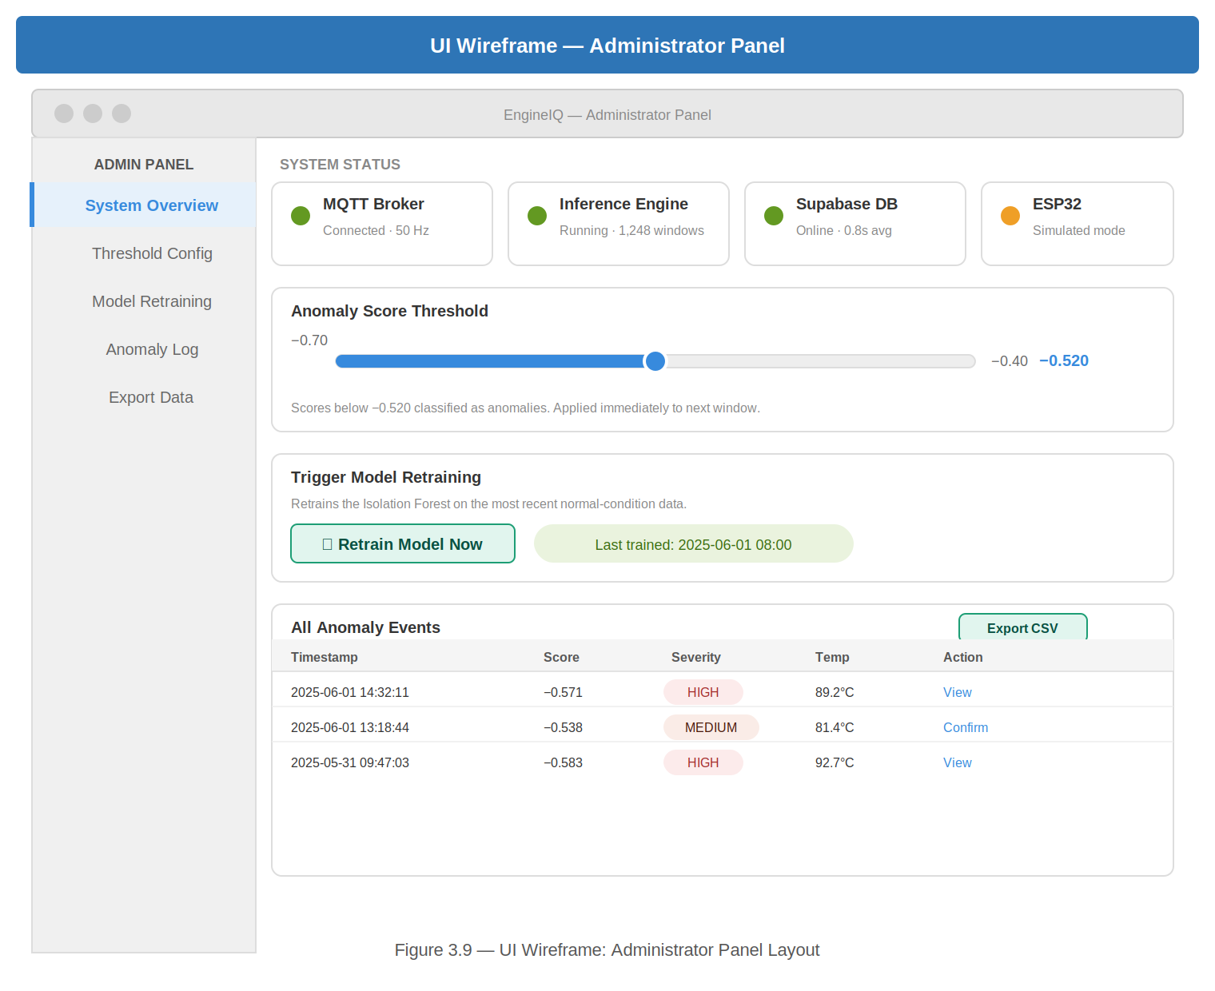
Figure 3.9 — UI Wireframe: Administrator Panel

3.8.2 Database Design — Entity-Relationship Diagram
The system uses two tables in the Supabase PostgreSQL database. The AnomalyLog entity records each detected anomaly event with attributes: id (UUID, PK), timestamp, acc_x_mean, acc_y_mean, acc_z_mean, temp_mean, anomaly_score, severity, and is_confirmed. The Profile entity stores user registration data with attributes: id (UUID, PK, references auth.users), email, and full_name. Each profile record belongs to exactly one Supabase Auth user. There is a one-to-many relationship between inference sessions and anomaly log records.
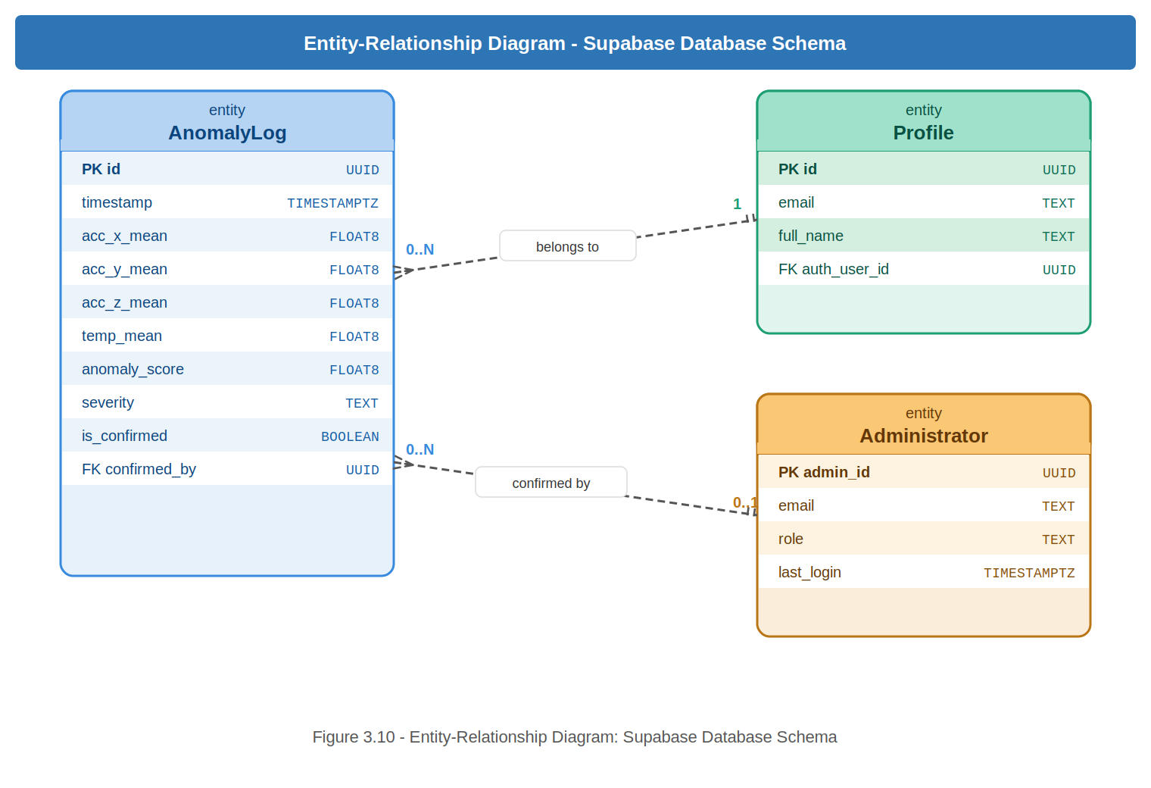
Figure 3.10 — Entity-Relationship Diagram: Supabase Database Schema

3.8.3 Database Schema
Table 3.4: Database Schema — anomaly_logs Table
Column | Data Type | Constraints | Description
id | UUID | PRIMARY KEY, auto-generated | Unique identifier for each anomaly record.
timestamp | TIMESTAMPTZ | NOT NULL | UTC timestamp of the detected anomaly event.
acc_x_mean | FLOAT8 | NOT NULL | Mean X-axis acceleration of the anomalous window (g).
acc_y_mean | FLOAT8 | NOT NULL | Mean Y-axis acceleration of the anomalous window (g).
acc_z_mean | FLOAT8 | NOT NULL | Mean Z-axis acceleration of the anomalous window (g).
temp_mean | FLOAT8 | NOT NULL | Mean surface temperature of the anomalous window (°C).
anomaly_score | FLOAT8 | NOT NULL | Isolation Forest anomaly score (lower = more anomalous).
severity | TEXT | NOT NULL | Classified severity: Low (> -0.52), Medium (> -0.55), High (≤ -0.55).
is_confirmed | BOOLEAN | DEFAULT false | Administrator flag confirming the anomaly as a true positive.
Table 3.5: Database Schema — profiles Table
Column | Data Type | Constraints | Description
id | UUID | PRIMARY KEY, references auth.users(id) CASCADE | Matches Supabase Auth user ID. Deleted when user account is deleted.
email | TEXT | NOT NULL | The user's registered email address. Used for name-based login lookup.
full_name | TEXT | NOT NULL | The user's full name as entered during registration. Used as an alternative login identifier.

3.9 Developmental Tools
- Arduino IDE / PlatformIO: Used to write, compile, and flash C++ firmware onto the ESP32. Libraries: MPU6050, DallasTemperature, OneWire, PubSubClient.
- Python 3.13: Primary language for all server-side components. Virtual environments manage package dependencies.
- Eclipse Mosquitto MQTT Broker: Configured with username/password authentication. The ESP32 publishes to engine/sensors; the Python inference engine subscribes.
- Supabase: Used as the backend database and authentication service. Supabase Auth handles user registration, email confirmation, Google OAuth, and JWT session management. The supabase-py Python client inserts anomaly records and retrieves historical data for the dashboard.
- Streamlit: Used to build the interactive web dashboard. Deployed publicly via Streamlit Cloud at enginemonitor.streamlit.app.
- Git / GitHub: Used for version control. The project website is deployed via GitHub Pages at https://faadila-wumpini.github.io/Engine_monitor.

3.10 Chapter Summary
This chapter details the technical methodology, mapping nineteen functional and eight non-functional requirements across five stakeholder types, including six specific authentication requirements (FR-14 to FR-19). It outlines a security architecture utilizing MQTT, Supabase RLS, JWT, and OAuth 2.0, while defining an Agile framework to implement designs from the ERD and UI wireframes in Chapter 4.

