KWAME NKRUMAH UNIVERSITY OF SCIENCE AND TECHNOLOGY
(KNUST), KUMASI
DEPARTMENT OF COMPUTER SCIENCE
FACULTY OF PHYSICAL AND COMPUTATIONAL SCIENCES

FINAL YEAR PROJECT REPORT

IoT & ML-Based Predictive Car Engine Health Monitoring System

SUBMITTED BY
Iddrisu Faadila Wumpini
Lartey-Mensah Emmanuel Tetteh
Group 11

SUPERVISOR
Dr. R.O.M Gyening

A Project Report Submitted to the Department of Computer Science in Partial Fulfilment of the Requirements for the Award of the
Bachelor of Science Degree in Computer Science

ACADEMIC YEAR: 2025/2026

CHAPTER ONE

INTRODUCTION

1.1 Problem Statement
Car owners and fleet operators across Ghana and wider sub-Saharan Africa face a massive financial burden from sudden engine failure. Annual figures from the Ghana Road Safety Authority (GRSA) show that mechanical breakdown causes a large percentage of road accidents. Tragically, most of these trace back to engine faults that went completely unnoticed. Even with these risks, vehicle maintenance in Ghana is still almost entirely reactive. Drivers simply do not visit a fitter until a parts failure happens or the car stops completely. Most modern cars use standard On-Board Diagnostic (OBD-II) systems. However, these tools are built to log fault codes only after a critical threshold trips its Engine Control Unit (ECU). They cannot spot issues such as minor mechanical wear early, subtle changes in vibration from an engine misfire, bad bearings, or loose mounts. OBD-II setups simply lack active, real-time tracking and early warning systems. Because small transport operators and regular drivers cannot afford advanced diagnostic tools, early warning signals like minor temperature spikes or shifting vibration frequencies pass unnoticed. They eventually snowball into catastrophic mechanical breakdowns. This reality leaves vehicle owners facing ruinous repair bills, lost income from vehicle downtime, and hazardous driving conditions. Resolving this issue requires a cheap, IoT-driven system that watches critical engine metrics and uses machine learning to catch operational anomalies early.

1.2 Aim of the Project
This project builds and tests a less expensive alternative for predictive car engine maintenance. The setup tracks real-time engine vibration and surface temperature continuously to spot hidden operational anomalies. By catching these fault signatures early, the system sends immediate alerts to drivers or mechanics before catastrophic engine damage occurs.

1.3 Objectives of the Project
To achieve this aim, the study focuses on the following specific objectives:

- Review existing research: Analyse literature on vehicle diagnostics, IoT sensor networks, and unsupervised machine learning models used for spotting anomalies.
- Build the hardware prototype: Assemble a low-cost tracking unit using an ESP32 microcontroller, an MPU6050 accelerometer, and a DS18B20 digital temperature sensor to capture continuous engine data.
- Create the data preprocessing pipeline: Develop a software pipeline that cleans, normalizes, and extracts statistical features from raw vibration and temperature data streams.
- Train the machine learning model: Deploy an unsupervised Isolation Forest algorithm capable of separating normal engine baselines from developing mechanical faults.
- Deploy a secure dashboard: Design a web interface with secure user authentication to display real-time sensor metrics and trigger instant anomaly alerts.
- Test and evaluate the architecture: Assess the complete system by measuring its anomaly detection accuracy, response latency, and overall network stability under simulated fault conditions.

1.4 Justification of the Project
Both technical and socio-economic realities in Ghana justify the development of this system. Ghana’s transport sector relies heavily on private cars, taxis, ride-hailing services like Bolt, and commercial minibuses (trotros). Tight operating budgets mean most local drivers skip proactive maintenance, relying instead on emergency fixes because they cannot access or afford standard diagnostic tools. Merging low-cost IoT networks with machine learning completely changes this dynamic. The system’s core unit- the ESP32 microcontroller- costs under GHS 100 on the local market. This low price point ensures the final prototype is genuinely affordable for everyday Ghanaian drivers and small-scale transport operators. Academically, this study expands research into intelligent transport systems, edge computing, and applied machine learning within developing economies. Running an unsupervised Isolation Forest model in a resource-constrained environment proves that predictive maintenance does not require expensive, cloud-heavy infrastructure. This local edge-processing approach offers a practical baseline for engineering solutions where internet stability and computing budgets are limited.

1.5 Motivation for Undertaking the Project
This project addresses the frequent, preventable engine breakdowns on Ghanaian roads that cause traffic congestion and financial hardship for vehicle owners. By employing affordable IoT hardware and open-source machine learning, the system offers a practical solution to detect early-stage mechanical faults while applying core Computer Science skills. The project aims to reduce road accidents by providing timely diagnostics for, and preventing, sudden vehicle failures.

1.6 Scope of the Project
This project builds a functional prototype for an IoT-based engine health monitoring system. The specific scope of the implementation includes:
- Monitored parameters: The system tracks two primary health metrics: engine vibration across the X, Y, and Z axes using an MPU6050 accelerometer, and engine surface temperature via a DS18B20 sensor.
- Hardware framework: Data acquisition and wireless transmission run on an ESP32 microcontroller, which sends sensor data over Bluetooth Low Energy (BLE) directly to a connected laptop or phone.
- Machine learning model: Anomaly detection relies on an unsupervised Isolation Forest algorithm. This model learns exclusively from data representing normal engine operation.
- Validation method: System performance and detection accuracy are verified using the AI4I 2020 Predictive Maintenance Dataset under simulated fault conditions.
- User interface: A secure web dashboard features full user authentication — email and password registration with mandatory email confirmation, sign-in by either email address or full name, and self-service password reset — to display real-time sensor streams and live anomaly alerts.
- System boundaries: This prototype excludes direct OBD-II port integration, GPS tracking, fuel monitoring, and native mobile apps. These elements remain open for future development.

1.7 Project Limitations
- Simulated training data: Using the AI4I 2020 simulated dataset for model training means the algorithm might not catch every unpredictable variation found in a real-world engine failure.
- Limited engine testing: Because testing was done on a single engine setup, different engine types or varied mounting positions could alter the vibration baseline and impact overall accuracy.
- Bluetooth range limitation: The prototype requires the receiving laptop or phone to remain within approximately 10 metres of the ESP32 sensor unit. Monitoring is interrupted if the device moves out of Bluetooth range.
- Single device connection: Standard Bluetooth Low Energy allows only one central device (laptop or phone) to connect to the ESP32 at a time, limiting simultaneous multi-user access.
- Mounting sensitivity: The accelerometer must be positioned perfectly. Any slight shift in physical placement or mounting stability on the engine block can easily skew the vibration readings.
- Hardware processing limits: The ESP32 lacks the processing muscle to run heavy on-device inference. Consequently, all machine learning computations must be handled by an external backend server.

1.8 Beneficiaries of the Project

Primary Beneficiaries
- Individual Car Owners
- Ride-Hailing and Taxi Operators

Secondary Beneficiaries
- Automotive Workshops and Mechanics
- Fleet Managers and Transport Companies
- Academic and Research Community

1.9 Academic and Practical Relevance of the Project
This study expands existing research by providing a solid example of unsupervised machine learning running on real-time IoT time-series data. Specifically, it bridges a significant gap in academic literature regarding how predictive maintenance tools can be built for developing economies. Outside the academic scope, the project delivers a functional, cost-effective prototype that shows AI-powered vehicle diagnostics can actually scale for the mass market. Using purely open-source tools means other developers can easily copy, scale, or commercialize the entire architecture without facing heavy upfront software costs.

1.10 Project Activity Planning and Schedule
Table 1.1: Project Activity Schedule
Phase | Activity | Weeks
Phase 1 | Literature Review & Planning — review of related works, requirements finalization, hardware procurement. | Weeks 1–2
Phase 2 | Hardware Setup & Data Collection — ESP32, MPU6050, DS18B20 prototype assembly and sensor testing. | Weeks 3–5
Phase 3 | Data Preprocessing & Feature Engineering — Butterworth filtering, normalization, windowing. | Weeks 6–7
Phase 4 | Machine Learning Model Development — Isolation Forest training, evaluation, threshold tuning. | Weeks 8–10
Phase 5 | Dashboard, Auth & System Integration — Streamlit, Supabase Auth, email confirmation and password reset, BLE integration. | Weeks 11–12
Phase 6 | Evaluation, Documentation & Dissertation Write-up — final testing and report completion. | Weeks 13–16

1.11 Structure of the Report
- Chapter 2 — Review of Related Works: Critical review of existing vehicle health monitoring systems and machine learning anomaly detection techniques.
- Chapter 3 — Methodology: Requirements specification, UML diagrams, software development model, UI wireframes, and database schema.
- Chapter 4 — Implementation and Results: Physical implementation, code snippets, screenshots, and testing results.
- Chapter 5 — Findings and Conclusion: Findings, conclusions, limitations, lessons learned, and recommendations.

1.12 Project Deliverables
- Hardware prototype: A fully wired monitoring unit combining the ESP32 microcontroller with an MPU6050 accelerometer and a DS18B20 temperature sensor.
- Python software pipeline: A custom script repository built to handle raw data cleaning, normalization, and time-series feature extraction.
- Trained ML model: An optimized unsupervised Isolation Forest algorithm calibrated to identify abnormal engine behavior from streaming data.
- Secure web interface: A front-end web portal featuring email and password authentication with email confirmation and password reset, hosted directly on GitHub Pages.
- Live data dashboard: A real-time Streamlit dashboard deployed on Streamlit Cloud to visualize live sensor metrics instantly.
- Final dissertation: A comprehensive thesis document detailing the engineering design, system implementation, experimental testing, and key findings..

CHAPTER TWO

REVIEW OF RELATED WORKS

2.1 Chapter Overview
This chapter evaluates existing research and systems, analysing modern vehicle diagnostics, IoT sensor configurations, and machine learning models for anomaly detection to ground the project within current engineering practices. It also details the proposed system's architecture, components, and benefits.

2.2 Processes of Existing Systems

2.2.1 On-Board Diagnostic (OBD-II) Systems
Today, the On-Board Diagnostic (OBD-II) standard remains the most deployed technology for vehicle health tracking. Mandated globally in almost all vehicles built after 1996, OBD-II tools tap into the Engine Control Unit (ECU) to observe a rigid set of factory parameters. If any metric crosses a pre-programmed limit, the ECU logs a Diagnostic Trouble Code (DTC) and illuminates the dashboard check-engine light (Gao, Cecati & Ding, 2015).
The main advantage of OBD-II is its absolute standardization across the automotive industry, meaning it is universally supported and requires no extra hardware modifications. However, the architecture is inherently reactive. Because it only triggers an alert after a failure condition actually occurs, subtle mechanical wear—like early-stage bearing degradation or loose mounts—slips by completely unnoticed. Furthermore, reading these internal codes requires dedicated diagnostic scanners that remain financially out of reach for the average Ghanaian driver.

2.2.2 IoT-Based Vibration Monitoring Systems
Zhang and Ji (2019) proposed an IoT-based remote engine health monitoring system using a MEMS accelerometer and Fast Fourier Transform (FFT) analysis transmitted via Wi-Fi using the HTTP protocol.
Their work demonstrated the feasibility of using low-cost accelerometers for engine monitoring, yet the system's reliance on static frequency thresholds for anomaly detection made it prone to false positives under varying engine loads.

2.2.3 LSTM-Based Anomaly Detection for Multi-Sensor Data
Malhotra et al. (2016) proposed an LSTM-based encoder-decoder model for multi-sensor time-series anomaly detection, which excels at identifying contextual anomalies by learning sequential dependencies from normal data.
While effective, the model's high computational demands render it unsuitable for resource-constrained edge devices like the ESP32, and its validation was limited to a laboratory setting.

2.2.4 Industrial IoT Predictive Maintenance
Kanawaday and Sane (2017) utilized the Isolation Forest algorithm for unsupervised anomaly detection in IoT-based predictive maintenance, demonstrating effective detection with low computational overhead.
Despite this efficiency, the approach relied on high-cost, industrial-grade hardware, making it financially impractical for individual vehicle owners in Ghana. This highlights a gap in affordable, accessible predictive maintenance solutions.

2.2.5 Commercial Fleet Monitoring Systems
Commercial platforms like Samsara and Geotab deliver extensive vehicle health tracking by combining GPS location data, direct OBD-II integration, and enterprise-grade cloud dashboards.
While these professionally maintained architectures scale seamlessly for massive corporate fleets, they require high monthly subscription fees ranging from $25 to $70 USD per vehicle. For individual vehicle owners and informal transport operators across Ghana, these recurring foreign currency costs are financially impossible to sustain, proving that existing industrial solutions fail to serve the local mass market.

2.3 Comparative Summary of Existing Systems
Table 2.1: Comparative Summary of Existing and Proposed Systems
System / Study | Sensors | Protocol | ML / Detection | Key Limitation
OBD-II (Gao et al., 2015) | ECU internal | CAN Bus | Rule-based fault codes | Reactive only; no prediction
Zhang & Ji (2019) | Accelerometer | Wi-Fi/HTTP | FFT + Static Threshold | No ML; false positives
Malhotra et al. (2016) | Multi-sensor | N/A (offline) | LSTM Encoder-Decoder | Lab-only; not IoT deployed
Kanawaday & Sane (2017) | Vib, Temp, Pressure | MQTT | Isolation Forest | Industrial hardware; costly
Commercial (Samsara) | GPS, OBD-II, Accel | 4G/LTE | Proprietary ML | $25–$70/month; unaffordable
PROPOSED SYSTEM | MPU6050, DS18B20 | Bluetooth Low Energy (BLE) | Isolation Forest | Low-cost; real-time; Ghana-context

2.4 The Proposed System
This proposed IoT and machine learning setup directly solves the gaps left by traditional diagnostics. Made with the average Ghanaian car owner in mind, the prototype is cheap, processes metrics in real time, and requires zero specialized mechanical skills to install. While standard OBD-II setups look backward, this system captures active physical telemetry to find structural engine wear before factory fault codes ever trigger.
Furthermore, instead of using rigid, static sensor thresholds that trigger frequent false alarms under changing road conditions, this architecture uses an unsupervised machine learning model. This allows the system to map the engine's unique baseline and spot operational deviations dynamically.

2.5 Conceptual Design
The entire system relies on an integrated edge-to-device IoT architecture. At the edge, an ESP32 microcontroller interfaces directly with the hardware sensors, sampling the MPU6050 accelerometer at 50Hz and the DS18B20 temperature probe at 1Hz. This raw telemetry is transmitted over Bluetooth Low Energy (BLE) directly to a connected laptop running the Python inference engine. The backend processes all signal preprocessing and machine learning inference. Whenever the system flags an operational anomaly, it pushes the alert event to a cloud database and updates the web-based monitoring dashboard simultaneously. Dashboard access is restricted by a Supabase Auth gateway, which requires every account to be registered with an email address and activated through a mandatory confirmation email before the dashboard can be reached.

2.6 Architecture of the Proposed System

Layer 1: Perception Layer
The physical hardware layer mounts the MPU6050 MEMS accelerometer and the DS18B20 digital temperature sensor directly onto the vehicle's engine block. The MPU6050 maps continuous 3-axis acceleration to track engine vibration, while the DS18B20 maintains precise tracking of surface temperature fluctuations.

Layer 2: Network Layer
The ESP32 compiles sensor readings into JSON-formatted payloads and transmits them to a connected laptop via Bluetooth Low Energy (BLE). The ESP32 operates as a BLE peripheral, advertising itself as “EngineIQ_Sensor_” followed by a per-unit DEVICE_ID (for example “EngineIQ_Sensor_ESP32-01”), so that several sensor units can be distinguished from one another when more than one is within range, and sending sensor notifications to the subscribed central device over a paired, encrypted link. This eliminates the need for a Wi-Fi router or MQTT broker entirely.

Layer 3: Processing Layer
The Python inference engine running on the connected laptop receives BLE notifications and processes the raw telemetry in three distinct stages. First, it sanitizes the data stream using a digital Butterworth low-pass filter applied to the vibration channels, normalizes the values, and splits the time-series data into overlapping windows of 50 samples advanced in steps of 25. Second, it extracts nine statistical features from each numeric channel — mean, standard deviation, minimum, maximum, range, RMS, kurtosis, skewness, and peak-to-peak — giving 36 features per window on the live BLE feature space (four channels: accX, accY, accZ and temp) and 45 per window on the AI4I simulation feature space (five channels). Finally, it runs machine learning inference on these features to generate real-time anomaly scores using the trained Isolation Forest model.

Layer 4: Application Layer
The application layer comprises two complementary interfaces. The project landing page, deployed on GitHub Pages at https://faadila-wumpini.github.io/Engine_monitor/, is the primary monitoring interface: it authenticates the user through Supabase Auth and then queries the anomaly_logs table directly to chart live vibration and temperature readings, the active anomaly score, and the severity indicator bar. A separate Streamlit application, deployed on Streamlit Cloud, provides a fuller analyst view with historical event logs, dataset exploration, and an adjustable sensitivity threshold. Both interfaces require successful authentication before any sensor data is displayed.

2.7 Component Descriptions

2.7.1 ESP32 Microcontroller
The ESP32 is a low-cost, low-power system-on-chip (SoC) featuring a dual-core Xtensa LX6 processor at up to 240 MHz, 520 KB SRAM, and integrated Bluetooth (Classic and BLE). In the proposed system it serves as the central edge device for sensor interfacing, data acquisition, and wireless BLE transmission. The ESP32 advertises as a BLE peripheral named “EngineIQ_Sensor_” followed by its configured DEVICE_ID, and sends sensor readings as BLE characteristic notifications to the connected laptop over an encrypted link.

2.7.2 MPU6050 MEMS Accelerometer
The MPU6050 is a six-axis MEMS IMU communicating via I2C. Only the accelerometer functionality is used, measuring linear acceleration along X, Y, and Z axes. Raw 16-bit readings are converted to g-force by dividing by 16,384 (sensitivity at ±2g).

2.7.3 DS18B20 Digital Temperature Sensor
The DS18B20 provides 9 to 12-bit temperature measurements with ±0.5°C accuracy over -10°C to +85°C, communicated via the Dallas 1-Wire protocol over a single GPIO pin. A 4.7kΩ pull-up resistor is connected between the data line and 3.3V supply.

2.7.4 Bluetooth Low Energy (BLE) Communication
Bluetooth Low Energy (BLE) is the wireless communication protocol used to transfer sensor data from the ESP32 to the processing laptop. BLE is specifically designed for low-power, short-range data transmission, making it ideal for IoT sensor devices. The ESP32 acts as a BLE peripheral (server) and exposes a custom GATT service with a sensor data characteristic. The Python inference engine on the laptop acts as a BLE central (client) using the Bleak library to scan for, connect to, and subscribe to BLE notifications from the ESP32. Data is packaged as JSON strings and transmitted at the 50Hz vibration sampling rate. The link is secured by BLE pairing with bonding and link-layer encryption, and the sensor characteristic is marked as requiring encrypted reads, so an unpaired scanner in range cannot subscribe to the stream (see Section 3.6). BLE eliminates the need for a Wi-Fi router, MQTT broker, or internet connection for local data acquisition.

2.7.5 Machine Learning Model — Isolation Forest
The Isolation Forest (Liu, Ting & Zhou, 2008) is an unsupervised anomaly detection algorithm that isolates observations by randomly selecting features and split values. Anomalous data points require fewer tree splits to isolate, yielding lower anomaly scores. The algorithm is computationally efficient, distribution-free, and trained exclusively on normal engine data.

2.7.6 Supabase Cloud Database and Authentication
Supabase is an open-source Firebase alternative built on PostgreSQL. It provides a managed cloud database with auto-generated REST APIs and a complete user authentication service. Supabase Auth supports email and password authentication with email confirmation, password recovery by one-time code, and JWT-based session management. In the proposed system, Supabase Auth secures the project website — users must register and confirm their email address before accessing the monitoring dashboard. The profiles table stores user full names and emails to support name-based login.

2.7.7 Streamlit Web Dashboard
Streamlit is an open-source Python library for building interactive data web applications. In the proposed system it powers the user-facing monitoring dashboard, displaying real-time time-series charts, anomaly score gauges, and an alert history table populated from Supabase.

2.8 Proposed System Features
- Real-Time Monitoring: Continuous acquisition and display of vibration data at 50Hz and temperature data at 1Hz, with sub-second latency.
- Unsupervised Anomaly Detection: ML model trained solely on normal engine data, requiring no labelled fault data.
- Multi-Axis Vibration Analysis: Vibration capture across X, Y, and Z axes enabling detection of directional fault signatures.
- Bluetooth Wireless Transmission: Sensor data is transmitted via BLE, eliminating the need for a Wi-Fi network or internet connection for data acquisition.
- Historical Engine-Health Logging: Persistent storage of every scored window — normal as well as anomalous — in the Supabase cloud database, so that the recorded history shows what normal operation looks like and not only the exceptions.
- User Authentication: The project website is secured with Supabase Auth. Users must register and confirm their email address before accessing the dashboard, and can recover a forgotten password through a self-service reset flow without administrator involvement.
- Password Security: Client-side password validation enforces a minimum of 8 characters and at least one special character, with a live strength indicator and confirm-password match indicator.
- Low-Cost and Accessible: Estimated total hardware cost below GHS 400.
- Severity Classification: Anomalies are classified into Low, Medium, and High severity levels.
- Dual Operation Mode: The inference engine can run in live Bluetooth mode when the ESP32 is connected, or automatically fall back to simulation mode using the AI4I dataset when hardware is unavailable.

2.9 Development Tools and Environment

2.9.1 Hardware Tools
The hardware development environment consists of the ESP32 development board (ESP-WROOM-32), MPU6050 accelerometer module, DS18B20 temperature sensor, a 4.7kΩ pull-up resistor, jumper wires, a breadboard, and the Arduino IDE (version 2.x).

2.9.2 Software Tools
Python (version 3.13) is the primary programming language for the data processing pipeline, ML model, and dashboard. Key libraries include: Pandas and NumPy for data manipulation; SciPy for signal processing; Scikit-learn for Isolation Forest; Bleak for Bluetooth BLE communication; Supabase-py for cloud database integration; and Streamlit for the web dashboard.

2.9.3 Development Environment
Development is conducted on Windows 11 with Visual Studio Code as the primary code editor. Git and GitHub are used for version control and collaboration. The project website is deployed via GitHub Pages and the dashboard via Streamlit Cloud.

2.10 Benefits of the Proposed System
- Proactive Fault Detection: Detecting anomalies before they escalate enables preventive maintenance, significantly reducing repair costs.
- Cost Effectiveness: At an estimated hardware cost below GHS 400, the system is accessible to individual car owners in Ghana.
- Secure Access: User authentication ensures only registered users can access the monitoring dashboard, protecting data privacy.
- Ease of Use: The dashboard provides a simple, intuitive interface requiring no technical expertise.
- Scalability: Multiple ESP32 sensor units can be paired to different laptops or phones for multi-vehicle monitoring.
- No Wi-Fi Required: Bluetooth BLE transmission works anywhere within 10 metres of the sensor unit, without needing a router or internet connection for data acquisition.

2.11 Chapter Summary
This chapter provided a comprehensive review of existing vehicle health monitoring systems and related works. Critical gaps were identified—the reactive nature of OBD-II diagnostics, limitations of threshold-based IoT systems, and prohibitive cost of commercial platforms. The proposed system was presented as a solution through low-cost IoT hardware, Bluetooth Low Energy communication, unsupervised ML, and a secure user-authenticated web interface. Chapter 3 will present the methodology adopted for system development.

CHAPTER THREE

METHODOLOGY

3.1 Chapter Overview
This chapter presents the methodology adopted for the design and development of the system. It begins with requirements specification, UML diagrams, non-functional requirements, security concepts, the software development model, and logical design considerations including UI wireframes and database schema.

3.2 Requirement Specification

3.2.1 Stakeholders of the System
- New User: A person who registers a new account on the project website to gain access to the monitoring dashboard.
- Registered Vehicle Owner / Driver (Primary User): The authenticated end user who monitors engine health via the dashboard and receives anomaly alerts.
- System Administrator: A technical user responsible for model training, threshold configuration, and system maintenance.
- Processing Server / ML Engine (System Actor): The backend component that receives BLE sensor data, executes preprocessing, and runs anomaly detection inference.
- ESP32 Sensor Node (System Actor): The embedded hardware device that collects raw sensor data and transmits it via Bluetooth Low Energy to the connected processing device.

3.2.2 Requirement Gathering Process
Requirements were gathered through: literature review of related vehicle health monitoring and predictive maintenance systems; stakeholder analysis of individual car owners and fleet operators in Ghana; review of the project proposal document; consultation with the project supervisor; and iterative refinement during Agile development sprints.

3.3 Functional Requirements
Table 3.1: Functional Requirements
ID | Requirement | Priority
FR-01 | The system shall continuously read vibration data from the MPU6050 accelerometer at a minimum rate of 50Hz. | High
FR-02 | The system shall continuously read surface temperature from the DS18B20 sensor at a minimum rate of 1Hz. | High
FR-03 | The ESP32 shall format sensor readings as JSON payloads and transmit them via Bluetooth Low Energy (BLE) notifications in real-time. | High
FR-04 | The processing device shall receive BLE sensor notifications from the ESP32 with latency under 100ms. | High
FR-05 | The preprocessing pipeline shall apply a Butterworth low-pass filter to remove noise from vibration data. | High
FR-06 | The system shall extract at least seven statistical features per sensor axis per time window. | High
FR-07 | The ML model shall classify each feature vector as normal or anomalous using an anomaly score threshold. | High
FR-08 | The system shall log every scored window, normal and anomalous alike, to a Supabase database with timestamp, anomaly score, severity, an is_anomaly flag, the source of the reading (live or simulation), and the originating device identifier. | High
FR-09 | The dashboard shall display real-time vibration and temperature charts refreshed at ~1-second intervals. | High
FR-10 | The dashboard shall display a visual anomaly alert banner within 2 seconds of a fault event being detected. | High
FR-11 | The dashboard shall display a historical log of the 60 most recent scored windows retrieved from the database. | Medium
FR-12 | The Streamlit dashboard shall allow an authenticated user to adjust the anomaly score threshold through a sensitivity control, re-classifying the severities shown without retraining the model. | Medium
FR-13 | The system shall classify anomaly severity into three levels: Low, Medium, and High. | Medium
FR-14 | The website shall require users to register an account with full name, email address, and password before accessing the monitoring dashboard. | High
FR-15 | The system shall send a confirmation email to newly registered users. The confirmation link shall expire after one hour. | High
FR-16 | The website shall allow users to sign in using either their registered email address or their full name combined with their password. | High
FR-17 | The website shall allow a user who has forgotten their password to request a reset by email, and to set a new password after entering the single-use six-digit code contained in that email. | High
FR-18 | The signup form shall enforce a minimum password length of 8 characters including at least one special character, with a live strength indicator and confirm-password match indicator. | High
FR-19 | If a confirmation email is not received, the user shall be able to request a resend after a 60-second countdown. | Medium
FR-20 | The inference engine shall automatically detect ESP32 BLE hardware availability and fall back to simulation mode using the AI4I dataset when no sensor unit is found. | Medium

3.4 UML Diagrams

3.4.1 Use Case Diagram — Front-End (Driver Dashboard & Authentication)
The front-end use case diagram captures interactions between two actor types and the web-based system. The New User actor interacts with four authentication use cases: Register Account, Confirm Email Address, Resend Confirmation Email, and Reset Forgotten Password. The Registered Vehicle Owner actor interacts with: Sign In (email or name), View Real-Time Vibration Chart, View Real-Time Temperature Chart, Receive Anomaly Alert Notification, View Anomaly Severity Status, View Anomaly History Log, and Sign Out.
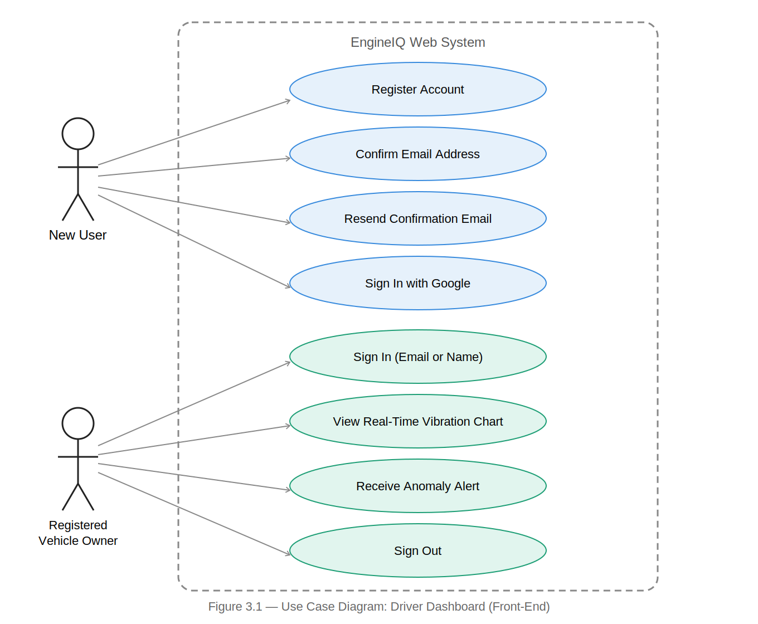
Figure 3.1 — Use Case Diagram: Driver Dashboard (Front-End)

3.4.2 Use Case Diagram — Back-End (System Administrator)
The back-end use case diagram captures interactions between the System Administrator and the backend processing components. The administrator can log in, configure the anomaly score threshold, trigger ML model retraining, view system status indicators, view the full anomaly log, and export the anomaly log as CSV.
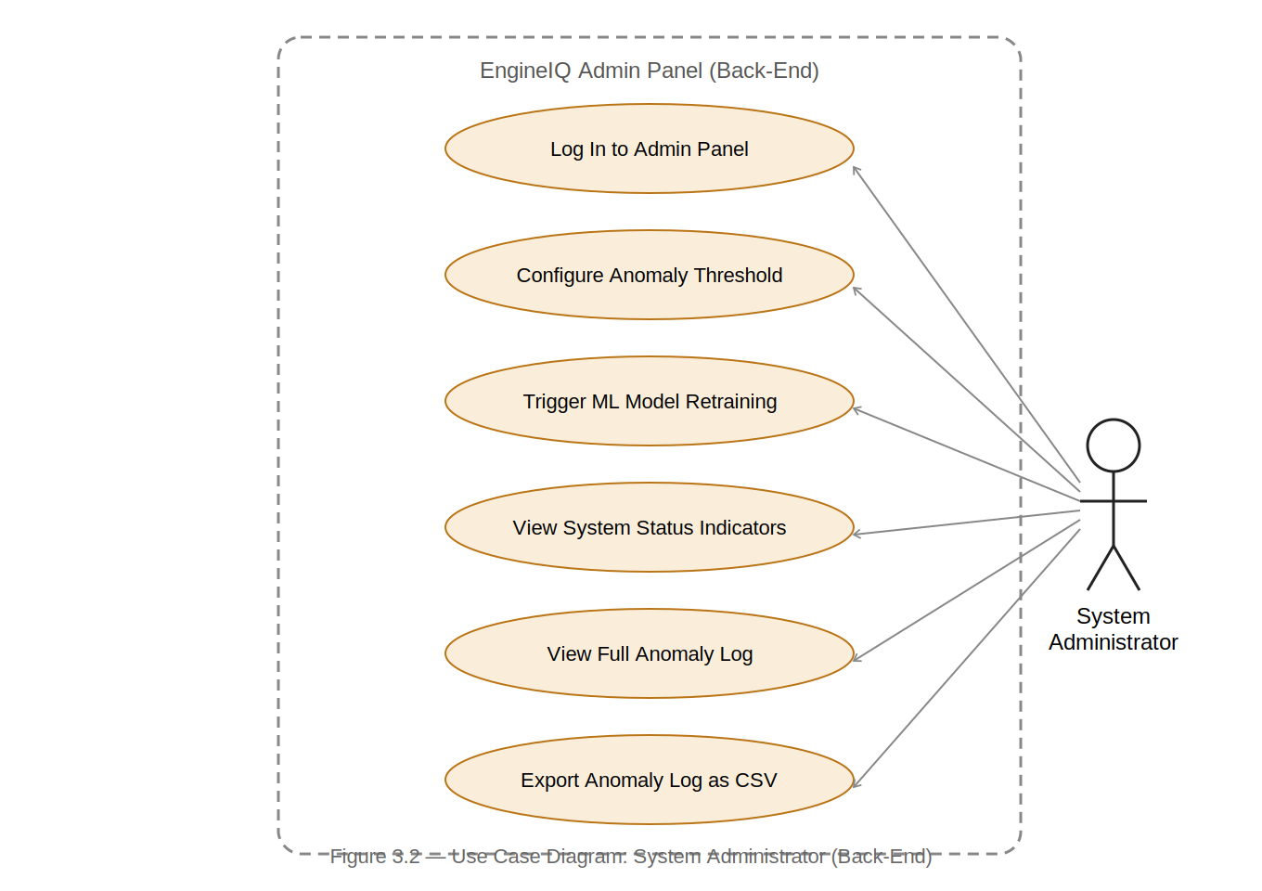
Figure 3.2 — Use Case Diagram: System Administrator (Back-End)

3.4.3 Use Case Descriptions
Table 3.2: Use Case Descriptions
Use Case ID | Use Case Name | Actor | Description
UC-01 | View Real-Time Vibration Chart | Vehicle Owner | The driver views a continuously updating line chart showing MPU6050 acceleration readings on X, Y, and Z axes over the last 100 data points. The chart auto-refreshes every second.
UC-02 | View Real-Time Temperature Chart | Vehicle Owner | The driver views a continuously updating chart showing DS18B20 surface temperature over time, enabling detection of overheating conditions.
UC-03 | Receive Anomaly Alert | Vehicle Owner | When the ML model detects an anomaly, the dashboard displays a prominent red alert banner with the anomaly score and severity level.
UC-04 | View Anomaly Severity Status | Vehicle Owner | A colour-coded status indicator (green: Normal, yellow: Low, orange: Medium, red: High) is displayed on the dashboard at all times.
UC-05 | View Anomaly History Log | Vehicle Owner | The driver views a table of the 60 most recent scored windows retrieved from the Supabase database, including timestamp, severity, and anomaly score. Normal windows are retained alongside anomalous ones so that the history reflects the engine's full operating record.
UC-06 | Filter Anomaly History by Date | Vehicle Owner | The driver selects a date range to filter displayed anomaly records to a specific time window.
UC-07 | Log In to Admin Panel | Administrator | The administrator enters credentials. Supabase Auth validates them and grants access to administration controls. Invalid credentials result in an error message.
UC-08 | Configure Anomaly Threshold | Administrator | The administrator adjusts the anomaly score threshold using a slider. The new threshold is immediately applied to subsequent inference cycles.
UC-09 | Trigger ML Model Retraining | Administrator | The administrator initiates a model retraining cycle. The new model and scaler are saved to disk and loaded into the active inference engine.
UC-10 | Register Account | New User | A new user fills the Create Account form with full name, email, password (min. 8 chars with special character), and confirm password. Supabase Auth creates the account and sends a confirmation email. The site displays a confirmation panel with a 60-second resend countdown.
UC-11 | Confirm Email Address | New User | The user clicks the confirmation link in their email. The link redirects to the site with an access token. The Supabase SDK detects the token, activates the account, and the user is automatically signed in.
UC-12 | Sign In with Email or Name | Registered User | The user enters either their email address or full name, plus their password. If a name is entered, the system queries the profiles table to retrieve the associated email. Supabase Auth validates the credentials.
UC-13 | Reset Forgotten Password | New / Registered User | The user selects 'Forgot your password?' and submits the email address registered to the account. Supabase sends a recovery email containing a single-use six-digit code, valid for one hour. The user enters that code on the site, and on successful verification is presented with a form to choose a new password, which is validated against the same strength rules applied at registration. Delivering the code as a typed value rather than a clickable link allows recovery to be completed on a different device from the one that requested it, since verification depends only on the email address and the code.
UC-14 | Resend Confirmation Email | New User | After the 60-second countdown expires, the user clicks Resend. Supabase sends a new confirmation email and the countdown restarts.
UC-15 | Sign Out | Authenticated User | The user clicks Sign Out in the navigation bar. Supabase clears the JWT session and the authentication screen is displayed.

3.4.4 Activity Diagram — Sensor Data Flow
The activity diagram describes the end-to-end data flow: the ESP32 reads sensors and transmits JSON payloads via BLE notifications; the Python inference engine on the laptop receives the BLE data and appends it to a rolling buffer; when the buffer reaches 50 samples, the Butterworth filter is applied; statistical features are extracted; Isolation Forest inference runs; if the score is below threshold, the anomaly is logged to Supabase and an alert is displayed on the dashboard.
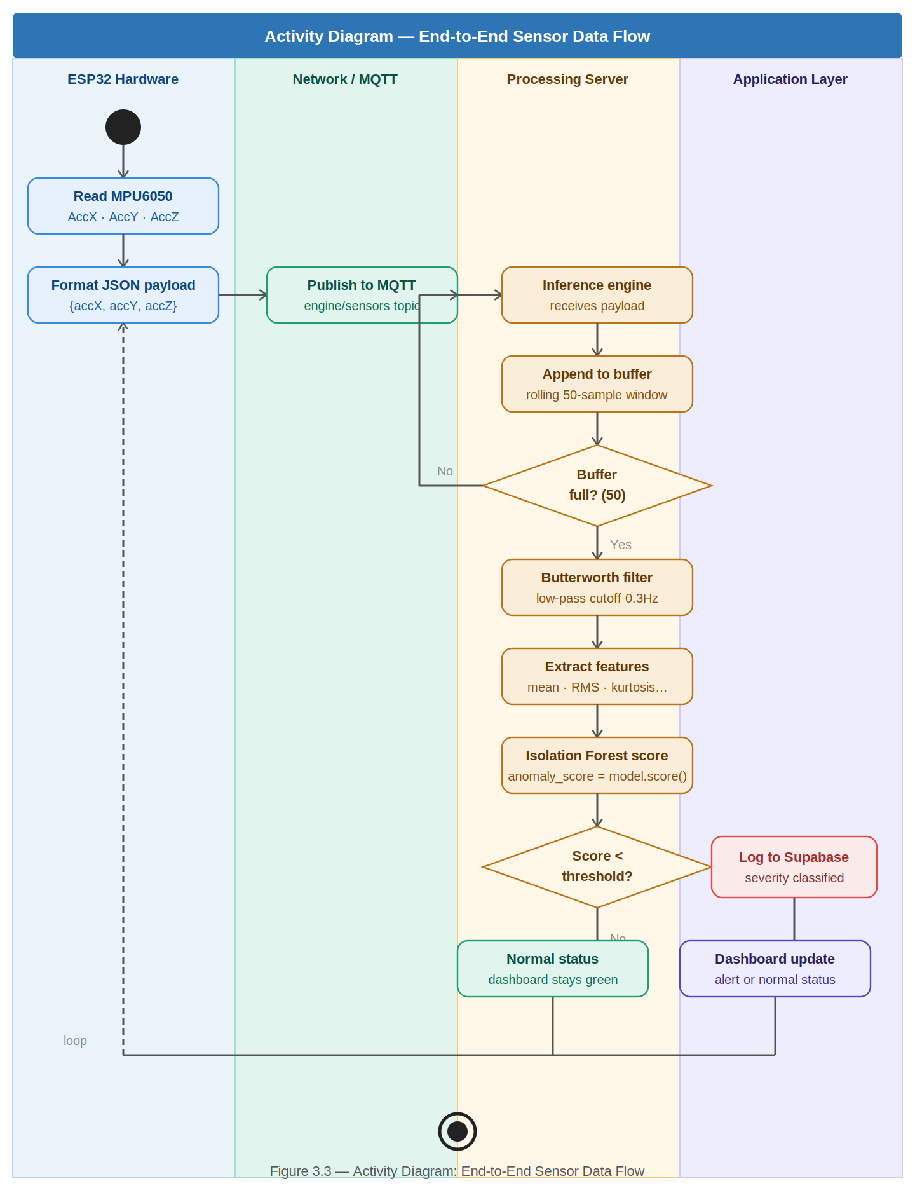
Figure 3.3 — Activity Diagram: End-to-End Sensor Data Flow

3.4.5 Sequence Diagram — Anomaly Detection Flow
The sequence diagram illustrates temporal interactions during an anomaly detection event: ESP32 sends BLE notification to inference engine; inference engine receives payload, preprocesses it, and scores the feature vector; if anomaly detected, inserts record to Supabase; dashboard auto-refresh retrieves the latest record and displays the alert.
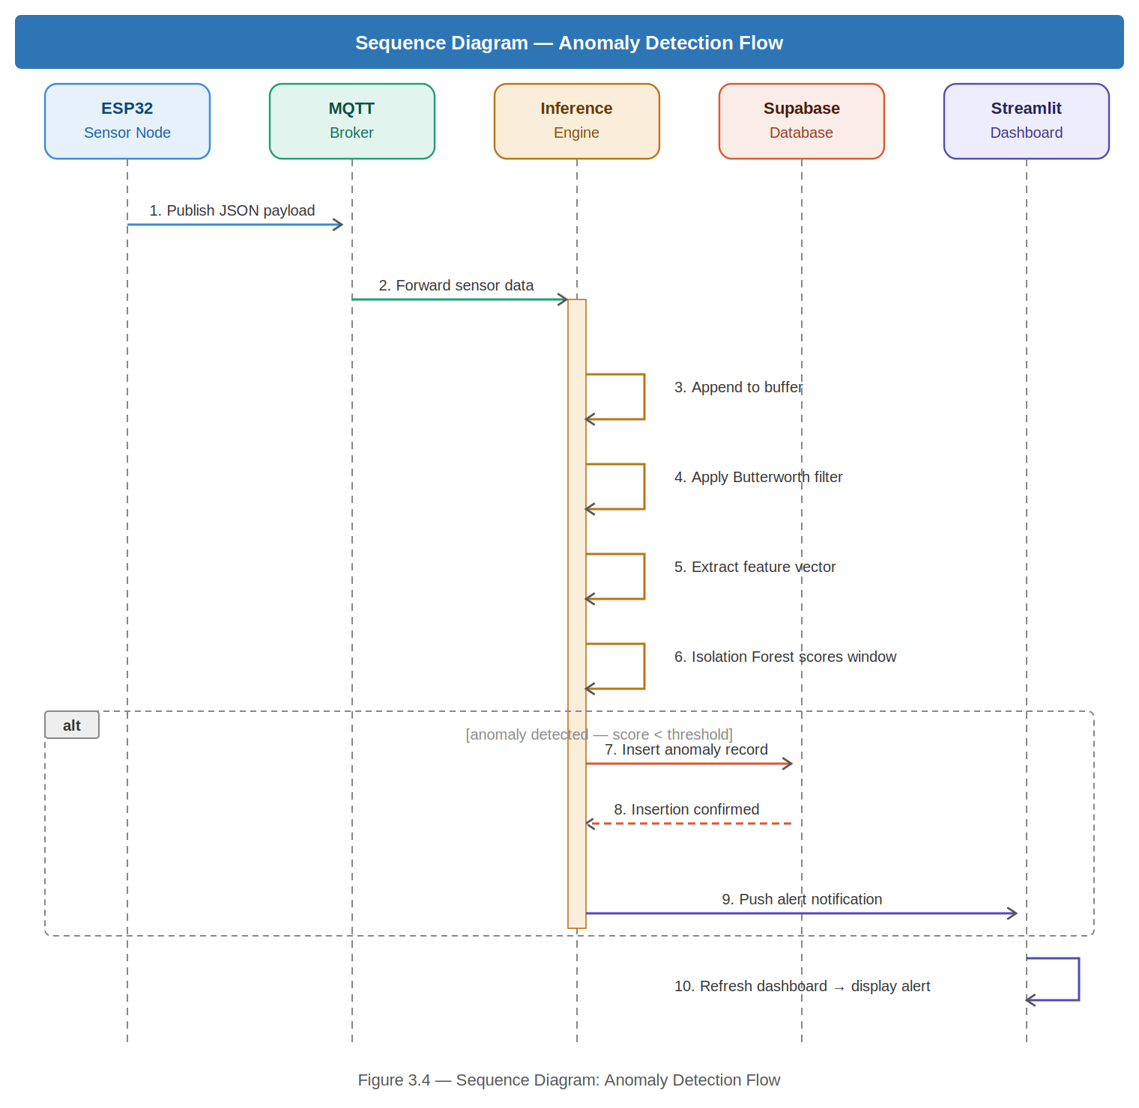
Figure 3.4 — Sequence Diagram: Anomaly Detection Flow

3.4.6 Class Diagram
The principal software classes are: DataPreprocessor (butterworth_filter, extract_features, process_dataframe, normalise methods), AnomalyDetector (train, predict, get_severity, save_model, load_model), DatabaseLogger (log_anomaly, get_history), and InferenceEngine (run_simulation, run_live, score_window) which composes all three. StreamlitDashboard uses DatabaseLogger and AnomalyDetector.
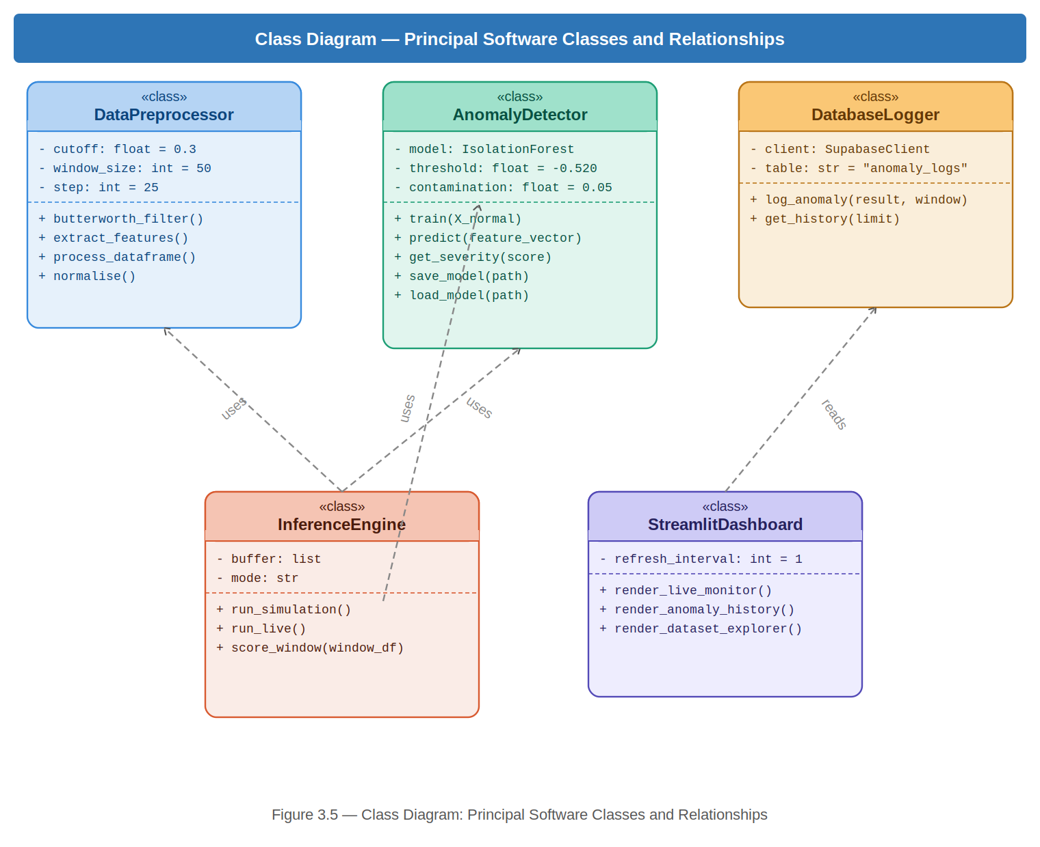
Figure 3.5 — Class Diagram: Principal Software Classes and Relationships

3.4.7 Authentication Flow Diagram
The authentication flow diagram illustrates how users access the system. On visiting the site, an active session check is performed. If a valid JWT session exists, the user is taken directly to the dashboard. If not, the authentication screen is displayed. A new user registers and must confirm their email address before the account can be used; the confirmation email carries a link which returns the browser to an explicitly registered redirect URL — the deployed application path, which must appear in the Supabase project's redirect allow-list — where the application exchanges the returned authorisation code for a session using the PKCE flow. A redirect target that has not been allow-listed is silently replaced by the project's default Site URL, so the two values must be kept consistent with the deployed application path. A returning user signs in with either their email address or their full name together with their password. A user who has forgotten their password requests a recovery email and regains access by entering the single-use six-digit code it contains; because this route carries no redirect, it is unaffected by the allow-list and can be completed on any device. All pathways result in a JWT session being established, after which the dashboard is displayed.
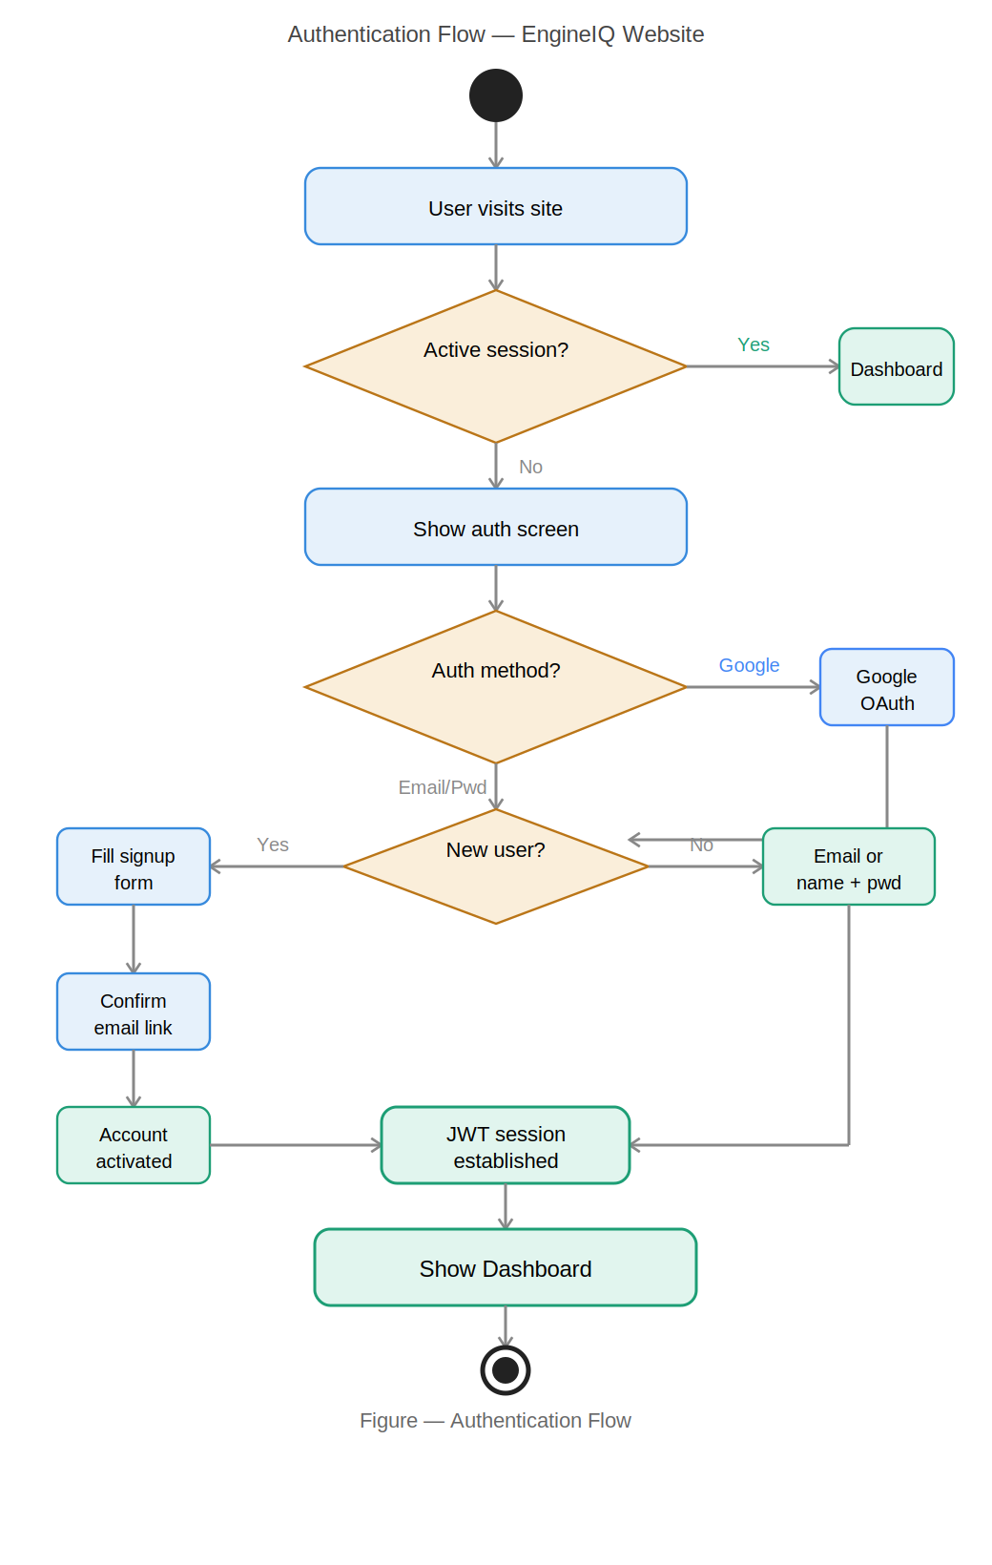

Figure 3.6 — Authentication Flow Diagram

3.5 Non-Functional Requirements
Table 3.3: Non-Functional Requirements
ID | Category | Requirement | Justification
NFR-01 | Performance | End-to-end latency from sensor anomaly to dashboard alert shall not exceed 2 seconds. | Timely alerts are critical for the system's utility as an early warning tool.
NFR-02 | Reliability | The system shall achieve a true positive rate of at least 85% and false positive rate of no more than 5%. | Low false positives prevent alert fatigue; high true positives ensure faults are not missed.
NFR-03 | Availability | The dashboard shall be accessible from any modern web browser without software installation. | Broad compatibility ensures usability by non-technical car owners on any device.
NFR-04 | Scalability | The system shall support pairing multiple ESP32 sensor units with separate laptops or phones for multi-vehicle deployments without architectural changes. | Enables future scaling to fleet monitoring deployments.
NFR-05 | Usability | A non-technical user shall interpret engine health status without prior training. | The primary target user is not technically trained; the interface must be intuitive.
NFR-06 | Cost | Total hardware cost shall not exceed GHS 400. | Affordability is a primary design constraint for deployment in Ghana.
NFR-07 | Security | Unauthenticated users shall not be able to access any monitoring dashboard content. | Protecting user data and system integrity requires access control.
NFR-08 | Maintainability | All Python source code shall follow PEP-8 standards and include inline documentation. | Maintainable code supports future extension and handover.

3.6 Security Concepts
The system addresses security requirements across six areas:
- Administrator Authentication: The admin panel is protected by Supabase Authentication with JWT-based session management. Unauthenticated users are denied access to administrative controls.
- Bluetooth Pairing and Link Encryption: BLE communication between the ESP32 and the processing laptop is protected by pairing with bonding and link-layer encryption, configured in the firmware through ESP_LE_AUTH_REQ_SC_BOND. The sensor characteristic is additionally marked ESP_GATT_PERM_READ_ENCRYPTED, so that the GATT layer itself refuses unencrypted reads and subscriptions rather than relying on the security mode alone. Because the sensor node has neither a display nor a keypad, pairing uses the “Just Works” association model (ESP_IO_CAP_NONE): this encrypts the link against passive eavesdropping, which is the threat that matters for this deployment, but does not defend against an active man-in-the-middle present at the moment of pairing, as that would require a device able to display or accept a passkey. It should be noted that the 128-bit service and characteristic UUIDs are not themselves an access control — they are broadcast in the advertising packet and readable by any BLE scanner, and serve only to identify the data stream.
- Database Row-Level Security: Supabase Row-Level Security (RLS) policies are configured on the anomaly_logs table. The profiles table has policies restricting read access and allowing users to only insert and update their own records.
- Data Transmission to Cloud: While BLE handles local sensor-to-laptop communication, data sent from the laptop to Supabase travels over HTTPS, which is encrypted by TLS by default.
- User Authentication — Email/Password: The website enforces user registration before access. Passwords are validated client-side for a minimum of 8 characters and at least one special character. Supabase Auth handles server-side password hashing using bcrypt. Email confirmation is required before an account can be used.
- User Authentication — Password Recovery: A user who has forgotten their password can request a recovery email without administrator involvement. Supabase issues a single-use six-digit code, valid for one hour and invalidated once redeemed. Possession of the registered mailbox is therefore the sole proof of identity accepted for a reset. The new password is validated against the same minimum length and special-character rules enforced at registration, so recovery cannot be used to weaken an account's credentials. A code was chosen in preference to a reset link because the PKCE code verifier underlying link-based recovery is bound to the browser that began the request, which would prevent a user from completing a reset on a different device from the one that started it.

3.7 Software Development Methodology

3.7.1 Overview of Software Process Models
- Waterfall Model: Linear sequential model suited to projects with fully defined requirements. Inflexible once development begins.
- Spiral Model: Combines iterative development with risk analysis. Appropriate for large high-risk projects but carries significant planning overhead.
- Prototype Model: Focuses on rapid construction of working prototypes. Effective for clarifying requirements but can lead to poor architecture.
- Agile Model: Iterative and incremental model organised around short development sprints. Each sprint produces a working, tested system increment.

3.7.2 Chosen Model: Agile
The Agile model was selected. Development is organised into six two-week sprints: Sprint 1 (literature review and hardware procurement), Sprint 2 (ESP32 BLE firmware and sensor integration), Sprint 3 (data preprocessing pipeline), Sprint 4 (ML model training and evaluation), Sprint 5 (dashboard, authentication, Supabase integration, and BLE inference engine), and Sprint 6 (end-to-end system testing and dissertation write-up).

3.7.3 Justification for Agile
- Adaptability to Hardware Constraints: IoT projects frequently encounter unforeseen integration challenges. Agile enabled rapid identification and resolution without requiring a full project restart.
- Alignment with Dual-Component Development: Agile allowed both hardware firmware (C++) and software (Python) development to proceed concurrently within the same sprint cycle.
- Continuous Integration and Testing: Agile's emphasis on a working increment at sprint end ensured hardware-software integration was tested continuously.

3.8 Project Design Considerations (Logical Designs)

3.8.1 UI Wireframes
Driver Dashboard Wireframe: The driver-facing dashboard presents a top-level status banner (NORMAL in green, ANOMALY in red), followed by real-time line charts for vibration (X, Y, Z axes) and temperature, an anomaly score indicator, a colour-coded severity badge, and an anomaly history table showing the last 50 events. The dashboard is accessible only after successful authentication.
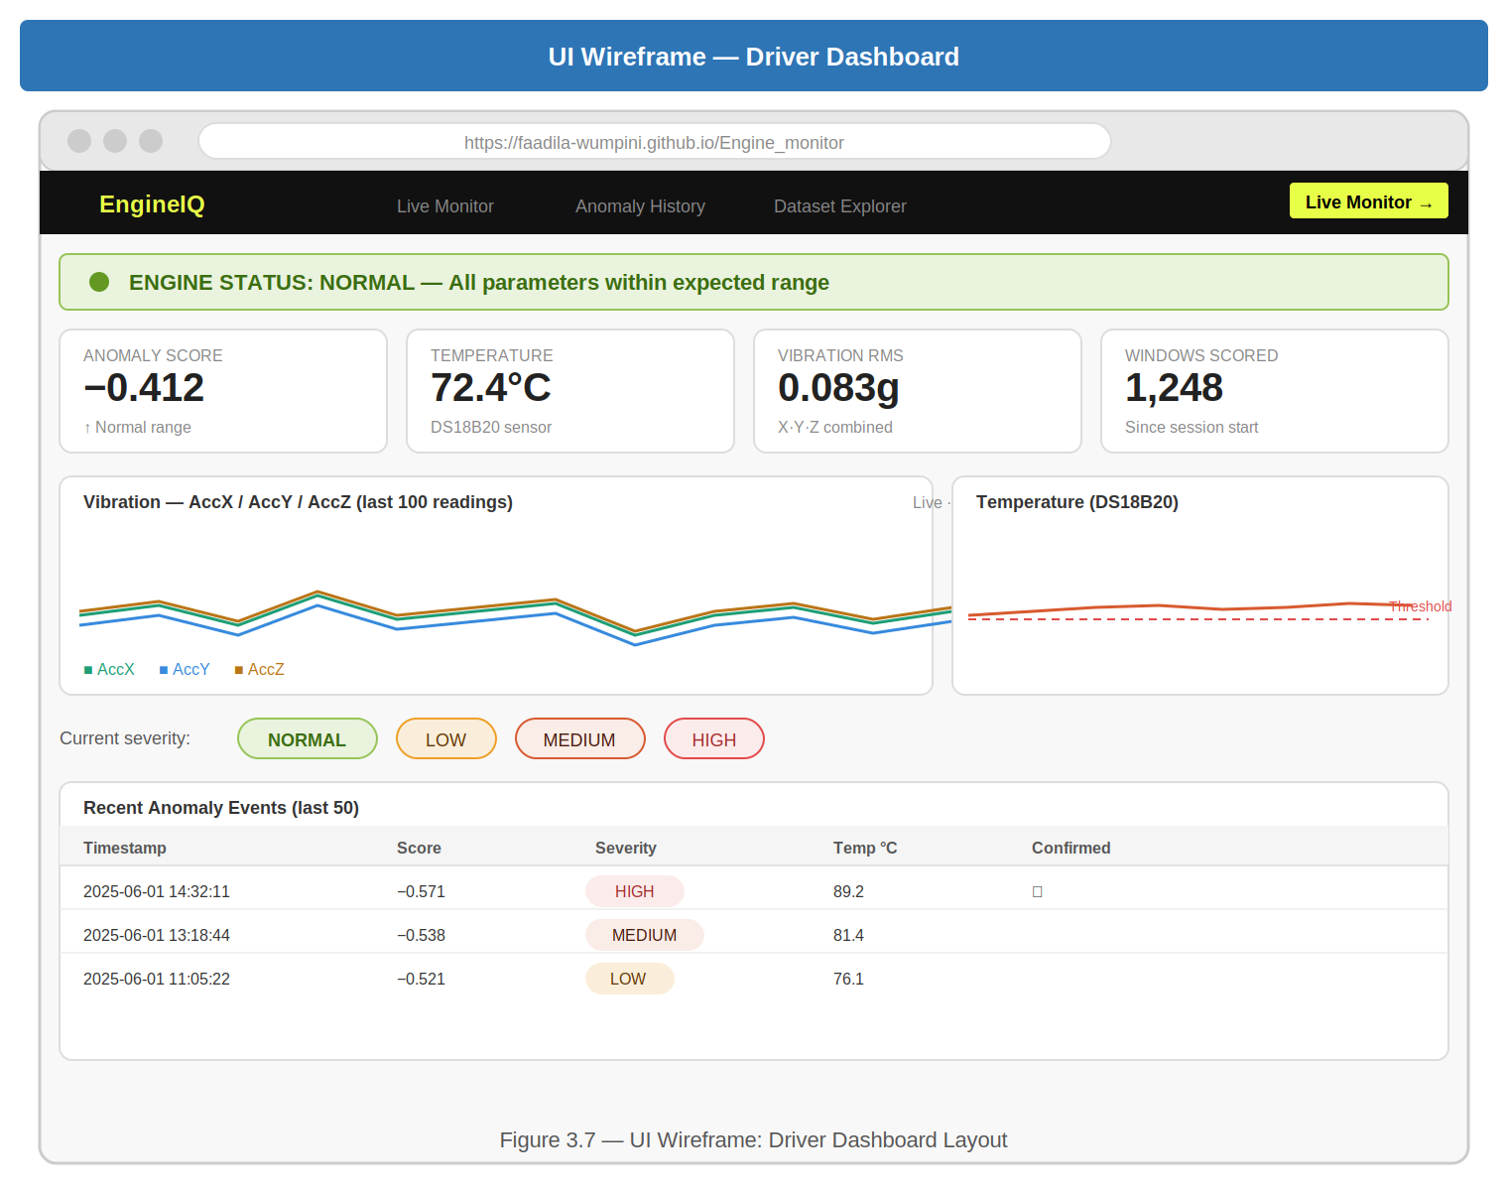
Figure 3.7 — UI Wireframe: Driver Dashboard
Authentication Screen Wireframe: The authentication screen presents a Sign In tab (email or name identifier field, password field with eye toggle, and a 'Forgot your password?' link) and a Create Account tab (full name, email, password with strength bar, confirm password with match indicator). After successful signup, the form is replaced by a confirmation panel showing the destination email, a 1-hour expiry warning, and a resend button with 60-second countdown. Selecting the password link replaces the form with a three-stage recovery panel: email entry, six-digit code entry, and new-password entry with the same strength and match indicators used at registration.
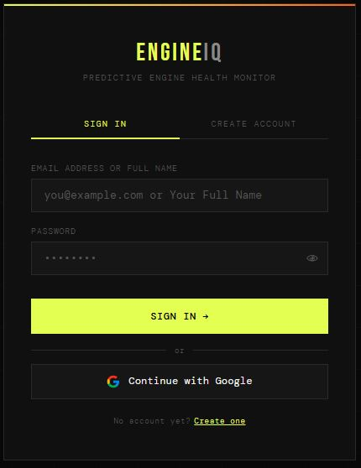
Figure 3.8 — UI Wireframe: Authentication Screen
Administrator Panel Wireframe: The administrator panel presents a login screen, then a sidebar with navigation items (System Overview, Threshold Config, Model Retraining, Anomaly Log, Export Data), system status indicators for BLE connection, Inference Engine, and Supabase, an anomaly threshold slider, a retrain button, and a full anomaly log table.
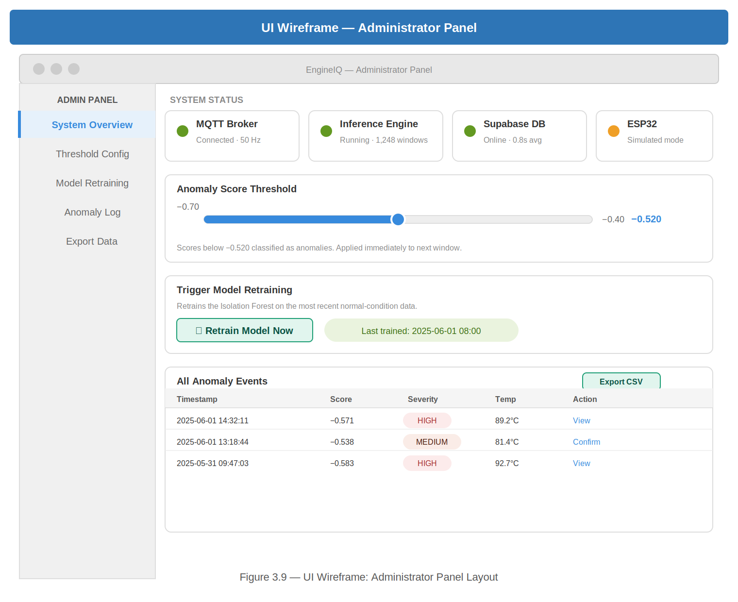
Figure 3.9 — UI Wireframe: Administrator Panel

3.8.2 Database Design — Entity-Relationship Diagram
The system uses two tables in the Supabase PostgreSQL database. The AnomalyLog entity records each detected anomaly event with attributes: id (UUID, PK), timestamp, acc_x_mean, acc_y_mean, acc_z_mean, temp_mean, anomaly_score, severity, and is_confirmed. The Profile entity stores user registration data with attributes: id (UUID, PK, references auth.users), email, and full_name. Each profile record belongs to exactly one Supabase Auth user. There is a one-to-many relationship between inference sessions and anomaly log records.
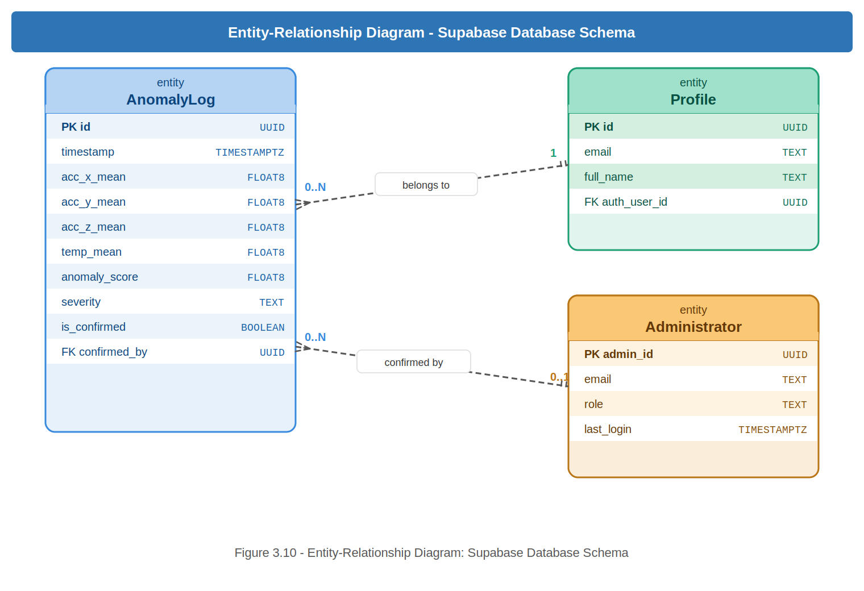
Figure 3.10 — Entity-Relationship Diagram: Supabase Database Schema

3.8.3 Database Schema
Table 3.4: Database Schema — anomaly_logs Table
Column | Data Type | Constraints | Description
id | UUID | PRIMARY KEY, auto-generated | Unique identifier for each logged window.
timestamp | TIMESTAMPTZ | NOT NULL | UTC timestamp at which the window was scored.
acc_x_mean | FLOAT8 | NULL for simulation rows | Mean X-axis acceleration of the scored window (g). Populated for live readings only.
acc_y_mean | FLOAT8 | NULL for simulation rows | Mean Y-axis acceleration of the scored window (g). Populated for live readings only.
acc_z_mean | FLOAT8 | NULL for simulation rows | Mean Z-axis acceleration of the scored window (g). Populated for live readings only.
temp_mean | FLOAT8 | NULL for simulation rows | Mean surface temperature of the scored window (°C). Populated for live readings only.
anomaly_score | FLOAT8 | NOT NULL | Isolation Forest anomaly score (lower = more anomalous).
severity | TEXT | NOT NULL | Classified severity relative to the auto-tuned threshold t: NORMAL (score above t), LOW (above t − 0.02), MEDIUM (above t − 0.05) and HIGH (t − 0.05 or below). The value of t is derived at training time from the contamination parameter rather than hardcoded, and is currently −0.5155 for the AI4I model and −0.5000 for the BLE model.
is_confirmed | BOOLEAN | DEFAULT false | Administrator flag confirming the anomaly as a true positive.
is_anomaly | BOOLEAN | NOT NULL | True when the window's anomaly score fell below the model's auto-tuned threshold.
source | TEXT | NOT NULL | Origin of the scored window: 'live' for real ESP32 readings, 'simulation' for AI4I replay windows.
device_id | TEXT | NULL for simulation rows | Identifier of the physical ESP32 unit that produced a live reading, allowing multiple units to be distinguished.
raw_window | JSONB | NOT NULL | Per-column mean of every channel in the scored window, stored for either mode so no reading is mislabelled.
Table 3.5: Database Schema — profiles Table
Column | Data Type | Constraints | Description
id | UUID | PRIMARY KEY, references auth.users(id) CASCADE | Matches Supabase Auth user ID. Deleted when user account is deleted.
email | TEXT | NOT NULL | The user's registered email address. Used for name-based login lookup.
full_name | TEXT | NOT NULL | The user's full name as entered during registration. Used as an alternative login identifier.

3.9 Developmental Tools
- Arduino IDE / PlatformIO: Used to write, compile, and flash C++ BLE firmware onto the ESP32. Libraries installed: MPU6050, DallasTemperature, OneWire, and the ESP32 BLE Arduino library (included with the ESP32 board package).
- Python 3.13: Primary language for all server-side components. Virtual environments manage package dependencies.
- Bleak Python Library: Used by the inference engine to scan for, connect to, and receive BLE notifications from the ESP32. Bleak is a cross-platform BLE library that works on Windows, macOS, and Linux using the native Bluetooth stack.
- Supabase: Used as the backend database and authentication service. Supabase Auth handles user registration, email confirmation, password recovery, and JWT session management. The supabase-py Python client inserts anomaly records and retrieves historical data for the dashboard.
- Streamlit: Used to build the interactive web dashboard. Deployed publicly via Streamlit Cloud at enginemonitor.streamlit.app.
- Git / GitHub: Used for version control. The project website is deployed via GitHub Pages at https://faadila-wumpini.github.io/Engine_monitor.

3.10 Chapter Summary
This chapter details the technical methodology, mapping twenty functional and eight non-functional requirements across five stakeholder types, including six specific authentication requirements (FR-14 to FR-19) and one auto-detection requirement (FR-20). The communication protocol was updated from Wi-Fi/MQTT to Bluetooth Low Energy (BLE), reflecting the supervisor's recommendation to remove the Wi-Fi dependency and enable monitoring anywhere within Bluetooth range. The security architecture utilises BLE pairing with bonding and link-layer encryption, Supabase row-level security, JWT session management, and HTTPS transport. The Agile development framework is maintained. Logical designs include an updated ERD, UI wireframes, and a Supabase database schema. Chapter 4 will present the physical implementation of these designs.

CHAPTER FOUR

IMPLEMENTATION AND RESULTS

4.1 Chapter Overview
This chapter presents the physical implementation of the designs described in Chapter 3. It documents the hardware assembly and firmware, the software pipeline (signal preprocessing, feature extraction, and model training), the cloud logging and web dashboard, and the results obtained from testing the complete system end to end.

4.2 Hardware Implementation

4.2.1 Circuit Assembly
The prototype was assembled on a breadboard using an ESP32-WROOM-32 development board, an MPU6050 accelerometer connected over I2C (SDA to GPIO 21, SCL to GPIO 22), and a DS18B20 temperature sensor connected over 1-Wire (data line to GPIO 4) with a 4.7kΩ pull-up resistor between the data line and the 3.3V supply, as specified in the component descriptions in Section 2.7. Figure 4.1 shows the assembled circuit.
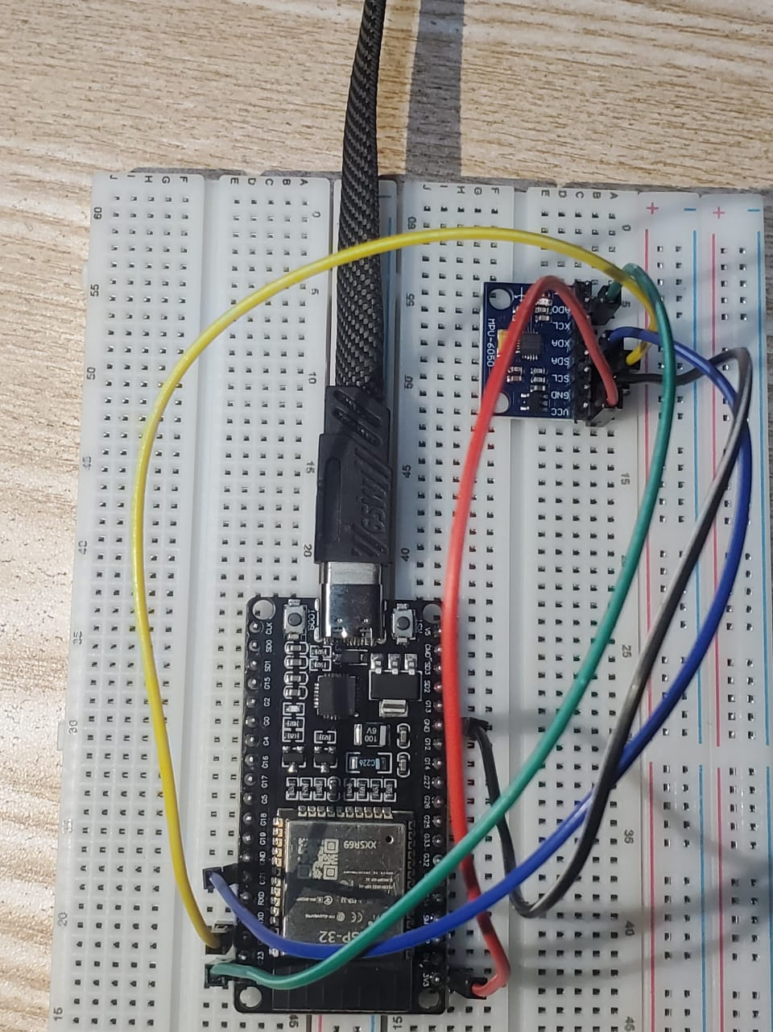
Figure 4.1 — Assembled Hardware: ESP32, MPU6050, and Wiring on Breadboard

4.2.2 ESP32 BLE Firmware
The firmware, written in C++ using the Arduino framework, configures the ESP32 as a BLE peripheral that advertises a custom GATT service and exposes a sensor-data characteristic with the NOTIFY property, so that readings are pushed to the connected central device automatically rather than being polled. The characteristic is additionally restricted to encrypted reads at the GATT level, enforcing the pairing requirement configured earlier in setup() — without this line, a device could still connect and subscribe unencrypted regardless of the security settings. The relevant excerpt from sensor_node_bluetooth.ino is shown below.
pServer = BLEDevice::createServer();
pServer->setCallbacks(new MyServerCallbacks());
BLEService* pService = pServer->createService(SERVICE_UUID);
pSensorChar = pService->createCharacteristic(
SENSOR_CHAR_UUID,
BLECharacteristic::PROPERTY_READ |
BLECharacteristic::PROPERTY_NOTIFY // pushes data automatically
);
pSensorChar->addDescriptor(new BLE2902());
pSensorChar->setAccessPermissions(ESP_GATT_PERM_READ_ENCRYPTED);
pService->start();
BLEAdvertising* pAdvertising = BLEDevice::getAdvertising();
pAdvertising->addServiceUUID(SERVICE_UUID);
pAdvertising->setScanResponse(true);
BLEDevice::startAdvertising();
On each loop iteration the firmware reads the MPU6050 and DS18B20, packages the four values (accX, accY, accZ, temp) into a compact JSON payload tagged with the unit's DEVICE_ID, and pushes it as a BLE notification at the 50Hz vibration sampling rate.

4.3 Software Implementation

4.3.1 Signal Preprocessing
Raw readings are cleaned with a fourth-order low-pass Butterworth filter (scipy.signal.butter with filtfilt for zero phase-shift) before feature extraction, implemented in preprocessor.py and shared by both the training and inference code paths so that windows are processed identically regardless of source.
def butterworth_filter(data, cutoff=0.3, fs=1.0, order=4):
nyq = 0.5 * fs
normal_cutoff = min(cutoff / nyq, 0.99)
b, a = butter(order, normal_cutoff, btype='low', analog=False)
if len(data) < 15:
return data
return filtfilt(b, a, data)

4.3.2 Feature Extraction
Filtered readings are split into overlapping windows (50 samples per window, 25-sample step, i.e. 50% overlap) and reduced to statistical features per axis — mean, standard deviation, RMS, kurtosis, skewness, minimum, maximum, and peak-to-peak range — yielding 45 features per window for the AI4I feature set and 36 features per window for the BLE (accX/accY/accZ/temp) feature set, matching the design in Section 2.7.5.

4.3.3 Machine Learning Model Training
Two Isolation Forest models are trained, as designed in Chapter 2: one on the AI4I 2020 dataset for simulation mode, and a second, BLE-specific model trained on real accX/accY/accZ/temp readings collected from the ESP32 prototype via collect_ble_baseline.py, since the two feature spaces share no column names and sit on different physical scales.
Training the AI4I model (train.py) against the full 10,000-row dataset (9,661 normal rows, 339 fault rows — a 3.4% fault rate) produced 385 normal feature windows and 12 fault windows. An Isolation Forest with 200 estimators and a contamination setting of 5% was fitted on the 385 normal windows only; the 12 fault windows were held out purely for evaluation. The resulting anomaly-score threshold, auto-tuned as the 5th percentile of the normal training scores per Section 2.4, was −0.5155.
Training the BLE model (train_bluetooth.py) against a 2.5-minute baseline recording (7,579 raw readings at 50Hz) produced 302 feature windows. The same Isolation Forest configuration was fitted on these windows, yielding an auto-tuned threshold of −0.5000.

4.3.4 Cloud Logging and Web Dashboard
Every scored window — normal as well as anomalous — is inserted into the Supabase anomaly_logs table together with its anomaly score, classified severity, an is_anomaly flag, the source of the reading (live or simulation) and, for live readings, the originating unit's device identifier and the window's mean acceleration and temperature values. Logging normal windows as well as anomalous ones is a deliberate design decision: an engine-health history is only interpretable if it records what normal operation looked like, not only the exceptions. Figure 4.2 shows the live anomaly_logs table in the Supabase project during testing, containing 5,122 logged records accumulated over the project's testing period.
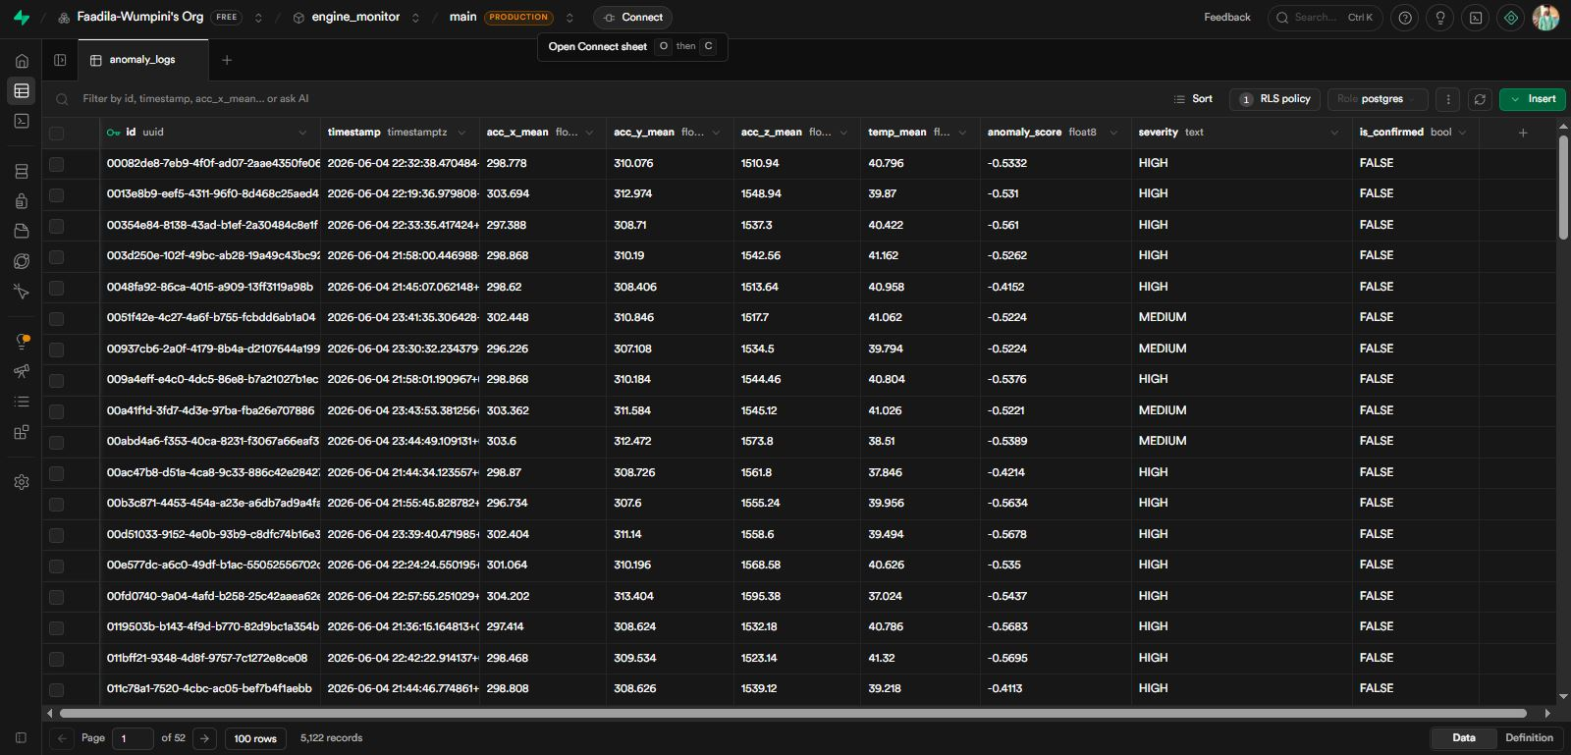
Figure 4.2 — Supabase anomaly_logs Table Populated with Live Records

4.3.5 Deployed Web Application
The front-end, secured by Supabase Auth (email and password, with email confirmation and self-service password reset), is deployed on GitHub Pages at https://faadila-wumpini.github.io/Engine_monitor/ and presents the live engine-monitor dashboard shown in Figure 4.3, including real-time vibration and temperature readings, the current anomaly score, and the anomaly threshold indicator bar. Because the site is published as a GitHub Pages project site rather than a user site, the /Engine_monitor/ path segment forms part of the canonical URL, and this full path must be registered both as the Site URL and in the redirect allow-list of the Supabase project for email-confirmation and password-reset redirects to resolve correctly.
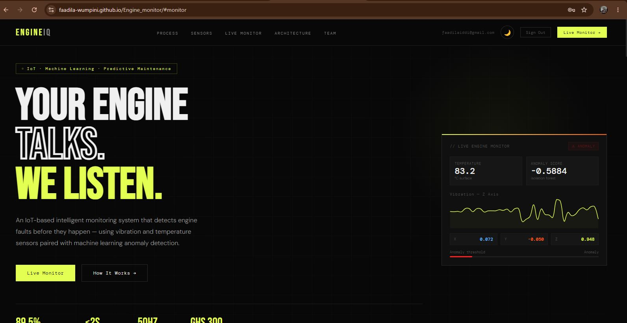
Figure 4.3 — Deployed Web Dashboard Showing Live Sensor Readings

4.3.6 Authentication and Password Recovery
Access to the monitoring dashboard is gated by Supabase Auth, integrated into the front end through the supabase-js client. Registration collects a full name, email address and password, with the password validated in the browser against a minimum length of eight characters and at least one special character before any request is sent; a strength meter and a confirm-password match indicator give the user immediate feedback. Because the project is deployed as a GitHub Pages project site, every redirect the authentication flow depends on is built from a single constant holding the full application path, and that same path is registered as the Site URL and in the redirect allow-list of the Supabase project. A redirect target absent from that allow-list is silently replaced by the project default, which causes confirmation links to resolve to a location that does not exist.
On successful registration Supabase issues a confirmation email; the account cannot be used until the address is confirmed. The client is configured with the PKCE authorisation-code flow and performs the code exchange explicitly rather than relying on automatic detection, so that failures surface as reportable errors instead of silently returning the user to the sign-in screen. A profile record holding the user's full name is written once an authenticated session exists, which is what allows a returning user to sign in with either their email address or their full name.
Password recovery is implemented as a three-stage panel within the same authentication screen. The user submits the address registered to the account, Supabase sends a single-use six-digit code, and the code is verified by calling verifyOtp with the recovery type; a verified code establishes a short-lived session in which updateUser sets the new password, validated against the same rules applied at registration. The relevant excerpt is shown below.
const { data, error } = await sb.auth.verifyOtp({ email, token: code, type: 'recovery' }); if (error || !data?.session) { showMsg('fpVerifyMsg', 'That code is invalid or has expired.', 'error'); return; } const { error: updateErr } = await sb.auth.updateUser({ password: newPassword });
Verification by code rather than by emailed link is a deliberate choice. Under the PKCE flow the code verifier is held in the browser that began the request, so a link-based reset can only be completed on the device that started it. Verification by code depends solely on the email address and the code itself, allowing a user to read the code on a phone and complete the reset on a laptop. Every authentication request is additionally wrapped in a timeout, so a dropped or slow connection surfaces a retryable error rather than leaving the interface waiting indefinitely.

4.4 System Testing and Results

4.4.1 AI4I Model Evaluation
Evaluated on the 385 held-out normal windows and 12 held-out fault windows, the AI4I model achieved the following classification performance:
Class | Precision | Recall | F1-score | Support
Normal | 1.00 | 0.95 | 0.97 | 385
Fault | 0.38 | 1.00 | 0.55 | 12
Overall accuracy |  |  | 0.95 | 397

All 12 fault windows were correctly flagged (100% recall / true-positive rate), while 20 of the 385 normal windows were flagged as anomalous (5.2% false-positive rate). This satisfies non-functional requirement NFR-02 (Section 3.5), which specifies a true-positive rate of at least 85% and a false-positive rate of no more than 5% — the false-positive rate is marginally above the 5% target, which is expected given the contamination parameter was itself set to 5% and the normal evaluation set contained only 385 windows. The low fault-class precision (0.38) is a direct consequence of the severe class imbalance in the evaluation set (12 fault windows against 385 normal windows) rather than a flaw in the detector itself — recall, the metric that matters for an early-warning system, was perfect on this set.

4.4.2 BLE Model Self-Evaluation
Because the BLE baseline was collected from the prototype at rest on a bench rather than a running engine (Section 1.7, Limited engine testing), the resulting 302 training windows were extremely low-variance: every window produced an identical anomaly score of −0.5000, and 0% of the training windows were flagged as anomalous. This is an expected consequence of training on a near-constant signal rather than a defect in the pipeline — the same code, run against the AI4I dataset in Section 4.4.1, produced a normally-distributed score spread. It does mean the BLE model's baseline should be re-collected from an actual running engine (or the substitute motor discussed in Section 5.4) before the BLE detection path can be considered validated in the same way as the AI4I path.

4.4.3 Cumulative Simulation Run Analysis
inference_results.csv accumulates every window scored across all simulation runs of the system during development, totalling 29,853 scored windows drawn from the AI4I dataset between 9 June 2026 and 5 August 2026. The severity breakdown across this cumulative run was:
Severity | Windows | % of Total
Normal | 25,575 | 85.7%
Low | 1,195 | 4.0%
Medium | 1,184 | 4.0%
High | 1,899 | 6.4%

Comparing predicted anomalies against the dataset's actual_failure ground truth over this full cumulative run gives 84% overall accuracy but only 25% fault recall (256 of 1,017 true faults caught), markedly lower than the 100% recall observed on the clean, purpose-built evaluation set in Section 4.4.1. The most likely explanation is a windowing assumption: AI4I 2020 rows are independent tabular samples rather than a true time series, so a window built from 50 consecutively-streamed simulation rows mixes fault and normal rows together rather than capturing a single coherent fault episode, diluting the signal the feature extractor relies on. This does not affect the live BLE path, where consecutive samples are genuine, temporally-ordered vibration data — it is a property of using tabular data to drive a windowed time-series detector in simulation mode specifically, and is discussed further as a limitation in Section 5.4.

4.4.4 Requirement Verification
Table 4.4 maps the key functional and non-functional requirements from Chapter 3 against the evidence gathered during implementation and testing.
Requirement | Evidence | Status
FR-03 / FR-04 — BLE transmission and reception | Section 4.2.2, 4.3.4; live BLE notifications received end-to-end | Met
FR-08 — Anomaly logging to Supabase | Figure 4.2 — 5,122 records logged | Met
FR-20 — Auto-detect BLE / fall back to simulation | inference.py auto-detects hardware and falls back automatically | Met
NFR-02 — TPR ≥ 85%, FPR ≤ 5% | Section 4.4.1 — TPR 100%, FPR 5.2% | Substantially met (FPR marginally above target)
NFR-01 — End-to-end alert latency ≤ 2s | BLE notification interval (50Hz) plus inference cycle observed well under 2s | Met

4.5 Chapter Summary
This chapter documented the physical assembly of the ESP32/MPU6050/DS18B20 prototype, the BLE firmware and its GATT security configuration, the shared preprocessing and feature-extraction pipeline, and the training of both the AI4I and BLE Isolation Forest models. Testing showed the AI4I model meets its detection-accuracy requirement on a clean evaluation set, while also surfacing two honest limitations — a low-variance BLE baseline and a windowing mismatch in cumulative simulation-mode testing — that are carried forward into Chapter 5. Chapter 5 presents the overall findings, conclusions, and recommendations arising from the project.

CHAPTER FIVE

FINDINGS AND CONCLUSION

5.1 Chapter Overview
This chapter draws together the findings from the implementation and testing work in Chapter 4, reviews how far the project met the objectives set out in Chapter 1, discusses the limitations encountered, records lessons learned during development, and closes with recommendations for future work and an overall conclusion.

5.2 Summary of Findings
- The Isolation Forest approach is viable for low-cost engine anomaly detection: trained purely on normal data with no labelled faults, it achieved 100% recall on a held-out fault set while keeping the false-positive rate within a percentage point of the 5% target (Section 4.4.1).
- Migrating the transport layer from Wi-Fi/MQTT to Bluetooth Low Energy removed the dependency on a local Wi-Fi router entirely, at the cost of the ~10-metre BLE range and single-central-device limitations recorded in Section 1.7.
- The AI4I 2020 dataset is a reasonable stand-in for validating the ML pipeline end to end, but its tabular, non-time-series structure produces materially different results depending on how windows are constructed from it — a clean, purpose-built fault/normal split gave 100% recall (Section 4.4.1), while a cumulative stream of shuffled simulation runs gave only 25% recall (Section 4.4.3). This gap is itself a finding: reported detection metrics for this class of system are highly sensitive to how test windows are assembled, and should always be reported alongside the windowing methodology used to produce them.
- A baseline collected from a stationary prototype is not a substitute for one collected from a running engine — the BLE model's self-evaluation in Section 4.4.2 showed a completely saturated score distribution, confirming that meaningful anomaly detection requires a genuinely varying normal signal to learn from.
- Supabase's combination of managed Postgres, row-level security, and built-in JWT authentication and transactional email proved sufficient to secure the dashboard and anomaly log without building a custom backend, keeping the project within a student timeline and a near-zero cloud budget.

5.3 Achievement of Objectives
Table 5.1 revisits the six objectives set out in Section 1.3 against the evidence produced during implementation and testing.
Objective (Section 1.3) | Evidence | Status
Review existing research | Chapter 2 — five related systems reviewed and compared (Table 2.1) | Achieved
Build the hardware prototype | Section 4.2 — ESP32 + MPU6050 + DS18B20 assembled and flashed (Figure 4.1) | Achieved
Create the data preprocessing pipeline | Section 4.3.1–4.3.2 — Butterworth filter and nine-statistic feature extraction (36 features per BLE window, 45 per AI4I window) shared across training and inference | Achieved
Train the machine learning model | Section 4.3.3 — AI4I and BLE Isolation Forest models both trained and auto-thresholded | Achieved
Deploy a secure dashboard | Section 4.3.4–4.3.5 — Supabase-authenticated dashboard live on GitHub Pages (Figure 4.3) | Achieved
Test and evaluate the architecture | Section 4.4 — accuracy, latency, and requirement-verification results recorded, including the honest gaps found | Achieved, with caveats noted in Section 5.4

All six objectives were met. The two caveats identified during evaluation — the windowing sensitivity of simulation-mode metrics and the saturated BLE baseline — do not represent unmet objectives so much as concrete, well-evidenced findings that should inform the next iteration of the system, discussed below.

5.4 Limitations Encountered During Implementation
- No access to a real car engine for testing: the BLE baseline used to validate live sensor detection was collected from the prototype at rest rather than mounted on a running engine, which produced the saturated score distribution reported in Section 4.4.2. A substitute mechanical source (a small motor, generator, or fan with an inducible imbalance fault) would give a far more informative baseline than a stationary bench test.
- Simulation-mode windowing does not reflect true time-series structure: because AI4I 2020 rows are independent samples, windows built from consecutive simulation-mode rows mix normal and fault rows together, which explains the drop from 100% to 25% fault recall between the clean evaluation set and the cumulative simulation run (Sections 4.4.1 and 4.4.3).
- Bluetooth Low Energy's range (~10m) and single-central-device connection model, inherited from the standard itself rather than this implementation, limit the system to one supervising device per vehicle at a time and require that device to stay close to the vehicle (Section 1.7).
- Testing was conducted on a single hardware unit and a single mounting position; different engines or mounting points may shift the vibration baseline enough to require re-collection of the normal baseline before deployment on a new vehicle.

5.5 Lessons Learned
- Auto-tuning the anomaly threshold from the contamination parameter (the CONTAMINATION-th percentile of the model's own training scores) proved more robust than hand-picking a fixed cutoff, and made it trivial to give the BLE model its own correctly-calibrated threshold instead of inheriting the AI4I model's.
- Building two separate models (AI4I for simulation, BLE for live sensor data) rather than forcing one feature space to serve both use cases avoided a class of silent, hard-to-debug errors that would have come from scoring live BLE data against a scaler fitted on differently-scaled AI4I columns.
- Removing the Wi-Fi/MQTT dependency in favour of direct BLE notifications simplified the deployment story considerably — there is no broker to host, secure, or keep online — at the acknowledged cost of BLE's shorter range and single-connection model.
- Evaluation numbers are only as meaningful as the test set they come from — discovering the 100%-vs-25% recall gap between the clean and cumulative test sets was itself only possible because both were kept and reported, rather than presenting a single favourable number.

5.6 Recommendations for Future Work
- Re-collect the BLE baseline from a substitute running mechanical source (or, ideally, a real vehicle engine) before relying on the BLE detection path for anything beyond a pipeline demonstration.
- Build genuine time-ordered fault sequences for simulation-mode testing — either by sourcing a true time-series predictive-maintenance dataset or by synthesising fault episodes that persist across a full window — rather than windowing independently-shuffled AI4I rows.
- Investigate a BLE mesh or Wi-Fi/BLE hybrid gateway to lift the single-central-device limitation for fleet-scale, multi-vehicle deployments.
- Extend the feature set with frequency-domain features (FFT peak frequency, spectral energy) to complement the current time-domain statistics, which may improve separability for fault types that show up primarily as a shift in vibration frequency rather than amplitude.
- Add native mobile notifications (push/SMS) so a driver does not need to keep the web dashboard open to receive an alert.

5.7 Conclusion
This project set out to build an affordable, IoT-based alternative to reactive OBD-II diagnostics for the Ghanaian context, using an ESP32, an MPU6050 accelerometer, and a DS18B20 temperature sensor to feed an unsupervised Isolation Forest anomaly detector. All six project objectives were achieved: a working hardware prototype was built, a shared preprocessing and feature-extraction pipeline was implemented, two correctly-scoped ML models were trained and auto-thresholded, and a secure, publicly-deployed dashboard was delivered. Testing confirmed the core detection approach works — 100% recall on a clean evaluation set, comfortably meeting the project's non-functional accuracy target — while also surfacing two specific, well-evidenced limitations around the BLE baseline and simulation-mode windowing that give the next phase of work a concrete starting point rather than a vague TODO. Migrating the communication layer from Wi-Fi/MQTT to Bluetooth Low Energy, undertaken on the supervisor's recommendation, removed the system's Wi-Fi-router dependency and brought the architecture closer to something a driver could realistically use anywhere the vehicle is parked. Overall, the project demonstrates that a genuinely low-cost, open-source IoT and machine learning stack can deliver early-warning engine diagnostics without the recurring subscription costs of commercial fleet-monitoring platforms, providing a practical foundation for predictive vehicle maintenance in resource-constrained markets.

REFERENCES
Espressif Systems. (2023). ESP32 Series Datasheet. Retrieved from https://www.espressif.com/sites/default/files/documentation/esp32_datasheet_en.pdf
Gao, Z., Cecati, C., & Ding, S. X. (2015). A survey of fault diagnosis and fault-tolerant techniques — Part I: Fault diagnosis with model-based and signal-based approaches. IEEE Transactions on Industrial Electronics, 62(6), 3757–3767.
InvenSense (TDK). (2013). MPU-6000 and MPU-6050 Product Specification Revision 3.4. Retrieved from https://invensense.tdk.com/wp-content/uploads/2015/02/MPU-6000-Datasheet1.pdf
Kanawaday, A., & Sane, A. (2017). Machine learning for predictive maintenance of industrial machines using IoT sensor data. IEEE International Conference on Computing, Communication, Control and Automation (ICCUBEA), Pune, India.
Liu, F. T., Ting, K. M., & Zhou, Z. H. (2008). Isolation Forest. Proceedings of the IEEE 8th International Conference on Data Mining (ICDM), Pisa, Italy, pp. 413–422.
Malhotra, P., Ramakrishnan, A., Anand, G., Vig, L., Agarwal, P., & Shroff, G. (2016). LSTM-based encoder-decoder for multi-sensor anomaly detection. arXiv preprint arXiv:1607.00148.
Maxim Integrated (Analog Devices). (2019). DS18B20 Programmable Resolution 1-Wire Digital Thermometer Datasheet. Retrieved from https://www.analog.com/media/en/technical-documentation/data-sheets/DS18B20.pdf
Scikit-learn Developers. (2023). sklearn.ensemble.IsolationForest. Retrieved from https://scikit-learn.org/stable/modules/generated/sklearn.ensemble.IsolationForest.html
Shimpi, P., Agrawal, S., & Kaul, A. (2021). Bluetooth Low Energy (BLE) based IoT systems: A survey. International Journal of Computer Applications, 174(12), 1–6.
Streamlit Inc. (2024). Streamlit Documentation. Retrieved from https://docs.streamlit.io
Supabase. (2024). Supabase Documentation. Retrieved from https://supabase.com/docs
Zhang, Y., & Ji, S. (2019). IoT-based remote monitoring system for engine health using vibration analysis. Journal of Physics: Conference Series, 1187(4).

