City of Disaster
Project Documentation
A detailed process record of planning, design decisions, GeoGebra construction, troubleshooting,
and scene-by-scene asset development for the GLUT/GeoGebra based project “City of Disaster”.
Prepared by: Fahim Hassan
Prepared from the full assistant-user collaboration log
This document is intended to be readable by other students, reviewers, or teachers who were not present during the conversation, so that they can understand exactly what was designed, why it was designed that way, which problems occurred, and how the work progressed from start to finish.
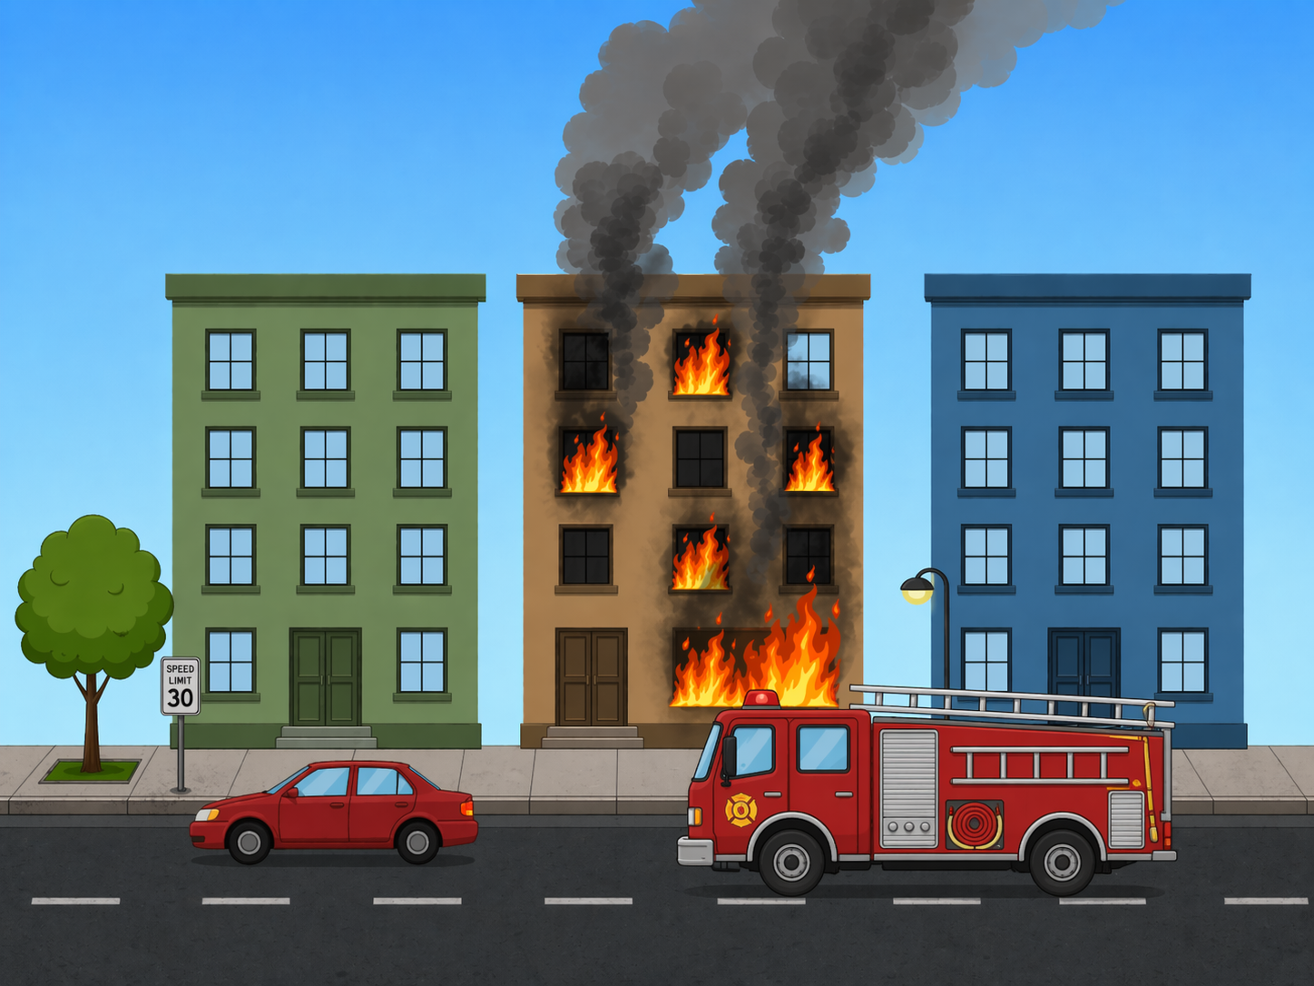
Reference fire scene that helped define the common city layout.

1. Purpose of this documentation
This document records the full design and development journey of the “City of Disaster” project. The objective is not only to preserve final coordinates, but to show the logic behind every major decision. This includes disaster selection, background consistency, use of GeoGebra as a plotting and planning tool, troubleshooting of commands and tools, iterative redesign of assets, and the final recommendations for presentation and hard-copy submission.
In other words, this file is written so that someone else can later read it and answer the following questions without needing the original chat:
- What was the original project idea and what were the selected disaster scenes?
- How was the same city background maintained across all scenes?
- Why were certain assets simplified and others redesigned?
- What problems happened inside GeoGebra and how were they solved?
- Which assets received dedicated coordinate work?
- What was intended for static plotting and what could later be animated?
- What files and visual references were created during the work?

2. Project summary
Project title: “City of Disaster”
Main idea: Create a city-based disaster project where multiple disaster situations are shown using the same overall background so that the audience immediately understands that the same city is experiencing different crises.
Main tools involved:
- GLUT / OpenGL concept planning for final project direction
- GeoGebra for plotting, coordinate testing, static composition, and hard-copy friendly scene building
- Reference image generation for clean visual guidance in fire, flood, earthquake, and storm scenes
- Documentation and point extraction files for organization and later reuse
Core requirement that stayed constant throughout the work: all disaster scenes should use essentially the same city layout, with three background buildings and a limited set of city assets, so that the project remains clean, understandable, and manageable.

3. High-level scene plan chosen at the beginning
At the beginning of the project, the main problem was to decide which four disasters would be visually strong, easier to plot, and still suitable for a city theme. After discussion, the following four scenes were selected:
- Fire / City Fire
- Flood / Heavy Rain + Water Logging
- Earthquake
- Storm / Cyclone / Tornado-like Wind
This combination was chosen because each scene could be represented clearly with simple geometry and because all four fit a city-based narrative. Disasters such as tsunami, volcano, drought, or pandemic were deliberately avoided because they were harder to show clearly in a simple city project or did not match the visual style as well.

4. Common city background that was reused across scenes
A major design decision was to keep the same city background in all scenes. This gave continuity, made the project more professional, and reduced unnecessary complexity. The common background included:
- Three rectangular buildings: left (green), middle (brown/orange), right (blue)
- Road and footpath / sidewalk
- A tree on the left side
- A streetlight / lamp post on the right side
- A red sedan car on the road
- Open sky / space for weather effects, smoke, lightning, and flying debris
Once this base composition was agreed upon, every later scene became a variation on the same layout. This was one of the most important project-level decisions.

5. Chronological work log

5.1 Initial visual planning
After selecting the disasters, clean visual references were generated to establish how the scenes should look. The key rule was that the scenes should be understandable at a glance and not overly crowded. These reference images helped determine the relative sizes of the buildings, vehicles, smoke, waves, and other scene objects.
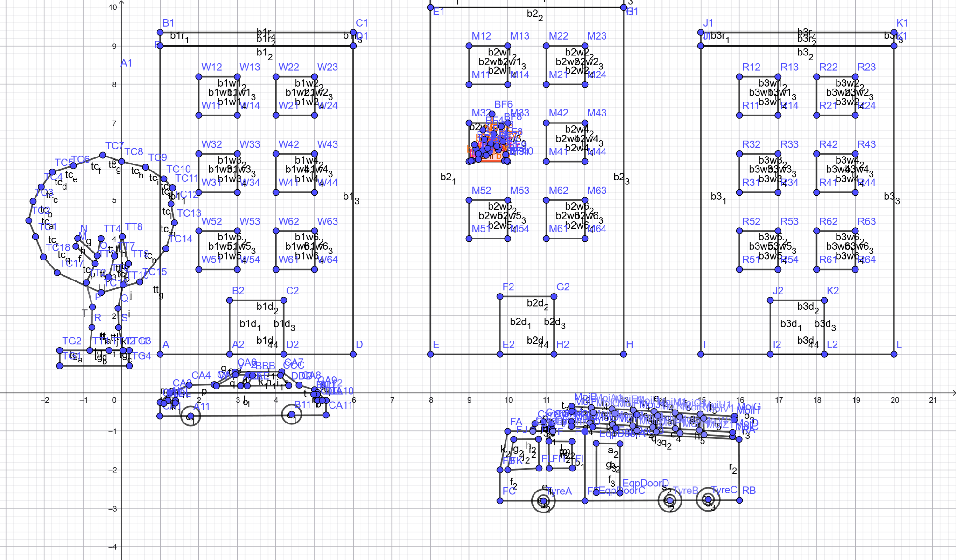
Reference plotting stage showing the shared building layout and disaster assets under development.

5.2 Fire scene planning
The fire scene focused on the middle building. The core components were the burning windows, smoke above the building, darkened windows, and later a fire truck placed in front of the building. The design goal was to make the fire scene dramatic but still easy to reconstruct in GeoGebra and later in GLUT.
At first, the scene only showed burning windows and smoke. Later, the fire scene was enhanced by adding a fire truck, small human figures, and flame coordinate sets for low-flame and big-flame versions so that the fire could appear to grow and shrink.

5.3 Flood scene planning
The flood scene introduced heavy rain, water on the road, a partially submerged car, and rescue storytelling. To make the flood scene more meaningful, a rescue boat with people was planned. This made the scene more than just a wet road; it became an active rescue situation.
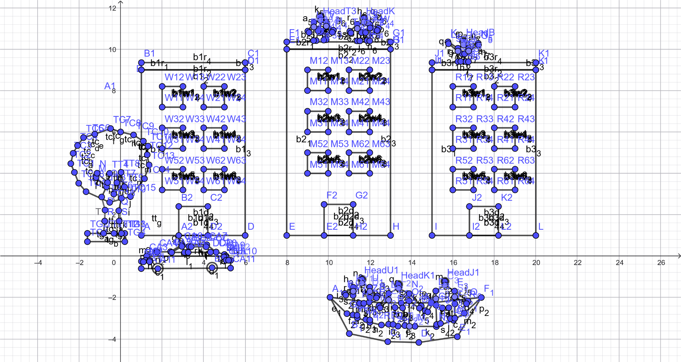
Flood reference showing water logging, rescue context, and shared city structure.

5.4 Earthquake scene planning
The earthquake scene required a different kind of visual storytelling. Instead of weather or flames, the main ideas were: buildings tilting, cracks on the road, broken surfaces, and a vehicle falling into a road crack. The important decision here was not to rebuild the city from zero, but to alter the existing building coordinates so the same city appeared shaken rather than replaced.
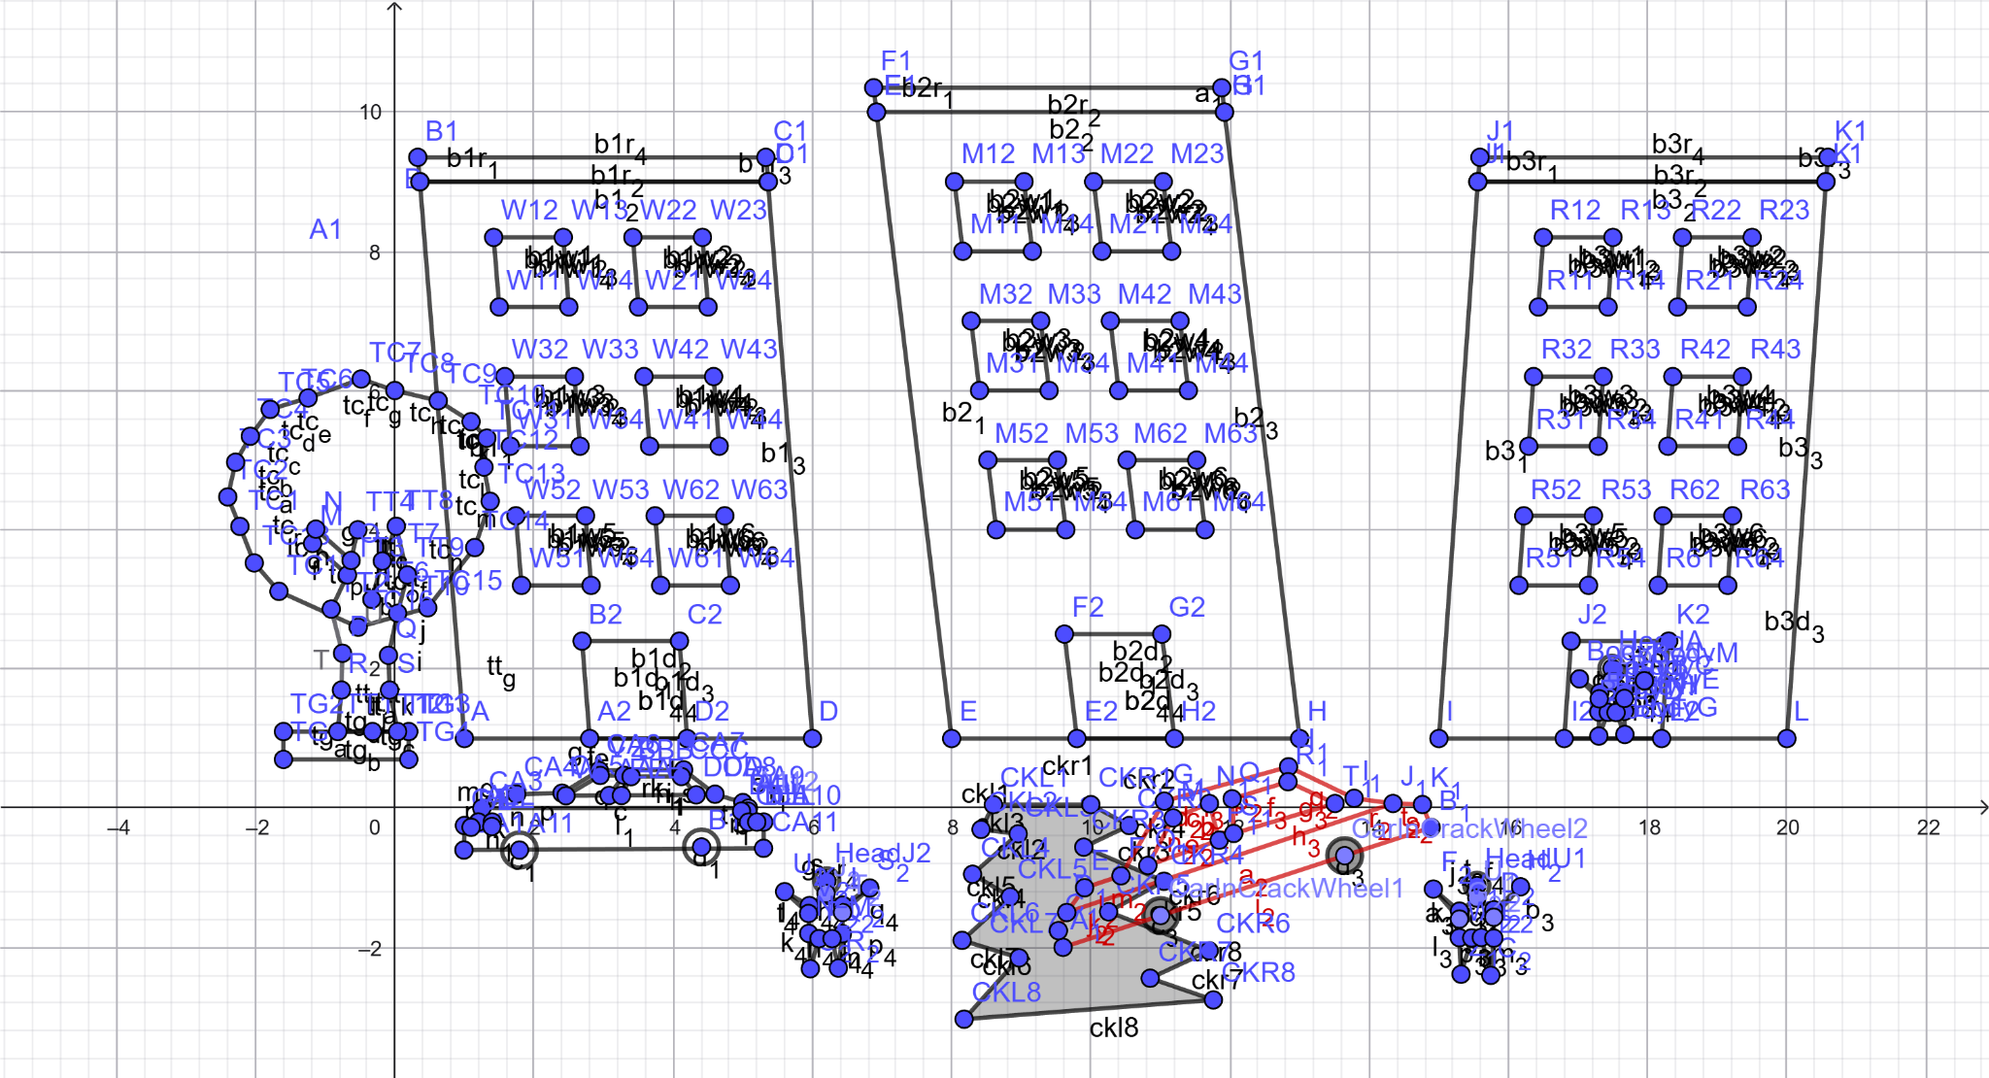
Earthquake reference showing tilt, cracks, and road failure.

5.5 Storm scene planning
The storm scene was built around motion cues rather than destruction alone. Because the project had to remain hard-copy friendly, the storm was represented using static but expressive objects: flying paper, flying leaves, wind-wave lines, a bent tree, a bent streetlight, optional slanted rain lines, and lightning. Later, rooftop clothes flying in the wind were also proposed.
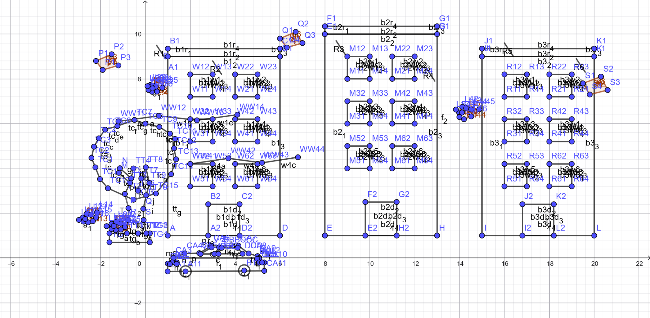
Storm reference emphasizing debris, wind lines, and atmospheric motion.

6. GeoGebra workflow and troubleshooting

6.1 Early interface confusion
At the beginning, work was attempted from the GeoGebra profile/resources side rather than the actual graphing workspace. This caused confusion because the expected commands could not be used there. Once the Graphing Calculator / Classic workspace was opened, plotting became possible.

6.2 “Unknown command: Polygon” issue
One of the biggest technical problems was that Polygon commands did not work consistently in the interface being used. Several fallback strategies were tried:
- checking whether the user was inside the correct GeoGebra app
- verifying syntax and point formatting
- switching from command input to manual tool-based construction
- using Point + Segment construction when polygon tools were missing or inconsistent
- using inequalities for filled rectangles when direct polygon commands failed
Eventually, the workflow stabilized and both Segment and Polygon became usable. This is important because it explains why some assets were defined first as points and Segment chains rather than as direct polygons.

6.3 Tool panel mismatch
There were moments when the expected Polygon tool was not visible in the tools list. During those phases, construction relied on manually placing points and joining them with segments. Later, in a different interface or project state, Polygon worked properly again.

6.4 Label clutter
As more objects were added, labels made the scene visually crowded and difficult to read. A major recommendation that emerged from the work was to keep labels visible during construction but hide most labels in the final version, leaving only important ones if needed.

7. Asset-by-asset development

7.1 Buildings
The three buildings were the first major coordinate assets. For each building, main body points, roof strip, door rectangle, and six windows were defined. The naming system remained consistent across buildings: A/B/C/D style for Building 1, E/F/G/H style for Building 2, and I/J/K/L style for Building 3.

7.2 Tree redesign
The first tree shape did not look natural enough. Because of this, the tree was redesigned with a better trunk, rounder canopy, and more realistic proportions. The later version was much better for hard-copy plotting and general scene quality.

7.3 Car redesign
The sedan car also went through multiple versions. Early attempts produced proportions that did not match the desired side-view sedan look. A later redesign provided a much more convincing red car, including body outline, windows, wheel centers, wheel radii, and optional details like lights and handles.

7.4 Fire truck development
The fire truck became one of the most detailed assets in the project. The final truck included a large body, cabin windows, side compartments, reel, ladder, ladder rungs, front and rear lights, wheel circles, and even symbol/siren style details. This truck was positioned in front of the burning middle building.

7.5 Boat extraction and flood rescue details
For the flood scene, boat points were extracted and prepared so that the boat body could be reused in GeoGebra. The boat was intended to support a rescue narrative, with optional people on or near the boat.

7.6 Flames, smoke, and fire intensity
Flames were designed in two sizes so that the same window could alternate between a low flame and a big flame, giving a simple animation-like effect even without full motion. Smoke was conceptually planned as rising above the burning building, and fire windows were selected so that the middle building appeared to be the main source of the fire.

7.7 Human figures
Simple stick-man style human figures were created because they are easy to understand and require few points. Multiple poses were later developed: a running person, a person with one hand raised, a person looking toward the fire truck, and a person running out from the middle building door.

7.8 Earthquake crack and fallen car
Road crack coordinates were created using two edge chains that defined a jagged, widening split. Additional branch cracks were suggested to make the crack more realistic. A rotated and shifted version of the sedan was then created so that it could appear to have fallen into the crack.

7.9 Storm objects and motion cues
The storm scene used papers, leaves, and wind-wave lines as the main indicators of strong wind. This was important because full physical simulation was not required. Instead, the project needed to visually communicate motion in a static plot.

8. Scene-specific documentation

8.1 Fire scene
Final fire scene concept: same city background, middle building burning, flame polygons in selected windows, dark smoke rising above the building, and a fire truck parked in front of the building. Optionally, human figures could be shown running or responding to the incident. The fire scene became one of the most developed scenes because it involved building fire, emergency vehicle, and human action.

8.2 Flood scene
Final flood scene concept: heavy rain, road water, rescue boat, floating debris, and rescue storytelling. The scene needed to feel active rather than empty. Boat points and people/pose work supported this objective.

8.3 Earthquake scene
Final earthquake scene concept: same buildings but tilted by coordinate modification, cracked road, branch cracks, broken or fallen street infrastructure, and a car falling into a road crack. This scene relied heavily on geometry changes and the idea of reusing previous coordinates instead of starting over.

8.4 Storm scene
Final storm scene concept: flying papers, leaves, wind lines, optional rain slashes, bent tree, bent streetlight, and atmospheric darkness or lightning. The storm scene was especially suited to static hard-copy output because motion could be suggested rather than truly animated.

9. Static plotting vs. animation planning
A repeated concern throughout the conversation was that the project may need to be submitted or reviewed in hard-copy form. Because of that, the recommended approach became: build strong static scenes first, and then, only if necessary, add simple movement through small coordinate changes or slider-based offsets. For example:
- flames could alternate between low and big coordinates
- a running person could be moved rightward by changing x-values in small steps
- papers or leaves could later use x + t or y + 0.1 sin(t) type formulas if motion was needed
- storm wind could be suggested with fixed wave lines rather than real animation
This distinction between static communication and later possible movement is central to understanding the final design philosophy.

10. Major technical lessons learned
- Consistency of background matters more than adding too many different objects.
- GeoGebra tool behavior may vary by interface, so fallback methods are necessary.
- Labels are helpful during construction but harmful in the final visual if left everywhere.
- Simple geometric storytelling is often stronger than complex but messy detail.
- Reusing coordinates and modifying them is more efficient than rebuilding assets from scratch.
- Scene readability is a more important goal than maximum detail for hard-copy submission.

11. Key coordinate appendix
The following appendix includes the most important coordinate sets that were developed during the work. These are not every single point used across every experiment, but they are the coordinate sets most useful for reconstructing the project.

11.1 Core building coordinates
A=(1,1) B=(1,9) C=(6,9) D=(6,1)
A1=(1,9) B1=(1,9.35) C1=(6,9.35) D1=(6,9)
A2=(2.8,1) B2=(2.8,2.4) C2=(4.2,2.4) D2=(4.2,1)
W11=(2,7.2) W12=(2,8.2) W13=(3,8.2) W14=(3,7.2)
W21=(4,7.2) W22=(4,8.2) W23=(5,8.2) W24=(5,7.2)
W31=(2,5.2) W32=(2,6.2) W33=(3,6.2) W34=(3,5.2)
W41=(4,5.2) W42=(4,6.2) W43=(5,6.2) W44=(5,5.2)
W51=(2,3.2) W52=(2,4.2) W53=(3,4.2) W54=(3,3.2)
W61=(4,3.2) W62=(4,4.2) W63=(5,4.2) W64=(5,3.2)

E=(8,1) F=(8,10) G=(13,10) H=(13,1)
E1=(8,10) F1=(8,10.35) G1=(13,10.35) H1=(13,10)
E2=(9.8,1) F2=(9.8,2.5) G2=(11.2,2.5) H2=(11.2,1)
M11=(9,8) M12=(9,9) M13=(10,9) M14=(10,8)
M21=(11,8) M22=(11,9) M23=(12,9) M24=(12,8)
M31=(9,6) M32=(9,7) M33=(10,7) M34=(10,6)
M41=(11,6) M42=(11,7) M43=(12,7) M44=(12,6)
M51=(9,4) M52=(9,5) M53=(10,5) M54=(10,4)
M61=(11,4) M62=(11,5) M63=(12,5) M64=(12,4)

I=(15,1) J=(15,9) K=(20,9) L=(20,1)
I1=(15,9) J1=(15,9.35) K1=(20,9.35) L1=(20,9)
I2=(16.8,1) J2=(16.8,2.4) K2=(18.2,2.4) L2=(18.2,1)
R11=(16,7.2) R12=(16,8.2) R13=(17,8.2) R14=(17,7.2)
R21=(18,7.2) R22=(18,8.2) R23=(19,8.2) R24=(19,7.2)
R31=(16,5.2) R32=(16,6.2) R33=(17,6.2) R34=(17,5.2)
R41=(18,5.2) R42=(18,6.2) R43=(19,6.2) R44=(19,5.2)
R51=(16,3.2) R52=(16,4.2) R53=(17,4.2) R54=(17,3.2)
R61=(18,3.2) R62=(18,4.2) R63=(19,4.2) R64=(19,3.2)

11.2 Improved tree coordinates
TG1=(-1.6,0.7) TG2=(-1.6,1.1) TG3=(0.2,1.1) TG4=(0.2,0.7)
TT1=(-0.82,1.1) TT2=(-0.82,2.8) TT3=(-0.68,3.35) TT4=(-0.53,4.0)
TT5=(-0.34,3.55) TT6=(-0.33,3.0) TT7=(-0.18,3.55) TT8=(0.02,4.05)
TT9=(0.18,3.35) TT10=(0.04,2.8) TT11=(0.04,1.1) TT12=(-0.32,1.1)
TC1=(-2.05,4.75) TC2=(-2.15,5.25) TC3=(-2.00,5.80) TC4=(-1.65,6.25)
TC5=(-1.20,6.60) TC6=(-0.65,6.90) TC7=(-0.05,7.00) TC8=(0.55,6.85)
TC9=(1.00,6.50) TC10=(1.28,6.00) TC11=(1.38,5.45) TC12=(1.28,4.90)
TC13=(1.00,4.40) TC14=(0.55,4.00) TC15=(0.00,3.80) TC16=(-0.60,3.75)
TC17=(-1.15,3.90) TC18=(-1.60,4.20)

11.3 Red sedan car coordinates
NC1=(1.20,-0.70) NC2=(1.20,-0.20) NC3=(1.38,0.10) NC4=(1.90,0.28)
NC5=(2.35,0.68) NC6=(3.40,0.70) NC7=(3.95,0.65) NC8=(4.35,0.35)
NC9=(4.85,0.25) NC10=(5.20,0.08) NC11=(5.30,-0.18) NC12=(5.30,-0.70)
WCF=(1.95,-0.70) WCR=(4.35,-0.70) rOuter=0.33 rInner=0.16

11.4 Fire truck summary coordinates
FT1=(8.80,-0.75) FT2=(8.80,0.10) FT3=(9.20,0.75) FT4=(10.20,0.90)
FT5=(13.90,0.90) FT6=(14.30,0.80) FT7=(14.55,0.50) FT8=(14.55,-0.10)
FT9=(14.75,-0.10) FT10=(14.75,-0.40) FT11=(14.45,-0.40) FT12=(14.45,-0.75)
FW1=(9.15,0.18) FW2=(9.35,0.63) FW3=(10.00,0.70) FW4=(10.00,0.18)
WF1=(10.40,-0.75) WF2=(13.45,-0.75) rTruck=0.38 rTruckIn=0.18

11.5 Flame coordinates (low and big)
LF1=(9.08,6.02) LF2=(9.18,6.34) LF3=(9.28,6.18) LF4=(9.40,6.58)
LF5=(9.52,6.24) LF6=(9.64,6.72) LF7=(9.76,6.30) LF8=(9.88,6.52) LF9=(9.92,6.02)

BF1=(9.05,6.02) BF2=(9.14,6.44) BF3=(9.24,6.20) BF4=(9.36,6.82)
BF5=(9.48,6.34) BF6=(9.60,6.97) BF7=(9.72,6.40) BF8=(9.84,6.78) BF9=(9.95,6.18) BF10=(9.98,6.02)

11.6 Boat summary coordinates
A_1=(10.086371,-1.988463) B_1=(11.013609,-3.743235) C_1=(12.868084,-4.132077)
D_1=(14.363629,-4.171958) E_1=(16.218104,-3.892790) F_1=(17.374658,-1.998433)
T_1=(14.951876,-2.257661) S_1=(13.516153,-2.267631) Q_1=(11.970757,-2.227750)

11.7 Human pose samples
Running person: RH=(7.0,2.15), rR=0.18, RN=(7.0,1.97), RB=(7.0,1.45)
Raised-hand person: UH=(13.6,2.15), rU=0.18, UN=(13.6,1.97), UB=(13.6,1.42)
Looking person: LH=(14.8,2.15), rL=0.18, LN=(14.8,1.97), LB=(14.8,1.42)
Door running figure (middle building): MDH=(11.45,2.15), rMD=0.16

11.8 Storm objects
P1=(-3.1,8.9) P2=(-2.7,9.3) P3=(-2.2,9.0) P4=(-2.6,8.6)
Q1=(5.9,9.8) Q2=(6.4,10.1) Q3=(7.0,9.7) Q4=(6.3,9.4)
S1=(19.4,7.7) S2=(19.8,8.1) S3=(20.4,7.6) S4=(19.8,7.3)
WW11=(-1.2,6.1) WW12=(0.6,6.35) WW13=(2.3,6.15) WW14=(4.1,6.4)
WW21=(6.4,7.7) WW22=(8.2,7.95) WW23=(10.0,7.75) WW24=(11.8,8.0)
WW31=(13.9,6.4) WW32=(15.6,6.65) WW33=(17.3,6.45) WW34=(19.0,6.7)
WW41=(2.0,4.2) WW42=(3.7,4.45) WW43=(5.2,4.25) WW44=(6.8,4.5)

11.9 Earthquake crack and fallen car summary
Crack left edge: CKL1=(8.60,0.05) CKL2=(8.35,-0.20) CKL3=(8.75,-0.55) CKL4=(8.30,-0.95)
CKL5=(8.70,-1.35) CKL6=(8.15,-1.90) CKL7=(8.55,-2.45) CKL8=(8.05,-3.00)
Crack right edge: CKR1=(10.00,0.05) CKR2=(10.55,-0.25) CKR3=(10.25,-0.65) CKR4=(11.05,-1.05)
CKR5=(10.75,-1.55) CKR6=(11.70,-2.05) CKR7=(11.25,-2.55) CKR8=(12.20,-3.10)
Fallen car sample: FCA1=(8.588,-0.650) FCA2=(8.723,-0.466) FCA3=(8.950,-0.426) FCA4=(9.290,-0.506)
FCA5=(9.644,-0.741) FCA6=(10.049,-0.766) FCA7=(10.699,-1.214) FCA8=(10.808,-1.568)
FCA9=(10.976,-1.781) FCA10=(11.031,-2.042) FCA11=(10.889,-2.242)

12. File and artifact inventory mentioned during the work
- Fire scene images and reference files
- Flood scene images and .ggb files
- Storm scene images and .ggb files
- Earthquake scene images and .ggb files
- Combined GeoGebra scene files containing tree, car, fire truck, fire-in-building, humans, crack, and storm assets
- Documentation and grouped point extraction files
This means the work was not limited to one single diagram. It evolved across multiple scene-specific files and multiple design iterations.

13. Final recommendations for anyone continuing this project
- Keep one clean GeoGebra file for each disaster scene rather than one overloaded master file when preparing final submission.
- Use labels only during construction; hide them before final export.
- Reuse the same background building coordinates wherever possible.
- Do not overcomplicate human figures—simple stick figures are often enough.
- For hard-copy presentation, static motion cues (flying paper, leaves, wave lines, flame size changes) are sufficient.
- Maintain a separate file containing grouped point lists for future editing and debugging.
- If later converting to GLUT, use the GeoGebra plotting as a coordinate reference rather than treating it as the final animation system.

14. Closing note
This documentation captures the project as a collaborative design-and-build process rather than as a single final image. The work moved through planning, testing, debugging, redesign, extraction, and scene variation. That full history matters because many later decisions—such as coordinate naming, asset simplification, and scene clarity—only make sense when seen in their chronological context. This file is therefore intended to serve both as a project record and as a guide for anyone who wants to reconstruct, review, improve, or present the City of Disaster project in the future.

15. Visual appendix
Selected scene references are included below so that a reader can immediately understand the intended visual appearance of the major disasters and compare them with the corresponding GeoGebra plotting work.
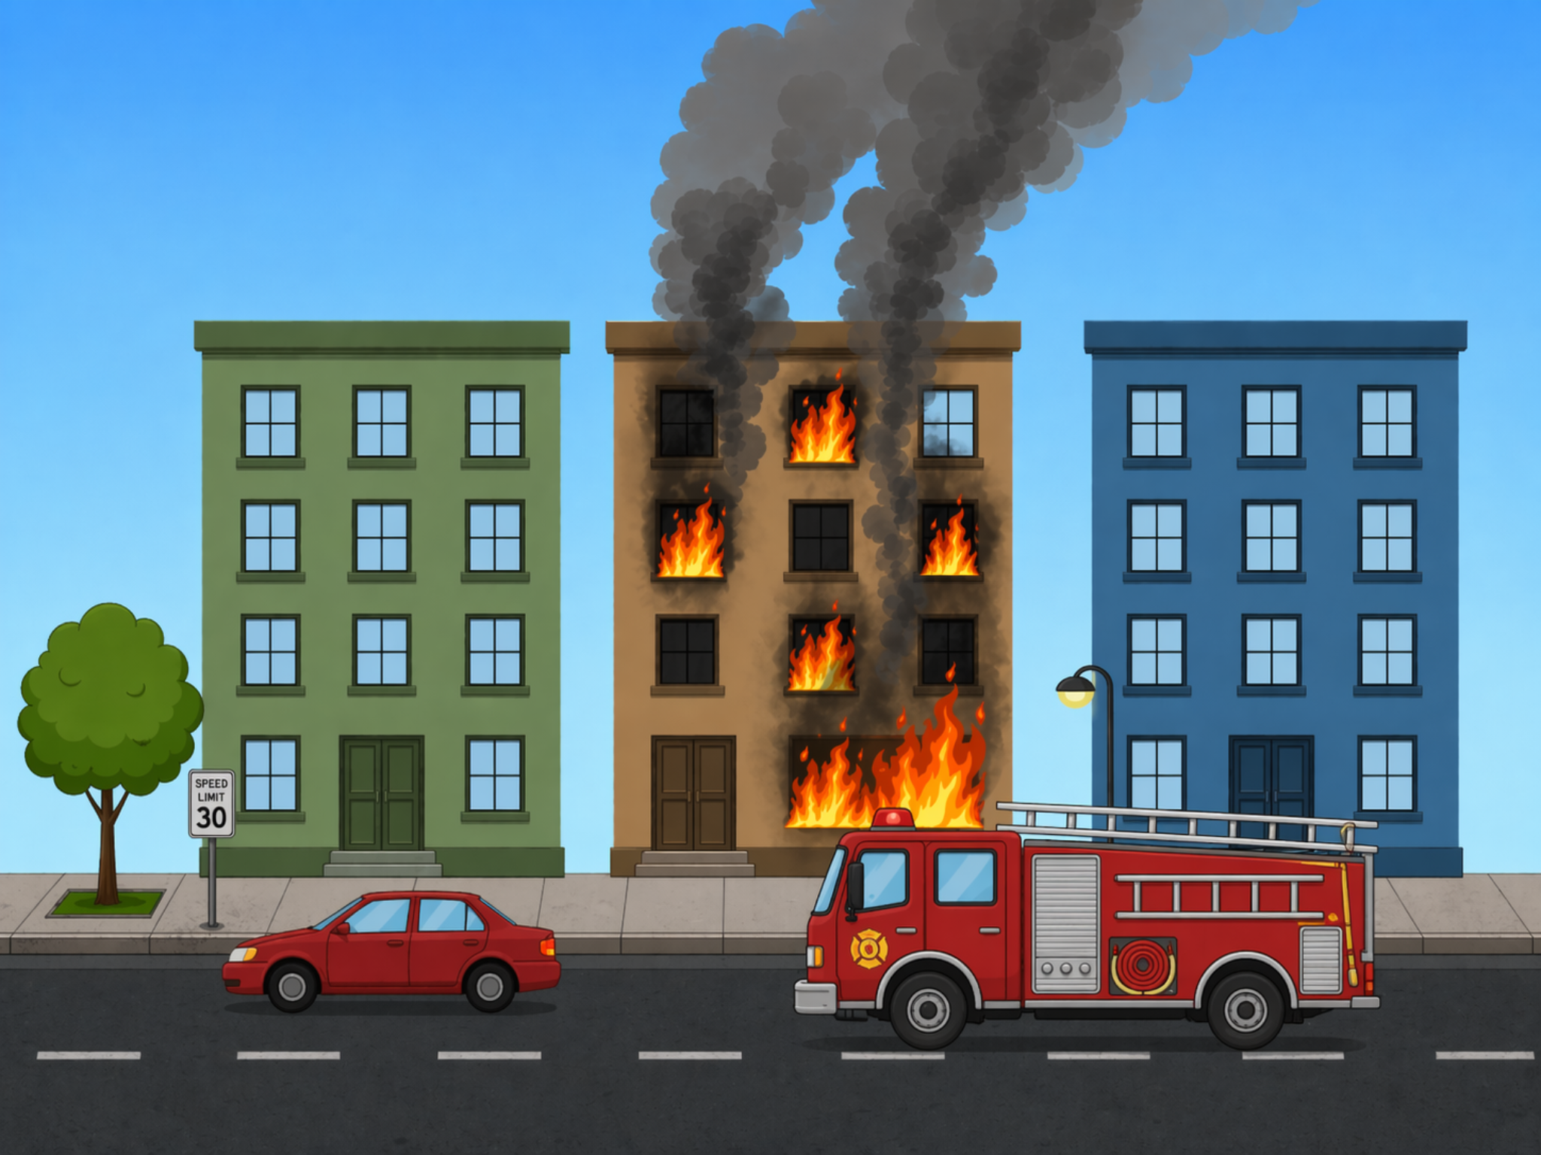
Fire scene visual reference.

Storm scene visual reference.
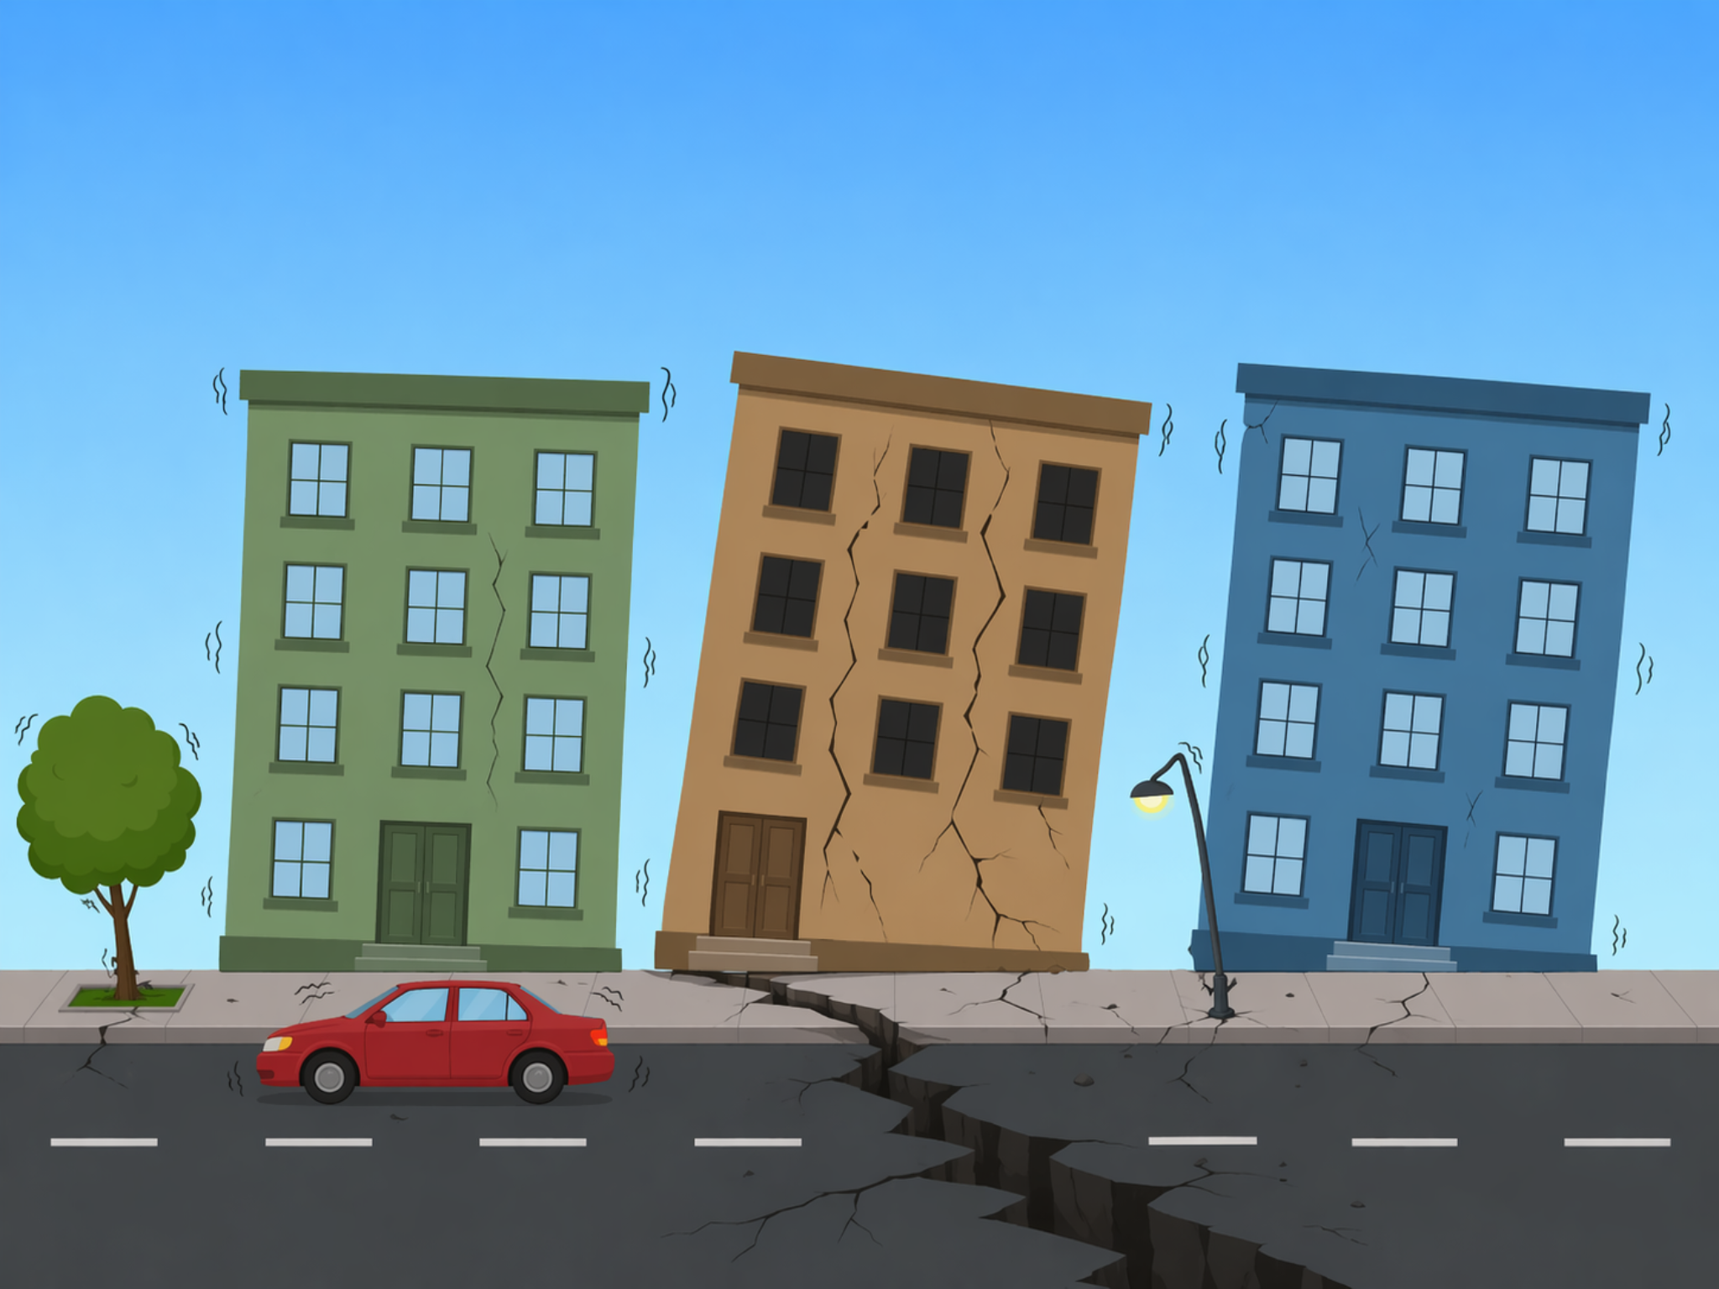
Earthquake visual reference.

