American International University-Bangladesh (AIUB)  
Department of Computer Science  
Faculty of Science &Technology (FST)  
Spring 21 22

Section: A  
Software Quality Assurance and Testing

FORM EXPLORE

A Report submitted

By

|  |  |  |
| --- | --- | --- |
| SN | Student Name | Student ID |
| 1 | Fahim, Abu Talha | 18-38125-2 |
| 2 | Faahim, Mohammad Zaahirul Islam | 18-38163-2 |
| 3 | Sayed Mahmudul Hasan | 18-38095-2 |
| 4 | Tanvir Ahmed | 18-38323-2 |

Under the supervision of

Abhijit Bhowmik

Associate Professor



S

Software Test Plan

for

# Form Explore

Version 1.0 approved

Prepared by

Fahim, Abu Talha

Faahim, Mohmmad Zaahirul Islam

Sayed Mahmudul Hasan

Tanvir Ahmed

17th April, 2022

Table of Contents

Revision History 3

1. TEST PLAN IDENTIFIER: RS-MTP01.3 4
2. REFERENCES 4
3. INTRODUCTION 4

Background to the Problem 4

Solution to the Problem 4

1. REQUEIREMNT SPECIFICATION 5
   1. System Features 5
   2. System Quality Attributes 6
   3. System Interface 7
   4. Project Requirements 8
2. FEATURES NOT TO BE TESTED 10
3. TESTING APPROACH 10
   1. Testing Levels 10
   2. Test Tools 12
   3. Meetings 13
4. TEST CASES/TEST ITEMS 14
5. ITEM PASS/FAIL CRITERIA 18
6. TEST DELIVERABLES 18
7. STAFFING AND TRAINING NEEDS 18
8. RESPONSIBILITIES 19
9. TESTING SCHEDULE 20
10. PLANNING RISKS AND CONTINGENCIES 20
11. APROVALS 20

Revision History

|  |  |  |  |
| --- | --- | --- | --- |
| Revision | Date | Updated by | Update Comments |
| 0.1 | 2022.04.15 | Fahim, Abu Talha | First Draft |
| 0.2 | 2021.04.17 | Mahmudul Ikram | Second Draft |
|  |  |  |  |
|  |  |  |  |
|  |  |  |  |

### 1. TEST PLAN IDENTIFIER:

### REFERENCES:

None

### Introduction

### Background to the Problem

Nowadays, it is common to find that a lot of information is requested when discussing a project with two organizations. When the project is completed, the organization that performs the work is required to provide a large amount of information and documents, such as PDF, picture, video, doc file, and so on. And when I take that information, I show a lot of patience, and after giving a lot of information, I give it all at once, which is required to start the project. As a result, such documents will be required in the future by another firm. It is also obvious that exchanging this paper is a waste of time. The Form Explore concept was developed to address this issue.It's a very simple solution, similar to many Google forms, but it comes with a lot of security and benefits that we believe will make dealing with this problem much easier.

### Solution to the Problem

Form Explore is a web application that allows you to manage forms. Through which a custom form for the required requirement that the firm is providing them the job can be created so that they can provide all of the necessary information to the development company in that form at the start of the task. The form will not be accepted unless all of the required information is provided. As a result, gathering what is required at the beginning of a project will take less time, which is the primary goal of our project. This solution is correct in our opinion because it allows both parties to verify. Furthermore, both companies have the necessary data security in place. Google Forms can now be used to rectify the situation Google Forms can also be used to create custom forms. On the other hand, Google Form has some limitations. They have a 500 KB document memory limit and a 2 MB photo memory limit, as well as customization restrictions and security concerns.

The concept of Form Explore has been brought to solve these problems.

### 

### 4. REQUEIREMENT SPECIFICATION

### 4.1 System Features

* + 1. SystemLogin Functional Requirements

1.1 The software shall allow users to login with their given username and password

1.2 If the username and/or password has been inserted wrong for more than three times, the random verification code will be generated by the system to retry login.

1.3 If the number of login attempt exceed its limit (5 times), the system shall block the user account login for one hour.

Priority Level: High

Precondition: the user has a valid user id and password

* + 1. System registration
       1. Any company or developing group can register into the system at any time.
       2. The registering company should give at least minimum information for registering into the account.
       3. The registering company or group should able to register only through email and password
       4. The registering company should able to complete their profile later on.

Priority Level: High

Precondition: the user has a valid email and password

3.Create Form

Functional requirements

* 1. The software shall allow users to create and customize forms as needed.
  2. User should have the chance to upload any media into the form.
  3. User should have the chance to create sections for uploading media.

Priority Level: High

Precondition: the user has a valid account on the system.

1. Share form link

4.1 User should have the flexibility to share the link through clipboard or any.

* 1. The link should redirect the other company to that form.

4.3 From the link the form should be submit table.

Priority Level: medium

Precondition: the user must have a complete form with at least one input field in it

### System Quality Attributes

**Reliability:** Users should be free to make changes to the form as they see necessary.

Under the system conditions, the system should work correctly at that moment.

**Availability:** This system will be a web application that will be available at all times and can be visited.

**Usability:** The application's user interface will be as simple as possible, allowing people to use it with ease.

**Performance:** In order to design this software, we shall consider all conceivable constraints. It's a little piece of software, for example, with extremely few HTTP requests, allowing it to reply quickly.

**Extensibility:** The application's internal structure will be so simple that any additional features can be introduced in the future without affecting the rest of the code.

**Security:** Because all data will be shared between two companies, confidentiality will be a top priority for us. Users should be able to conduct security work without difficulty, and two- factor authentication and further security levels will be implemented as needed.

### System Interface

We have used Figma for creating system interface. The most important part of the system is the form creation part which is given below:

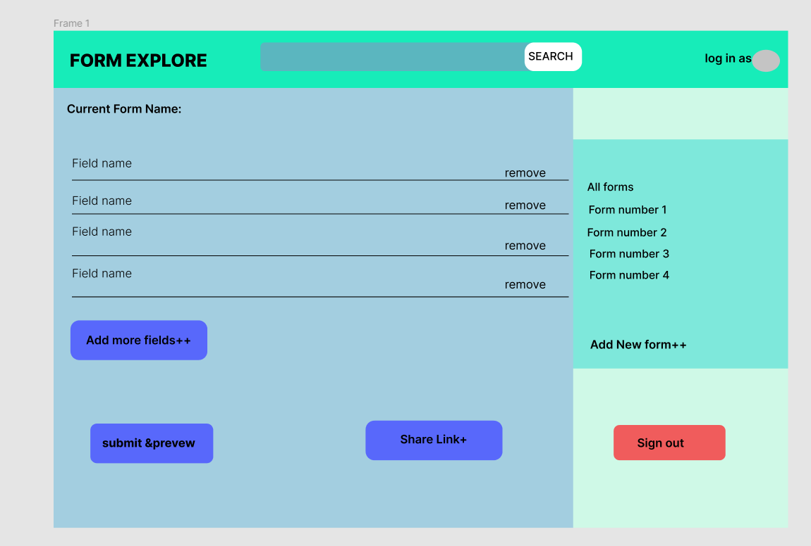

### 

### 4.4 Project Requirements

### 

### Project Estimation

In this project Constructive Cost Model will be used for calculation estimation. Our system is

Complete software, no hardware. So Coefficient: 2.4

Project complexity P: 1.05

SLOC dependent coefficient T: 0.38 Source line of code (guessed) SLOC:3000

### Effort Estimation Formulas:

Effort = PM = Coefficient * (SLOC/1000) ^P Development Time = DM = 2.50 * (PM) ^T Required number of people = ST = PM/DM Using these formulas, we get,

Effort = PM = 2.4 * (3000/1000) ^1.05 = 7.61 person-days needed for the project (labor working hours)

Development Time = DM = 2.50 * (7.61) ^0.38 = 5.41 Weeks (week-days) Required number of people = ST = 7.61 /5.41 = 1.41 ≡ 2

Cost:

Labour cost : 2 * 20,000 = 40,000/= Taka (Approximately) Service cost:10000 =10000/=

50,000/= Taka (Approximately) or

$591(Approximately)

### FEATURES NOT TO BE TESTED

The number of form creation testing because the company who will provide form it depends on them how many and what type of form they will make to provide the other company.

### TESTING APPROACH

### 6.1 Testing Levels

* + 1. Unit, System/Integration (combined), and Acceptance test levels will be used for the From Explore project. For system/integration testing, it is planned that at least two full- time independent test persons will be available. However, due to the financial limits and time constraints, the majority of testing will be done by the test manager with the help of the development teams.
    2. The engineer will complete UNIT testing, which will be approved by the development group's pioneer. Before unit testing is acknowledged and provided to the test individual, the software engineer should provide verification of unit testing to the group head. All unit test data will also be provided to the test subject.
    3. Framework/INTEGRATION The test director and improvement group pioneer will conduct the testing, with assistance from individual engineers as needed. There are no specific test devices available for this project. After all basic flaws have been corrected, projects will be sent to the System/Integration test. A program may have up to two major malformations as long as they do not prevent the program from being tested (I.E. there is a workaround for the blunder).
    4. Acknowledgment With the support of the test chief and the advancement group pioneer, genuine end-clients will execute the testing. For a period of one month following the completion of the System/Integration test measure, the acknowledgment test will be conducted in accordance with the present manual measure.

### Test Tools

The only test tools to be used are the Figma and selenium.

For designing and testing the prototype of the software Figma will be the tool for testing. Figma has this best feature that a complete prototype can be designed and tested easily.

For other types of testing (Unit testing, integration testing, and acceptance testing) selenium will be the best option. Selenium has many good features that allow it to make full use cases of the software functions.

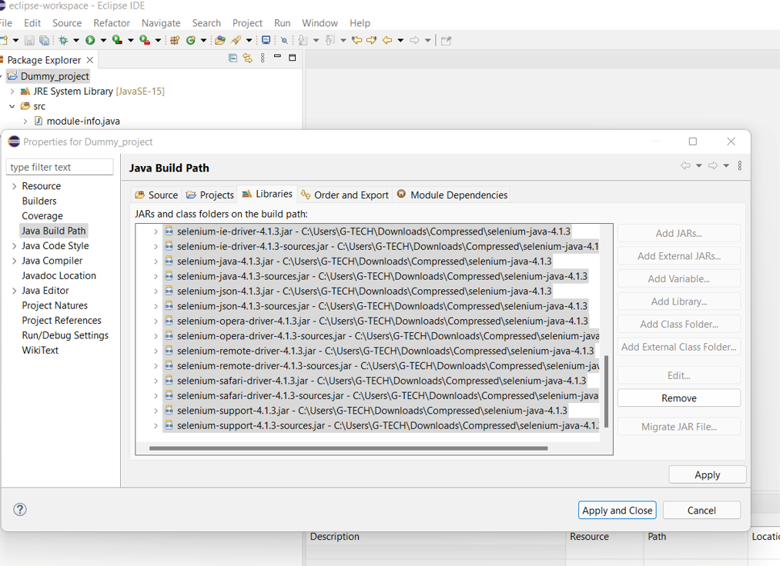

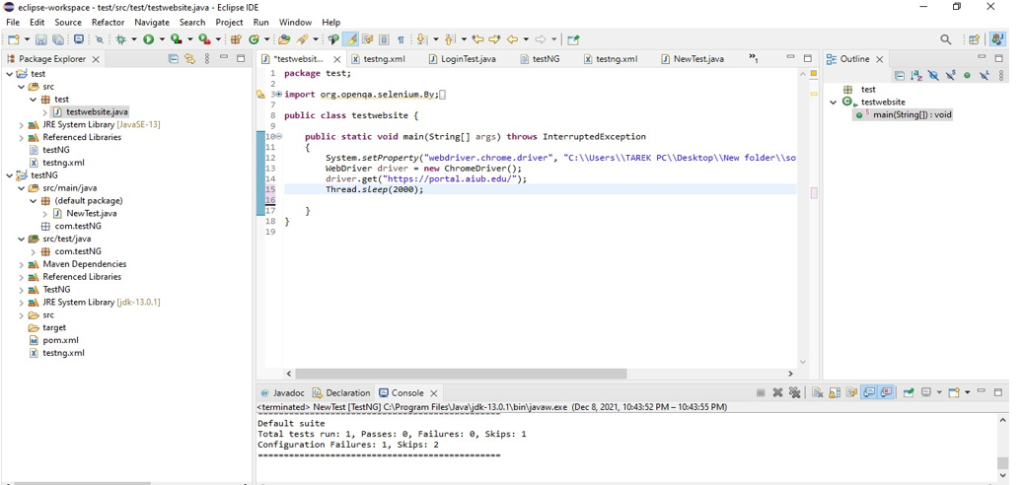

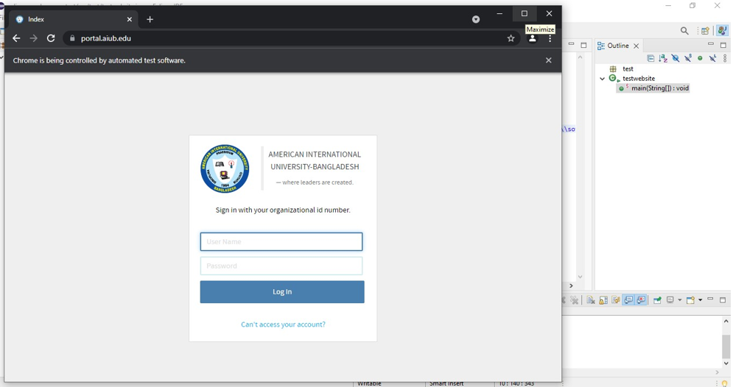

### Meetings

The test group will meet once a month, on the dot, to analyze progress to date and identify error trends and concerns as soon as possible given the conditions. Like clockwork, the leader of the test group and the project manager will meet with the turn of events. These two gatherings will take place over the course of several weeks. For a crisis, extra gatherings can be convened as needed.

### TEST CASES/TEST ITEMS

|  |  |  |  |  |  |
| --- | --- | --- | --- | --- | --- |
| Project Name: From Explore | | | Test Designed by:  Mahmudul Ikram | | |
| Test Case ID: FR_1 | | | Test Designed date: 14.04.2022 | | |
| Test Priority (Low, Medium, High): High | | | Test Executed by: Fahim, Abu Talha | | |
| Module Name: Login Session | | | Test Execution date: 15.04.2022 | | |
| Test Title: verify login with valid username and  password | | |  | | |
| Description: Test web application login page | | |  | | |
| Precondition (If any): User must have valid username and password | | | | | |
| Test Steps | Test Data | Expected Results | | Actual Results | Status (Pass/Fail) |
| 1. Go to the website 2. Enter username 3. Enter password 4. Click submit | Username: 99999999999  Password: 321 | User should login into the application | | As expected, | Pass |
| Post Condition: User is validated with database and successfully login to account. The account  session details are logged in the database. | | | | | |

|  |  |
| --- | --- |
| Project Name: From Explore | Test Designed by:  Mahmudul, Ikram |
| Test Case ID: FR_2 | Test Designed date: 14.04.2022 |
| Test Priority (Low, Medium, High): High | Test Executed by: Fahim, Abu Talha |
| Module Name: Registration Session | Test Execution date: 15.04.2022 |
| Test Title: verify registration with valid email and |  |

|  |  |  |  |  |  |
| --- | --- | --- | --- | --- | --- |
| password | | |  | | |
| Description: Test web application registration  page | | |  | | |
| Precondition (If any): User must have valid email and password | | | | | |
| Test Steps | Test Data | Expected Results | | Actual  Results | Status (Pass/Fail) |
| 1.Go to the website  2.Enter email  3.Enter password  4.Re-enter password  5.Click submit | email: Emonfahim789@gmail.com  Password: | User should login into the application  after register into the system | | As expected, | Pass |
|  | 321 |  | |  |  |
| Post Condition: User is validated with database and successfully login to the account after  successful account creation. The account session details are logged in the database. | | | | | |

|  |  |  |  |  |  |
| --- | --- | --- | --- | --- | --- |
| Project Name: From Explore | | | Test Designed by:  Mahmudul, Ikram | | |
| Test Case ID: FR_3 | | | Test Designed date: 14.04.2022 | | |
| Test Priority (Low, Medium, High): High | | | Test Executed by: Fahim, Abu Talha | | |
| Module Name: Creat form Session. | | | Test Execution date: 15.04.2022 | | |
| Test Title: Verify login with valid username and  Password. | | |  | | |
| Description: Test website creat form session. | | |  | | |
| Precondition (If any):The user must have a valid account on the system | | | | | |
| Test Steps | Test Data | Expected Results | | Actual Results | Status (Pass/Fail) |
| 1. Go to the website 2. Login to account 3. Click new form 4. Add input field 5. Click on the share   link. | Username:  Mahmudul, Ikr  am | Users should | | As expected, | Pass |
|  | Mahmudul@gmail.com | Creat a shareable  form | |  |  |
|  |  |  | |  |  |
|  | Password: |  | |  |  |
|  | 321 |  | |  |  |
| Post Condition: User copied the link from on the clipboard as clicked on the share link button and  all the log should be updated into database.  . | | | | | |

|  |  |  |  |  |  |
| --- | --- | --- | --- | --- | --- |
| Project Name: From Explore | | | Test Designed by:  Mahmudul, Ikram | | |
| Test Case ID: FR_4 | | | Test Designed date: 14.04.2022 | | |
| Test Priority (Low, Medium, High): High | | | Test Executed by: Fahim,Abu Talha | | |
| Module Name: Shareable link | | | Test Execution date: 15.04.2022 | | |
| Test Title: verify the form link redirects to the  proper page | | |  | | |
| Description: Test website shareable link | | |  | | |
| Precondition (If any): User must have a valid account on the system | | | | | |
| Test Steps | Test Data | Expected Results | | Actual Results | Status (Pass/Fail) |
| 1.Click on the link  2.fill the form if it | Username:  Emonfahim789  @gmail.com | Users should able  to click on the | | As expected, | Pass |
| redirects to the page |  | shared link and | |  |  |
| 3.click on submit to |  | fill the form as | |  |  |
| give information | Password: | given. | |  |  |
|  | 321 |  | |  |  |
| Post Condition: User clicked on the link which redirects to the form page and fill up the form  then submitted it. After the session, all the information is updated into the database. | | | | | |

### ITEM PASS/FAIL CRITERIA

Once the initial set of test cases has been built in Selenium Webdriver, the testing process will be done. All of the test cases are constructed in such a way that they must be satisfied in order for the system to be completed. since the program has not yet been developed The aforementioned criteria for pass/fail can be used.

### TEST DELIVERABLES

* + 1. Acceptance test plan
    2. System/Integration test plan
    3. Unit test plans/turnover documentation
    4. Screen prototypes
    5. Report mock-ups
    6. Defect/Incident reports and summaries
    7. Test logs and turnover reports

### STAFFING AND TRAINING NEEDS

It is favored that there will be at any rate one full-time analyzer allotted to the task for the framework/mix and acknowledgment testing periods of the undertaking. This will require the task of individual low maintenance toward the start of the venture to take an interest in surveys and so on and roughly two months into the undertaking they would be appointed full time. In theevent that a different test individual isn't accessible, the venture chief/test administrator will accept this job. To give total and appropriate testing the accompanying territories should be tended to as far as preparing.

* + 1. The developers and tester will need to be trained on the basic operations of the selenium interface. Prior to final acceptance of the project, the operations staff will also require complete training on the selenium testing process.

### RESPONSIBILITIES

|  |  |  |  |
| --- | --- | --- | --- |
| Responsibilities | Development Team | Test team | Client |
| Acceptance test documentation & execution | X | X | X |
| System/integration test | X | X |  |
| Unit test | X | X |  |
| System design reviews | X | X |  |
| Test procedures and rules | X | X |  |
| Prototype Review | X | X | X |
| Control change | X | X | X |

### TESTING SCHEDULE

Time has been allocated within the project plan for the following testing activities. The specific dates and times for each activity are defined in the project plan timeline. The persons required for each process are detailed in the project timeline and plan as well. Coordination of the personnel required for each task, test team, development team, tester, and the client will be handled by the project manager/Development team leader.

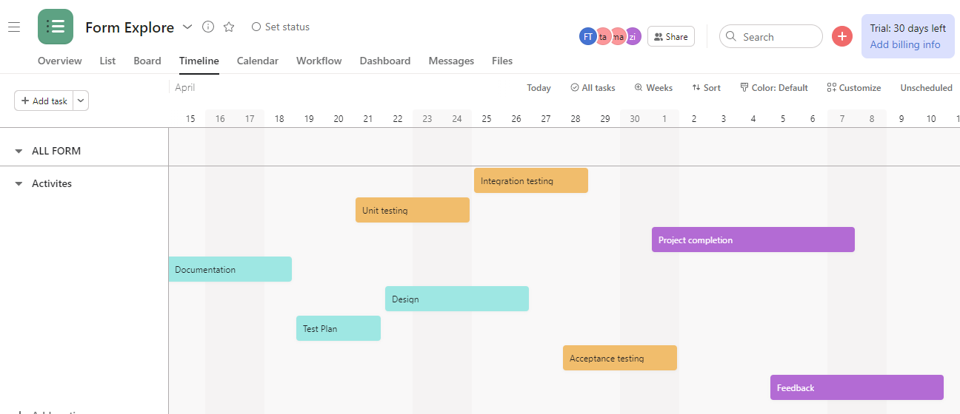

### PLANNING RISKS AND CONTINGENCIES

1. Lack of individual assets when testing is to start.
2. The prerequisites might be changed or refreshed.
3. Low staff and tension on explicit individual.

### APROVALS

|  |  |
| --- | --- |
| **Approval** | **Personnel** |
| Documentation | The development team then the client |
| System Layout | The development team then Client |
| Acceptance testing | Tester |
| Integration and Unit testing | Developer then Tester |
| Test Procedures and rules | Tester |
| Data Validation results | The development team then Tester |
| Overall Test cases | Tester |
| Final Project completion | the tester then developer team |

**THE END**