Queues
Queues

Queue is a Linear Data Structure that follows the principal of FIFO - First In First Out.
Think of people lining up: the first person to join the queue is the first to be served.

Queue has two parts:
- Front/Head - Elements always pop from Front/Head
- Rear/Tail - Elements always push from Rear/Tail
Front/Head
Rear/Tail
Index

Core Operations:

- enqueue(x) — add, push element to the rear/tail
- dequeue() — remove.pop element from the front/head
- peek() / front() — look at the front element without removing
- is_empty(), size(), clear(), search(), display()

Why use Queue:
Task scheduling, breadth-first search (BFS), producer/consumer patterns, IO buffers, message passing, level order traversal of trees, job queues.
Time Complexity
- Enqueue: O(1) (amortized)
- Dequeue: O(1)
- Peek: O(1)
- Using Python list as naive queue (pop(0)) → dequeue O(n) — avoid that.

OverFlow:
When you insert elements more than the size of the queue, then it is called OverFlow.
UnderFlow:
When you remove elements from an empty queue, then it is called UnderFlow.

Real-World Everyday Examples
- 🏦 Bank line — Jo pehle line me khada hua, usko pehle service milti hai.
- 🚌 Bus stop — Pehla banda pehle bus me chadta hai.
- 🛒 Supermarket billing line — Pehla customer pehle checkout karta hai.
- 🎟 Movie ticket line — Jo pehle line me khada, pehle ticket milti hai.
- 🍔 Fast food counter — Orders FIFO order me serve hote hain.

More:

Task Scheduling (CPU / OS Queues)
- Operating system me ready queue hoti hai jahan processes wait karte hain execution ke liye.
- CPU scheduler FIFO, Round Robin, ya Priority Queues use karta hai.
- Example: Process A, B, C queue me jate hain → CPU ne A execute kiya → fir B → fir C.
- Ye OS-level queue ka classic example hai.

Print Spooler
- Jab tum multiple documents print karte ho: Document 1, 2, 3 → printer queue me jate hain.
- Printer pehle document 1 print karega, phir 2, phir 3.
- Yani processing exactly FIFO order me hoti hai.

Implementation

Implementation of Queue

Queue using Arrays - OOP

- enqueue()
- dequeue()
- peek()
- search()
- is_empty()
- clear()
- size()
- display() - using loop , join, recursion

Code Link: Click Here

Queue using Arrays - Collection Module

- Collection Module uses special deque() which allows to append or remove elements from both ends.

- Time Complexity: 0(1) as compared to 0(n)

- It is fast because there is no data shifting.

Code Link: Click Here

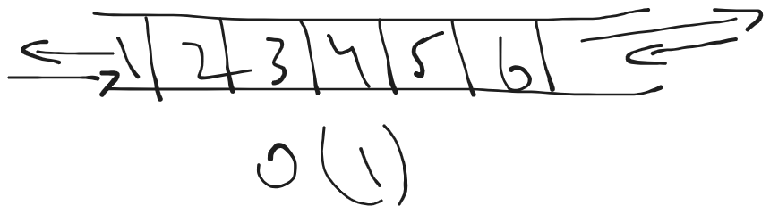
Queue using Linked List

Code Link: Click Here

Circular Queues
Circular Queues:

A Circular Queue is a special type of queue in which the last position connects back to the first position — that’s why it’s called “circular.”
Means:
- In a normal queue, once the specified size limit is reached, you cannot insert any new elements — even if some slots at the beginning have become empty after dequeuing.
- In contrast, a circular queue allows wrap-around insertion, meaning when the end of the queue is reached, new elements can be added at the beginning (first) positions if there is available space.

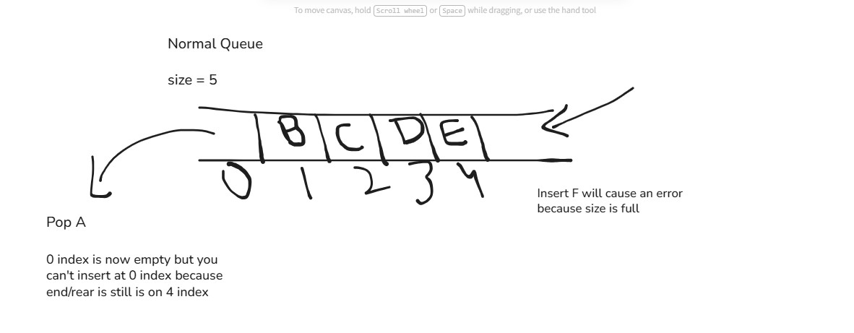

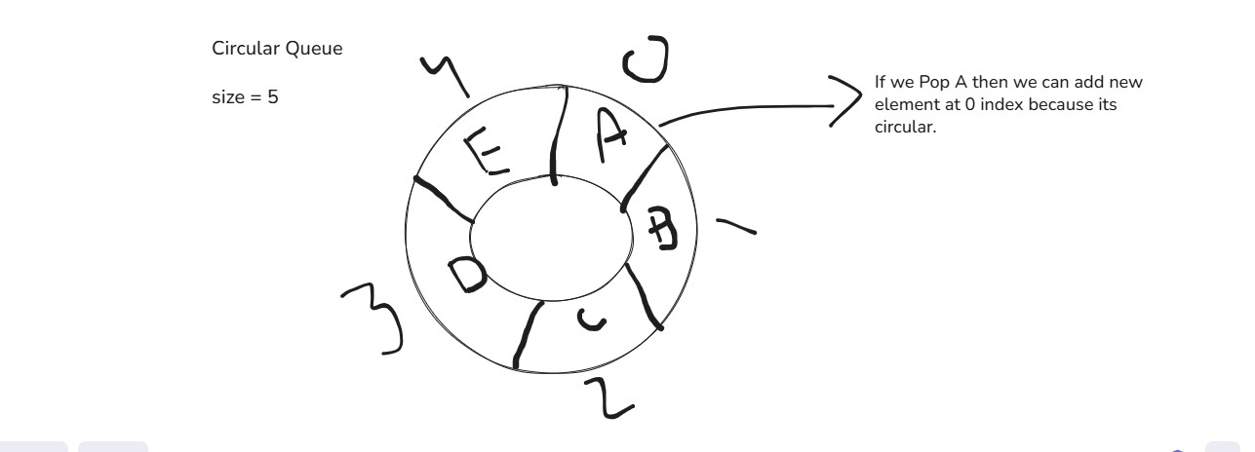
.
Why Use Circular Queues:
- Space Reused
- Memory Efficient
- Circular Traversal
- Rear Wrap Around

Use Cases:
- Traffic Lights
- CPU Scheduling
- Printer Spooler

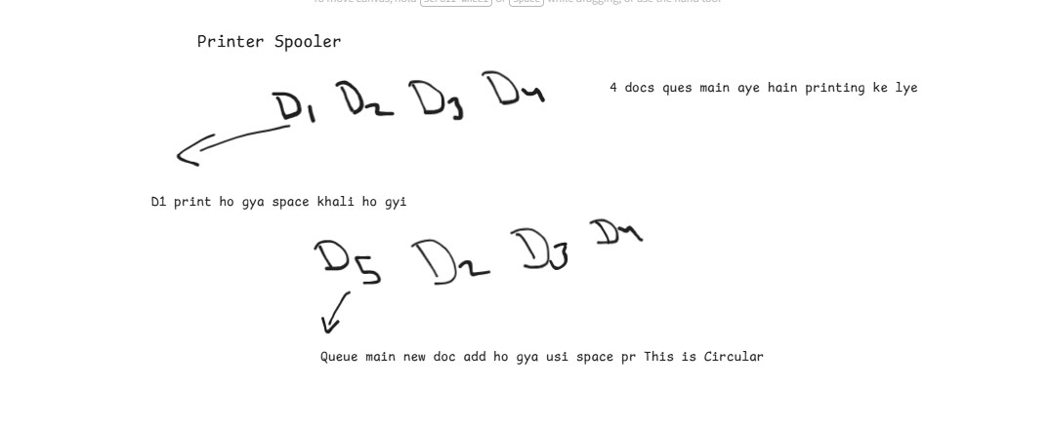

Circular queue impl.
Implementation using Arrays:

- __init__()
- enqueue()
- dequeue()
- is_full()
- is_empty()
- display()

Code Link: Click Here

Documentation
Topics Covered in Queues

- What are Queues
- What are Linear Queues
- Core Operations
- Time Complexity
- Use Cases
- Implementation
Queues with Arrays
Queues with Collection.Deque()
Queues with Linked List
- What are Circular Queues
- Use Cases
- Implementation

