NAME: FAATINA S REG NO:3122 23 5001 046
DATE: 04.02.2026 EX NO: 5

ASSIGNMENT -5
Form-Servlet Communication
AIM
To design and develop a web-based authentication and registration system using HTML, CSS, JavaScript, and Java Servlets, demonstrating form–servlet communication, server-side validation, and page redirection based on user credentials.
DESCRIPTIONS
<web-app> — Root tag that defines and configures the web application.
<servlet> — Declares a servlet and its configuration details.
<servlet-name> — Specifies the logical name of the servlet.
<servlet-class> — Defines the Java class that implements the servlet.
<servlet-mapping> — Maps the servlet to a client request URL.
<url-pattern> — Specifies the URL path used to access the servlet.
HttpServlet — Base class extended to create an HTTP servlet.
doPost() — Handles client requests sent using the POST method.
HttpServletRequest — Object used to receive data from the client request.
HttpServletResponse — Object used to send response back to the client.
request.getParameter() — Retrieves form input values from the request.
response.sendRedirect() — Redirects the client to another web page.
HttpSession — Creates or accesses session data for a user.
request.getSession() — Returns the current session object.
session.setAttribute() — Stores data in the session scope.
response.setContentType() — Sets the MIME type of the response sent to the browser.
PrintWriter out = response.getWriter() — Sends text/HTML output to the client.
RESULT
The web-based authentication application was successfully designed and developed using HTML and Java Servlets. Form–Servlet communication was established, server-side validation was implemented for username and password, and user authentication was performed. Based on the entered credentials, the system successfully redirected users to the appropriate success or error page.

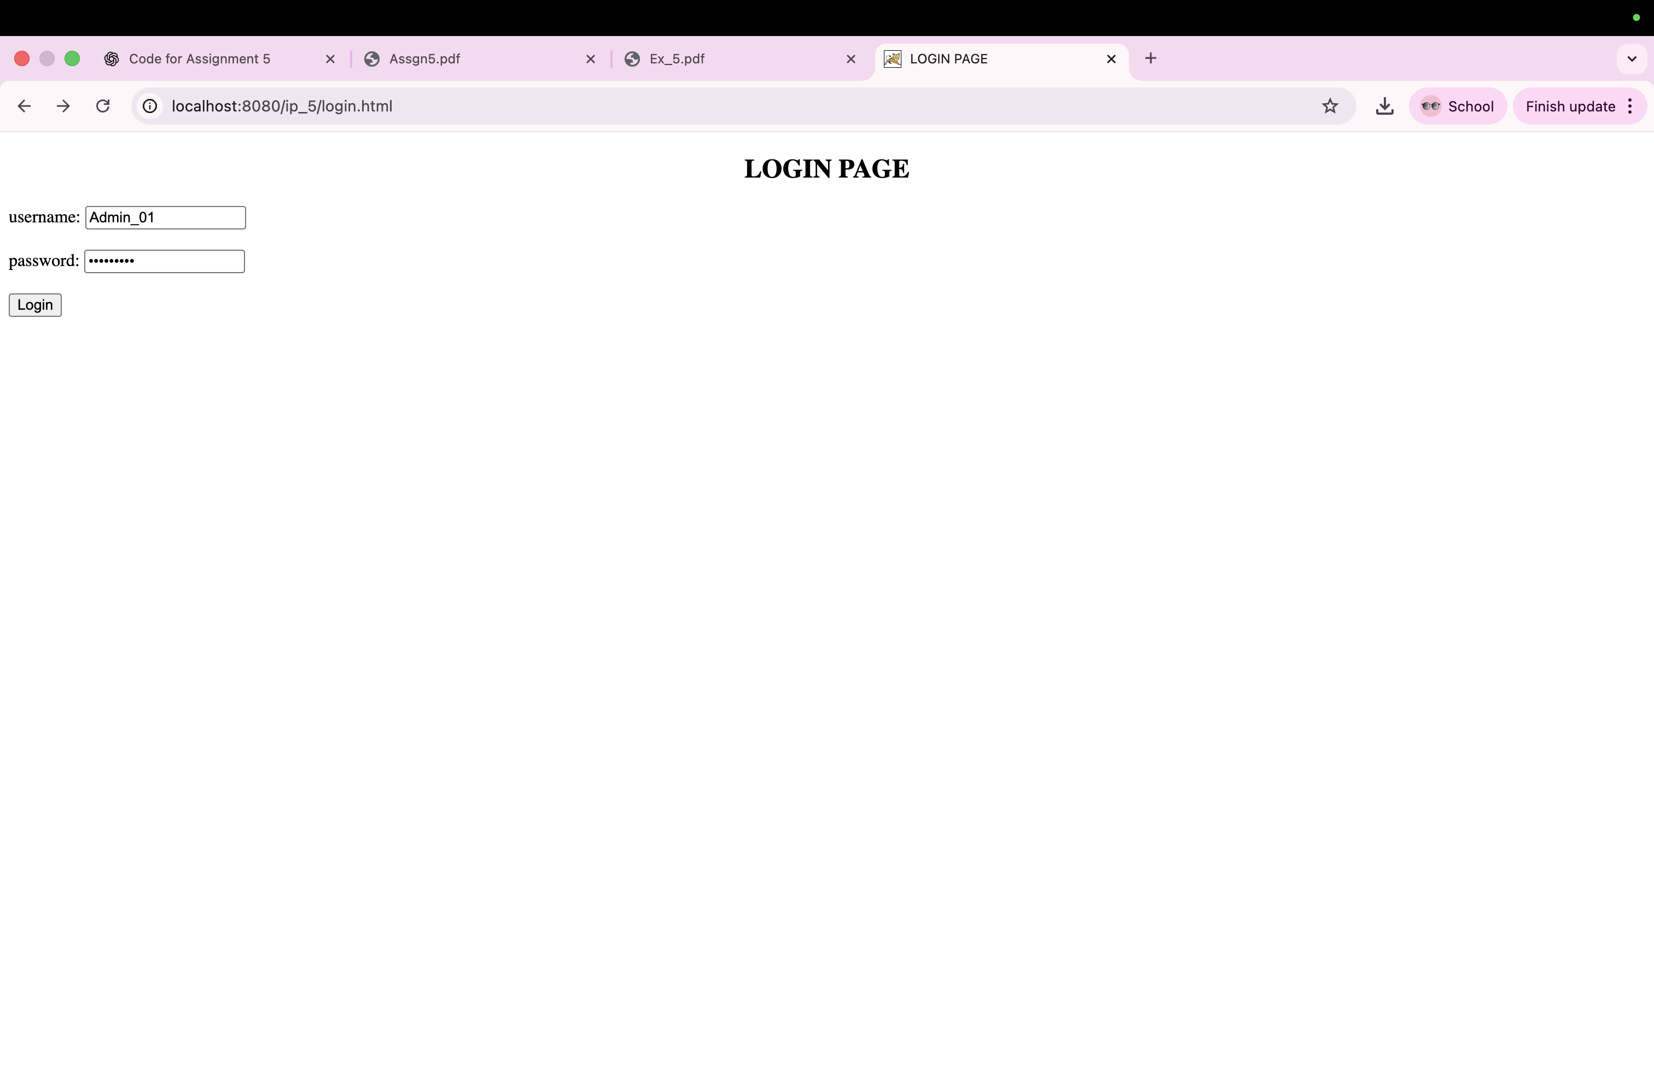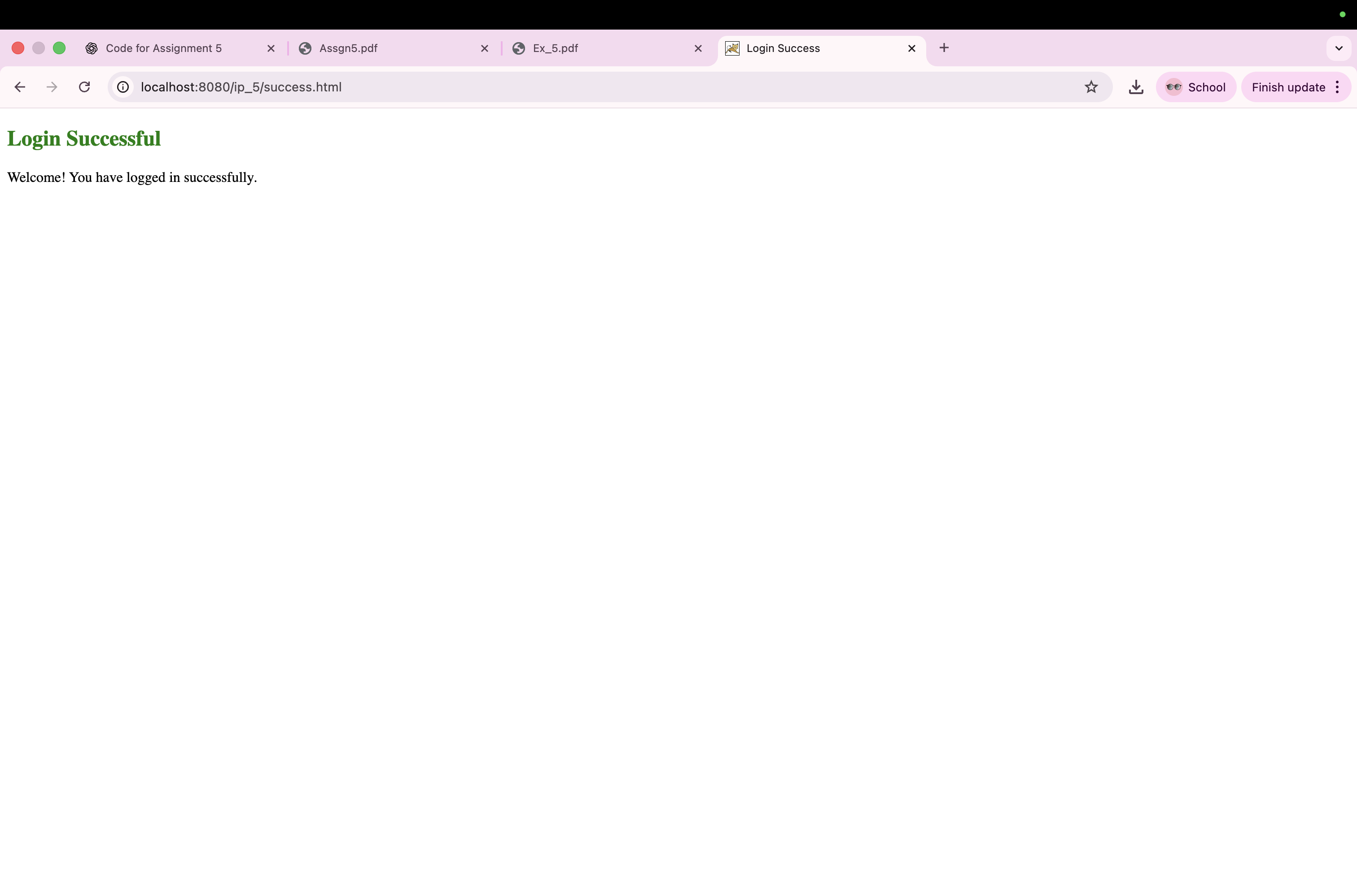
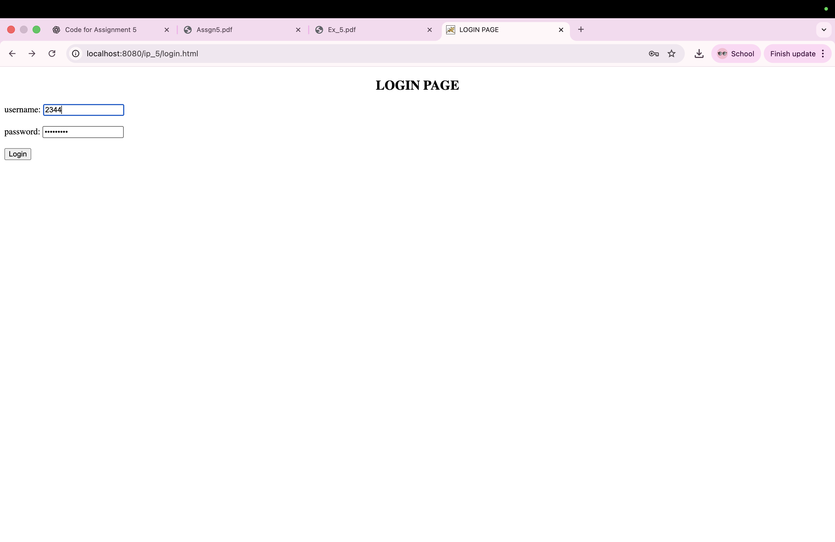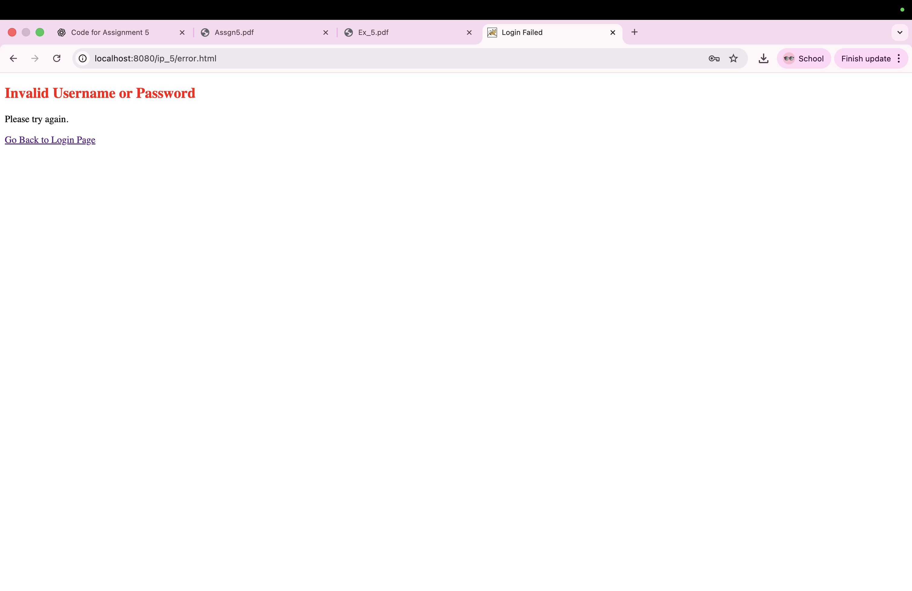
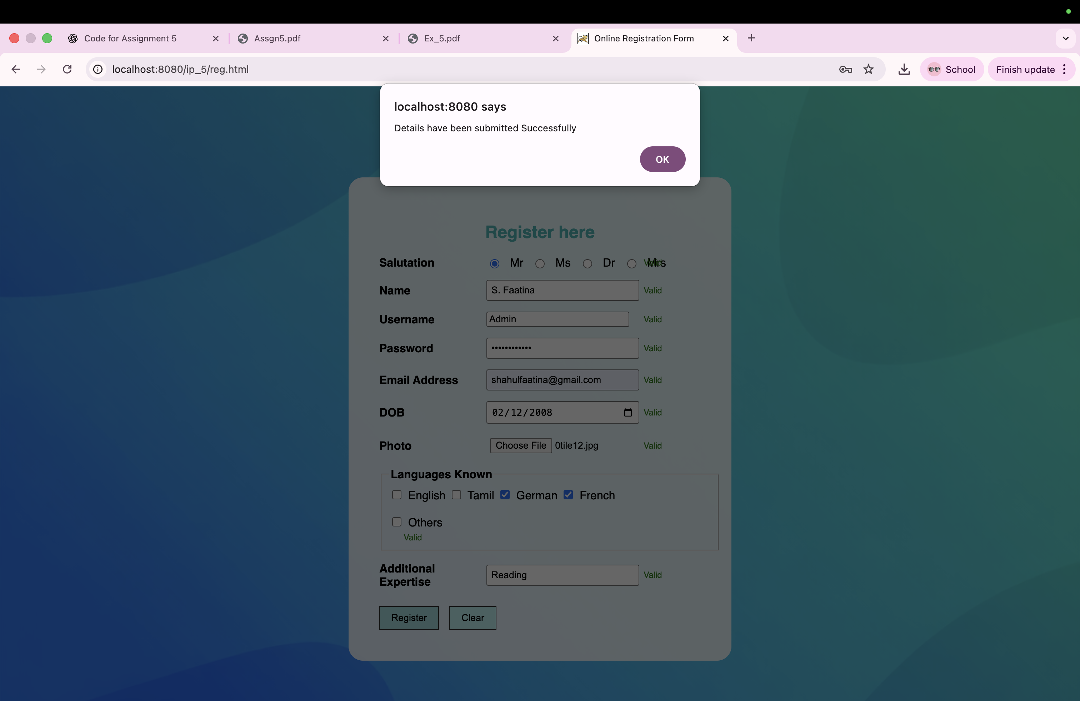

LEARNING OUTCOME
- Understood the communication between HTML forms and Java Servlets using GET and POST methods.
- Implemented server-side validation for username and password based on the specified rules.
- Developed authentication logic to verify user credentials using predefined values.
- Applied page navigation using response.sendRedirect() for success and failure scenarios.
- Gained knowledge of session handling to store and display error messages.
- Learned the deployment and execution of servlet-based web applications on the Apache Tomcat server.

