NAME: FAATINA S REG NO:3122 23 5001 046
DATE:8.03.2026 EX NO: 8

ASSIGNMENT -8

Session based Shopping Cart using Java Servlets and HttpSession

AIM
To develop a session-based shopping cart web application using Java Servlets and HttpSession that allows users to add products, store cart items in a session, view cart contents, remove items, and calculate subtotal and grand total dynamically.
CODE
Product.html
<!DOCTYPE html>
<html>
<head>
<title>Products</title>
<style>
body {
font-family: Arial, sans-serif;
margin: 20px;

}
h2 {
color: #333;
}
form {
border: 1px solid #ccc;
padding: 15px;
margin-bottom: 20px;
width: 300px;
}
input[type="number"] {
width: 50px;
}
a {
color: #007BFF;
}
</style>
</head>
<body>
<h2>Product List</h2>
<form action="Add_to_cart_servlet" method="post">
<h3>Laptop - 50000</h3>
<input type="hidden" name="name" value="Laptop">
<input type="hidden" name="price" value="50000">
Quantity:
<input type="number" name="quantity" value="1" min="1">
<br><br>
<input type="submit" value="Add to Cart">
</form>
<br>

<form action="Add_to_cart_servlet" method="post">
<h3>Mobile - 20000</h3>
<input type="hidden" name="name" value="Mobile">
<input type="hidden" name="price" value="20000">
Quantity:
<input type="number" name="quantity" value="1" min="1">
<br><br>
<input type="submit" value="Add to Cart">
</form>
<br>

<form action="Add_to_cart_servlet" method="post">
<h3>Headphones - 3000</h3>
<input type="hidden" name="name" value="Headphones">
<input type="hidden" name="price" value="3000">
Quantity:
<input type="number" name="quantity" value="1" min="1">
<br><br>
<input type="submit" value="Add to Cart">
</form>

<br><br>
<a href="View_cart_servlet" style="text-decoration: none;">View Cart</a>

</body>
</html>
CartItem.java
import java.io.Serializable;

public class CartItem implements Serializable {
private String name;
private double price;
private int quantity;

public CartItem(String name, double price, int quantity) {
this.name = name;
this.price = price;
this.quantity = quantity;
}
public String getName() {
return name;
}
public void setName(String name) {
this.name = name;
}
public double getPrice() {
return price;
}
public void setPrice(double price) {
this.price = price;
}
public int getQuantity() {
return quantity;
}
public void setQuantity(int quantity) {
this.quantity = quantity;
}
}

Add_to_cart_Servlet.java

import java.io.IOException;
import java.util.ArrayList;
import java.util.List;
import jakarta.servlet.ServletException;
import jakarta.servlet.http.HttpServlet;
import jakarta.servlet.http.HttpServletRequest;
import jakarta.servlet.http.HttpServletResponse;
import jakarta.servlet.http.HttpSession;

public class Add_to_cart_servlet extends HttpServlet {

protected void doPost(HttpServletRequest request, HttpServletResponse response)throws ServletException, IOException {

String name = request.getParameter("name");
double price = Double.parseDouble(request.getParameter("price"));
int quantity = Integer.parseInt(request.getParameter("quantity"));

HttpSession session = request.getSession();
List<CartItem> cart = (List<CartItem>) session.getAttribute("cart");
if (cart == null) {
cart = new ArrayList<CartItem>();
}

boolean found = false;
for (CartItem item : cart) {
if (item.getName().equals(name)) {
item.setQuantity(item.getQuantity() + quantity);
found = true;
break;
}
}

if (!found) {
CartItem item = new CartItem(name, price, quantity);
cart.add(item);
}
session.setAttribute("cart", cart);
response.sendRedirect("products.html");
}
}
View_cart_Servlet.java
import java.io.IOException;
import java.io.PrintWriter;
import java.util.List;

import jakarta.servlet.ServletException;
import jakarta.servlet.http.HttpServlet;
import jakarta.servlet.http.HttpServletRequest;
import jakarta.servlet.http.HttpServletResponse;
import jakarta.servlet.http.HttpSession;

public class View_cart_servlet extends HttpServlet {

protected void doGet(HttpServletRequest request, HttpServletResponse response)throws ServletException, IOException {

response.setContentType("text/html");
PrintWriter out = response.getWriter();
HttpSession session = request.getSession();
List<CartItem> cart = (List<CartItem>) session.getAttribute("cart");
double grandTotal = 0;
out.println("<!DOCTYPE html>");
out.println("<html>");
out.println("<head>");
out.println("<title>Shopping Cart</title>");
out.println("<style>");
out.println("table { width:50%; border-collapse:collapse; }");
out.println("th, td { border:1px solid black; padding:8px; text-align:left; }");
out.println("th { background-color:#f2f2f2; }");
out.println("a { color:#007BFF; text-decoration:none; }");
out.println("</style>");

out.println("</head>");
out.println("<body>");
out.println("<h2>Your Cart</h2>");
if (cart == null || cart.size() == 0) {
out.println("<p>Cart is empty</p>");
} else {

out.println("<table>");
out.println("<tr>");
out.println("<th>Name</th>");
out.println("<th>Price</th>");
out.println("<th>Quantity</th>");
out.println("<th>Subtotal</th>");
out.println("<th>Action</th>");
out.println("</tr>");

for (CartItem item : cart) {

double subtotal = item.getPrice() * item.getQuantity();
grandTotal += subtotal;
out.println("<tr>");
out.println("<td>" + item.getName() + "</td>");
out.println("<td>" + item.getPrice() + "</td>");
out.println("<td>" + item.getQuantity() + "</td>");
out.println("<td>" + subtotal + "</td>");
out.println("<td>");
out.println("<a href='Remove_from_cart_servlet?name=" + item.getName() + "'>Remove</a>");
out.println("</td>");
out.println("</tr>");
}

out.println("</table>");
out.println("<h3>Grand Total: " + grandTotal + "</h3>");
}

out.println("<br>");
out.println("<a href='products.html' style=\"text-decoration: none;\">Back to Products</a>");

out.println("</body>");
out.println("</html>");
}
}

Remove_from_cart_servlet.java

import java.io.IOException;
import java.util.Iterator;
import java.util.List;

import jakarta.servlet.ServletException;
import jakarta.servlet.http.HttpServlet;
import jakarta.servlet.http.HttpServletRequest;
import jakarta.servlet.http.HttpServletResponse;
import jakarta.servlet.http.HttpSession;

public class Remove_from_cart_servlet extends HttpServlet {

protected void doGet(HttpServletRequest request, HttpServletResponse response)throws ServletException, IOException {

String name = request.getParameter("name");
HttpSession session = request.getSession();
List<CartItem> cart = (List<CartItem>) session.getAttribute("cart");
if (cart != null) {
Iterator<CartItem> iterator = cart.iterator();
while (iterator.hasNext()) {
CartItem item = iterator.next();
if (item.getName().equals(name)) {
iterator.remove();
break;
}
}
}

session.setAttribute("cart", cart);
response.sendRedirect("View_cart_servlet");
}
}
Web.xml
<web-app>

<servlet>
<servlet-name>Add_to_cart_servlet</servlet-name>
<servlet-class>Add_to_cart_servlet</servlet-class>
</servlet>

<servlet-mapping>
<servlet-name>Add_to_cart_servlet</servlet-name>
<url-pattern>/Add_to_cart_servlet</url-pattern>
</servlet-mapping>

<servlet>
<servlet-name>View_cart_servlet</servlet-name>
<servlet-class>View_cart_servlet</servlet-class>
</servlet>

<servlet-mapping>
<servlet-name>View_cart_servlet</servlet-name>
<url-pattern>/View_cart_servlet</url-pattern>
</servlet-mapping>

<servlet>
<servlet-name>Remove_from_cart_servlet</servlet-name>
<servlet-class>Remove_from_cart_servlet</servlet-class>
</servlet>

<servlet-mapping>
<servlet-name>Remove_from_cart_servlet</servlet-name>
<url-pattern>/Remove_from_cart_servlet</url-pattern>
</servlet-mapping>

</web-app>

OUTPUT
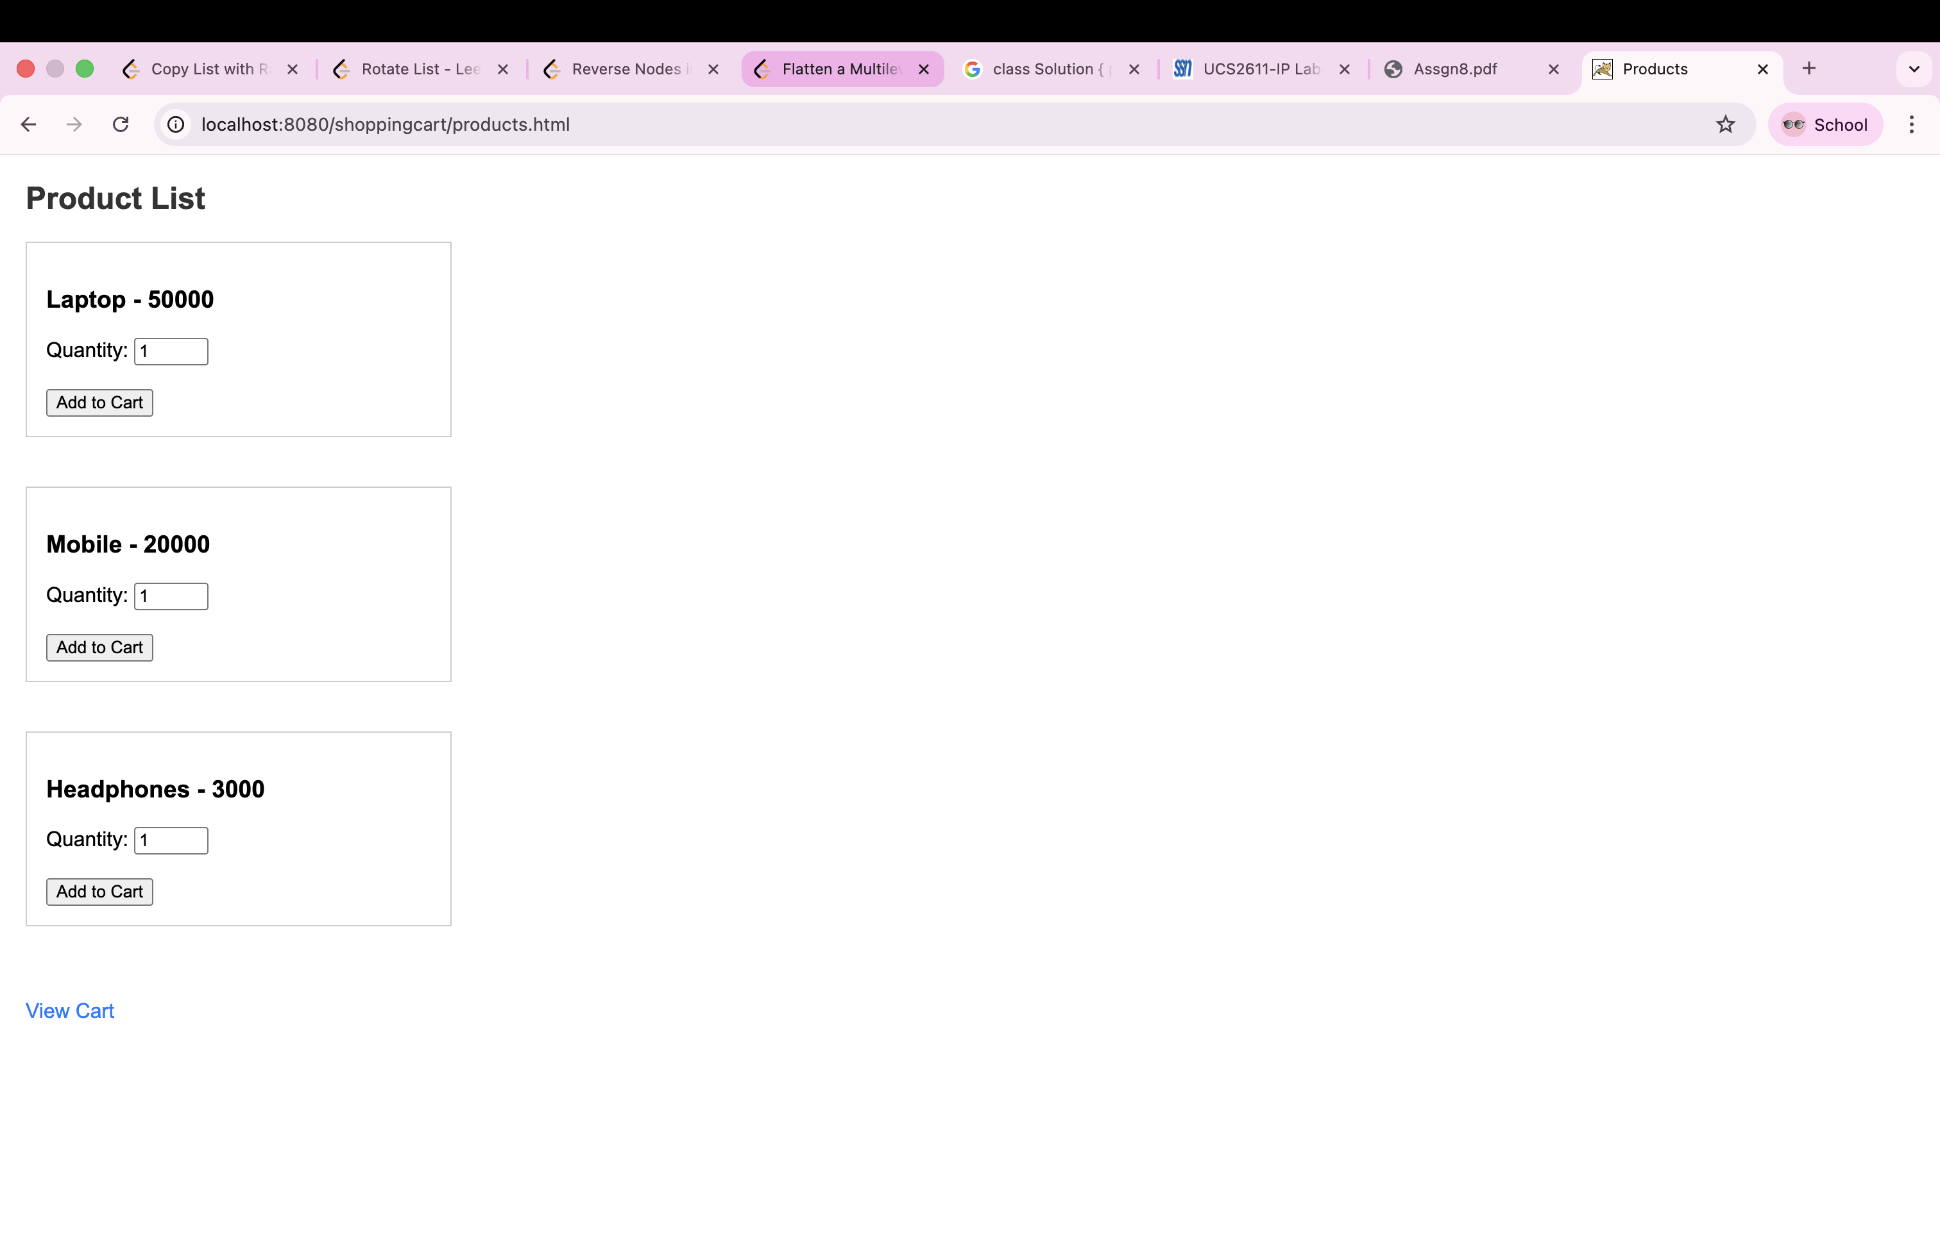
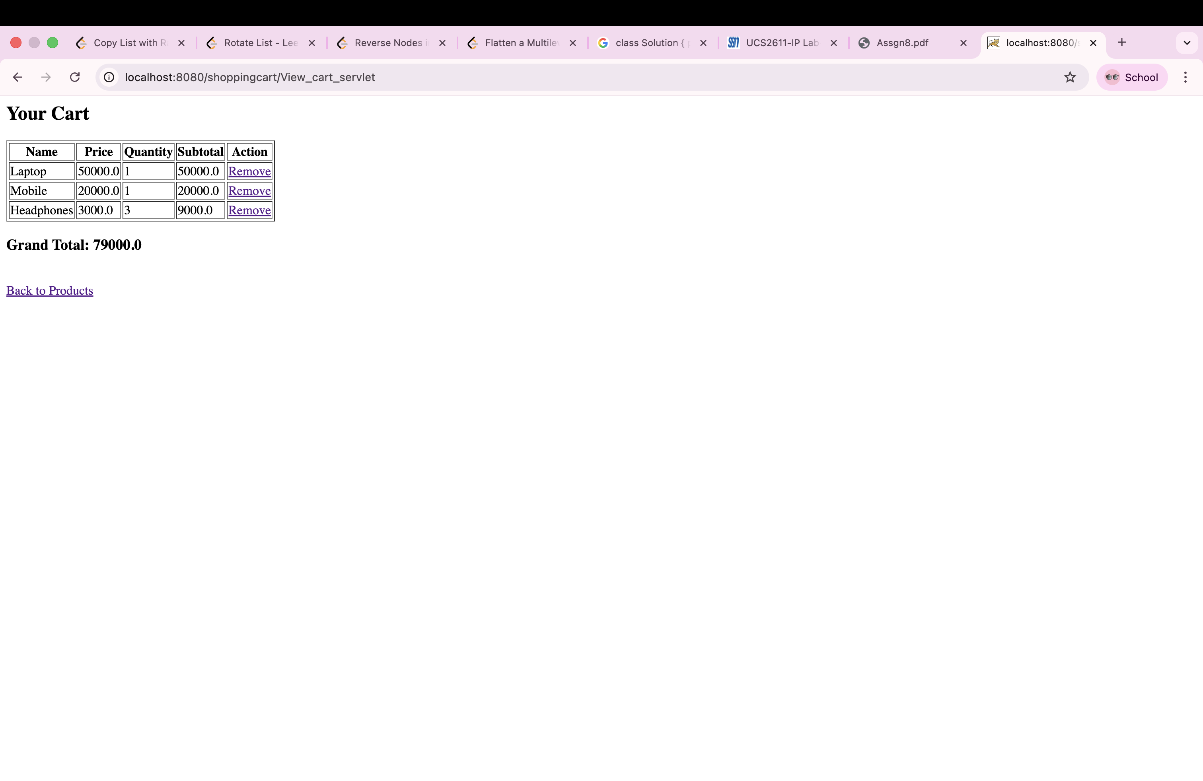
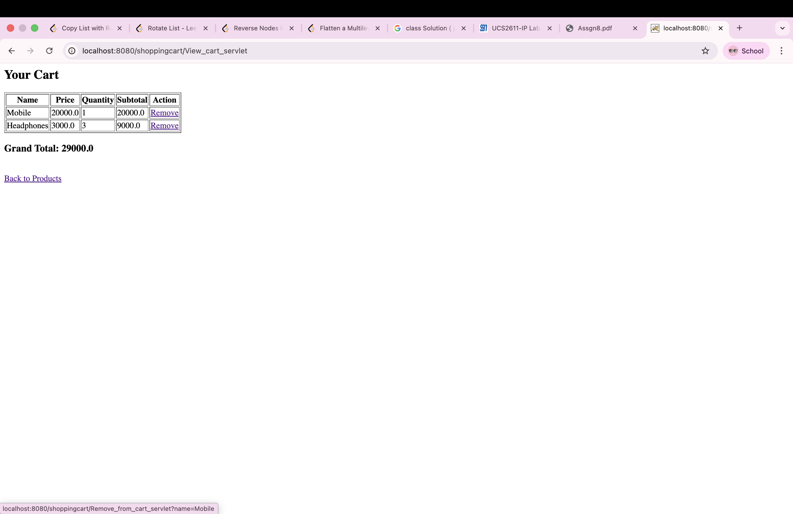
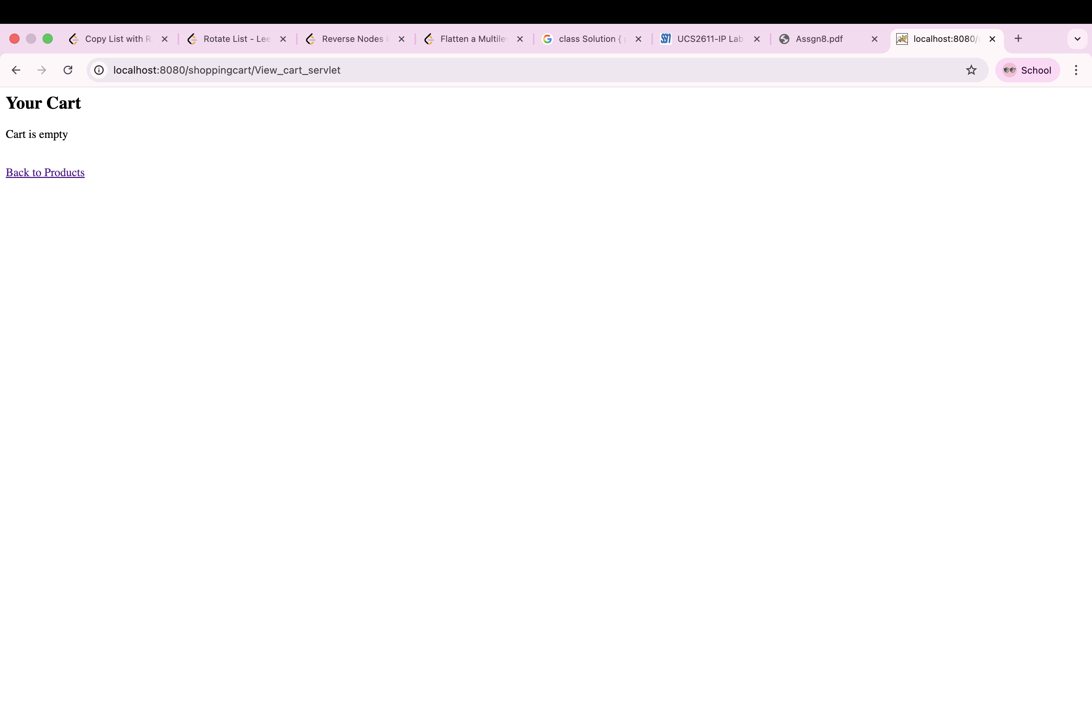
LEARNING OUTCOME
- Understand how Java Servlets handle HTTP requests and responses in a web application.
- Learn how to use HttpSession to store and manage user session data such as cart items.
- Implement a model class (POJO) with serialization to represent cart items containing name, price, and quantity.
- Develop the ability to process form data and dynamically generate HTML responses using servlets.
- Gain experience in building a simple shopping cart system with item addition, removal, quantity handling, and total price calculation.

