NAME: FAATINA S REG NO:3122 23 5001 046
DATE:19.03.2026 EX NO: 9

ASSIGNMENT -9

Library Management System using React, NodeJS and MySQL
AIM
To design and develop a full-stack Library Management System using React for the frontend, Node.js with Express for the backend, and MySQL as the database, to perform CRUD (Create, Read, Update, Delete) operations on book records with proper routing, user interaction, and real-time data updates.
DESCRIPTION
useState:
Used to store and update component state
syntax: const [data, setData] = useState(initialValue);
useEffect:
Used to run code when component loads or updates
syntax: useEffect(() => { /* code */ }, []);
useParams:
Used to get parameters from URL
syntax: const { id } = useParams();
GET (Axios):
Used to fetch data from backend
syntax: axios.get(url).then(res => setData(res.data));
POST (Axios):
Used to send new data to backend
syntax: axios.post(url, data);
PUT (Axios):
Used to update existing data
syntax: axios.put(\${url}/id`, data);`
DELETE (Axios):
Used to delete data
syntax: axios.delete(\${url}/id`);`
Express Route:
Used to define API endpoints
syntax: app.get("/path", (req, res) => {});
MySQL Query:
Used to execute SQL commands
syntax: db.query("SQL QUERY", values, callback);
React Router:
Used to navigate between components
syntax: <Route path="/path" element={<Component />} />
OUTPUT
Home page
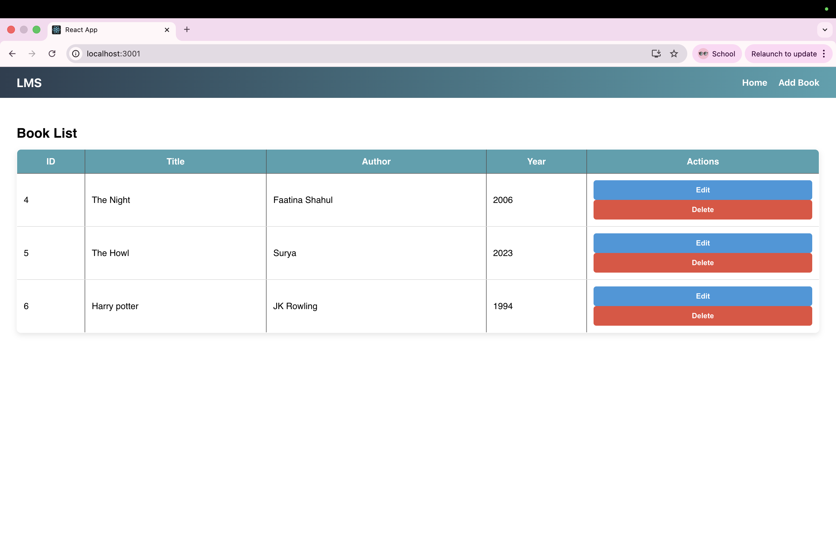
Adding a Book
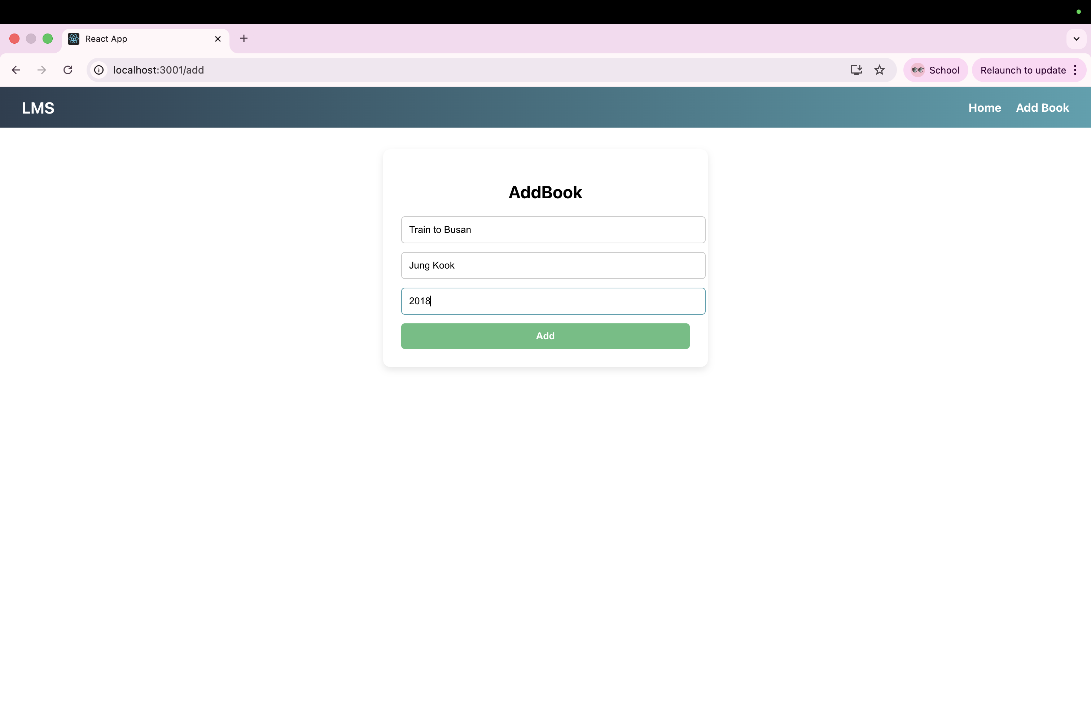

After adding the book “Train to Busan”
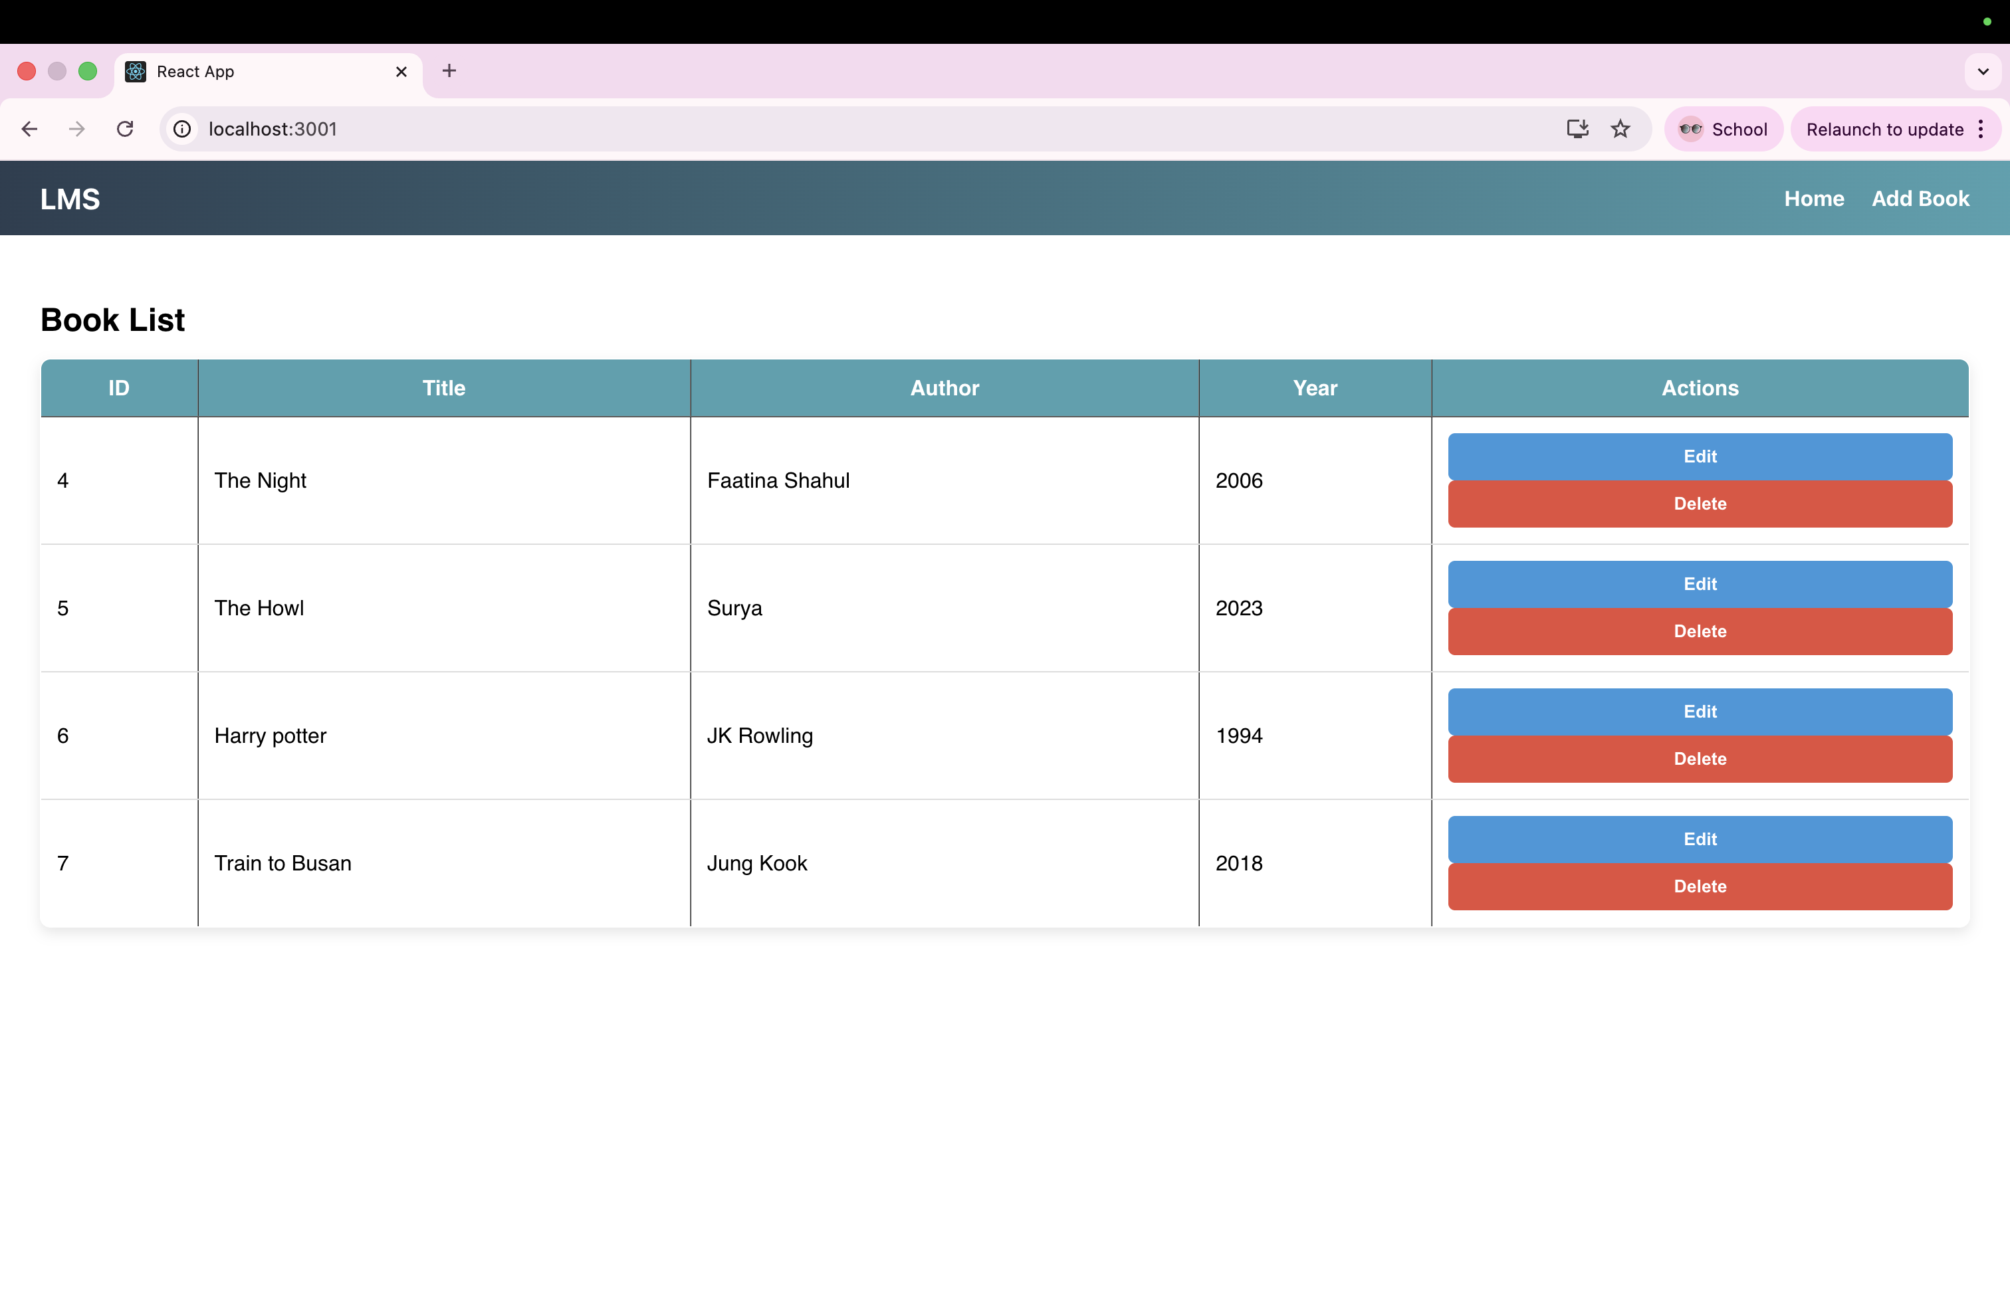
Editing the book “The Night”
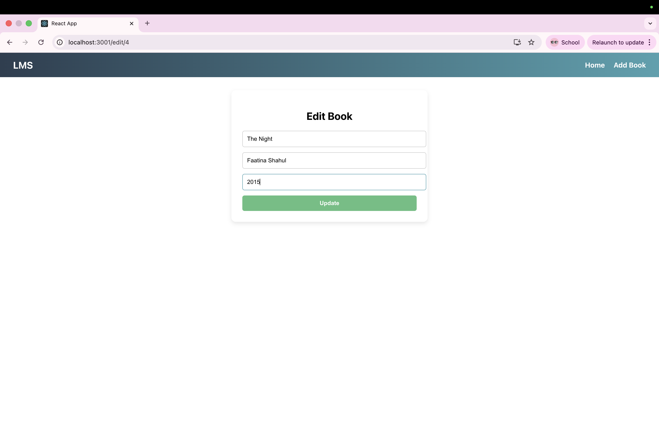

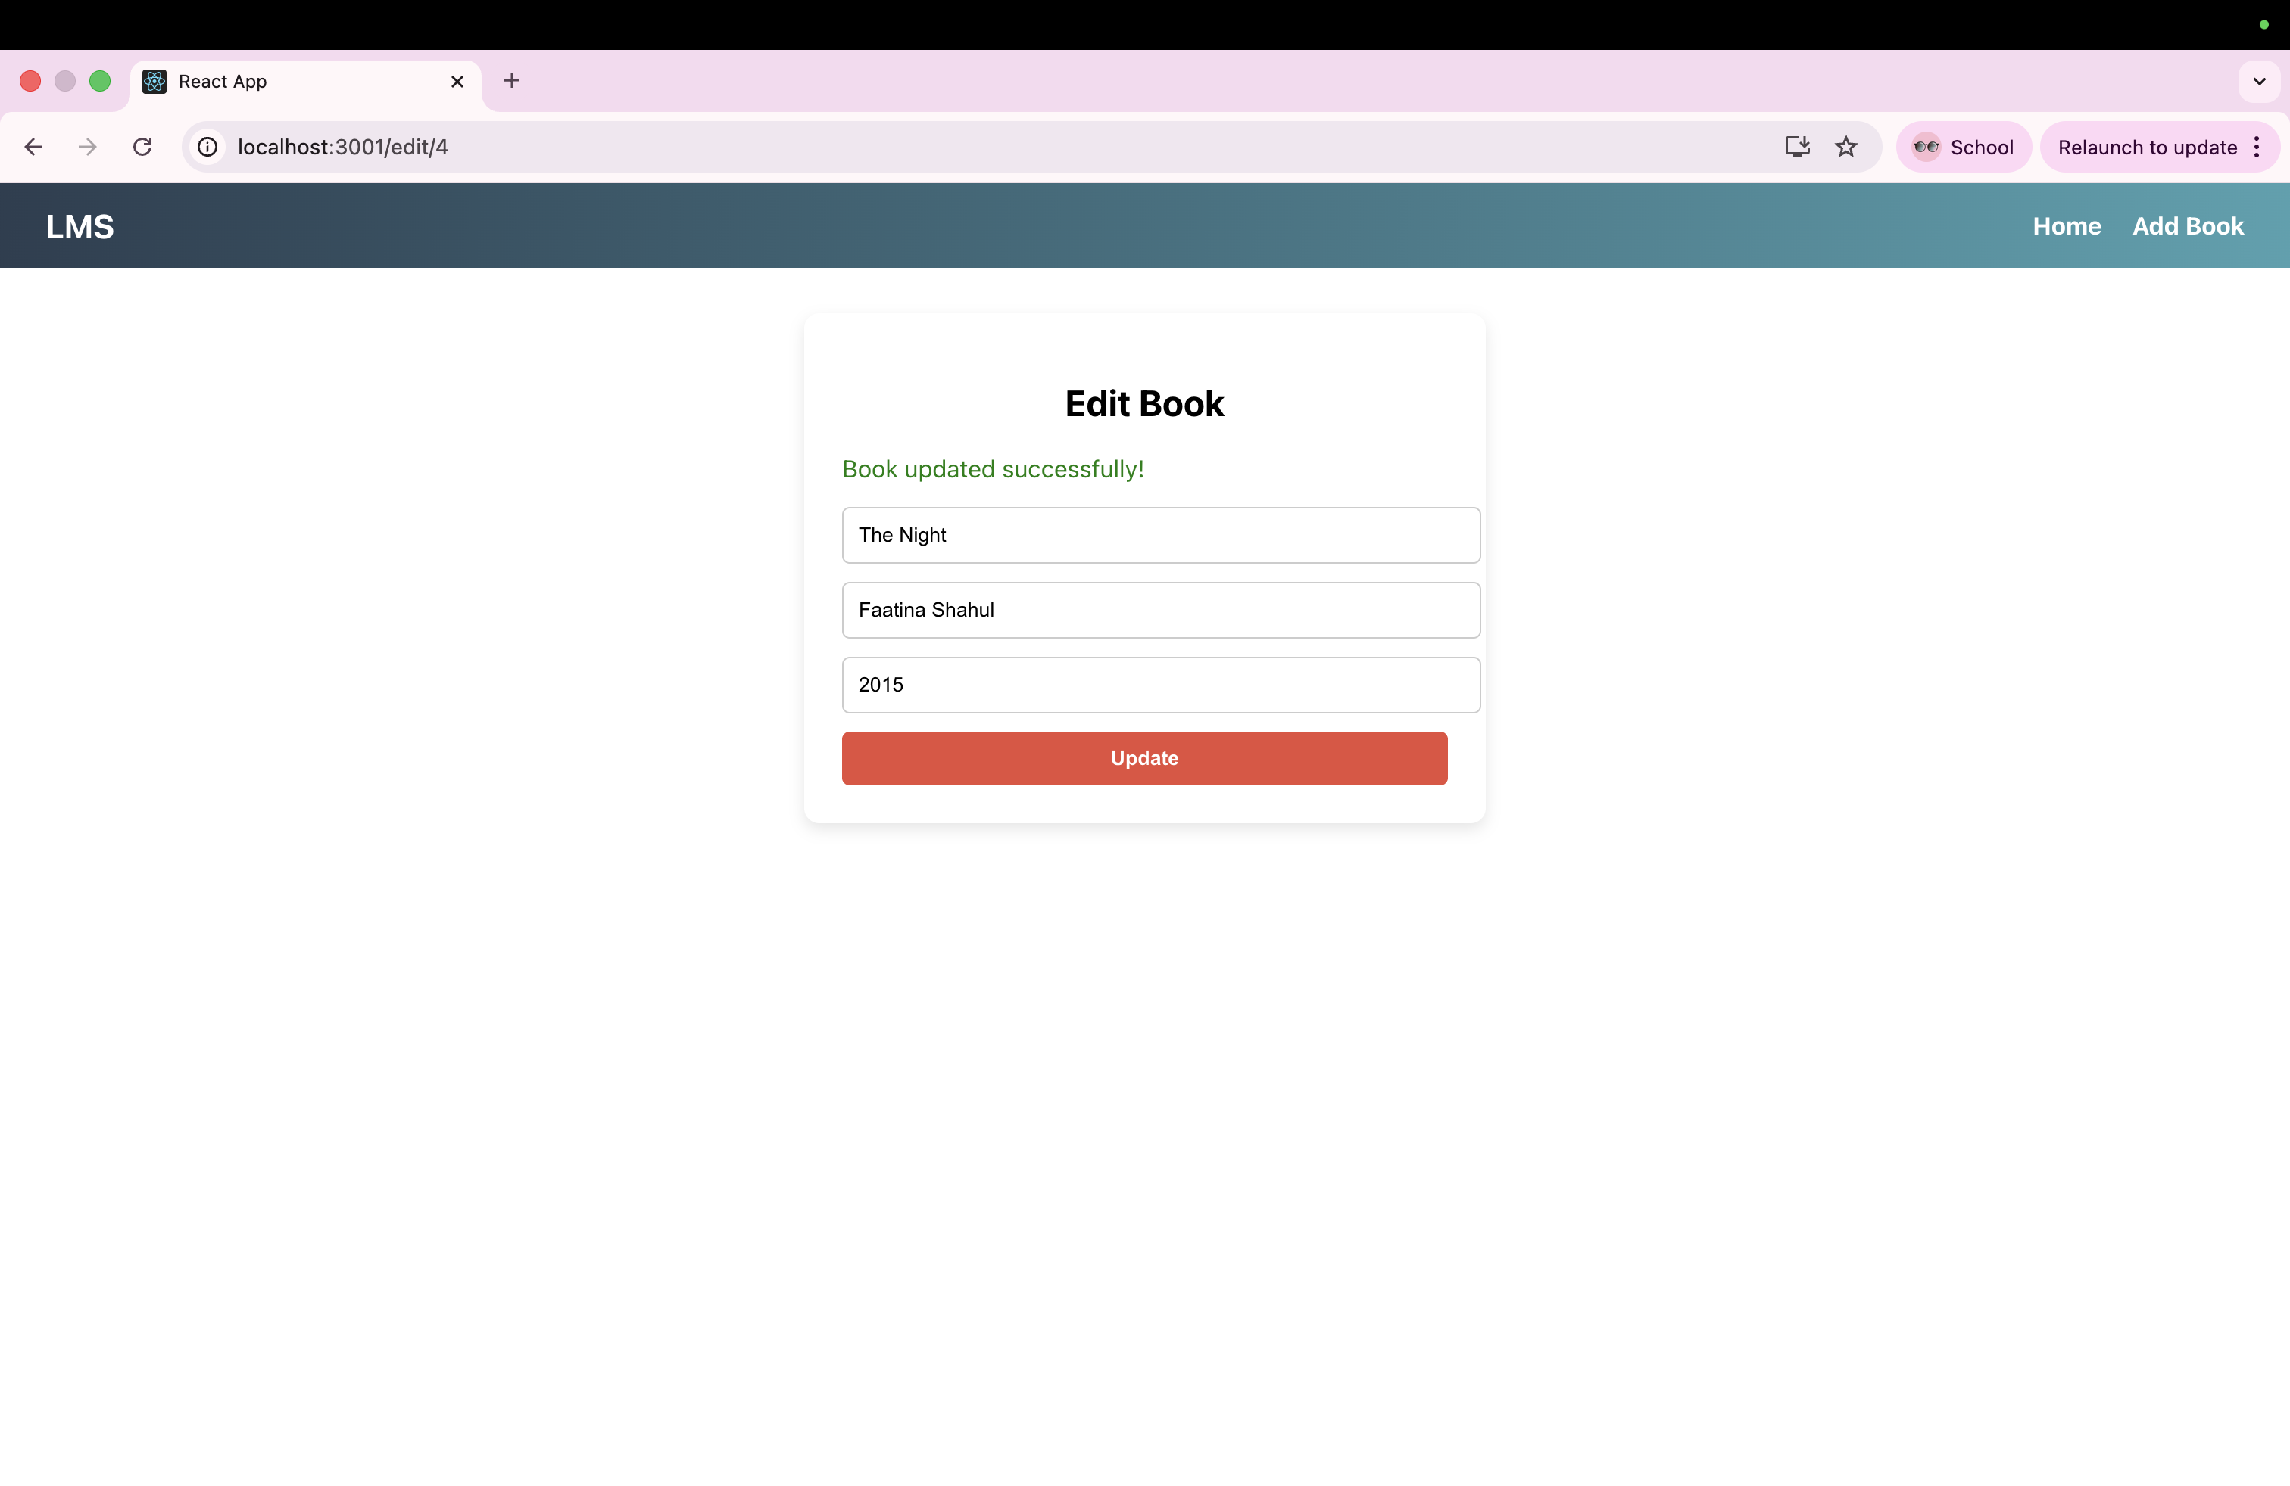

Deleting the book “The Night”
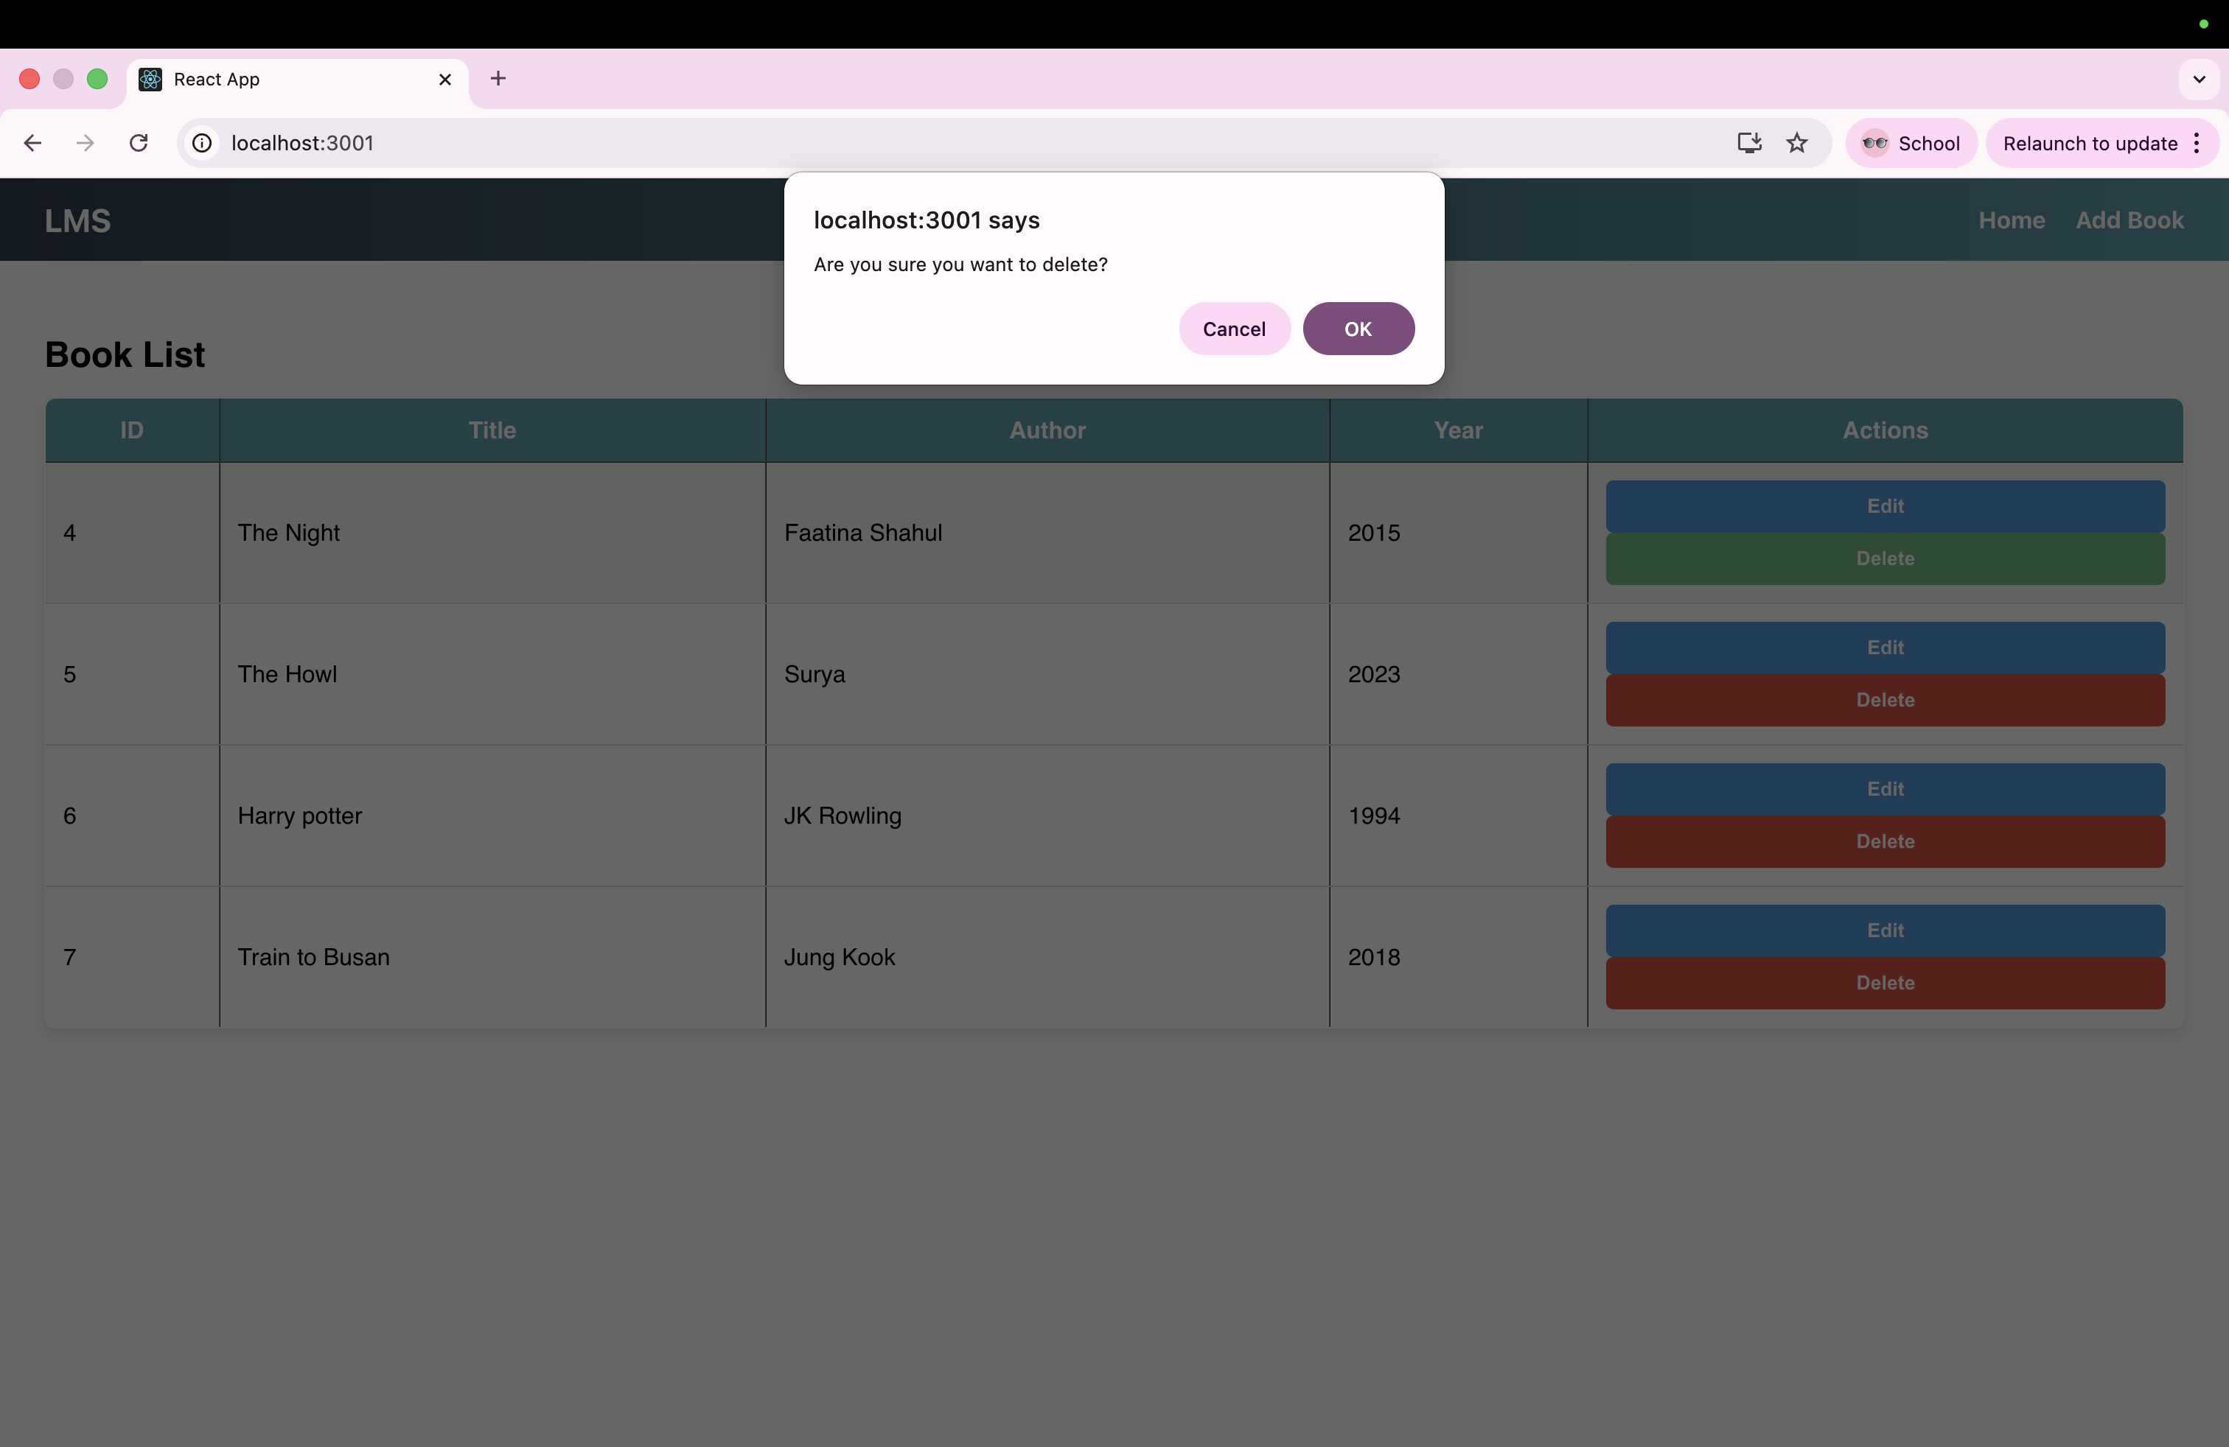
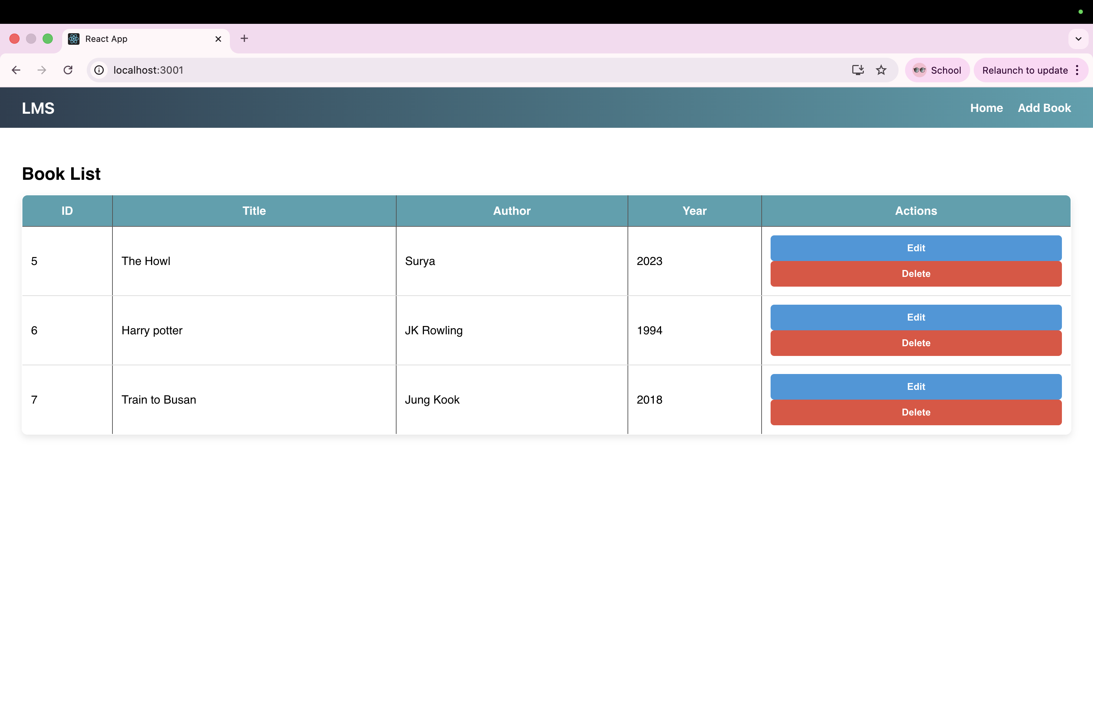
LEARNING OUTCOME
- Developed a full-stack application integrating React, Node.js, and MySQL for managing library records.
- Implemented CRUD operations using RESTful APIs to add, view, update, and delete book details.
- Designed and navigated multiple React components using React Router for smooth user interaction.
- Connected the frontend with backend services using Axios to handle asynchronous data exchange.
- Ensured dynamic UI updates and basic error handling to reflect changes immediately after operations.

