DATE: 19/01/2026 NAME: Faatina S
EX NO :3 REG NO :3122 23 5001 046

UCS2612 & Machine Learning Laboratory
Experiment 3: Email Spam or Ham Classification using Naive Bayes, KNN, and SVM

Aim
To classify emails as Spam or Ham using Naive Bayes, K-Nearest Neighbors (KNN), and Support Vector Machine (SVM) algorithms and evaluate their performance using accuracy metrics, ROC analysis, and K-Fold Cross-Validation.

Libraries Used
- NumPy – numerical computations
- Pandas – data loading and manipulation
- Matplotlib – data visualization
- Seaborn – statistical plots
- Scikit-learn
  - Data preprocessing (StandardScaler, MinMaxScaler)
  - Model building (Naïve Bayes, KNN, SVM)
  - Model evaluation (accuracy, precision, recall, F1-score, ROC, AUC)
  - Cross-validation (KFold, cross_val_score)

Objective
- To load and preprocess the Spambase email dataset.
- To perform exploratory data analysis to understand class distribution and feature behavior.
- To implement Naïve Bayes (Gaussian, Multinomial, Bernoulli), KNN, and SVM classifiers.
- To evaluate the models using Accuracy, Precision, Recall, F1-Score, Confusion Matrix, and ROC Curve.
- To compare the models using 5-Fold Cross-Validation and training time.
- To identify the best performing model for email spam classification.
Code
mport pandas as pd
#LOADING THE DATASET
df=pd.read_csv("spambase_csv.csv")
df.info()
RangeIndex: 4601 entries, 0 to 4600
Data columns (total 58 columns):
5 rows × 58 columns

df.isnull().sum()
word_freq_make 0
word_freq_address 0
word_freq_all 0
word_freq_3d 0
word_freq_our 0
word_freq_over 0
word_freq_remove 0
word_freq_internet 0
word_freq_order 0
word_freq_mail 0
word_freq_receive 0
word_freq_will 0
word_freq_people 0
word_freq_report 0
word_freq_addresses 0
word_freq_free 0
word_freq_business 0
word_freq_email 0
word_freq_you 0
word_freq_credit 0
word_freq_your 0
word_freq_font 0
word_freq_000 0
word_freq_money 0
word_freq_hp 0
word_freq_hpl 0
word_freq_george 0
word_freq_650 0
word_freq_lab 0
word_freq_labs 0
word_freq_telnet 0
word_freq_857 0
word_freq_data 0
word_freq_415 0
word_freq_85 0
word_freq_technology 0
word_freq_1999 0
word_freq_parts 0
word_freq_pm 0
word_freq_direct 0
word_freq_cs 0
word_freq_meeting 0
word_freq_original 0
word_freq_project 0
word_freq_re 0
word_freq_edu 0
word_freq_table 0
word_freq_conference 0
char_freq_%3B 0
char_freq_%28 0
char_freq_%5B 0
char_freq_%21 0
char_freq_%24 0
char_freq_%23 0
capital_run_length_average 0
capital_run_length_longest 0
capital_run_length_total 0
class 0
dtype: int64

df.columns
Index(['word_freq_make', 'word_freq_address', 'word_freq_all', 'word_freq_3d',
'word_freq_our', 'word_freq_over', 'word_freq_remove',
'word_freq_internet', 'word_freq_order', 'word_freq_mail',
'word_freq_receive', 'word_freq_will', 'word_freq_people',
'word_freq_report', 'word_freq_addresses', 'word_freq_free',
'word_freq_business', 'word_freq_email', 'word_freq_you',
'word_freq_credit', 'word_freq_your', 'word_freq_font', 'word_freq_000',
'word_freq_money', 'word_freq_hp', 'word_freq_hpl', 'word_freq_george',
'word_freq_650', 'word_freq_lab', 'word_freq_labs', 'word_freq_telnet',
'word_freq_857', 'word_freq_data', 'word_freq_415', 'word_freq_85',
'word_freq_technology', 'word_freq_1999', 'word_freq_parts',
'word_freq_pm', 'word_freq_direct', 'word_freq_cs', 'word_freq_meeting',
'word_freq_original', 'word_freq_project', 'word_freq_re',
'word_freq_edu', 'word_freq_table', 'word_freq_conference',
'char_freq_%3B', 'char_freq_%28', 'char_freq_%5B', 'char_freq_%21',
'char_freq_%24', 'char_freq_%23', 'capital_run_length_average',
'capital_run_length_longest', 'capital_run_length_total', 'class'],
dtype='object')

#FEATURES
x=df.drop(["class","capital_run_length_average","capital_run_length_longest","capital_run_length_total"],axis=1)
y=df["class"]

#Normalizing or standardizing the features
from sklearn.preprocessing import StandardScaler,MinMaxScaler
scaler=StandardScaler()
x_scaled=scaler.fit_transform(x,y)

import matplotlib.pyplot as plt
import seaborn as sns
sns.countplot(x="class",data=df)
plt.title("Spam Distribution")
plt.show()

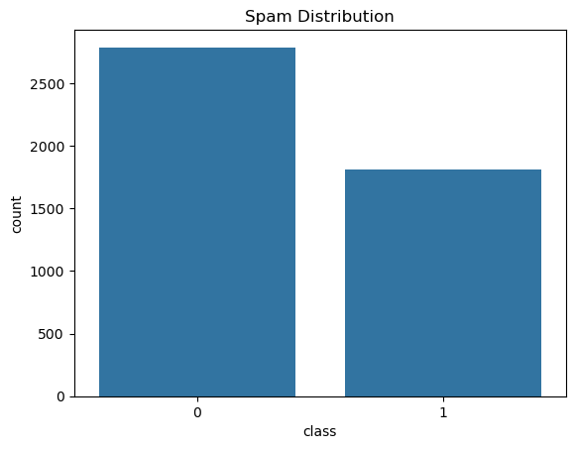

sns.histplot(df["word_freq_free"],kde="true")
plt.title("FREE WORD HISTOGRAM DISTRIBUTION")
plt.show()
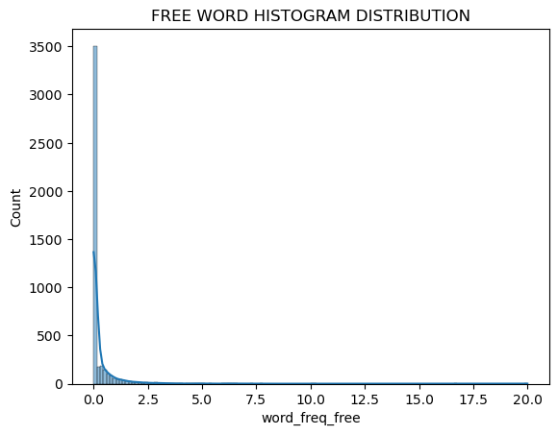
sns.scatterplot(data=df,x="word_freq_free",y="word_freq_money",hue="class")
plt.title("FREE WORD vs MONEY WORD")
plt.show()

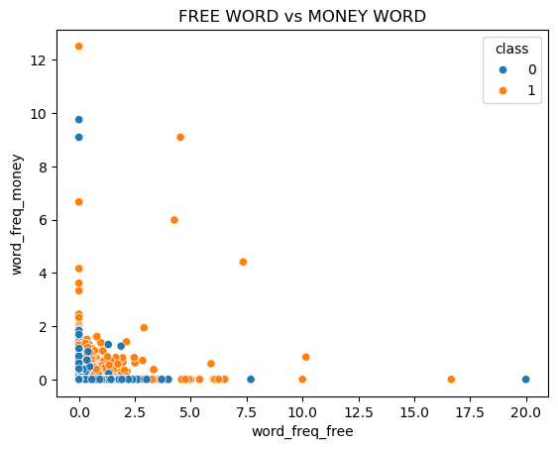

sns.boxplot(x="class",y="word_freq_order",data=df)
plt.title("BOX PLOT")
plt.show()

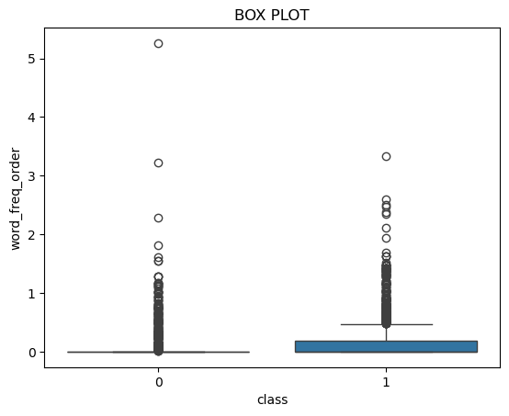

#splitting data
from sklearn.model_selection import train_test_split
x_train,x_test,y_train,y_test=train_test_split(x_scaled,y,test_size=0.2,random_state=42)

#class balance
import numpy as np
np.bincount(y_train)
array([2257, 1423])

#Training the models
#Naıve Bayes (Gaussian, Multinomial, Bernoulli)

from sklearn.naive_bayes import GaussianNB, MultinomialNB, BernoulliNB
from sklearn.metrics import accuracy_score, precision_score, recall_score, f1_score,confusion_matrix,roc_curve,auc
result={}

mm=MinMaxScaler()
x_train_mm=mm.fit_transform(x_train)
x_test_mm=mm.transform(x_test)

for name,model in {("Gaussian",GaussianNB()),("Multinomial",MultinomialNB()),("Bernoulli",BernoulliNB())}:
if name=="Multinomial":
train,test=x_train_mm,x_test_mm
else:
train,test=x_train,x_test
model.fit(train,y_train)
y_pred=model.predict(test)

#Accuracy, Precision, Recall, F1-score
result[name]={"accuracy": accuracy_score(y_test, y_pred),"precision": precision_score(y_test, y_pred),"recall": recall_score(y_test, y_pred),"f1": f1_score(y_test, y_pred)}

#Confusion Matrix
print("Confusion Matrix:",name)
cm=confusion_matrix(y_test, y_pred)
print(cm)

#roc curve
y_prob= model.predict_proba(test)[:,1]
fpr,tpr,_=roc_curve(y_test,y_prob)
roc=auc(fpr,tpr)

plt.plot(fpr,tpr,label="ROC CURVE" + str(round(roc,4)))
plt.plot([0,1],[0,1],'--')
plt.xlabel("False positive rate")
plt.ylabel("True positive rate")
plt.title("ROC CURVE")
plt.legend()
plt.show()

pd.DataFrame(result)

Confusion Matrix: Gaussian
[[384 147]
[ 24 366]]

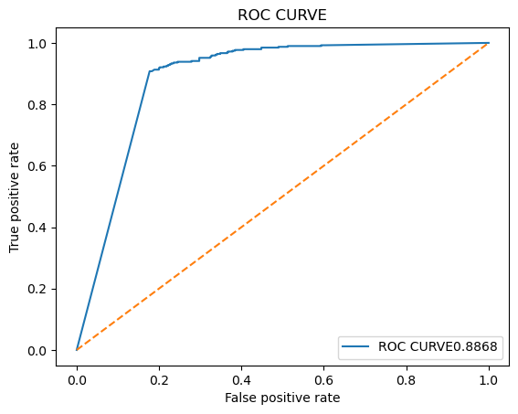
Confusion Matrix: Bernoulli
[[506 25]
[ 64 326]]

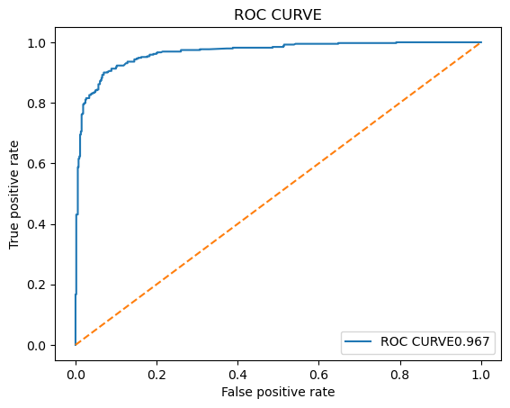
Confusion Matrix: Multinomial
[[515 16]
[ 95 295]]

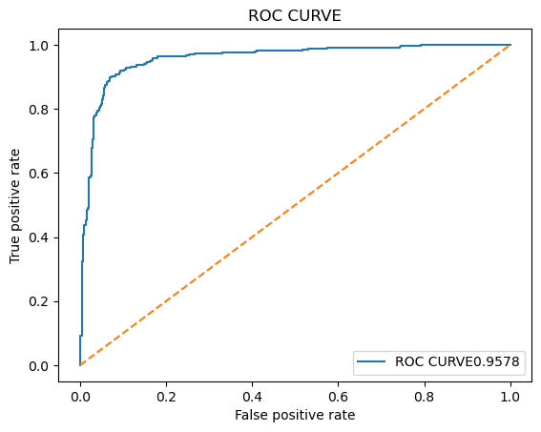
Naıve Bayes Variant Comparison
TABLE 1 : Performance Comparison of Naıve Bayes Variants
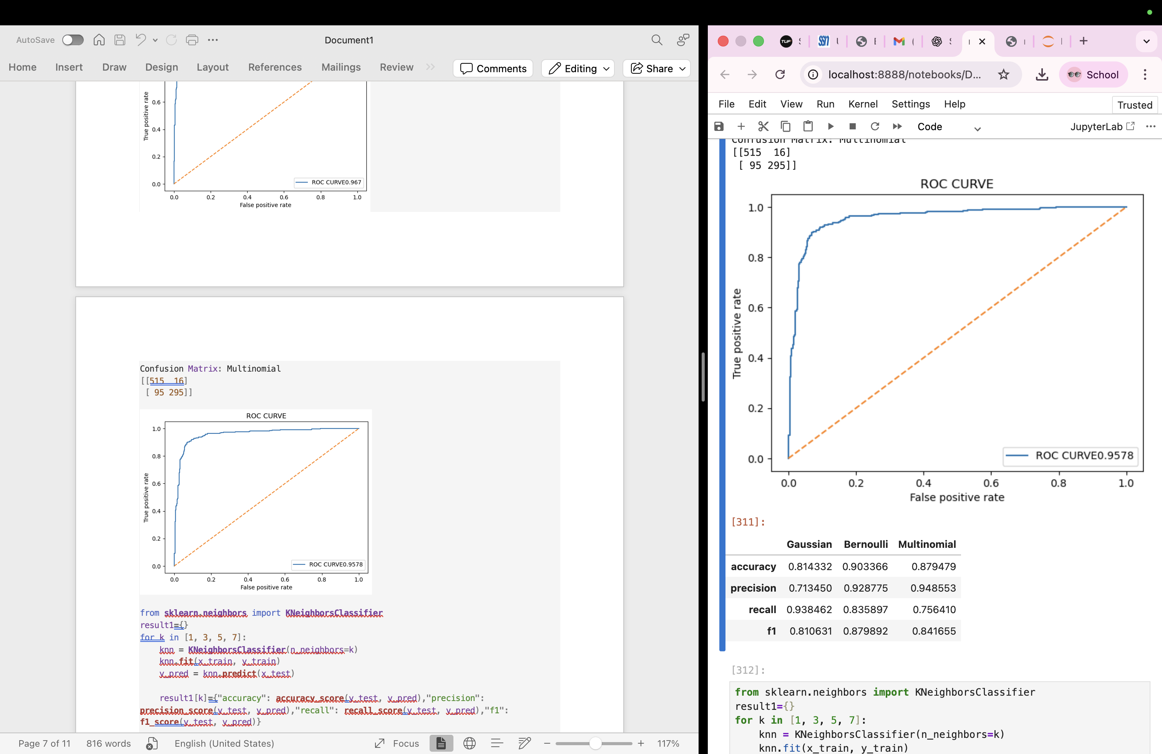
from sklearn.neighbors import KNeighborsClassifier
result1={}
for k in [1, 3, 5, 7]:
knn = KNeighborsClassifier(n_neighbors=k)
knn.fit(x_train, y_train)
y_pred = knn.predict(x_test)

result1[k]={"accuracy": accuracy_score(y_test, y_pred),"precision": precision_score(y_test, y_pred),"recall": recall_score(y_test, y_pred),"f1": f1_score(y_test, y_pred)}

print(k)
cm=confusion_matrix(y_test, y_pred)
sns.heatmap(cm, annot=True, fmt="d")
plt.show()

#roc curve
y_prob= model.predict_proba(x_test)[:,1]
fpr,tpr,_=roc_curve(y_test,y_prob)
roc=auc(fpr,tpr)

plt.plot(fpr,tpr,label="ROC CURVE" + str(round(roc,4)))
plt.plot([0,1],[0,1],'--')
plt.xlabel("False positive rate")
plt.ylabel("True positive rate")
plt.title("ROC CURVE")
plt.legend()
plt.show()
pd.DataFrame(result1)

1

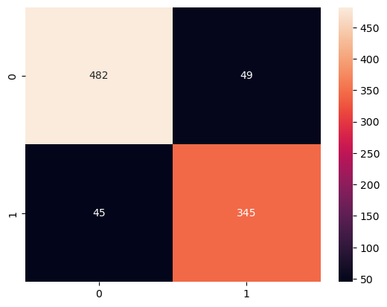

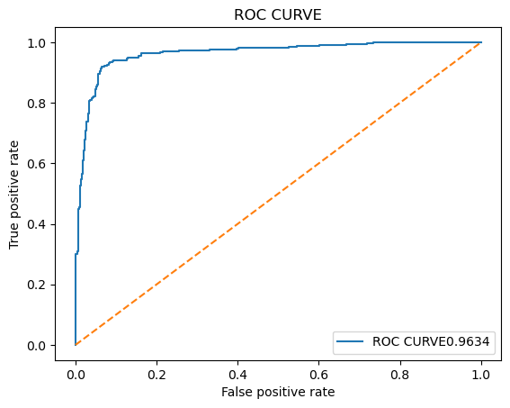

3
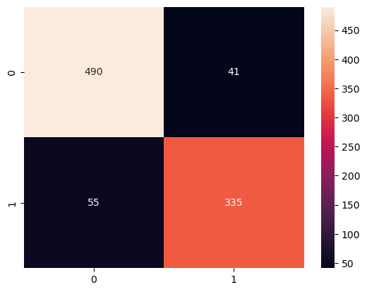



5
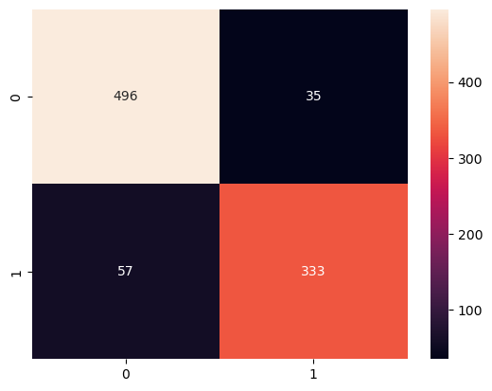


7
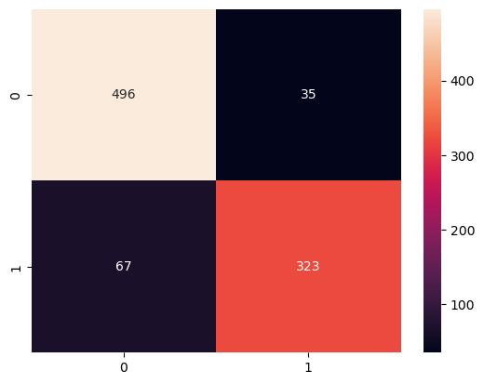



KNN: Varying k Values

TABLE 2: KNN Performance for Different k Values

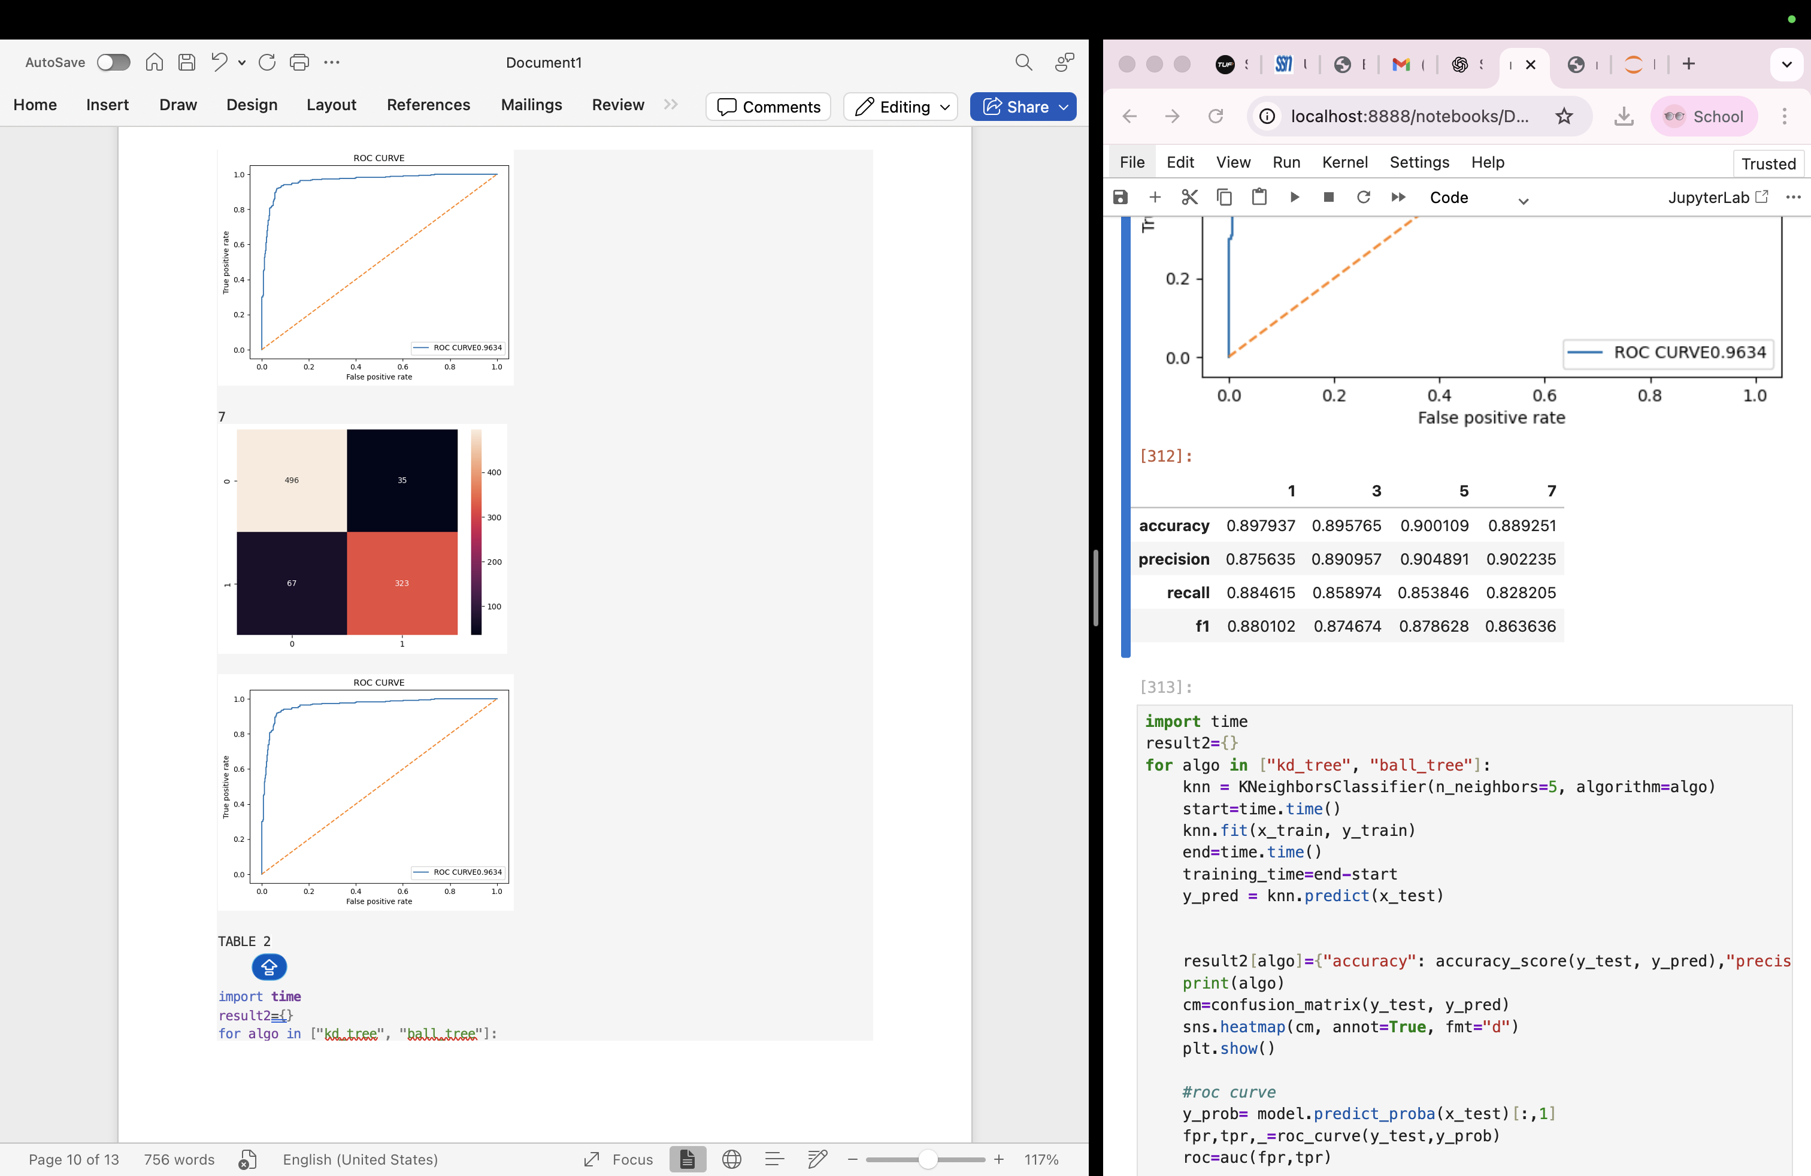

import time
result2={}
for algo in ["kd_tree", "ball_tree"]:
knn = KNeighborsClassifier(n_neighbors=5, algorithm=algo)
start=time.time()
knn.fit(x_train, y_train)
end=time.time()
training_time=end-start
y_pred = knn.predict(x_test)

result2[algo]={"accuracy": accuracy_score(y_test, y_pred),"precision": precision_score(y_test, y_pred),"recall": recall_score(y_test, y_pred),"f1": f1_score(y_test, y_pred),"Training time(s)":training_time}
print(algo)
cm=confusion_matrix(y_test, y_pred)
sns.heatmap(cm, annot=True, fmt="d")
plt.show()

#roc curve
y_prob= model.predict_proba(x_test)[:,1]
fpr,tpr,_=roc_curve(y_test,y_prob)
roc=auc(fpr,tpr)

plt.plot(fpr,tpr,label="ROC CURVE" + str(round(roc,4)))
plt.plot([0,1],[0,1],'--')
plt.xlabel("False positive rate")
plt.ylabel("True positive rate")
plt.title("ROC CURVE")
plt.legend()
plt.show()
pd.DataFrame(result2)

kd_tree





ball_tree

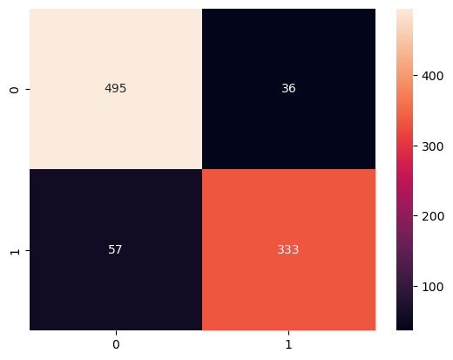

KNN: KDTree vs BallTree
TABLE 3 : KNN Comparison: KDTree vs BallTree
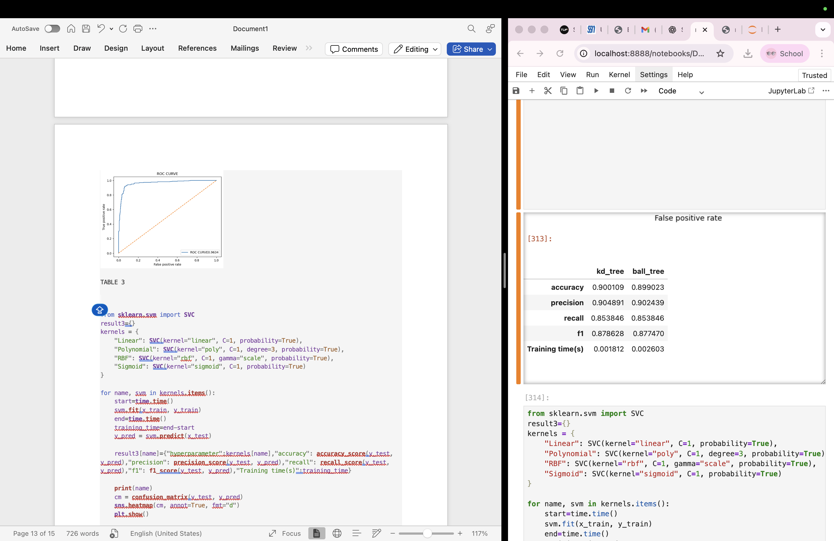
from sklearn.svm import SVC
result3={}
kernels = {
"Linear": SVC(kernel="linear", C=1, probability=True),
"Polynomial": SVC(kernel="poly", C=1, degree=3, probability=True),
"RBF": SVC(kernel="rbf", C=1, gamma="scale", probability=True),
"Sigmoid": SVC(kernel="sigmoid", C=1, probability=True)
}

for name, svm in kernels.items():
start=time.time()
svm.fit(x_train, y_train)
end=time.time()
training_time=end-start
y_pred = svm.predict(x_test)

result3[name]={"hyperparameter":kernels[name],"accuracy": accuracy_score(y_test, y_pred),"precision": precision_score(y_test, y_pred),"recall": recall_score(y_test, y_pred),"f1": f1_score(y_test, y_pred),"Training time(s)":training_time}

print(name)
cm = confusion_matrix(y_test, y_pred)
sns.heatmap(cm, annot=True, fmt="d")
plt.show()

#roc curve
y_prob= model.predict_proba(x_test)[:,1]
fpr,tpr,_=roc_curve(y_test,y_prob)
roc=auc(fpr,tpr)

plt.plot(fpr,tpr,label="ROC CURVE" + str(round(roc,4)))
plt.plot([0,1],[0,1],'--')
plt.xlabel("False positive rate")
plt.ylabel("True positive rate")
plt.title("ROC CURVE")
plt.legend()
plt.show()
pd.DataFrame(result3)

Linear
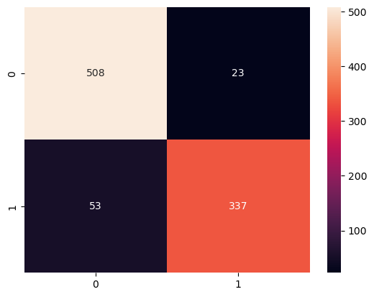



Polynomial

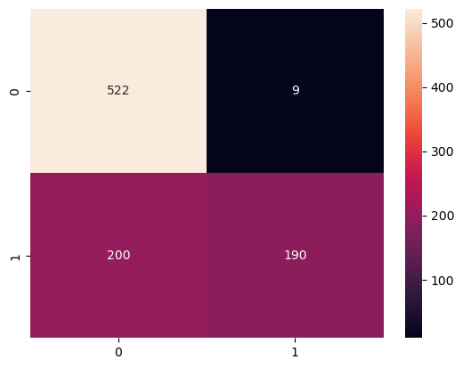



RBF

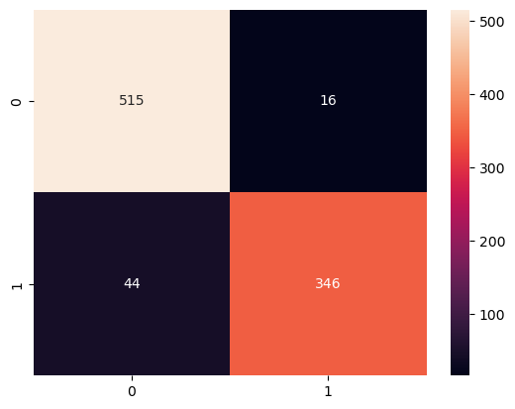



Sigmoid

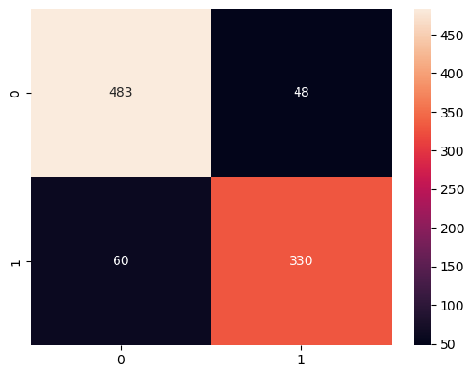



SVM Kernel-wise Results

TABLE 4: SVM Performance with Different Kernels and Parameters
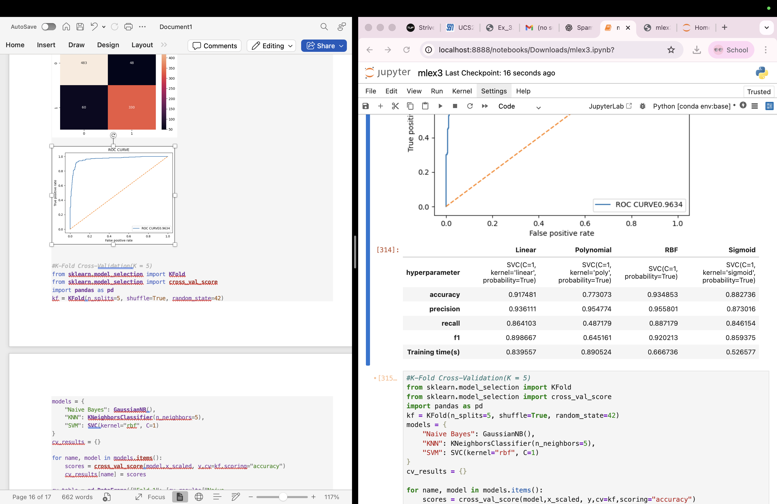

#K-Fold Cross-Validation(K = 5)
from sklearn.model_selection import KFold
from sklearn.model_selection import cross_val_score
import pandas as pd
kf = KFold(n_splits=5, shuffle=True, random_state=42)
models = {
"Naive Bayes": GaussianNB(),
"KNN": KNeighborsClassifier(n_neighbors=5),
"SVM": SVC(kernel="rbf", C=1)
}
cv_results = {}

for name, model in models.items():
scores = cross_val_score(model,x_scaled, y,cv=kf,scoring="accuracy")
cv_results[name] = scores

cv_table = pd.DataFrame({"Fold 1": [cv_results["Naive Bayes"][0],cv_results["KNN"][0],cv_results["SVM"][0]],
"Fold 2": [cv_results["Naive Bayes"][1],cv_results["KNN"][1],cv_results["SVM"][1]],
"Fold 3": [cv_results["Naive Bayes"][2],cv_results["KNN"][2],cv_results["SVM"][2]],
"Fold 4": [cv_results["Naive Bayes"][3],cv_results["KNN"][3],cv_results["SVM"][3]],
"Fold 5": [cv_results["Naive Bayes"][4],cv_results["KNN"][4],cv_results["SVM"][4]],
"Average": [cv_results["Naive Bayes"].mean(),cv_results["KNN"].mean(),cv_results["SVM"].mean()]
},
index=["Naive Bayes", "KNN", "SVM"])
print(cv_table.T)

K-Fold Cross-Validation Results (K = 5)

Table 5: Cross-Validation Scores for Each Model

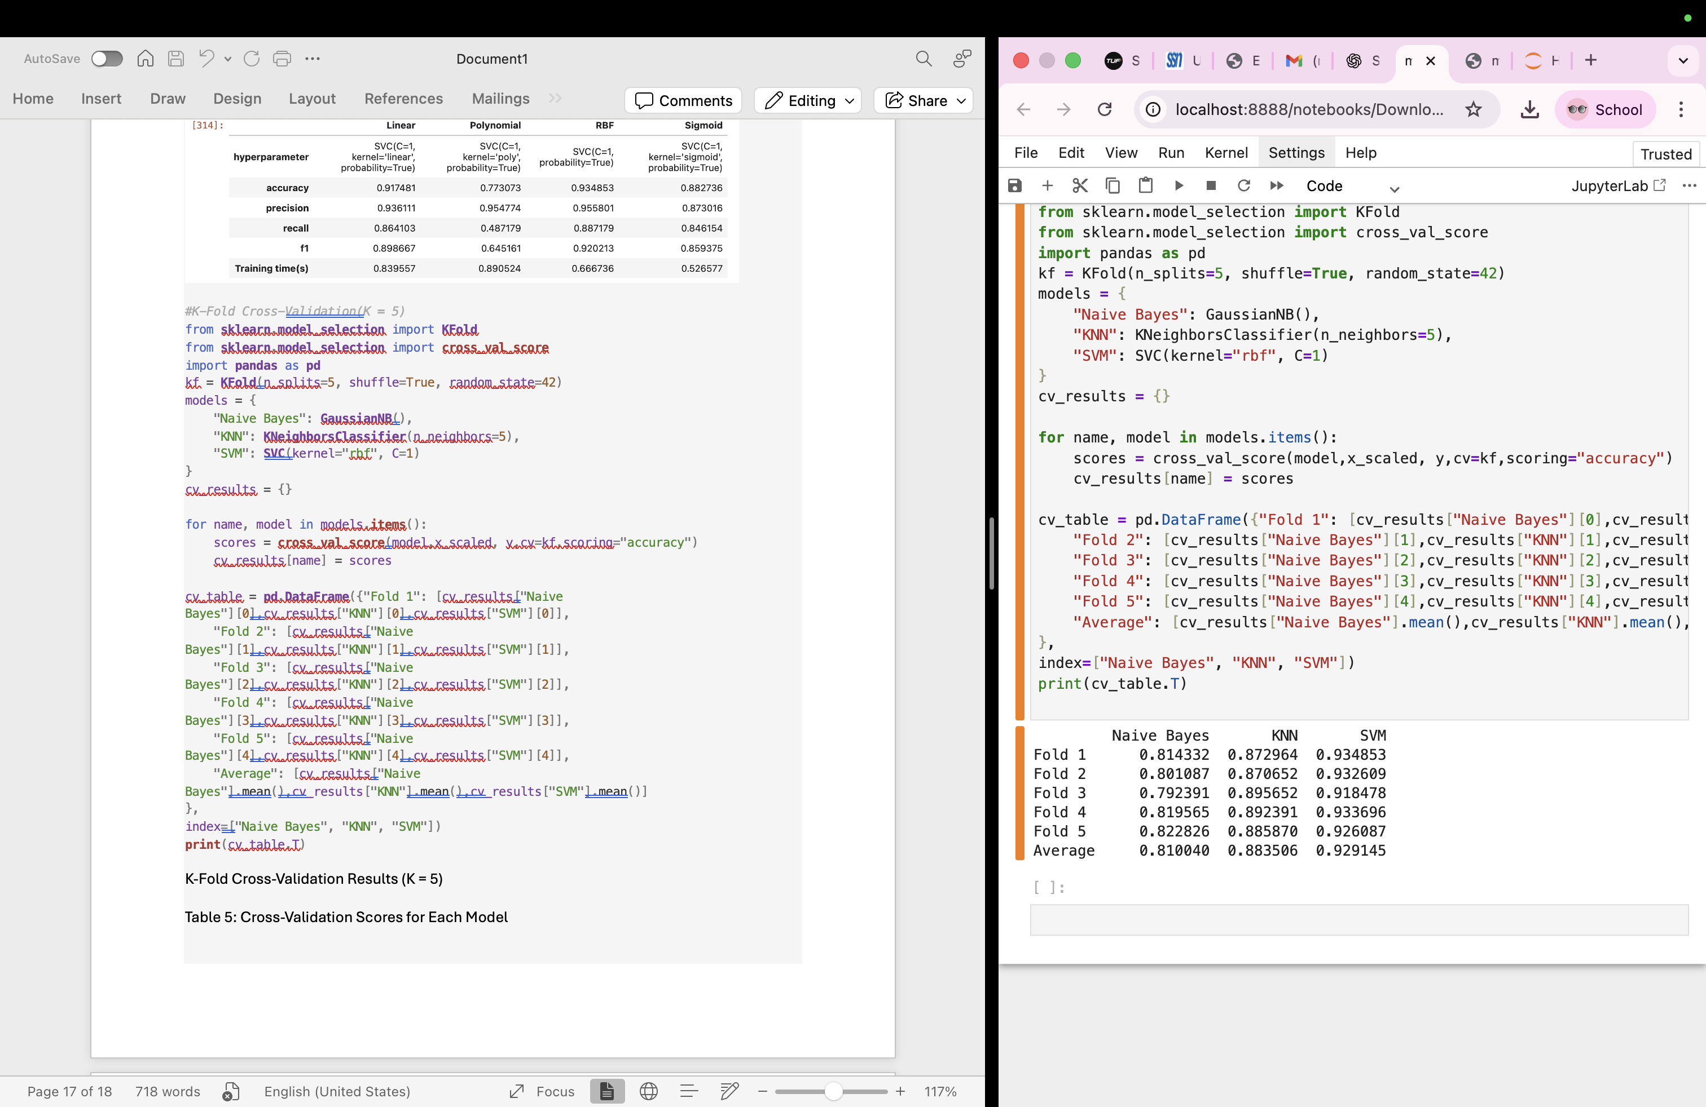

Observations

1. Which classifier had the best average accuracy?
Support Vector Machine (SVM) achieved the best average accuracy.

2. Which Naive Bayes variant worked best?
Bernoulli performed the best.

3. How did KNN accuracy vary with k and tree type?
Accuracy increased up to k = 5 and then slightly decreased; KDTree and BallTree showed similar accuracy.

4. Which SVM kernel was most effective?
The RBF kernel was the most effective.

5. How did hyperparameters influence performance?
Proper hyperparameter selection improved accuracy and reduced overfitting.

Conclusion
The experiment successfully demonstrated email spam classification using multiple machine learning algorithms. Among the models evaluated, Support Vector Machine (RBF kernel) achieved the best overall performance in terms of accuracy and ROC-AUC score. Gaussian Naïve Bayes provided fast and reliable baseline performance, while KNN showed competitive results with optimal parameter selection. Cross-validation results confirmed that the models generalize well to unseen data.

