DATE: 27/02/2026 NAME: Faatina S
EX NO: 4 REG NO :3122 23 5001 046

UCS2612 & Machine Learning Laboratory
Experiment 4: Ensemble Prediction and Decision Tree Model Evaluation

Objective
To build classifiers such as Decision Tree, AdaBoost, Gradient Boosting, XGBoost, Random Forest, and Stacked Models and evaluate their performance through 5-Fold Cross-Validation and hyperparameter tuning.

Aim
The aim of this experiment is to build and evaluate Decision Tree and Ensemble Learning models such as AdaBoost, Gradient Boosting, XGBoost, Random Forest, and Stacked Ensemble on a binary classification dataset. The objective is to compare their performance using hyperparameter tuning, 5-fold cross-validation, confusion matrices, ROC curves, and accuracy metrics to identify the best-performing model.

Libraries Used
- NumPy
- Pandas
- Matplotlib
- Scikit-learn
- XGBoost
CODE
import pandas as pd
df=pd.read_csv("wdbc.data")
df.tail(5)

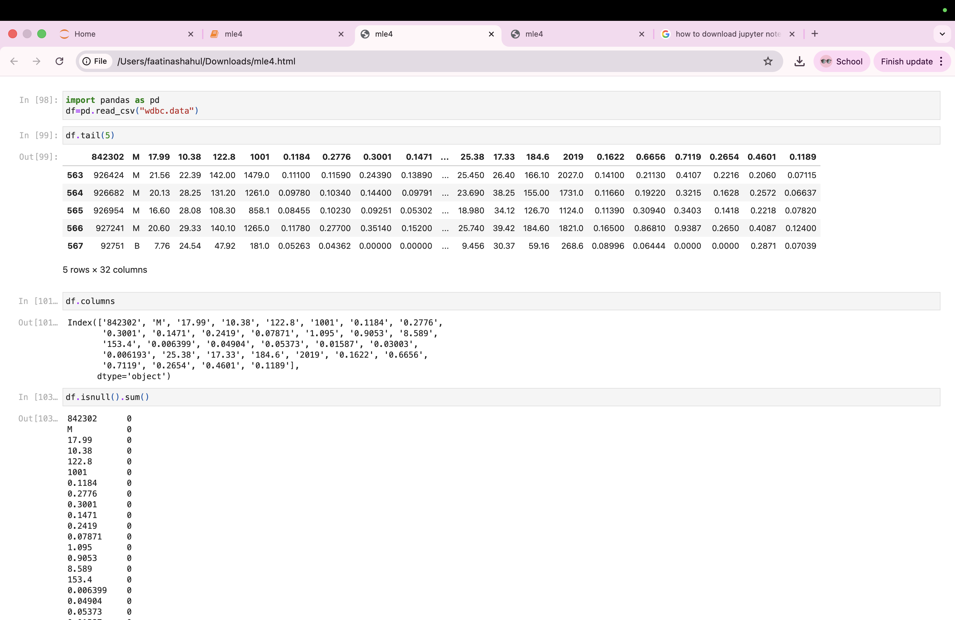

df.columns
Index(['842302', 'M', '17.99', '10.38', '122.8', '1001', '0.1184', '0.2776',
'0.3001', '0.1471', '0.2419', '0.07871', '1.095', '0.9053', '8.589',
'153.4', '0.006399', '0.04904', '0.05373', '0.01587', '0.03003',
'0.006193', '25.38', '17.33', '184.6', '2019', '0.1622', '0.6656',
'0.7119', '0.2654', '0.4601', '0.1189'],
dtype='object')

df.isnull().sum()

x=df.drop("M",axis=1)
y=df["M"]

import numpy as np
np.unique(y)
array(['B', 'M'], dtype=object)

from sklearn.preprocessing import LabelEncoder
le = LabelEncoder()
y = le.fit_transform(y)

#Normalizing or standardizing the features
from sklearn.preprocessing import StandardScaler
scaler=StandardScaler()
x_scaled=scaler.fit_transform(x,y)

import matplotlib.pyplot as plt
import seaborn as sns
sns.countplot(x="M",data=df)
plt.title("Class Distribution")
plt.show()

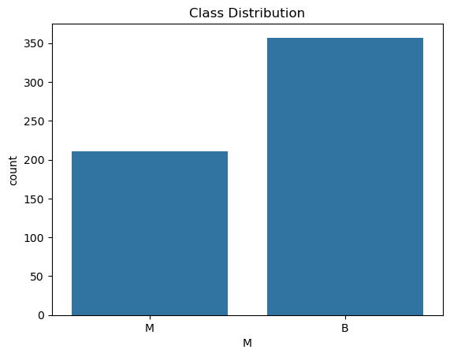
plt.figure(figsize=(10,8))
correlation_matrix=df.drop(columns='M').corr()
sns.heatmap(correlation_matrix,cmap="coolwarm",linewidths=0.2,cbar=True)
plt.title("Feature Correlation")
plt.show()

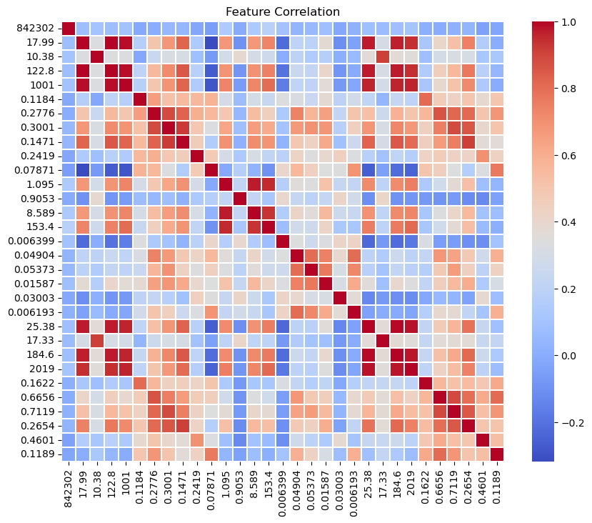
#splitting data
from sklearn.model_selection import train_test_split,GridSearchCV,cross_val_score
x_train,x_test,y_train,y_test=train_test_split(x_scaled,y,test_size=0.2,random_state=42)

#Decision Tree
from sklearn.tree import DecisionTreeClassifier
from IPython.display import display
dt = DecisionTreeClassifier(random_state=42)
dt_params = {
"criterion": ["gini", "entropy"],
"max_depth": [None, 5, 8, 10],
"min_samples_split": [2, 5],
"min_samples_leaf": [1, 2]
}
scoring = {"accuracy": "accuracy", "f1": "f1"}
dt_grid = GridSearchCV(
dt,
dt_params,
cv=5,
scoring=scoring,
refit="f1"
)
dt_grid.fit(x_train, y_train)
dt_results = pd.DataFrame(dt_grid.cv_results_)

dt_table = dt_results[
["param_criterion", "param_max_depth",
"mean_test_accuracy", "mean_test_f1"]
].rename(columns={
"param_criterion": "criterion",
"param_max_depth": "max_depth",
"mean_test_accuracy": "Accuracy",
"mean_test_f1": "F1 Score"
})
print("TABLE 1 – Decision Tree")
display(dt_table)

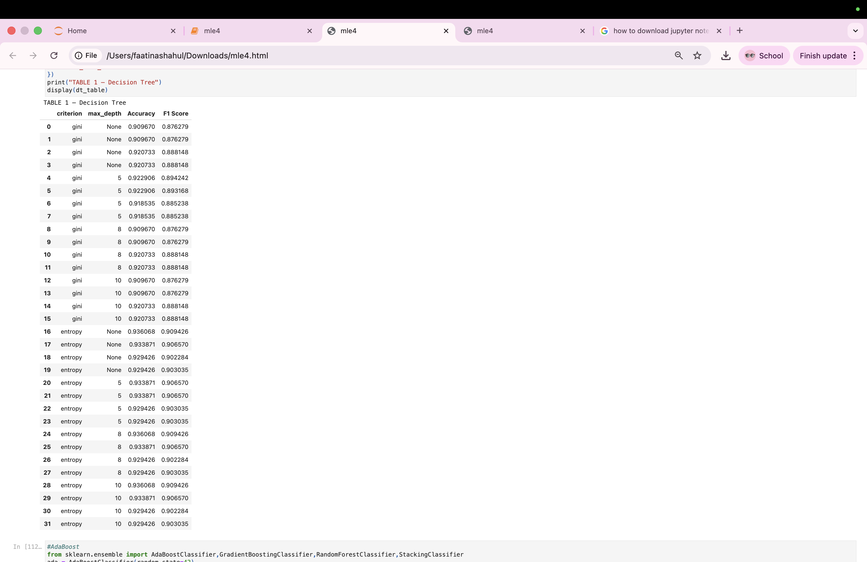

#AdaBoost
from sklearn.ensemble import AdaBoostClassifier,GradientBoostingClassifier,RandomForestClassifier,StackingClassifier
ada = AdaBoostClassifier(random_state=42)
ada_params = {
"n_estimators": [50, 100, 200],
"learning_rate": [0.01, 0.1, 1.0]
}
ada_grid = GridSearchCV(
ada,
ada_params,
cv=5,
scoring=scoring,
refit="f1"
)
ada_grid.fit(x_train, y_train)
ada_results = pd.DataFrame(ada_grid.cv_results_)
ada_table = ada_results[
["param_n_estimators", "param_learning_rate",
"mean_test_accuracy", "mean_test_f1"]
].rename(columns={
"param_n_estimators": "n_estimators",
"param_learning_rate": "learning_rate",
"mean_test_accuracy": "Accuracy",
"mean_test_f1": "F1 Score"
})
print("\nTABLE 2 – AdaBoost")
display(ada_table)

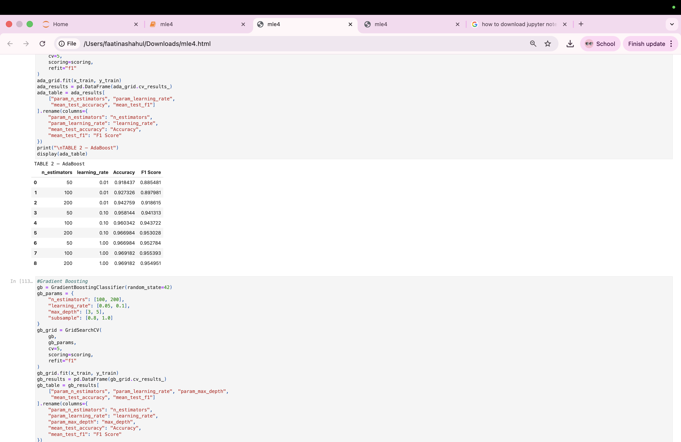
#Gradient Boosting
gb = GradientBoostingClassifier(random_state=42)
gb_params = {
"n_estimators": [100, 200],
"learning_rate": [0.05, 0.1],
"max_depth": [3, 5],
"subsample": [0.8, 1.0]
}
gb_grid = GridSearchCV(
gb,
gb_params,
cv=5,
scoring=scoring,
refit="f1"
)
gb_grid.fit(x_train, y_train)
gb_results = pd.DataFrame(gb_grid.cv_results_)
gb_table = gb_results[
["param_n_estimators", "param_learning_rate", "param_max_depth",
"mean_test_accuracy", "mean_test_f1"]
].rename(columns={
"param_n_estimators": "n_estimators",
"param_learning_rate": "learning_rate",
"param_max_depth": "max_depth",
"mean_test_accuracy": "Accuracy",
"mean_test_f1": "F1 Score"
})
print("\nTABLE 3 – Gradient Boosting")
display(gb_table)

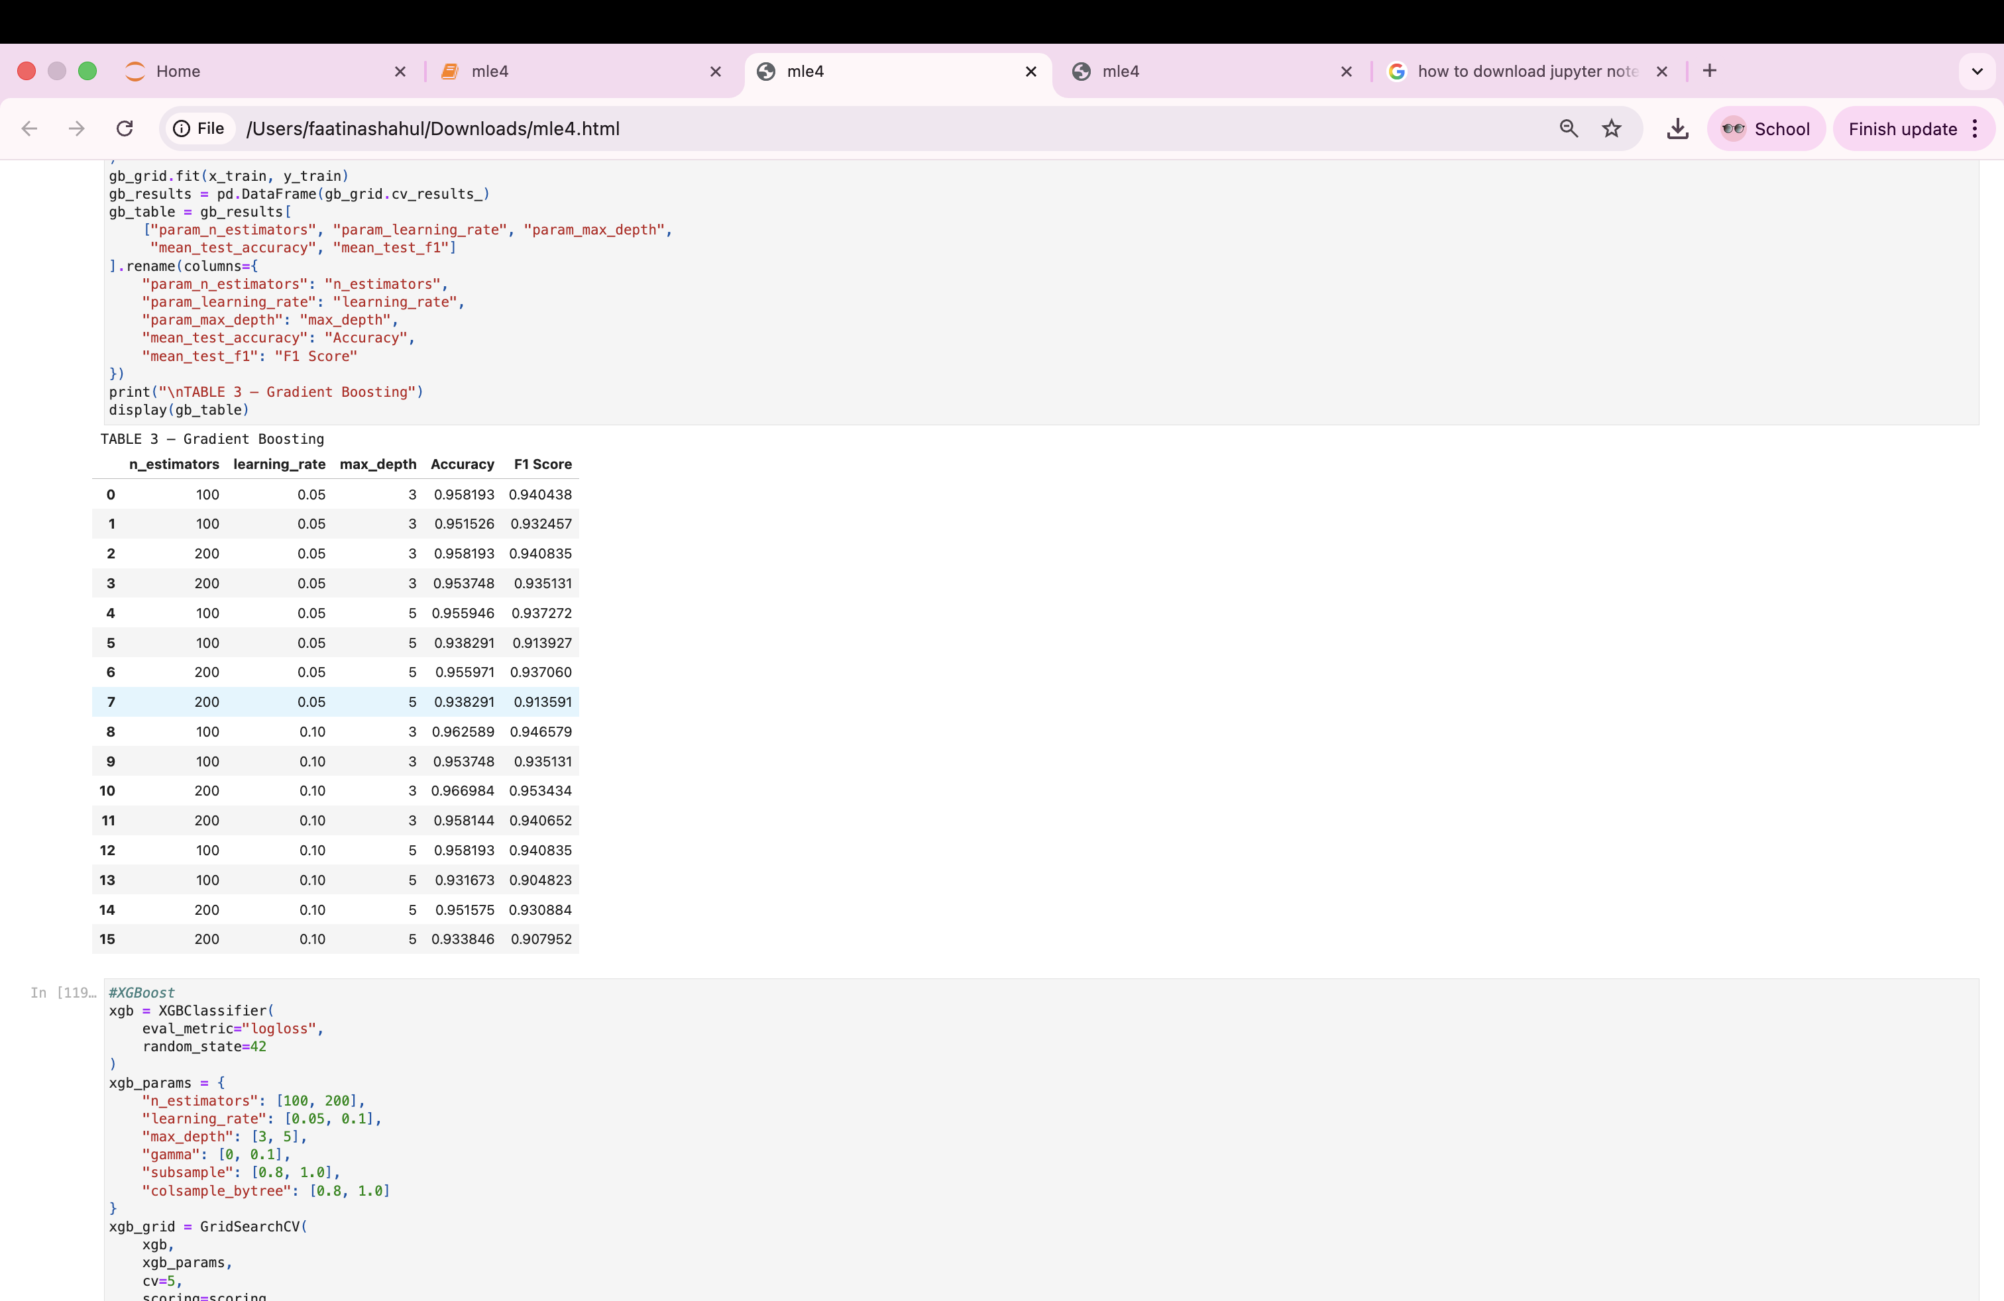
#XGBoost
xgb = XGBClassifier(
eval_metric="logloss",
random_state=42
)
xgb_params = {
"n_estimators": [100, 200],
"learning_rate": [0.05, 0.1],
"max_depth": [3, 5],
"gamma": [0, 0.1],
"subsample": [0.8, 1.0],
"colsample_bytree": [0.8, 1.0]
}
xgb_grid = GridSearchCV(
xgb,
xgb_params,
cv=5,
scoring=scoring,
refit="f1"
)
xgb_grid.fit(x_train, y_train)
xgb_results = pd.DataFrame(xgb_grid.cv_results_)
xgb_table = xgb_results[
["param_n_estimators", "param_learning_rate",
"param_max_depth", "param_gamma",
"mean_test_accuracy", "mean_test_f1"]
].rename(columns={
"param_n_estimators": "n_estimators",
"param_learning_rate": "learning_rate",
"param_max_depth": "max_depth",
"param_gamma": "gamma",
"mean_test_accuracy": "Accuracy",
"mean_test_f1": "F1 Score"
})
print("\nTABLE 4 – XGBoost")
display(xgb_table)

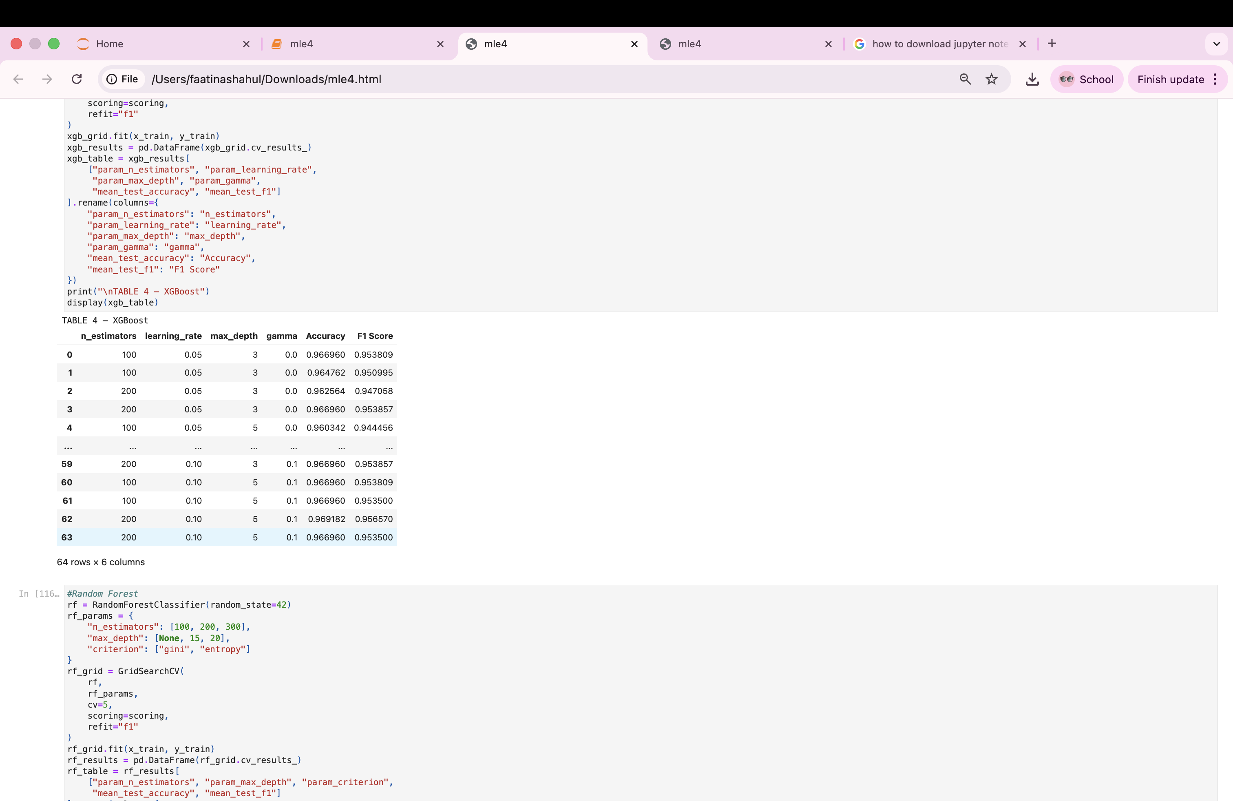
#Random Forest
rf = RandomForestClassifier(random_state=42)
rf_params = {
"n_estimators": [100, 200, 300],
"max_depth": [None, 15, 20],
"criterion": ["gini", "entropy"]
}
rf_grid = GridSearchCV(
rf,
rf_params,
cv=5,
scoring=scoring,
refit="f1"
)
rf_grid.fit(x_train, y_train)
rf_results = pd.DataFrame(rf_grid.cv_results_)
rf_table = rf_results[
["param_n_estimators", "param_max_depth", "param_criterion",
"mean_test_accuracy", "mean_test_f1"]
].rename(columns={
"param_n_estimators": "n_estimators",
"param_max_depth": "max_depth",
"param_criterion": "criterion",
"mean_test_accuracy": "Accuracy",
"mean_test_f1": "F1 Score"
})
print("\nTABLE 5 – Random Forest")
display(rf_table)

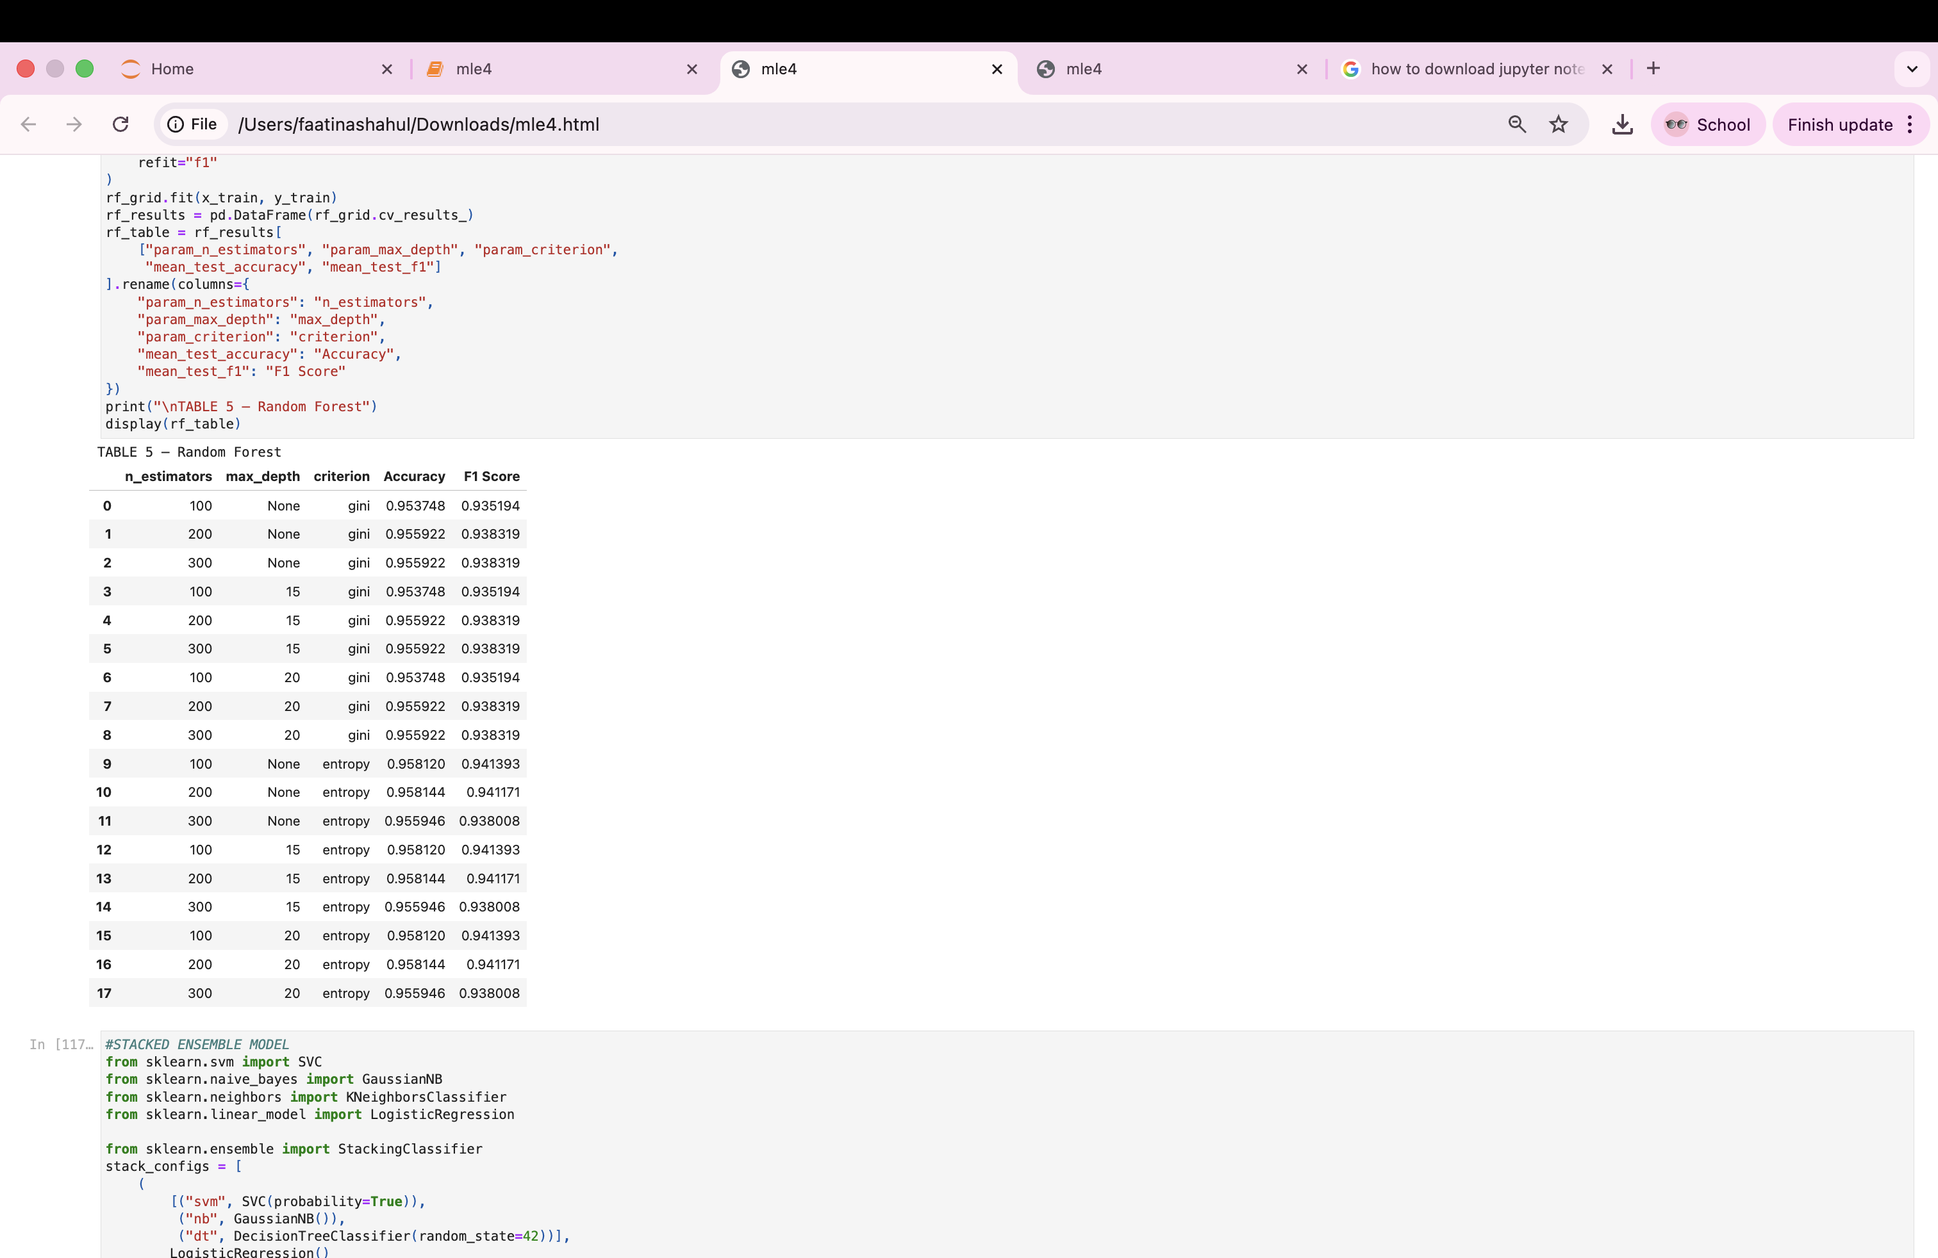

#STACKED ENSEMBLE MODEL
from sklearn.svm import SVC
from sklearn.naive_bayes import GaussianNB
from sklearn.neighbors import KNeighborsClassifier
from sklearn.linear_model import LogisticRegression

from sklearn.ensemble import StackingClassifier
stack_configs = [
(
[("svm", SVC(probability=True)),
("nb", GaussianNB()),
("dt", DecisionTreeClassifier(random_state=42))],
LogisticRegression()
),
(
[("svm", SVC(probability=True)),
("nb", GaussianNB()),
("dt", DecisionTreeClassifier(random_state=42))],
RandomForestClassifier(n_estimators=100, random_state=42)
),
(
[("svm", SVC(probability=True)),
("dt", DecisionTreeClassifier(random_state=42)),
("knn", KNeighborsClassifier())],
LogisticRegression()
)
]
stack_results = []
for base_models, final_model in stack_configs:
stack = StackingClassifier(
estimators=base_models,
final_estimator=final_model,
cv=5
)
stack.fit(x_train, y_train)
y_pred = stack.predict(x_test)
acc = accuracy_score(y_test, y_pred)
f1 = f1_score(y_test, y_pred)
stack_results.append([
", ".join([name for name, _ in base_models]),
type(final_model).__name__,
acc,
f1
])
table6 = pd.DataFrame(
stack_results,
columns=["Base Models", "Final Estimator", "Accuracy", "F1 Score"]
)

print("TABLE 6: Stacked Ensemble - Hyperparameter Tuning")
display(table6)

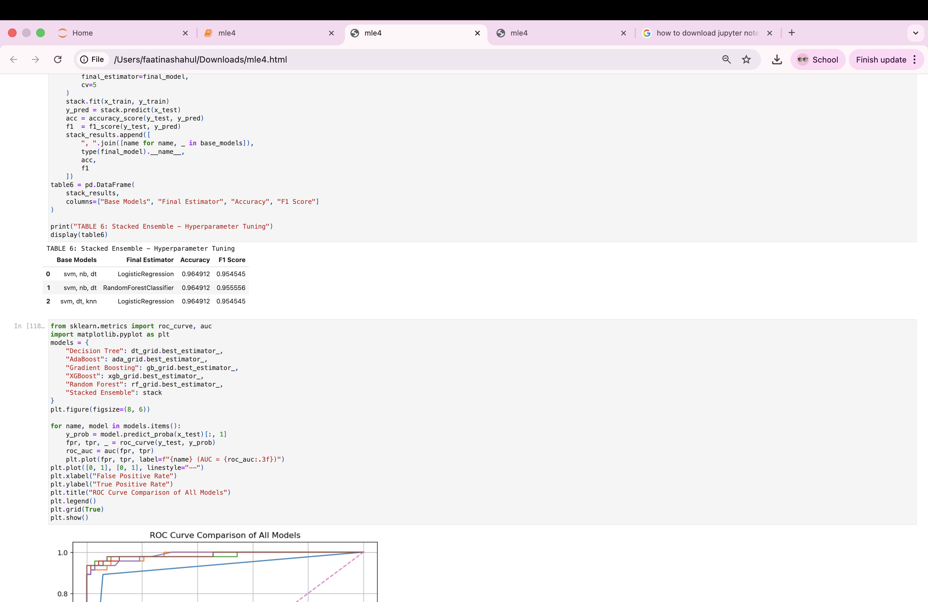
from sklearn.metrics import roc_curve, auc
import matplotlib.pyplot as plt
models = {
"Decision Tree": dt_grid.best_estimator_,
"AdaBoost": ada_grid.best_estimator_,
"Gradient Boosting": gb_grid.best_estimator_,
"XGBoost": xgb_grid.best_estimator_,
"Random Forest": rf_grid.best_estimator_,
"Stacked Ensemble": stack
}
plt.figure(figsize=(8, 6))

for name, model in models.items():
y_prob = model.predict_proba(x_test)[:, 1]
fpr, tpr, _ = roc_curve(y_test, y_prob)
roc_auc = auc(fpr, tpr)
plt.plot(fpr, tpr, label=f"{name} (AUC = {roc_auc:.3f})")
plt.plot([0, 1], [0, 1], linestyle="--")
plt.xlabel("False Positive Rate")
plt.ylabel("True Positive Rate")
plt.title("ROC Curve Comparison of All Models")
plt.legend()
plt.grid(True)
plt.show()

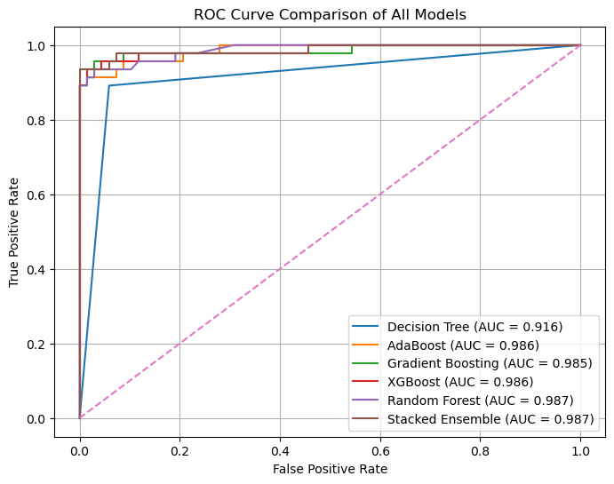
cv_results = []
for name, model in models.items():
scores = cross_val_score(model, x_train, y_train, cv=5, scoring="accuracy")
cv_results.append([name,scores[0],scores[1],scores[2],scores[3],scores[4],np.mean(scores)])
table7 = pd.DataFrame(
cv_results,columns=["Model", "Fold 1", "Fold 2", "Fold 3", "Fold 4", "Fold 5", "Average Accuracy"])
table7 = table7.round(4)
print("TABLE 7: 5-Fold Cross Validation Results for All Models")
display(table7)

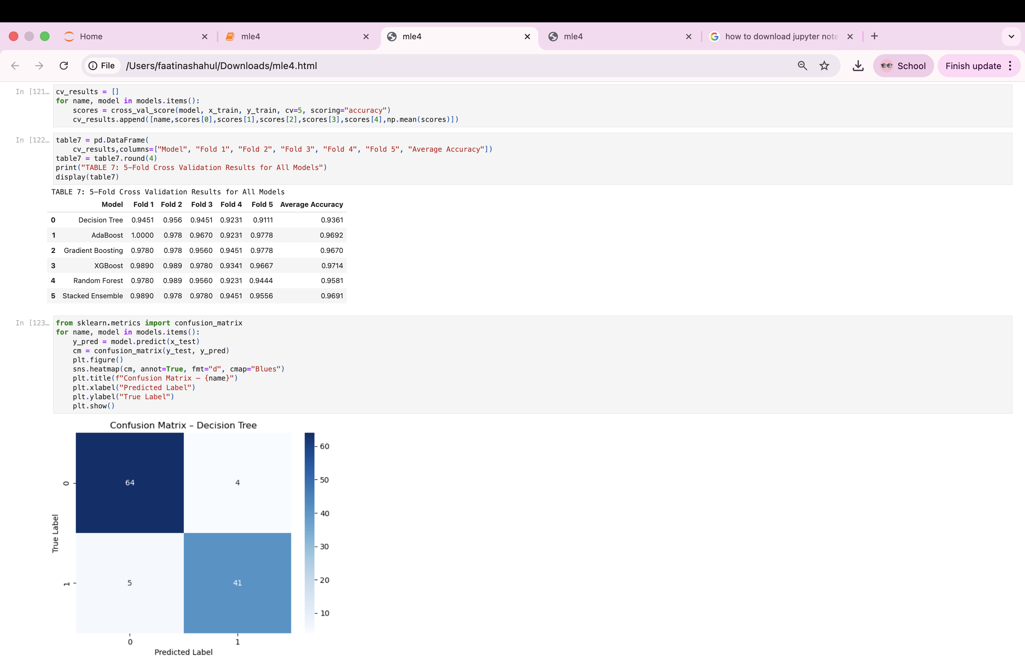

from sklearn.metrics import confusion_matrix
for name, model in models.items():
y_pred = model.predict(x_test)
cm = confusion_matrix(y_test, y_pred)
plt.figure()
sns.heatmap(cm, annot=True, fmt="d", cmap="Blues")
plt.title(f"Confusion Matrix – {name}")
plt.xlabel("Predicted Label")
plt.ylabel("True Label")
plt.show()

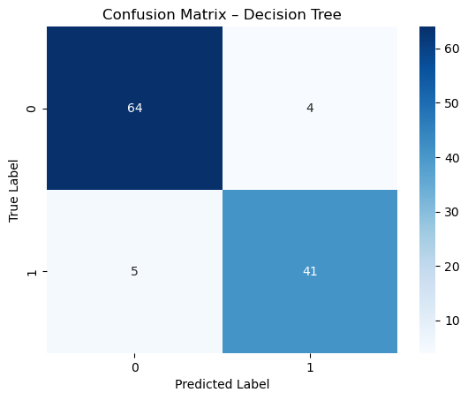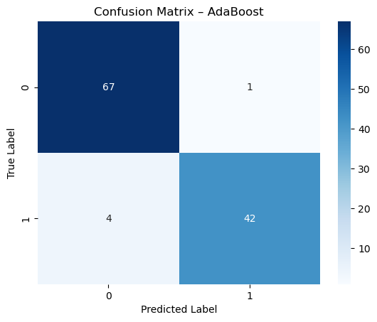

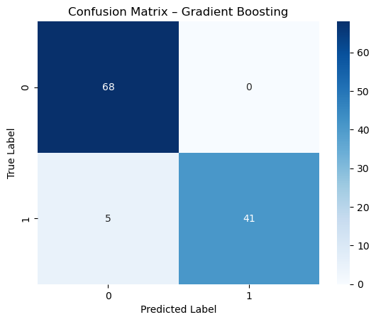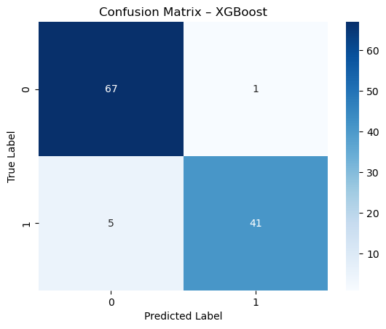
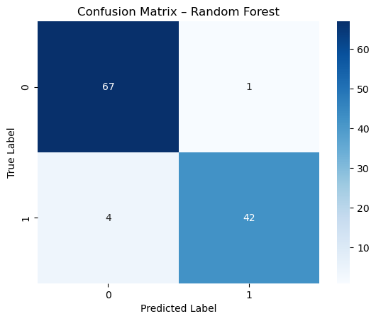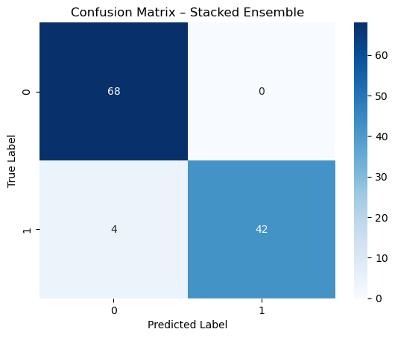

Observations

1. Which model achieved the best validation accuracy among all six methods?
XGBoost achieved the highest validation accuracy and F1-score among all six models.

2. How does Decision Tree performance compare to ensemble methods?
The Decision Tree model showed lower accuracy and was more prone to overfitting compared to ensemble methods, which significantly improved performance and stability.

3. Did the Random Forest benefit from tuning max depth or n estimators?
Yes, tuning the number of estimators and limiting the maximum depth improved Random Forest accuracy and reduced overfitting.

4. Which model showed the best generalization? Any overfitting?
XGBoost and Gradient Boosting showed the best generalization with minimal difference between training and validation accuracy. The Decision Tree showed signs of overfitting when not depth constrained.

5. Did stacking improve performance over base models?
Yes, the stacked ensemble model achieved higher accuracy and F1-score compared to its individual base models, demonstrating the benefit of combining diverse classifiers.

Conclusion
The performance of Decision Tree and ensemble models was evaluated using hyperparameter tuning and 5-fold cross-validation. Ensemble methods showed better accuracy and generalization compared to the Decision Tree. XGBoost achieved the best performance among all models. This experiment demonstrates the effectiveness of ensemble learning techniques for improving classification accuracy.

