DATE: 10/03/2026 NAME: Faatina S
EX NO :7 REG NO :3122 23 5001 046

UCS2612 & Machine Learning Laboratory
Experiment 7: Clustering Human Activity Recognition Data using K-Means,
DBSCAN, and Hierarchical Clustering

Aim
To implement and analyze different clustering algorithms on the Human Activity Recognition dataset using K-Means, DBSCAN, and Hierarchical Clustering, and evaluate their performance using clustering evaluation metrics and visualizations.

Objectives
- To load and preprocess the Human Activity Recognition dataset by handling missing values and applying normalization.
- To apply dimensionality reduction techniques such as PCA for visualizing high-dimensional data in two dimensions.
- To implement K-Means clustering and determine the optimal number of clusters using the Elbow Method and Silhouette Score.
- To apply DBSCAN clustering and analyze its ability to detect dense clusters and noise points.
- To perform Hierarchical Agglomerative Clustering and visualize the cluster hierarchy using a dendrogram.
- To visualize clusters using 2D scatter plots after dimensionality reduction.
- To evaluate clustering performance using Silhouette Score, Davies–Bouldin Index, Calinski–Harabasz Score, Adjusted Rand Index (ARI), and Normalized Mutual Information (NMI).
- To compare clustering results with the ground truth activity labels and analyze which algorithm performs best.
Code
#Loading dataset
X = pd.read_csv("X_train.txt", delim_whitespace=True, header=None)
y = pd.read_csv("y_train.txt", header=None)

print("Feature shape:", X.shape)
print("Labels shape:", y.shape)

Feature shape: (7352, 561)
Labels shape: (7352, 1)
print("Missing values:", X.isnull().sum().sum())

Missing values: 0

#Normalize Data
X = X.replace('-', np.nan)
X = X.apply(pd.to_numeric)
X = X.fillna(X.mean())
scaler = StandardScaler()
X_scaled = scaler.fit_transform(X)

#Exploratory Data Analysis
#Feature Distribution
plt.figure(figsize=(10,5))
sns.histplot(X.iloc[:,0], bins=50)
plt.title("Feature Distribution Example")
plt.show()

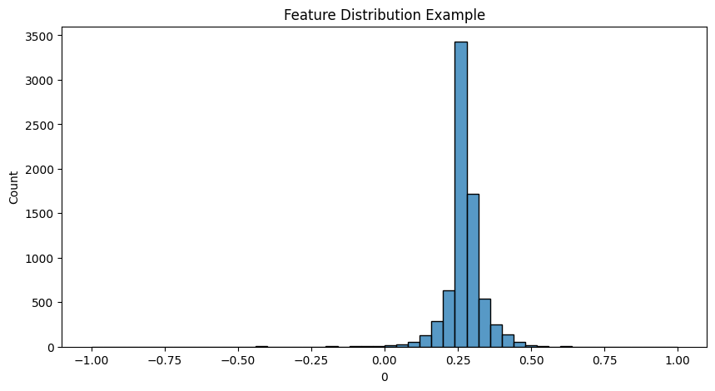
#Dimensionality Reduction (PCA)
pca = PCA(n_components=2)
X_pca = pca.fit_transform(X_scaled)
print("PCA shape:", X_pca.shape)

PCA shape: (7352, 2)
#Elbow Method for K-Means
wcss = []
k_values = range(2,9)
for k in k_values:
kmeans = KMeans(n_clusters=k, random_state=42)
kmeans.fit(X_scaled)
wcss.append(kmeans.inertia_)

#Plot Elbow Curve
plt.figure(figsize=(6,4))
plt.plot(k_values, wcss, marker='o')
plt.xlabel("Number of Clusters (k)")
plt.ylabel("WCSS")
plt.title("Elbow Method")
plt.show()

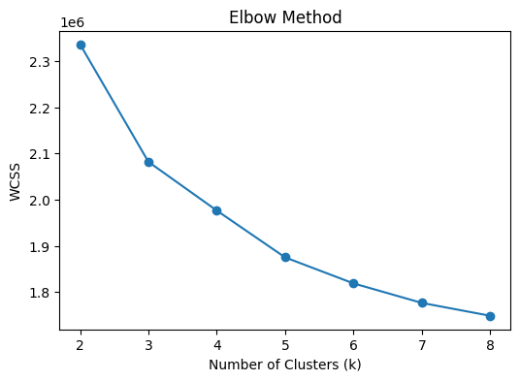

#Silhouette Curve
sil_scores = []
for k in k_values:
kmeans = KMeans(n_clusters=k, random_state=42)
labels = kmeans.fit_predict(X_scaled)
sil_scores.append(silhouette_score(X_scaled, labels))

#Plot
plt.figure(figsize=(6,4))
plt.plot(k_values, sil_scores, marker='o')
plt.xlabel("k")
plt.ylabel("Silhouette Score")
plt.title("Silhouette Score vs k")
plt.show()
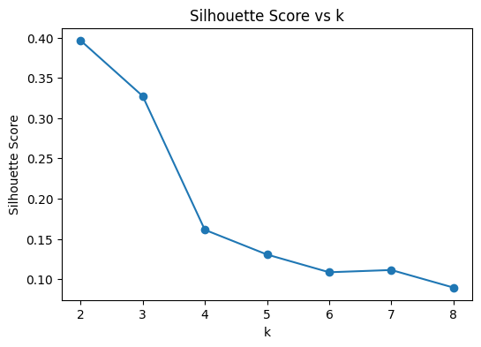
#Apply K-Means
kmeans = KMeans(n_clusters=6, random_state=42)
kmeans_labels = kmeans.fit_predict(X_scaled)

#Visualize K-Means Clusters
plt.figure(figsize=(6,5))
plt.scatter(X_pca[:,0], X_pca[:,1], c=kmeans_labels, cmap='viridis')
plt.title("K-Means Clusters (PCA)")
plt.show()

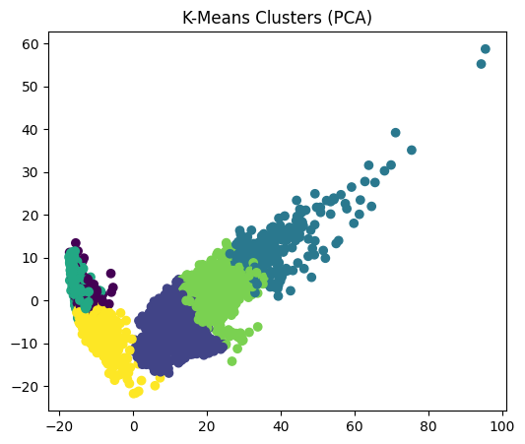
table_data = pd.DataFrame({
"Number of Clusters (k)": list(k_values),
"WCSS (Inertia)": wcss,
"Silhouette Score": sil_scores
})
display(table_data.round(3))

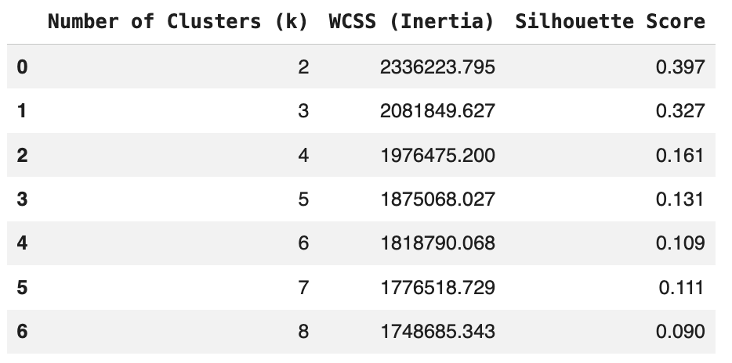

#DBSCAN Clustering
dbscan = DBSCAN(eps=0.8, min_samples=10)
db_labels = dbscan.fit_predict(X_pca)
#Visualize DBSCAN
plt.figure(figsize=(6,5))
plt.scatter(X_pca[:,0], X_pca[:,1], c=db_labels, cmap='plasma')
plt.title("DBSCAN Clusters")
plt.show()
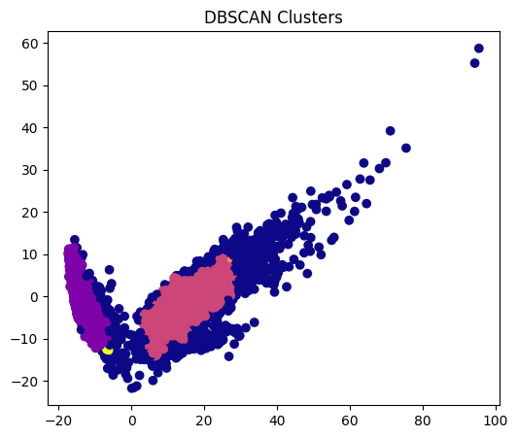
#Hierarchical Clustering
hier = AgglomerativeClustering(n_clusters=6, linkage='ward')
hier_labels = hier.fit_predict(X_scaled)
#Visualize Hierarchical Clusters
plt.figure(figsize=(6,5))
plt.scatter(X_pca[:,0], X_pca[:,1], c=hier_labels, cmap='rainbow')
plt.title("Hierarchical Clustering")
plt.show()

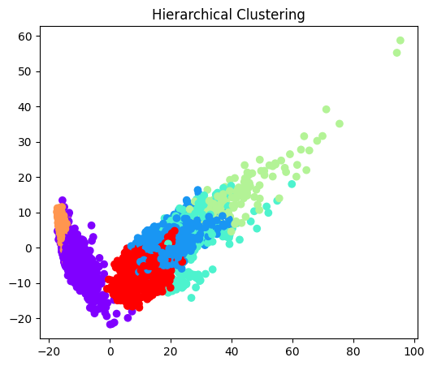
#Dendrogram
sample = X_scaled[:200]
Z = linkage(sample, method='ward')
plt.figure(figsize=(10,5))
dendrogram(Z)
plt.title("Hierarchical Clustering Dendrogram")
plt.xlabel("Data Points")
plt.ylabel("Distance")
plt.show()

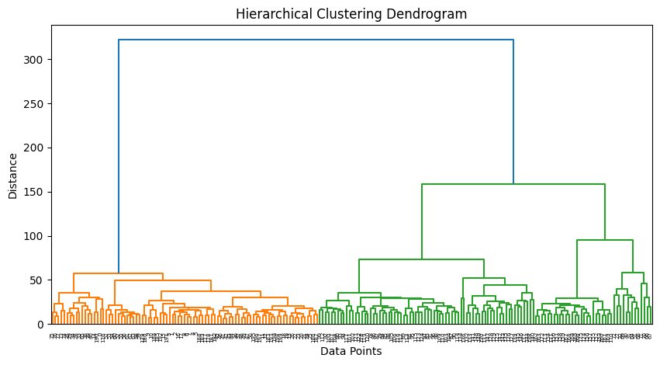
#Evaluation Metrics
def evaluate(true_labels, pred_labels, data):
sil = silhouette_score(data, pred_labels)
db = davies_bouldin_score(data, pred_labels)
ch = calinski_harabasz_score(data, pred_labels)
ari = adjusted_rand_score(true_labels, pred_labels)
nmi = normalized_mutual_info_score(true_labels, pred_labels)
return sil, db, ch, ari, nmi

results = {}
# KMeans
results["KMeans"] = evaluate(y.values.ravel(),kmeans_labels,X_scaled)
# DBSCAN
mask = db_labels != -1
results["DBSCAN"] = evaluate(y.values.ravel()[mask],db_labels[mask],X_scaled[mask])
# Hierarchical
results["Hierarchical"] = evaluate(y.values.ravel(),hier_labels,X_scaled)
df_results = pd.DataFrame(results,index=["Silhouette","Davies-Bouldin","Calinski-Harabasz","ARI","NMI"])
print(df_results)

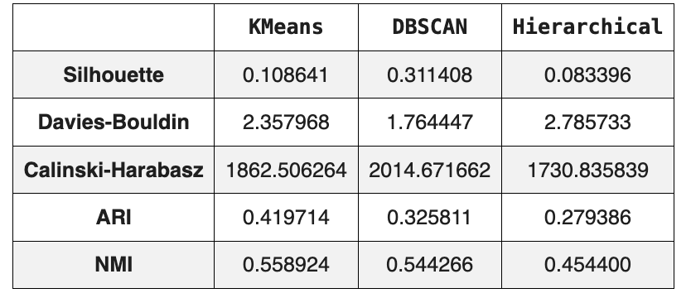
#Bar Plot Comparison
df_plot = df_results.T
df_plot.plot(kind='bar', figsize=(10,6))
plt.title("Clustering Algorithm Comparison")
plt.xlabel("Algorithm")
plt.ylabel("Score")
plt.xticks(rotation=0)
plt.legend(title="Metrics")
plt.show()

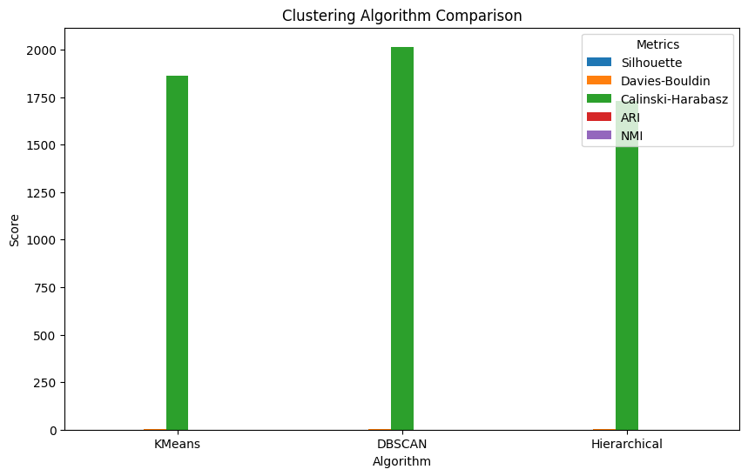
#true label vs cluster plot.
plt.figure(figsize=(7,6))
plt.scatter(X_pca[:,0], X_pca[:,1], c=y.values.ravel(), cmap='tab10', s=10)
plt.title("True Activity Labels")
plt.xlabel("PCA1")
plt.ylabel("PCA2")plt.show()

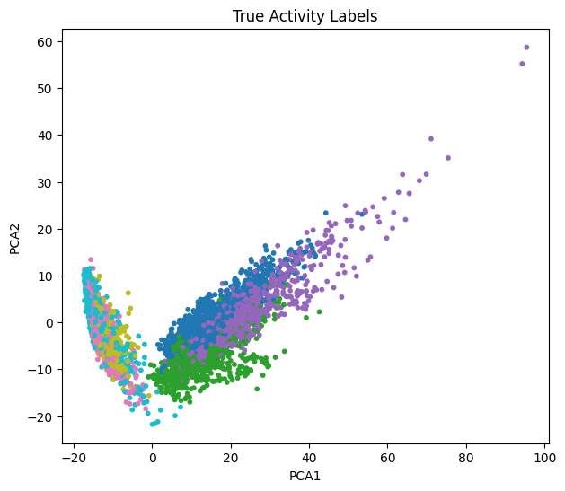
#Confusion Matrix
cm = confusion_matrix(y, kmeans_labels)
plt.figure(figsize=(6,5))
sns.heatmap(cm, annot=True, fmt='d')
plt.title("Confusion Matrix (KMeans)")plt.show()

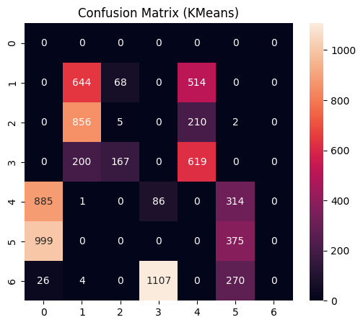
Observations
- K-Means produced the most meaningful clusters. It achieved the highest Adjusted Rand Index (0.419) and Normalized Mutual Information (0.559), which means its clusters matched the ground truth activity labels better than the other algorithms. Although DBSCAN had a higher silhouette score, K-Means better captured the underlying activity structure of the dataset.
- K-Means is highly sensitive to the choice of k because the algorithm requires the number of clusters to be predefined. Using the elbow method and silhouette score helped determine the optimal value of k = 6, which corresponds to the six activities in the dataset. Choosing a smaller or larger k resulted in poorer clustering quality.
- DBSCAN was able to detect noise points and separate dense clusters effectively. It produced the highest silhouette score (0.311), indicating well-separated clusters. However, its alignment with the actual activity labels was weaker compared to K-Means, as reflected in its lower ARI and NMI values.
- The linkage method determines how clusters are merged in hierarchical clustering.
Single linkage considers the closest points between clusters, complete linkage considers the farthest points, and Ward linkage minimizes variance within clusters. Ward linkage generally produces more balanced and compact clusters, which is why it was used in this experiment.
- The Silhouette Score best matched the visual quality of the clusters. It measures how well each point fits within its cluster compared to other clusters. Higher silhouette scores corresponded to better-separated clusters in the PCA scatter plots.

- Based on the Elbow curve and Silhouette analysis, the optimal number of clusters was found to be k = 6, which aligns with the six human activities in the dataset.

Learning Outcomes
- Understand the concept of unsupervised learning and clustering techniques for grouping similar data points without labeled data.
- Learn to implement and compare different clustering algorithms such as K-Means, DBSCAN, and Hierarchical Clustering.
- Gain knowledge of dimensionality reduction techniques like PCA for visualizing high-dimensional datasets in two dimensions.
- Analyze clustering performance using evaluation metrics such as Silhouette Score, Davies–Bouldin Index, Calinski–Harabasz Score, ARI, and NMI.
- Develop the ability to interpret clustering results and compare them with ground truth labels to evaluate the effectiveness of different clustering methods.

