GET
FILE='C:\Users\faazm\Downloads\hr_employee_attrition.sav'.
DATASET NAME DataSet1 WINDOW=FRONT.
RECODE YearsAtCompany (0 thru 2=1) (3 thru 5=2) (6 thru 10=3) (11 thru Highest=4) INTO tenure_band.
EXECUTE.
FREQUENCIES VARIABLES=tenure_band
/ORDER=ANALYSIS.

Frequencies

Notes
Output Created |  | 06-NOV-2026 17:56:02
Comments
Input | Data | C:\Users\faazm\Downloads\hr_employee_attrition.sav
Input | Active Dataset | DataSet1
Input | File Label | IBM HR Analytics Employee Attrition
Input | Filter | <none>
Input | Weight | <none>
Input | Split File | <none>
Input | N of Rows in Working Data File | 1470
Missing Value Handling | Definition of Missing | User-defined missing values are treated as missing.
Missing Value Handling | Cases Used | Statistics are based on all cases with valid data.
Syntax |  | FREQUENCIES VARIABLES=tenure_band  /ORDER=ANALYSIS.
Resources | Processor Time | 00:00:00.02
Resources | Elapsed Time | 00:00:00.02

[DataSet1] C:\Users\faazm\Downloads\hr_employee_attrition.sav

Statistics
tenure_band
N | Valid | 1470
N | Missing | 0

tenure_band
 |  | Frequency | Percent | Valid Percent | Cumulative Percent
Valid | 0-2 yrs | 342 | 23.3 | 23.3 | 23.3
Valid | 3-5 yrs | 434 | 29.5 | 29.5 | 52.8
Valid | 6-10 yrs | 448 | 30.5 | 30.5 | 83.3
Valid | 11+ yrs | 246 | 16.7 | 16.7 | 100.0
Valid | Total | 1470 | 100.0 | 100.0

* Chart Builder.
GGRAPH
/GRAPHDATASET NAME="graphdataset" VARIABLES=Department MEANCI(JobSatisfaction, 95)[name="MEAN_JobSatisfaction" LOW="MEAN_JobSatisfaction_LOW" HIGH="MEAN_JobSatisfaction_HIGH"] MISSING=LISTWISE REPORTMISSING=NO
/GRAPHSPEC SOURCE=INLINE.
BEGIN GPL
SOURCE: s=userSource(id("graphdataset"))
DATA: Department=col(source(s), name("Department"), unit.category())
DATA: MEAN_JobSatisfaction=col(source(s), name("MEAN_JobSatisfaction"))
DATA: LOW=col(source(s), name("MEAN_JobSatisfaction_LOW"))
DATA: HIGH=col(source(s), name("MEAN_JobSatisfaction_HIGH"))
GUIDE: axis(dim(1), label("Department"))
GUIDE: axis(dim(2), label("Mean Job satisfaction"))
GUIDE: text.title(label("Mean job satisfaction by department"))
SCALE: linear(dim(2), include(0))
ELEMENT: interval(position(Department*MEAN_JobSatisfaction), shape.interior(shape.square))
ELEMENT: interval(position(region.spread.range(Department*(LOW+HIGH))), shape.interior(shape.ibeam))
END GPL.

GGraph

Notes
Output Created |  | 06-NOV-2026 17:58:08
Comments
Input | Data | C:\Users\faazm\Downloads\hr_employee_attrition.sav
Input | Active Dataset | DataSet1
Input | File Label | IBM HR Analytics Employee Attrition
Input | Filter | <none>
Input | Weight | <none>
Input | Split File | <none>
Input | N of Rows in Working Data File | 1470
Syntax |  | GGRAPH  /GRAPHDATASET NAME="graphdataset" VARIABLES=Department MEANCI(JobSatisfaction, 95)[name="MEAN_JobSatisfaction" LOW="MEAN_JobSatisfaction_LOW" HIGH="MEAN_JobSatisfaction_HIGH"] MISSING=LISTWISE REPORTMISSING=NO  /GRAPHSPEC SOURCE=INLINE.  BEGIN GPL  SOURCE: s=userSource(id("graphdataset"))  DATA: Department=col(source(s), name("Department"), unit.category())  DATA: MEAN_JobSatisfaction=col(source(s), name("MEAN_JobSatisfaction"))  DATA: LOW=col(source(s), name("MEAN_JobSatisfaction_LOW"))  DATA: HIGH=col(source(s), name("MEAN_JobSatisfaction_HIGH"))  GUIDE: axis(dim(1), label("Department"))  GUIDE: axis(dim(2), label("Mean Job satisfaction"))  GUIDE: text.title(label("Mean job satisfaction by department"))  SCALE: linear(dim(2), include(0))  ELEMENT: interval(position(Department*MEAN_JobSatisfaction), shape.interior(shape.square))  ELEMENT: interval(position(region.spread.range(Department*(LOW+HIGH))), shape.interior(shape.ibeam))  END GPL.
Resources | Processor Time | 00:00:00.84
Resources | Elapsed Time | 00:00:00.72

[DataSet1] C:\Users\faazm\Downloads\hr_employee_attrition.sav

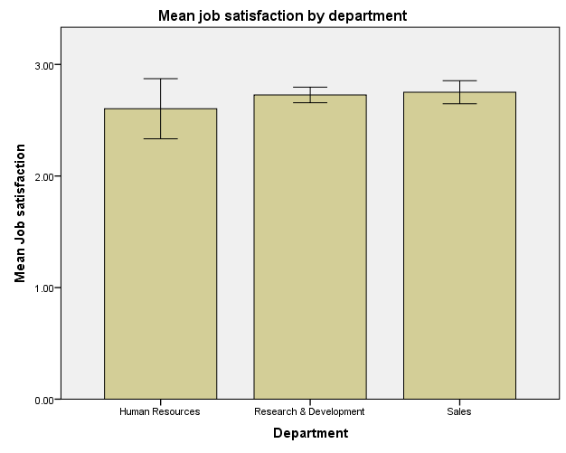

* Chart Builder.
GGRAPH
/GRAPHDATASET NAME="graphdataset" VARIABLES=OverTime MEANCI(JobSatisfaction, 95)[name="MEAN_JobSatisfaction" LOW="MEAN_JobSatisfaction_LOW" HIGH="MEAN_JobSatisfaction_HIGH"] MISSING=LISTWISE REPORTMISSING=NO
/GRAPHSPEC SOURCE=INLINE.
BEGIN GPL
SOURCE: s=userSource(id("graphdataset"))
DATA: OverTime=col(source(s), name("OverTime"), unit.category())
DATA: MEAN_JobSatisfaction=col(source(s), name("MEAN_JobSatisfaction"))
DATA: LOW=col(source(s), name("MEAN_JobSatisfaction_LOW"))
DATA: HIGH=col(source(s), name("MEAN_JobSatisfaction_HIGH"))
GUIDE: axis(dim(1), label("OverTime"))
GUIDE: axis(dim(2), label("Mean Job satisfaction"))
GUIDE: text.title(label("Mean job satisfaction by overtime status"))
SCALE: linear(dim(2), include(0))
ELEMENT: interval(position(OverTime*MEAN_JobSatisfaction), shape.interior(shape.square))
ELEMENT: interval(position(region.spread.range(OverTime*(LOW+HIGH))), shape.interior(shape.ibeam))
END GPL.

GGraph

Notes
Output Created |  | 06-NOV-2026 17:59:08
Comments
Input | Data | C:\Users\faazm\Downloads\hr_employee_attrition.sav
Input | Active Dataset | DataSet1
Input | File Label | IBM HR Analytics Employee Attrition
Input | Filter | <none>
Input | Weight | <none>
Input | Split File | <none>
Input | N of Rows in Working Data File | 1470
Syntax |  | GGRAPH  /GRAPHDATASET NAME="graphdataset" VARIABLES=OverTime MEANCI(JobSatisfaction, 95)[name="MEAN_JobSatisfaction" LOW="MEAN_JobSatisfaction_LOW" HIGH="MEAN_JobSatisfaction_HIGH"] MISSING=LISTWISE REPORTMISSING=NO  /GRAPHSPEC SOURCE=INLINE.  BEGIN GPL  SOURCE: s=userSource(id("graphdataset"))  DATA: OverTime=col(source(s), name("OverTime"), unit.category())  DATA: MEAN_JobSatisfaction=col(source(s), name("MEAN_JobSatisfaction"))  DATA: LOW=col(source(s), name("MEAN_JobSatisfaction_LOW"))  DATA: HIGH=col(source(s), name("MEAN_JobSatisfaction_HIGH"))  GUIDE: axis(dim(1), label("OverTime"))  GUIDE: axis(dim(2), label("Mean Job satisfaction"))  GUIDE: text.title(label("Mean job satisfaction by overtime status"))  SCALE: linear(dim(2), include(0))  ELEMENT: interval(position(OverTime*MEAN_JobSatisfaction), shape.interior(shape.square))  ELEMENT: interval(position(region.spread.range(OverTime*(LOW+HIGH))), shape.interior(shape.ibeam))  END GPL.
Resources | Processor Time | 00:00:00.13
Resources | Elapsed Time | 00:00:00.30

[DataSet1] C:\Users\faazm\Downloads\hr_employee_attrition.sav

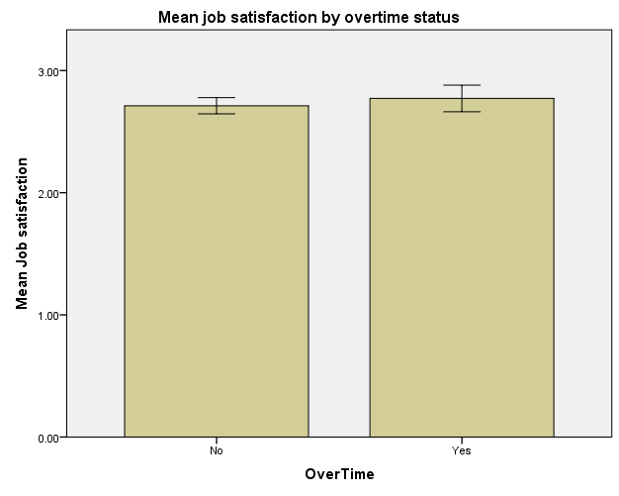

* Chart Builder.
GGRAPH
/GRAPHDATASET NAME="graphdataset" VARIABLES=tenure_band MEANCI(JobSatisfaction, 95)[name="MEAN_JobSatisfaction" LOW="MEAN_JobSatisfaction_LOW" HIGH="MEAN_JobSatisfaction_HIGH"] MISSING=LISTWISE REPORTMISSING=NO
/GRAPHSPEC SOURCE=INLINE.
BEGIN GPL
SOURCE: s=userSource(id("graphdataset"))
DATA: tenure_band=col(source(s), name("tenure_band"), unit.category())
DATA: MEAN_JobSatisfaction=col(source(s), name("MEAN_JobSatisfaction"))
DATA: LOW=col(source(s), name("MEAN_JobSatisfaction_LOW"))
DATA: HIGH=col(source(s), name("MEAN_JobSatisfaction_HIGH"))
GUIDE: axis(dim(1), label("tenure_band"))
GUIDE: axis(dim(2), label("Mean Job satisfaction"))
GUIDE: text.title(label("Mean job satisfaction by tenure"))
SCALE: cat(dim(1), include("1.00", "2.00", "3.00", "4.00"))
SCALE: linear(dim(2), include(0))
ELEMENT: interval(position(tenure_band*MEAN_JobSatisfaction), shape.interior(shape.square))
ELEMENT: interval(position(region.spread.range(tenure_band*(LOW+HIGH))), shape.interior(shape.ibeam))
END GPL.

GGraph

Notes
Output Created |  | 06-NOV-2026 17:59:43
Comments
Input | Data | C:\Users\faazm\Downloads\hr_employee_attrition.sav
Input | Active Dataset | DataSet1
Input | File Label | IBM HR Analytics Employee Attrition
Input | Filter | <none>
Input | Weight | <none>
Input | Split File | <none>
Input | N of Rows in Working Data File | 1470
Syntax |  | GGRAPH  /GRAPHDATASET NAME="graphdataset" VARIABLES=tenure_band MEANCI(JobSatisfaction, 95)[name="MEAN_JobSatisfaction" LOW="MEAN_JobSatisfaction_LOW" HIGH="MEAN_JobSatisfaction_HIGH"] MISSING=LISTWISE REPORTMISSING=NO  /GRAPHSPEC SOURCE=INLINE.  BEGIN GPL  SOURCE: s=userSource(id("graphdataset"))  DATA: tenure_band=col(source(s), name("tenure_band"), unit.category())  DATA: MEAN_JobSatisfaction=col(source(s), name("MEAN_JobSatisfaction"))  DATA: LOW=col(source(s), name("MEAN_JobSatisfaction_LOW"))  DATA: HIGH=col(source(s), name("MEAN_JobSatisfaction_HIGH"))  GUIDE: axis(dim(1), label("tenure_band"))  GUIDE: axis(dim(2), label("Mean Job satisfaction"))  GUIDE: text.title(label("Mean job satisfaction by tenure"))  SCALE: cat(dim(1), include("1.00", "2.00", "3.00", "4.00"))  SCALE: linear(dim(2), include(0))  ELEMENT: interval(position(tenure_band*MEAN_JobSatisfaction), shape.interior(shape.square))  ELEMENT: interval(position(region.spread.range(tenure_band*(LOW+HIGH))), shape.interior(shape.ibeam))  END GPL.
Resources | Processor Time | 00:00:00.05
Resources | Elapsed Time | 00:00:00.12

[DataSet1] C:\Users\faazm\Downloads\hr_employee_attrition.sav

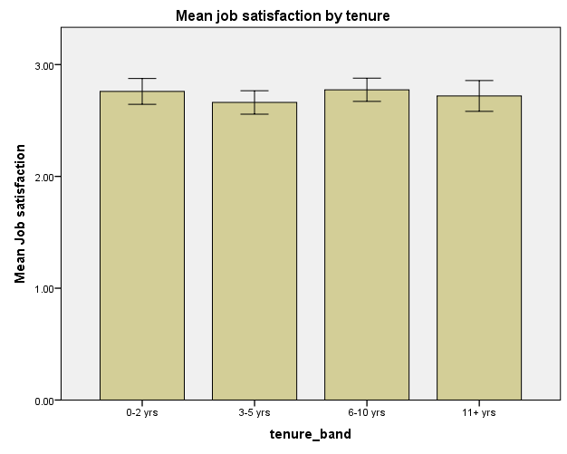

* Chart Builder.
GGRAPH
/GRAPHDATASET NAME="graphdataset" VARIABLES=MonthlyIncome MISSING=LISTWISE REPORTMISSING=NO
/GRAPHSPEC SOURCE=INLINE.
BEGIN GPL
SOURCE: s=userSource(id("graphdataset"))
DATA: MonthlyIncome=col(source(s), name("MonthlyIncome"))
GUIDE: axis(dim(1), label("Monthly income"))
GUIDE: axis(dim(2), label("Frequency"))
ELEMENT: interval(position(summary.count(bin.rect(MonthlyIncome))), shape.interior(shape.square))
END GPL.

GGraph

Notes
Output Created |  | 06-NOV-2026 18:00:59
Comments
Input | Data | C:\Users\faazm\Downloads\hr_employee_attrition.sav
Input | Active Dataset | DataSet1
Input | File Label | IBM HR Analytics Employee Attrition
Input | Filter | <none>
Input | Weight | <none>
Input | Split File | <none>
Input | N of Rows in Working Data File | 1470
Syntax |  | GGRAPH  /GRAPHDATASET NAME="graphdataset" VARIABLES=MonthlyIncome MISSING=LISTWISE REPORTMISSING=NO  /GRAPHSPEC SOURCE=INLINE.  BEGIN GPL  SOURCE: s=userSource(id("graphdataset"))  DATA: MonthlyIncome=col(source(s), name("MonthlyIncome"))  GUIDE: axis(dim(1), label("Monthly income"))  GUIDE: axis(dim(2), label("Frequency"))  ELEMENT: interval(position(summary.count(bin.rect(MonthlyIncome))), shape.interior(shape.square))  END GPL.
Resources | Processor Time | 00:00:00.13
Resources | Elapsed Time | 00:00:00.16

[DataSet1] C:\Users\faazm\Downloads\hr_employee_attrition.sav

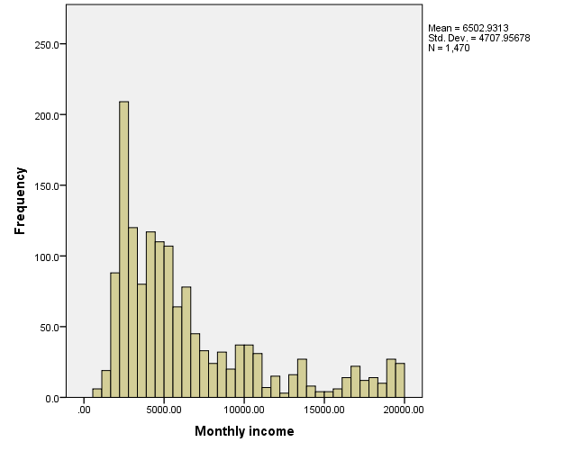

* Chart Builder.
GGRAPH
/GRAPHDATASET NAME="graphdataset" VARIABLES=Department MonthlyIncome MISSING=LISTWISE REPORTMISSING=NO
/GRAPHSPEC SOURCE=INLINE.
BEGIN GPL
SOURCE: s=userSource(id("graphdataset"))
DATA: Department=col(source(s), name("Department"), unit.category())
DATA: MonthlyIncome=col(source(s), name("MonthlyIncome"))
DATA: id=col(source(s), name("$CASENUM"), unit.category())
GUIDE: axis(dim(1), label("Department"))
GUIDE: axis(dim(2), label("Monthly income"))
SCALE: linear(dim(2), include(0))
ELEMENT: schema(position(bin.quantile.letter(Department*MonthlyIncome)), label(id))
END GPL.

GGraph

Notes
Output Created |  | 06-NOV-2026 18:01:47
Comments
Input | Data | C:\Users\faazm\Downloads\hr_employee_attrition.sav
Input | Active Dataset | DataSet1
Input | File Label | IBM HR Analytics Employee Attrition
Input | Filter | <none>
Input | Weight | <none>
Input | Split File | <none>
Input | N of Rows in Working Data File | 1470
Syntax |  | GGRAPH  /GRAPHDATASET NAME="graphdataset" VARIABLES=Department MonthlyIncome MISSING=LISTWISE REPORTMISSING=NO  /GRAPHSPEC SOURCE=INLINE.  BEGIN GPL  SOURCE: s=userSource(id("graphdataset"))  DATA: Department=col(source(s), name("Department"), unit.category())  DATA: MonthlyIncome=col(source(s), name("MonthlyIncome"))  DATA: id=col(source(s), name("$CASENUM"), unit.category())  GUIDE: axis(dim(1), label("Department"))  GUIDE: axis(dim(2), label("Monthly income"))  SCALE: linear(dim(2), include(0))  ELEMENT: schema(position(bin.quantile.letter(Department*MonthlyIncome)), label(id))  END GPL.
Resources | Processor Time | 00:00:00.17
Resources | Elapsed Time | 00:00:00.18

[DataSet1] C:\Users\faazm\Downloads\hr_employee_attrition.sav

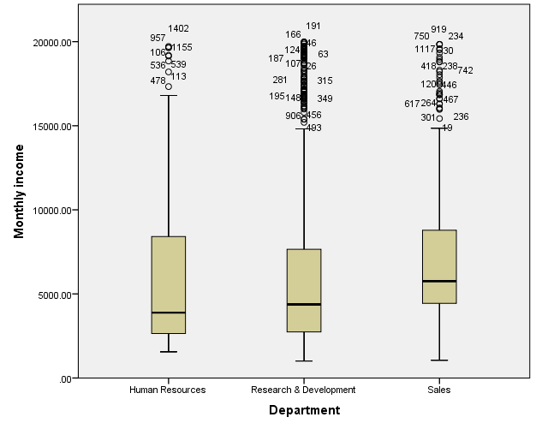

FACTOR
/VARIABLES EnvironmentSatisfaction JobSatisfaction RelationshipSatisfaction JobInvolvement WorkLifeBalance YearsAtCompany YearsInCurrentRole YearsSinceLastPromotion YearsWithCurrManager
/MISSING LISTWISE
/ANALYSIS EnvironmentSatisfaction JobSatisfaction RelationshipSatisfaction JobInvolvement WorkLifeBalance YearsAtCompany YearsInCurrentRole YearsSinceLastPromotion YearsWithCurrManager
/PRINT INITIAL KMO EXTRACTION ROTATION
/PLOT EIGEN
/CRITERIA MINEIGEN(1) ITERATE(25)
/EXTRACTION PC
/CRITERIA ITERATE(25)
/ROTATION VARIMAX
/METHOD=CORRELATION.

Factor Analysis

Notes
Output Created |  | 06-NOV-2026 18:05:45
Comments
Input | Data | C:\Users\faazm\Downloads\hr_employee_attrition.sav
Input | Active Dataset | DataSet1
Input | File Label | IBM HR Analytics Employee Attrition
Input | Filter | <none>
Input | Weight | <none>
Input | Split File | <none>
Input | N of Rows in Working Data File | 1470
Missing Value Handling | Definition of Missing | MISSING=EXCLUDE: User-defined missing values are treated as missing.
Missing Value Handling | Cases Used | LISTWISE: Statistics are based on cases with no missing values for any variable used.
Syntax |  | FACTOR  /VARIABLES EnvironmentSatisfaction JobSatisfaction RelationshipSatisfaction JobInvolvement WorkLifeBalance YearsAtCompany YearsInCurrentRole YearsSinceLastPromotion YearsWithCurrManager  /MISSING LISTWISE  /ANALYSIS EnvironmentSatisfaction JobSatisfaction RelationshipSatisfaction JobInvolvement WorkLifeBalance YearsAtCompany YearsInCurrentRole YearsSinceLastPromotion YearsWithCurrManager  /PRINT INITIAL KMO EXTRACTION ROTATION  /PLOT EIGEN  /CRITERIA MINEIGEN(1) ITERATE(25)  /EXTRACTION PC  /CRITERIA ITERATE(25)  /ROTATION VARIMAX  /METHOD=CORRELATION.
Resources | Processor Time | 00:00:00.08
Resources | Elapsed Time | 00:00:00.21
Resources | Maximum Memory Required | 11172 (10.910K) bytes

[DataSet1] C:\Users\faazm\Downloads\hr_employee_attrition.sav

KMO and Bartlett's Test
Kaiser-Meyer-Olkin Measure of Sampling Adequacy. |  | .810
Bartlett's Test of Sphericity | Approx. Chi-Square | 3494.845
Bartlett's Test of Sphericity | df | 36
Bartlett's Test of Sphericity | Sig. | .000

Communalities
 | Initial | Extraction
Satisfaction with work environment | 1.000 | .390
Job satisfaction | 1.000 | .255
Satisfaction with colleague relationships | 1.000 | .385
Job involvement | 1.000 | .560
Work-life balance | 1.000 | .496
Years at company | 1.000 | .847
YearsInCurrentRole | 1.000 | .780
Years since last promotion | 1.000 | .579
YearsWithCurrManager | 1.000 | .769
Extraction Method: Principal Component Analysis.

Total Variance Explained
Component | Initial Eigenvalues |  |  | Extraction Sums of Squared Loadings |  |  | Rotation Sums of Squared Loadings
Component | Total | % of Variance | Cumulative % | Total | % of Variance | Cumulative % | Total | % of Variance | Cumulative %
1 | 2.973 | 33.031 | 33.031 | 2.973 | 33.031 | 33.031 | 2.972 | 33.018 | 33.018
2 | 1.053 | 11.700 | 44.732 | 1.053 | 11.700 | 44.732 | 1.049 | 11.661 | 44.679
3 | 1.036 | 11.508 | 56.240 | 1.036 | 11.508 | 56.240 | 1.040 | 11.561 | 56.240
4 | .989 | 10.992 | 67.232
5 | .976 | 10.846 | 78.078
6 | .954 | 10.599 | 88.677
7 | .531 | 5.905 | 94.582
8 | .282 | 3.131 | 97.713
9 | .206 | 2.287 | 100.000
Extraction Method: Principal Component Analysis.

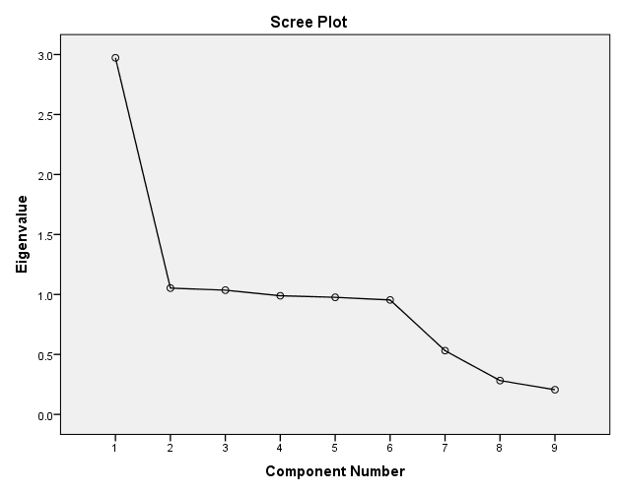

Component Matrixª
 | Component
 | 1 | 2 | 3
Satisfaction with work environment | .013 | .307 | .544
Job satisfaction | -.023 | -.500 | .068
Satisfaction with colleague relationships | .015 | .589 | -.193
Job involvement | -.004 | .418 | -.621
Work-life balance | .033 | .431 | .556
Years at company | .920 | -.026 | -.006
YearsInCurrentRole | .883 | -.011 | .019
Years since last promotion | .761 | .007 | .016
YearsWithCurrManager | .875 | -.010 | -.054
Extraction Method: Principal Component Analysis.
a. 3 components extracted.

Rotated Component Matrixª
 | Component
 | 1 | 2 | 3
Satisfaction with work environment | .000 | .011 | .624
Job satisfaction | -.012 | -.472 | -.179
Satisfaction with colleague relationships | .004 | .610 | .111
Job involvement | -.006 | .663 | -.347
Work-life balance | .017 | .114 | .695
Years at company | .920 | -.008 | .001
YearsInCurrentRole | .883 | -.006 | .030
Years since last promotion | .760 | .009 | .033
YearsWithCurrManager | .876 | .029 | -.034
Extraction Method: Principal Component Analysis.
Rotation Method: Varimax with Kaiser Normalization.
a. Rotation converged in 3 iterations.

Component Transformation Matrix
Component | 1 | 2 | 3
1 | 1.000 | .014 | .021
2 | -.022 | .879 | .476
3 | -.012 | -.477 | .879
Extraction Method: Principal Component Analysis.
Rotation Method: Varimax with Kaiser Normalization.

AUTORECODE VARIABLES=Department
/INTO dept_n
/PRINT.

Department into dept_n (Department)
Old Value New Value Value Label

Human Resources 1 Human Resources
Research & Development 2 Research & Development
Sales 3 Sales

ONEWAY JobSatisfaction BY dept_n
/STATISTICS DESCRIPTIVES HOMOGENEITY WELCH
/PLOT MEANS
/MISSING ANALYSIS
/POSTHOC=TUKEY GH ALPHA(0.05).

Oneway

Notes
Output Created |  | 06-NOV-2026 18:10:02
Comments
Input | Data | C:\Users\faazm\Downloads\hr_employee_attrition.sav
Input | Active Dataset | DataSet1
Input | File Label | IBM HR Analytics Employee Attrition
Input | Filter | <none>
Input | Weight | <none>
Input | Split File | <none>
Input | N of Rows in Working Data File | 1470
Missing Value Handling | Definition of Missing | User-defined missing values are treated as missing.
Missing Value Handling | Cases Used | Statistics for each analysis are based on cases with no missing data for any variable in the analysis.
Syntax |  | ONEWAY JobSatisfaction BY dept_n  /STATISTICS DESCRIPTIVES HOMOGENEITY WELCH  /PLOT MEANS  /MISSING ANALYSIS  /POSTHOC=TUKEY GH ALPHA(0.05).
Resources | Processor Time | 00:00:00.19
Resources | Elapsed Time | 00:00:00.19

[DataSet1] C:\Users\faazm\Downloads\hr_employee_attrition.sav

Descriptives
Job satisfaction
 | N | Mean | Std. Deviation | Std. Error | 95% Confidence Interval for Mean |  | Minimum | Maximum
 |  |  |  |  | Lower Bound | Upper Bound | Minimum | Maximum
Human Resources | 63 | 2.6032 | 1.07072 | .13490 | 2.3335 | 2.8728 | 1.00 | 4.00
Research & Development | 961 | 2.7263 | 1.10162 | .03554 | 2.6566 | 2.7961 | 1.00 | 4.00
Sales | 446 | 2.7511 | 1.11110 | .05261 | 2.6477 | 2.8545 | 1.00 | 4.00
Total | 1470 | 2.7286 | 1.10285 | .02876 | 2.6721 | 2.7850 | 1.00 | 4.00

Test of Homogeneity of Variances
Job satisfaction
Levene Statistic | df1 | df2 | Sig.
.094 | 2 | 1467 | .910

ANOVA
Job satisfaction
 | Sum of Squares | df | Mean Square | F | Sig.
Between Groups | 1.222 | 2 | .611 | .502 | .605
Within Groups | 1785.478 | 1467 | 1.217
Total | 1786.700 | 1469

Robust Tests of Equality of Means
Job satisfaction
 | Statisticª | df1 | df2 | Sig.
Welch | .524 | 2 | 167.474 | .593
a. Asymptotically F distributed.

Post Hoc Tests

Multiple Comparisons
Dependent Variable: Job satisfaction
 | (I) Department | (J) Department | Mean Difference (I-J) | Std. Error | Sig. | 95% Confidence Interval
 |  |  |  |  |  | Lower Bound | Upper Bound
Tukey HSD | Human Resources | Research & Development | -.12315 | .14348 | .667 | -.4598 | .2135
Tukey HSD | Human Resources | Sales | -.14795 | .14849 | .579 | -.4963 | .2004
Tukey HSD | Research & Development | Human Resources | .12315 | .14348 | .667 | -.2135 | .4598
Tukey HSD | Research & Development | Sales | -.02479 | .06321 | .919 | -.1731 | .1235
Tukey HSD | Sales | Human Resources | .14795 | .14849 | .579 | -.2004 | .4963
Tukey HSD | Sales | Research & Development | .02479 | .06321 | .919 | -.1235 | .1731
Games-Howell | Human Resources | Research & Development | -.12315 | .13950 | .653 | -.4571 | .2108
Games-Howell | Human Resources | Sales | -.14795 | .14479 | .565 | -.4936 | .1977
Games-Howell | Research & Development | Human Resources | .12315 | .13950 | .653 | -.2108 | .4571
Games-Howell | Research & Development | Sales | -.02479 | .06349 | .919 | -.1739 | .1243
Games-Howell | Sales | Human Resources | .14795 | .14479 | .565 | -.1977 | .4936
Games-Howell | Sales | Research & Development | .02479 | .06349 | .919 | -.1243 | .1739

Homogeneous Subsets

Job satisfaction
 | Department | N | Subset for alpha = 0.05
 | Department | N | 1
Tukey HSD^{a,b} | Human Resources | 63 | 2.6032
Tukey HSD^{a,b} | Research & Development | 961 | 2.7263
Tukey HSD^{a,b} | Sales | 446 | 2.7511
Tukey HSD^{a,b} | Sig. |  | .461
Means for groups in homogeneous subsets are displayed.
a. Uses Harmonic Mean Sample Size = 156.611.
b. The group sizes are unequal. The harmonic mean of the group sizes is used. Type I error levels are not guaranteed.

Means Plots



