GET
FILE='C:\Users\faazm\Downloads\telco_churn.sav'.
DATASET NAME DataSet1 WINDOW=FRONT.
* ---------------------------------------------------------------------
* 2. DATA CLEANING AND RECODING
* ---------------------------------------------------------------------
* TotalCharges is stored as text and has blank values (customers with
* tenure = 0, i.e. brand-new customers who have not been billed yet).
COMPUTE TotalChg = NUMBER(TotalCharges, F8.2).
IF (tenure = 0) TotalChg = 0.
VARIABLE LABELS TotalChg 'Total charges to date'.
FORMATS TotalChg (F8.2).
RECODE Churn ('yes'=1) ('no'=0) INTO churn_flag.
VARIABLE LABELS churn_flag 'customer'.
EXECUTE.
RECODE tenure (0 thru 12=1) (13 thru 24=2) (25 thru 48=3) (49 thru Highest=4) INTO tenure_band.
EXECUTE.
* Chart Builder.
GGRAPH
/GRAPHDATASET NAME="graphdataset" VARIABLES=InternetService[LEVEL=NOMINAL] MEAN(churn_flag)[name="MEAN_churn_flag"] MISSING=LISTWISE REPORTMISSING=NO
/GRAPHSPEC SOURCE=INLINE.
BEGIN GPL
SOURCE: s=userSource(id("graphdataset"))
DATA: InternetService=col(source(s), name("InternetService"), unit.category())
DATA: MEAN_churn_flag=col(source(s), name("MEAN_churn_flag"))
GUIDE: axis(dim(1), label("InternetService"))
GUIDE: axis(dim(2), label("Mean customer"))
GUIDE: text.title(label("Churn rate by internrt service"))
SCALE: linear(dim(2), include(0))
ELEMENT: interval(position(InternetService*MEAN_churn_flag), shape.interior(shape.square))
END GPL.

COMPUTE churn_flag=Churn = "Yes".
EXECUTE.
* Chart Builder.
GGRAPH
/GRAPHDATASET NAME="graphdataset" VARIABLES=InternetService[LEVEL=NOMINAL] MEAN(churn_flag)[name="MEAN_churn_flag"] MISSING=LISTWISE REPORTMISSING=NO
/GRAPHSPEC SOURCE=INLINE.
BEGIN GPL
SOURCE: s=userSource(id("graphdataset"))
DATA: InternetService=col(source(s), name("InternetService"), unit.category())
DATA: MEAN_churn_flag=col(source(s), name("MEAN_churn_flag"))
GUIDE: axis(dim(1), label("InternetService"))
GUIDE: axis(dim(2), label("Mean customer"))
GUIDE: text.title(label("Churn rate by internrt service"))
SCALE: linear(dim(2), include(0))
ELEMENT: interval(position(InternetService*MEAN_churn_flag), shape.interior(shape.square))
END GPL.

GGraph

Notes
Output Created |  | 06-NOV-2026 15:09:10
Comments
Input | Data | C:\Users\faazm\Downloads\telco_churn.sav
Input | Active Dataset | DataSet1
Input | File Label | IBM Telco Customer Churn
Input | Filter | <none>
Input | Weight | <none>
Input | Split File | <none>
Input | N of Rows in Working Data File | 7043
Syntax |  | GGRAPH  /GRAPHDATASET NAME="graphdataset" VARIABLES=InternetService[LEVEL=NOMINAL] MEAN(churn_flag)[name="MEAN_churn_flag"] MISSING=LISTWISE REPORTMISSING=NO  /GRAPHSPEC SOURCE=INLINE.  BEGIN GPL  SOURCE: s=userSource(id("graphdataset"))  DATA: InternetService=col(source(s), name("InternetService"), unit.category())  DATA: MEAN_churn_flag=col(source(s), name("MEAN_churn_flag"))  GUIDE: axis(dim(1), label("InternetService"))  GUIDE: axis(dim(2), label("Mean customer"))  GUIDE: text.title(label("Churn rate by internrt service"))  SCALE: linear(dim(2), include(0))  ELEMENT: interval(position(InternetService*MEAN_churn_flag), shape.interior(shape.square))  END GPL.
Resources | Processor Time | 00:00:00.00
Resources | Elapsed Time | 00:00:00.08

[DataSet1] C:\Users\faazm\Downloads\telco_churn.sav

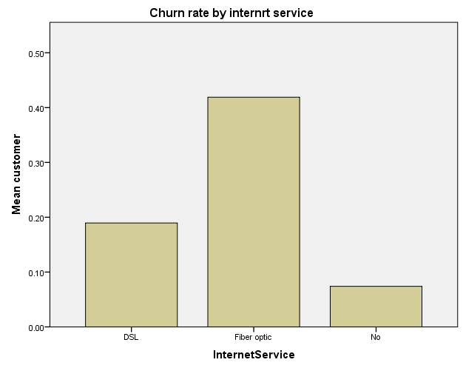

* Chart Builder.
GGRAPH
/GRAPHDATASET NAME="graphdataset" VARIABLES=Contract[LEVEL=NOMINAL] MEAN(churn_flag)[name="MEAN_churn_flag"] MISSING=LISTWISE REPORTMISSING=NO
/GRAPHSPEC SOURCE=INLINE.
BEGIN GPL
SOURCE: s=userSource(id("graphdataset"))
DATA: Contract=col(source(s), name("Contract"), unit.category())
DATA: MEAN_churn_flag=col(source(s), name("MEAN_churn_flag"))
GUIDE: axis(dim(1), label("Contract"))
GUIDE: axis(dim(2), label("Mean customer"))
GUIDE: text.title(label("Churn rate by contract type"))
SCALE: linear(dim(2), include(0))
ELEMENT: interval(position(Contract*MEAN_churn_flag), shape.interior(shape.square))
END GPL.

GGraph

Notes
Output Created |  | 06-NOV-2026 15:11:25
Comments
Input | Data | C:\Users\faazm\Downloads\telco_churn.sav
Input | Active Dataset | DataSet1
Input | File Label | IBM Telco Customer Churn
Input | Filter | <none>
Input | Weight | <none>
Input | Split File | <none>
Input | N of Rows in Working Data File | 7043
Syntax |  | GGRAPH  /GRAPHDATASET NAME="graphdataset" VARIABLES=Contract[LEVEL=NOMINAL] MEAN(churn_flag)[name="MEAN_churn_flag"] MISSING=LISTWISE REPORTMISSING=NO  /GRAPHSPEC SOURCE=INLINE.  BEGIN GPL  SOURCE: s=userSource(id("graphdataset"))  DATA: Contract=col(source(s), name("Contract"), unit.category())  DATA: MEAN_churn_flag=col(source(s), name("MEAN_churn_flag"))  GUIDE: axis(dim(1), label("Contract"))  GUIDE: axis(dim(2), label("Mean customer"))  GUIDE: text.title(label("Churn rate by contract type"))  SCALE: linear(dim(2), include(0))  ELEMENT: interval(position(Contract*MEAN_churn_flag), shape.interior(shape.square))  END GPL.
Resources | Processor Time | 00:00:00.00
Resources | Elapsed Time | 00:00:00.08

[DataSet1] C:\Users\faazm\Downloads\telco_churn.sav

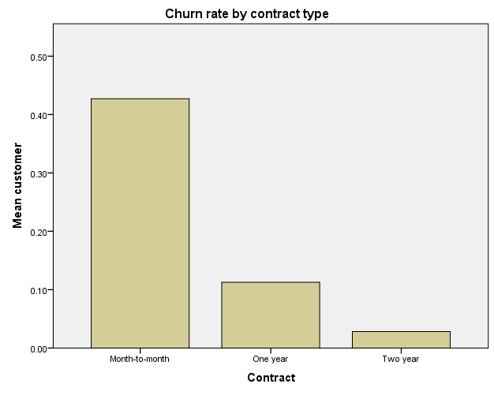

* Chart Builder.
GGRAPH
/GRAPHDATASET NAME="graphdataset" VARIABLES=PaymentMethod[LEVEL=NOMINAL] MEAN(churn_flag)[name="MEAN_churn_flag"] MISSING=LISTWISE REPORTMISSING=NO
/GRAPHSPEC SOURCE=INLINE.
BEGIN GPL
SOURCE: s=userSource(id("graphdataset"))
DATA: PaymentMethod=col(source(s), name("PaymentMethod"), unit.category())
DATA: MEAN_churn_flag=col(source(s), name("MEAN_churn_flag"))
GUIDE: axis(dim(1), label("PaymentMethod"))
GUIDE: axis(dim(2), label("Mean customer"))
GUIDE: text.title(label("Churn rate by payment method"))
SCALE: linear(dim(2), include(0))
ELEMENT: interval(position(PaymentMethod*MEAN_churn_flag), shape.interior(shape.square))
END GPL.

GGraph

Notes
Output Created |  | 06-NOV-2026 15:12:12
Comments
Input | Data | C:\Users\faazm\Downloads\telco_churn.sav
Input | Active Dataset | DataSet1
Input | File Label | IBM Telco Customer Churn
Input | Filter | <none>
Input | Weight | <none>
Input | Split File | <none>
Input | N of Rows in Working Data File | 7043
Syntax |  | GGRAPH  /GRAPHDATASET NAME="graphdataset" VARIABLES=PaymentMethod[LEVEL=NOMINAL] MEAN(churn_flag)[name="MEAN_churn_flag"] MISSING=LISTWISE REPORTMISSING=NO  /GRAPHSPEC SOURCE=INLINE.  BEGIN GPL  SOURCE: s=userSource(id("graphdataset"))  DATA: PaymentMethod=col(source(s), name("PaymentMethod"), unit.category())  DATA: MEAN_churn_flag=col(source(s), name("MEAN_churn_flag"))  GUIDE: axis(dim(1), label("PaymentMethod"))  GUIDE: axis(dim(2), label("Mean customer"))  GUIDE: text.title(label("Churn rate by payment method"))  SCALE: linear(dim(2), include(0))  ELEMENT: interval(position(PaymentMethod*MEAN_churn_flag), shape.interior(shape.square))  END GPL.
Resources | Processor Time | 00:00:00.05
Resources | Elapsed Time | 00:00:00.09

[DataSet1] C:\Users\faazm\Downloads\telco_churn.sav

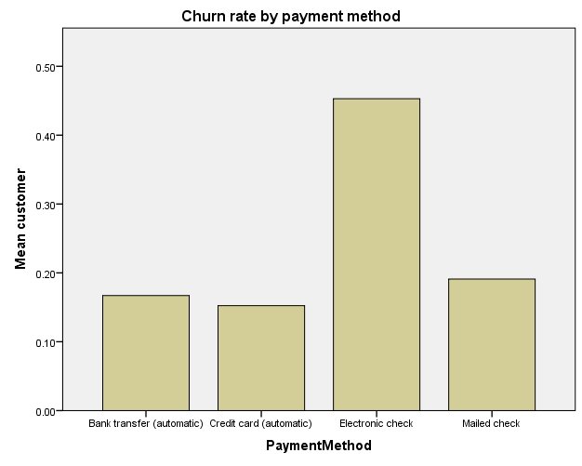

* Chart Builder.
GGRAPH
/GRAPHDATASET NAME="graphdataset" VARIABLES=InternetService[LEVEL=NOMINAL] MEAN(churn_flag)[name="MEAN_churn_flag"] MISSING=LISTWISE REPORTMISSING=NO
/GRAPHSPEC SOURCE=INLINE.
BEGIN GPL
SOURCE: s=userSource(id("graphdataset"))
DATA: InternetService=col(source(s), name("InternetService"), unit.category())
DATA: MEAN_churn_flag=col(source(s), name("MEAN_churn_flag"))
GUIDE: axis(dim(1), label("InternetService"))
GUIDE: axis(dim(2), label("Mean customer"))
GUIDE: text.title(label("Churn rate by internet service"))
SCALE: linear(dim(2), include(0))
ELEMENT: interval(position(InternetService*MEAN_churn_flag), shape.interior(shape.square))
END GPL.

GGraph

Notes
Output Created |  | 06-NOV-2026 15:13:02
Comments
Input | Data | C:\Users\faazm\Downloads\telco_churn.sav
Input | Active Dataset | DataSet1
Input | File Label | IBM Telco Customer Churn
Input | Filter | <none>
Input | Weight | <none>
Input | Split File | <none>
Input | N of Rows in Working Data File | 7043
Syntax |  | GGRAPH  /GRAPHDATASET NAME="graphdataset" VARIABLES=InternetService[LEVEL=NOMINAL] MEAN(churn_flag)[name="MEAN_churn_flag"] MISSING=LISTWISE REPORTMISSING=NO  /GRAPHSPEC SOURCE=INLINE.  BEGIN GPL  SOURCE: s=userSource(id("graphdataset"))  DATA: InternetService=col(source(s), name("InternetService"), unit.category())  DATA: MEAN_churn_flag=col(source(s), name("MEAN_churn_flag"))  GUIDE: axis(dim(1), label("InternetService"))  GUIDE: axis(dim(2), label("Mean customer"))  GUIDE: text.title(label("Churn rate by internet service"))  SCALE: linear(dim(2), include(0))  ELEMENT: interval(position(InternetService*MEAN_churn_flag), shape.interior(shape.square))  END GPL.
Resources | Processor Time | 00:00:00.00
Resources | Elapsed Time | 00:00:00.08

[DataSet1] C:\Users\faazm\Downloads\telco_churn.sav

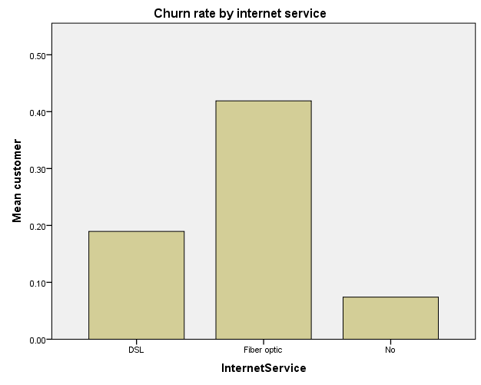

* Chart Builder.
GGRAPH
/GRAPHDATASET NAME="graphdataset" VARIABLES=Churn[LEVEL=NOMINAL] MonthlyCharges MISSING=LISTWISE REPORTMISSING=NO
/GRAPHSPEC SOURCE=INLINE.
BEGIN GPL
SOURCE: s=userSource(id("graphdataset"))
DATA: Churn=col(source(s), name("Churn"), unit.category())
DATA: MonthlyCharges=col(source(s), name("MonthlyCharges"))
DATA: id=col(source(s), name("$CASENUM"), unit.category())
GUIDE: axis(dim(1), label("Customer churned"))
GUIDE: axis(dim(2), label("Monthly charges"))
GUIDE: text.title(label("Monthly charges by churn status"))
SCALE: linear(dim(2), include(0))
ELEMENT: schema(position(bin.quantile.letter(Churn*MonthlyCharges)), label(id))
END GPL.

GGraph

Notes
Output Created |  | 06-NOV-2026 15:19:23
Comments
Input | Data | C:\Users\faazm\Downloads\telco_churn.sav
Input | Active Dataset | DataSet1
Input | File Label | IBM Telco Customer Churn
Input | Filter | <none>
Input | Weight | <none>
Input | Split File | <none>
Input | N of Rows in Working Data File | 7043
Syntax |  | GGRAPH  /GRAPHDATASET NAME="graphdataset" VARIABLES=Churn[LEVEL=NOMINAL] MonthlyCharges MISSING=LISTWISE REPORTMISSING=NO  /GRAPHSPEC SOURCE=INLINE.  BEGIN GPL  SOURCE: s=userSource(id("graphdataset"))  DATA: Churn=col(source(s), name("Churn"), unit.category())  DATA: MonthlyCharges=col(source(s), name("MonthlyCharges"))  DATA: id=col(source(s), name("$CASENUM"), unit.category())  GUIDE: axis(dim(1), label("Customer churned"))  GUIDE: axis(dim(2), label("Monthly charges"))  GUIDE: text.title(label("Monthly charges by churn status"))  SCALE: linear(dim(2), include(0))  ELEMENT: schema(position(bin.quantile.letter(Churn*MonthlyCharges)), label(id))  END GPL.
Resources | Processor Time | 00:00:00.02
Resources | Elapsed Time | 00:00:00.10

[DataSet1] C:\Users\faazm\Downloads\telco_churn.sav

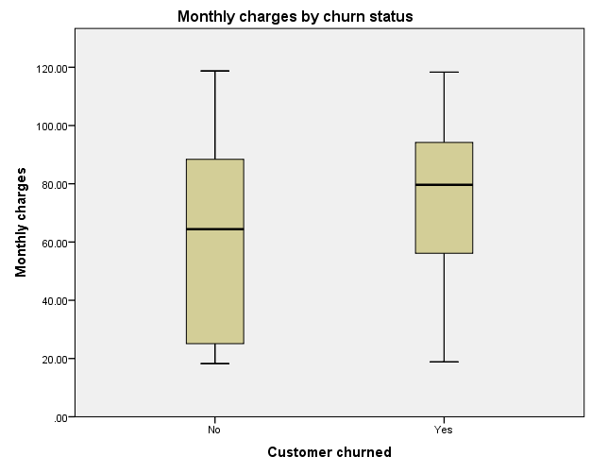

* Chart Builder.
GGRAPH
/GRAPHDATASET NAME="graphdataset" VARIABLES=tenure_band COUNT()[name="COUNT"] MISSING=LISTWISE REPORTMISSING=NO
/GRAPHSPEC SOURCE=INLINE.
BEGIN GPL
SOURCE: s=userSource(id("graphdataset"))
DATA: tenure_band=col(source(s), name("tenure_band"), unit.category())
DATA: COUNT=col(source(s), name("COUNT"))
GUIDE: axis(dim(1), label("tenure_band"))
GUIDE: axis(dim(2), label("Count"))
SCALE: cat(dim(1), include("1.00", "2.00", "3.00", "4.00"))
SCALE: linear(dim(2), include(0))
ELEMENT: interval(position(tenure_band*COUNT), shape.interior(shape.square))
END GPL.

GGraph

Notes
Output Created |  | 06-NOV-2026 15:20:37
Comments
Input | Data | C:\Users\faazm\Downloads\telco_churn.sav
Input | Active Dataset | DataSet1
Input | File Label | IBM Telco Customer Churn
Input | Filter | <none>
Input | Weight | <none>
Input | Split File | <none>
Input | N of Rows in Working Data File | 7043
Syntax |  | GGRAPH  /GRAPHDATASET NAME="graphdataset" VARIABLES=tenure_band COUNT()[name="COUNT"] MISSING=LISTWISE REPORTMISSING=NO  /GRAPHSPEC SOURCE=INLINE.  BEGIN GPL  SOURCE: s=userSource(id("graphdataset"))  DATA: tenure_band=col(source(s), name("tenure_band"), unit.category())  DATA: COUNT=col(source(s), name("COUNT"))  GUIDE: axis(dim(1), label("tenure_band"))  GUIDE: axis(dim(2), label("Count"))  SCALE: cat(dim(1), include("1.00", "2.00", "3.00", "4.00"))  SCALE: linear(dim(2), include(0))  ELEMENT: interval(position(tenure_band*COUNT), shape.interior(shape.square))  END GPL.
Resources | Processor Time | 00:00:00.02
Resources | Elapsed Time | 00:00:00.10

[DataSet1] C:\Users\faazm\Downloads\telco_churn.sav



