Create a repository and access it using the terminal



Use the cheat-sheet commands to link the local repository to your git



Create a file student.txt and include your Student Name & Student ID

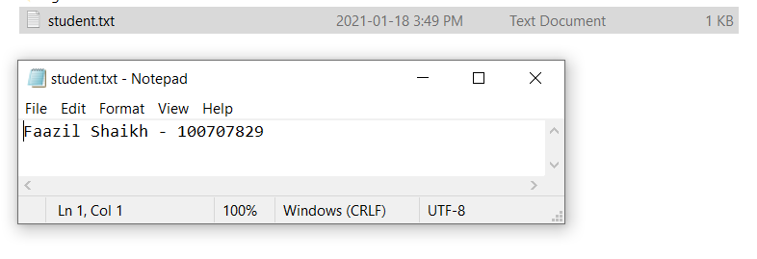

Use git status

Commit Changes

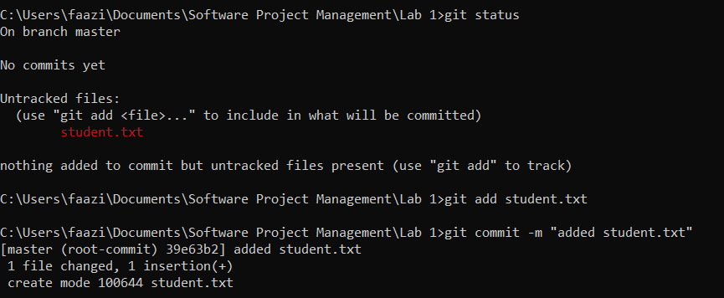

Create a new branch using git branch

Create a BranchExample.txt file

Use git add for update branch example and commit

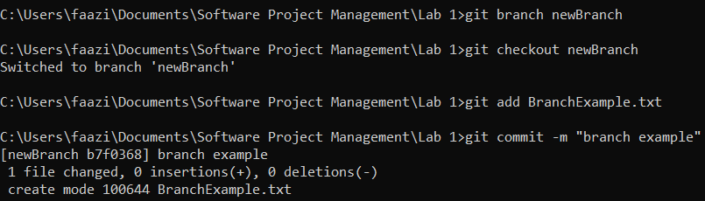

Switch back to master branch

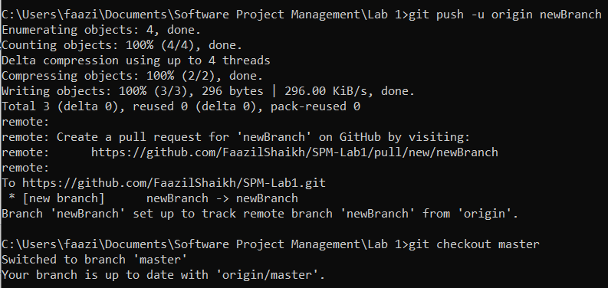

Remove RemoveExample.txt

Commit



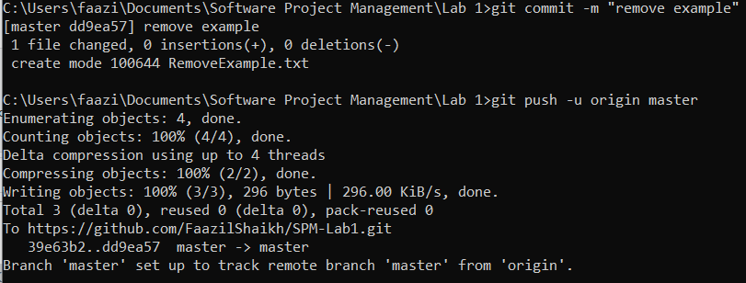

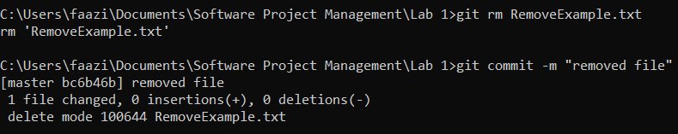

Use git status and screenshot outcome

