Homework_2

2024-12-09

View(weather)

## Warning: Paket 'tidyverse' wurde unter R Version 4.2.3 erstellt

## Warning: Paket 'ggplot2' wurde unter R Version 4.2.3 erstellt

## Warning: Paket 'tibble' wurde unter R Version 4.2.3 erstellt

## Warning: Paket 'tidyr' wurde unter R Version 4.2.3 erstellt

## Warning: Paket 'readr' wurde unter R Version 4.2.3 erstellt

## Warning: Paket 'purrr' wurde unter R Version 4.2.3 erstellt

## Warning: Paket 'dplyr' wurde unter R Version 4.2.3 erstellt

## Warning: Paket 'forcats' wurde unter R Version 4.2.3 erstellt

## Warning: Paket 'lubridate' wurde unter R Version 4.2.3 erstellt

## ── Attaching core tidyverse packages ──────────────────────── tidyverse 2.0.0 ──  
## ✔ dplyr 1.1.4 ✔ readr 2.1.4  
## ✔ forcats 1.0.0 ✔ stringr 1.5.0  
## ✔ ggplot2 3.5.1 ✔ tibble 3.2.1  
## ✔ lubridate 1.9.3 ✔ tidyr 1.3.1  
## ✔ purrr 1.0.1   
## ── Conflicts ────────────────────────────────────────── tidyverse_conflicts() ──  
## ✖ dplyr::filter() masks stats::filter()  
## ✖ dplyr::lag() masks stats::lag()  
## ℹ Use the ]8;;http://conflicted.r-lib.org/conflicted package]8;; to force all conflicts to become errors

## Warning: Paket 'nycflights13' wurde unter R Version 4.2.3 erstellt

## Warning: Paket 'ggridges' wurde unter R Version 4.2.3 erstellt

## # A tibble: 6 × 15  
## origin year month day hour temp dewp humid wind_dir wind_speed wind_gust  
## <chr> <int> <int> <int> <int> <dbl> <dbl> <dbl> <dbl> <dbl> <dbl>  
## 1 EWR 2013 1 1 1 39.0 26.1 59.4 270 10.4 NA  
## 2 EWR 2013 1 1 2 39.0 27.0 61.6 250 8.06 NA  
## 3 EWR 2013 1 1 3 39.0 28.0 64.4 240 11.5 NA  
## 4 EWR 2013 1 1 4 39.9 28.0 62.2 250 12.7 NA  
## 5 EWR 2013 1 1 5 39.0 28.0 64.4 260 12.7 NA  
## 6 EWR 2013 1 1 6 37.9 28.0 67.2 240 11.5 NA  
## # ℹ 4 more variables: precip <dbl>, pressure <dbl>, visib <dbl>,  
## # time_hour <dttm>

## # A tibble: 9 × 2  
## month cold_days  
## <int> <int>  
## 1 1 32  
## 2 2 29  
## 3 3 32  
## 4 4 22  
## 5 5 12  
## 6 9 3  
## 7 10 12  
## 8 11 28  
## 9 12 28

## # A tibble: 1 × 1  
## total_missing  
## <int>  
## 1 8255

## # A tibble: 1 × 20  
## total_missing_dep_time year month day dep_time sched_dep_time dep_delay  
## <int> <int> <int> <int> <int> <int> <int>  
## 1 0 0 0 0 521 0 521  
## # ℹ 13 more variables: arr_time <int>, sched_arr_time <int>, arr_delay <int>,  
## # carrier <int>, flight <int>, tailnum <int>, origin <int>, dest <int>,  
## # air_time <int>, distance <int>, hour <int>, minute <int>, time_hour <int>

## # A tibble: 1 × 4  
## total_missing_dep_time missing_sched_dep_time missing_arr_time  
## <int> <int> <int>  
## 1 521 0 521  
## # ℹ 1 more variable: missing_air_time <int>

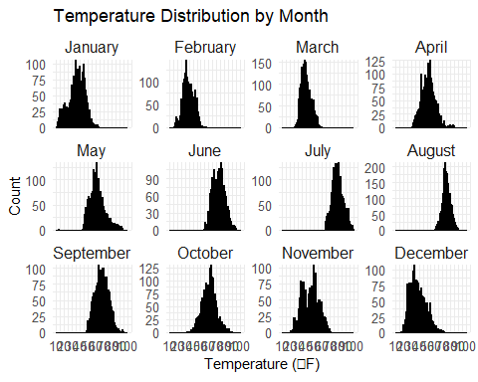

## Picking joint bandwidth of 1.58

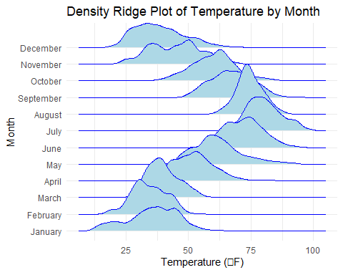

## Warning: Using `size` aesthetic for lines was deprecated in ggplot2 3.4.0.  
## ℹ Please use `linewidth` instead.  
## This warning is displayed once every 8 hours.  
## Call `lifecycle::last_lifecycle_warnings()` to see where this warning was  
## generated.

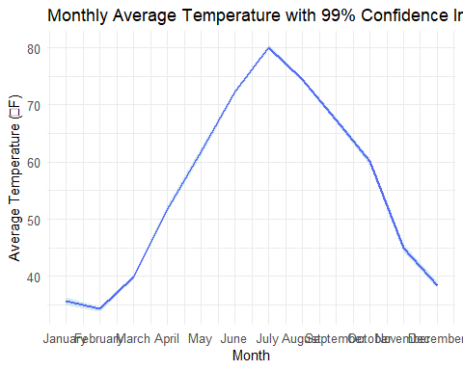

## R Markdown

This is an R Markdown document. Markdown is a simple formatting syntax for authoring HTML, PDF, and MS Word documents.

When you click the Knit button a document will be generated that includes both content as well as the output of any embedded R code chunks within the document. You can embed an R code chunk like this:

summary(cars)

## speed dist   
## Min. : 4.0 Min. : 2.00   
## 1st Qu.:12.0 1st Qu.: 26.00   
## Median :15.0 Median : 36.00   
## Mean :15.4 Mean : 42.98   
## 3rd Qu.:19.0 3rd Qu.: 56.00   
## Max. :25.0 Max. :120.00

## Including Plots

You can also embed plots, for example:



Note that the echo = FALSE parameter was added to the code chunk to prevent printing of the R code that generated the plot.