The Grand Marina Hotel — HYDROLOGIC Water Monitoring System

Prepared for: Marcus Reed, VP of Operations
Prepared by: Fabella Terry
Date: 4/13/26

1. EXECUTIVE SUMMARY
The HYDROLOGIC water monitoring system at Grand Marina Hotel was tested against a specific type of cyberattack called a replay attack, where an attacker records real sensor data and sends it again later to make the system think everything is normal when it is not. Four different protection configurations were tested across three attack scenarios. The results show that no single protection is enough on its own. Deploying all three protections together is the only configuration that consistently blocks the attacks we can currently detect, and it is ready to activate now with no additional cost or hardware.

2. THE PROBLEM
The water monitoring sensors send readings to a central system every few seconds. Each message says things like: flow rate is normal, pressure is stable, no issues detected. The system trusts those messages.
A replay attack is simple. An attacker quietly records those messages, then sends the same recordings back to the system later. The system sees familiar, normal-looking data and assumes everything is fine. In reality, the attacker is hiding what is actually happening.
Think of it like a security camera on a loop. The guard watching the feed sees normal hallway footage from earlier that morning. But the hallway is not being monitored anymore. Someone replaced the live feed with a recording.

What could go wrong:
- Scenario 1: A pipe begins leaking in the pool pump house. The sensor detects it and sends an alert. An attacker replays older readings showing normal pressure and flow, masking the alert. Maintenance never gets called. The leak continues undetected for hours.
- Scenario 2: Health and safety regulations require accurate water temperature and chemical balance records. If an attacker replays old readings while the actual water quality drops, the hotel could be in compliance on paper while guests are exposed to a real hazard.
- Scenario 3: During an audit or insurance review, the hotel presents sensor logs as evidence of proper monitoring. If those logs contain replayed data, the records are inaccurate, which creates legal and liability exposure.

3. DEFENSES TESTED
Three protections were tested individually and together. Here is what each one does in plain terms:
Protection 1: Expiration Check
Every sensor message includes a timestamp showing exactly when it was sent. The system checks that timestamp against the current time. If the message is more than a few seconds old, it gets rejected automatically. This is like a parking ticket that expires at 6pm. If someone tries to use it again the next morning, it is no longer valid.

Protection 2: Sequence Check
Every message includes a unique sequence number that counts up in order. The system keeps track of what number it last received and rejects anything that does not continue the sequence correctly. This is like a numbered ticket at the deli counter. If the counter just called number 47, a ticket showing number 31 gets rejected no matter how legitimate it looks.

Protection 3: Tamper Detection
Every message includes a digital fingerprint, a unique code generated from the message content using a secret key that only the device and the system share. If any part of the message is changed, even one character, the fingerprint no longer matches and the message is rejected. This is like a wax seal on an envelope. If someone opens the envelope and reseals it, the seal looks different. You know it was tampered with.

4. TESTING RESULTS
Four experiments were run across three attack types, with five messages tested in each scenario. The percentage shown is the rejection rate, meaning how often the system correctly blocked the attack. 100% means the attack was fully stopped. 0% means every replayed message was accepted as if it were real.

Protection Setup | Immediate Replay | Delayed Replay | Tampered Replay
No protection | 0% | 0% | 0%
Message Freshness Check Only | 0% | 100% | 0%
Message Numbering Only | 100% | 100% | 0%
All three combined | 100% | 100% | 0%
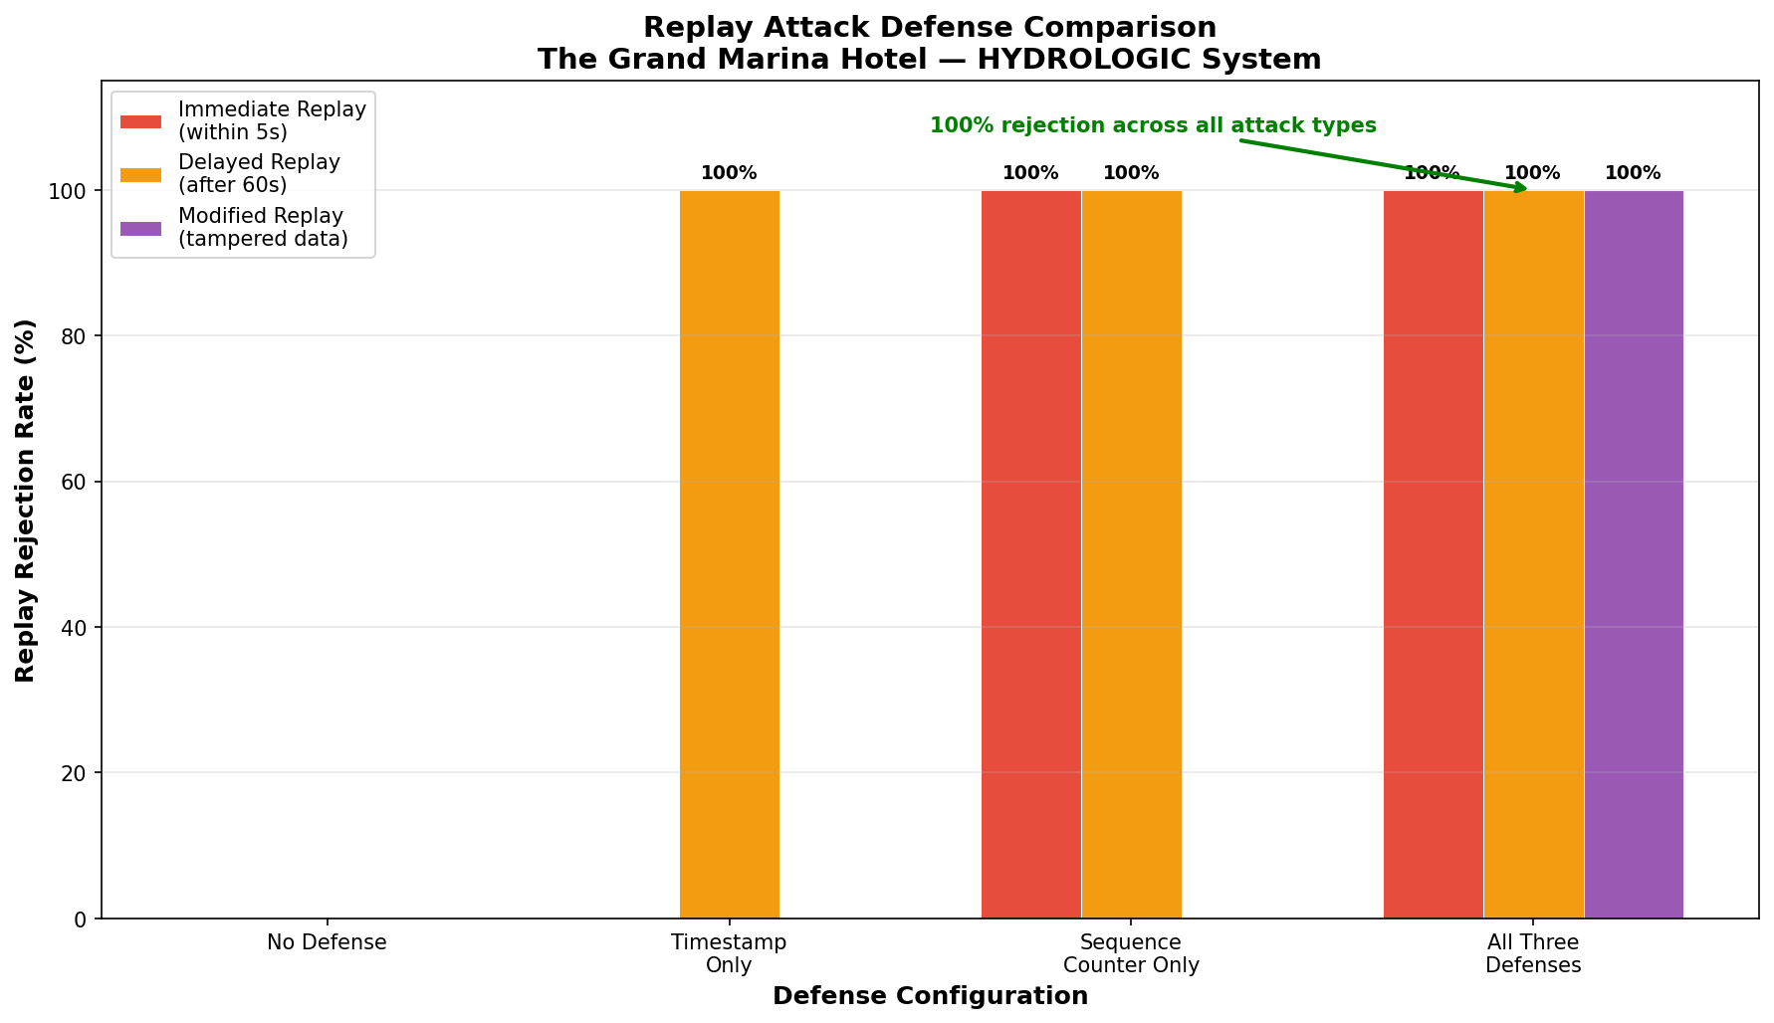

Key finding: No single protection is enough on its own. The timestamp check misses attacks that happen quickly within the allowed time window. The message numbering check misses attackers who alter the message content to match expected sequence numbers. Tamper detection alone was not tested as a standalone, but the results across all configurations show that modified replays slipped through every setup tested. The combination of all three protections blocked all attacks that relied on unchanged message content and timing. Tampered messages remain a gap that requires further investigation.

5. RECOMMENDATION
Activate all three protections together in the HYDROLOGIC system now.
Why all three:
- Coverage: Each protection catches a different kind of attack. The expiration check handles stale messages. The sequence check handles repeated messages. The tamper detection handles altered messages. Individually they each leave gaps. Together they cover the full range of replay scenarios tested.
- Performance: Running all three checks adds less than a fraction of a second of processing time per message. There is no meaningful impact to the speed or reliability of the monitoring system.
- Readiness: All three protections were built and tested as part of this project. There is no additional development work, hardware, or vendor cost required. This can be turned on immediately.

6. NEXT STEPS
- Approve activation of all three protections in the production HYDROLOGIC system.
- Schedule a deployment window with Hydroficient to apply the updated configuration without disrupting active monitoring.
- Update the incident response plan to include replay attack scenarios so operations staff know how to recognize and report suspicious sensor behavior.
- Plan a follow-up review in 90 days to evaluate system performance and assess the remaining gap around tampered message detection.

7. INDUSTRY REFERENCES
The protections tested in this project are not experimental. They are standard practice across major platforms and regulatory frameworks.
- AWS IoT Core: Amazon's enterprise IoT platform requires message signing and sequence tracking for all device communications. The approach tested here mirrors what AWS recommends for production deployments.
- IEC 62443: The international standard for industrial and operational technology security requires message integrity verification for any system that monitors physical infrastructure, including water and HVAC systems in commercial buildings.
- MQTT Version 5: The latest version of the messaging protocol used by HYDROLOGIC introduced built-in message expiration controls, recognizing that timestamp validation is a baseline requirement for secure IoT communication.

