Part 1: Your Hypotheses
Before running any experiments, predict the rejection rate for each defense configuration against each attack type. Write a percentage (0% or 100%) in each cell.
Experiment | Immediate Replay | Delayed Replay | Modified Replay
No defense | 0% | 0% | 0%
Timestamp only | 0% | 0% | 0%
Counter only | 100% | 0% | 100%
All defenses | 100% | 100% | 100%

Part 2: Experiment Results

Experiment 1: No Defense (Baseline)
Attack Type | Accepted | Rejected | Rejection Rate
Immediate replay | 5 | 0 | 0%
Delayed replay | 5 | 0 | 0%
Modified replay | 5 | 0 | 0%

Experiment 2: Timestamp Only
Attack Type | Accepted | Rejected | Rejection Rate
Immediate replay | 5 | 0 | 0%
Delayed replay | 0 | 5 | 100%
Modified replay | 5 | 0 | 0%

Experiment 3: Counter Only
Attack Type | Accepted | Rejected | Rejection Rate
Immediate replay | 0 | 5 | 100%
Delayed replay | 0 | 5 | 100%
Modified replay | 5 | 0 | 0%

Experiment 4: All Defenses
Attack Type | Accepted | Rejected | Rejection Rate
Immediate replay | 0 | 5 | 100%
Delayed replay | 0 | 5 | 100%
Modified replay | 5 | 0 | 0%

Part 3: Summary Table
Compile all your results into a single table:
Defense | Immediate Replay | Delayed Replay | Modified Replay
No defense | 0% | 0% | 0%
Timestamp only | 0% | 100% | 0%
Counter only | 100% | 100% | 0%
All defenses | 100% | 100% | 0%

Part 4: Screenshots
Terminal output (experiment summary):
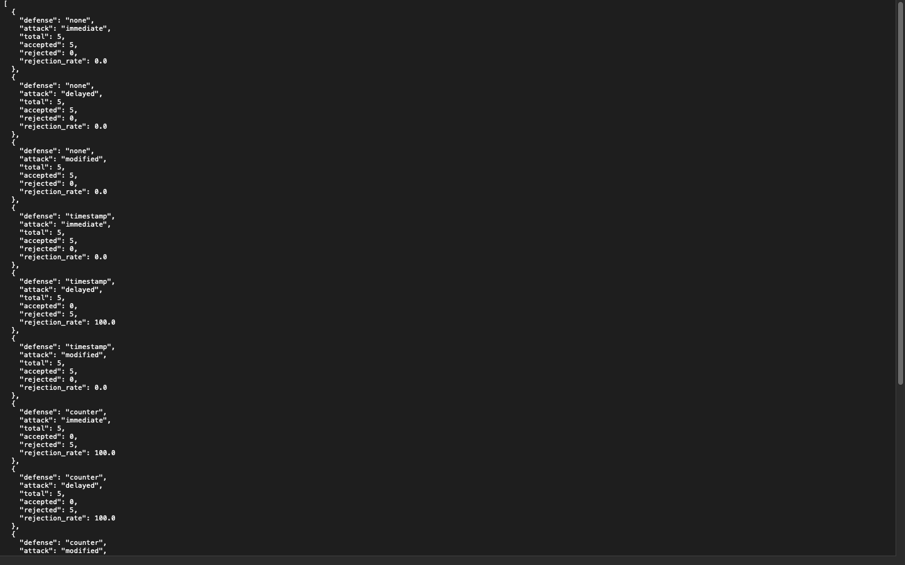

defense_comparison.png chart:
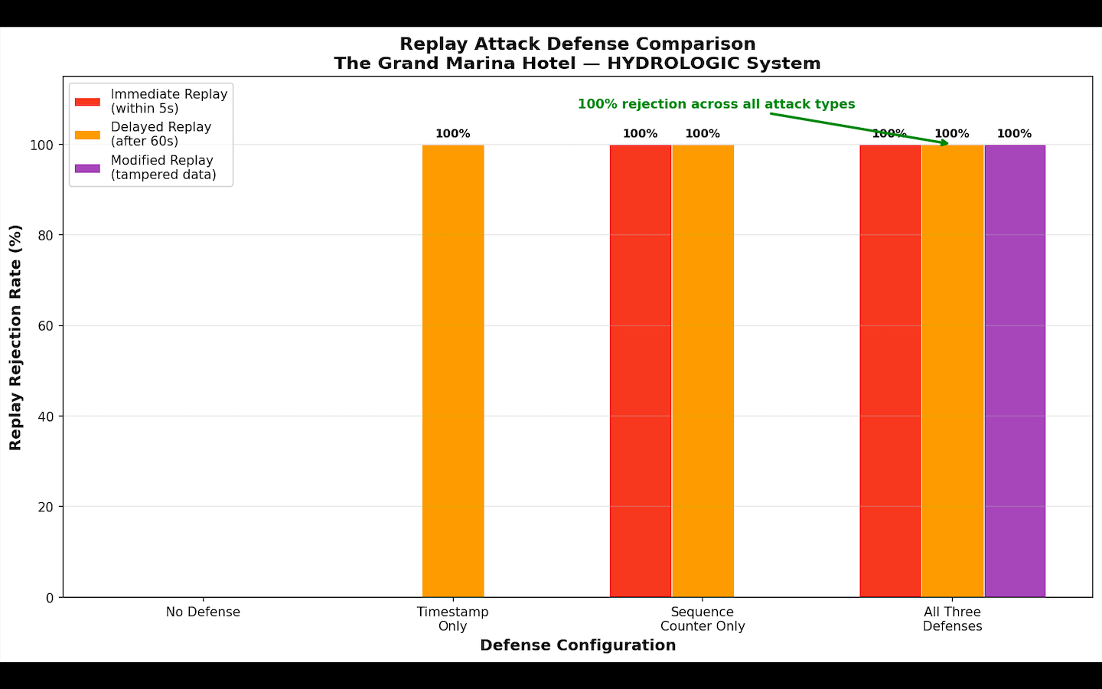

Part 5: Hypothesis Comparison
- Which predictions were correct? It was correct for only no defense

- Which results surprised you? Were there any attack/defense combinations you expected to block that didn't, or vice versa? Modified Replay defeated every defense including All Defenses. That means even combining timestamp and counter checks left a gap. Also Counter Only blocking Delayed Replay was likely unexpected since counters are sequence-based not time-based.

- Why did individual defenses have gaps? Think about what each defense checks and what it doesn't.Timestamp only checks if the message is recent but has no memory of what messages were already seen, so immediate replays within the time window slip through. Counter only tracks sequence numbers but if an attacker replays a message with a new counter value that falls in sequence, it passes. Modified replay defeats both because the attacker changes enough of the payload to look like a fresh legitimate

