Certificate Generation
Fabella Terry

Project 5 : Deliverables/Artifacts

Certificate Generation
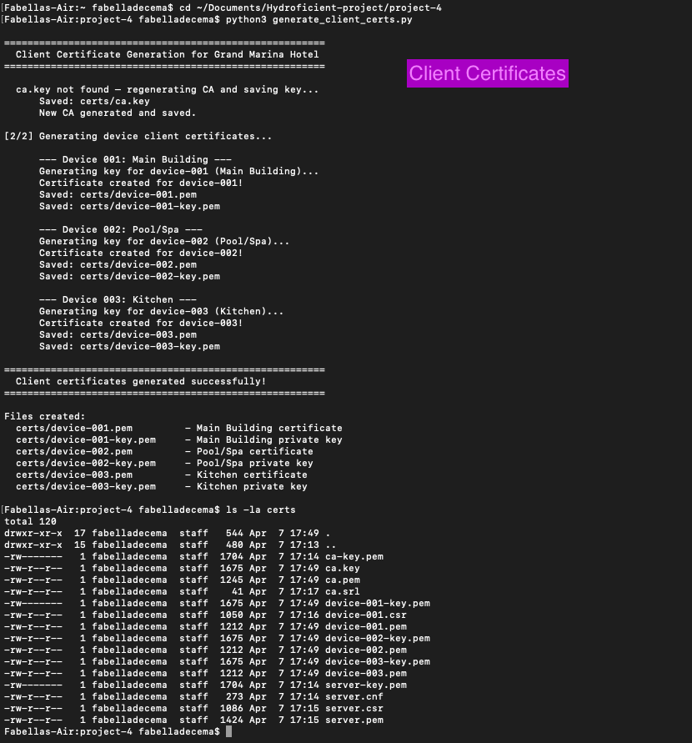

Broker Startup
Broker Startup
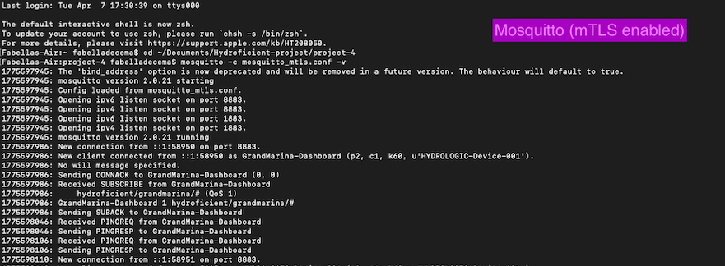

Subscriber/Publisher Connection
Subscriber/Publisher Connection

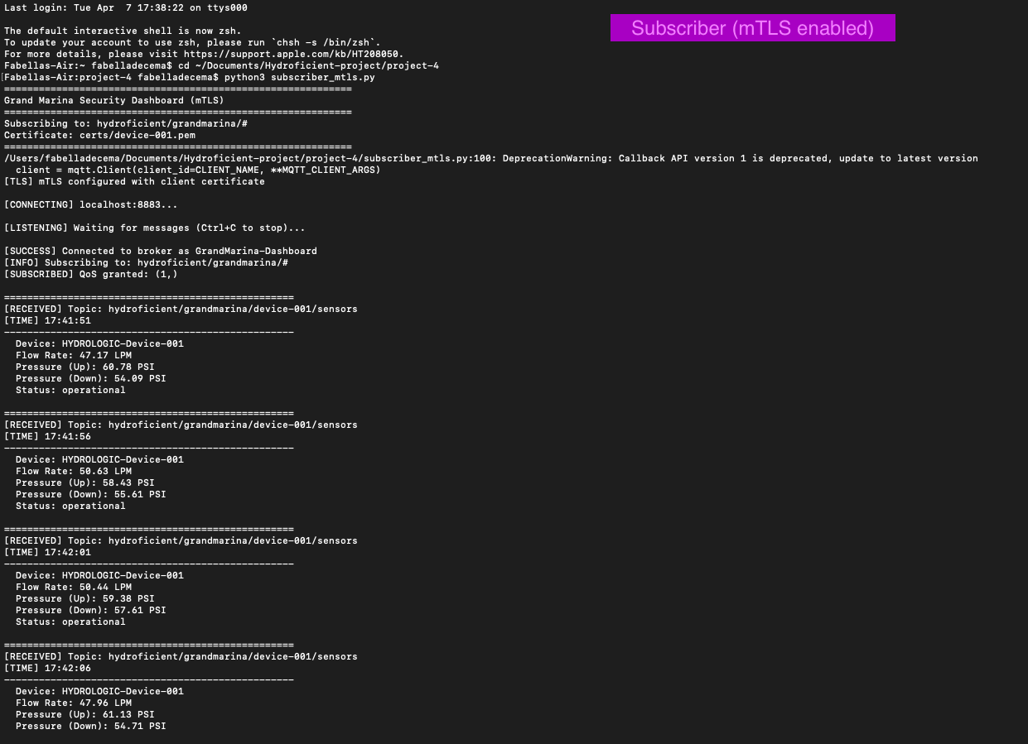

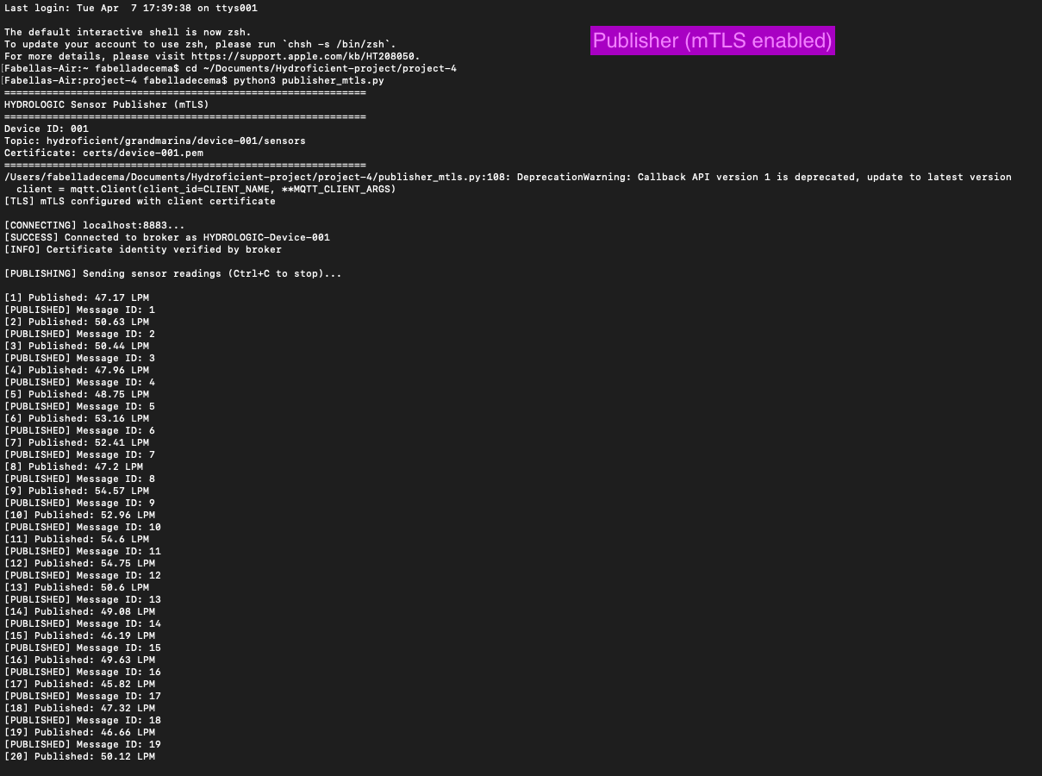

Rejection
Rejection Success

