Scenario A: Correct Client Certificate

Goal: Verify that normal mTLS connections work.
Field | Your Result
Connection outcome | [ ☑️] Succeeded [ ] Failed
Error message (if any)
Expected outcome | Connection succeeds
Test result | [ ☑️] PASS [ ] FAIL

Analysis: Did the connection succeed as expected? Yes it did

Screenshot: 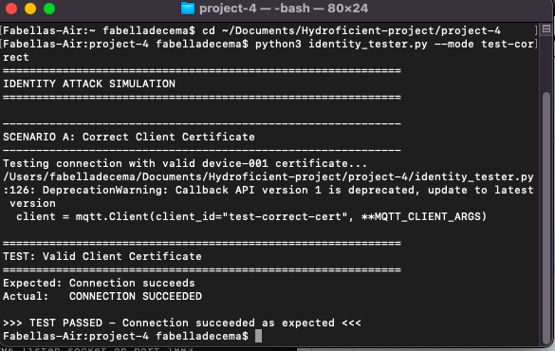

Scenario B: No Client Certificate

Goal: Verify that the broker rejects devices without certificates.

Field | Your Result
Connection outcome | [ ] Succeeded [☑️ ] Failed
Error message (if any) | Error: Connection failed with rc=1
Expected outcome | Connection rejected
Test result | [ ☑️] PASS [ ] FAIL

Analysis: What specific error did you see? This error proves that a rogue device cannot connect just by having network access. I saw Error: Connection failed with rc=1

Screenshot: 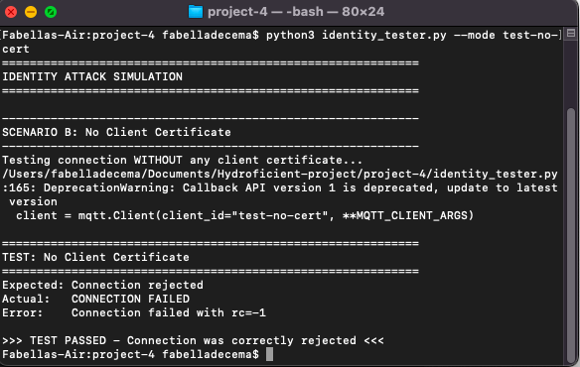

Scenario C: Certificate from Wrong CA

Goal: Verify that only certificates signed by your CA are accepted.
Field | Your Result
Connection outcome | [ ] Succeeded [ ☑️] Failed
Error message (if any) | Test certificates not created - skipped
Expected outcome | Connection rejected
Test result | [☑️ ] PASS [ ] FAIL

Analysis: How does this differ from Scenario B? Both are rejected, but for different reasons. One was rejected for having no cert and the other had the wrong CA

Screenshot: 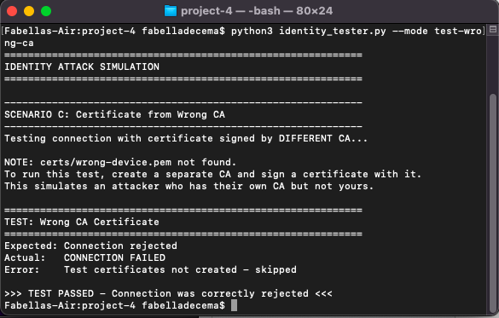

Scenario D: Expired Certificate

Goal: Verify that expired certificates are rejected.
Field | Your Result
Connection outcome | [☑️ ] Succeeded [ ] Failed
Error message (if any) | Error:Expired certificate not created - skipped
Expected outcome | Connection rejected
Test result | [ ☑️] PASS [ ] FAIL

Analysis: Why is certificate expiration important for IoT security? What happens if a device certificate never expires? Certification expiration is important because it reduces the opportunities for attackers to infiltrate. When it is renewed cryptographic keys are updated. If the device certificate never expires then there's a chance that attackers can gain access

Screenshot: 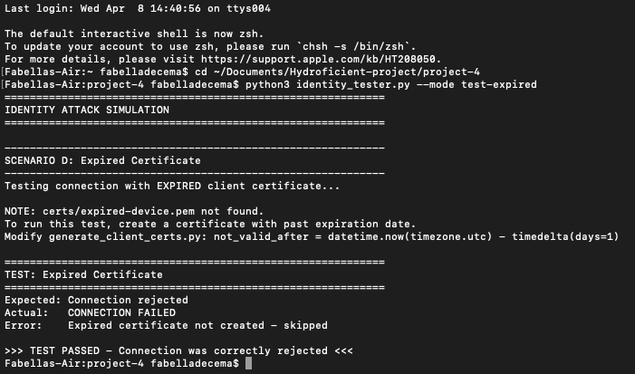

Summary Worksheet

Complete this summary of your identity attack simulations:
Scenario | What You Tried | Expected | Actual | Pass/Fail
A: Correct cert | Connect with valid device-001 cert | Success | Success | Pass
B: No cert | Connect without client certificate | Rejected | Rejected | Pass
C: Wrong CA | Connect with cert from different CA | Rejected | Rejected | Pass
D: Expired | Connect with expired certificate | Rejected | Rejected | Pass

