|  |  |  |
| --- | --- | --- |
|  | M1 | M2 |
| Center | 87% | 66% |
| 8 C | 65% | 58% |
| 16 C | 51% | 30% |
| 6 I | 56% | 48% |
| 6 A | 56% | 42% |
| 12 A | 47% | 31% |
| 6 B | 69% | 66% |
| 12 B | 45% | 46% |

**Supplemental Table S1.** Percentage of units showing a significant response (greater than baseline) at each of the 8 visual field positions during the presentation of a stimulus as S1 for each monkey.



**Supplemental Figure S1.** Extension of the receptive fields sizes along each visual meridian. The extent of the receptive fields were computed as the distance between two visual field positions to which a unit showed a significant (greater than baseline) response during the presentation of a visual stimulus as S1, separately for the vertical (**A**) and the horizontal (**B**) meridian. The data are separated per monkey (M1, green; M2, yellow; pooled data, black).

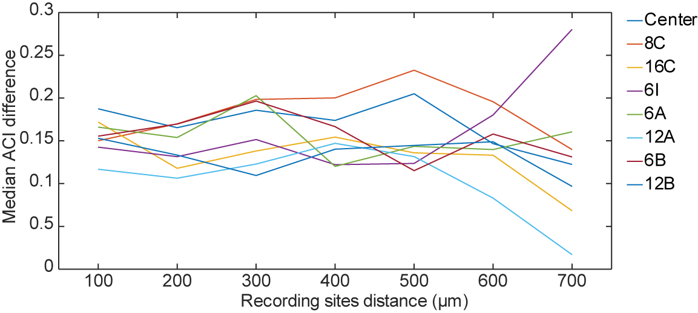

**Supplemental Figure S2.** Median difference of the ACI values as a function of the distance between recording sites. The absolute values of the differences in ACI for all channel pairs were computed separately for each recording session. Then, the resulting values were grouped based on the distance between the channels across all sessions and the median difference was computed. The analysis was performed for all conditions in which S2 was presented at the foveal position. Each color corresponds to a different S1 position (see insert).