Marissa Cleroux

Date: October 11th, 2024

Course: Web Programming I

Gatineau Tours Park Website Design Plan

Your Ultimate Outdoor Adventure Awaits

## Gatineau Park Tours

Gatineau Park Tours provides guided tours. The company offers tours to a range of athletes from novice to elite, including hikers, trail runners, and mountain bikers. Clients can add on a fully catered gourmet meal with locally sourced ingredients. The tours are all the fun and none of the grueling aspects of outdoor adventures; except of course, “Type 2” fun which is both grueling and fun.

## The Website

### Purpose

Gatineau Park Tours is new in the region and hopes to make a name for itself and reach its intended audience. The website will provide information about the company and its origins, a form for booking tours, and information about the specific tours offered.

### Target Audience

The target audience for the Gatineau Park Tours is any level of active outdoor enthusiast who hikes, trail runs, or mountain bikes because these are the services offered. The company also targets “foodies” by offering gourmet food services on the adventures. Gatineau Park Tours caters to anyone who has these interests and not anyone of a specific age group, gender, or race.

### Planned Pages

#### Home

The “Home” page will give prospective clients an introduction to Gatineau Park Tours. The home page will showcase photos taken on tours and what they can expect on a tour.

#### About Us

The “About Us” page describes the history and mission of Gatineau Park Tours. It will aim to show how Gatineau Park Tours stands apart from other services by providing gear, gourmet meals, high standards of safety, and local expertise.

#### Tours

The “Tours” page promotes all available tours offered by Gatineau Park. All tours will be displayed with photos taken on each of the adventures. There will also be more information about mountain biking and the gourmet food add-ons available.

#### Booking

The “Booking” page will be a form that allows clients to make a booking for an adventure. The form will be clear and easy to use for a client of any technical ability.

### Logo

The logo for Gatineau Park Tours is a simple forest icon, an image obtained from [Flaticon](https://www.flaticon.com/free-icon/forest_2118256) and created by Victoruler. This image is free for personal and commercial purposes with attribution.

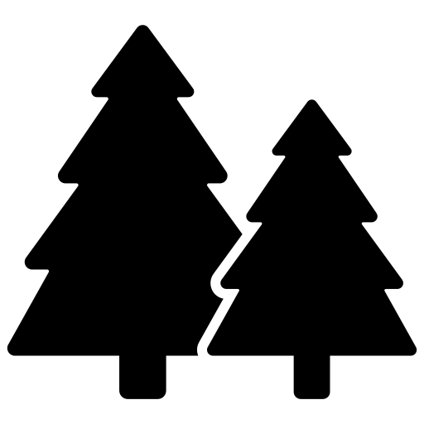

### Colour Palette

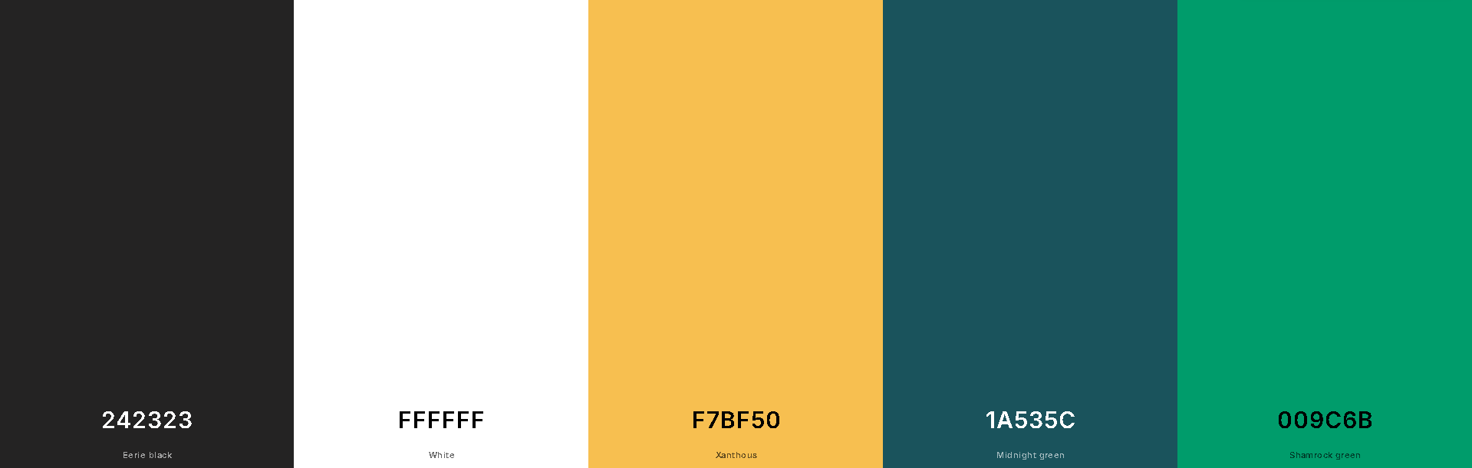

This colour palette was generated using https://coolors.org. The colours are a bright mix of natural colours to appeal to active, outdoor enthusiasts.

### Website Banner

### Mobile Layout

### Desktop Layout

