Inputs
- Patient Name
- Patient Age
- Patient ID

Processes
- Validate patient name input
- Validate patient age input
- Validate patient ID input
- Display registration confirmation
Outputs
- Patient details displayed
- Patient registration success message

Pseudocode
BEGIN

INPUT patient_name

WHILE patient_name is blank
DISPLAY "Invalid name"
INPUT patient_name
END WHILE

INPUT patient_age

WHILE patient_age <= 0
DISPLAY "Invalid age"
INPUT patient_age
END WHILE

INPUT patient_id

WHILE patient_id is blank
DISPLAY "Invalid ID"
INPUT patient_id
END WHILE

DISPLAY patient_name
DISPLAY patient_age
DISPLAY patient_id

DISPLAY "Patient Successfully Registered"

END

Flowchart
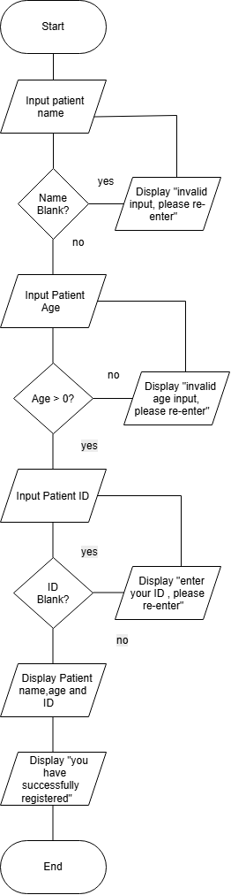

Python
def register_patient():

while True:
name = input("Enter Patient Name: ")

if name.strip() != "":
break

print("Error: Name cannot be blank.")

while True:
try:
age = int(input("Enter Patient Age: "))

if age > 0:
break

print("Error: Age must be positive.")

except ValueError:
print("Error: Please enter a valid number.")

while True:
patient_id = input("Enter Patient ID: ")

if patient_id.strip() != "":
break

print("Error: ID cannot be blank.")

print("\n===== PATIENT DETAILS =====")
print("Name:", name)
print("Age:", age)
print("ID:", patient_id)

print("\nPatient Successfully Registered!")

# Call the function
register_patient()

Screenshot Prompts

Prompt1
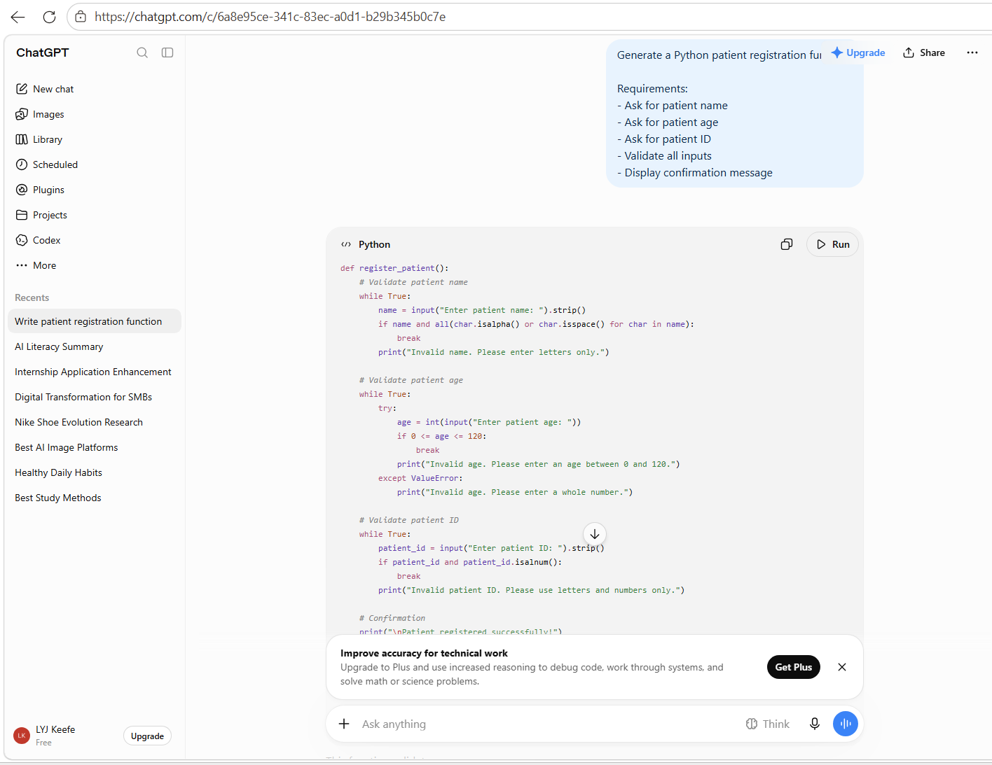

Prompt2
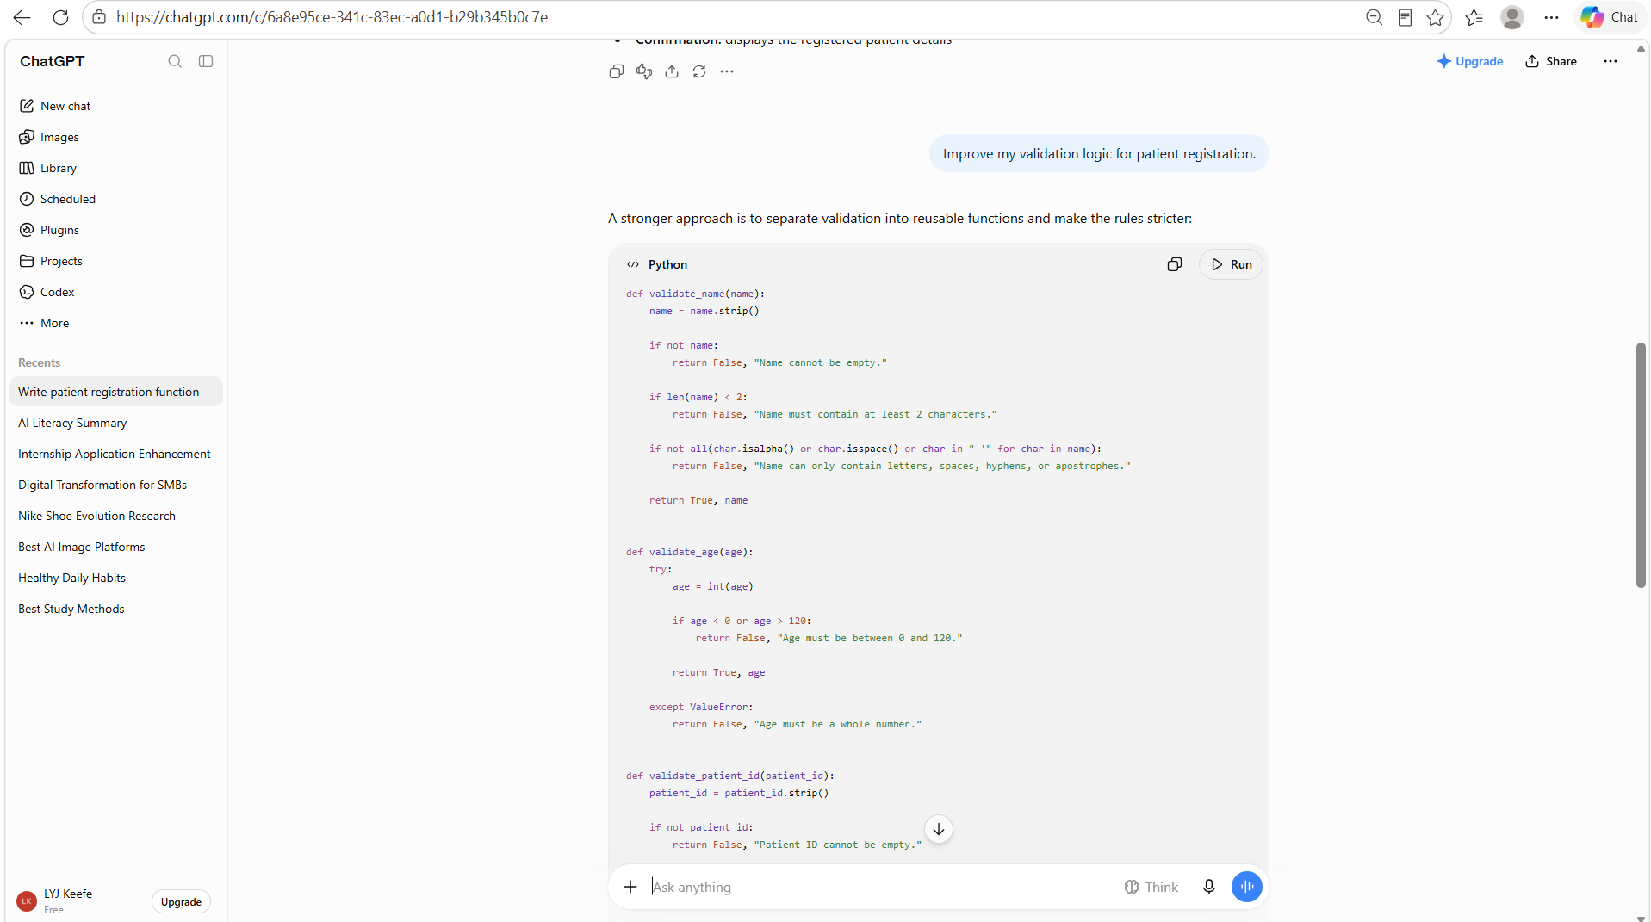
Prompt3
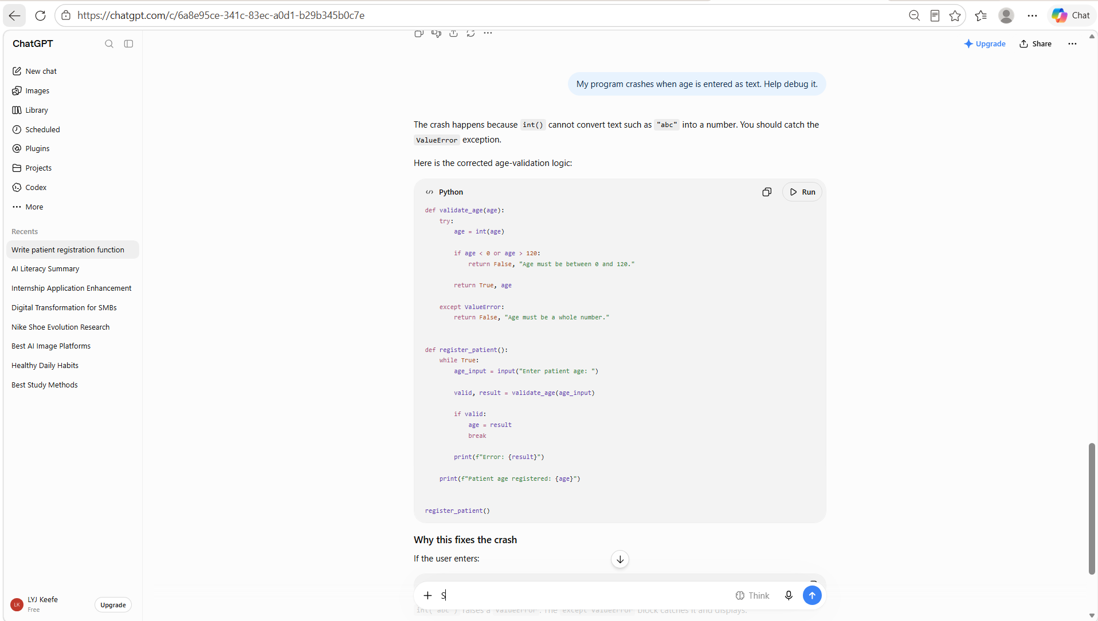

What I learnt
AI was used to assist in generating the initial Python code for the Register Patient function. The AI suggested input validation techniques, loop structures, and exception handling for invalid age inputs. AI was also used to debug issues encountered during testing and improve the user-friendliness of error messages.
Challenges Encountered
One challenge encountered was validating patient age when users entered letters instead of numbers. This caused the program to crash. AI assistance helped identify the issue and suggested the use of try-except statements to handle invalid inputs and prevent runtime errors.

Another challenge was ensuring that blank names and IDs were rejected. This was resolved using validation loops that repeatedly ask the user for valid input.

