Inputs
Department choice (GP or Specialist).
Preferred appointment date (YYYY-MM-DD format).

Processes
Prompt the user for a department and validate that the entry is either "GP" or "Specialist" (case-insensitive). Loop until valid.
Fetch the current date and calculate the minimum valid booking date (strictly more than 7 days in advance).
Prompt the user for a preferred date, validate that it matches the required date format, and verify that it is at least 8 days after the current date. Loop until valid.
Display a confirmation message with the finalized booking details once all inputs pass validation.

Outputs
Error messages for invalid inputs.
Booking confirmation displaying the selected department and confirmed appointment date.

Pseudocode
START Function BookAppointment
IMPORT datetime library

// Step 1: Input and Validate Department
REPEAT
DISPLAY "Choose Department (GP / Specialist):"
READ dept_input
CONVERT dept_input to uppercase
IF dept_input IS EQUAL TO "GP" OR dept_input IS EQUAL TO "SPECIALIST" THEN
dept = dept_input
VALID_DEPT = TRUE
ELSE
DISPLAY "Error: Invalid department. Choose either 'GP' or 'Specialist'."
VALID_DEPT = FALSE
ENDIF
UNTIL VALID_DEPT IS TRUE

// Step 2: Calculate Minimum Date (> 7 days from today)
today = GET_CURRENT_DATE()
min_date = today + 8 days

// Step 3: Input and Validate Appointment Date
REPEAT
DISPLAY "Enter preferred date (YYYY-MM-DD):"
READ date_input
TRY
booking_date = CONVERT date_input TO DATE
IF booking_date >= min_date THEN
VALID_DATE = TRUE
ELSE
DISPLAY "Error: Date must be more than 7 days from today."
VALID_DATE = FALSE
ENDIF
CATCH FormatError
DISPLAY "Error: Invalid date format. Please use YYYY-MM-DD."
VALID_DATE = FALSE
END TRY
UNTIL VALID_DATE IS TRUE

// Step 4: Display Confirmation
DISPLAY "[SUCCESS] Appointment Booked Successfully!"
DISPLAY "Department: " + dept + " | Date: " + booking_date
END Function

Python
import datetime

def book_appointment():
"""
Function 2: Book Appointment
Prompts for department and appointment date with validation logic.
"""
print("\n--- Book Appointment ---")

# Step 1: Input and validate department
while True:
dept = input("Choose Department (GP / Specialist): ").strip().upper()
if dept in ["GP", "SPECIALIST"]:
break
print("Error: Invalid department. Choose either 'GP' or 'Specialist'.")

# Step 2: Calculate minimum allowed date (strictly > 7 days from today)
today = datetime.date.today()
min_date = today + datetime.timedelta(days=8)

# Step 3: Input and validate date
while True:
date_str = input("Enter preferred date (YYYY-MM-DD): ").strip()
try:
booking_date = datetime.datetime.strptime(date_str, "%Y-%m-%d").date()
if booking_date >= min_date:
break
print(f"Error: Date must be more than 7 days from today (on or after {min_date}).")
except ValueError:
print("Error: Invalid date format. Please use YYYY-MM-DD.")

# Step 4: Display confirmation summary
print("\n[SUCCESS] Appointment Booked Successfully!")
print(f"Details: Department: {dept} | Date: {booking_date}")

# Execute function directly for testing
if __name__ == "__main__":
book_appointment()

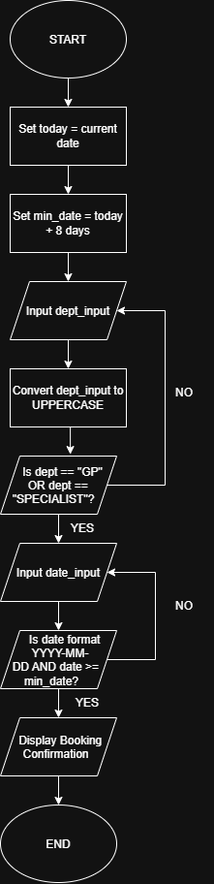
Flowchart

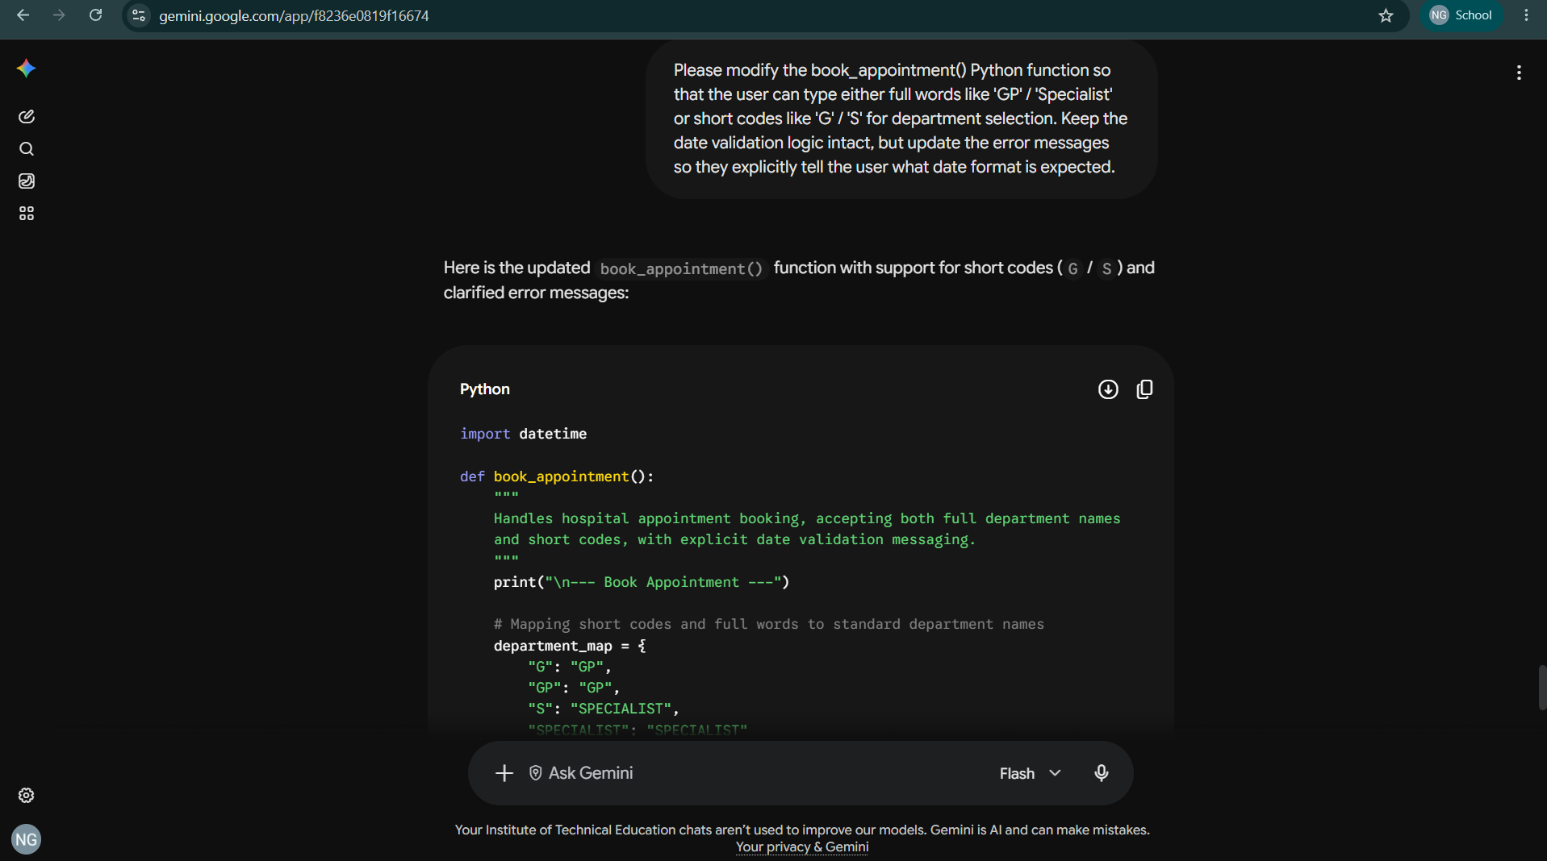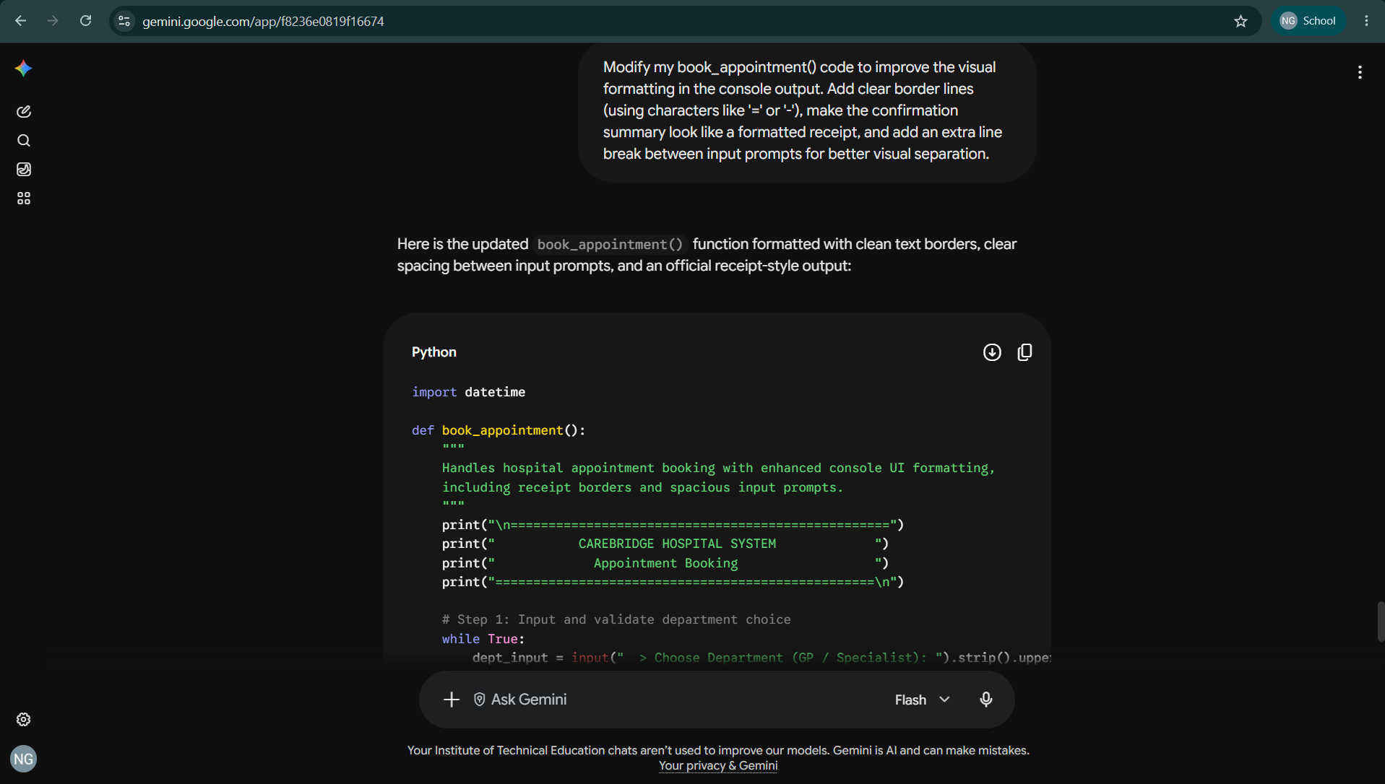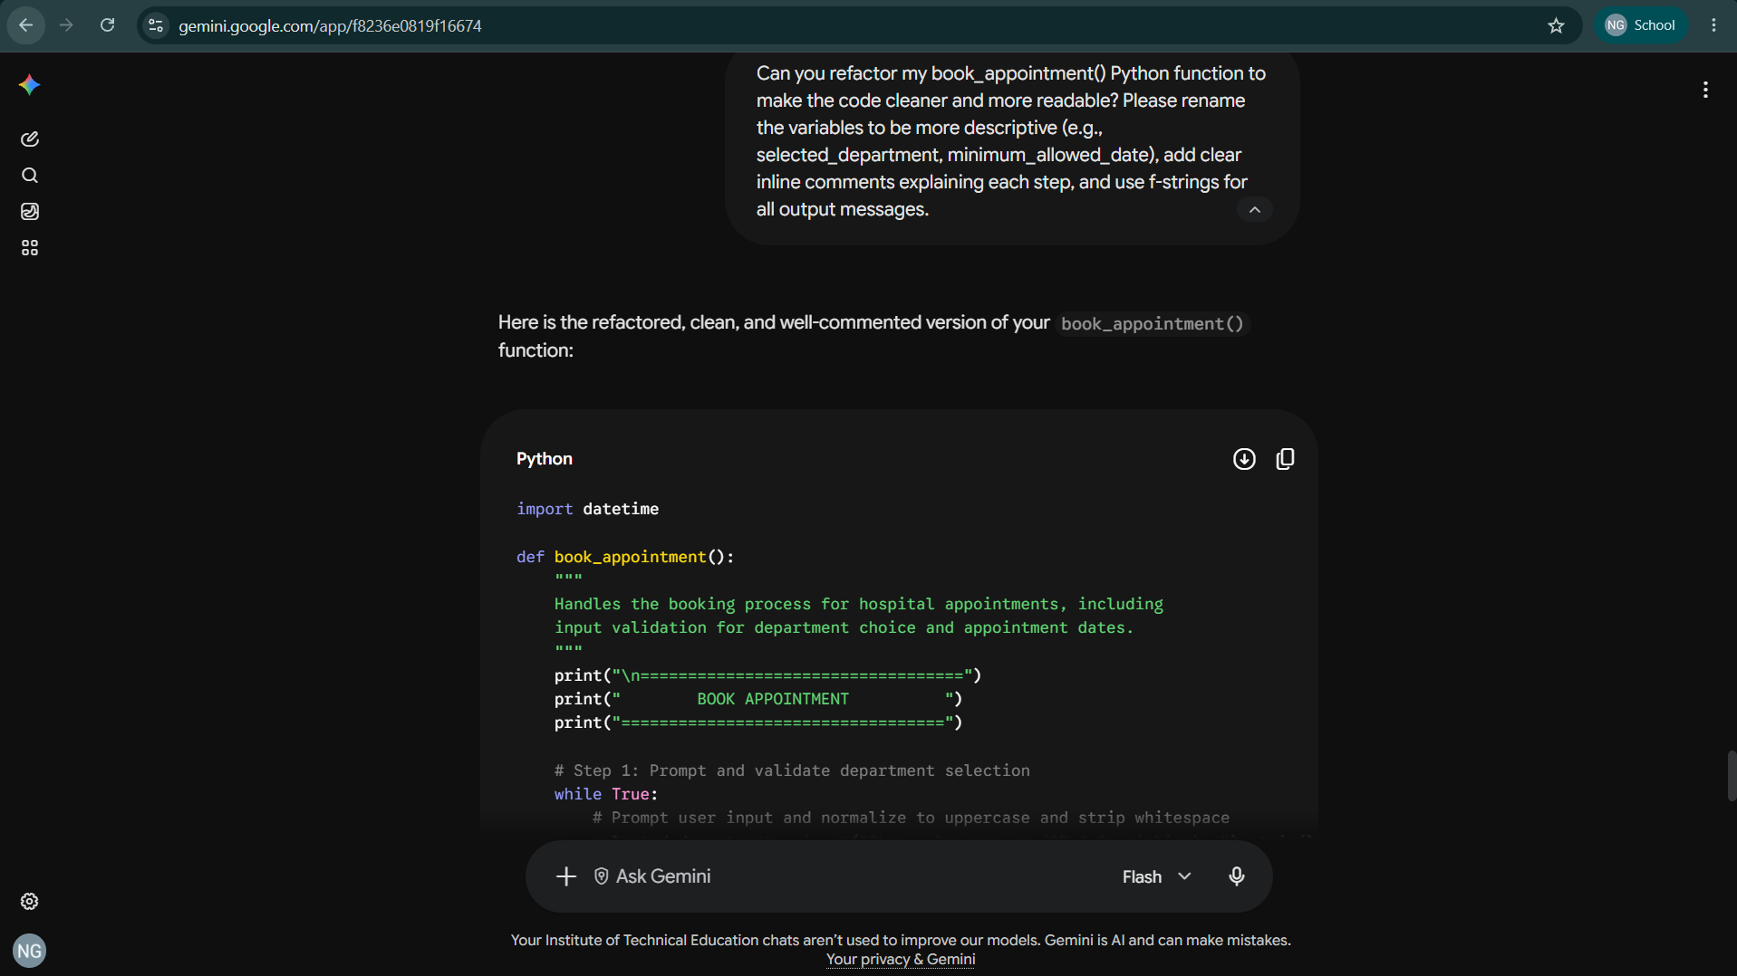

Explanation of AI Usage: Generative AI
(ChatGPT/GitHub Copilot) was used as a coding assistant to draft the input validation logic and handle date calculations efficiently. Specifically, the AI helped structure the standard while loop pattern for continuous user re-prompting and supplied the standard datetime module methods (strptime and timedelta) to verify that the booked date is strictly greater than 7 days from the current date.

Initial Generation
Write a Python function named book_appointment() for a menu-driven hospital system. It must prompt the user to choose between 'GP' or 'Specialist' and repeat if invalid. Then, prompt for a date in YYYY-MM-DD format. Use the datetime module to ensure the date entered is strictly more than 7 days from today. If invalid, re-prompt until valid, then print a confirmation message.

Debugging & Input Normalization
How can I make the department input case-insensitive so that typing 'gp' or 'specialist' in lowercase still works without throwing an error? Also, add error handling for when the user enters non-date text like 'tomorrow'.

What I Learnt
AI was used to assist in generating the initial Python code for the Book Appointment function. The AI suggested using the datetime module along with timedelta to handle date arithmetic and ensure appointments are strictly scheduled more than 7 days in advance. AI was also used to set up case-insensitive string matching (.upper()) for department selection and refine error messages to make the interface more user-friendly.

Challenges Encountered
One challenge encountered was calculating and enforcing the 7-day lead time rule. Initially, string comparisons failed when checking dates, and handling leap years or month boundaries manually was too complex. AI assistance helped resolve this by demonstrating how to parse inputs into datetime objects using strptime() and perform direct date comparisons.
Another challenge was handling invalid date formats when users entered text (like "next Monday") or wrong date patterns. This caused the program to crash. This was resolved by implementing a try-except ValueError block inside a validation loop to catch formatting errors, display a clear warning, and re-prompt until a valid YYYY-MM-DD date was entered.

