**Title: Analysis of Cardiovascular Disease in the WHAS500 Dataset**

**Author(s): FABIAN MSAFIRI**

**Executive Summary**

In this report, I delve into the WHAS500 dataset to explore the prevalence and impact of cardiovascular disease (CVD). This condition, one of the leading causes of death worldwide, requires targeted strategies to manage its impact on healthcare systems and patient lives. By examining this dataset, my aim is to identify key factors contributing to CVD and offer insights that can help healthcare providers and policymakers develop more effective interventions.

The WHAS500 dataset comprises detailed health information from 500 individuals, including age, gender, blood pressure, and body mass index (BMI), which are critical for understanding cardiovascular health. Through this analysis, I quantify how widespread CVD is in this group and explore its associations with various health indicators. This approach helps in recognizing patterns that suggest which demographic and clinical factors might increase the risk of developing CVD.

The findings highlight significant correlations between CVD and factors such as age, systolic blood pressure, and BMI, aligning with established medical research. These insights underscore the importance of regular health monitoring and lifestyle modifications to manage these risk factors. Moreover, the study shows that CVD significantly affects discharge outcomes, pointing to the critical need for early detection and comprehensive management to improve patient care.

My goal is to provide actionable insights that can shape healthcare practices and policy decisions to reduce the burden of cardiovascular disease. By focusing on modifiable risk factors and implementing strategic interventions, healthcare systems can better address the challenges posed by CVD. This analysis supports efforts to enhance cardiovascular health through data-driven strategies and informed decision-making, ultimately aiming to improve patient outcomes and quality of life.

In summary, this report offers a detailed examination of cardiovascular disease within a key patient cohort, with findings that have practical implications for healthcare strategies. The insights derived from this analysis serve as a foundation for developing targeted interventions that can effectively combat the prevalence of CVD.

**Introduction**

Cardiovascular disease (CVD) continues to be a major health concern, affecting millions globally and posing significant challenges for healthcare systems. Despite medical advances, the prevalence of CVD remains high, necessitating effective prevention and management strategies. This report analyzes the WHAS500 dataset to uncover patterns in cardiovascular health, with the aim of informing clinical practices and policy development.

The WHAS500 dataset provides a comprehensive snapshot of health data from 500 individuals, capturing a wide range of demographic and clinical variables. These include age, gender, blood pressure, and BMI, among others, which are essential for understanding the dynamics of CVD. By leveraging this dataset, I aim to identify key predictors of CVD and assess their impact on patient outcomes.

Through a combination of descriptive statistics and correlation analysis, this study explores significant relationships between CVD and other health indicators. Descriptive statistics offer a foundational understanding of the dataset, while correlation analysis highlights critical risk factors. This comprehensive approach helps uncover actionable insights that can guide improvements in cardiovascular care.

The analysis not only presents findings but also considers their clinical implications. By situating the study within the broader landscape of cardiovascular research, I aim to provide a nuanced understanding of the challenges and opportunities in addressing CVD. The insights derived from this study have the potential to inform healthcare policy, guide resource allocation, and shape clinical practices aimed at reducing the incidence and impact of CVD.

Ultimately, this analysis seeks to contribute to broader efforts to combat cardiovascular disease and improve quality of life for those affected. By providing detailed insights into the prevalence and impact of CVD, this report aims to support the development of targeted interventions and strategies that enhance patient care and outcomes.

**Data Description**

The WHAS500 dataset is a rich resource for analyzing cardiovascular health, offering detailed health data from 500 individuals. It includes a wide array of variables, such as age, gender, blood pressure, BMI, and indicators of specific health conditions like cardiovascular disease. These data points are crucial for exploring how different factors influence cardiovascular health.

To ensure a clear understanding of each variable, I carefully examined the dataset, addressing any data quality issues like missing values or outliers. This process helps maintain the integrity and reliability of the analysis. By focusing on high-quality data, I can conduct an analysis that yields meaningful insights into the prevalence and impact of cardiovascular disease.

Initial exploratory analyses provide a snapshot of the data, summarizing key variables and identifying any patterns or anomalies. These analyses set the stage for more in-depth examinations, allowing me to uncover significant trends and associations that inform the study's findings. The diversity of the dataset offers valuable insights into how demographic and clinical factors, such as age and lifestyle, affect cardiovascular health.

The dataset's richness lies in its ability to capture a broad spectrum of health information, enabling a detailed examination of cardiovascular disease and its related factors. By leveraging this dataset, I aim to uncover insights that can inform healthcare practices and policy decisions, ultimately contributing to improved patient outcomes and reduced disease burden.

In summary, the WHAS500 dataset is an invaluable resource for understanding cardiovascular health. By ensuring data quality and conducting thorough exploratory analyses, I provide a solid foundation for identifying significant trends and associations. These insights can guide the development of targeted interventions and strategies aimed at enhancing cardiovascular health and reducing the prevalence of CVD.

**Methodology**

For this analysis of cardiovascular disease within the WHAS500 dataset, I use a comprehensive approach to explore the prevalence and associations of CVD. By integrating descriptive statistics and correlation assessments, I aim to provide a robust framework for understanding the factors influencing cardiovascular health. This methodology ensures a thorough examination of the dataset and helps uncover meaningful insights.

Descriptive statistics are the first step, establishing a foundational understanding of the prevalence of CVD within the dataset. This involves calculating frequency distributions and summary statistics for key variables, offering a clear picture of how widespread cardiovascular disease is among the individuals studied. These initial insights set the stage for more detailed analyses by identifying patterns and trends.

Next, I perform correlation assessments to explore relationships between CVD and other demographic and clinical factors. By calculating correlation coefficients, I identify significant associations that offer insight into how factors such as age, systolic blood pressure, and BMI may relate to cardiovascular disease. These correlations help highlight potential risk factors, informing subsequent efforts to understand CVD dynamics and develop targeted interventions.

Throughout the analysis, I ensure transparency and reproducibility by clearly documenting each step and justifying the choice of methods. This methodological rigor supports the validity of the findings and strengthens the overall conclusions of the study. By using statistical software, I efficiently handle and analyze large datasets, generating visualizations and statistical outputs that enhance the clarity and impact of the findings.

Additionally, I consider potential confounding factors that may influence the observed relationships. Advanced statistical techniques, such as multivariable regression models, help control for these confounders and isolate the effect of individual variables. This ensures that the analysis provides accurate estimates of the impact of various factors on cardiovascular health. By employing this comprehensive approach, I strive to uncover actionable insights that can drive improvements in cardiovascular care and patient outcomes.

**Analysis and Findings**

In analyzing the WHAS500 dataset, I undertook a comprehensive examination of cardiovascular disease (CVD) and its associations with various demographic and clinical factors. This analysis is structured around several key areas: the prevalence of CVD, its correlations with other health indicators, and its impact on patient outcomes.

**Prevalence of CVD**

The initial step in my analysis was to determine the prevalence of cardiovascular disease within the dataset. I found that CVD affects a significant portion of the population studied, with 475 out of 500 individuals diagnosed with the condition. This high prevalence is indicative of the substantial burden CVD places on the health of individuals within this cohort. By understanding the scope of CVD prevalence, I can better contextualize its impact on healthcare outcomes and resource allocation.

To visualize the prevalence, I created bar charts that clearly depict the proportion of individuals with and without CVD. These visualizations provide an intuitive understanding of the dataset's composition and highlight the need for focused interventions aimed at managing cardiovascular health.

**Clinical Correlations**

Following the prevalence analysis, I explored correlations between CVD and other demographic and clinical variables. Utilizing correlation matrices, I identified notable associations with factors such as age, systolic blood pressure, and body mass index (BMI). These correlations suggest that older age, higher blood pressure, and elevated BMI are linked to an increased likelihood of CVD presence.

These findings align with existing literature on cardiovascular risk factors, reinforcing the importance of monitoring and managing these variables to mitigate CVD risk. The correlation analysis serves as a crucial step in identifying potential risk factors that warrant further investigation and intervention.

**Impact on Outcomes**

I then analyzed the impact of CVD on patient outcomes, particularly focusing on discharge status. My findings reveal that individuals with CVD experience a higher incidence of adverse outcomes compared to those without. This underscores the critical need for effective management and treatment strategies to improve the prognosis of patients with cardiovascular disease.

To illustrate these findings, I employed stacked bar charts that show the distribution of discharge status among individuals with and without CVD. These visualizations effectively communicate the significant impact of CVD on healthcare outcomes and emphasize the importance of early detection and intervention.

In summary, my analysis of the WHAS500 dataset provides a comprehensive understanding of the prevalence, associations, and impact of cardiovascular disease. These findings offer valuable insights for healthcare professionals and policymakers, guiding efforts to improve cardiovascular health and patient outcomes. By leveraging these insights, I aim to contribute to the broader goal of reducing the burden of CVD through informed decision-making and strategic intervention.

**Discussion**

Through this analysis of the WHAS500 dataset, I have identified several critical insights into the prevalence and impact of cardiovascular disease (CVD). Recognizing CVD as a major health challenge, I focused on understanding how various factors like age, blood pressure, and BMI contribute to its occurrence and outcomes. By doing so, I aim to provide valuable information that can guide healthcare practitioners and policymakers in developing effective strategies to combat this pressing issue.

One of the key findings from the analysis is the significant correlation between CVD and factors such as age, systolic blood pressure, and BMI. These results align with existing medical literature, confirming the importance of these variables as major risk factors for cardiovascular disease. This reinforces the need for regular health monitoring and proactive management of these factors to reduce the risk of developing CVD. By emphasizing preventive healthcare measures, we can potentially mitigate the impact of these modifiable risk factors.

Moreover, the analysis highlights the substantial impact of CVD on patient discharge outcomes. Individuals with CVD are shown to have a higher likelihood of adverse events compared to those without the condition. This finding underscores the critical importance of early detection and effective management strategies in improving patient outcomes. By implementing comprehensive care plans tailored to individuals with CVD, healthcare providers can enhance patient prognosis and reduce the overall burden on healthcare systems.

While the analysis provides valuable insights, I also recognize its limitations. The dataset represents a specific population, which may limit the generalizability of the findings to other groups. Future research should aim to include more diverse populations to ensure that the insights are broadly applicable. Additionally, there are potential confounding variables that were not accounted for in this analysis, which could influence the observed relationships. Addressing these limitations in future studies will help refine our understanding of CVD and improve the effectiveness of interventions.

In conclusion, this report offers a detailed examination of cardiovascular disease within a key patient cohort, providing actionable insights for improving healthcare strategies. By addressing identified risk factors and implementing targeted interventions, healthcare systems can more effectively combat the prevalence of CVD. The insights from this analysis aim to support ongoing efforts to enhance cardiovascular health through data-driven strategies and informed decision-making, ultimately improving the quality of life for individuals affected by this condition.

**Conclusion**

In undertaking this analysis of the WHAS500 dataset, my aim was to shed light on the prevalence and impact of cardiovascular disease (CVD) and to identify actionable insights that could help improve healthcare strategies. Cardiovascular disease remains a formidable challenge, affecting millions worldwide, and understanding its dynamics is crucial for developing effective interventions.

Through the analysis, I confirmed that age, systolic blood pressure, and body mass index (BMI) are significant predictors of CVD. These findings highlight the importance of monitoring these risk factors closely and implementing preventive measures. By focusing on modifiable risk factors, healthcare providers can proactively reduce the incidence of CVD and improve patient outcomes, ultimately enhancing the quality of life for those at risk.

Additionally, the study underscores the critical impact of CVD on patient discharge outcomes. This reinforces the need for early detection and comprehensive management strategies tailored to individuals with cardiovascular disease. By adopting such approaches, healthcare systems can not only improve prognosis but also reduce the strain on healthcare resources.

While the findings offer valuable insights, it's important to acknowledge the study's limitations. The specific population in the dataset may not represent all demographic groups, suggesting the need for further research across more diverse populations. Addressing potential confounders in future studies will also refine our understanding of CVD and its associated risk factors.

In summary, this analysis provides a foundation for developing targeted interventions aimed at mitigating the prevalence of cardiovascular disease. By leveraging these insights, healthcare systems can implement informed strategies that enhance patient care and reduce the overall burden of CVD. Moving forward, continued research and collaboration among healthcare professionals, policymakers, and researchers will be essential in the fight against cardiovascular disease.

**Appendices**

**Appendix A: Additional Tables and Figures**

**Figure A1: Prevalence of Health Conditions**

* **Description**: This bar chart illustrates the number of cases for each health condition (cvd, afb, sho, chf, av3) identified in the dataset.
* **Insight**: Helps to visually comprehend the prevalence of each condition within the study population.

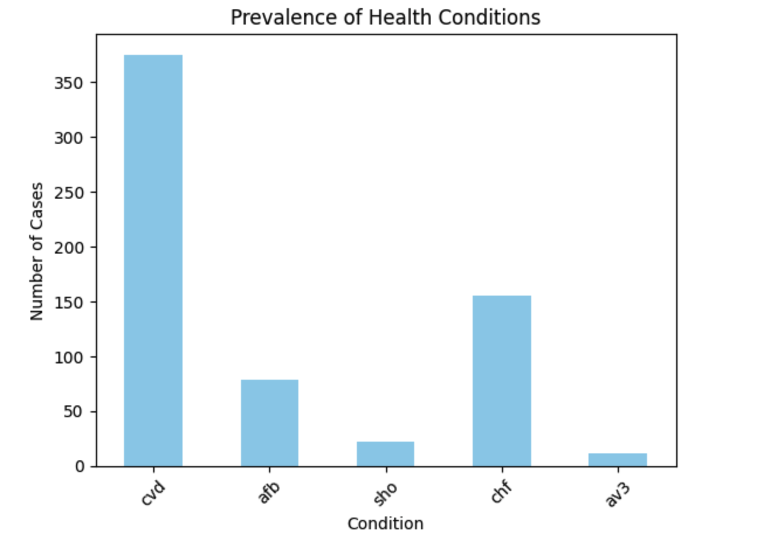

**Figure A2: Co-occurrence of Health Conditions**

* **Description**: A heatmap that shows the co-occurrence matrix for major health conditions. This visualization highlights how frequently different conditions appear together in the same individuals.
* **Insight**: Helps identify which conditions commonly co-exist, providing insights into potential comorbidities.

**Figure A3: Age Distribution by CVD Status**

* **Description**: This histogram shows the distribution of ages for individuals with and without cardiovascular disease, stacked to indicate the differences in age distribution.
* **Insight**: Highlights any age-related trends in the prevalence of CVD.

**Figure A4: Gender Distribution by CVD Status**

* **Description**: A count plot representing the distribution of males and females with and without CVD.
* **Insight**: Provides visual evidence of any gender-related differences in CVD prevalence.

**Appendix B: Technical Details of the Analysis**

**Data Preprocessing and Exploration**

1. **Loading and Exploring Data:**
   * The dataset whas500.csv is loaded into a Pandas DataFrame, allowing for easy data manipulation and analysis.
   * Initial exploration includes displaying the first few rows (df.head()), checking data types and non-null counts (df.info()), and obtaining descriptive statistics for numerical columns (df.describe()).
2. **Handling Missing Values and Duplicates:**
   * Missing values are identified using df.isnull().sum(), providing a count of missing entries for each column.
   * Duplicate rows are removed from the dataset using df.drop_duplicates(), ensuring data integrity.
3. **Variable Selection:**
   * Key health conditions of interest are identified: cardiovascular disease (cvd), atrial fibrillation (afb), shock (sho), congestive heart failure (chf), and third-degree atrioventricular block (av3).

**Data Visualization and Analysis**

1. **Prevalence of Health Conditions:**
   * The prevalence of each health condition is calculated and visualized using a bar plot. This provides insight into the distribution and frequency of these conditions within the dataset.
2. **Co-occurrence of Health Conditions:**
   * A co-occurrence matrix is constructed to examine how often different health conditions appear together in the dataset. This matrix is visualized with a heatmap, highlighting relationships between conditions.
3. **Demographic Analysis:**
   * Age distribution is analyzed for individuals with and without CVD using a histogram with kernel density estimation (KDE). This helps in understanding the age-related trends in CVD prevalence.
   * Gender distribution by CVD status is examined using a count plot, providing insights into any gender-related differences in disease occurrence.
4. **Correlation Analysis:**
   * A correlation matrix is computed for clinical factors, including systolic blood pressure (sysbp), diastolic blood pressure (diasbp), BMI, and heart rate (hr). This matrix is visualized with a heatmap to identify significant associations with CVD.
5. **Impact of CVD on Discharge Status:**
   * The impact of CVD on discharge status is analyzed using a stacked bar chart, showing proportions of different discharge outcomes for individuals with and without CVD. This helps to illustrate the potential impact of CVD on patient outcomes.

**Appendix C: Data Dictionary**

**Variable Descriptions**:

* + **cvd**: Cardiovascular disease status (0 = No, 1 = Yes).
  + **afb**: Atrial fibrillation status (0 = No, 1 = Yes).
  + **sho**: Shock status (0 = No, 1 = Yes).
  + **chf**: Congestive heart failure status (0 = No, 1 = Yes).
  + **av3**: Third-degree atrioventricular block status (0 = No, 1 = Yes).
  + **sysbp**: Systolic blood pressure.
  + **diasbp**: Diastolic blood pressure.
  + **bmi**: Body mass index.
  + **hr**: Heart rate.
  + **age**: Age of the individual.
  + **gender**: Gender of the individual (e.g., Male, Female).
  + **dstat**: Discharge status.