# Design for Integrated, Dynamic Circularity

# Introduction

As global battery consumption increases, effective recycling has become crucial to mitigating environmental harm and recovering scarce resources like lithium, cobalt, and nickel. Current recycling systems are often hampered by inefficiencies in subprocesses, suboptimal material recovery rates, and fragmentation in value chains. This proposal presents a detailed framework to streamline battery recycling operations by integrating advanced workflow modeling, predictive analytics, and value chain analysis.

# Objectives

1. **Streamline Subprocesses**:
   * Minimize delays in collection, sorting, and material recovery stages.
   * Reduce redundant tasks through workflow optimization.
2. **Maximize Material Recovery**:
   * Enhance extraction rates for critical materials.
   * Minimize environmental impact by improving recycling efficiency.
3. **Integrate Value Chain Activities**:
   * Improve collaboration across stakeholders, from collection agents to manufacturers.
   * Optimize material flows to reduce bottlenecks and improve throughput.
4. **Enhance Operational Adaptability**:
   * Introduce predictive systems to handle fluctuations in battery input quality and volume.
   * Enable real-time adjustments to process workflows.

The core principles of circularity and dynamic technological evolution direct the systems design. This implies the following key design principals would be maintained.

1. Configurability with no code user experience
2. Integration and interoperability, including designing for future systems integration
3. Granular Modularity, implying activity and next steps designed on the activity level
4. Central backbone, data at source, network and systems thinking combined with process centric design basis
5. AI based, deep learning user interfacing, driving optimum, intuitive interaction
   1. Design Building blocks

The foundational principles of the system are built around value chain-centric processes, ensuring that every step of waste management aligns with the goals of a circular economy. This includes seamless configurability with a no-code user experience, enabling users to dynamically design and modify value chain processes without requiring programming skills. The system emphasizes integration and interoperability, allowing for current and future systems to interact seamlessly.

By adopting granular modularity, the system breaks down value chains into individual activities and process steps, enabling precise control and adaptation. The central backbone ensures that data is managed at the source, fostering a network and systems-thinking approach while embedding a process-centric design basis. Advanced AI-based deep learning models support intuitive user interaction, driving efficiency by suggesting optimal configurations and highlighting areas for improvement.

**1.1 Value chain, process centric core**

The fundamental of the system is value chains centric, implying that the entire system is based on value chains and their process steps. The value chains will be developed by each process owner and each step defined in terms of process steps. This would include input/raw material, outputs and waste streams.

The process-centric design incorporates graphical interfaces that allow users to visually configure their value chains. This interactive design is enhanced by a deep learning model that acts as a knowledge hub, dynamically retrieving data and suggesting improvements based on prior configurations and database knowledge. Users, equipped with role-based rights, can input process data, auto-classify it, and save the value chain for future analysis and refinement.

The process level is defined below and would be developed in a graphics based no code environment. Role based user rights



The individual processes would be built with string identifiers, the deep learning tool would be operating in the background, searching the DB for every process step, looking for similar data. Advisory structure to be determined. The user would continue to input all process step data. The data would be auto classified and stored. The user would develop the value chain and store on the system with all inputs/ outputs and all data as required. The figure below provides a basic value chain process view. The self-configure tool would have the capacity to manage all input data, while searching all partner system data using a deep learning protocol.



* 1. THE AI-DEEP LEARNING MODEL

The deep learning model (Tensorflow – Functional API) acts as a knowledge base between the user requesting process steps and the information siting in the database. With the option to filter as user key in the process steps and submit their “POST” request, the AI-Model retrieves all the technology for the given process steps based on the value chain.

* 1. Process Level

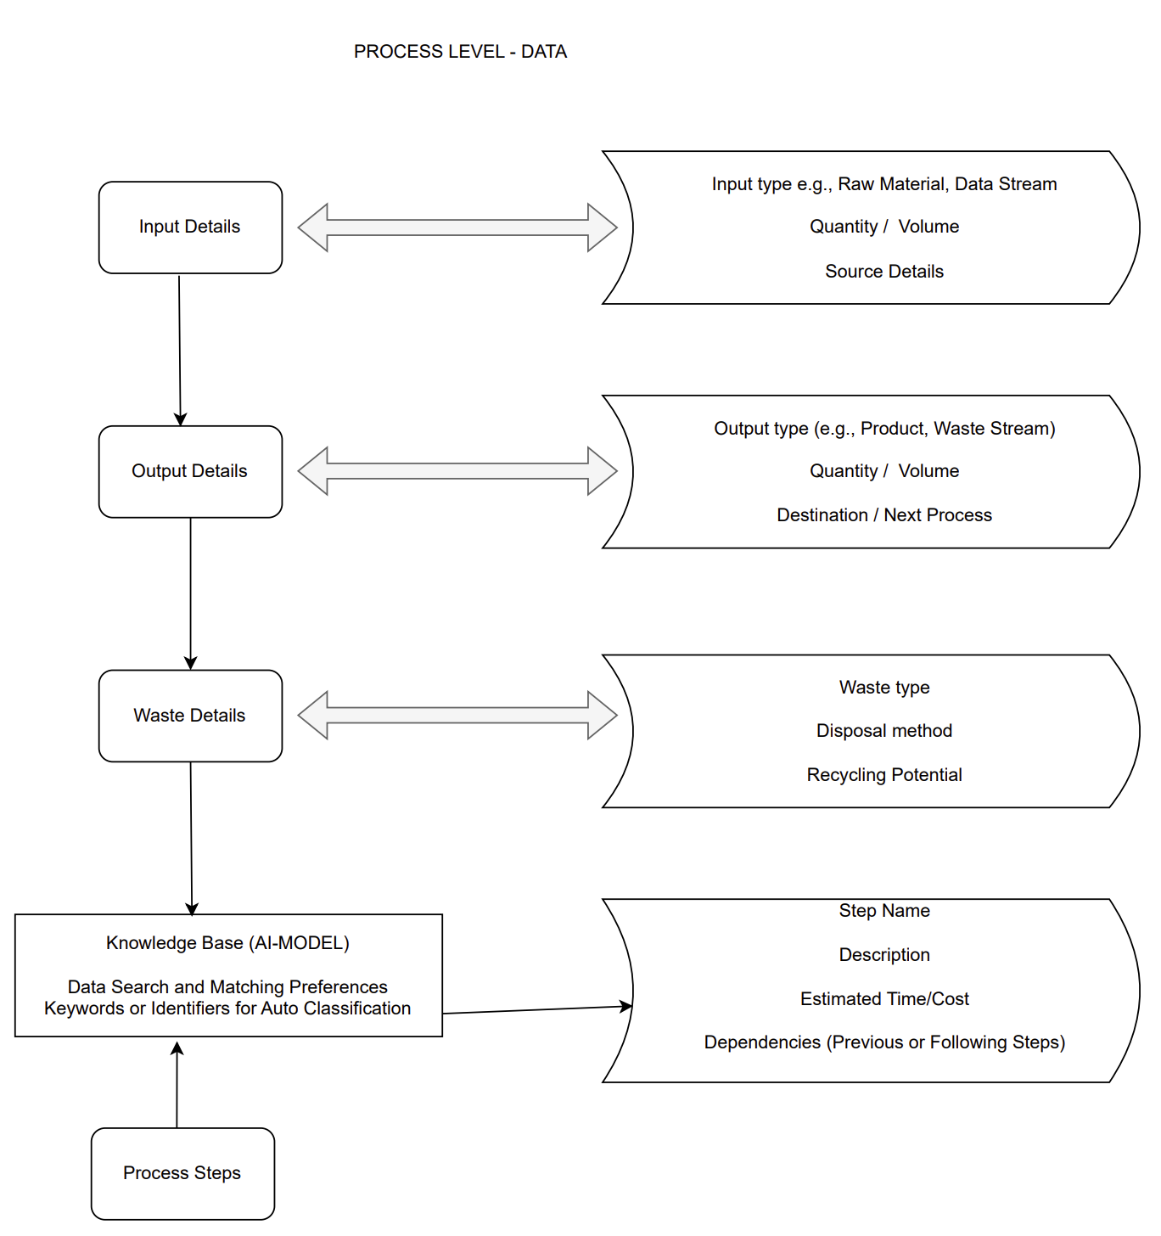

* 1. System Configuration

The System Configuration process is structured to allow users to define and manage their value chains by selecting the appropriate workflows and describing their individual steps. The configuration process includes three main components, as represented in the diagram: Select Value Chain, Process Name, and Process Description. Each component plays a vital role in building an effective value chain.

**4.1 Select Value Chain**

This step allows users to identify and choose the specific value chain they want to configure. Users can:

* Browse through pre-defined templates for various value chains (e.g., electronic waste, cellulose waste, organic waste).
* Start from scratch and define a new value chain specific to their operational needs.
* Utilize a graphics-based interface to visualize and select existing value chains within the system.

The system, enhanced by a deep learning tool, assists in retrieving relevant process data and providing recommendations based on previous configurations or similar workflows. This ensures that users start with a strong foundation for their value chain.

**4.2 Process Name**

In this step, users define the name of each process within the selected value chain. This naming convention allows for clarity, easy identification, and organization of the individual steps. Examples include:

* "Sorting and Storage" in an electronic waste value chain.
* "Pulping" in a cellulose waste value chain.
* "Composting" in an organic waste value chain.

The deep learning model helps validate the input by checking for similar or overlapping processes in the system. It can also suggest alternative process names or standardize naming conventions across value chains to enhance consistency.

**4.3 Process Description**

This step involves providing a detailed description of each process step. Users can:

* Specify the inputs (e.g., raw materials, components) required for the process.
* Define the outputs or expected results (e.g., recovered metals, compost, recycled paper).
* Highlight any waste streams generated and how they will be managed.

The process description serves as the backbone of the configuration, enabling the system to:

* Auto-classify and store the provided data in a centralized database.
* Use AI-driven insights to optimize each process step by identifying inefficiencies or recommending alternative methods.
* Link related processes across value chains, ensuring smooth transitions and feedback loops.

1. Process Level

**5.1 ELECTRONIC WASTE**

The electronic waste value chain follows a circular approach with a focus on resource recovery and waste reduction. It begins with the collection of e-waste, such as discarded TVs, accessories, and packaging, which are forwarded to sorting facilities. During the sorting stage, components like plastics, metals, and glass are separated and prepared for pre-processing. Pre-processing involves dismantling or shredding these components, producing raw materials such as shredded plastics, metals, and glass. These are then sent for material recovery, where valuable resources like gold, copper, and lead are extracted, while hazardous materials are treated or neutralized. Recovered materials feed into manufacturing, producing new products, and leftover scraps are returned to recycling or safely disposed of in the disposal phase.

The deep learning tool enhances this process by dynamically retrieving relevant technologies and process details for each step. For example, it can recommend the best method for recovering metals from circuit boards or separating glass from CRTs, optimizing material recovery while minimizing waste.

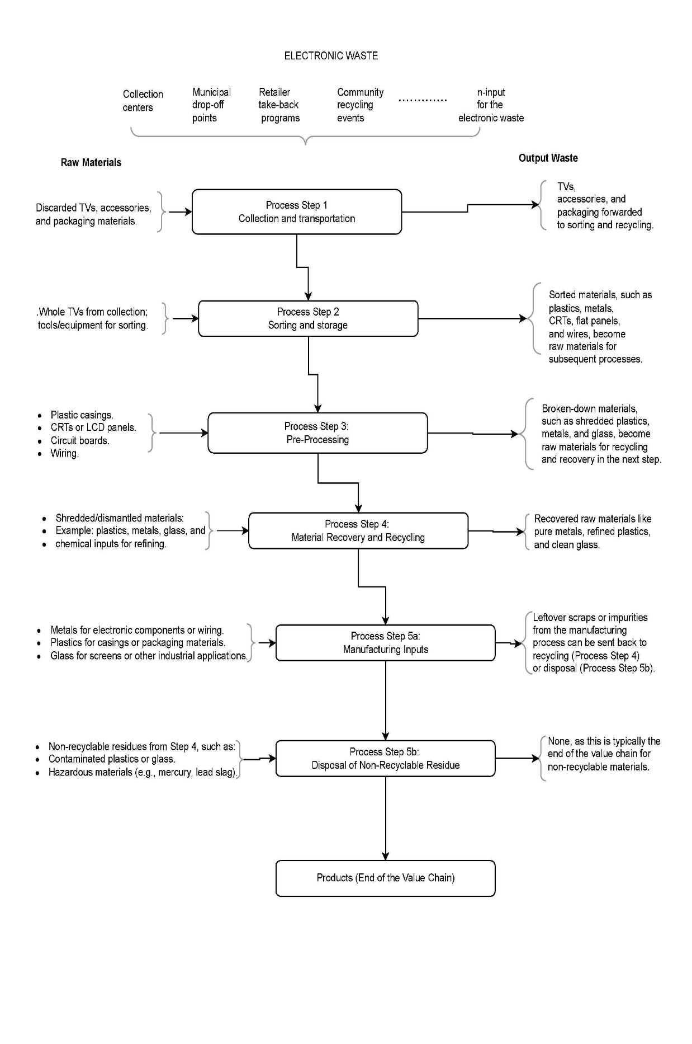

Figure Process flow of the electronic waste value chain processes.

**Summary of feedback loops for the electronic waste**

|  |  |
| --- | --- |
| Step | Outputs Fed Back as Inputs |
| Collection | TVs, accessories, and packaging forwarded to sorting and recycling. |
| Sorting | Sorted components like plastics, metals, and glass forwarded to pre-processing or recycling; non-recyclables to disposal. |
| Pre-Processing | Shredded plastics, metals, and glass are sent to material recovery; residues to disposal. |
| Material Recovery | Recovered metals, plastics, and glass sent to manufacturing; hazardous residues to disposal or specialized treatment. |
| Manufacturing | Recycled materials used for new products; leftover scraps returned to recycling or disposal. |
| Disposal | Inert or treated waste (e.g., slag) may find secondary use, but most waste ends here. |

**5.2 CELUULOSE WASTE**

The cellulose waste value chain focuses on recycling and utilizing biodegradable materials such as paper, cardboard, and untreated wood. The process starts with collection, where materials are sourced from households, industries, and agricultural sectors. During the sorting stage, clean paper, cardboard, and wood are separated from contaminants. Sorted materials then undergo pre-processing, where they are shredded, pulped, or chipped, resulting in intermediate products like paper pulp and wood chips. These materials are sent to the recycling stage, where they are transformed into products such as new paper, packaging, or construction materials like particleboard. Residues from recycling may be sent for disposal or energy recovery, where incineration or other processes generate energy from non-recyclable fractions.

The deep learning tool supports this value chain by identifying efficient recycling technologies and providing insights into the composition of cellulose materials, helping users optimize resource recovery and minimize contamination risks.

Figure Process flow of the cellulose waste value chain processes.

**Summary of feedback loops for the cellulose waste**

|  |  |
| --- | --- |
| Process Step | Outputs Fed Back as Inputs |
| Collection | Collected cellulose materials (paper, cardboard, wood) forwarded to sorting. |
| Sorting | Sorted paper, cardboard, and wood forwarded to pre-processing; non-recyclables sent to disposal or energy recovery. |
| Pre-Processing | Pulp, wood chips, and clean materials sent to recycling or material recovery; contaminated fractions to energy recovery. |
| Recycling | Recycled materials (e.g., paper pulp, wood fibers) sent to manufacturing; residues to disposal or energy recovery. |
| Manufacturing | Scraps or rejects from manufacturing fed back into recycling or pre-processing; some residues sent to disposal. |
| Disposal/Energy Recovery | Non-recyclable cellulose waste generates energy or is safely landfilled; ash may be reused in limited applications. |

**5.3 ORGANIC WASTE**

The organic waste value chain addresses biodegradable waste, such as food scraps, garden waste, and agricultural residues. The process starts with collection, where materials are gathered from households, farms, and industries. At the sorting stage, clean organic waste is separated from contaminants such as plastics or metals. The processing stage involves methods like composting, anaerobic digestion, or vermiculture, producing valuable outputs like compost, biogas, and vermicompost. These outputs are utilized during the recovery phase, where compost is applied as fertilizer, biogas is converted into energy, and digestate is used as a soil amendment. Non-recyclable residues, such as contaminated materials or ash from energy recovery, are safely handled during the disposal phase.

Deep learning enhances this process by suggesting optimal composting conditions or biogas production techniques based on the characteristics of the input waste. The system can also analyze feedback loops to improve efficiency and recommend alternative uses for recovered products.

Figure Process flow of the organic waste value chain processes.

**Summary of feedback loops for the organic waste**

|  |  |
| --- | --- |
| Step | Example Materials |
| Collection | Food scraps, garden clippings, crop residues, animal manure, food processing by-products. |
| Sorting | Clean organics (food waste, yard waste); contaminants (plastics, glass, metals). |
| Processing | Compost, biogas, digestate, and vermicompost. |
| Recovery | Compost used as fertilizer, biogas converted to energy, digestate used as soil amendment. |
| Utilization | Final products like compost and bioenergy applied to agriculture, landscaping, or energy systems. |
| Disposal | Contaminated residues, inert materials, or ash safely disposed or used in construction applications. |

1. Graphics based design

The system employs a graphics-based design interface to empower users in self-configuring their value chains step by step. Each step in the process is represented visually, making it easier for users to understand and manipulate the structure of their value chains. The self-configuring tool is equipped to handle all data inputs, simultaneously searching for related partner system data using a deep learning protocol.

This approach not only simplifies the process for users but also ensures that the value chain remains adaptable to changes and optimizations. Users can focus on fine-tuning individual steps or processes while the system automatically integrates and aligns new configurations with existing data. This modular and visual approach promotes better decision-making and fosters innovation in process design. The core design principles are

1. Partner data

Integration with partner systems is a cornerstone of the design, enabling data exchange and collaboration without compromising security or intellectual property. The system supports dynamic data exchange, allowing partner systems to provide critical inputs for specific functions without requiring full system integration. This flexibility ensures that the backbone remains robust while enabling diverse partners to contribute effectively.

The exchange of data is limited to inputs necessary for backbone operations and portfolio management, ensuring minimal exposure and maximum security. Partner systems are encouraged to integrate seamlessly while maintaining their autonomy, thereby fostering a collaborative ecosystem that thrives on shared functionality.

1. Systems security

To protect the system various security protocols would be enabled, role based and with multi-tier administration. External users would have full view rights on the system but limited configurability.

* User level: Full view and download capability, no login
* Basic Partner level: Login and authentication. Data inputs and portfolio usage.
* Advanced partner level: Login and authentication, configurability. Data inputs and portfolio usage
* Integration level: Login and authentication, configurability. Data inputs and portfolio usage. Data transfer, exchange.
* Function specific administrator
* Administrator

**Next steps**

Partner meetings with all systems owners and identification of first to go processes. The partners would be engaged to understand the full spectrum of systems functionality, design, integration, data exchange protocols and data sharing, security and sharing boundaries and limitations.

The process that are suggested as first to go are the building waste, and the e-waste processes.

1. ESG AND SUSTAINABILITY

ESG principles are implemented by incorporating sustainable practices into the design framework. The emphasis on value chain-centric systems is consistent with environmental responsibility, with granular and deep learning technologies being used to reduce waste and optimize processes. The proposal’s inclusion of data integration through partners promotes transparent collaboration, while also supporting governance through role-based access, security protocols, and accountability in data handling. Moreover, its emphasis on e-waste and building waste as initial processes reflects a commitment to addressing critical environmental challenges while promoting a circular economy. These elements collectively enhance ESG alignment, fostering dynamic, responsible system development.

1. Multi-tier partner accounts

Sustainability Practices

ESG principles are implemented by incorporating sustainable practices into the design framework. The emphasis on value chain-centric systems is consistent with environmental responsibility, with granular and deep learning technologies being used to reduce waste and optimize processes. The proposal’s inclusion of data integration through partners promotes transparent collaboration, while also supporting governance through role-based access, security protocols, and accountability in data handling. Moreover, its emphasis on e-waste and building waste as initial processes reflects a commitment to addressing critical environmental challenges while promoting a circular economy. These elements collectively enhance ESG alignment, fostering dynamic, responsible system development.

# Methodology

### 1. Data Collection and Preparation

* **Data Sources**:
  + Collection centers: Data on battery quantities, types, and locations.
  + Sorting facilities: Throughput rates, misclassification errors, and energy consumption.
  + Material recovery units: Recovery rates, energy usage, and operational timelines.
  + Waste management facilities: Residual waste volumes and handling metrics.
  + Logistics: Transportation times, costs, and material flow volumes.
* **ETL Process**:
  + **Extract**: Aggregate data from sensors, databases, and manual records.
  + **Transform**: Clean, normalize, and standardize data formats to ensure consistency.
  + **Load**: Store the prepared data in a centralized database for easy access during modeling.

### 2. Graph-Based Workflow Modeling

#### Objective

To construct a dynamic graph representation of the battery recycling process, enabling the identification of dependencies, bottlenecks, and optimization opportunities.

#### Graph Construction

* **Nodes**:
  + Represent subprocesses such as collection centers, sorting lines, preprocessing units, recovery facilities, and waste management sites.
  + **Attributes**: Processing capacity, operational status, and geographic location.
* **Edges**:
  + Represent material flows, dependencies, and transitions between nodes.
  + **Attributes**: Transition time, capacity, and material type.

#### Graph Visualization

* Use Neo4j or similar graph databases to create a visual map of the workflow.
* Include color-coded nodes and edges to represent critical paths, delays, and underutilized resources.

#### Dynamic Updates

* Integrate real-time data streams from IoT devices and monitoring systems.
* Automatically update graph properties, such as edge capacities and transition times, based on real-time events.

### 3. Dependency Analysis Using Graph Metrics

#### Objective

To leverage graph analytics for uncovering dependencies, critical paths, redundancies, and resource allocation inefficiencies.

#### Critical Path Analysis

* Use algorithms like Dijkstra’s or A* to identify the longest path that determines the overall process completion time.

#### Centrality Measures

* **Betweenness Centrality**: Identify nodes or edges critical to overall material flow.
* **Closeness Centrality**: Detect subprocesses that can quickly influence the rest of the workflow.
* **Degree Centrality**: Pinpoint highly connected nodes representing subprocesses with extensive dependencies.

#### Redundancy and Bottleneck Detection

* Identify cycles in the graph that indicate redundant operations.
* Detect bottlenecks by analyzing edge capacities and node processing times.

### 4. Predictive and Adaptive Modeling

* **Forecasting**:
  + Use machine learning models to predict recovery rates and processing delays.
* **Stochastic Modeling**:
  + Account for variability in input data such as battery type and operational conditions.
* **Real-Time Adaptation**:
  + Implement algorithms that dynamically adjust workflows in response to real-time data updates.

### 5. Optimization and Feedback Integration

* **Optimization Objectives**:
  + Minimize transition times and delays across subprocesses.
  + Maximize material recovery rates and throughput efficiency.
* **Feedback Loop**:
  + Monitor KPIs such as processing time per battery type and recovery rates.
  + Integrate feedback into graph models to refine predictions and adjustments.