Name: Fabiola INGABIRE
on 13 jun 2024
Email: fabiolaingabire02@gmail.com

ROBOTIC TEAM

WEEK1: Assignment

1.1: Change value via a pointer
Write a program to define an integer x and two pointers to integer.
Both pointers should point to the integer x.
Change the integer value via one pointer and read it back via the other pointer.

Documentation for Code: Variable Pointers

This document explains the code that demonstrates the concept of variable pointers in C.

Functionality:

The code explores how pointers can be used to access and modify the value of a variable indirectly.

Explanation:

1. Variable Declaration:
- An integer variable `x` is declared and initialized with the value 20.

2. Pointer Declaration:
- Two integer pointers, `p` and `d`, are declared. Pointers store memory addresses, not actual values.

3. Assigning Address to Pointer:
- The address of the variable `x` is assigned to both pointers `p` and `d` using the `&` (address-of) operator. This means `p` and `d` now point to the same memory location where the value of `x` is stored.

4. Accessing Value using Pointer:
- The `printf` statement `printf("The value of pointer p is %d\n",*p);` retrieves the value stored at the memory location pointed to by `p`. Since `p` points to `x`, it prints the value of `x` (which is 20).

5. Printing Address:
- The `printf` statement `printf("The adress of x is %p\n",p);` prints the address stored in the pointer `p`. This address is the same as the memory location where the value of `x` is stored.

6. Modifying Value through Pointer:
- The line `*d=30;` modifies the value stored at the memory location pointed to by `d`. Since `d` also points to `x`, this effectively changes the value of `x` to 30.

7. Printing Updated Value:
- The final `printf` statement `printf("The new value of pointer p is %d\n",*p);` again accesses the value through pointer `p`. Since `p` and `d` point to the same memory location where `x` is stored (which has been modified to 30), this prints the new value of `x` (which is now 30).

Key Points:
- Pointers store memory addresses.
- The `*` operator deference a pointer, meaning it accesses the value stored at the memory location pointed to by the pointer.
- Modifying the value through a pointer changes the original variable's value.

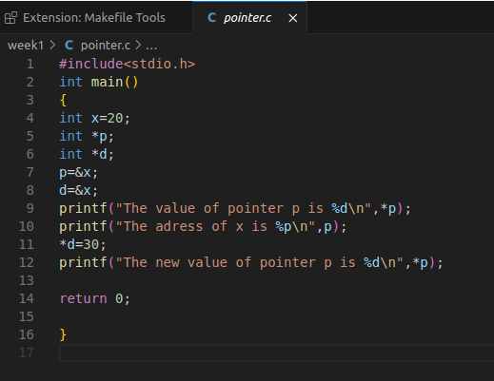
OUTPUT:

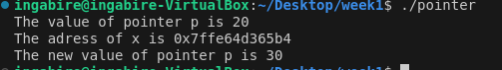

1.2 Value swap
When you want to return a value from a function, you can simply return that value.
What happens when you need to return more than one value? In that case you can use
a pointer type parameter.
Write a function that can swap two integer values.

The function is called swapValues(), the following code snippet explains what it does:
int value1 = 35;
int value2 = -97;
swapValues(….,…….);
// now value1 equals -97 and value2 equals 35.

Documentation for Code: Swap Values Function

This document explains the code that demonstrates a function for swapping the values of two integer variables in C.

Functionality:

The code defines a function `swapvalues` that takes pointers to two integer variables as arguments and swaps their values.

Explanation:

1. swapvalues` Function:
- This function is declared with the name `swapvalues`, taking two integer pointers (`int*a` and `int*b`) as arguments.

2. Temporary Variable:
- Inside the function, an integer variable `temp` is declared.

3. Swapping Values:
- The swapping process is achieved using the following steps:
- The value stored at the memory location pointed to by `a` is assigned to `temp`. This effectively stores the original value of `value1` in `temp`.
- The value stored at the memory location pointed to by `b` is assigned to the memory location pointed to by `a`. This copies the value of `value2` into `value1` (indirectly through `a`).
- Finally, the value stored in `temp` (which is the original value of `value1`) is assigned to the memory location pointed to by `b`. This completes the swap by placing the original value of `value1` into `value2`.

4. Function Call:
- In the `main` function, two integer variables `value1` and `value2` are initialized with values 35 and -97, respectively.
- The `swapvalues` function is called, passing the addresses of `value1` and `value2` using the `&` (address-of) operator (`swapvalues(&value1,&value2);`). This provides the function with a way to access and modify the original variables.

5. Printing Before and After Swap:
- `printf` statements are used to print the values of `value1` and `value2` before and after the swap function call. This demonstrates that the function successfully swapped the values of the original variables.

Key Points:

- The `swapvalues` function operates on the memory locations of the variables passed to it (using pointers).
- The temporary variable `temp` is used to hold the original value of one variable while the other variable's value is copied.
- Passing addresses using `&` allows the function to modify the original variables.

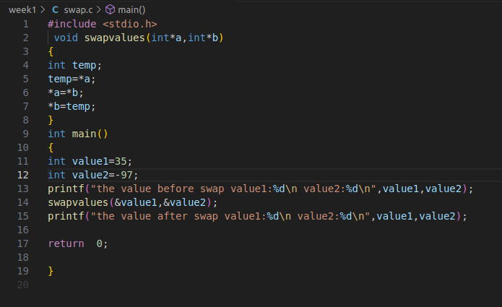
OUTPUT:

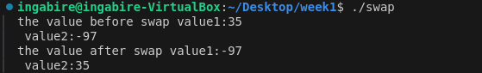

1.3 : Pointer arithmetic on array
Write a small program that declares an array of 5 integers and declare a pointer that
points to the last element of the array. Write a loop that traverses the array via the
pointer in reverse direction.
This means that a loop such as this is not allowed:
for (int i = 4; i >= 0; i--)
{
printf("%d\n", array[i]);
}
In other words: you are not allowed to use a loop counter, you can only use the pointer
you have.

Documentation for Code: Printing Array Elements in Reverse Order

This document explains the code that demonstrates how to print the elements of an array in reverse order using a pointer and a loop in C.

Functionality:

The code iterates through an array of integers in reverse order, accessing and printing each element's value using a pointer.

Explanation:

1.Array Declaration:
- An integer array `a` of size 5 is declared and initialized with values {12, 30, 40, 50, 60}.

2. Pointer Initialization: - An integer pointer `p` is declared and assigned the address of the last element in the array (`a[4]`). This means `p` initially points to the memory location where the value 60 is stored.

3. `while` Loop: - A `while` loop is used to iterate through the array elements in reverse order. The loop condition `p >= a` ensures that the loop continues as long as the pointer `p` points to a memory location within the array's boundaries (i.e., not less than the address of the first element `a`).

4. Printing Element Value: - Inside the loop:
- The value stored at the memory location pointed to by `p` is dereferenced using `*p`, and this value is printed using `printf("the Value is:%d\n",*p);`. This effectively prints the elements in reverse order because `p` starts at the last element and decrements in each iteration.

5. Decrementing Pointer:
- After printing the value, the pointer `p` is decremented using `p--`. This moves `p` one memory location backward, pointing it to the next element in the array (towards the beginning).

6. Loop Termination:
- The loop continues iterating as long as the condition `p >= a` remains true. Once `p` reaches a memory location less than the address of the first element `a`, the loop terminates.

Key Points:

- The pointer `p` is used to traverse the array in reverse order by starting at the end and moving backwards.
- The loop condition ensures the pointer stays within the valid memory range of the array.
- Dereferencing the pointer `*p` accesses the value stored at the memory location it points to.

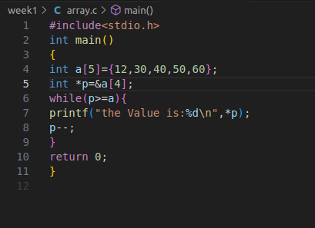

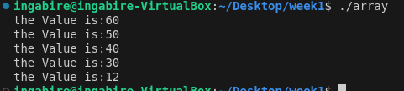
OUTPUT:

1.4 Generic array add
Write a function that can summarize a specific number of values in an array of
doubles and return the result.

Documentation for Code: Array Summarization Function

This document explains the code that demonstrates a function for calculating the sum and count of elements in a double-precision floating-point array in C.

**Functionality:**

The code defines a function `summarize_array` that takes a double array and its size as arguments and returns a structure containing the sum of the array elements and the number of elements.

Explanation:

1. `Summary` Structure:
- A structure named `Summary` is defined with two members:
- `sum`: A double-precision floating-point variable to store the sum of array elements.
- `count`: An integer variable to store the number of elements in the array.

2. `summarize_array` Function:
- This function is declared with the name `summarize_array`, taking two arguments:
- `arr`: A double array representing the data to be summarized.
- `size`: An integer representing the number of elements in the array.

3. Initializing `Summary`:
- Inside the function, a variable of type `Summary` named `summary` is declared.
- The `sum` member of `summary` is initialized to 0.0.
- The `count` member of `summary` is set to the value of `size` (the number of elements in the array).

4. Calculating Sum:
- A `for` loop iterates through the elements of the array `arr`.
- Inside the loop:
- The value of the current element `arr[i]` is added to the `sum` member of the `summary` structure using `summary.sum += arr[i]`.
- This accumulates the sum of all elements in the array.

5. Returning Structure:
- After the loop completes, the function returns the `summary` structure, which now contains the calculated sum and the original count (number of elements).

6. `main` Function:
- The `main` function creates a double array `arr` with sample values.
- It calculates the size of the array using `sizeof(arr) / sizeof(arr[0])`.
- The `summarize_array` function is called with the `arr` and its size as arguments.
- The returned `summary` structure is stored in the variable `summary`.
- Finally, the `sum` and `count` members of the `summary` structure are printed using `printf` statements.

Key Points:

- The `summarize_array` function encapsulates the logic for calculating the sum and count.
- The `Summary` structure is a user-defined data type that groups related data (sum and count) together.
- The function returns a structure to provide both calculated values (sum and count) in a single unit.

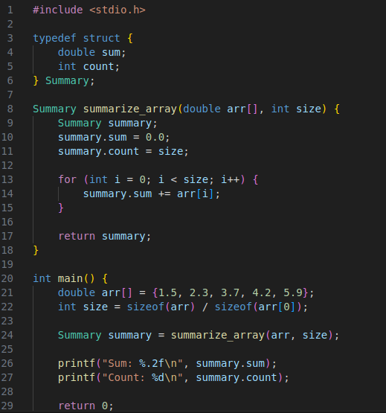

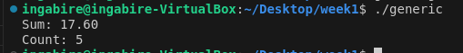
OUTPUT:

1.6 Generic array add (part 2)
Another way of writing the function in the previous assignment would be by returning
the result via a parameter. A reason to do this is if you need to return more than one
thing. For example: what would arrayAdd() do if it is called with a NULL pointer? It
has no way of telling the caller that an error occurred.
Please change the arrayAdd() function according this new specification.

Documentation for Code: Array Summarization Function with Error Handling
This document explains the code that demonstrates a function for calculating the sum and count of elements in a double-precision floating-point array in C, with error handling capabilities.
Functionality:

The code defines a function `summarize_array` that takes a double array, its size, and a pointer to a `Summary` structure as arguments. It calculates the sum and count, stores them in the provided structure, and returns an integer code indicating success or failure.

Explanation:

1. `Summary` Structure (same as previous example):
- A structure named `Summary` is defined with two members:
- `sum`: A double-precision floating-point variable to store the sum of array elements.
- `count`: An integer variable to store the number of elements in the array.

2. `summarize_array` Function:
- This function is declared with the name `summarize_array`, taking three arguments:
- `arr`: A double array representing the data to be summarized.
- `size`: An integer representing the number of elements in the array.
- `summary`: A pointer to a `Summary` structure where the results will be stored.

3. Error Checking:
- The function starts by checking if the provided array (`arr`) or the `summary` structure pointer (`summary`) is NULL (indicates invalid memory addresses).
- If either is NULL, it returns -1 to signal an error condition.

4. Initializing `Summary`:
- Assuming no errors are detected:
- The `sum` member of the `*summary` structure (accessed using the pointer) is initialized to 0.0.
- The `count` member of the `*summary` structure is set to the value of `size` (the number of elements in the array).

5. Calculating Sum:
- A `for` loop iterates through the elements of the array `arr`.
- Inside the loop:
- The value of the current element `arr[i]` is added to the `sum` member of the `*summary` structure using `(*summary).sum += arr[i]`.
- This accumulates the sum of all elements in the array.

6. Returning Success:
- After the loop completes, the function returns 0 to indicate successful execution.

7. `main` Function (similar with error handling):
- The `main` function creates a double array `arr` with sample values.
- It calculates the size of the array using `sizeof(arr) / sizeof(arr[0])`.

8. `Summary` Declaration and Function Call:
- A `Summary` structure variable `summary` is declared.
- The `summarize_array` function is called with the `arr`, its size, and the address of the `summary` variable (`&summary`) as arguments. This passes the memory location of `summary` to the function.

9. Error Handling in `main`:
- The return value (`result`) from the `summarize_array` function is checked.
- If `result` is 0 (success):
- The calculated `sum` and `count` are printed from the `summary` structure.
- If `result` is not 0 (error):
- An error message is printed to indicate the failure.

10. Returning from `main`:
- The `main` function returns 0 to signal successful program termination.

Key Points:

- The `summarize_array` function now handles potential errors by checking for NULL pointers.
- It returns an error code (-1) to indicate issues and 0 for success.
- The `main` function incorporates error handling by checking the return value from `summarize_array` and taking appropriate actions.
- Passing a pointer to the `Summary` structure allows the function to modify the original data structure in `main`.

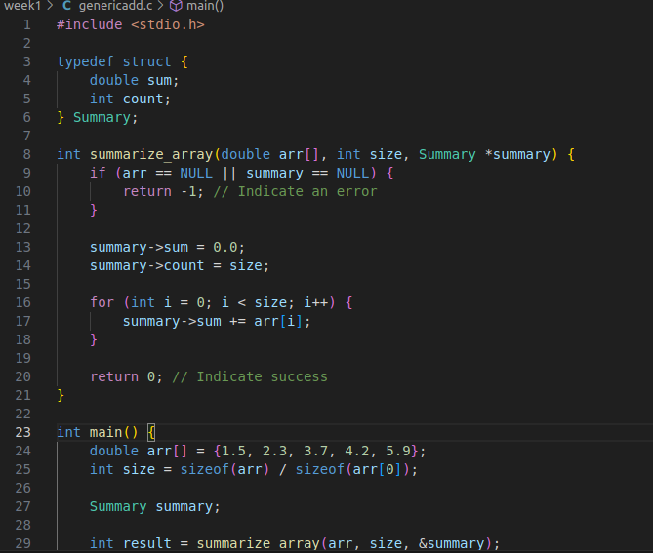

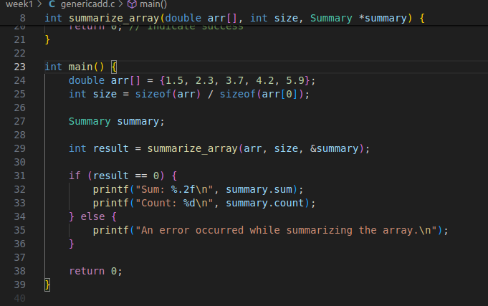
OUTPUT:
