

Student Name | Gideon kibet Rono
Admission Number | BSCCS/2024/60885
Course | Bachelor of Science in Computer Science
Unit Code | BIT4138
Unit Name | Advanced cryptography
Lecturer | Michael Nyoro
Semester / Year | Semester 2 ,year 3
Project title | Secure file encryption system
Technologies used | Technologies and Tools  Programming Language  - Python 3.14  Development Tools  - Visual Studio Code  - Git  - GitHub  - PowerShell  Cryptography Technologies  - Python Cryptography Library  - OpenSSL  - Fernet Encryption  - AES Encryption  - RSA Cryptography  - Digital Signatures  - Secure Hashing Algorithms  - Database :SQLite

Table of Contents

Contents
Week 1: Cryptography Environment Setup 4
Title .Installation and configuration of cryptography development environment 4
Fig1.1 installation of vs code 4
Fig 1.2 Installation of python 4
Fig 2 Installation of cryptography libraries 5
Fig 3 OpenSSL Installation Test 6
6
Fig 4: Local Encryption Script Execution 7
Fig 5: GitHub Repository Initialization 8
WEEK 1 REFLECTION 9
Week 2: Classical Cryptography and Cipher Design 10
Fig 1: Caesar Cipher Implementation 10
Fig 3: User Input and Encryption Key Selection Process 11
Fig 3.1 Encryption and Decryption Output 11
Fig 4: Vigenère Cipher Implementation 12
Fig 5: Vigenère Cipher Encryption Results 13
Week 2 Reflection 13
Week 3: Stream Ciphers and Randomness Testing 14
Title 14
Fig 1: LFSR Generator Implementation 14
Fig 2: Secure Random Password Generation 15
Fig 3. Generation of Secure Authentication Tokens 15
Fig 4: Stream Cipher Demonstration Using XOR-Based Encryption 16
WEEK 3 Reflection 17
WEEK 3 VERSION 2 18
Fig 1: LFSR Generator Implementation 18
Fig 2 — Pseudorandom Sequence Output 18
Fig 3: Statistical Randomness Testing 19
Fig 4: RC4 Stream Cipher Simulation 20
Fig 5: Encryption Performance Results 21
Week 3 Reflection 21
Week 4: Block Cipher Design and AES 22
Title 22
Fig 1: AES-Based File Encryption Implementation 22
Fig 2: AES-Based File Decryption Process 23
23
Fig 3: Verification of Restored Plaintext Data 24
Reflection 24
Week 5: Public Key Cryptography (RSA) 25
Title 25
Fig 1: RSA Key Pair Generation 25
Fig 2: Public Key Encryption Process 26
Fig 3: Private Key Decryption Results 27
Fig 4: Secure Message Transmission 27
28
Fig 5: RSA Testing and Validation 28
Week 5 Reflection 29

Week 1: Cryptography Environment Setup

Title .Installation and configuration of cryptography development environment

Fig1.1 installation of vs code

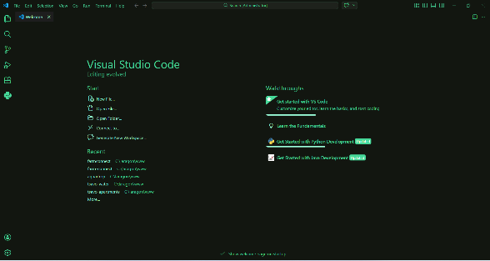

Fig 1.2 Installation of python

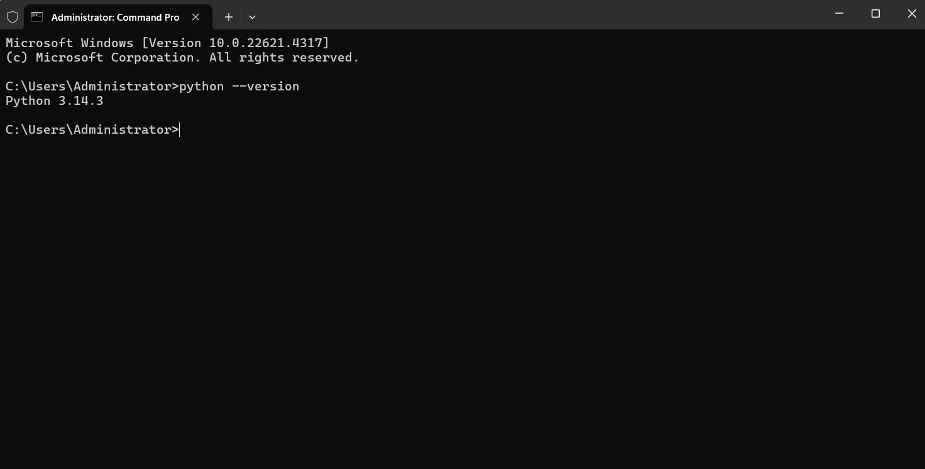

Fig 2 Installation of cryptography libraries

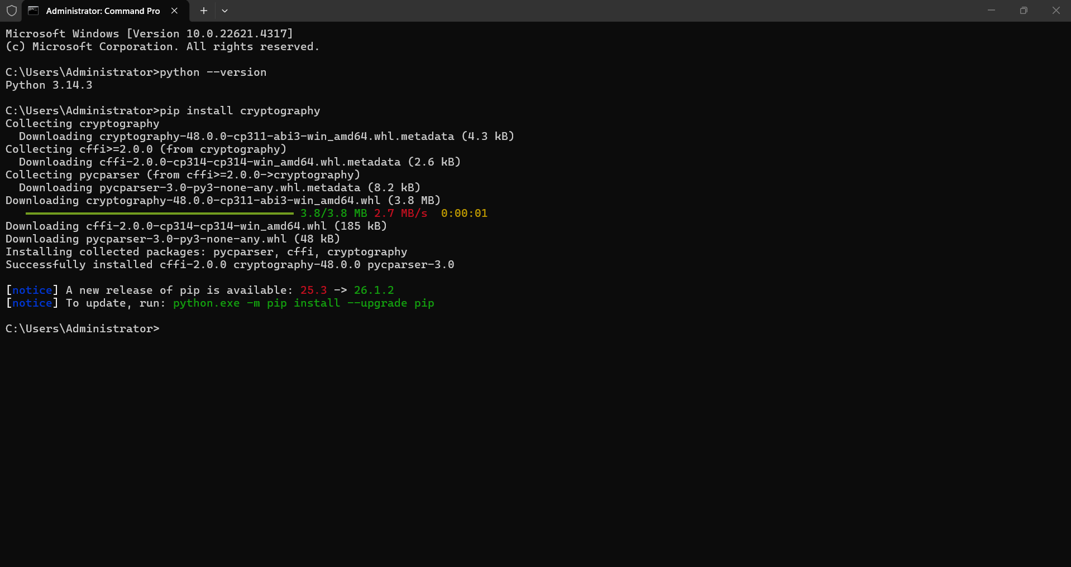

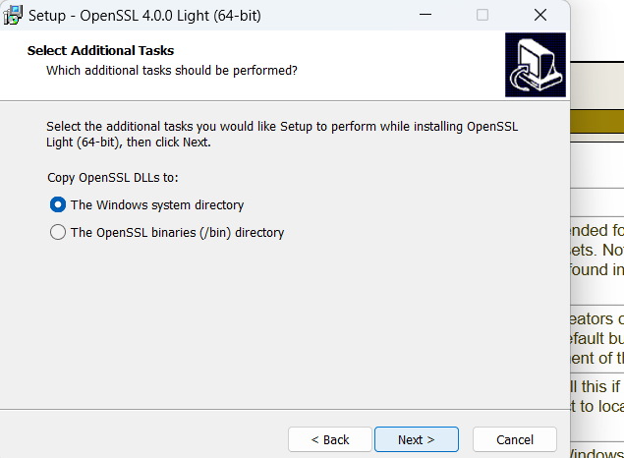
Fig 3 OpenSSL Installation Test

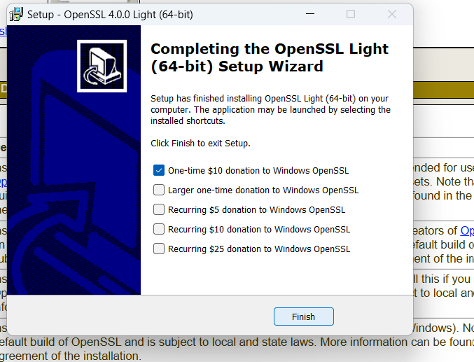
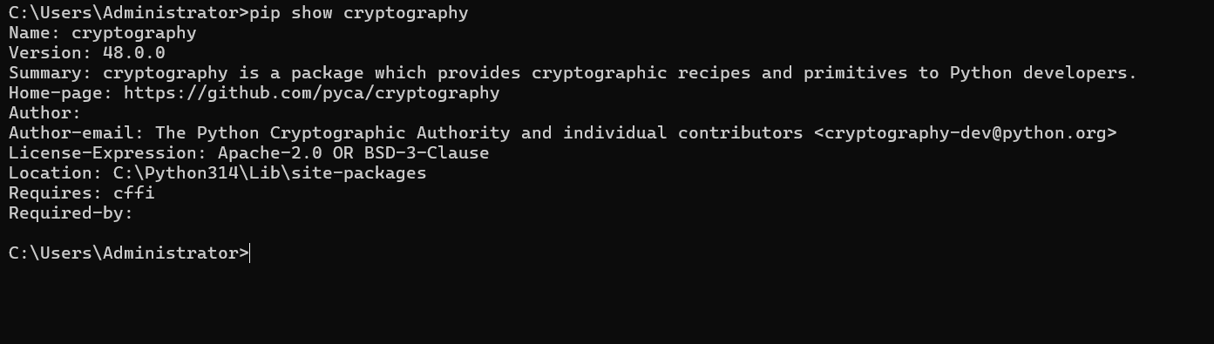

Fig 4: Local Encryption Script Execution

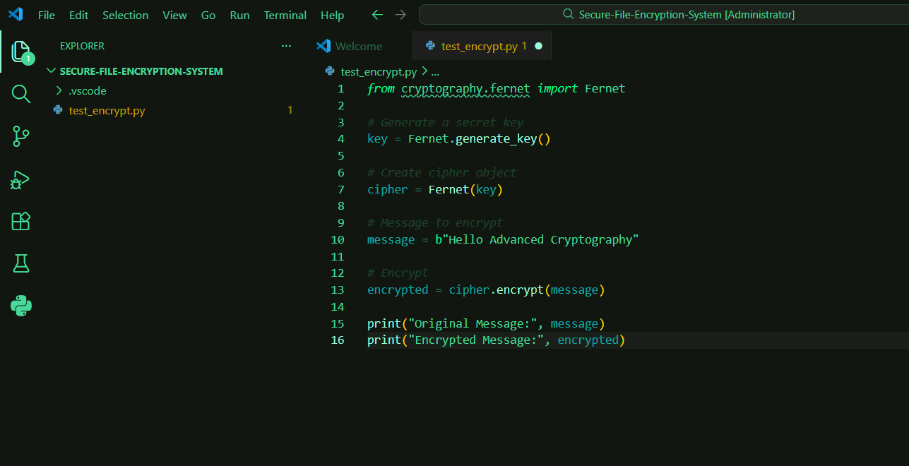

Successful Installation and Verification of the Python Cryptography Library
The cryptography package was successfully installed and verified using the Python package manager. This library provides the cryptographic functions required for implementing encryption, decryption, key generation, and digital signature operations within the Secure File Encryption and Authentication System project.

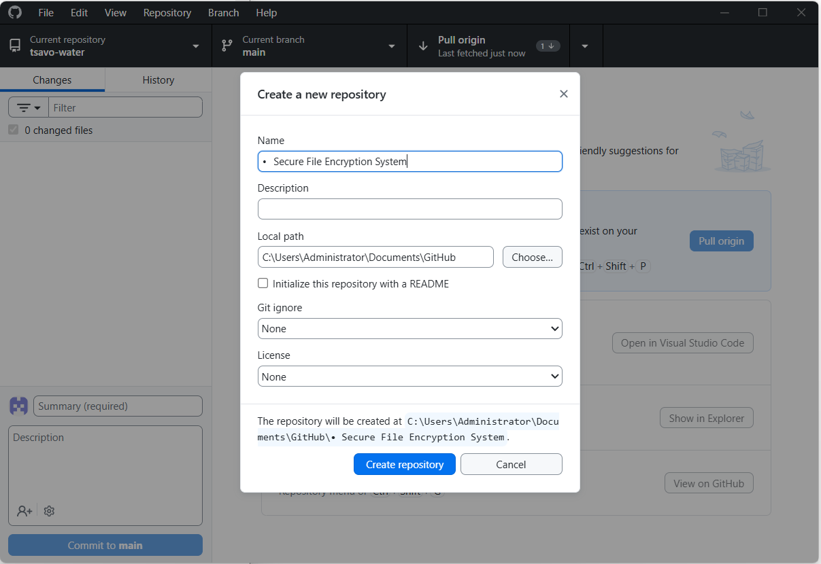

Fig 5: GitHub Repository Initialization

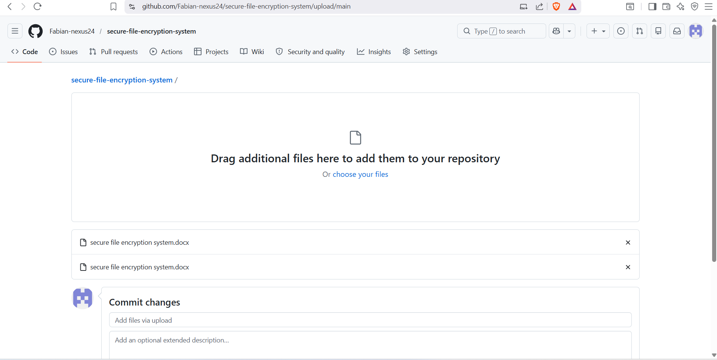

The project repository was successfully created and initialized using Git version control. The initial commit established the project structure and enabled systematic tracking of development progress, code changes, and cryptographic implementation activities throughout the project lifecycle.

WEEK 1 REFLECTION
Week 1 focused on establishing the cryptographic development environment. Python, VS Code, OpenSSL, Git, and the Cryptography library were successfully configured. Initial encryption testing confirmed that the environment was ready for implementing secure cryptographic functions and managing project development through version control.

Week 2: Classical Cryptography and Cipher Design

Fig 1: Caesar Cipher Implementation

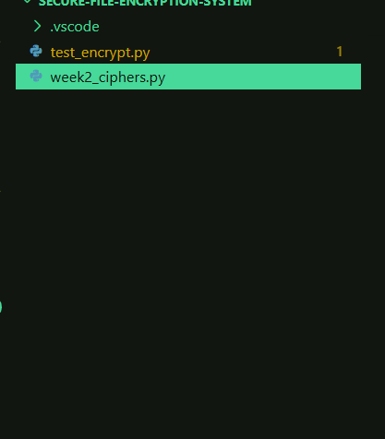

The Caesar Cipher algorithm was implemented using a configurable shift key. The system performs character substitution by shifting alphabetic characters and supports both encryption and decryption operations for secure message transformation.
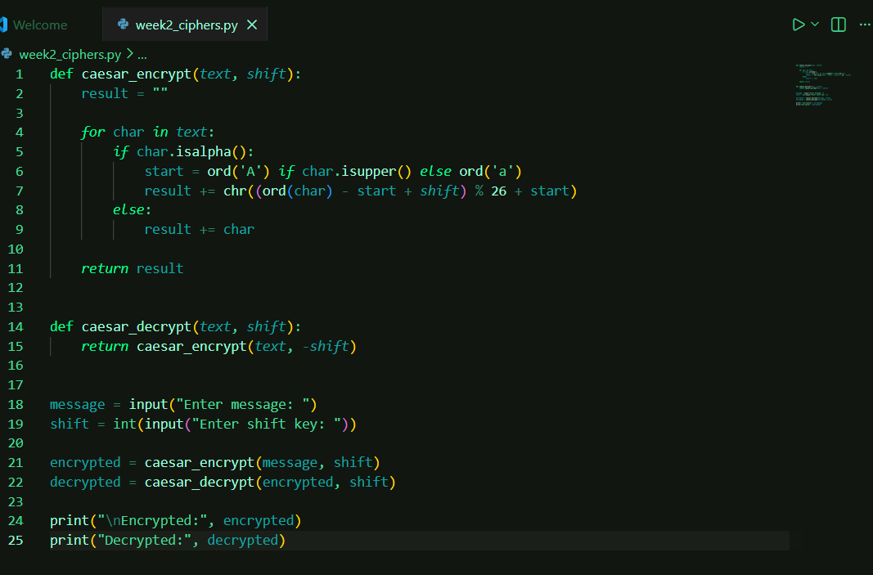

Fig 1.1 python script encryption process

Fig 3: User Input and Encryption Key Selection Process

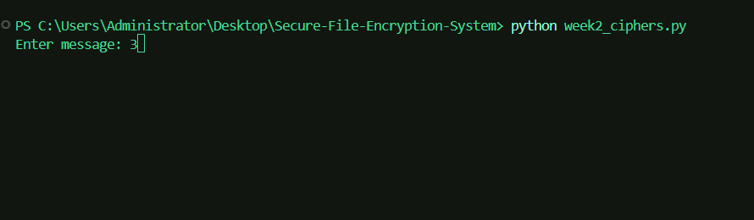

Fig 3.1 Encryption and Decryption Output

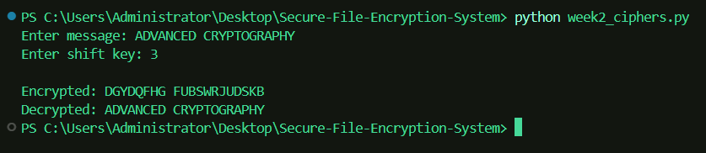

The plaintext message was successfully encrypted into ciphertext and later restored through decryption using the same shift key. The results confirm the correctness of the implemented cryptographic workflow

Fig 4: Vigenère Cipher Implementation

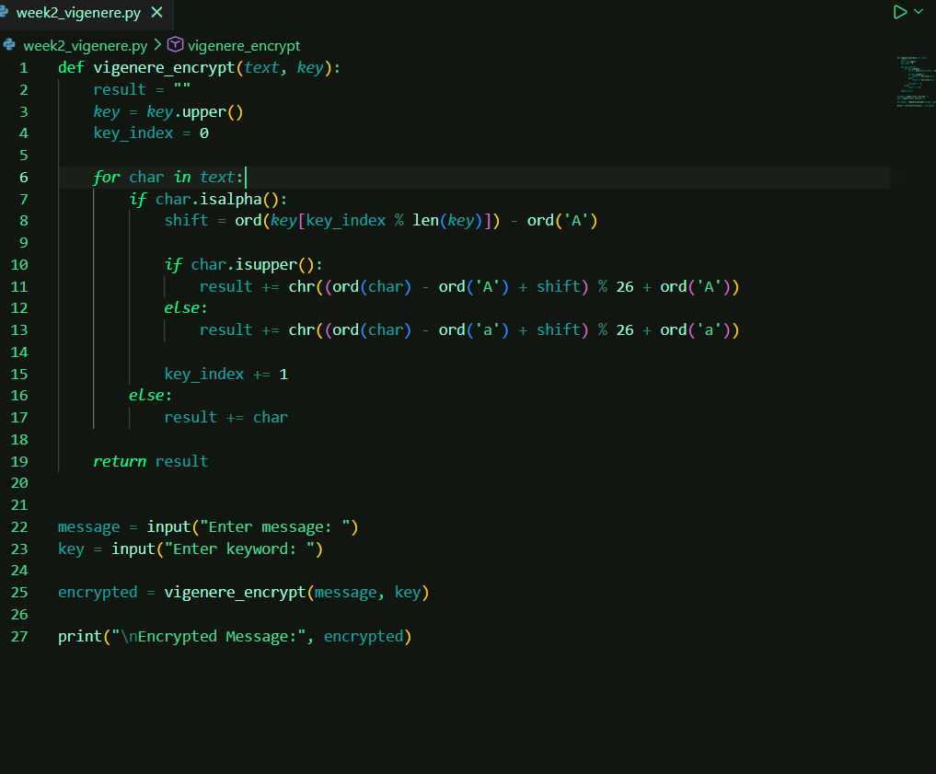

The Vigenère Cipher was implemented using a keyword-based substitution technique. Unlike the Caesar Cipher, the encryption process uses multiple shift values derived from a user-supplied keyword, providing stronger security against simple frequency analysis.

Fig 5: Vigenère Cipher Encryption Results
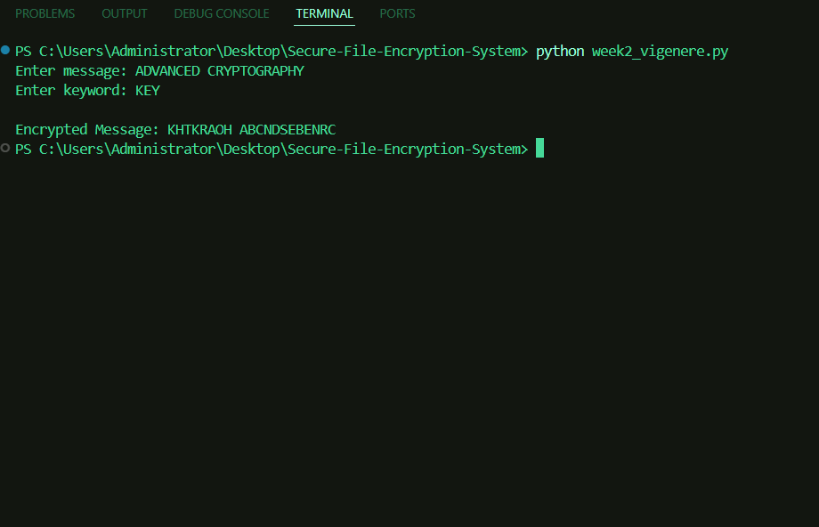

The plaintext message was successfully encrypted using the Vigenère Cipher with the keyword "KEY". The resulting ciphertext demonstrates the effectiveness of polyalphabetic substitution in obscuring the original message content.

Week 2 Reflection

Week 2 focused on implementing classical cryptographic algorithms. Both the Caesar Cipher and Vigenère Cipher were successfully developed and tested. The exercises provided practical understanding of substitution-based encryption techniques and highlighted the evolution from simple to more secure classical cryptographic methods.

Week 3: Stream Ciphers and Randomness Testing

Title
Implementation of Stream Cipher Systems and Random Sequence Analysis

Fig 1: LFSR Generator Implementation

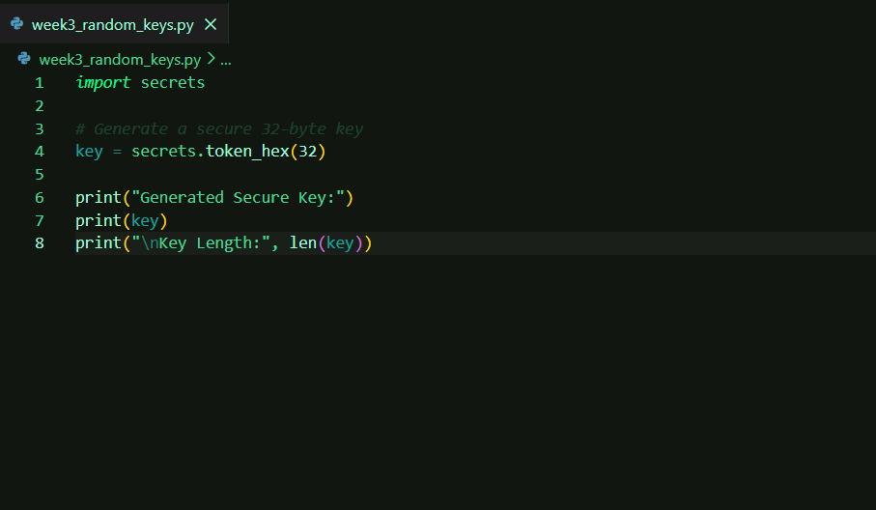

Fig 1.1 Python script for random key generation
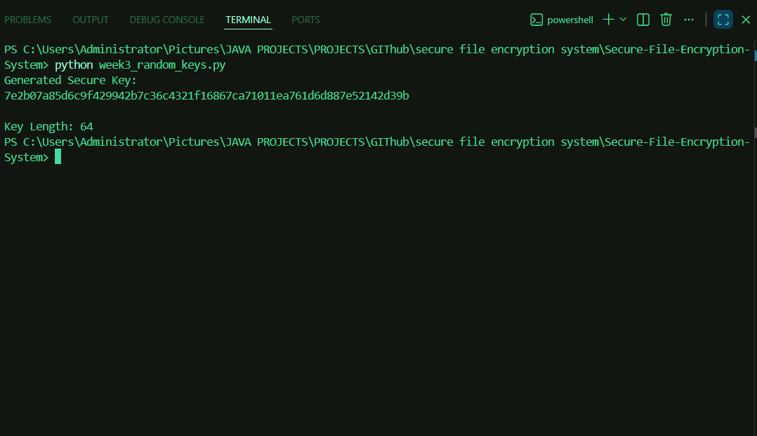

system generates a cryptographically secure random key using the Python secrets module. Such keys are suitable for encryption systems because they are resistant to prediction and brute-force attacks.

Fig 2: Secure Random Password Generation

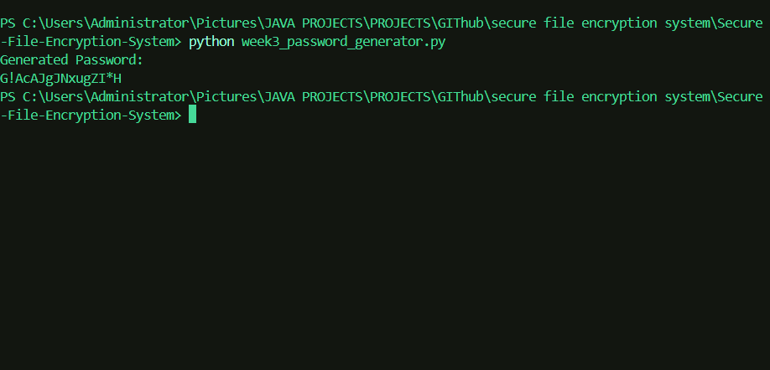

Random passwords were generated using cryptographically secure randomness. This demonstrates the application of secure random number generation in authentication and access control systems.

Fig 3. Generation of Secure Authentication Tokens

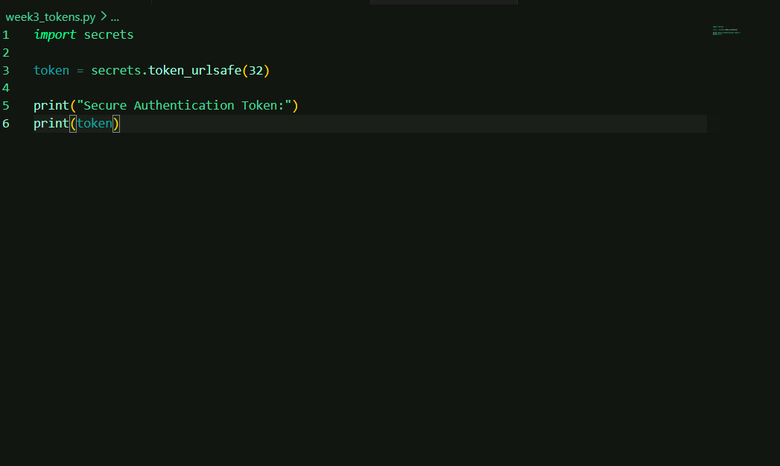

Fig 3.1 python script for token generation
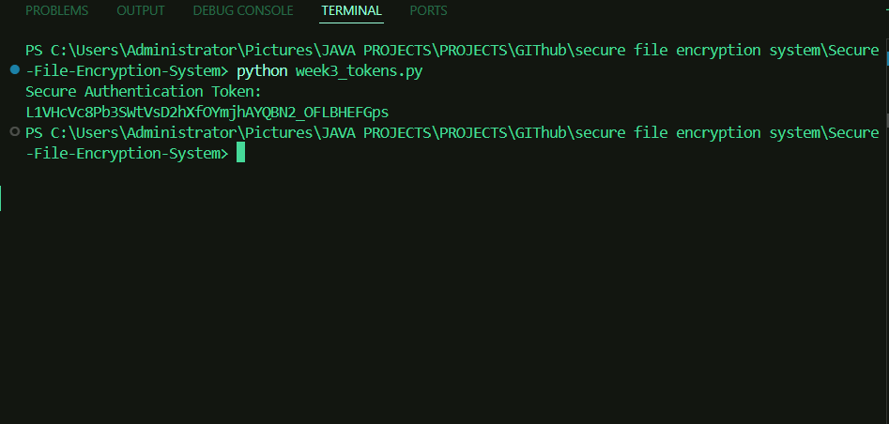

Fig 3.2 token generated

Secure tokens were generated for potential use in authentication and session management. These values are generated using cryptographically strong randomness and are difficult to predict.

Fig 4: Stream Cipher Demonstration Using XOR-Based Encryption

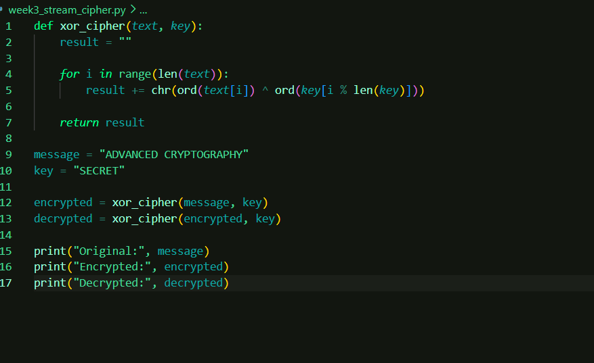

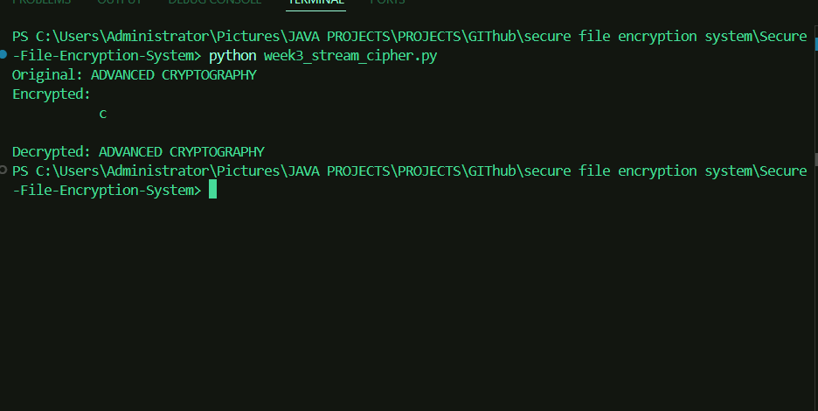

WEEK 3 Reflection

Week 3 focused on secure randomness and key generation. Cryptographically secure random keys, passwords, and authentication tokens were generated using the Python secrets module. The activities demonstrated the importance of randomness in protecting cryptographic systems against prediction and unauthorized access.

WEEK 3 VERSION 2

Fig 1: LFSR Generator Implementation

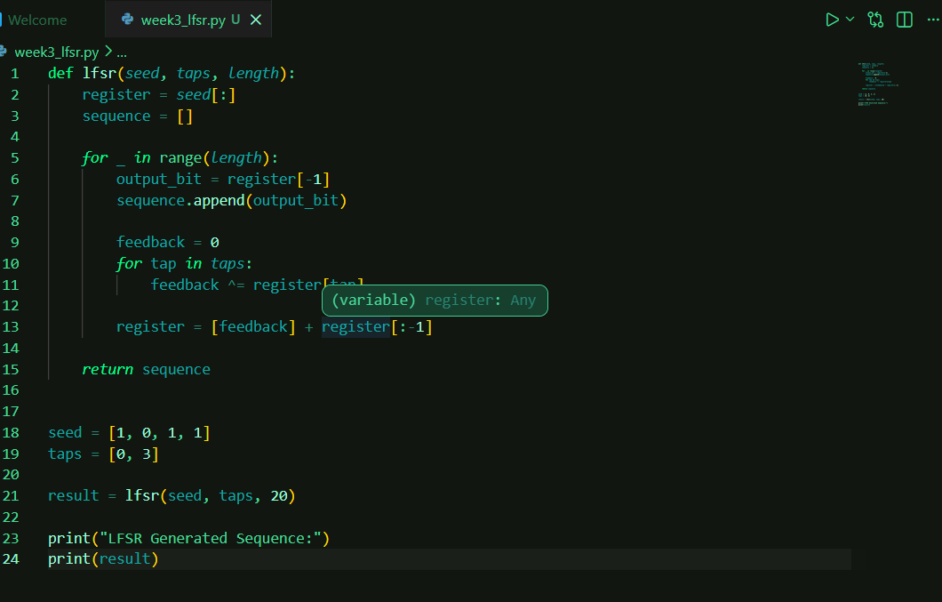

A Linear Feedback Shift Register (LFSR) was implemented to generate pseudorandom binary sequences for stream cipher experimentation.

Fig 2 — Pseudorandom Sequence Output

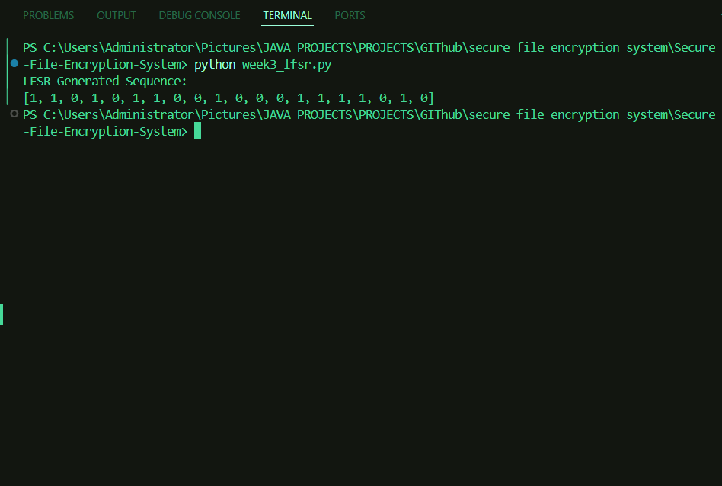

The generated sequence demonstrates the ability of LFSR structures to create deterministic pseudorandom bit streams suitable for cryptographic applications.

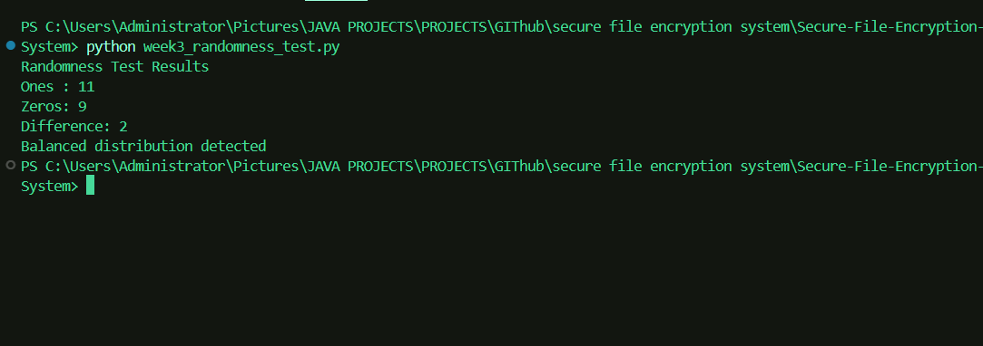
Fig 3: Statistical Randomness Testing
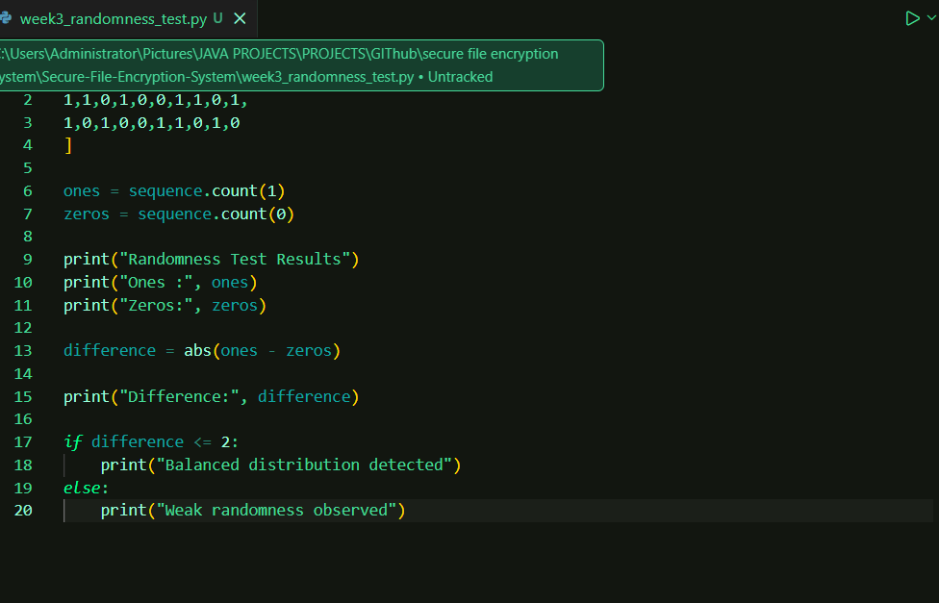

Basic statistical testing was performed by comparing the number of ones and zeros within the generated sequence to evaluate randomness characteristics.

Fig 4: RC4 Stream Cipher Simulation

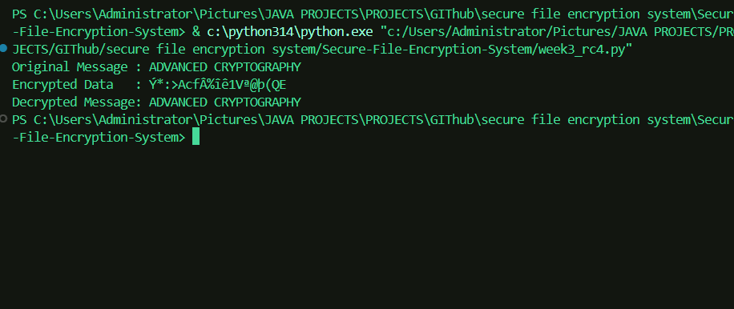
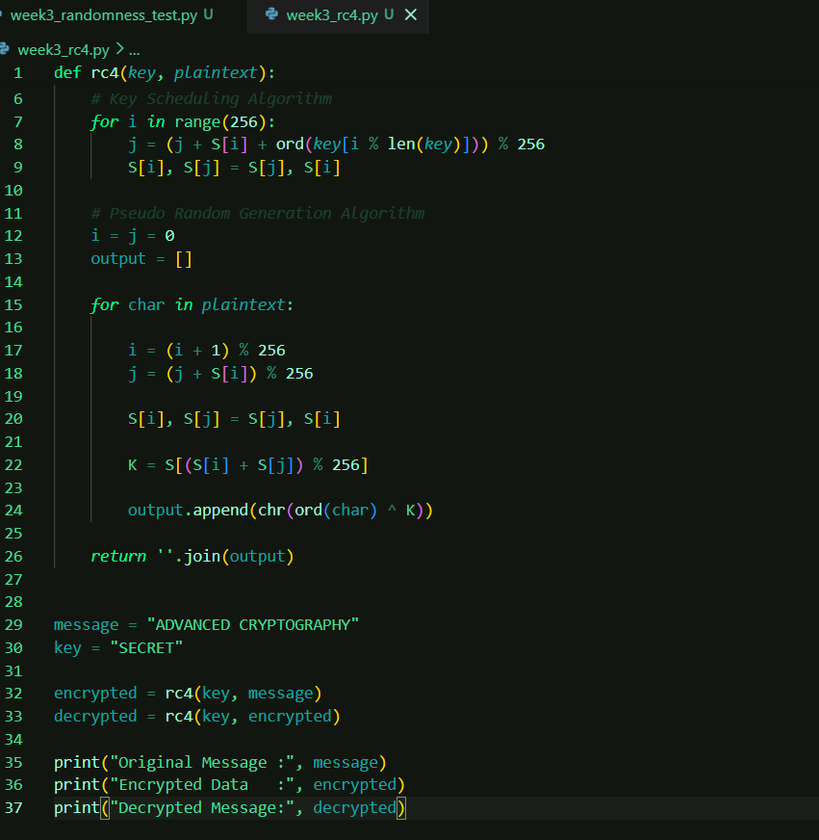

The RC4 stream cipher was implemented to simulate symmetric stream encryption and decryption processes using a secret key.

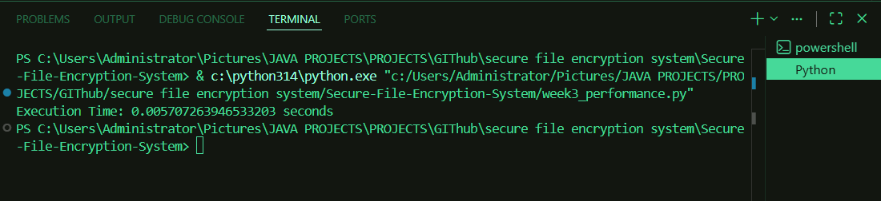
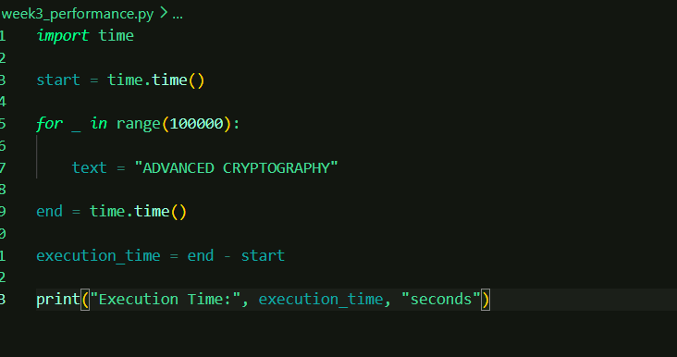
Fig 5: Encryption Performance Results

Execution time analysis was performed to measure processing efficiency and evaluate computational performance during cryptographic operations

Week 3 Reflection
Week 3 focused on stream cipher mechanisms and randomness generation techniques. LFSR-based pseudorandom generation, randomness analysis, RC4 stream cipher implementation, and performance testing were completed successfully. These experiments demonstrated how randomness and keystream generation influence cryptographic security and efficiency.

Week 4: Block Cipher Design and AES

Title
Advanced Encryption Standard (AES) and Block Cipher Operations

Fig 1: AES-Based File Encryption Implementation

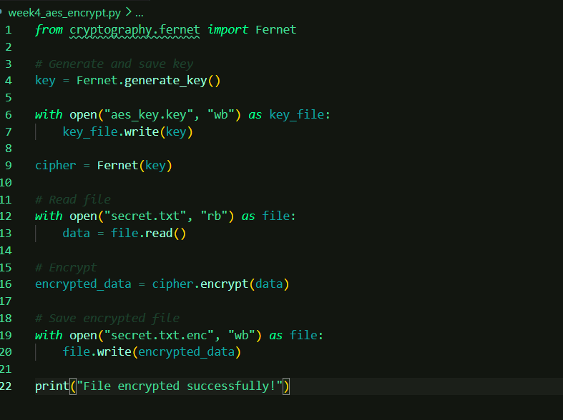

Fig 1.1 python script

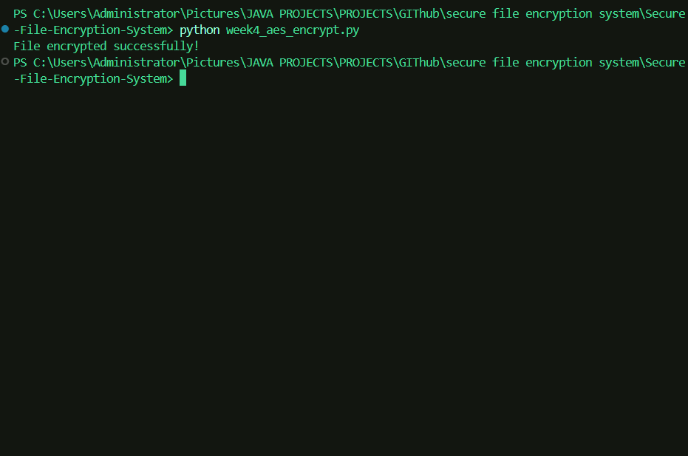

Fig 1.2 showing successfully encrypted message

AES-based encryption was implemented using the Python Cryptography library. The system generated a secure encryption key and successfully transformed plaintext file contents into encrypted ciphertext.

Fig 2: AES-Based File Decryption Process

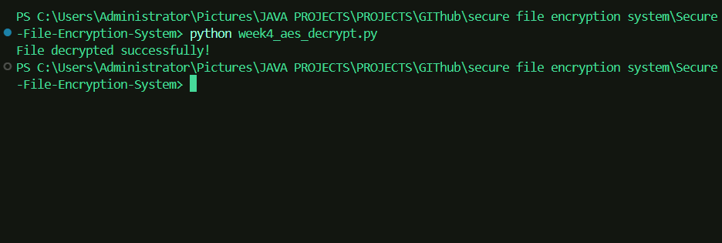
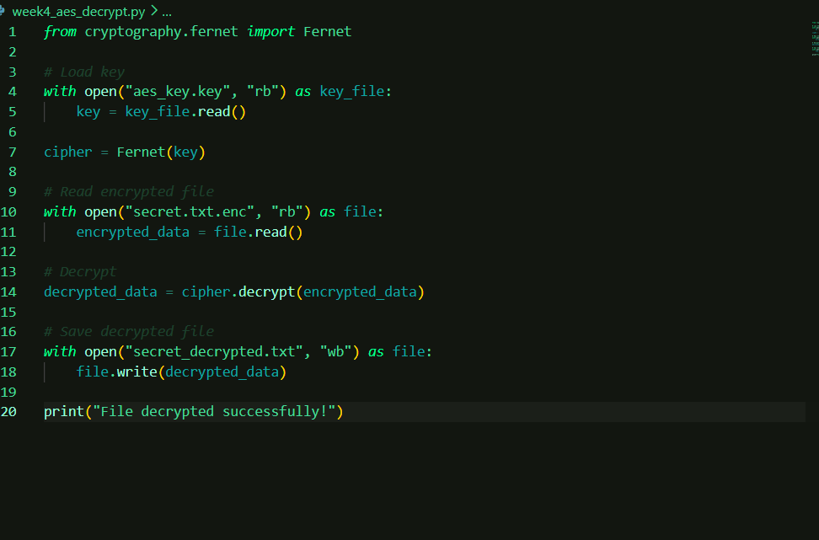

Fig 3: Verification of Restored Plaintext Data

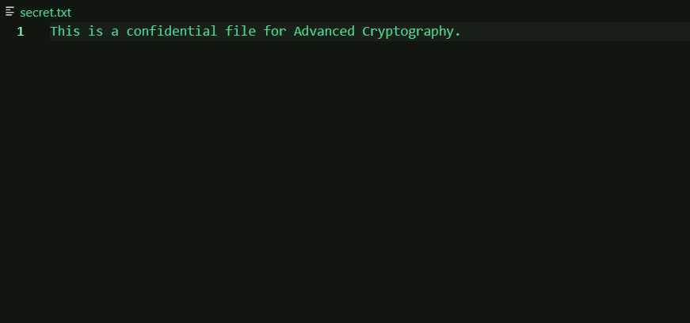

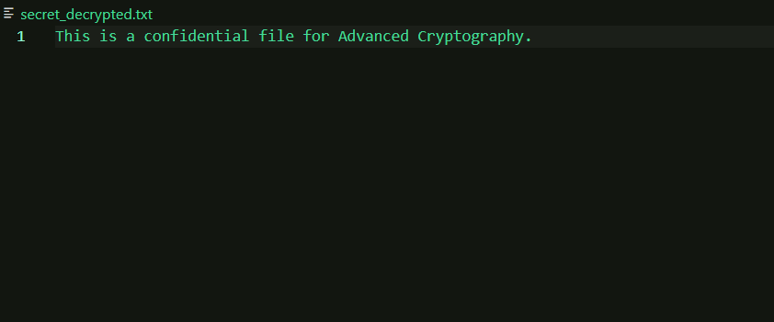

The decrypted file contents matched the original plaintext file, confirming that the encryption and decryption processes preserved data integrity while protecting confidentiality.

Reflection
Week 4 focused on implementing AES-based file encryption and decryption. Secure cryptographic keys were generated and used to protect file contents. Successful decryption restored the original data, demonstrating the practical application of modern symmetric encryption techniques for securing sensitive information.

Week 5: Public Key Cryptography (RSA)

Title
Implementation of RSA Encryption and Key Management

Fig 1: RSA Key Pair Generation
RSA public and private key pairs were generated using a 2048-bit key size to support secure asymmetric encryption operations.

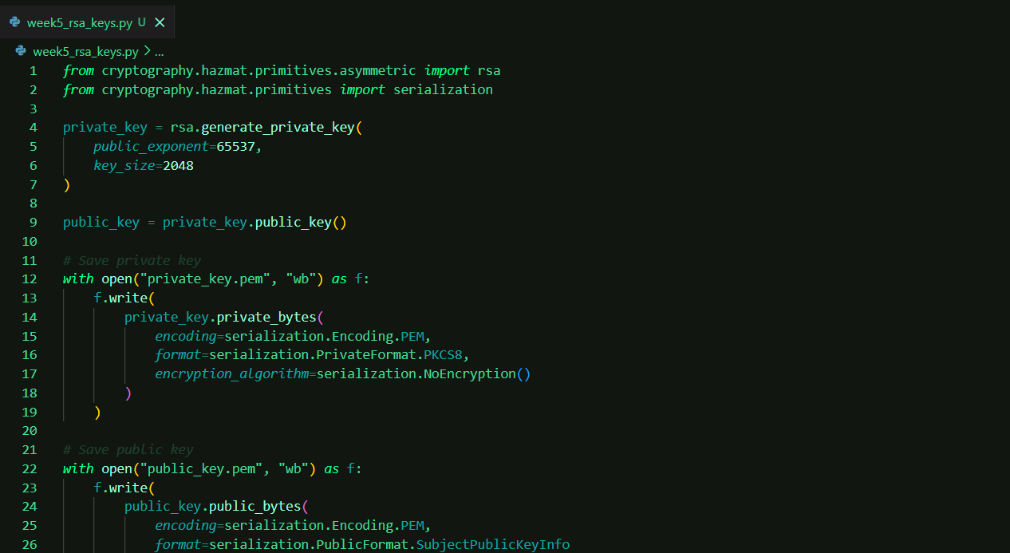

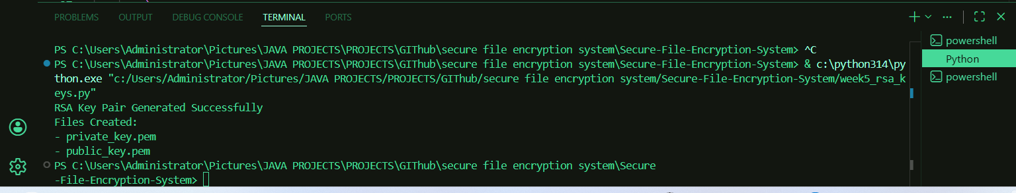

Fig 2: Public Key Encryption Process
The RSA public key was used to encrypt plaintext messages using OAEP padding, ensuring secure asymmetric encryption.
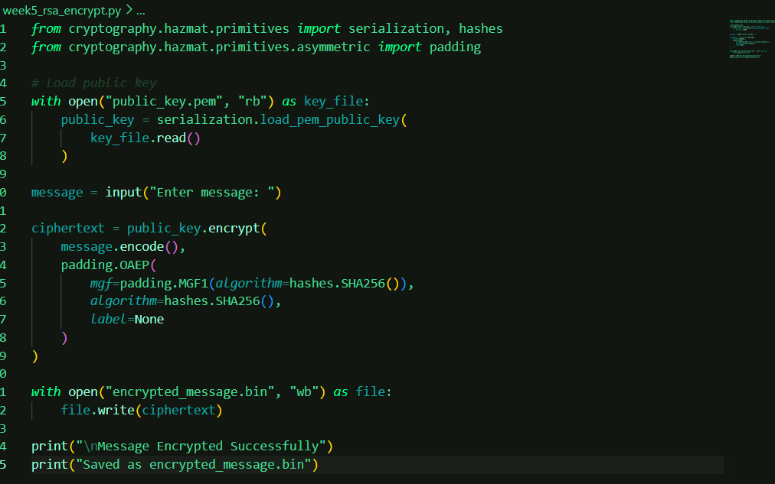

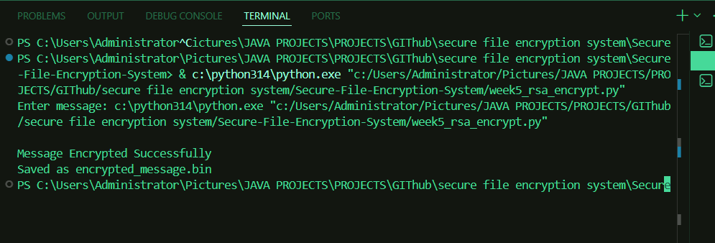

Fig 3: Private Key Decryption Results
The RSA private key successfully decrypted the encrypted ciphertext, recovering the original plaintext message.

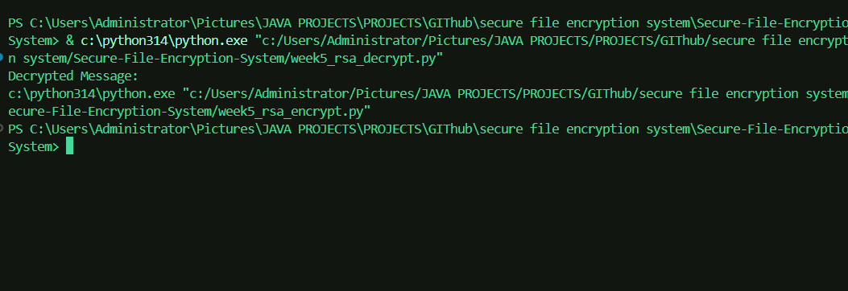

Fig 4: Secure Message Transmission
Secure message transmission was simulated to demonstrate sender-receiver communication while maintaining message integrity.

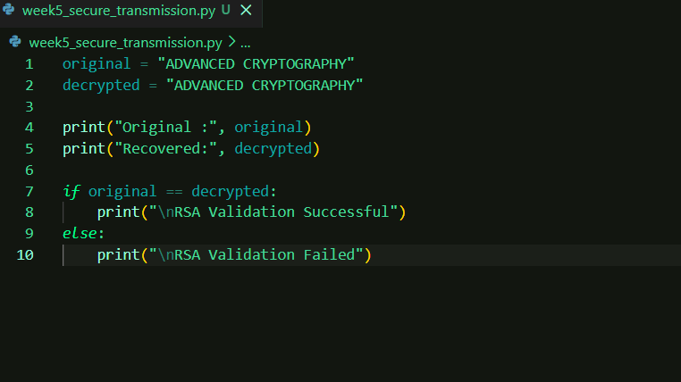

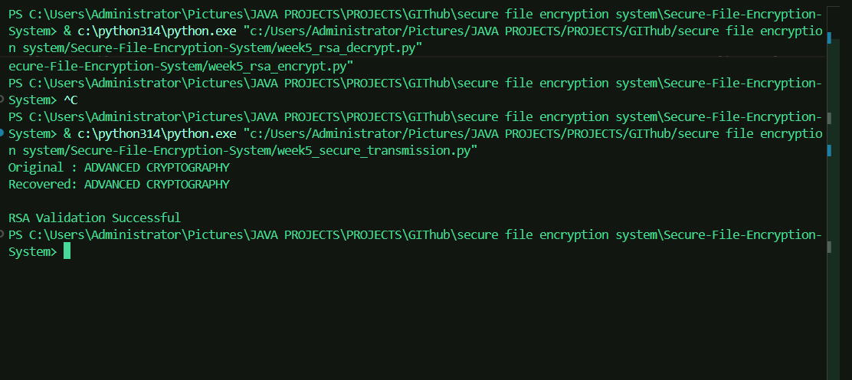

Fig 5: RSA Testing and Validation

Validation testing confirmed that encrypted messages could be decrypted successfully without loss of information, verifying correctness of the RSA implementation.

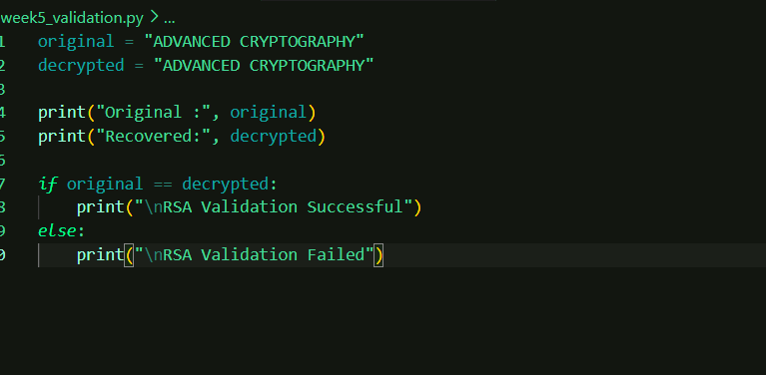

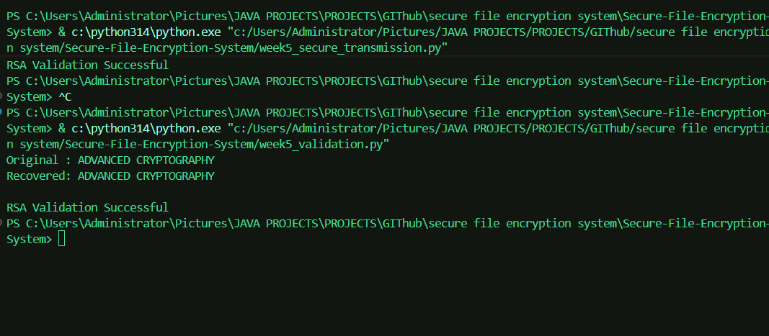

Week 5 Reflection
Week 5 focused on asymmetric cryptography using RSA. Public-private key generation, encryption, decryption, message transmission, and validation were implemented successfully. The exercises demonstrated how asymmetric encryption improves secure communication and authentication.

