**ShredderEx**

**Welcome**

**About:** ShredderEx was crafted to offer users a seamless and forceful file deletion experience. The term 'forceful' denotes the program's capability to delete files that Windows would typically deny.

**History:** The initial iteration of the Shredder software was conceived in February 2020.

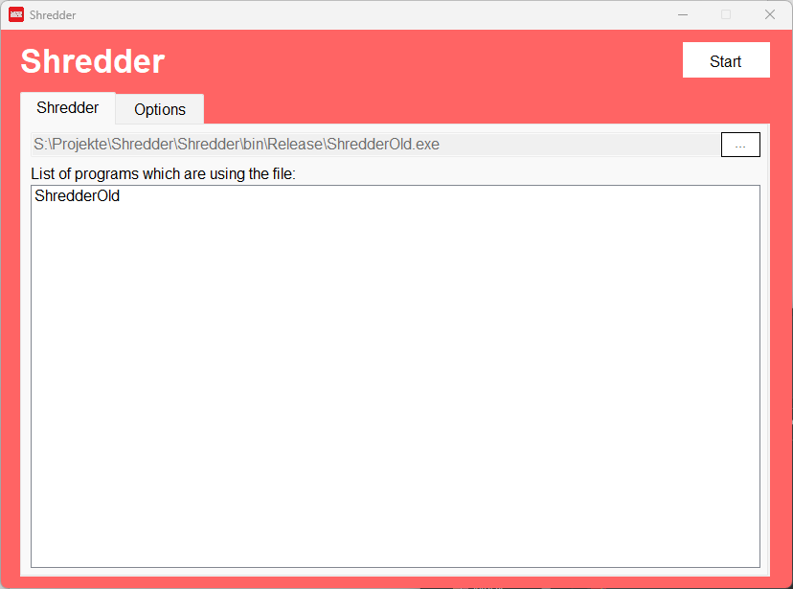  
*The first version of Shredder in Feb. 2020*

Subsequently, both the design and functionality of the software underwent a comprehensive upgrade. While the original version solely offered file deletion capabilities, the enhanced iteration introduced a feature for directory deletion as well. This revamped version was developed and released in December 2020.

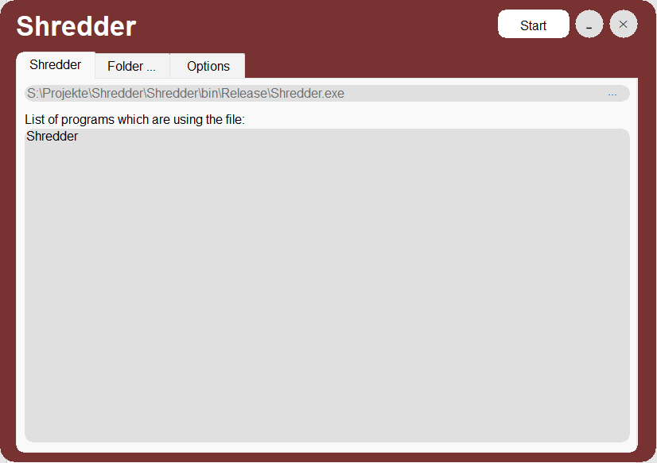

*The second version of Shredder in Dec. 2020*

In December 2021, Shredder underwent its most significant transformation to date. The entire program was deconstructed and meticulously rebuilt from the ground up. The latest iteration, now named ShredderExtension, evolved into an add-on integrated directly into the Windows context menu, enhancing user accessibility and streamlining the file deletion process.

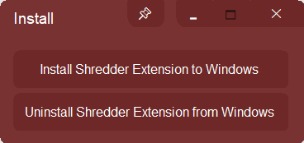 Ein Bild, das Text, Screenshot, Schrift enthält.

*The third version of Shredder in Dec. 2021*

In September 2022, Shredder unveiled its fourth major iteration, rebranded as ShredderEx. This update signified a complete reinvention of the software, with a new button layout to streamline user interaction. The name ShredderEx subtly hints at its enhanced capabilities. The interface received a makeover to align closely with the Windows style, and the software's efficiency in deleting resistant files reached new heights of aggressiveness.

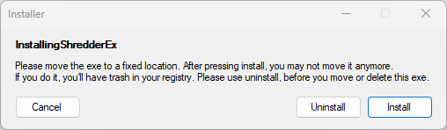

*The fourth version of Shredder in Sep. 2022*

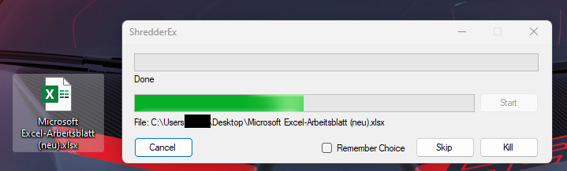

*The fourth version of Shredder in Sep. 2022 (active)*

In December 2023, ShredderEx unveiled its fifth version, setting a new standard in file deletion technology. This latest update ensures that once data is processed by the shredder, it becomes permanently irrecoverable, defying even the most sophisticated recovery software. The program now runs entirely natively, featuring improved multi-threading and optimized CPU and RAM utilization. This iteration also brings a complete overhaul in design, offering a fresher, more modern user interface. Reflecting its continued evolution, the software was rebranded as ShredderEx2. Additionally, ShredderEx2 can be used both as a standalone application and as a context menu extension, expanding its versatility and user accessibility.

Ein Bild, das Text, Screenshot, Schrift enthält.

*The fifth version of Shredder in Dec. 2023*

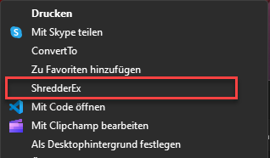

**How does it work?**

ShredderEx is a unique software that combines both the application and installer in a single executable file. To set it up, select a permanent location for the program. Once you've placed the executable in the desired directory, launch it. You'll be prompted to grant administrative permissions. After granting these, simply click 'Install' to complete the setup. Remember, if you wish to relocate ShredderEx, you must first select 'Uninstall' before moving it. To verify a successful installation, right-click on any file or directory and look for the new "ShredderEx2" option. Note that in Windows 11, this option appears only in the old-style context menu. ShredderEx2 allows you to delete either a single file or an entire directory, but multi-selection deletion is not supported.

**How to uninstall?**

It's unfortunate to hear that you'd like to remove ShredderEx2. The uninstallation process is straightforward. Simply run the executable file once more and select 'Uninstall.' After clicking 'Uninstall,' please verify if the option has been removed from the context menu. If it persists, attempt the process again. Ensure that you restart the program before clicking 'Uninstall.' It's important to note that toggling between 'Install' and 'Uninstall' without restarting may lead to functionality issues.

**How to use ShredderEx?**

You've initiated ShredderEx2 by either right-clicking and selecting the ShredderEx2 option or by double-clicking the executable. But what happens next? It's quite straightforward! The program immediately begins scanning the selected file or directory. The duration of the scan depends on the number of files you've chosen. Once the scan is complete, you have the option to either cancel the operation or proceed with shredding.

What if a file cannot be deleted? ShredderEx2 will prompt you to decide whether it should forcefully remove the file, a more potent option compared to standard deletion, or if you prefer to skip the file. By checking the "Remember Choice" checkbox, you can instruct the program to always use your selected option (skip or forcefully remove) without asking again until the program is restarted. The operation is considered finished when the "Cancel" button changes to "Close.".

Made with ♥ in Germany