GitHub Username: Your GitHub username here

NFC Share Contacts

Description

Easy way to exchange your number and(!) social media accounts with people you just met via NFC. Handle all your friends data fast and easy. Decide what information you want to send and which you'd better keep this time. This App is for everybody who wants exchange more than numbers or maybe less super fast. Store these special contacts apart from your real contact list or add them – that's up to you Access the social media directly from the app.

Intended User

Travellers, social active people, nfc-technology-lovers

Features

- Saves information
- Sends and receives data per NFC

User Interface Mocks
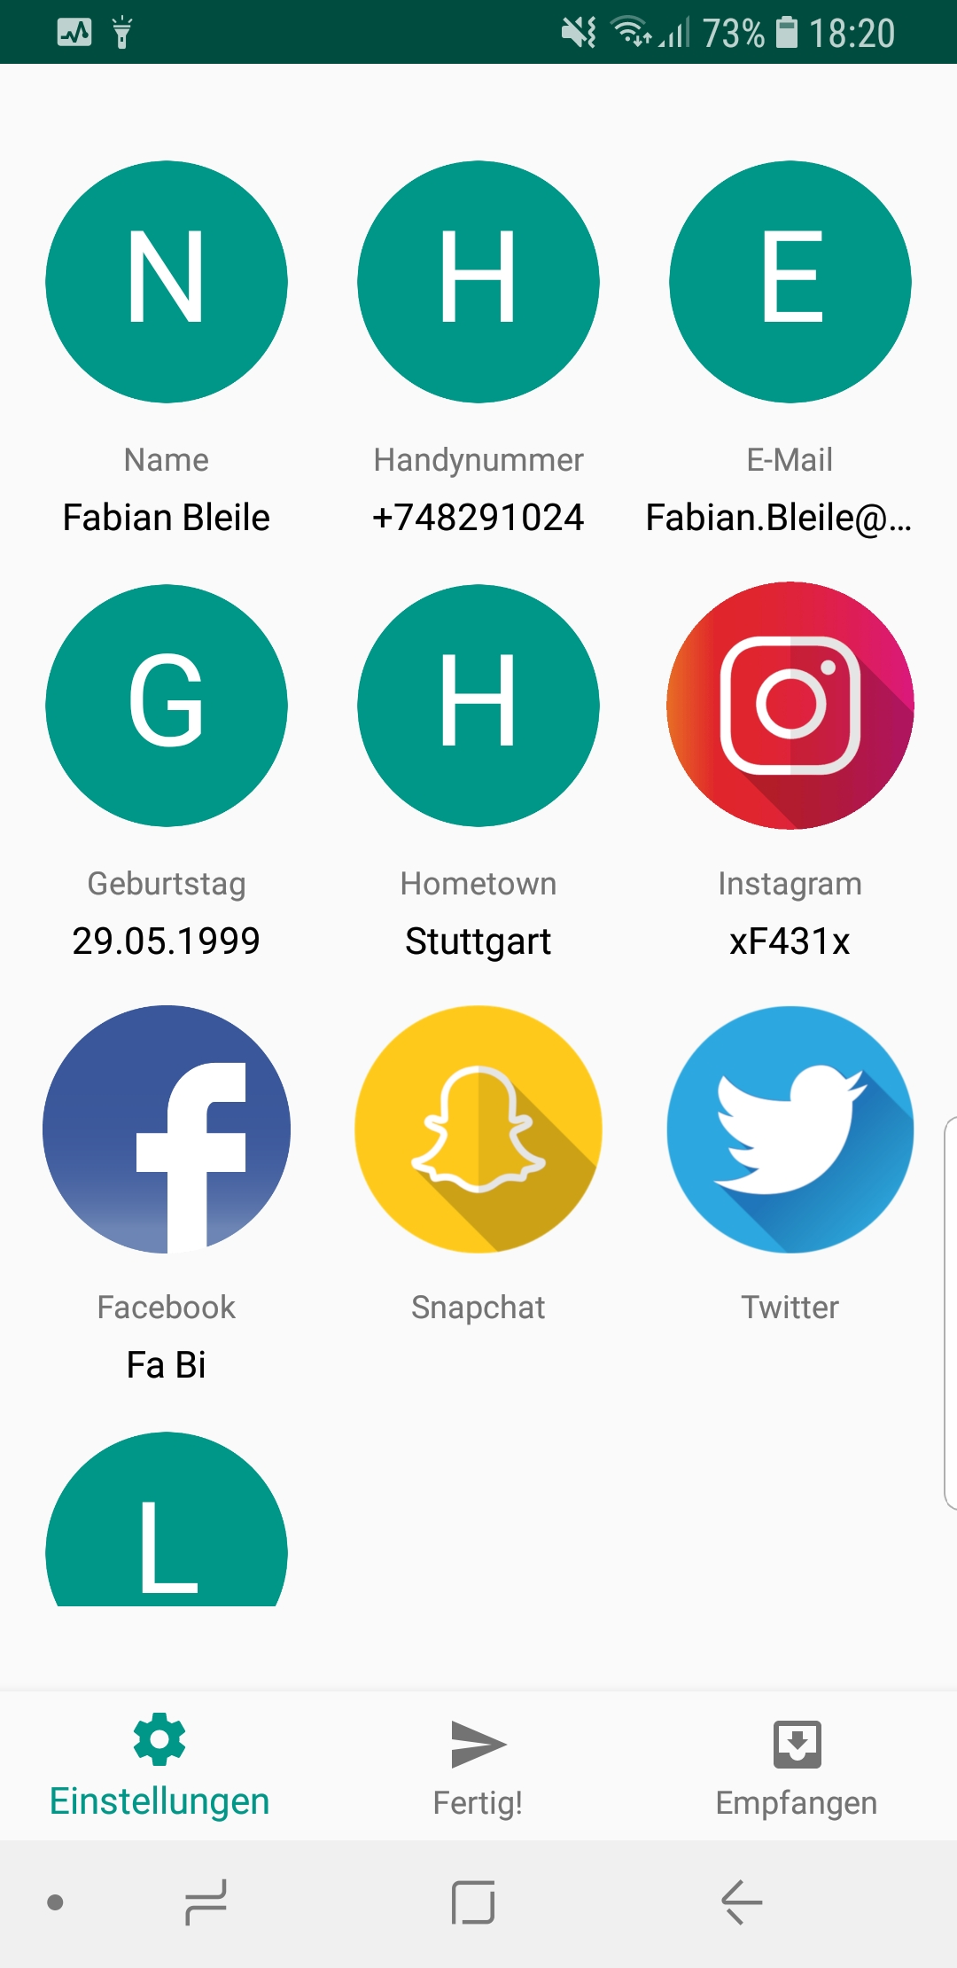
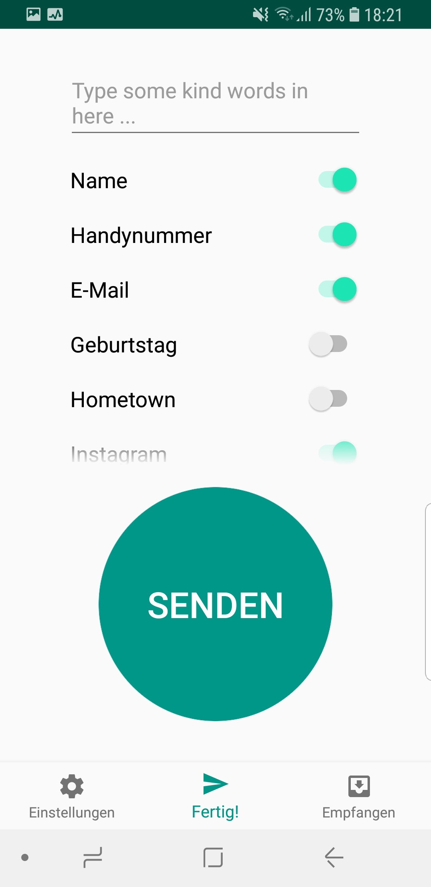
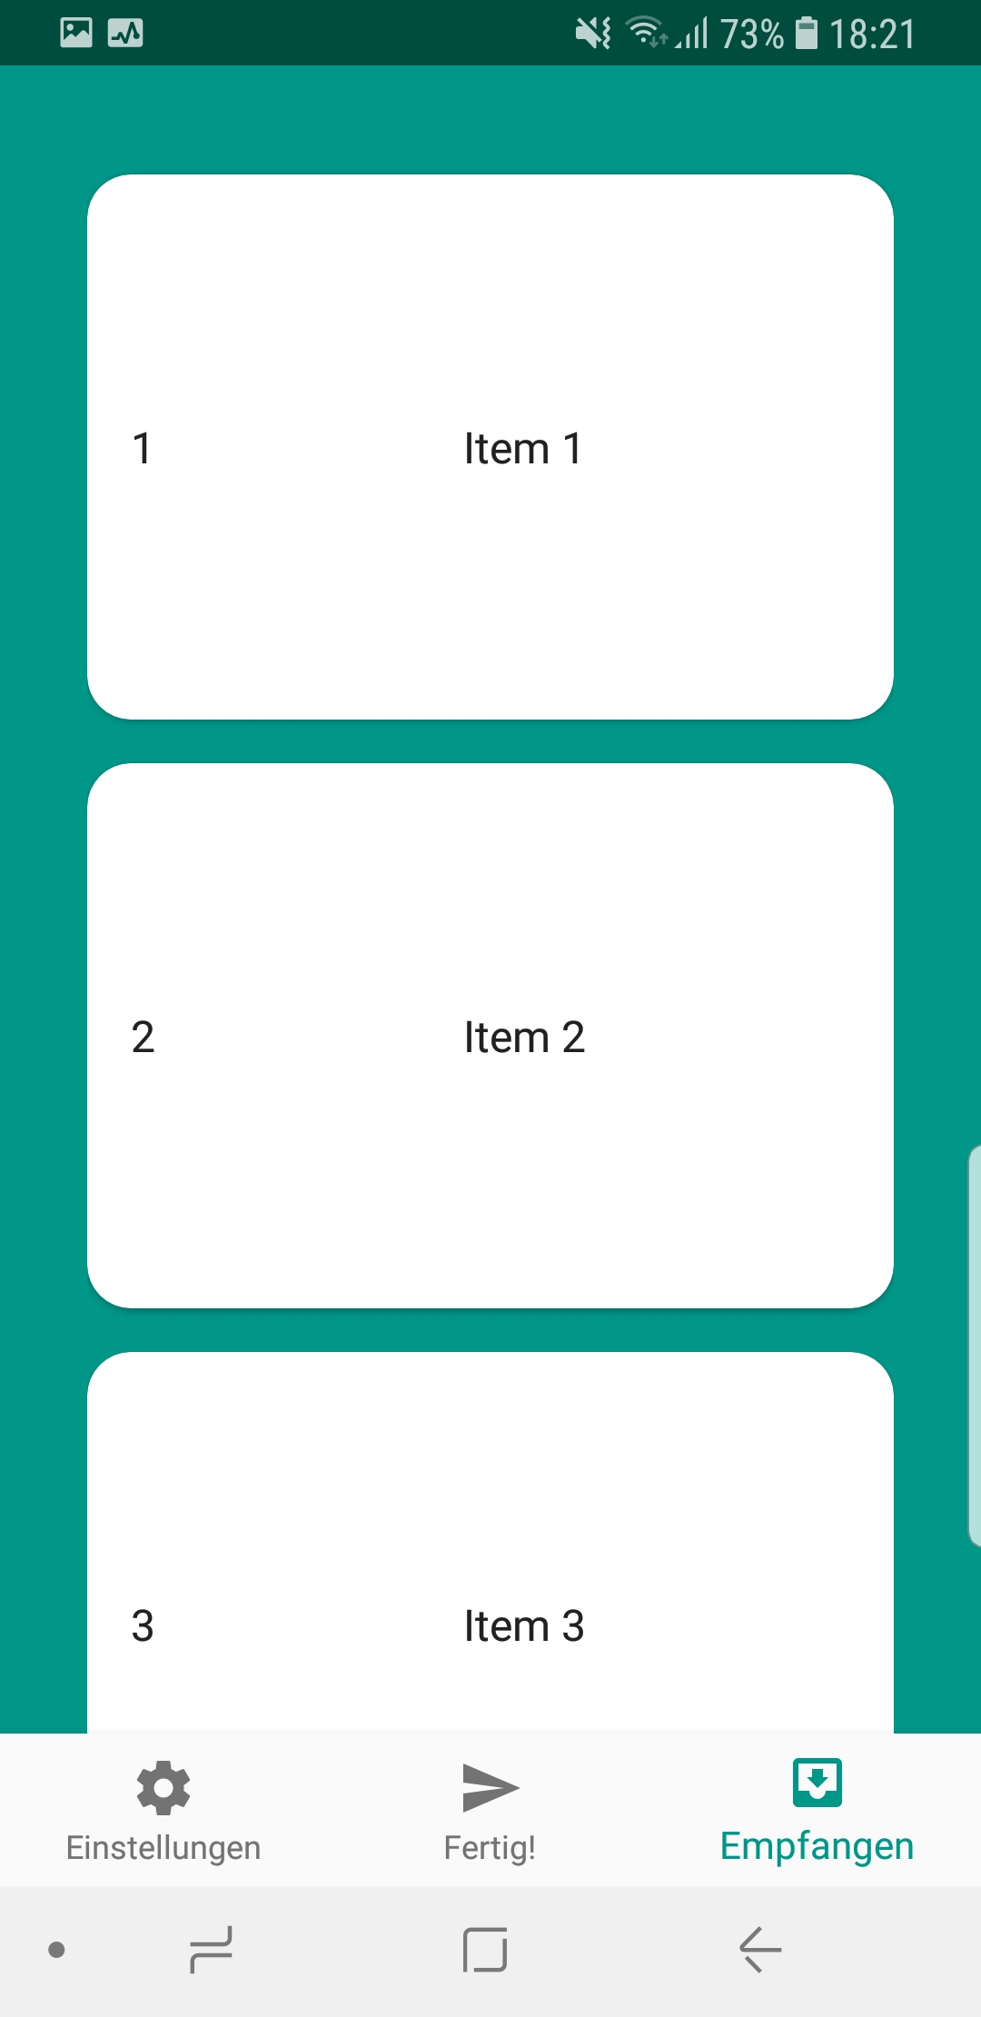

Screen 1: Settings Screen where all the information should be stored which are supposed to be sended via NFC.
Screen 2: Select all the information you want to send. With a click on Send the file is created and the beam invoked.
Screen 3: Display all the recieved contacts in a card views.

Screen 4: Detail Activity to show received data
Screen 5: Widget

Key Considerations

How will your app handle data persistence?

- SharedPreferences for Settings and „personal information“
- Room for received data

Describe any edge or corner cases in the UX.

Navigate
- from widget to MainActivity
- from MainActivity (ReiceiveFragment) to DetailActivity and back

Describe any libraries you’ll be using and share your reasoning for including them.

- Room for data persistance
- Gson for object to string to send it via nfc
- Firebase and Google Services for AdMob and Location

Describe how you will implement Google Play Services or other external services.

- Location, to get the last known location. Sharing this makes it easier to handle contacts
- adMob in form of an intertitial ad launching on data transfer complete

Next Steps: Required Tasks

Task 1: Project Setup

- Configure Libraries

Task 2: Implement UI for Each Activity and Fragment

- Build UI for MainActivity
- Build UI for Fragments (SettingsScreen, SendScreen, ReceiveScreen, ChatScreen(?))
- Build UI for BottomNavigationMenu
- Build UI for DetailActivity

Task 3: Implement SharedPreferences for SettingsScreen

- make SettingsScreen responsive
- handle Sharedpreferences for peersonal contact

Task 4: Make nfc data transfer working

- create object to send
- handle sending and receiving device

Task 5: Widget

- create configure activity

Task 6: DetailActivity

- list received contacts and equip the activity with implicit intents to quickly use the received data

Common Project Requirements

- I am going to use Java to develop the application

Android Studio | 03.01.03
Gradle | 03.01.03
Google services | 4.0.1
Gson | 02.08.05
Play services location | 15.0.1
Firebase ads | 15.0.1
room | 01.01.01
Lifecycle | 01.01.01

Implementing all features required for Stage 2

- App keeps all strings in strings.xml and enables RTL layout switching in the manifest
- Async task is used to run tasks asyncronously
- Room is used coming with view model and live data

