README Contents
WeatherLink for Vantage Pro

Table of Contents

Version
Station location
Retrieving Data From the Data Logger
Time and Date formats supported
DataSets.dat and DataLists.dat File Structures
Data File Structure
Format of the Expansion_Modules\ModuleList.dat file

Version 6.0.5 Features
- • Supports 15 minutes and 5 minutes auto download and network upload in additional to hourly schedule.
- • In Yearly Rainfall report, display dashes for yearly total rainfall if not all months have valid data.

Station location
Since June 2021 the weather station was located in Palmeira, a sub region of Manhica District. As of 15th of September 2023, the station is located at CISM in Manhica Village

WeatherLink Network Notes
On your My Weather page you have an option at the bottom to select your units. If you choose, “Your console settings”, it will not use the console settings, but the unit settings you have set in the software.

ADD DETAILS OF HOW TO LOGIN- who has a username and password? Which email is it connected to?

Retrieving Data From the Data Logger

Using WeatherLink software, data can be downloaded and included in your WeatherLink data files stored in the laptop/PC.
To incorporate this data into your WeatherLink data files:

1. From the weatherLink app, download the data by connecting your laptop/PC to the data logger via USB cable
2. Choose Download in the File menu or click on the download icon.
WeatherLink will do a full download of all data stored in the data logger.

3. Choose Browse in the Window menu or click on the Browse icon.

Add screenshots?

Data download schedule to local machine

The data must be downloaded on a bi-weekly basis to avoid data being over written, the data that is stored on the data logger is kept in the data logger for 21 days, after 21 days the data is overwritten by the system to create space to store more data.

Data upload to the cloud

To upload the data to weatherlink cloud services, a laptop/PC that has the weatherlink app installed needs to be connected to the data logger and the internet, once connected, data is uploaded on command by cliking: setup -> weatherlink network
Automatic download can also be enabled by checking the box: setup -> Network upload (if checked), this way, once the laptop/PC is connected to the data logger the upload begins

The process

Fig 1: Data download process

Fig 2: Data download process (from weather station to local PC/ laptop and upload to ISGlobal server and weather link cloud)

Storing the data

The downloaded file is first stored in the laptop/PC connected to the data logger, after the download is complete, you can browse to the location in the laptop/ PC that the download took place and copy the file to: \\fs01.isglobal.lan\AirPollution\MOZAMBIQUE\Mozambique_weather_data

Each time a file is downloaded, the system saves as palmeira_weather_data.txt, in order to avoid file being over written while saving, each file should have the date that the download took place as part of the file name. CAN YOU ADD AN EXAMPLE filename

The data is downloaded on txt format and it contains a total of 55 variables, and out of the 55 variables we only use “Date”, “Time” and “Temp Out”.

We can read the txt. File using R, then we select only the 3 variables that we need (Date, Time and Temp Out (outside temperature)) and create a new dataset with just the 3 variables.

Reading the data in R
##
Palmeira_weather_data_10022023 <- read.delim("/Weatherlink/Palmeira_weather_data.txt")

CAN YOU MAKE A COPY OF THE R SCRIP AND PUT IN Folder \fs01.isglobal.lan\AirPollution\MOZAMBIQUE\Mozambique_weather_data

##The first row of the .txt file are letters created by the system, so it is necessary to remove the first row and make the second row (with the headings or variables) as header###

weatherlink_data_10022023 <- weatherlink_data_08252023[-c(1),]

##date and time is labeled as “X” and “X.1” respectively, so we change the variables name##

out_temp_10022023 <- weatherlink_data_10022023 %>%
dplyr::select(date = "X", time = "X.1", "out_temp" = "Temp")

##date is in character format, so we change it to date format so it is easy to plot time series##

out_temp_10022023$date <- ymd(out_temp_10022023$date)

##some rows have “---“, these are instances that the data logger did not take any measurement, reason undefined, so we set the values to zero “0” so it does not give us error during the plotting of time series##

out_temp_10022023$out_temp[out_temp_10022023$out_temp == "---"] = NA

Each file should be saved as palmeira_weather_data_MM/DD/YYYY(month, day and year) as cvs file

The process to read the time series

## we calculate the daily mean of outside temperature##

daily_mean_out_temp <- out_temp_10022023 %>%
group_by(date) %>%
summarise(out_temp_mean = mean(as.numeric(out_temp)))

## we plot the time series of outside temperature

ggplot(daily_mean_out_temp_jan_aug) +
aes(x = date, y = out_temp_mean) +
geom_line()

The process to download the information from API

07_Mozam_weather_api\R\historical_multi_requests.py (I will update when I load the project on github )

on this file you will find all the steps that we need to download the load information on https://api.weatherlink.com/v2/historic/

as a current requirement that we need to update the information, is modifying the line:

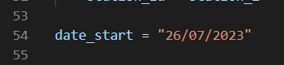

Where we will put the start date that we want download till the current date. The result of download is by day and it will be saved on JSON format. It looks like (see the below image), on the names is stationid_DD_MM_YYYYstart_to_DD_MM_YYYYend, daily download:

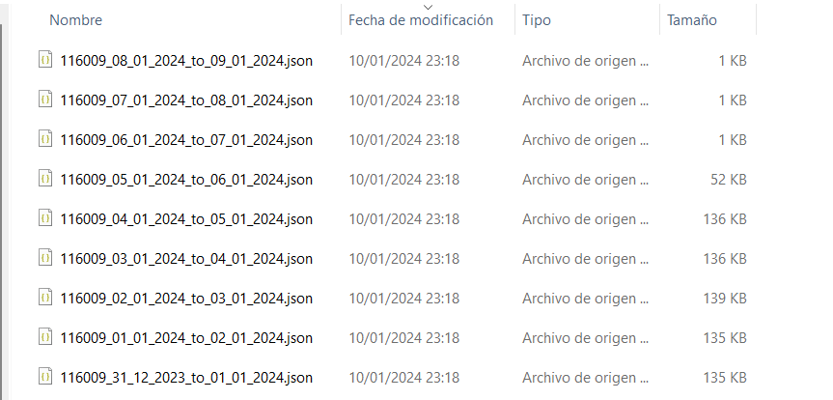
as you can apreciate, the storage on the files that contain information is diferent to “1 KB”. Per this reason when we update the download is good to put a date 4-5 days before of the last end date. Because this information can be loaded in the next manual loading.

This process is developed on PYTHON, the librarys requiered are: hmac, hashlib, time, requests, json, datetime, pprint, pathlib, os, time. The first two packages are used to codify a serie of information on hmac codification, that condification is interpreted by the api that get us a information we demand.

STEPS on the script:

- Lines 24 – 36: reading the station id that we load on pre request.
- Lines 37 – 59: we define the api keys that we need to create the request, and define the start date we start the download, and give the correct format.
- Lines 60 – 100: we define the number of iterations we need, end_date – start_date. And we give the correct format to all dates
- Lines 101 – 106: we create the “request” to send to the API. This need fills a template in the correct order with api keys, information about the station, and the start and end date we want. In this case we are downloading this daily.
- Lines 107 – 114: We concatenate the HMAC codification, created in the step before, with the URL that connect with the API. And we save the status code of the request. (if it is 200 the download is correct)
- Lines 115 – 131: we save the result of the request. Creating the name of the file, and we update the start date to download the next day.

On the next steps we will load the project to github, and made a description of the complete environment of work.

