System Architectures – Lab 1

Command and Query Responsibility Segregation (CQRS)

EGARTNER Fabian, Meier Matthias

2022

Inhalt

Diagram of the Project 2

Scenarios 3

Create a Booking 3

Show All Bookings 5

Show bookings within a specific period 7

Cancel a booking 9

Find free rooms 12

Test Cases 15

Rooms that have already been reserved for a certain period (for a booking) are not listed in the Room Overview 15

Rooms are released again when a booking is cancelled 17

# Diagram of the Project

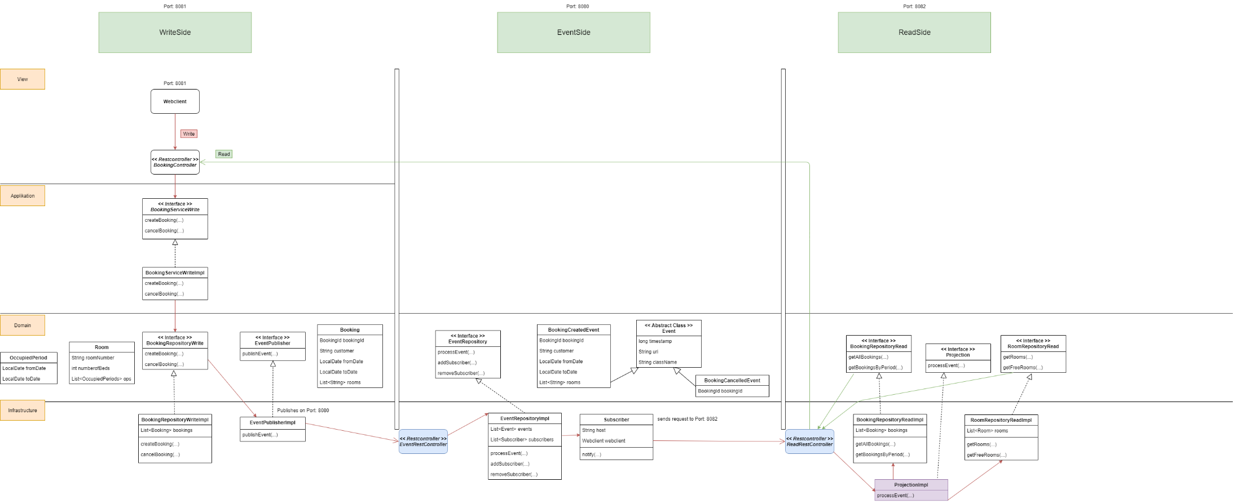

# Scenarios

## Create a Booking

1. **open a browser on http://localhost:8081**

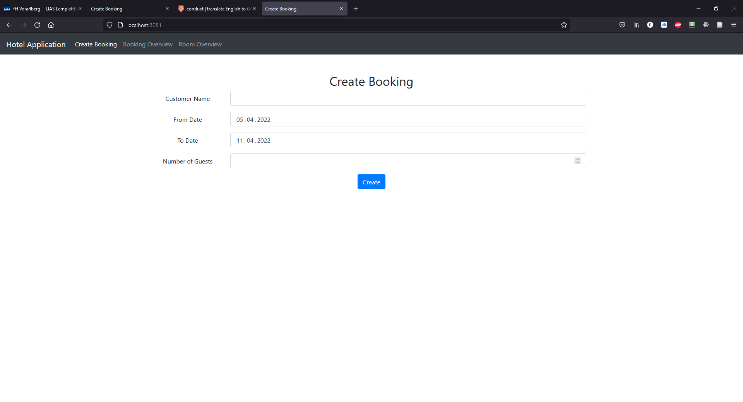

1. **enter your data (customer name, from date, to date, number of guests)**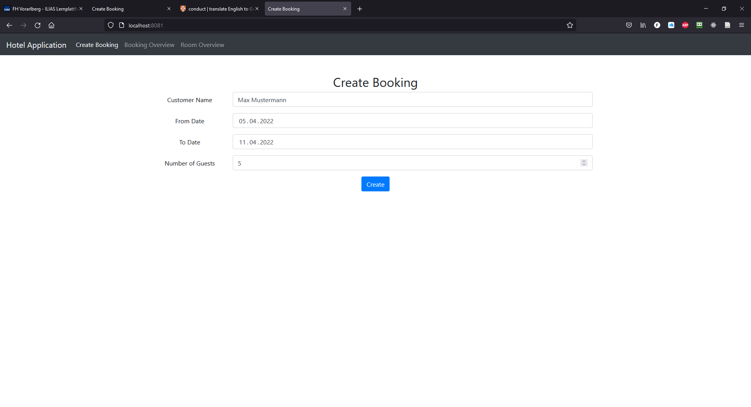
2. **press the “Create”-button**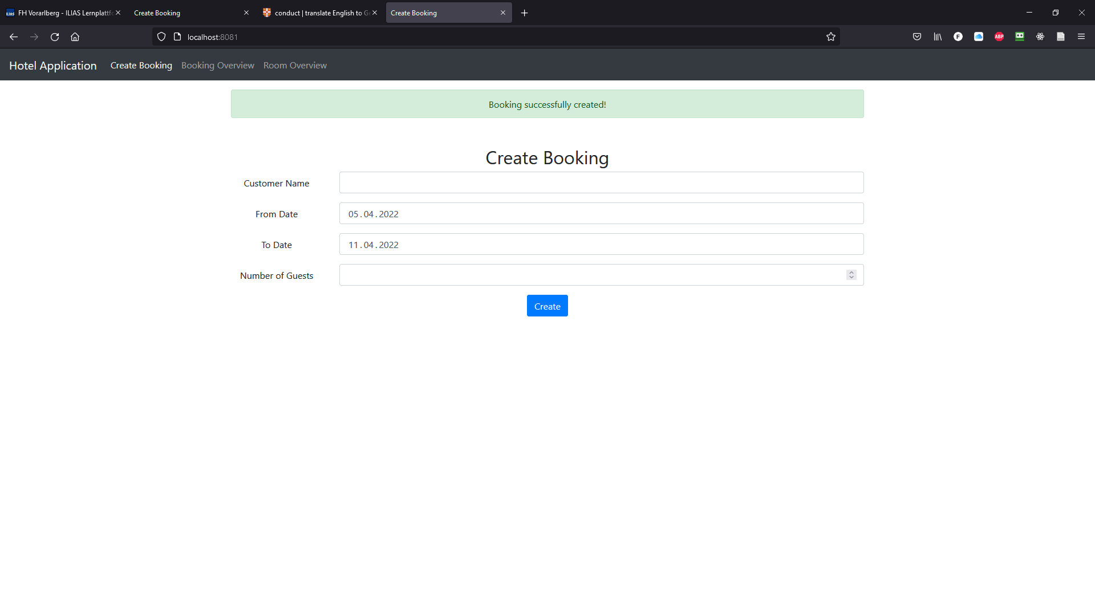

## Show All Bookings

1. **open a browser on http://localhost:8081**



1. **click on „Booking Overview“ in the Navigationbar**

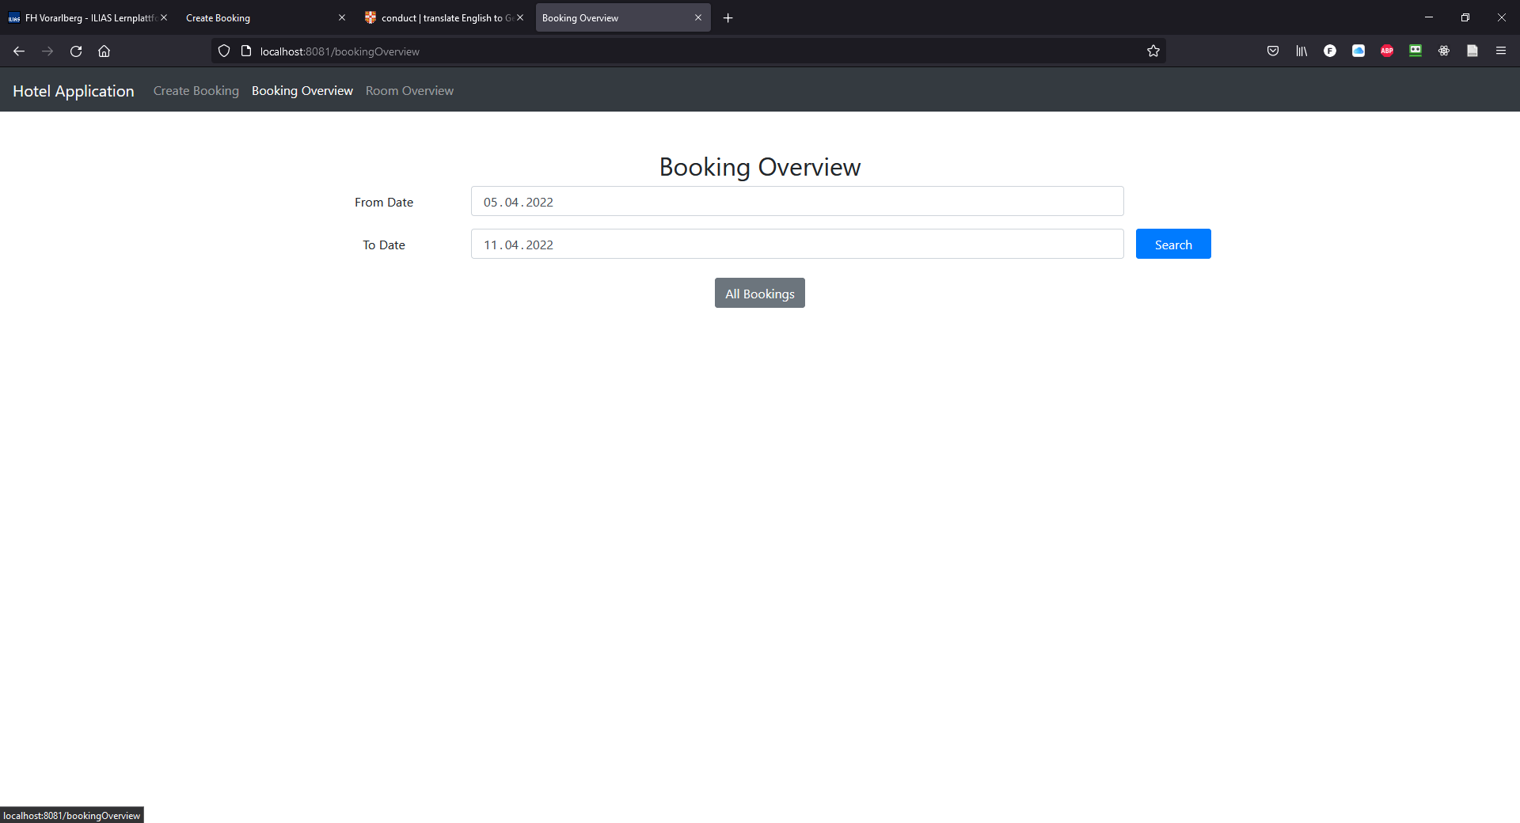

1. **click on „All Bookings“ in the Navigationbar**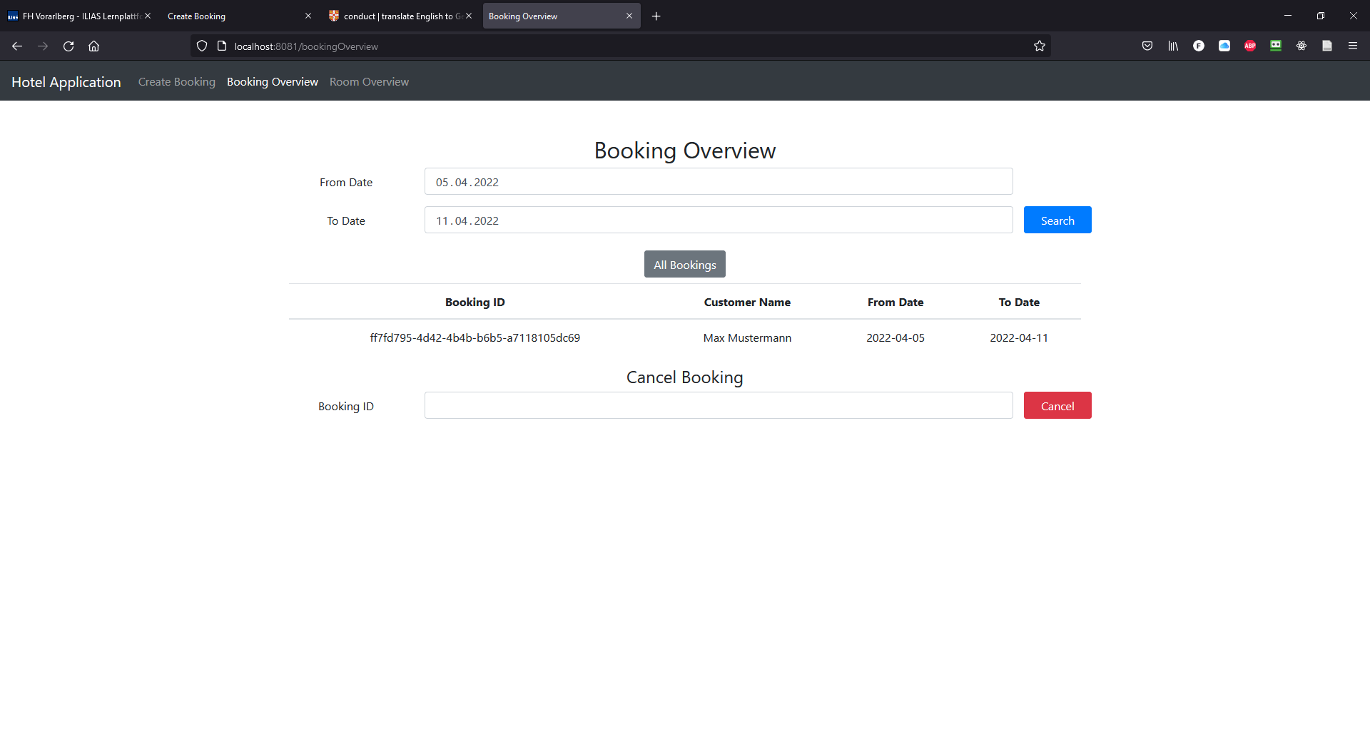

## Show bookings within a specific period

1. **open a browser on http://localhost:8081**



1. **click on „Booking Overview“ in the Navigationbar**



1. **choose a fromDate and toDate**

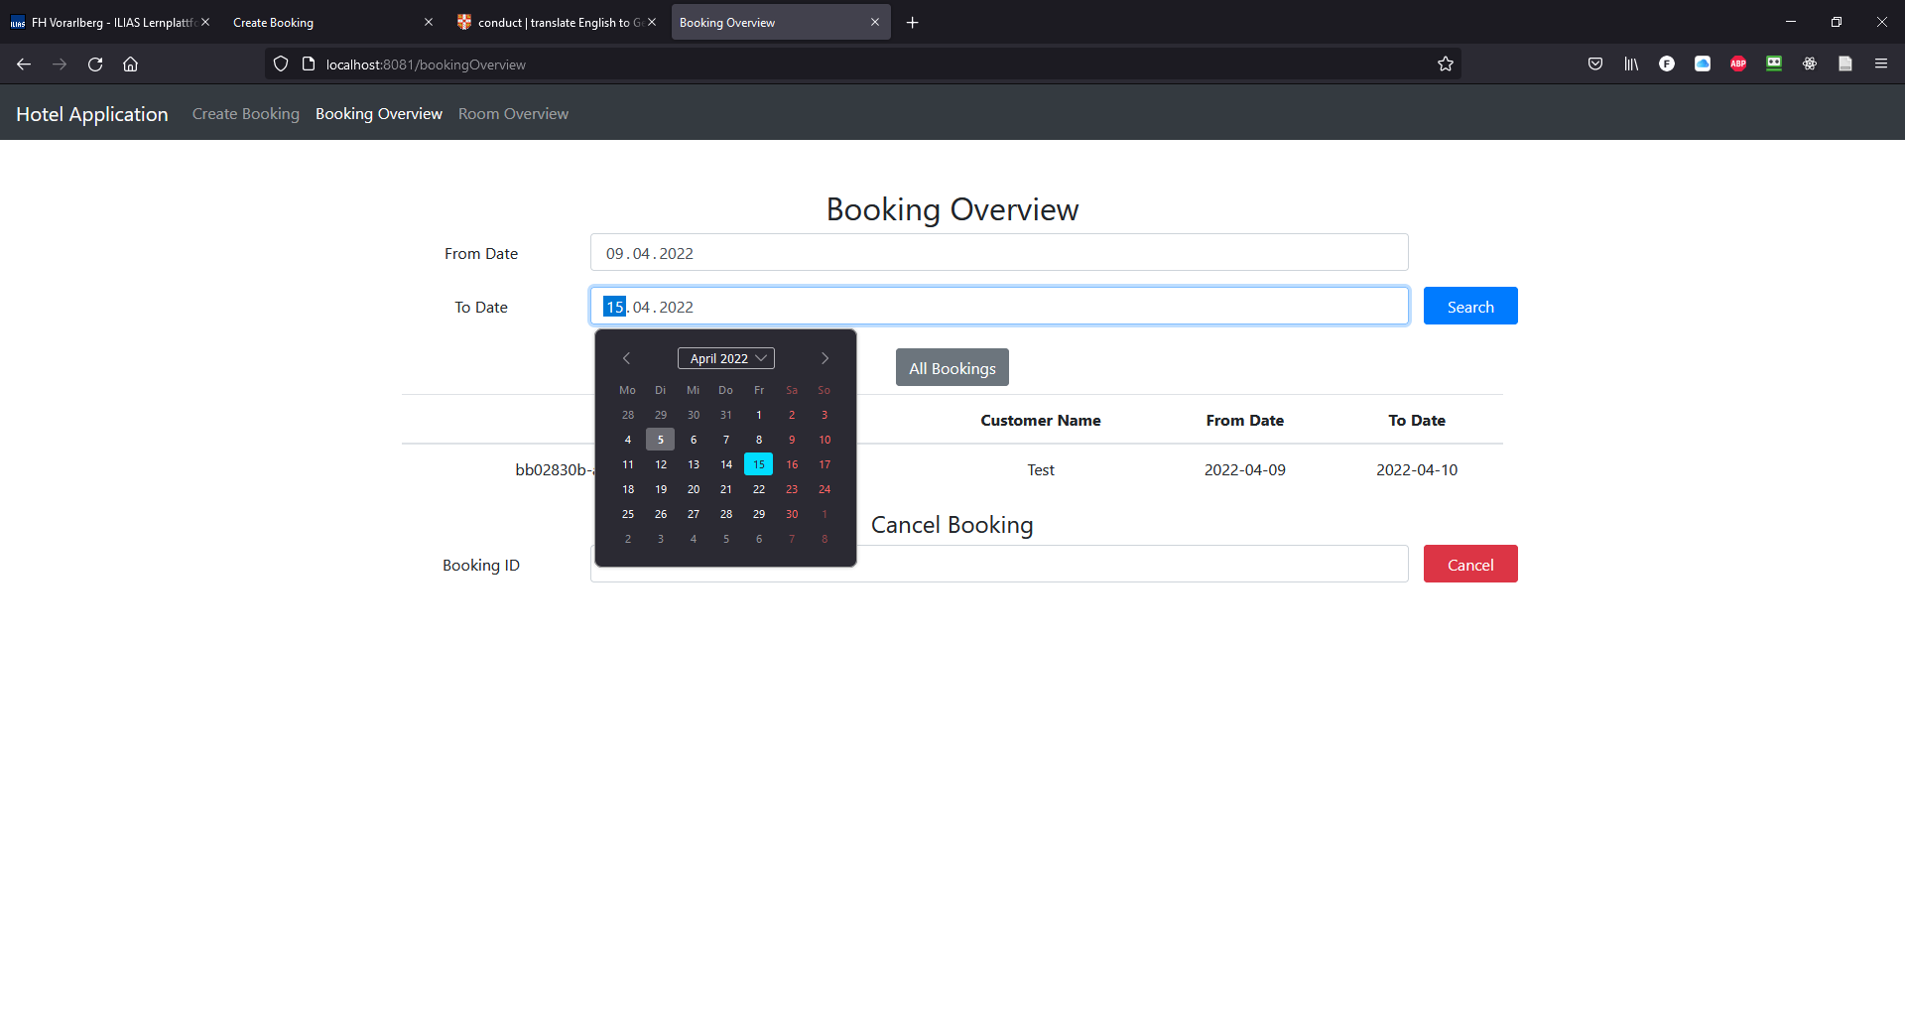

1. **click on the “Search”-button**

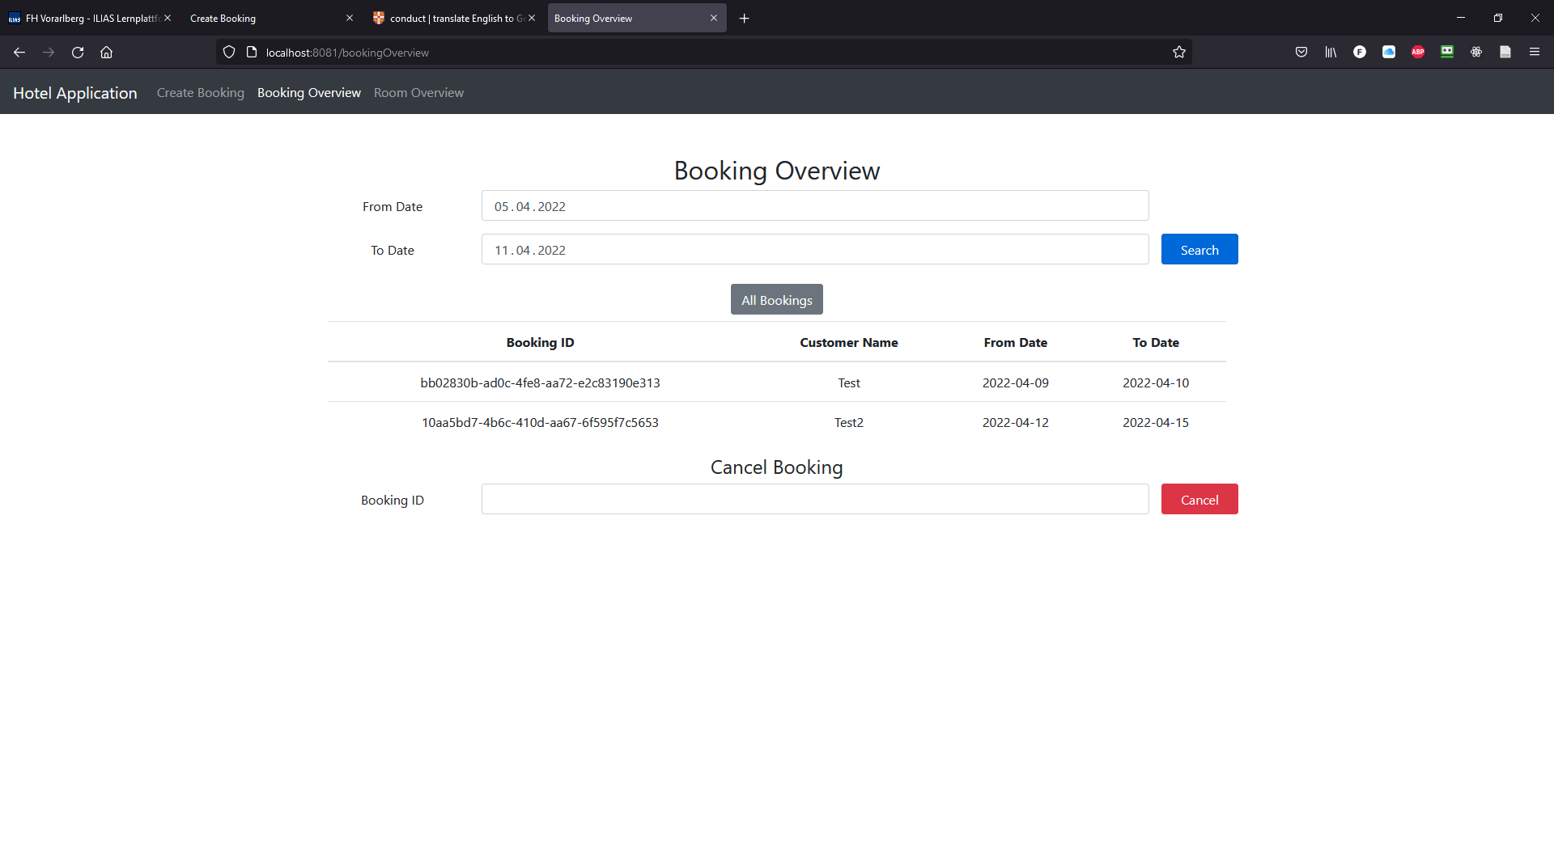

## Cancel a booking

1. **open a browser on http://localhost:8081**



1. **click on „Booking Overview“ in the Navigationbar**



1. **click on the „All Bookings“-button in the Navigationbar**
2. **copy the Booking ID (UUID) you would like to delete and paste it into the Booking ID Textfield**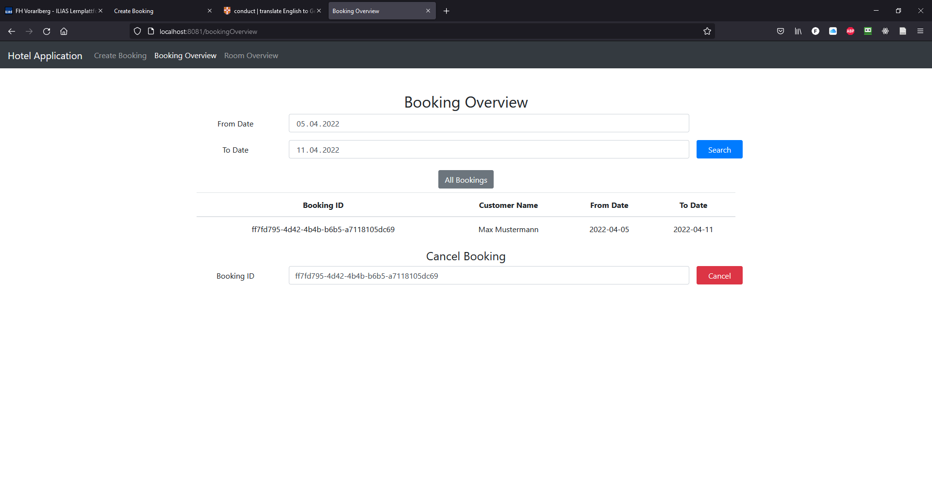
3. **click on the “Cancel”-button**

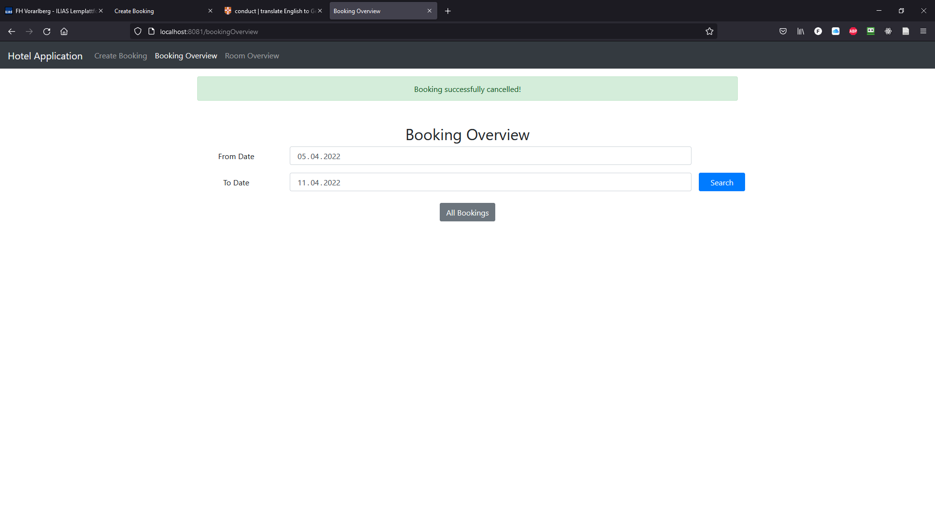

## Find free rooms

1. **open a browser on http://localhost:8081**



1. **click on “Room Overview” in the Navigationbar**

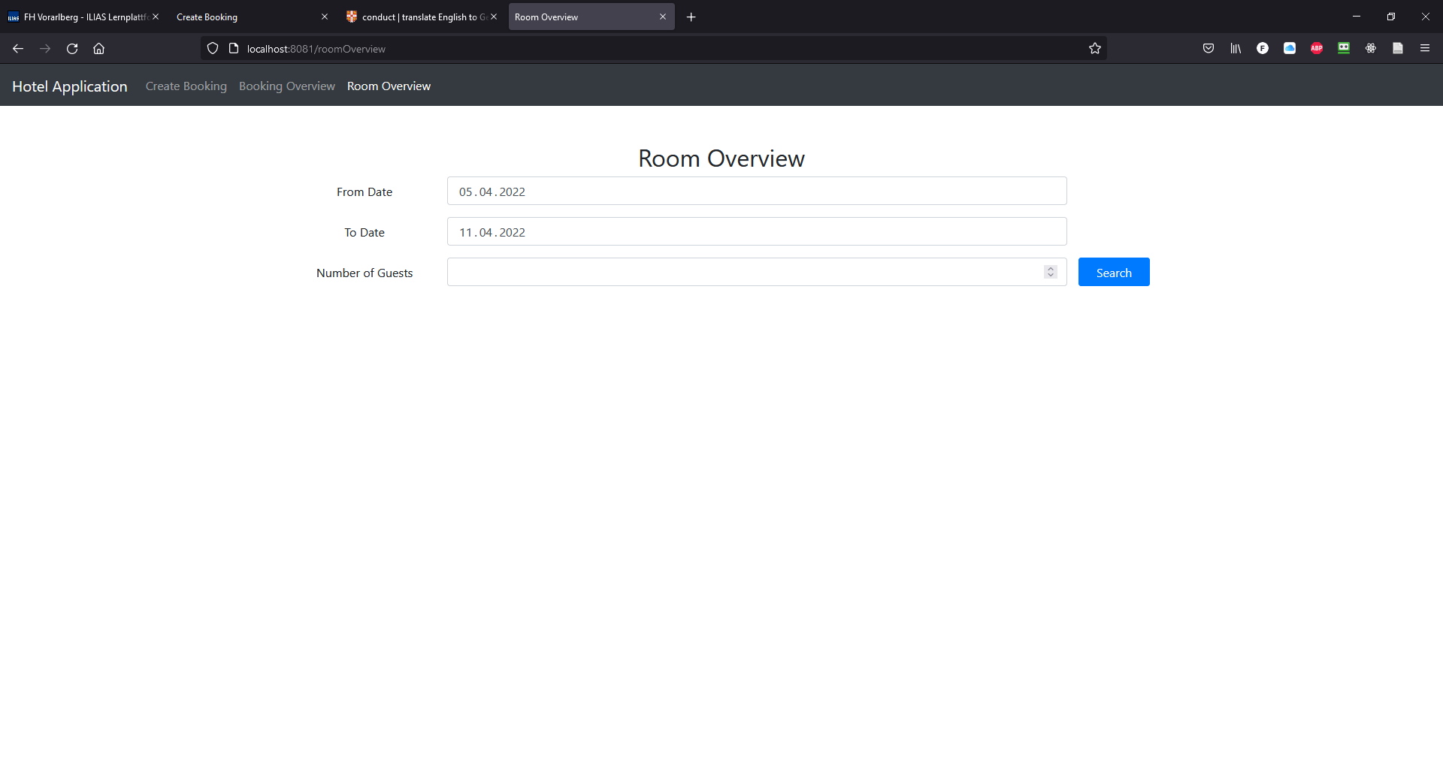

1. **choose a From Date and To Date**

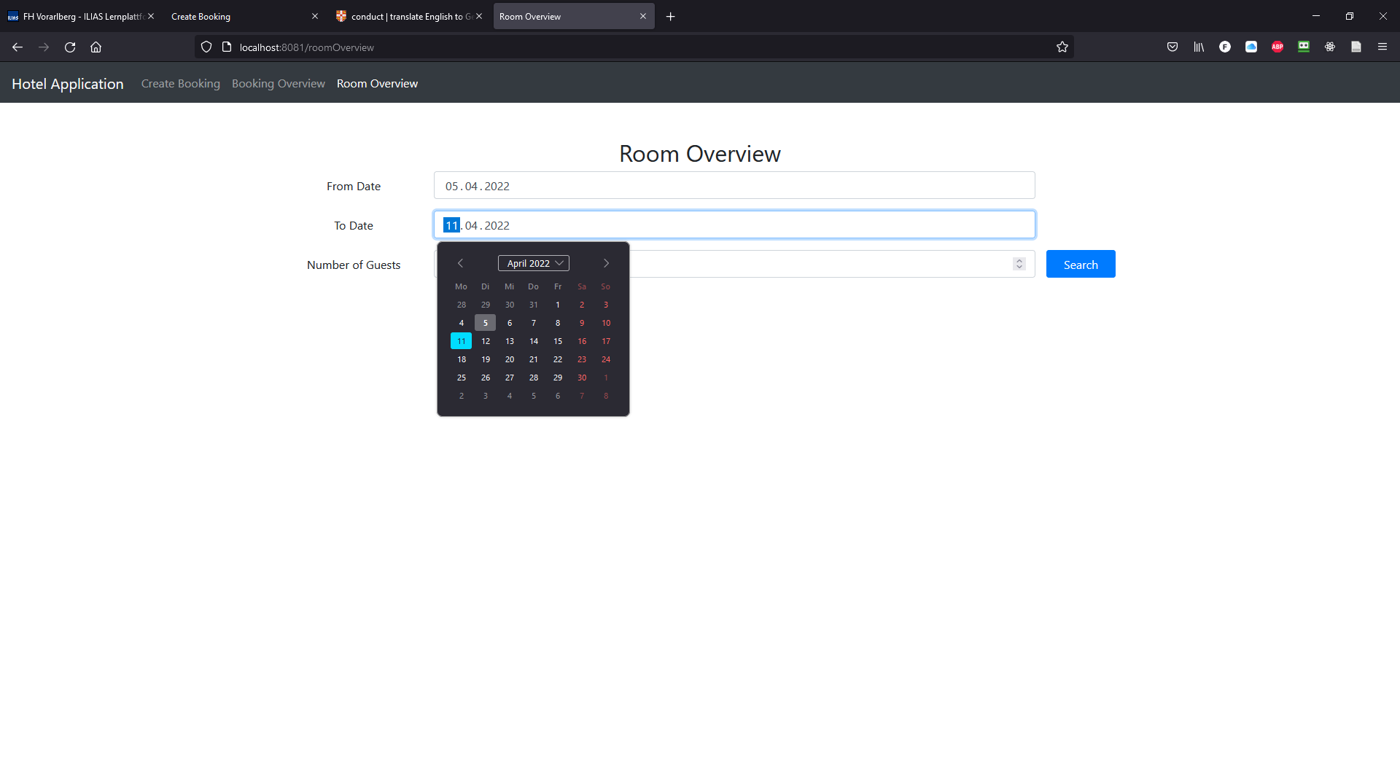

1. **specify the number of Guests**

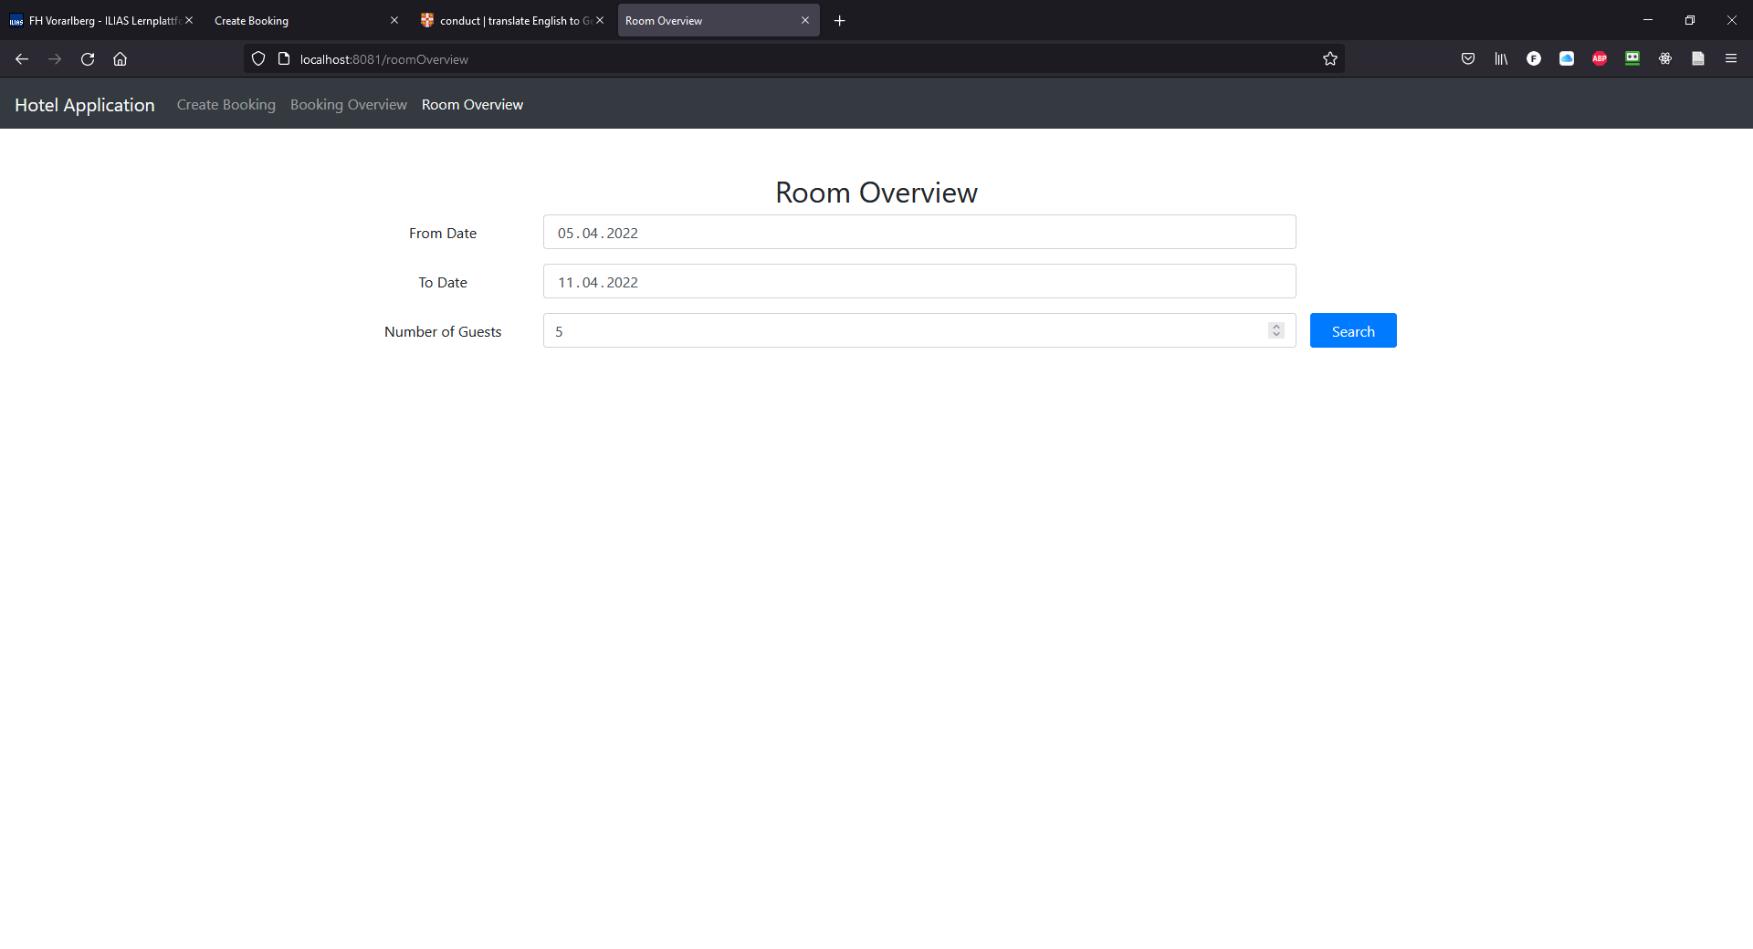

1. **click the “Search”-button**

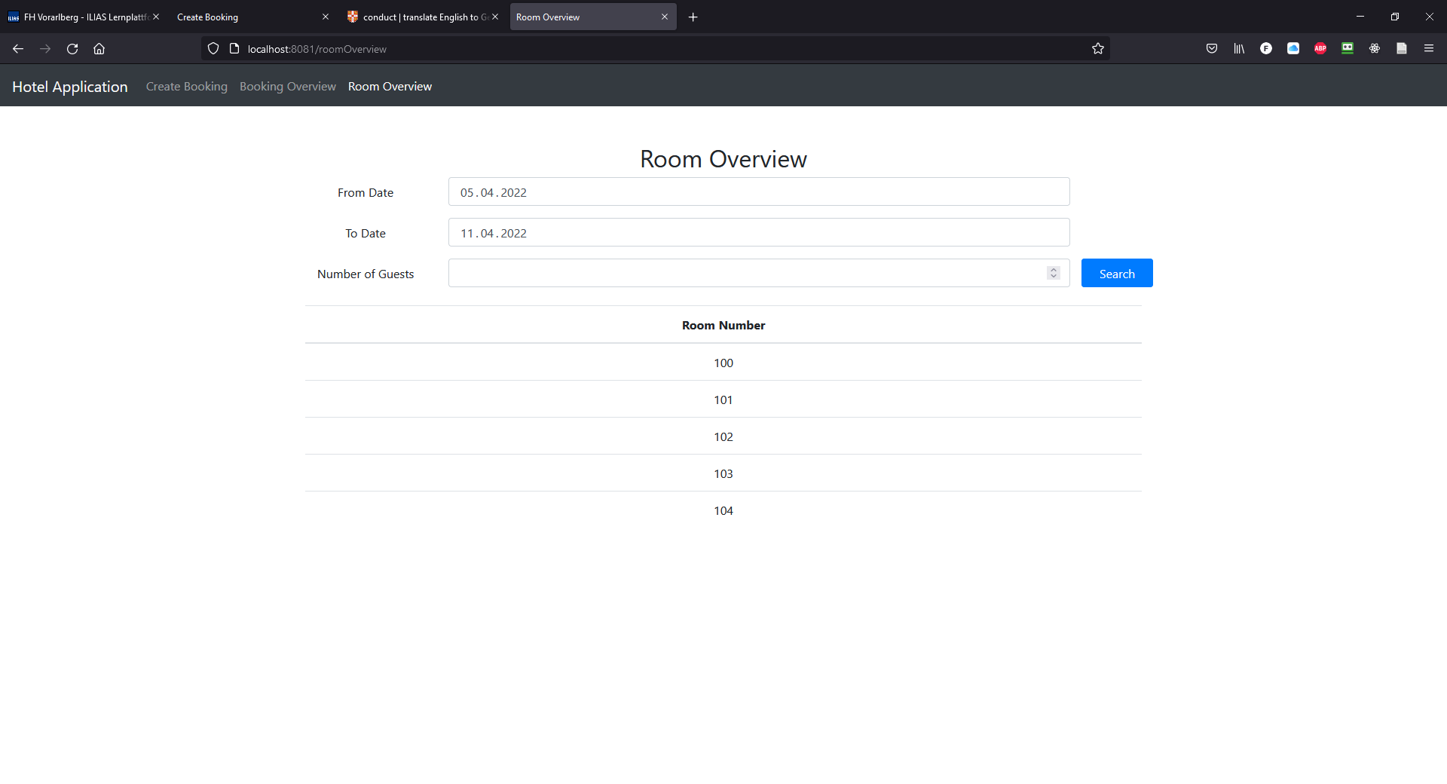

# Test Cases

## Rooms that have already been reserved for a certain period (for a booking) are not listed in the Room Overview

Suppose we create a booking for this specific period (06.04.-12.04.) and this number of guests (five):

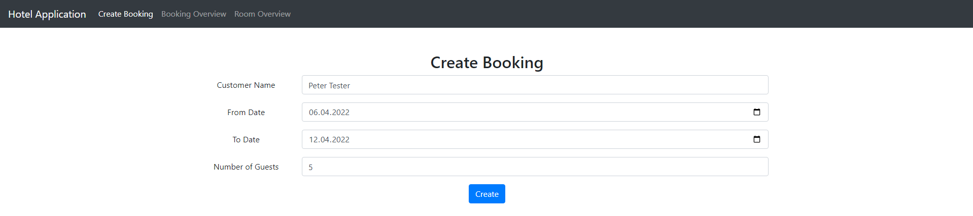

The application now selects five rooms from the available rooms list. In this case, five single bed rooms would be chosen (100, 101, 102, 103, 104). Because of that, it is important that these rooms are not listed in the Room Overview when we are searching for the same period (06.04.-12.04.):

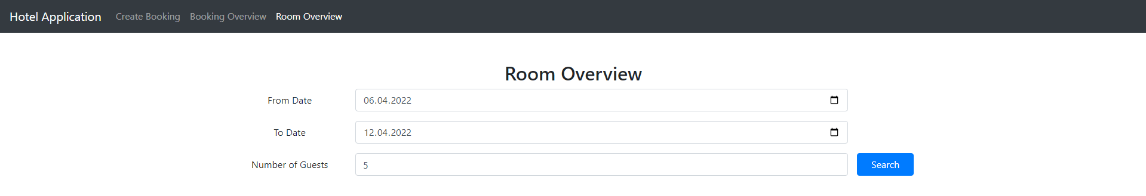

And indeed, these rooms are not display, but only the next free rooms (starting at room number 105):



## Rooms are released again when a booking is cancelled

Suppose we cancel the booking that we just created in the step above:

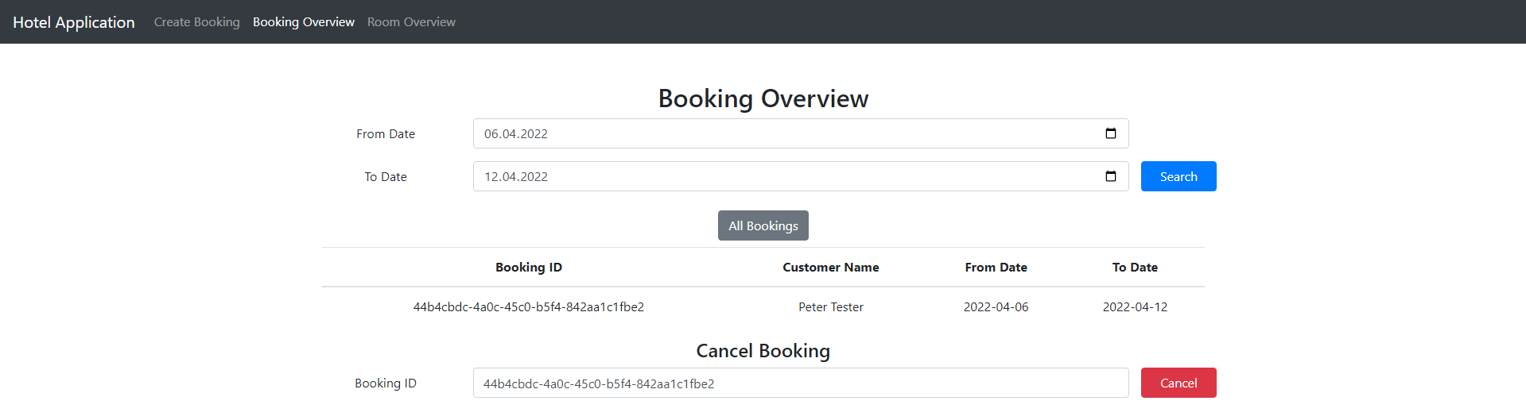

First of all, it is important that the booking is no longer in the Booking Overview:

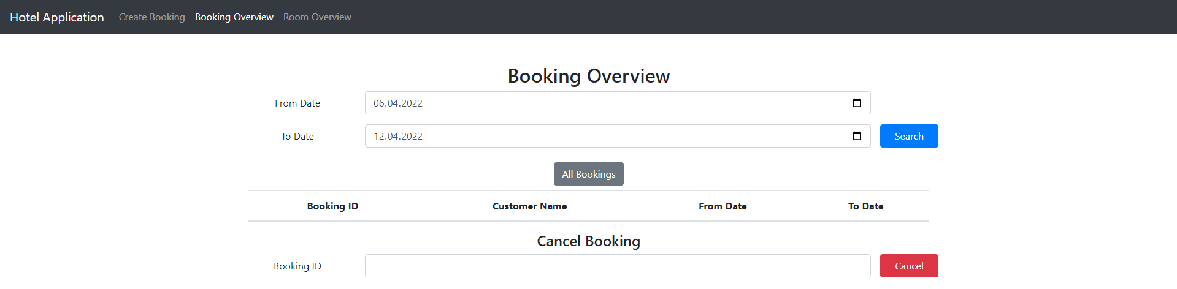

In addition, the rooms that were first reserved for this booking (100, 101, 102, 103, 104) must now be displayed again in the Room Overview:

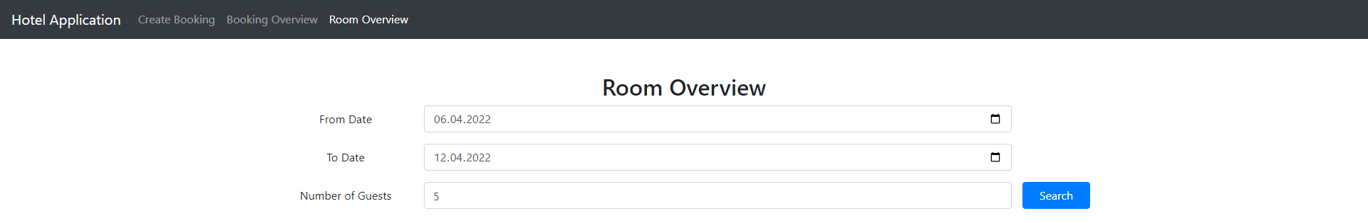

And indeed, the rooms are now available again:

