US Military Intervention and Civilian Casualty Patterns
Project Final Report
Data Science | Spring 2026
Submitted: May 5, 2026

1. Problem Statement and Importance
The United States military has killed a documented minimum of 22,679 civilians in airstrikes carried out since the start of the War on Terror in 2001 (Airwars, 2025). Yet the US military’s own acknowledged death toll for the ISIS campaign alone was approximately 1,500 civilian deaths, while independent monitors estimated between 8,000 and 13,000 (Airwars, 2021). Across Iraq, Syria, Afghanistan, and Yemen, Airwars documents civilian deaths with maximum estimates approaching 48,000, many individually named and verified, yet never acknowledged by the US military. This systematic gap between official reporting and independent documentation represents one of the most consequential transparency failures of modern warfare.
The core question this project asks is whether the observable patterns in US military strikes--their locations, types, tactical contexts, and scales--can be used to predict civilian casualty counts with sufficient accuracy to expose where and how official reporting falls short. This is not isolated to one campaign. Across Iraq, Syria, Afghanistan, and Yemen there have been thousands of civilian casualties, and the emergence of large-scale independent conflict databases like Airwars and UCDP now makes systematic analysis of these patterns feasible (Högbladh, 2025). If these patterns can be modelled, then global organisations--including the International Criminal Court (ICC), investigative journalists, and humanitarian bodies--can use the resulting predictions as independent, data-driven evidence to challenge the systematic undercounting that official US military reporting actively produces.
The populations most directly affected by US military strikes have been largely deprived of accountability and justice for the afflictions brought on them by US intervention. Humanitarian organisations can use predictive models of civilian harm to pre-position aid, medical resources, and displacement support before or immediately after a strike, rather than reacting weeks later. For legal bodies like the ICC, a predictive model offers independent and data-driven estimates of anticipated civilian casualties that can serve as evidence to challenge strikes before they occur, or to establish disregard for civilian life after the fact.

2. Literature Review

2.1 Machine Learning and Conflict Prediction: A Use Case
Perry, C. (2013). Stability: International Journal of Security & Development, 2(3), 56, pp. 1-18. https://doi.org/10.5334/sta.cr
Problem. The author examines whether open-source data and national statistics can be combined to identify vulnerability indicators for violent events, whether aggregation and modelling can be parallelised to handle larger datasets in real time, and whether modern computing techniques can be used to predict conflict and feed into early warning systems.
Methodology. The study introduces conflict data drawn from ACLED, covering over 50 countries from 1997 to 2012, aggregated to district level using administrative boundaries from Columbia’s GRUMP dataset, alongside socioeconomic indicators including GDP, population, ethnic composition, and governance data. The author tests two models--Naive Bayes and Random Forest--in their abilities to predict the occurrence and intensity of armed conflict at the district level.
Results and Findings. Model specification was an important factor in predictive efficacy--Naive Bayes using only prior battles achieved 18.3% conflict event prediction accuracy, whereas default Random Forest achieved 58.5%. Full models incorporating socioeconomic and geographic features also outperformed those relying on prior conflict history alone, suggesting that contextual indicators carry meaningful predictive power beyond historical violence. This directly informed this project’s feature selection strategy, which emphasises spatial, tactical, and administration-level context over simple historical counts.

2.2 The Promise of Machine Learning in Violent Conflict Forecasting
Murphy, M., Sharpe, E., & Huang, K. (2024). Data & Policy, 6, e35. https://doi.org/10.1017/dap.2024.27
Problem. The authors examine why the international community continuously fails at forecasting violent conflict, especially with unexpected outbreaks like Ethiopia’s 2020 Tigray crisis. They ask whether machine learning, combined with expanding open-source data, can meaningfully improve forecasting accuracy. Their central argument is that machine learning’s promise depends on solving two bottlenecks: poor data quality and lack of model interpretability.
Methodology. As a commentary rather than an empirical study, the authors review the evolution of conflict forecasting and survey the major data sources and modelling approaches, identifying the technical and policy conditions under which machine learning can responsibly support conflict prediction.
Results and Findings. The authors conclude that machine learning-based forecasting holds promise but is only useful if data quality improves and models become more interpretable. They highlight that major datasets can diverge dramatically--in Mexico in 2021, ACLED reported 6,739 civilian deaths while UCDP-GED reported 28 (Murphy et al., 2024). This divergence validates this project’s multi-source approach and its use of IBC as an independent cross-validation mechanism rather than a training feature.

2.3 Prevention Is Better Than Cure: Machine Learning Approach to Conflict Prediction in Sub-Saharan Africa
Musumba, M., Fatema, N., & Kibriya, S. (2021). Sustainability, 13(13), 7366. https://doi.org/10.3390/su13137366

Problem. The authors determine whether machine learning classification algorithms can more accurately predict civil conflict than traditional logistic regression, using fine-grained sub-national data across sub-Saharan Africa. They assess whether addressing class imbalance, selecting appropriate performance metrics, and comparing multiple algorithms can produce more reliable early-warning predictions.
Methodology. The study uses ACLED conflict data 1997–2016 combined with geographic, socioeconomic, political, and agricultural variables at a 0.5°×0.5° grid resolution, producing 5,928 observations across 48 African countries. Five models are compared: logistic regression, random forest, gradient boosting, support vector machines, and multilayer perceptron. As only 7.9% of grid cells experience conflict, the authors apply SMOTE to correct class imbalance.
Results and Findings. Gradient boosting achieves the strongest baseline performance with 0.94 accuracy and 0.543 F1 score. After applying SMOTE, gradient boosting becomes the best model when recall is prioritised. The authors’ conclusion that model selection should be driven by policy goals--high recall to avoid missing conflict events--directly parallels this project’s decision to use RMSE as the primary metric, penalising underprediction that could leave humanitarian organisations under-resourced or legal bodies with incomplete evidence.

3. Data
This project integrates four datasets. The primary dataset is UCDP-GED (Sundberg & Melander, 2013; Högbladh, 2025), which provides global georeferenced conflict event data from 1989-2024 with daily temporal resolution and precise geocoding to individual towns and villages. After filtering to events where the US or a US-led coalition is the recorded perpetrating party across Iraq, Syria, Afghanistan, and Yemen, the working dataset contains 3,950 events spanning 2001-2024. All datasets are publicly available at the following sources:
- UCDP-GED: https://ucdp.uu.se/downloads
- Airwars: https://airwars.org/belligerent/us-forces/
- ACLED: https://acleddata.com/data-export-tool
- IBC: https://www.iraqbodycount.org/database
ACLED (Armed Conflict Location & Event Data Project, 2025) supplements UCDP-GED with tactical metadata including event type, actor interaction codes, and population estimates at the event location, merged via a heuristic spatial join described in Section 4. Airwars (2025) monitoring is incorporated heuristically: events are flagged as Airwars-monitored based on whether the source_article field in UCDP-GED references Airwars, generating a binary confidence_rating feature (Fair/High vs. Low/Official). IBC (Iraq Body Count, 2026) is used exclusively for post-hoc validation, providing independent monthly maximum civilian death counts for Iraq, and is not used as a training feature.
Input variables:
From UCDP-GED:
- country: country in which the event takes place (categorical)
- year: year of the event (integer)
- month: extracted from date_start, captures seasonal patterns (integer)
- type_of_violence: state-based, non-state, or one-sided (categorical)
- region: broader geographic context (categorical)
- latitude/longitude: precise location, useful for spatial clustering (continuous)
- side_b: who the US was fighting against, i.e. Taliban, ISIS, etc. (categorical)
- best: total fatality estimate, strong predictor of civilian harm (integer)
- event_clarity: how precisely the event was documented, 1 or 2 (categorical)

From ACLED:
- event_type: airstrike, ground assault, etc., unified into derived unified_tactic feature (categorical)
- population_best: population estimate at event location (integer)

Derived features:
- administration: US presidential administration during the event, derived from year (categorical)
- confidence_rating: Airwars monitoring flag--Fair/High vs. Low/Official (categorical)

Output Variable:
- deaths_civilians: best estimate of civilian deaths per event (integer, regression target)

4. Methodology
This methodology incorporates two items of instructor feedback from the proposal stage. First, inline citations have been added throughout Section 1 to source all factual claims. Second, a feature-level ablation study (Section 5.3) has been conducted as further analysis: features were grouped by shared semantics, one group was removed at a time, a model was trained from scratch on the remaining features, and performance was evaluated--providing quantified insight into the contribution of each feature group.

4.1 Data Preprocessing and Preparation
Dataset Filtering and Cleaning. The full UCDP-GED database was filtered to retain only events occurring in Iraq, Syria, Afghanistan, or Yemen where the US or a US-led coalition--including ISAF, NATO, and Airwars-referenced actors--appears on either side of the conflict or in the source metadata. This produced 3,950 qualifying events. Numeric fields (deaths_civilians, best, latitude, longitude, year) were coerced to numeric types with missing values filled to zero. The date_start field was parsed to datetime to enable temporal feature extraction.
ACLED Spatial Integration. ACLED and UCDP-GED use different coordinate precision standards, making direct coordinate matching infeasible. A heuristic spatial join was performed by rounding both datasets’ latitudes and longitudes to one decimal place, corresponding to approximately 11 km precision, and merging on the combination of rounded coordinates and event date. After merging, duplicate events by UCDP event ID were dropped, and ACLED-derived columns were filled with ‘Unknown’ or 0 for unmatched events. A SimpleImputer was embedded in the preprocessing pipeline to handle any remaining missing values from the merge safely.
Feature Engineering. A binary confidence_rating was derived by checking whether each event’s source_article field references Airwars, rating events as Fair/High or Low/Official accordingly. A US presidential administration label (Bush: 2001–2008, Obama: 2009-2016, Trump: 2017–2020, Biden: 2021-2024) was derived from the event year to capture policy-level shifts in strike tactics and doctrine. A unified_tactic feature bridges ACLED’s detailed classification with UCDP’s broader violence types, producing consistent tactical labels across the full dataset.
Encoding and Scaling. Categorical features (country, region, side_b, administration, event_clarity, unified_tactic, confidence_rating) were encoded using OneHotEncoder with unknown category handling enabled. Numerical features (year, month, latitude, longitude, best, population_best) were standardised using StandardScaler. All preprocessing was integrated into a scikit-learn Pipeline to prevent data leakage during cross-validation.

4.2 Data Exploration and Visualisation
Geographic Density of Civilian Harm. Figure 1 visualises all events with at least one documented civilian death, with bubble size and colour corresponding to the deaths_civilians count. The distribution is strongly non-uniform, with the highest density clusters in two geographic bands: the Iraq/Syria corridor (longitude 36-45, latitude 33–36) corresponding to the Mosul and Raqqa anti-ISIS campaign, and Afghanistan’s eastern provinces (longitude 63-70, latitude 32-35). The largest individual bubbles, representing 200-250 documented civilian deaths, appear in the Iraq/Syria band. Yemen shows comparatively sparse coverage, consistent with well-documented limitations in conflict monitoring there.
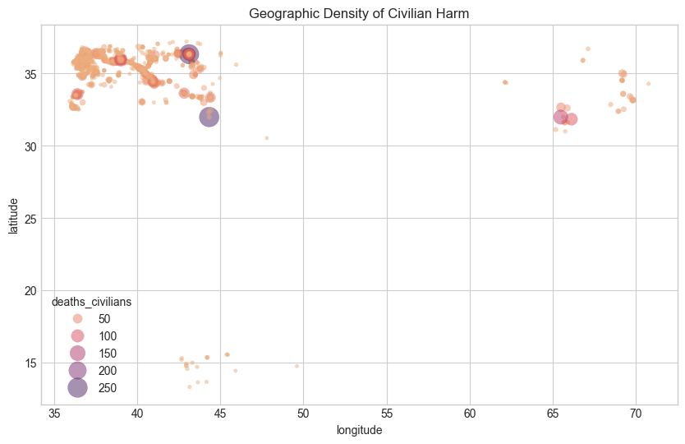
Figure 1: Geographic density of civilian harm. Bubble size and colour correspond to deaths_civilians.
Tactical Shift by Administration. Figure 2 presents the count of events per unified tactic category across the four presidential administrations on a log scale. The dominant category across all administrations is One-Sided (GED). The most substantively important trend is the growth of Remote Violence from the Obama era onward--absent entirely under Bush, appearing at roughly 100 events under Obama, and peaking at approximately 700 under Trump. This is consistent with the documented strategic pivot toward drone warfare following the drawdown of ground forces in Iraq. The Biden era shows a sharp reduction in total event count, reflecting the end of major US-led operations.
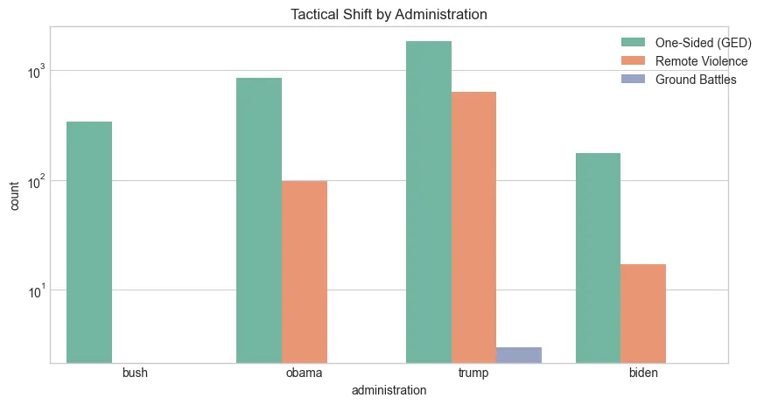
Figure 2: Tactical shift by administration (log scale). Each bar represents event count per unified tactic.
Feature Correlation Matrix. Figure 3 presents the correlation matrix across all numerical features including the airwars_monitored flag. The most notable finding is that deaths_civilians shows weak linear correlations with every individual feature--the strongest being population_best (r = 0.10) and best (r = 0.09)--confirming that civilian casualty counts cannot be predicted by any single linear relationship and that an ensemble-based approach is well-motivated. The strong negative correlation between longitude and airwars_monitored (r = -0.84) indicates a geographic monitoring bias: Airwars coverage is concentrated in Syria/Iraq at lower longitudes, while Afghanistan at higher longitudes receives comparatively less independent verification.
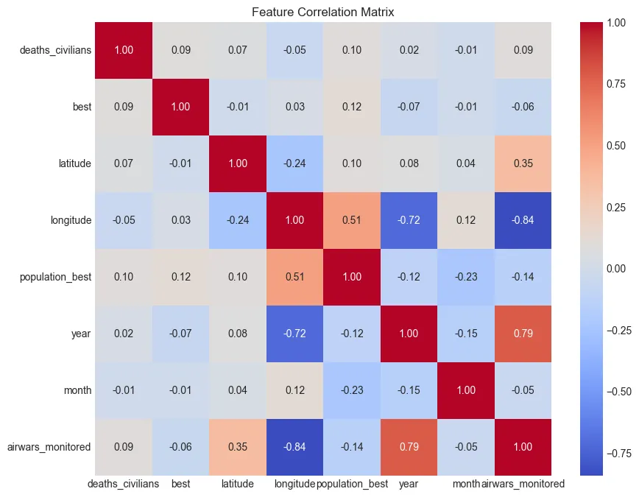
Figure 3: Feature correlation matrix across all numerical variables including the airwars_monitored flag.

4.3 Modelling Approaches
A progressive modelling pipeline was implemented, beginning with interpretable baseline models and advancing to ensemble methods. Five models were evaluated:
- K-Nearest Neighbours (KNN): An instance-based baseline that predicts by similarity to nearby events in feature space.
- Decision Tree: Included for interpretability and as a weak learner baseline. Its tendency to overfit individual training folds on conflict data was anticipated.
- Support Vector Regression (SVR, RBF kernel): Included to test kernel-based non-linear mapping in the high-dimensional one-hot-encoded feature space.
- Random Forest: Selected as the primary final model. Its ensemble averaging across multiple decision trees handles non-linear geographic and tactical interactions while remaining resistant to outliers typical of casualty count distributions.
- XGBoost: Included as the strongest expected performer on tabular data and used as the base estimator for the ablation study due to its sensitivity to feature removal, which produces a clearer signal for variable contribution.

All models were evaluated using 5-fold cross-validation with RMSE as the primary metric--chosen because it penalises large underprediction errors, which in this context would mean underestimating civilian harm and leaving humanitarian organisations under-resourced or legal bodies with incomplete evidence. R² is reported as a supplementary metric for variance explanation. The final deployed model is the Random Forest tuned via GridSearchCV.

5. Evaluation and Analysis

5.1 Experimental Setup and Hyperparameter Tuning
All models were evaluated using 5-fold cross-validation on the full 3,950-event dataset, ensuring that reported performance figures reflect generalisation to unseen data rather than in-sample fit. Hyperparameter tuning was conducted on the Random Forest using GridSearchCV with a 3-fold inner cross-validation, searching the following parameter grid:
- n_estimators: [100, 200]
- max_depth: [10, 20]

The grid search optimised for R² and identified max_depth=10 and n_estimators=100 as the best configuration, achieving a cross-validated R² of 0.5547. The tuned model was used for all subsequent hold-out testing, feature importance extraction, and residual analysis.

5.2 Comparative Model Results
Table 1 reports the 5-fold cross-validated RMSE and R² for all five implemented models.

Model | CV RMSE | CV R²
K-Nearest Neighbours | 8.84 | 0.19
Decision Tree | 10.76 | -0.18
SVR (RBF kernel) | 9.47 | 0.08
Random Forest | 6.68 | 0.58
XGBoost | 7.95 | 0.39

Table 1: 5-fold cross-validated performance across all implemented models.

The Random Forest substantially outperforms all other models, achieving a CV RMSE of 6.68 and R² of 0.58, compared to the next-best XGBoost at RMSE 7.95 and R² of 0.39. The three baseline models produce R² values at or below 0.19, with the Decision Tree reaching a negative R² of -0.18. A negative R² indicates the model performs worse than simply predicting the mean for every event--a direct consequence of the Decision Tree’s aggressive overfitting to individual training folds. The gap between the Random Forest and Decision Tree R² values (0.58 vs. -0.18) confirms that ensemble averaging is not just incrementally better but categorically more appropriate for this problem.

5.3 Ablation Study
A feature-level ablation study was conducted to quantify the marginal contribution of each semantic feature group to predictive performance. Features were grouped based on shared semantics into three categories. One group was removed at a time, XGBoost was trained from scratch on the remaining features, and performance was evaluated using 5-fold cross-validation. XGBoost was selected as the base estimator for the ablation because its sensitivity to feature removal produces a clearer signal for variable contribution than Random Forest’s averaging would allow.
- Temporal: year, month, administration--capturing when the strike occurred and under which political context
- Spatial: latitude, longitude, region, country, population_best--capturing where the strike occurred and the local population environment
- Conflict Context: side_b, best, event_clarity, unified_tactic, confidence_rating--capturing who was involved, the overall fatality scale, documentation quality, and tactical method

Table 2 reports the ablation results. The XGBoost baseline RMSE of 7.95 is taken from the full cross-validated model evaluation in Section 5.2.

Feature Group Removed | CV RMSE | Change from Baseline
Baseline (all features) | 7.95 | --
No Temporal features | 8.99 | +1.04
No Spatial features | 7.94 | −0.01 (negligible)
No Conflict Context | 12.03 | +4.08

Table 2: Ablation study results--5-fold CV RMSE using XGBoost trained from scratch on remaining features.

The results reveal a clear hierarchy of feature group importance. Removing the Conflict Context group drives RMSE from 7.95 to 12.03, a 51% increase in prediction error--by far the largest impact of any removal. This confirms that tactical and scale features are the dominant predictive signals: civilian harm follows what is happening on the ground more than where or when it is happening. Removing the Temporal group causes a moderate RMSE increase of 1.04, indicating that administration-level and seasonal patterns carry meaningful but secondary predictive power. The near-zero impact of removing Spatial features is consistent with the correlation heatmap’s finding that raw coordinates have weak linear relationships with civilian deaths.

5.4 Feature Importance Analysis
Figure 4 presents the top 15 predictive features extracted from the final Random Forest model. The best feature (total fatality estimate) is the dominant predictor by a substantial margin, with an importance score exceeding 0.70--more than six times the next feature. This is consistent with the ablation study’s finding that the Conflict Context group is responsible for the majority of predictive power. Longitude and latitude rank second and third, reflecting the geographic concentration of high-casualty events in specific corridors identified in Figure 1. The appearance of event_clarity, confidence_rating_Fair/High, and administration_trump in the top 15 validates the preprocessing decisions to construct these derived features.
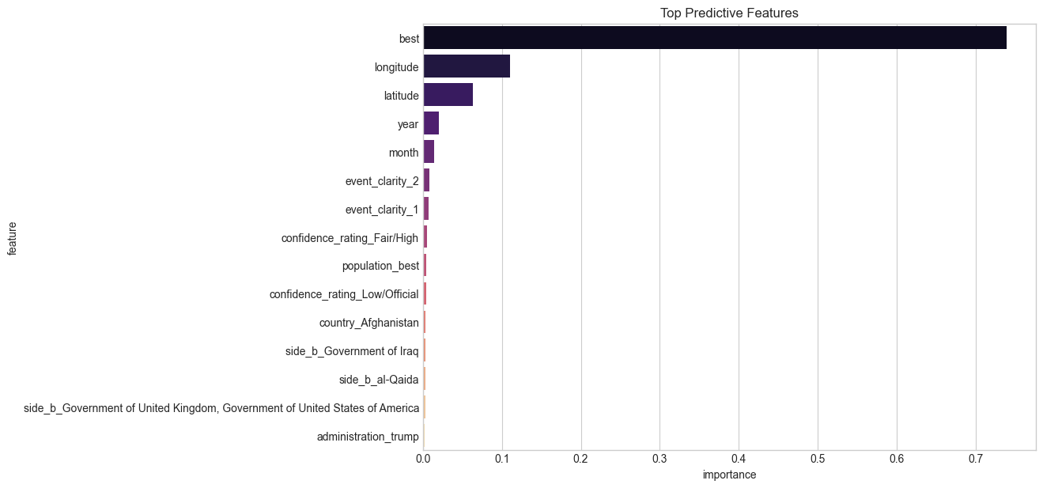
Figure 4: Top 15 predictive features by Random Forest importance score.

5.5 Residual Error Analysis
Figure 5 presents the residual error analysis from the final trained Random Forest on the 20% hold-out test set. For the large majority of events with predicted values below 20, residuals are tightly clustered around zero, indicating reliable and unbiased performance for typical strikes. However, the plot reveals a consistent pattern of underestimation for high-fatality outlier events--two points with residuals above 100 represent strikes where the true civilian death toll significantly exceeded the model’s prediction. These are the strikes that matter most from a humanitarian and legal accountability perspective, and this underestimation bias at the tail of the distribution is the primary target for future work.
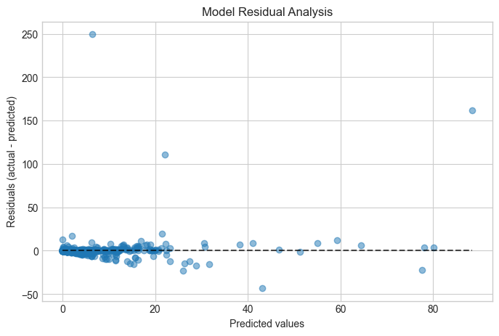
Figure 5: Model residual analysis--actual minus predicted civilian deaths against predicted values.

5.6 Yemen 2024 Out-of-Sample Validation
The tuned Random Forest was evaluated on a held-out set of Yemen 2024 events, a temporal and geographic subset entirely unseen during training. The model achieved an R² of 0.8576 on this subset, substantially higher than the full cross-validated R² of 0.58. This indicates strong generalisation to the specific tactical signature of recent US remote warfare in Yemen: concentrated airstrikes against a consistent adversary in Houthi forces, with civilian harm closely tied to the overall scale of individual strikes.

5.7 IBC Independent Validation: The Fatality Gap
Figure 6 compares monthly documented civilian deaths in Iraq from the UCDP-based dataset (red) against IBC’s independently recorded figures (blue) over the full 2003-2024 period. The UCDP-documented series tracks the temporal trend of IBC closely--both peak sharply during the 2006-2007 Iraq Surge and again during the 2014-2017 ISIS campaign--but IBC figures are consistently and substantially higher across the entire period. The IBC peak during the Surge exceeds 4,000 civilian deaths in a single month; the UCDP-documented series for the same period remains below 500.
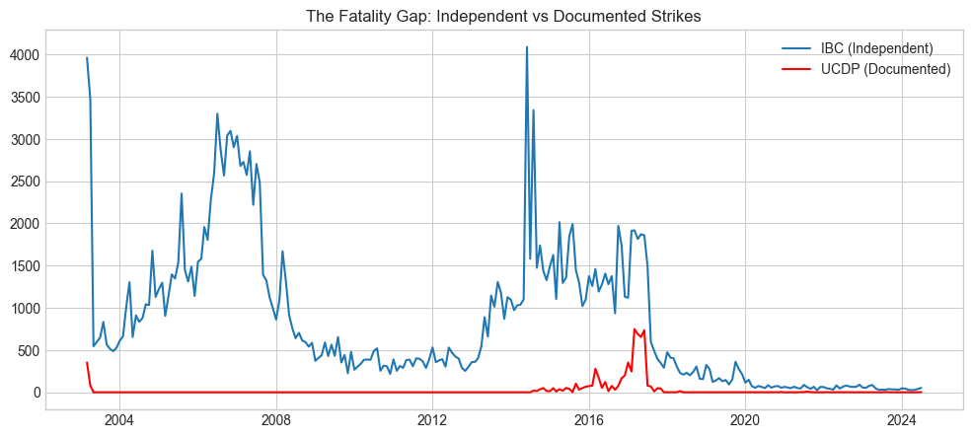
Figure 6: The fatality gap--IBC independent monthly counts (blue) vs. UCDP-documented strikes (red) for Iraq.
This validation confirms that the model is learning genuine patterns in documented harm rather than artefacts of dataset construction, and makes the underreporting problem concrete: the UCDP figures the model trains on are themselves an undercount relative to IBC, which is itself acknowledged to be an undercount relative to true civilian deaths. The model’s predictions therefore represent a principled lower bound on actual harm.

6. Conclusion
This project demonstrates that civilian harm in US military operations follows consistent, predictable patterns tied primarily to the tactical context and scale of individual strikes. A Random Forest trained on UCDP-GED event data supplemented by ACLED tactical metadata and a heuristic Airwars confidence signal achieves a cross-validated R² of 0.58 and RMSE of 6.68 across 3,950 events, rising to R² of 0.86 on the Yemen 2024 held-out subset. The feature-level ablation study conclusively identifies the Conflict Context group as responsible for the majority of predictive power: removing tactical and scale features alone increases RMSE by 51%, while removing spatial features has a negligible effect.
The IBC validation makes the layered underreporting problem visible: the model is trained on UCDP figures that are themselves systematically lower than IBC, which is itself an undercount of true civilian deaths. The model’s predictions are therefore best understood as a principled lower bound rather than an absolute estimate. The residual analysis identifies the model’s primary limitation: it reliably predicts typical strikes but consistently underestimates high-fatality outlier events, the exact cases that carry the greatest humanitarian and legal significance.
Future Work. Preliminary experiments combining Random Forest and XGBoost into a stacked regressor with a Ridge meta-learner(Lumina, 2026) show promise for reducing the underestimation bias on high-casualty events. Extracting environmental context from raw event narrative fields using NLP could substantially improve prediction of high-fatality outliers. Systematically modelling the relationship between monitoring coverage density and reported casualty rates would allow future models to correct for the geographic monitoring bias identified in Figure 3.

References
Airwars. (2021). Tens of thousands of civilians likely killed by US in forever wars. https://airwars.org/tens-of-thousands-of-civilians-likely-killed-by-us-in-forever-wars/
Airwars. (2025). US forces. https://airwars.org/belligerent/us-forces/
Armed Conflict Location & Event Data Project. (2025). Conflict data export tool. https://acleddata.com/conflict-data
Högbladh, S. (2025). UCDP GED codebook version 25.1. Department of Peace and Conflict Research, Uppsala University. https://ucdp.uu.se/downloads/
Iraq Body Count. (2026). Database. https://www.iraqbodycount.org/database/
Musumba, M., Fatema, N., & Kibriya, S. (2021). Prevention is better than cure: Machine learning approach to conflict prediction in sub-Saharan Africa. Sustainability, 13(13), 7366. https://doi.org/10.3390/su13137366
Murphy, M., Sharpe, E., & Huang, K. (2024). The promise of machine learning in violent conflict forecasting. Data & Policy, 6, e35. https://doi.org/10.1017/dap.2024.27
Perry, C. (2013). Machine learning and conflict prediction: A use case. Stability: International Journal of Security & Development, 2(3), 56, pp. 1–18. https://doi.org/10.5334/sta.cr
Sundberg, R., & Melander, E. (2013). Introducing the UCDP Georeferenced Event Dataset. Journal of Peace Research, 50(4), 523–532. https://doi.org/10.1177/0022343312452421
Lumina. (2026, March 9). The stacking principle in machine learning: Base learners, meta-learners, and the art of learning to learn | by Lumina | Mar, 2026 | Medium. Medium. https://medium.com/@ayasc/the-stacking-principle-in-machine-learning-base-learners-meta-learners-and-the-art-of-learning-524a085f3255

