Covid-19 Data Dashboard

Partial results of the project

Name: **Fabian Heudorfer**

Course: **Applied Data Science with Python**

**Libraries:**

import dash  
from dash import dcc  
from dash import html  
from dash.dependencies import Input, Output  
import plotly.express as px  
from plotly import graph_objs as go  
import pandas as pd  
import numpy as np  
from datetime import datetime

**DataHandling:**

**Get csv File with all Covid-19 Data from repository with latest data**

dataframeGlobal=pd.read_csv('https://raw.githubusercontent.com/owid/covid-19-data/master/public/data/owid-covid-data.csv')

**columns to show:**

location

date

total_cases_per_million

total_deaths_per_million

excess_mortality_cumulative_per_million

people_fully_vaccinated_per_hundred

dataframeFiltered = dataframeGlobal[dataframeGlobal.date.eq(selectedDate)]

🡪 data filtered for specific date which is to be presented on map

worldmap = go.Choropleth()

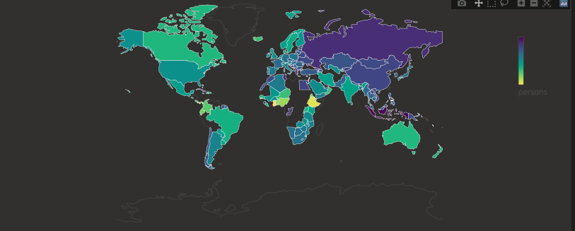

**GitHub Repository:**

git folder structure:

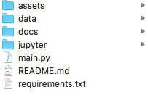

[**https://github.com/FabianHeu/DataScienceProject**](https://github.com/FabianHeu/DataScienceProject)

**User Interface:**

**User Interface is based on plotly and dash**

|  |  |
| --- | --- |
| User information & input | worldmap |
| graph |

