UNIVERSITY OF TARTU
FABIAN E. PARRA GIL
ROS
2019

In order to make the robot move the first step is to launch the file

roslaunch final_exam r2d2_movecontrol.launch followed by roslaunch my_r2d2 r2d2.launch,
in which basically find the description of the robot with the find command searching for the xacro file. And initialize the configuration in Rviz in order to be able to visualize the robot. The fixed frame is setup as odom to allow the movement. Im using the topic cmd_vel.

I creates a server and client where I define the send request (two numbers) and the response with also a number which im not really using it.

rosrun final_exam move_client 0 0.
the first parameter correspond to a linear movement (X) and the second is the angular.

rosrun final_exam move_server
The server takes the values provided by the client, and based on that information publish in cmd_vel topic the values to move the robot.

The type of data implemented is geometry_msgs/Twist Message whis represent the velocity in space diveded in linear and angular.

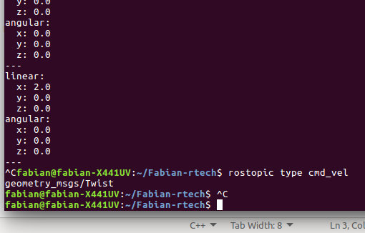

The package and nodes for y solution are:

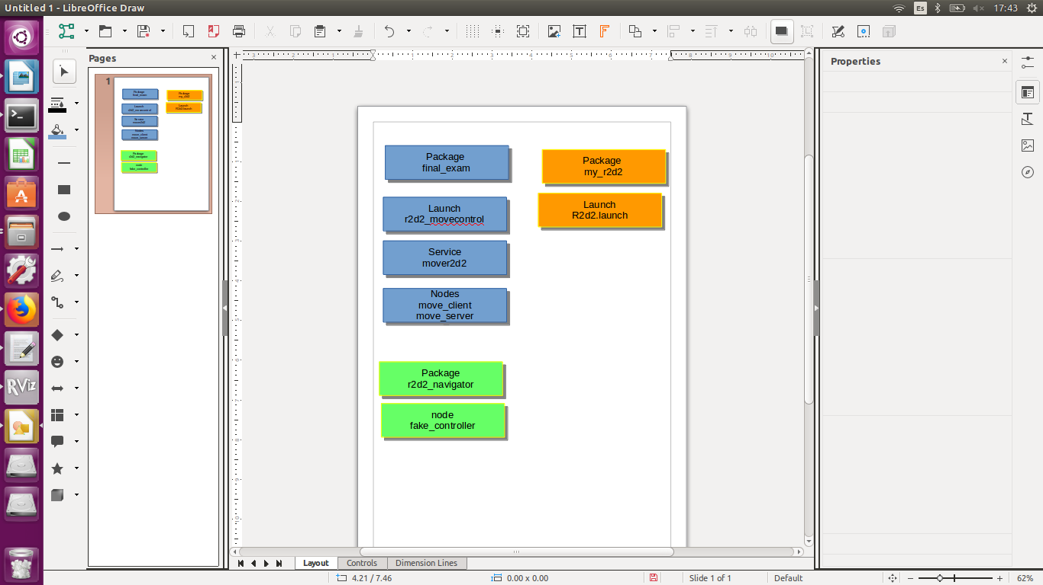

I tried to create a timer to count until 3 seconds and replace the X and ang values to 0, comparing in an if case if the value is less than 3, in that case send the value get from the client, if the time exceed, then send 0 to stop the movement.

