CS 360 Module Three: Android Studio Layout Editor

Activity Main Layout Screenshot
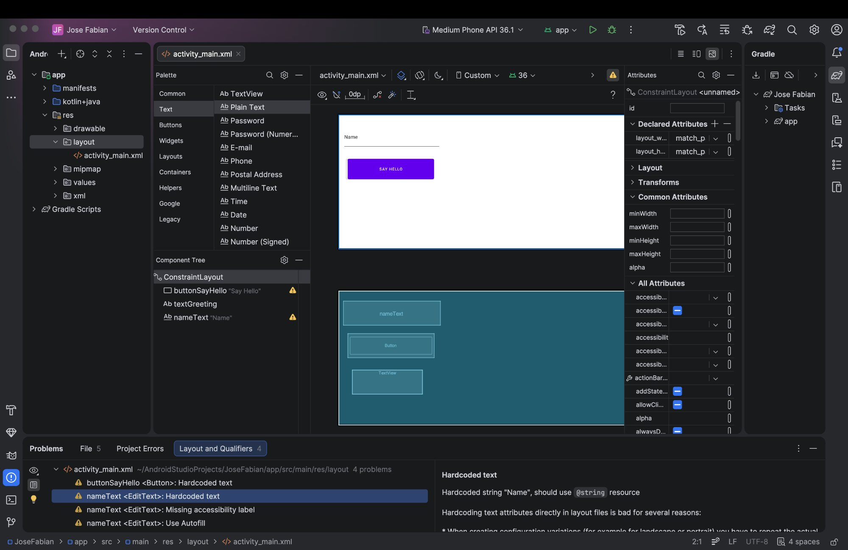
Figure 1: Android Studio Layout Editor showing activity_main.xml with buttonSayHello, textGreeting, and nameText elements.

Challenges with Android Studio
My overall experience getting started with Android Studio was more positive than I expected. Installing the application on my Mac was actually pretty straightforward. The process did not feel complicated, and it took less than five minutes from start to finish before I had Android Studio up and running. Opening the app and creating a new project also went smoothly. I followed the steps to select the No Activity option, chose Java as the language, set the target SDK to API 34, and selected Groovy DSL as the build configuration without running into any major issues.
The area where I struggled the most was understanding where everything is located inside Android Studio. Since this was my first time using the application, the interface felt unfamiliar and it took some time to get comfortable navigating it. Finding the right folders in the project panel, knowing where to create the layout directory, and understanding how the different sections of the screen relate to each other was not immediately obvious. It was not that any one thing was especially difficult, but rather that everything was new at once, which made it harder to know where to start.
Working in the Layout Editor and editing the attributes for each element was also a bit tricky at first. Adding the text boxes for the button and the name view and then going into the Attributes panel to update the IDs and text values required some patience, especially since I was still learning where to find everything. That said, I never felt completely lost, and I was able to work through it. I think the biggest takeaway from this experience is that Android Studio is one of those tools that gets easier the more you use it. The more time I spend in it, the more familiar everything will become, and I am looking forward to building on what I learned here as the course continues.

