App Development Proposal
Weight-Tracking App

Project Goals
The goal of this project is to develop a weight-tracking mobile application for Android that allows users to log their daily weight, set a personal goal weight, and receive a notification when that goal is reached. The app will be built using Java in Android Studio and will use a local SQLite database with three tables: one for user login credentials, one for daily weight entries, and one for the stored goal weight. The application must include a login and account-creation screen, a grid-based weight history display, input mechanisms for daily weight and goal weight, and an automated SMS notification triggered when the user’s logged weight matches their goal.

Users and Assumptions
Three primary user types have been identified for this application:
Weight-loss user: Wants to reach a lower target weight. Logs daily and relies on the notification to confirm goal achievement. Likely engages with the app for several months.
Maintenance user: Has already reached a healthy weight and uses the app to stay within a comfortable range. May log a few times per week and could use the app long-term.
Muscle-gain user: Is tracking weight progress upward during a strength training program. Their goal weight is set above their starting weight, and their usage follows their training cycle.
The app assumes users have basic smartphone literacy, are self-motivated to log consistently, and have granted SMS permission for goal notifications. The UI will be kept simple to minimize friction and encourage daily use.

Screens, Features, and Navigation
The app will consist of four screens. Navigation between screens follows a simple linear and hub-and-spoke model, as illustrated in the diagram below.

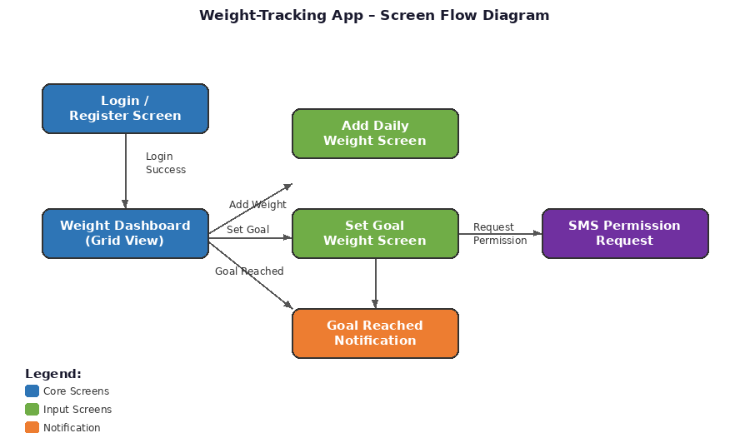
Figure 1: Screen flow diagram for the Weight-Tracking App.

Screen 1
Login / Register Screen: The entry point of the app. Users enter a username and password to log in. If no account exists, they can register from the same screen. This dual-purpose design follows Android’s guideline of minimizing the number of screens users must navigate to get started. On successful login, the user is taken to the Dashboard.

Screen 2
Weight Dashboard (Grid View): The main screen. Displays a scrollable grid of all logged weights alongside the dates they were entered. Contains buttons to navigate to the Add Daily Weight screen and the Set Goal Weight screen. This screen serves as the central hub of the app.

Screen 3
Add Daily Weight Screen: A simple input screen where the user enters today’s weight and saves it to the database. After saving, the app checks whether the logged weight matches the goal weight and triggers a notification if so. The user is returned to the Dashboard after saving.

Screen 4
Set Goal Weight Screen: Allows the user to enter or update their goal weight. This value is stored in the goal weight table. The user is returned to the Dashboard after saving. If SMS permission has not been granted, the app will prompt for it when a goal weight is first set.
These design decisions are guided by Android’s core quality guidelines, which emphasize purposeful screen layouts, clear navigation paths, and minimizing unnecessary steps for the user.

Code Design and UI Connection
The table below outlines the major UI components on each screen, the data they display or accept, and where that data comes from.
Screen | UI Components & Data | Data Source / Flow
Login / Register | EditText (username, password); Login Button; Register Button | User input → INSERT or SELECT from users table in SQLite
Dashboard | RecyclerView / GridView (date, weight columns); Add Weight Button; Set Goal Button | SELECT * FROM daily_weights → displayed in grid adapter
Add Daily Weight | EditText (weight value); Save Button | User input → INSERT into daily_weights table; SELECT from goal_weight to compare
Set Goal Weight | EditText (goal weight); Save Button; SMS permission prompt | User input → INSERT/UPDATE goal_weight table; SMS permission via Android runtime request

Data flows from user input fields through the app’s database helper class (extending SQLiteOpenHelper), which handles all read and write operations. Each screen’s Activity class calls the appropriate database method (e.g., insertWeight(), getGoalWeight(), getAllWeights()) and passes results to the UI. When a daily weight is saved, the app compares it against the stored goal weight; if they match, it uses the Android SmsManager class to send a notification, provided SMS permission has been granted. All database interactions are handled on the main thread, given the small data volumes involved, keeping the code straightforward and appropriate for the app’s scope.

