Mobile App UI Redesign
Dashboard Screen Redesign

The redesigned screen for this task is the primary Dashboard of the Weight-Tracking App. Originally conceived, the dashboard was a basic grid listing logged weight entries and their dates, with buttons to add a daily weight and set a goal weight. This was an effective strategy, but it did not give the users any visual sense of progress and necessitated them to interpret the raw data in their heads to see how they were doing in relation to the goal. The update retains all original functionality; it includes: a ring card indicating the current weight against the goal, a recent entries list color-coded, with a change indicator, a 7-day trend line chart, and a persistent bottom navigation bar which connects to Home, Stats, Log, and Profile screens. The full revised experience is shown on all screens below with screenshots.
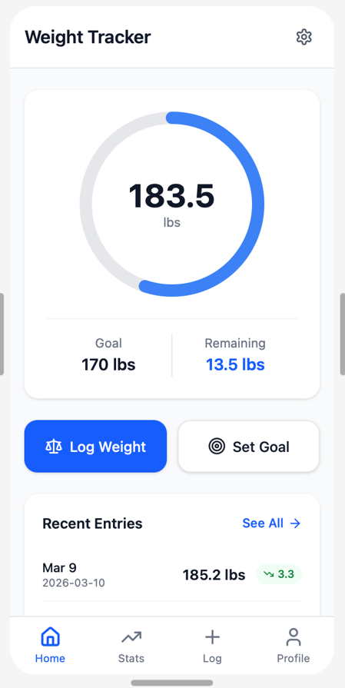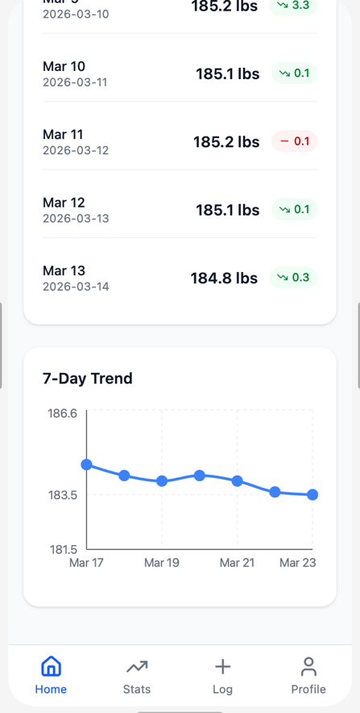
Figure 1: Home Screen (scroll view) Progress ring, quick actions, recent entries, and 7-day trend
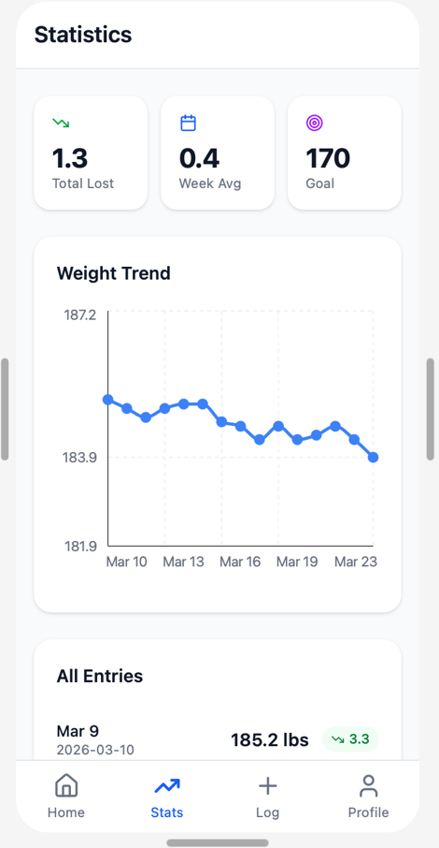

Figure 2: Stats Screen, Summary cards, weight trend chart, and all entries list

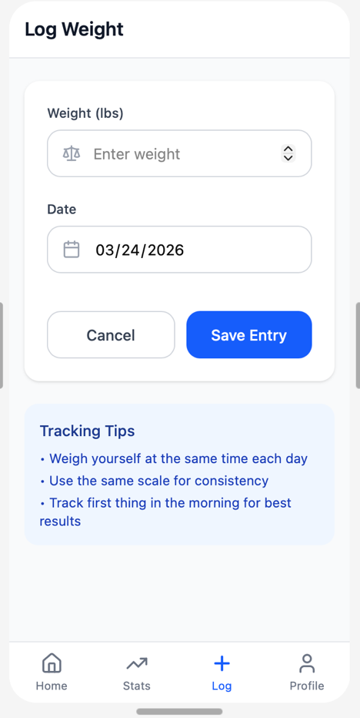
Figure 3: Log Screen, Log weight, input weight.

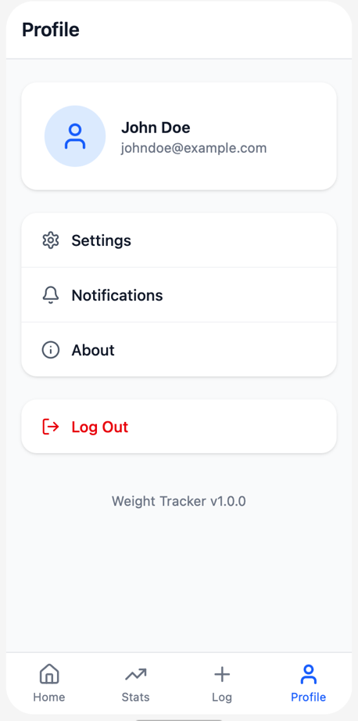
Figure 4:Profile Screen, settings, Notifications, about.

Screen Components, Interactivity, and Data
The table below labels describes every major component across the redesigned screens, indicating whether each is interactive and what data it displays or collects.
Component | Interactive? | Data Displayed / Collected
Progress Ring Card | No, display only | Current weight and goal weight read from daily_weights and goal_weight tables; calculates and displays lbs remaining.
Log Weight Button | Yes, navigates to Log screen | Triggers navigation to weight entry screen; accepts new daily weight input
Set Goal Button | Yes, navigates to goal input | Triggers navigation; accepts goal weight value stored in goal_weight table
Recent Entries List | Yes, ‘See All’ link | Date, weight value, and color-coded change indicator; read from daily_weights table
7-Day Trend Chart | No, display only | Last 7 daily weight entries plotted as a line graph; read from daily_weights table
Stats Summary Cards | No, display only | Total weight lost, weekly average, and goal weight; calculated from daily_weights and goal_weight tables
Weight Trend Chart (Stats) | No, display only | Full weight history plotted over time; read from daily_weights table
Bottom Navigation Bar | Yes, all four tabs | Home, Stats, Log, Profile navigation; controls active screen; no data stored
Settings Icon (top bar) | Yes, opens settings | Links to app settings and user preferences

Design Justification
Each design decision in this redesign is user-driven and aligned with the Android Design and Quality Guidelines (Material Design 3), which emphasize clarity, efficiency, and meaningful feedback throughout the user experience.

Progress Ring Card: The original design provided no visual summary of the user’s progress toward their goal. According to the Android Design Guidelines, the most important information should be surfaced prominently and presented in a format that minimizes cognitive effort. The progress ring translates the relationship between current weight and goal weight into an instantly readable visual, so users understand their status without performing any mental calculation.

Color-Coded Change Indicators: The raw weight values in the original grid were presented unencumbered. The redesign also presents a change column showing how each entry compares to the previous one, using green for a decrease and red for an increase. From the Material Design aspect, the guidelines advise using colors intentionally to convey meaning, so trends are easy to find without manually comparing rows.
7-Day Trend Chart: This is a new feature that was not included in the original design. Users who weigh themselves daily often feel discouraged by natural short-term fluctuations. A seven-day trend line smooths out this variance and gives users a more accurate picture of their overall trajectory. This feature was introduced to address the motivational and emotional needs of the user, which the Android Design Guidelines identify as a key consideration in user-centered design.

Stats Screen: The stats screen consolidates summary data (total lost, weekly average, goal) and a complete historical trend chart into a special view. This keeps the home screen tidy and uncluttered, and even allows for less time-consuming and higher-quality data to be brought to you with one tap. The Android guidelines prescribe placing the content into a hierarchy and trying not to saturate a single screen at the expense of other content.

Bottom Navigation Bar: The original design lacked persistent navigation. Adding a bottom navigation bar with four destinations (Home, Stats, Log, Profile) gives users a consistent and predictable way to move through the app from any screen. Material Design 3 specifically recommends bottom navigation for apps with three to five top-level destinations, making this both a user-friendly and standards-compliant improvement.

