CS 360 Module Six: SensorManager in Android Studio
Accelerometer Sensor App

Purpose of SensorManage
SensorManager is an Android system service that connects physical and virtual hardware sensors within a mobile device. SensorManager must be designed based on this principle. It is the central interface between an app and the device's sensor hardware, enabling developers to capture, register, and read data from sensors such as accelerometers, gyroscope, magnetometer, proximity sensor, barometer, etc. If there were no SensorManager features, an app wouldn't be able to interface with the varied array of sensors throughout different Android devices. First, a developer invokes getSystemService(SENSOR_SERVICE) to retrieve an instance of SensorManager. Then they can run getDefaultSensor() to get an instance of a specific type of sensor and register a SensorEventListener to receive incoming callbacks when sensor values change. Every time there is new data, the onSensorChanged() method is invoked automatically, and the SensorEvent object that will receive readings is passed back. If an app is no longer in the foreground, it should be unregistered with an unregisterListener() to save battery life and system resources. When developing and testing the Accelerometer Sensor App for this assignment, the role of SensorManager was easily apparent. SensorManager was used to register a listener for the TYPE_ACCELEROMETER sensor, which records the force of acceleration applied to the device in three direction axes X, Y, and Z. When the emulator's virtual sensor controls changed the accelerometer values, the onSensorChanged() method in real time updated and displayed values on screen.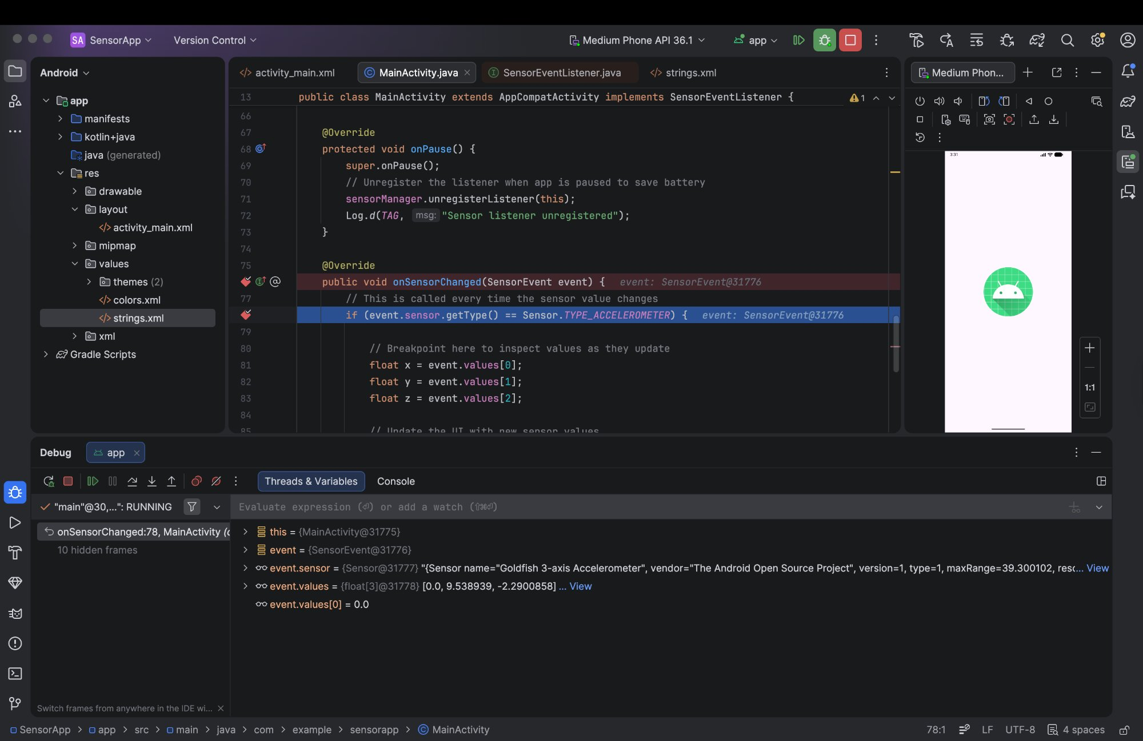
Figure 1: Debugger breakpoint paused inside onSensorChanged() showing live accelerometer values: X: 0.0, Y: 9.538939, Z: -2.2900858.

Setting a breakpoint inside onSensorChanged() confirmed that the method was being called continuously as sensor data changed, with the debugger showing live values of X: 0.0, Y: 9.54, and Z: -2.29, consistent with the force of gravity acting on a device held upright. The debugger also confirmed the sensor identity as the “Goldfish 3-axis Accelerometer” provided by the Android Open-Source Project emulator.

Uses within SensorManager

SensorManager would be useful to have for a Mobile Application Developer for many practical reasons. Below, I describe three direct uses.

To begin, SensorManager is common to fitness and health tracking apps. Apps that count steps, track pace in running, or detect exercise rely on the accelerometer and gyroscope sensors to pick up on patterns of movement. As an example, a pedometer app would leverage the SensorManager tool to register a step detector or step counter sensor, which fires an event when the device recognizes a footstep after detecting acceleration patterns. This kind of real-time, continuous monitoring of data is precisely what SensorManager is meant to facilitate.

Second, SensorManager is the key resource in navigation and augmented reality applications. Applications that have a compass or where they’re superimposed over the real world employ magnetometer and accelerometer sensors that collaborate to find the orientation of the device in three-dimensional space. SensorManager has access to the sensors and allows the app to merge their readings and create a smooth and accurate orientation estimate with sensor fusion techniques. This applies to navigation apps, the rotation of the map, and the alignment of virtual objects in augmented reality features. Thirdly, SensorManager can aid in enhancing user experience in common applications by providing context awareness. For instance, a media player app could employ the proximity sensor through SensorManager to cause music to automatically pause at the moment someone holds the phone up to their ear, or a brightness app could apply the light sensor to the display to increase/decrease brightness depending on the ambient environment. These actions show us that SensorManager is not just something that can be used only for niche apps, but that, when used carefully, it can contribute intelligent sensor-based behavior to pretty much any app.

Reflection

Creating and testing the Accelerometer Sensor App was very instructive in understanding how accessible SensorManager makes hardware interaction on Android. The API is structured and consistent. Registering a listener and reading values in onSensorChanged(), and unregistering when the app pauses follow a nice logical pattern easily adaptable to other sensor types. The key takeaway from this experience is that SensorManager ought to be combined with thoughtfulness regarding its lifecycle. And you could register listeners in onResume() and unregister in onPause() so that your app does not use battery or system resources when not being used, and, really, in mobile development, this is an absolute requirement.

