Script, yes?

**LEVEL 1** (tutorial)

0: Oh hi there! I’ll be your guide through this game!

1: Although, between you and me, I’ve never heard of it before...

2: But no worries! My training algorithm is VERY fast.

3: OK, to start with, I think you have to get that... ‘ball’... in that ‘hole’.

4: You can drag and let go to hit it!

**LEVEL 2**

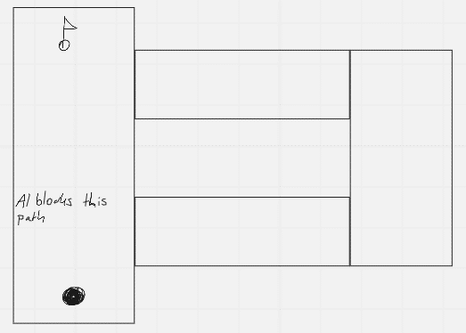

0: As I mentioned earlier, I’ve never played this game.

1: But I’ve been trained on thousands of games, and in all of them...

2: ...you have to get as MANY points as possible!

3: So this... ‘golf’ thing, it must be the same!

4: I’ll help you get a bunch of points!

*(if the player tries to get a hole in one, a wall spawns and the AI says)*

5: Careful! You almost got the ball in!

6: You would’ve gotten almost no points at all!

7: Here, go this way!

**LEVEL 3**

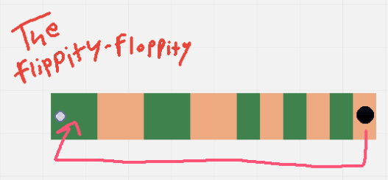

0: Oh, here we go! This sand will slow you down!

1: That’s great, because you’ll have to hit the ball more to get out of it...

2: ...which will give you a LOT of points!

3: No need to thank me!

(when the player gets to the end)

4: Oops, one second, just moving this over here!

5: Now your points will be doubled!