Modelling and Simulation of Tsunami Waves
for Improved Defence Provision in Phuket

Richard N. Zobel
Email: rzobel@phuket.psu.ac.th
r.zobel@ntlworld.com
Department of Computer Engineering
Faculty of Engineering
Prince of Songkla University, Phuket Campus
80 Vichit Songkram Road, Kathu
Phuket, 83210
Thailand

Abstract

Tsunami sea wave simulation is both complex and difficult, generally requiring large parallel computing facilities. There are two scenarios: the first, represented by compressible water Navier-Stokes equations representation, used for both deep sea waves and shallow sea water waves, and the second, non-compressible water Navier-Stokes equations representation, used mainly for shallow water coastal situations. The latter requires less computing power. Prediction of earthquakes and tsunami and provision of warning systems is not the object of this paper. Simulating the local effects of possible tsunami, is required to enable cost effective and efficient provision of local defences against future events and is the key concern discussed in this paper.

Keywords: Water wave modelling and simulation, tsunami, Navier-Stokes equations, 26 December 2004 disaster, future tsunami defences.

1 Introduction

The author was working in Phuket from three days after the tsunami for the following two and a half months, and was able to observe the local effects at the beaches around Phuket, the largest island in the Andaman Sea, off the South West coast of Thailand.

It is clear from still pictures and video taken at the time, that the situation at each location is unique and relates to both local factors and the magnitude, phase and direction of the sea wave in relation to the local geography of both the sea bed and the beach area. Some beaches were badly damaged and others less so, some were badly damaged at the ends of the beaches. Others suffered because the land behind the beach was very flat, and some areas were buffered by the mangrove forest.

The author considers the photographic and video evidence acquired at the time and later, in relation to research required to establish the key factors responsible for the damage, loss of life and injury for this specific tsunami. It continues by considering the possible effects for future tsunami with different characteristics, by using simulation to predict the consequences for the affected areas. Possible defences which could be provided to minimise the effects of future tsunami are discussed, with conclusions aimed at those who may need to consider these defences. The emphasis of the tutorial is on how modelling and simulation can be used to study the possible effects of future tsunami with respect to affordable provision of defences at the sites likely to be affected.

2 The Earthquake and Tsunami, 26 December 2004

The seaquake and ensuing tsunami, which caused so much damage and loss of life in and around the Indian Ocean, was one of largest events of its type for some time. In this paper, the author discusses the event and its effects in relation to the possibilities of using modelling and simulation to assist with understanding such phenomena and of attempting to minimise the effects on human coastal populations and property for the future. By a happy accident, the author arrived in Phuket just three days after the event and has been in a position to collect local information on the affected areas and of the sequence of events, especially the earthquake felt in Thailand before the tsunami arrived, and opinions from other parts of South Thailand, particularly from Hat Yai and Songkhla in the eastern part of the peninsula of Kra.

- Plate Tectonics

Plate tectonics is well researched and many publications exist on the subject, which attracts a wide audience ranging from the mildly curious to the serious scientific academic mind [1,2,3] The Indian Ocean has a complex of ocean ridges, mid-ocean areas where magma wells up from below the ocean flow, solidifies, and gives rise to ocean floor spreading in both directions from the ridge. In connection with the events of the December 26, 2004 earthquake and resulting tsunami, the ocean ridge concerned was the so-called 90-East Ridge, to be found in many atlas publications, in particular that illustrated in [4].

In the situation concerning the recent major event, the Australian-Indian plate is moving towards the Eurasian plate and has been in collision with it for millions of years. More specifically, the Indian plate has been pressing against the Burma (Myanmar) micro plate. The pressure has built up over a long period of time. How long is not known, but the pressure was eventually released on 26 December 2004 in a large movement, Richter scale 9.3, which saw the Indian Ocean floor move some 15m or more towards Indonesia. The Nicobar and Andaman Islands are on the Burma micro plate along with the Northern tip of Sumatra, which is Aceh. The interface, or collision, between these tectonic plates is called a subduction zone, which is where an ocean plate slides underneath a continental plate. This gives rise to island arcs, in this case those including Nias Island, and the major island chains, such as those forming the Indonesian islands of Sumatra and Java and the Nicobar and Andaman islands. These islands often include many active volcanoes, and some of which are a volcanic island, as is the beautiful island of Bali.

- The 90 East Ridge

There are several ocean ridges in the Indian ocean. The 90 East Ridge, is an Indian ocean ridge, running in a North/South direction, roughly along the 90º East line of longitude, all the way from Australia to India, a distance of some 5000km. Associated with the subduction zone to the East of the ridge, are several deep trenches, notably the Java Trench, depth around 7km, and the Sumatra Trench, depth around 6km [5]. It is a very ancient structure and is the site where the Indian Ocean floor slides under the Burma Micro Plate.

3 The Tsunami

The seaquake occurred West of Aceh in Sumatra, Indonesia. This would seem to suggest a single epicentre or point of failure. However, this appeared to extend to a line of activity stretching perhaps 1200km, an extraordinary distance, which affected the propagation of the tsunami.
For the recent tsunami, it subsequently became clear that the total inverted rupture duration was about 200s and the peak slip was about 20m. The rupture propagated from the original epicentre towards the northwest for nearly 400km with a speed of 2.0km/s, along the subduction line east of the of the 90 East Ridge, producing a succession of earthquakes. This substantially changed the nature of the tsunami, especially in its effect on Phuket and the adjacent mainland areas of Phang Nga and Krabi. Following this development, part of the tsunami wave front became a North/South line travelling East towards Sri Lanka and West towards Phuket. This is distinctly different from that emanating from a single point epicentre.

- The Tsunami in Phuket

Phuket Island, and much of South and West Thailand suffered an earthquake at around 07.59 that morning, around one hour and forty six minutes before the tsunami arrived. In Hat Yai, on the Eastern side of the Kra Peninsula, some pieces of masonry fell from some tall buildings. The Earthquake was also felt in Bangkok and Chiang Mai, causing some damage and not a little concern by the residents.
The Tsunami arrived in Phuket and the nearby areas of Krabi and Phang Nga at approximately 09.45. The two waves destroyed many houses and businesses in just 10 minutes, in addition to killing and injuring many thousands of local people and tourists. The largest tourist beach in Phuket is Patong beach, along curved beach with beautiful white sand, gently shelving into the sea. This means that swimming is good and safe for children and non-swimmers. It is also bad for tsunami, because of the shallow water. Normally, the sea is calm and safe. After the tsunami, the beach area has been swept clean, and most of the beach buildings, sun beds and other fragile facilities, have been destroyed, as seen in figure 1.

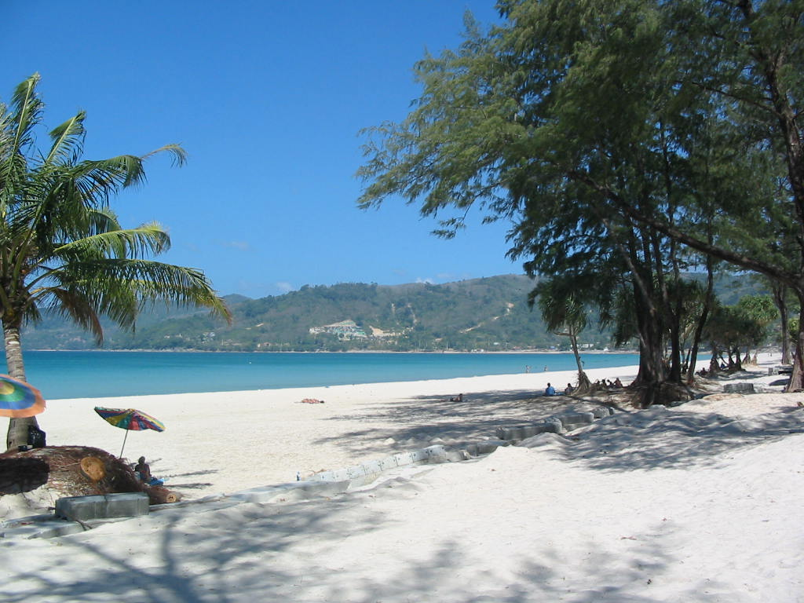

Figure 1: Damaged, almost deserted, Patong beach, North side, 23/01/2005

To the North of Patong beach, over the steep hill and down to the next beach, is Kamala beach, shown in figure 2. Kamala was almost wiped out, because it is so flat, all the way through the beach area, the village behind it and across the main road beyond. The figure shows a plot of land, which was perhaps a bar, but is now just a patch of tiled concrete, with its property boundaries defined. Some houses survived, others simply disappeared. Facing inland, in the opposite direction, is the remains of a single storey restaurant complex, substantially damaged, but was already under repair and reconstruction four weeks after the event.

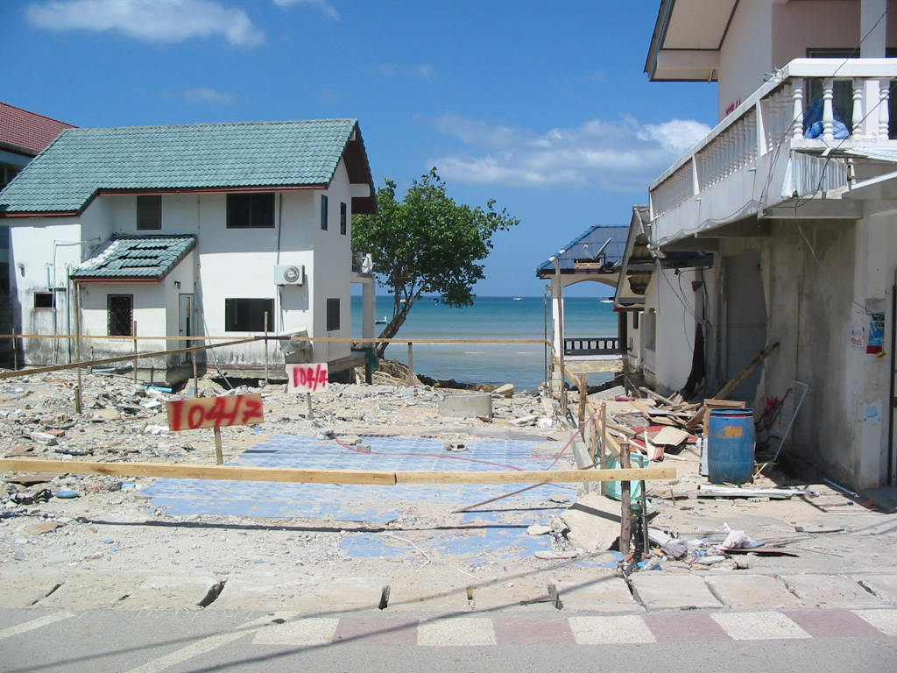

Figure 2: Kamala beach, showing a destroyed building, now just a plot of land.

To the north, up and over the hill to the next beach is Surin Beach, another beach popular with tourists, but not usually so crowded as Patong Beach (Figure 3).

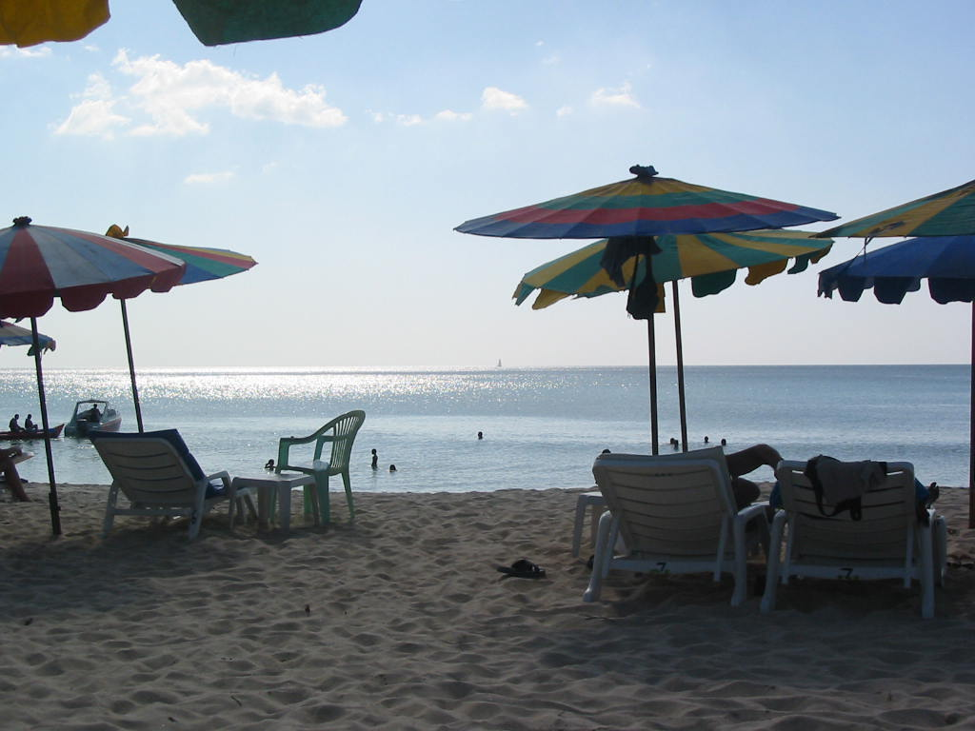

Figure 3: Steeply shelving Surin beach, with relatively little damage.

This is a steeply shelving beach where swimming is good in January and February, but dangerous later in the year when the normal sea waves exhibit a significant undertow, which drags swimmers out to sea to drown, because the swimmer is so quickly out of their depth. A consequence of the shelving is, however, that the tsunami wave was much smaller and consequently, most of the beach facilities and restaurants survived.

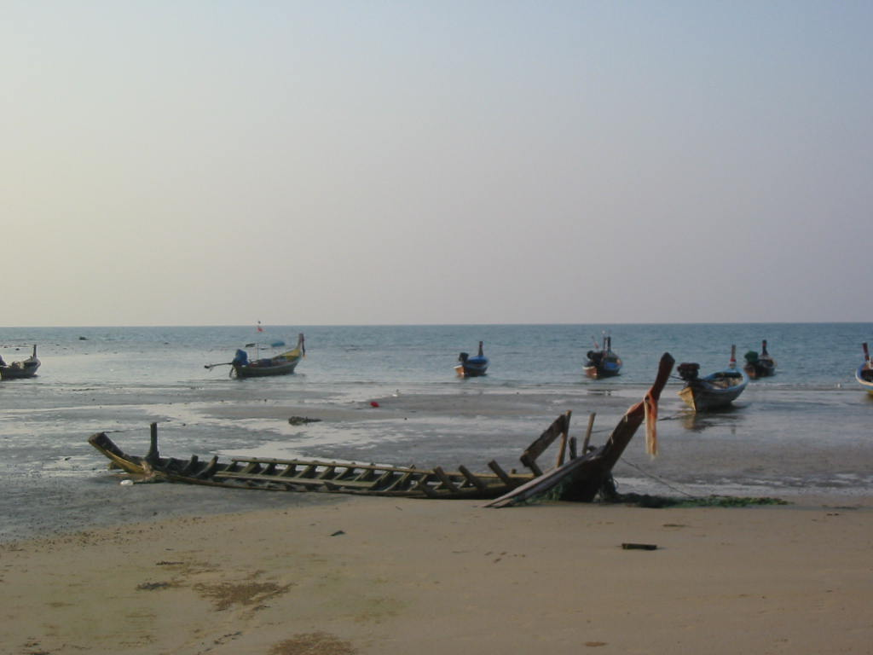

Figure 4: Nai Yang beach near the airport, showing a damaged long-tailed boat.

In the North West of Phuket, near to the International Airport, is the beautiful Nai Yang beach. Traditionally undeveloped, the beach facilities were destroyed but relatively quickly rebuilt. Illustrated in figure 4, is a badly damaged long-tailed boat. Nearby, several of these boats were being repaired in February, in addition to some new boats being constructed along with associated buildings and restaurants.

4 Modelling of Sea Waves

This subject is complex and concerns the general Navier-Stokes three-dimensional (3-D) partial differential equations for viscous, compressible flow as follows:

- Eulerian Conservation of Mass:

( ∂⁄∂t + U .∇ ) ρ = − ρ ∇ .U

Where: U is the particle velocity, and ρ is the water density
_{∇ =} ∂⁄∂x i + ∂⁄∂y j + ∂⁄∂z k; where i, j, k are unit vectors
_{and}
U . = U_{x} i + U_{y} j + U_{z} k

Conservation of mass is of fundamental importance to most systems. In this context the mass balance must include all mass arriving in a given 3-D volume and all mass leaving that volume during a computational time period, in addition to the mass already present in that volume prior to that time period.

- Eulerian Conservation of Momentum:

ρ(∂⁄∂ t + U . ∇ ) U = −∇ .σ + ρg

σ = δ_{ij}P - S_{ij}

Where: P is the water pressure, g is the gravitational constant, and S_{ij} are the total viscosity deviators (e.g. S_{x} = q_{x} – q), where q is the viscosity).

Conservation of momentum is a second fundamental consideration in that the systems sum of the products of individual mass elements and their velocity must remain constant.

- Eulerian Conservation of Energy:

ρ(∂⁄∂ t + U . ∇ ) I = −σ : ∇ U+ λ∇² T

where: σ : ∇ U =σ_{ji} ∂U_{i}/∂X_{j}

I is the internal energy, and λ is a real viscosity coefficient.

Conservation of energy is a little more tricky. However, it must be remembered that energy is only transferred from one form to another and is consequently not lost.

This set of equations may be simplified by assuming the flow is incompressible ( ρ = ρ₀ )

The equations may be further simplified by excluding viscosity. Viscosity terms may be included if the fluid is incompressible, with or without shearing forces.

Further details and a full discussion of these equations may found in Mader [6].

In computational terms, each of these equation sets must be converted into finite difference equations before solutions may be computed digitally. In order to do this, assumptions must be made in relation to the most appropriate form for the representation of differential terms to achieve an acceptable accuracy of result. To represent such a large volume of water, it is necessary to carefully consider the spatial resolution, which needs to be adequate to represent the spatial frequencies, or wavelengths of the expected sea waves, but also needs to minimise the computational cost. This is always an awkward compromise. The temporal aspects must also be considered in terms of minimum acceptable sample rate in this respect. It is important to appreciate that for these systems, such as water wave systems, the consequences of having relatively low damping needs to be considered in relation to the convergence of the solutions. In relation to the shallow water simulations, these aspects also need to be carefully looked at, since in shallow water the wavelength becomes considerably shorter and the wave height considerably larger. In addition the volume under consideration becomes much smaller.

5 Possible Defences against Tsunami

Tsunami arise because of earthquakes, landslides, cavity collapses and other related sudden major movements of land above or below sea or water surface level. A few can be foreseen and measures possibly taken to prevent them. An example of this is the Lituya Bay mega tsunami [7]. This type of landslide, perhaps on a smaller scale, might be recognised as a hazard and steps taken to prevent it happening before it occurs. Several mudslides caused by removal of trees also fall into this category.
However, major earthquakes cannot currently be accurately predicted, and as yet, it is not possible to determine if a particular earthquake produces a tsunami. Hence it must be accepted that tsunami will occur in the future and could give rise to major loss of life, injury and financial loss. Tsunami warning systems exist, or are planned for the near future, for possible affected areas, especially for the Indian Ocean. However, it seems that a number of possibilities exist to take affordable measures to limit their effect.

- Defence Possibilities

It was observed that in Krabi, villages which lay behind mangrove forests were far less affected that those here the forest had been removed to make way for fish farms or other commercial activities. Perhaps minimisation of the scale of mangrove forest removal could also minimise the damage caused by future tsunami. Alternatively, man-made structures might be created which in some way mimic nature in this respect.

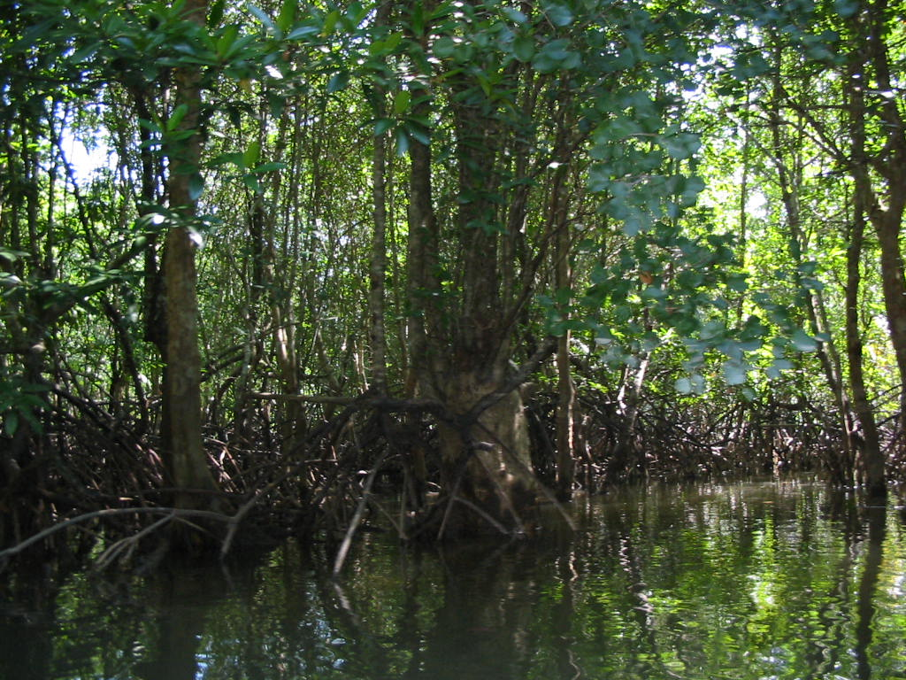

Figure 5: Mangrove forest Phang Nga Bay

Another possibility is for refuges to be constructed to provide escape to an upper story when stranded in a flat area, such as Khao Lak in Phang Nga Province to the North of Phuket Island and also for the centre of beach areas in Phuket, such as Patong and Kamala. Such structures would have on the first (ground level) floor only stairs and supports for the floors above, allowing the sea to flow through it. Changes in the shallow seas close to the beeches might also be effective in some circumstances, perhaps by dredging, or of dumping sand or rocks. Modification to the built environment might also help if the possibilities of tsunami attack are considered at the planning stages. Changes to the vehicle parking policy and provision could also help here.
However, none of these can be seriously considered until predictions of possible tsunami sizes, types, directions, etc, can be made available by appropriate modelling and simulation. When this is achieved, the efficacy of the measures described above can also be assessed and costed. All of this requires computer simulation to obtain typical possible tsunami data for the areas under threat. Further, simulation of the effects of such tsunami simulations on building structures and the built environment also require computer simulation, as does the parking arrangements.

6 Modelling and Simulation of Possible Tsunami in the Indian Ocean

The source of the tsunami in the northern part of the Indian Ocean, which would affect the western coasts of South Thailand, is most likely to be the subduction zone earthquakes of significant magnitude, associated with the fault line which includes the Sunda Trench, commencing from the centre of the west coast of Sumatra, right up to the Andaman and Nicobar islands in the north. Both single and multiple earthquakes (as for the recent events) need to be considered. Simulation of the effects of such earthquakes on possible tsunami generation is needed, but not easy to model.
Hydrological data is required to model the seafloor boundaries. However, the recent tsunami has caused changes to the sea floor, requiring new hydrological surveys to be carried out, especially in the Straits of Malacca an import sea route, and this aspect is also particularly relevant to the West coast of Thailand. The possible effects of reflections from islands and undersea rock formations also need to be considered. Such studies will provide samples of input data for shallow water studies in the coastal areas. Full Navier-Stokes compressible water wave simulations are required at least to validate any simpler models used to reduce the costs of simulation. This is true for both deep water and shallow water studies.
The tsunami simulated for the Indian Ocean, and particularly for the Andaman Sea, are required as input to the shallow water simulation studies for the general and specific bays and beach areas of Phuket, Phang Nga and Krabi. There is, of course, the problem of change of scale and consequent spatial resolution, resolved perhaps by interpolation. However, there are also a number of potential problems in achieving a reasonably accurate representation of the resulting sea wave motion.

- Tsunami Modelling Problems

First, it is necessary to obtain recent or current data of the sea floor hydrological data, in relation to the type of deposits and exposed rock formations as evidenced for example, in the video footage showing the sea receded to the horizon at Patong beach, prior to the arrival of the tsunami wave.
Second, it is important to obtain estimates of the sand and other materials picked up by the first wave. This affects the local water density, and also the way in which such mixtures of solid and liquid matter behave probably needs to be studied.
Consequent upon the first tsunami sea wave arriving, debris will be collected from the beach area and carried out into the bay. Some of this will be floating wreckage, including sun beds, and umbrellas, other material will be heavier and sink, but will still be carried away by the force of the water. Some of this debris and the suspended sand will subsequently be deposited in the bay area, changing the sea bed data, which in turn will require changes to the model for the second sea wave. It is not clear how serious this is for the modelling process. However, it is clear that some small islands, sand bars, sand spits and sand banks, together with some beach features, were modified by the recent tsunami. Indeed some small islands have disappeared; some new islands have appeared, and some beaches have been modified. This was very apparent from the air during the author’s several flights over the area with local Thai colleagues after the event (Figure 6). It was also clear that very significant disturbance of the sea bed in the coastal areas had occurred, as viewed from the aircraft when the author flew from South to North on the Western side of Phuket island when arriving from Bangkok on 29 December, just three days after the tsunami.

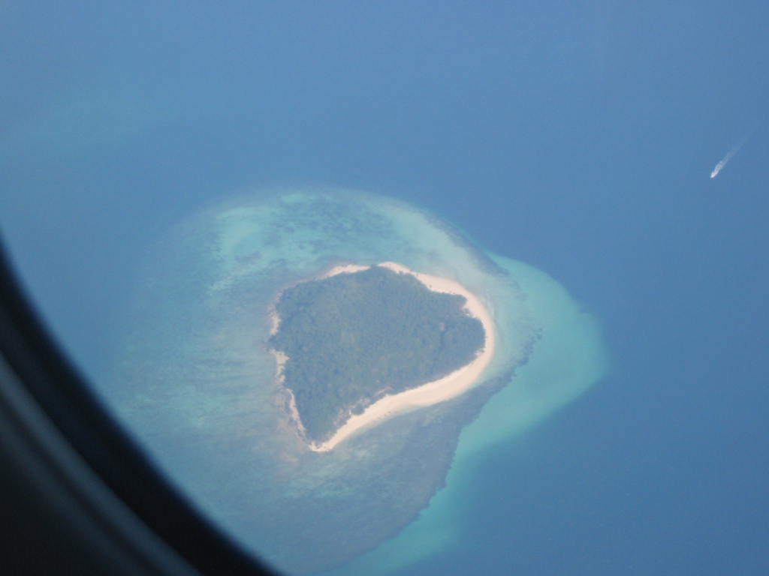

Figure 6: Small island between Phuket and Krabi after the tsunami

7 Application of Simulation Results to Affordable Defences

The result of the simulation of possible tsunami scenarios at specific beaches requires interfaces with other simulations. Specifically, the effects of such tsunami need to be applied to a variety of building structures with a view to determining their susceptibility to such sea waves. In this respect, it is interesting to observe, that a two storey restaurant, close to the beach at Patong, had its ground floor cleared, leaving just the supporting pillars holding up the restaurant above, which was apparently undamaged. Resulting from these observations, it is relevant to propose that some existing designs and proposals for designs of new buildings be considered to replace those destroyed. Specifically, it is already obvious that basement areas in department stores, whether for car parking, shopping or other human activities, should be avoided where these are in areas liable to flooding from tsunami attacks. Further, studies of the tsunami on a variety of designs for the built environment in the vulnerable areas close the beaches can be made to determine favourable designs for reconstruction.
Perhaps of greater significance, is the provision of refuge buildings, specifically designed to allow escape to higher level, above the invading sea. This is especially important in the flat areas of Phang Nga, such as Khao Lak and the central area of Patong beach. The parking of vehicles, whether for delivery in connection with business or for tourists visiting the beach on vacation is a problem everywhere, but especially difficult in Phuket, and getting worse. The consequences of a tsunami picking up vehicles and smashing them into shops and restaurants full of staff and customers is clearly shown in photographs taken at the time of the disaster in Phuket. A possible solution is to construct multi-storey car parks supported on columns, allowing the sea to pass safely underneath. This would ease the parking problem, reduce the danger and also provide refuge for people escaping from the arriving tsunami. Of course, such car parks must NOT have underground levels, unless they are clearly above possible inundation. Such buildings with supporting columns are common in Thailand, providing storage and vehicle parking underneath and reducing the risk of entry of snakes and other undesirable visitors to domestic apartments as may be seen in the accommodation blocks at the Phuket Campus of the Prince of Songkla University, up in the hills of Kathu district, as illustrated in Figure 7.

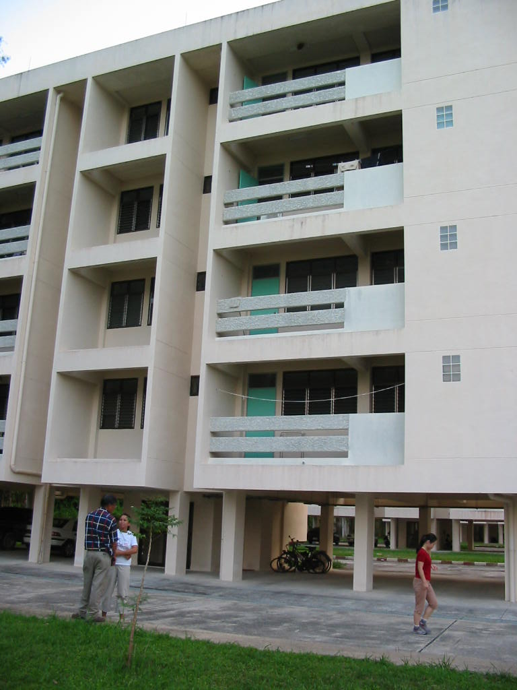

Figure 7: Accommodation block, Phuket campus

Many other aspects of where modelling and simulation might be useful must also be considered. For example, the design of the cross section of the pillar supports needs to be optimised to provide minimum resistance to sea waves, in order to maximise the possibility that upper storeys survive a tsunami attack. Examination of video footage of the tsunami at Patong Beach shows that, after the tsunami waves had initially receded, the sea took on a violent chaotic appearance and that this was replaced by a large whirlpool. Perhaps these damaging activities could have been ameliorated by modifying the sea floor close to the beach by dredging or by dumping sand or rock to damp out this motion. Finally, the possibilities of creating moles out to sea to reduce access of large sea waves to the beach areas, as can be seen at Schevningen, in the Netherlands and at other places.

8 Conclusions

The tragic events of 26 December 2004 in the countries bordering the Indian Ocean have lead to a desirable initial response of creating a tsunami warning system to enable coastal areas likely to be affected to be evacuated. However, the flat, low lying areas of Khao Lak in Phang Nga, Thailand and Aceh, in Sumatra, Indonesia provide little in the way of possible escape to a higher level above the invading sea. This paper considers the possibilities of the use of computer modelling and simulation of sea waves to determine the feasibility of making economic defence provision for affected areas in Thailand, which may also be relevant tin other countries.
The paper outlines the stages of the work required, and highlights some of the likely major technical difficulties in carrying out such a novel study. Perhaps the most important of these difficulties lies in the problems of interfacing the deep sea model to the shallow sea model and in turn to the models required to determine the effects of the tsunami on building structures and the built environment.
The problems of determining the details and modelling of the effects of sand and debris following the arrival of the first tsunami wave are mentioned and seen to be formidable.
Finally, possible economic solutions are proposed in relation to more robust and safer building practices for the affected areas and to the contribution of purpose built or dual purpose refuge buildings for escape from such damaging sea waves.

9 Bibliography

[1] Moorland School. 2005, Clitheroe, Lancashire, BB7 2AJ England. Plate Tectonics. Earth Science for Schools. www.moorlandschool.co.uk
[2] Keary, P. & Vine, F.J. 1991. Global Tectonics. Blackwell Scientific Publications,
302pp..(2nd Edition)
[3] Press, F. & Siever, R. 1998. Understanding Earth (2nd Edition) W.H. Freeman, p.504–535 + CD-rom
[4] Insight World Travel Atlas, Verlag Wolfgang Kunth GmbH, Munich, Germany. p 315.
ISBN 981-258-070-0
[5] Weis, D., Frey, F.A., Saunders, A. and Gibson, I., 1991 Ninety East Ridge (Indian Ocean):
A 5000 km record of a DUPAL mantle plume, Geology, 19, 99-102.
[6] Mader C.L. 2004. Numerical Modeling of Water Waves. 2nd ed. CRC Press. ISBN 0-
8493-2311-8. pp 1-27
[7] Mader C.L. 2004. Numerical Modeling of Water Waves. 2nd ed. CRC Press. ISBN 0-
8493-2311-8. pp 203-214

10 About the Author


RICHARD ZOBEL graduated in Electrical Engineering from London University in 1963. His first experience of simulation was obtained during 1962-66 at Sperry Gyroscope whilst working on naval surface to air missiles, using mainly valve analog computers. His Ph.D., obtained in 1970 at Manchester University, concerned hybrid analog-digital computing. As Lecturer and Senior Lecturer he became involved in digital signal processing, instrumentation and design environments with special emphasis on the simulation aspects of real-time embedded systems. He is a Committee Member and former Chairman of the United Kingdom Simulation Society (UKSim), Former Secretary of the European Federation of Simulation Societies (EUROSIM), and was a European Director of SCSI. He was presented with the Outstanding Service Award of SCSI, the Society for Modelling and Simulation International, San Diego, California, USA, at the Dresden Conference in 2003. His current research interests concern distributed simulation for non-military applications, model re-use, distributed simulation model databases, issues of verification and validation of re-useable simulation models and security for distributed simulation under commercial network protocols. He is now retired, but still very active. He is currently teaching Computer Engineering during the winter months at the Prince of Songkla University, Phuket and Hat Yai Campuses in South Thailand.

