Final project CSC445

Fabien FORESTIER

TIC TAC TOE Game

My application is a realisation of the game Tic Tac Toe. There is a welcome page where the user can chose whether he want to play or see the previous scores. Actually I couldn’t get the saving of the score in a database working so for the moment it is a white page.

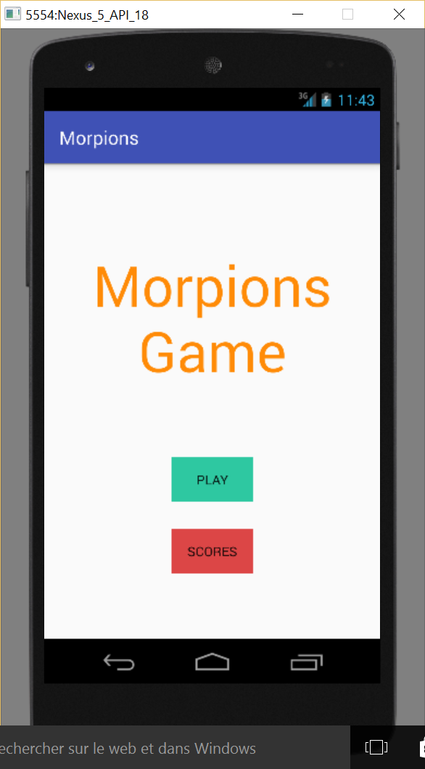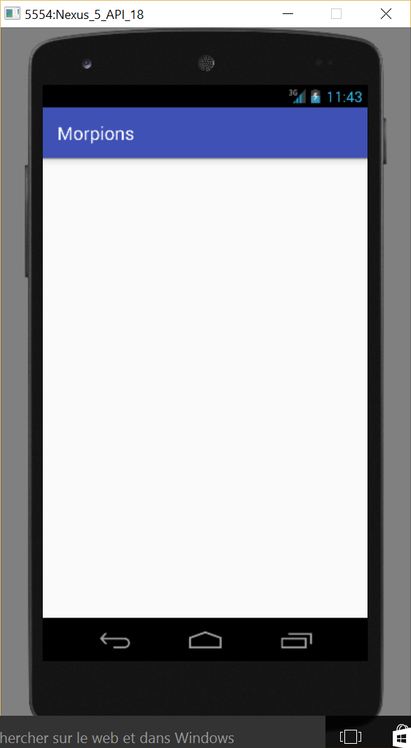

Once the player clicked on play, he is redirected to a page where he chose the names of the players.

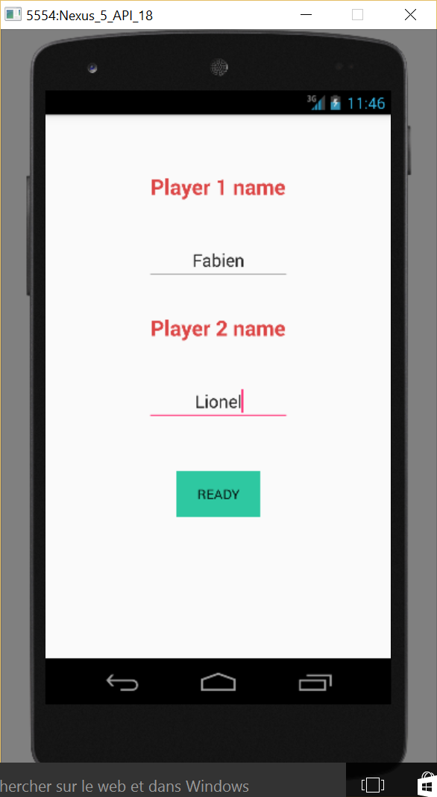

When he is done editing the name he can start to play by clicking the Ready button.

The next page is composed of a table 3\*3 with buttons in each square. By default the square is green but when they tap on it the color change and the symbol of the player is displayed. We can see under each name the symbol that correspond to the play as well as the score of the player. The background color of the name change to green when this is the turn of this player.

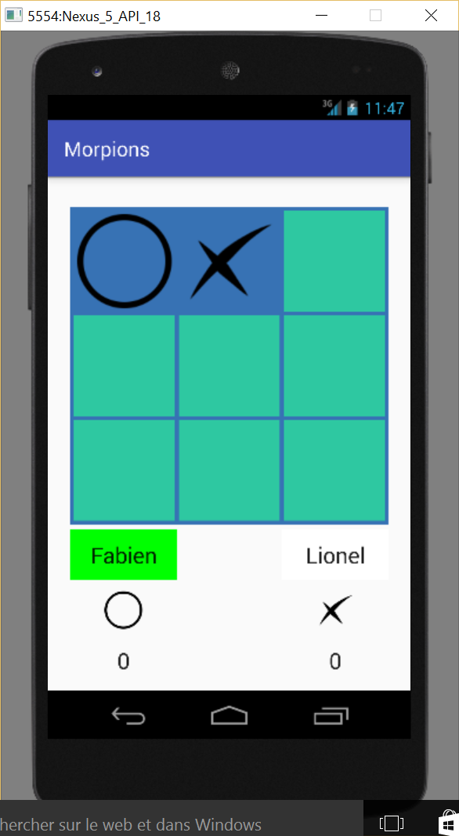

Each time one of the player won or if nobody won but all the square have been typed a message appear asking if they want to play again or if they want to stop. The score of the winning player is increased by one. If they click yes the board is reinitialized. If they click no they are redirected to the page where they chose the names.

