B I O S Y N C
User Guide
Athlete space
Calendar · Check-in · Debrief · Dashboard · Nutrition · Messages

Welcome to BioSync
BioSync is the app your coach uses to build your sessions, track your recovery, and support your nutrition. This guide walks you through each feature, step by step.
💡 Every screenshot in this guide matches the exact interface you'll use — same colours, same buttons. They're shown in French; you can switch the app to English or Spanish from the login screen.
Contents
→ 0. Installing the app on your phone
→ 1. Signing in
→ 2. Your training calendar
→ 3. The morning check-in
→ 4. The session debrief
→ 5. Your recovery dashboard
→ 6. Nutrition
→ 7. Messaging your coach

0 Installing the app on your phone
BioSync isn't on the App Store or Google Play — it's a web app you open from a link, then add to your home screen to use like a regular app.
App address: biosync-blue.vercel.app

Scan this QR code with your phone's camera to open the app directly.
On iPhone (Safari)
1. Open the link above (or scan the QR code) in Safari.
2. Tap the Share icon at the bottom of the screen.
3. Scroll down and tap "Add to Home Screen".
4. Tap "Add" in the top right corner.
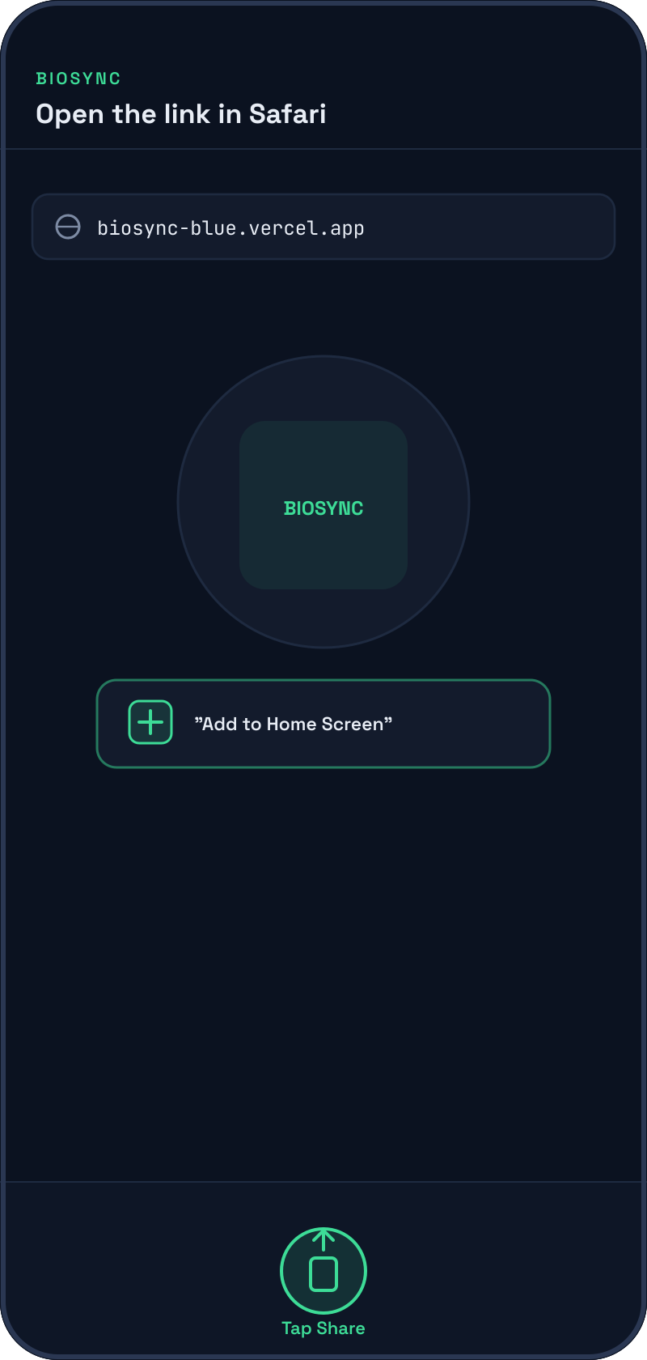
On Android (Chrome)
1. Open the link above (or scan the QR code) in Chrome.
2. Tap the ⋮ menu in the top right corner.
3. Tap "Add to Home screen" or "Install app".
4. Confirm — a BioSync icon appears on your phone.

💡 Once added, the app opens full-screen like an installed app, without the browser's address bar.

1 Signing in
Your coach has created an account for you with a username and password. Open the app from the icon added to your home screen, enter your details, and tap "Sign in".
→ You can change the app's language (FR / EN / ES) at the top of the login screen.
→ If you've forgotten your password, ask your coach — only they can reset it.
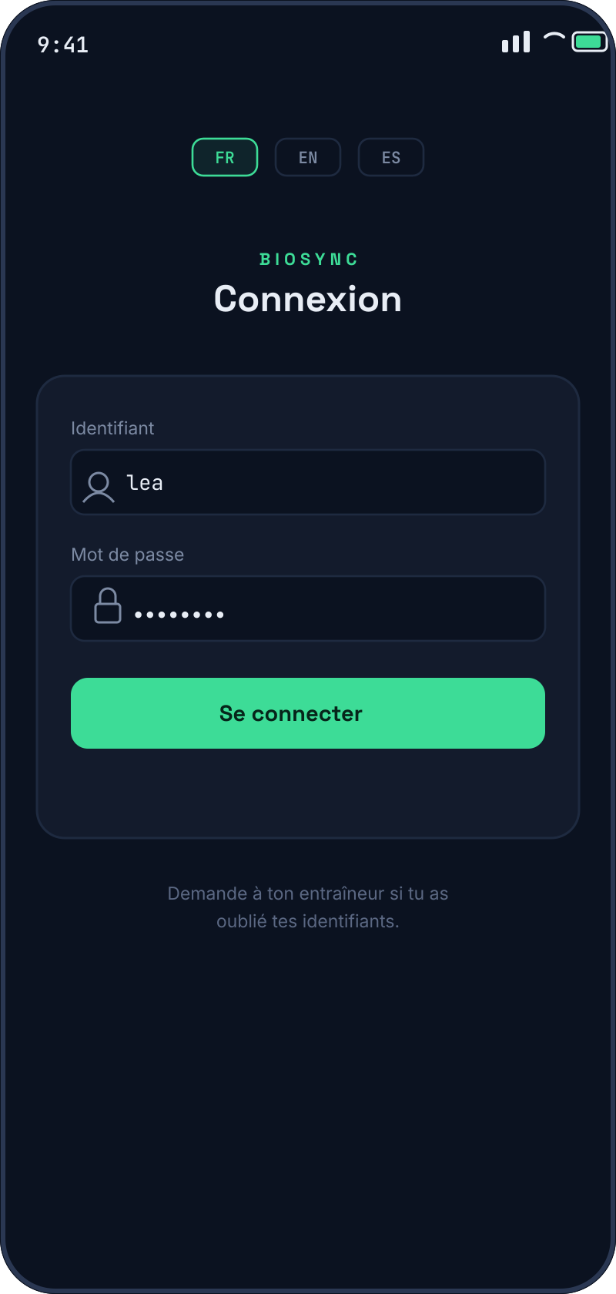

2 Your training calendar
The calendar shows every session your coach has scheduled for you. A green dot = session done, an amber dot = session planned.
→ Tap a day to see that day's session in detail.
→ Tap the session card to expand it — you'll see 3 blocks: warm-up, main set, cool-down, with each exercise's detail.
→ Once expanded, a "Send session debrief" button appears at the bottom — that's how you send feedback to your coach.
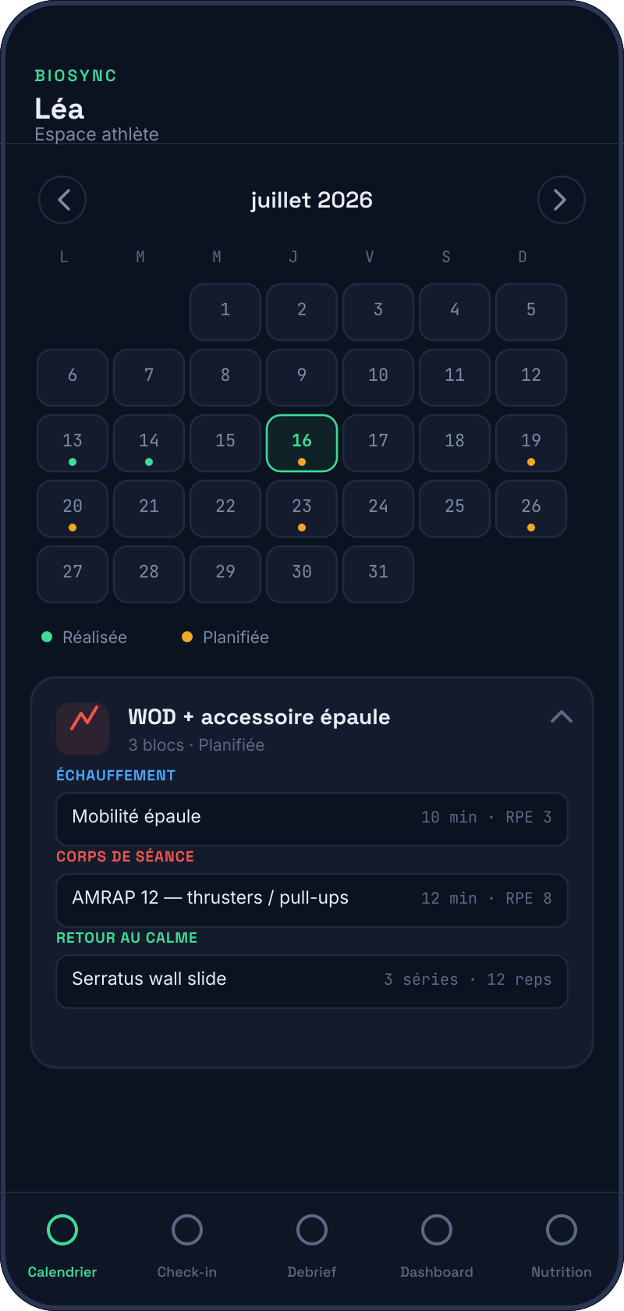
💡 A session may include a comment from your coach and sometimes an attached file (PDF, video, image) — check these before you start.

3 The morning check-in
Every morning, before training, take a minute to fill in your check-in. This data helps your coach — and the app's readiness engine — adjust your training load.
→ Night HRV and resting HR: enter the values from your wearable.
→ Night temperature: this is the deviation given by your wearable versus your baseline (typically -1°C to +1°C), not an absolute temperature.
→ Sleep: duration in hours, plus a perceived quality rating from 1 to 5.
→ Hooper questionnaire: 4 sliders (fatigue, stress, soreness, sleep quality) from 1 to 7.
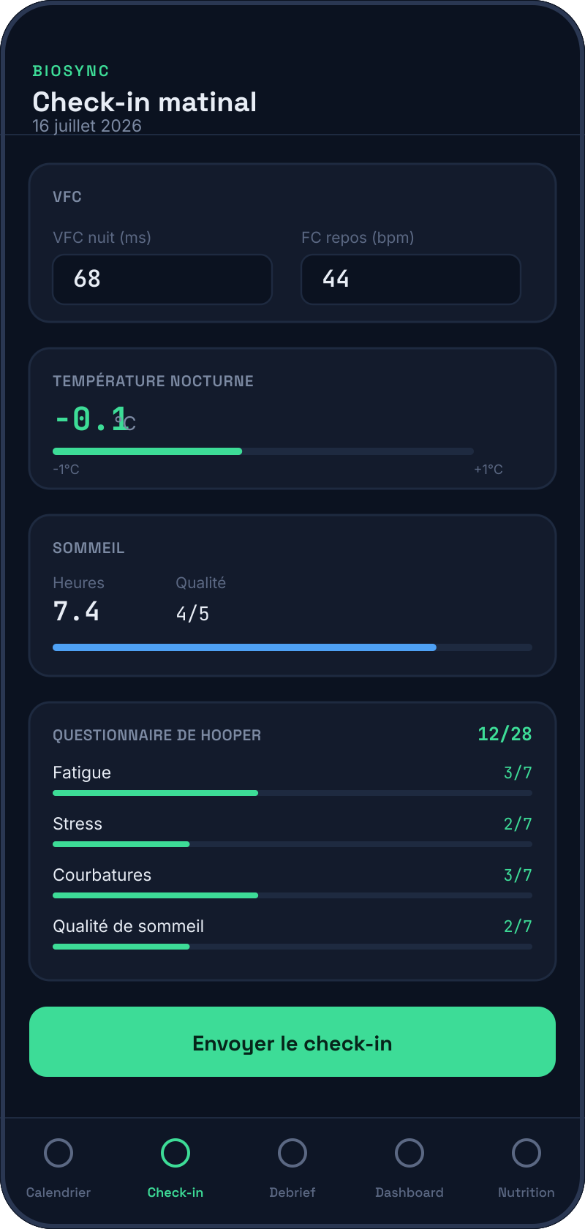

4 The session debrief
After every session, send a debrief to your coach — it takes a minute and gives your coach a clear picture of how the session actually went.
→ RPE: your perceived effort for the session, from 1 (very easy) to 10 (maximal).
→ Sensations: select whichever feelings apply (feeling good, tired, breathless...).
→ Pain intensity: rate it 0 to 10, and specify the area if needed.
→ Session file: attach your wearable's export (.csv, .fit, .gpx) if you have one.
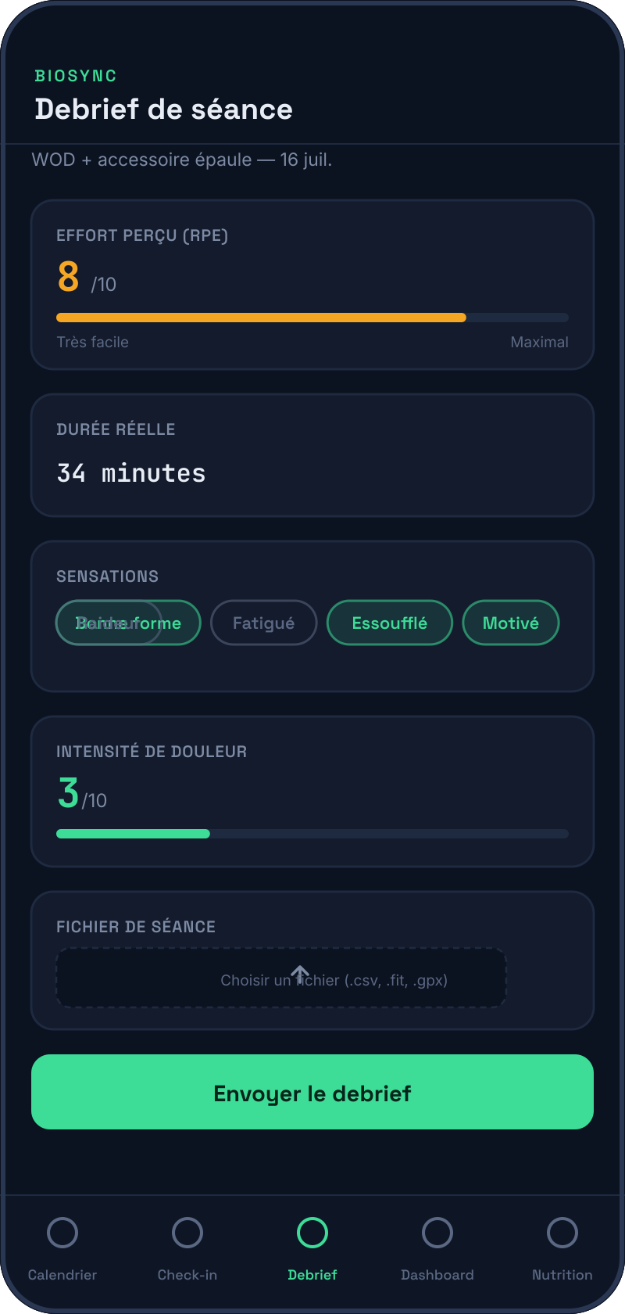
💡 If you report significant pain (≥7/10) or acute pain, your coach is notified immediately.

5 Your recovery dashboard
The dashboard summarises your state for the day at a glance: a Readiness Score from 0 to 100, a clear recommendation, and the factors behind it.
→ The score and recommendation at the top are the most important read — they tell you what to do today.
→ The cards below (load, HRV, sleep, pain...) explain why the score is what it is.
→ "Show advanced analysis" expands more detailed indicators (monotony, weekly/monthly load) meant for your coach.
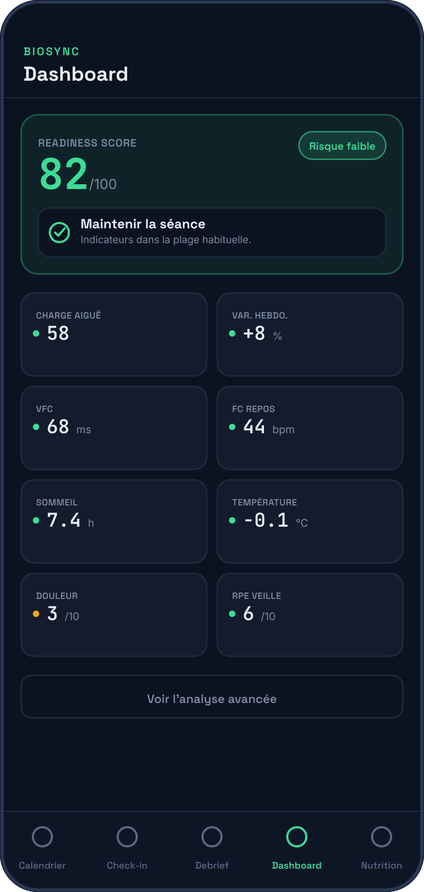
💡 This score helps you understand your state better — it never replaces your coach's judgement or a healthcare professional's advice.

6 Nutrition
If your coach has enabled this option for you, the Nutrition tab offers a daily meal plan, adjusted to your training load and session time.
→ The daily plan shows 4 meals with their macros — the meal right before/after your session is highlighted.
→ Tap "Swap" on a meal to build your own version from a food list.
→ In the Profile tab, you can set your dietary preferences and, if you're prepping for a race, enable "Carb loading" or "Race day" mode.
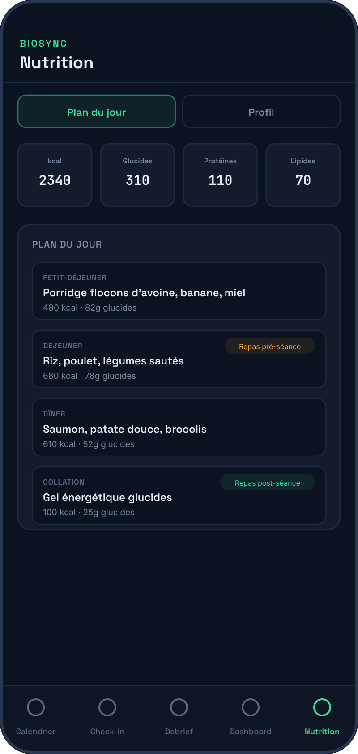

7 Messaging your coach
Chat directly with your coach from the app — no need for separate texts or emails.
→ Your messages appear in green on the right, your coach's in grey on the left.
→ Your coach is automatically notified for every message, check-in, or debrief you send.
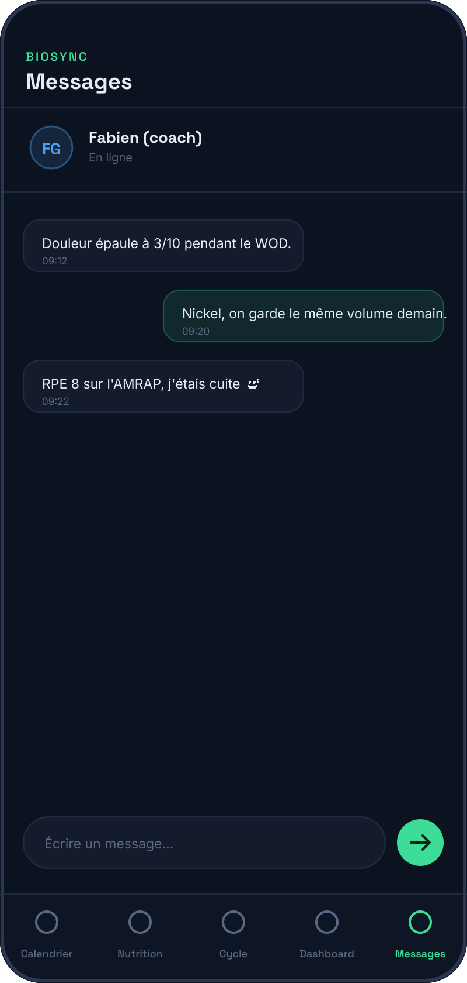
Questions? Message your coach directly from the app.

