Privacy-Preserving and Explainable Federated Learning for Outcome Prediction in Primary Biliary Cirrhosis under Heterogeneous Data
Abstract
Primary biliary cirrhosis (PBC) is a chronic liver disease, and outcome prediction for it would gain from data held at several hospitals, yet patient records cannot be pooled freely. This study builds a federated learning pipeline that predicts death or survival in PBC, adds privacy and communication layers, and explains the final model. The 418-patient Mayo Clinic data were split once into training, validation and test subsets, and the training subset was distributed to five simulated hospitals under IID and Dirichlet non-IID partitions. A small neural network was trained with FedAvg, FedProx and FedNova using clipped, 8-bit quantised and securely masked updates, with Gaussian differential privacy noise added by the aggregator. Every experiment was repeated with five random seeds. With all protections active, the best federated setting reached a mean test accuracy of 0.689 ± 0.044 (AUC 0.688 ± 0.054) on non-IID data and 0.730 ± 0.045 (AUC 0.784 ± 0.045) on IID data, while centralised reference models reached 0.775 to 0.787. Differential privacy caused most of the loss: at ε of 5 or below, accuracy fell to between 0.58 and 0.64, close to the 0.62 share of survivors. Quantisation to 8 bits and secure upload had no measurable effect on accuracy and cut the upload of each client from 1.32 KB to 0.33 KB per round, and even 2-bit updates gave a similar accuracy. SHAP, LIME and permutation importance agreed that age and alkaline phosphatase were among the most influential features, and they also exposed the missing-treatment indicator, a dataset artefact, as a strong predictor. The results show what privacy-preserving federated learning costs on a small clinical data set, and they do not support clinical use of the model without external validation.
Keywords: federated learning, differential privacy, quantisation, secure aggregation, non-IID data, explainable artificial intelligence, primary biliary cirrhosis

1. Introduction
Primary biliary cirrhosis, now often called primary biliary cholangitis, is a chronic autoimmune disease of the small bile ducts that can progress to cirrhosis and liver failure [1], [2]. Predicting which patients will die has been a clinical aim for decades, and the Mayo risk model built on the clinical trial data used in this paper is a well-known example [3]. Modern machine learning can use many more variables than such a score, but it needs data, and the records of rare diseases such as PBC are spread over many hospitals. Privacy rules and institutional policies make it hard to pool those records in one place.
Federated learning (FL) addresses this problem by keeping the data where it is and moving the model instead. Each hospital trains the shared model on its own patients and sends back only a weight update, and a central server combines the updates [4], [5]. The approach has been explored in several medical settings [6], [7], [8]. It is not free of problems, however. Weight updates can still reveal information about the data behind them, so they need extra protection such as clipping, noise and secure aggregation [9], [10], [11]. Sending full-precision updates in every round is costly, which has led to compression and quantisation [12], [13]. The data of different hospitals are also rarely identically distributed, and this heterogeneity can slow or damage training [14], [15], [16].
A clinical model must also be understandable to the people who might use it [17]. Feature attribution methods such as SHAP and LIME can describe what a trained model does [18], [19], but they are usually demonstrated on centrally trained models. Whether the same explanations remain consistent for a model trained under privacy constraints deserves a direct look. A further concern is methodological. Studies on small medical tables are easily affected by information leaking from the test data into training, which inflates reported accuracy [20], [21]. A pipeline that is meant to support a paper should therefore be built so that such leakage cannot occur.
This paper makes four contributions. First, it presents a complete federated pipeline for PBC outcome prediction in which the holdout split is made before any fitting, preprocessing statistics are computed from client training data only, and model selection never uses the test subset. Second, it compares FedAvg, FedProx and FedNova under IID and Dirichlet non-IID partitions, with five random seeds for every setting. Third, it measures the cost of each protection layer, including a sweep of the differential privacy parameter and a study of the quantisation bit width, and it reports the communication saving. Fourth, it explains the final global model with SHAP, LIME and permutation importance and checks whether the three methods agree. The results are modest in absolute accuracy, and we report them as they are, together with the limits of the study.
The rest of the paper is organised as follows. Section 2 reviews related work. Section 3 describes the data, the federated pipeline, the protection layers, the evaluation protocol and the explainability methods. Section 4 reports the results, Section 5 discusses them, Section 6 lists limitations and future work, and Section 7 concludes.

2. Related Work
Federated learning in healthcare:- Federated averaging introduced the idea of training a shared model from locally computed updates [4], and reviews of the field describe its open problems in detail [5], [22], [23]. In medicine, FL has been proposed as a way to build models across institutions without moving patient data, with examples in medical imaging and clinical prediction [6], [7]. Kaissis and colleagues argue that FL should be combined with additional privacy techniques, since federation alone does not guarantee that the training data stay private [8]. Our work follows this view and studies several protection layers together.
Data heterogeneity and aggregation:- When clients hold different class proportions, local models drift apart and the averaged model degrades [14]. The Dirichlet partition is a common way to create such heterogeneity in experiments [16]. FedProx limits drift with a proximal term in the local objective [15], and FedNova corrects the bias that arises when clients perform different numbers of local steps [24]. We compare these two methods with FedAvg on a clinical table, where client sizes and class balance can differ strongly.
Privacy and communication:- Differential privacy gives a formal way to limit what a released quantity reveals about one individual [11]. In FL it is applied by clipping each client update and adding Gaussian noise, so that the contribution of a whole client is hidden [25], [26], [9]. Secure aggregation lets the server see only the sum of the updates, not the individual ones [10]. Quantisation reduces the size of each upload and has been studied for both stochastic gradient methods and federated averaging [27], [13], [12]. The interaction of these layers on a small medical data set, and in particular the effect of very coarse quantisation, receives less attention, and we measure it directly.
Explainability and evaluation rigour:- SHAP assigns each feature a contribution based on Shapley values [18], LIME fits a local surrogate model [19], and permutation importance measures the loss in accuracy when a feature is shuffled [28]. Each method has weaknesses, so using several together gives a more careful picture. Rudin argues that explanations of black-box models can mislead in high-stakes settings [17], and we treat them as descriptions of the model and not as clinical evidence. Finally, leakage between training and test data is a documented cause of over-optimistic results in machine learning for science and medicine [20], [21], and resampling or preprocessing applied before the split is one known route to such leakage [20]. Class imbalance itself is a standard difficulty in clinical prediction [29]. We use class-weighted losses and a single early holdout split to avoid both issues.

3. Methodology

3.1 Overview of the proposed framework
This study predicts the outcome of patients with primary biliary cirrhosis (PBC), death or survival, with a federated learning (FL) model, and then explains the decisions of the final model. The complete workflow is shown in Fig. 1. It has three parts. In the first part, the clinical table is cleaned, converted into 18 numerical features and divided once into training, validation and test subsets. In the second part, the training subset is distributed among K = 5 simulated hospitals (clients), and a global neural network is trained through repeated communication rounds with a central server. In the third part, the selected global model is evaluated on the held-out test subset and explained with SHAP, LIME and permutation importance.
The federation is simulated on a single machine. Each client is a separate data object that keeps its own rows and runs its own preprocessing and training, and the server receives only protected weight updates. No real network is involved, so the experiments measure statistical behaviour (accuracy, privacy cost, effect of heterogeneous data) and communication volume, not network latency.
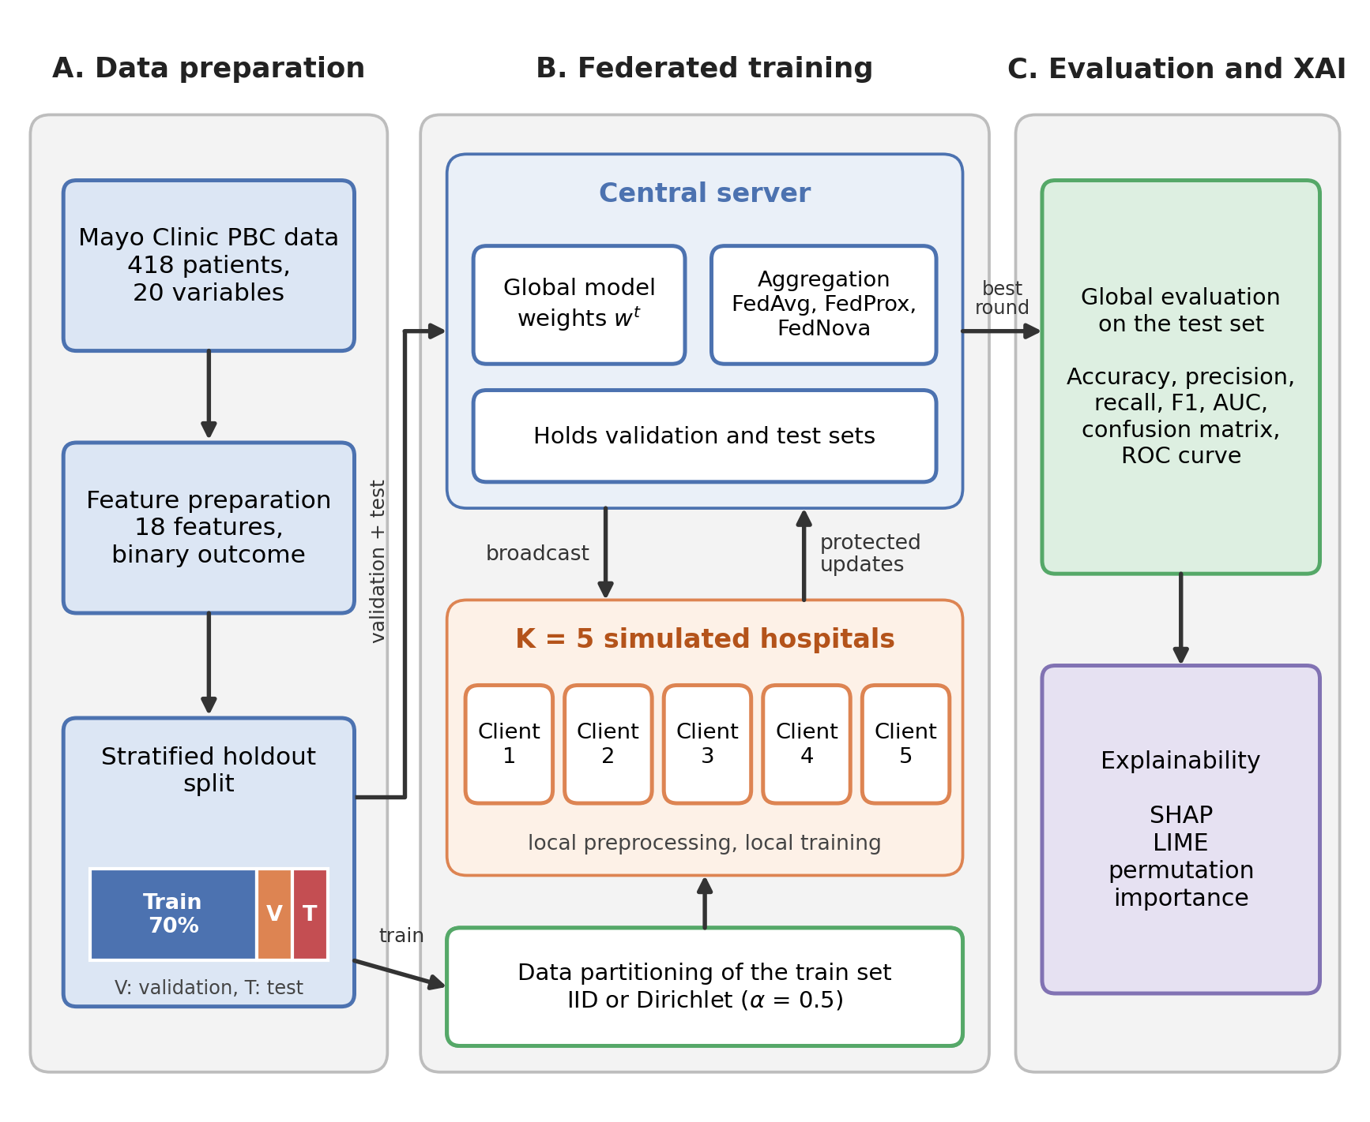
Fig. 1. Overall framework: (A) data preparation and holdout split, (B) privacy-preserving federated training between a central server and five simulated hospitals, and (C) global evaluation and explainability.

3.2 Dataset and outcome definition
The data come from the Mayo Clinic trial of D-penicillamine in PBC [34], conducted between 1974 and 1984 [3], [30]. The table holds 418 patients and 20 variables. Of these patients, 312 took part in the randomised trial, and the other 106 were followed without randomisation; the latter have no treatment label and lack several laboratory values. The variables cover demographics, treatment, clinical signs (ascites, hepatomegaly, spider angiomas, oedema), nine laboratory measurements, histologic stage, follow-up time in days, and a three-level status (censored, censored at liver transplantation, or death).
Status was converted into a binary target: death (n = 161, 38.5%) against survival (n = 257). The survival class joins the 232 patients censored alive with the 25 patients censored at transplantation. This formulation treats the task as outcome classification, so the time of death or censoring is not used. Missing values are common. Treatment, ascites, hepatomegaly, spider angiomas, alkaline phosphatase and SGOT are absent in 106 records (25.4%), copper in 108, and cholesterol and triglycerides in 134 and 136 records (about 32%).
Follow-up time was left out of the input features. It is measured after baseline and depends on the outcome itself, because patients who died early have short follow-up, so a model could learn the length of observation instead of the condition of the patient. The code contains a switch for this variable, and it was kept off in all experiments.
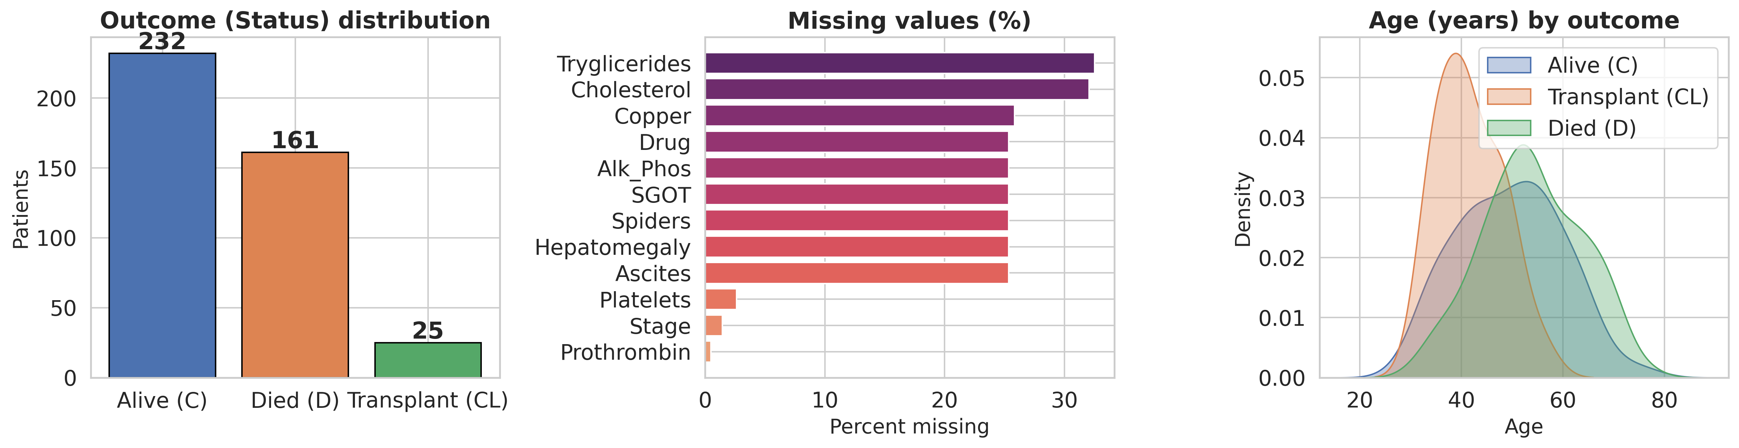
Fig. 2. Overview of the raw data: outcome distribution, missing values per variable and age distribution by outcome.

3.3 Feature preparation
Feature preparation uses only operations that act on one record at a time. No information passes between patients, so this step cannot carry test information into training. Age was converted from days to years, and binary and ordinal variables were coded as numbers (Table 1). A missing-treatment indicator (Drug_missing) was added, since the absence of a treatment label identifies the non-randomised patients. Eight skewed laboratory variables were transformed with log(1 + x). Patient identifier, follow-up time and status were removed from the inputs. The result is a matrix with 18 input features.
Table 1. Variable groups and their handling before federated training.
Group | Variables (as named in the file) | Handling
Demographic | Age, Sex | Age in years (days / 365.25); sex coded 0 (female) or 1 (male)
Treatment | Drug, Drug_missing | Placebo = 0, D-penicillamine = 1; indicator equals 1 when the treatment label is absent
Clinical signs | Ascites, Hepatomegaly, Spiders, Edema | Binary 0/1; Edema ordinal: none = 0, untreated or diuretic-controlled = 1, despite diuretics = 2
Laboratory (skewed) | Bilirubin, Cholesterol, Copper, Alk_Phos, SGOT, Tryglicerides, Platelets, Prothrombin | log(1 + x)
Laboratory | Albumin | Used as measured
Histology | Stage | Ordinal 1 to 4 from biopsy; 6 values missing
Removed | ID, N_Days, Status | Identifier; follow-up time; source of the target

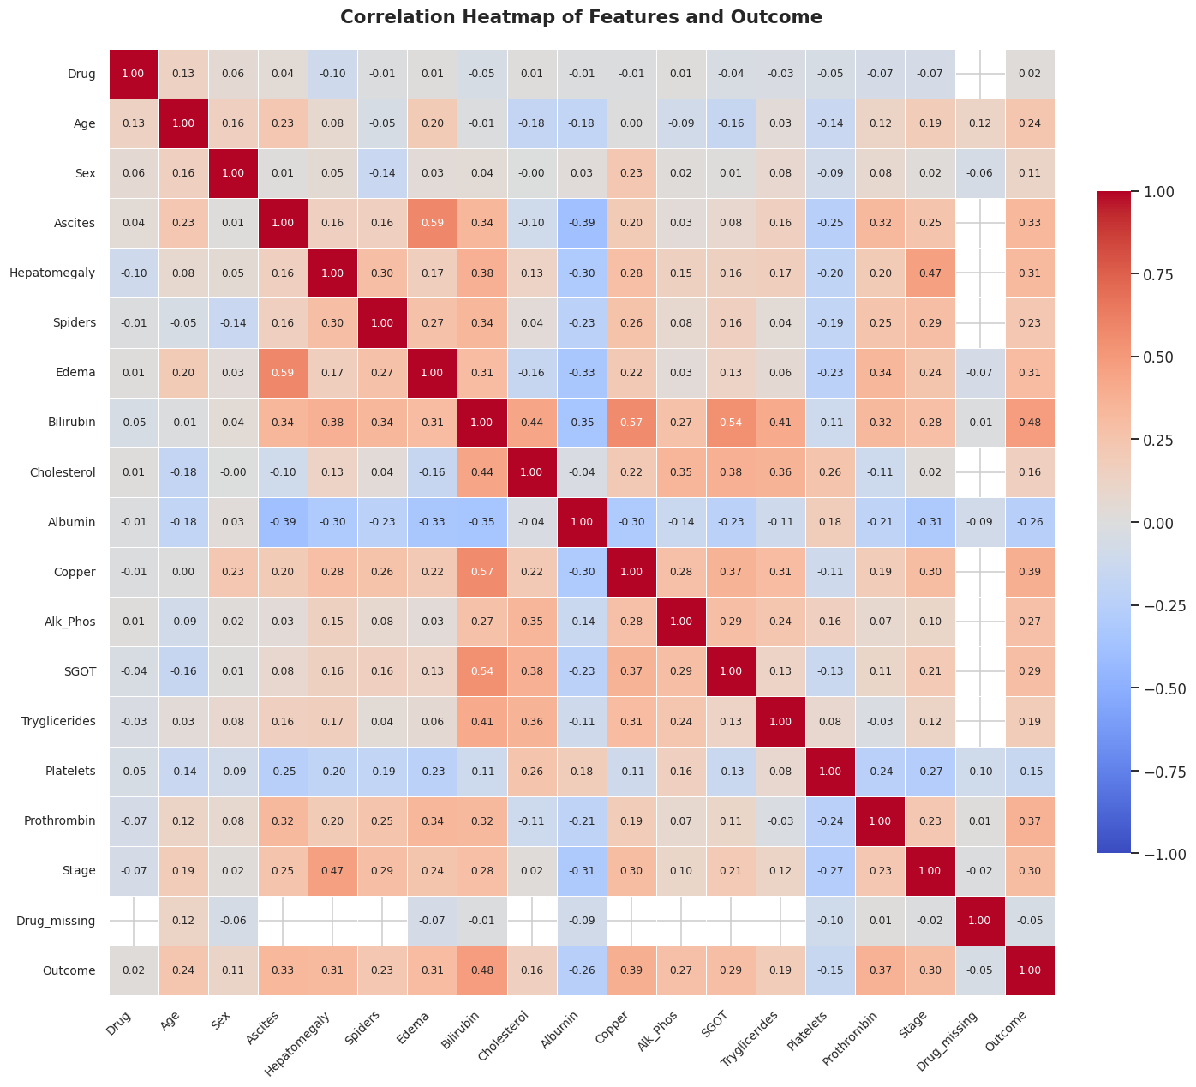
Fig. 3. Correlation heatmap of the 18 input features and the binary outcome.

3.4 Holdout strategy
The data were divided once, before any fitting, into training (70%), validation (15%) and test (15%) subsets by stratified random sampling on the outcome. With random seed 42 this gives 292, 63 and 63 patients, containing 112, 25 and 24 deaths respectively (Fig. 4a). The server keeps the validation and test subsets, and only the training subset is handed to the clients. The validation subset was used to select the best communication round and, among a few candidates, the aggregation method and the hidden-layer size. The test subset was used only to report final results and to compute explanations.

3.5 Data partitioning and heterogeneity
The training subset was divided among K = 5 clients in two ways. In the IID setting, the patients of each class were shuffled and cut into five equal parts, so every client has nearly the same class balance (Fig. 4b). In the non-IID setting, the share of each class given to each client was drawn from a Dirichlet distribution [16] (Eq. 1), where p_{c} is the vector of proportions for class c, α controls the skew, n_{c} is the number of training patients of class c, and n_{c,k} is the number given to client k.
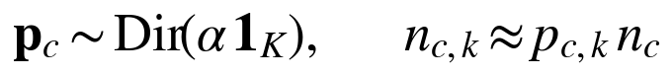 (1)
A small α produces clients dominated by one class, and a large α approaches the IID case. The main non-IID setting used α = 0.5. The draw was repeated until every client held at least 20 patients, with at most 500 attempts. Fig. 4c shows the partition obtained with seed 42. One client holds 158 of the 292 training patients, 146 of them survivors, while three other clients hold mostly patients who died. This imbalance is deliberate, since it imitates hospitals that treat different patient groups.
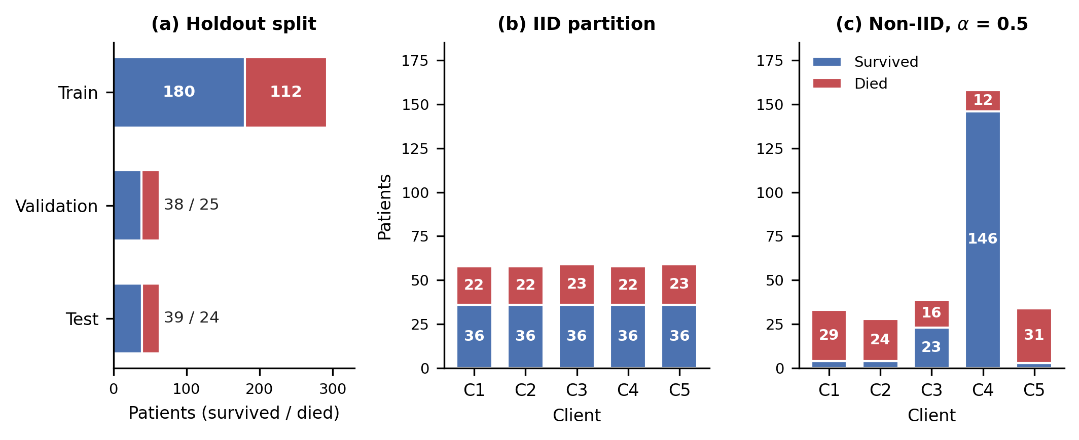
Fig. 4. (a) Holdout split with the number of survivors and deaths in each subset. (b) Class composition of the five clients under the IID partition. (c) Class composition under the Dirichlet partition with α = 0.5. All panels use seed 42.

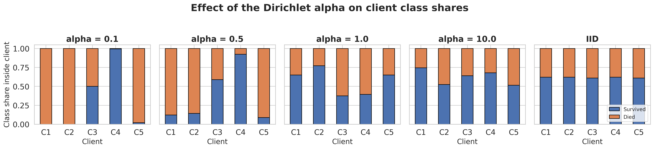
Fig. 5. Class shares inside each client for several values of the Dirichlet parameter α (seed 42).

3.6 Local preprocessing in the federated setting
Imputation and scaling were fitted without pooling raw rows. First, each client computes the median of every feature on its own rows and sends the medians, with the counts of observed values, to the server, which averages them into global medians. Second, each client fills its missing entries with its own medians, and uses the global median only if a feature is completely missing locally. Third, each client sends the count, the sum and the sum of squares of its imputed data, from which the server computes a global mean and standard deviation and broadcasts them. Each client then standardises its data with these values. The server applies the same global medians, mean and standard deviation to the validation and test subsets. Every statistic comes from training rows only. These shared summaries are sent without noise and are therefore not covered by the differential privacy mechanism of Section 3.8.

3.7 Model and local training
The global model is a fully connected neural network with 18 inputs, one hidden layer of 16 ReLU units and a two-unit softmax output, which gives 338 trainable weights. Weights were initialised with the He method [31]. A small network suits the small sample size and keeps every update cheap to transmit. The network was written in NumPy [32] without a deep learning framework, so that clipping, quantisation and masking act directly on one flat weight vector.
Each client minimises a class-weighted cross-entropy with L2 regularisation (Eq. 2). Here D_{k} is the local data, ℓ is the cross-entropy loss, s_{i} is the weight of patient i, n_{k} is the local sample size, n_{k,y} is the number of local patients in the class y_{i} of patient i, and λ = 10⁻³ is the weight decay on the weight matrices. The class weights come from the client's own label counts. They replace oversampling, so no synthetic records are created and the class balance of the validation and test subsets is untouched.
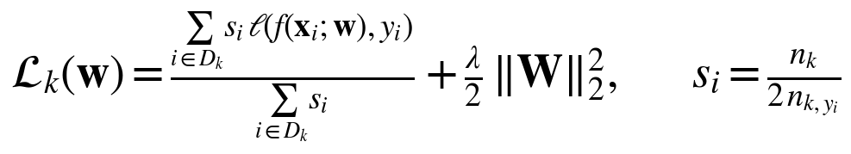 (2)
When FedProx is used, a proximal term is added to the local objective (Eq. 3), where w^{t} are the global weights received at the start of the round and μ = 0.05. Local training uses mini-batch gradient descent with batch size 16, learning rate 0.05 and E = 5 local epochs in every round.
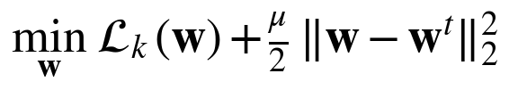 (3)

3.8 Privacy and communication layers
After local training, client k computes its weight update as the difference between its local weights and the global weights it received. Before upload, the update passes through three protection layers, and the server adds a fourth (Fig. 6, boxes 3 to 8).
Clipping:- The update is scaled so that its Euclidean norm does not exceed C = 1 [25], [26] (Eq. 4).
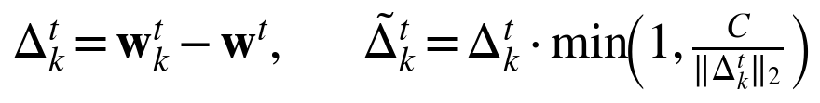 (4)
Quantisation:- The clipped update is mapped to b = 8 bit integers with a symmetric uniform quantiser [13] (Eq. 5), where s_{k} is the quantisation step. The values are converted back to real numbers so that the server can sum them. For 338 weights, this reduces the upload of one client from about 1.3 KB to about 0.33 KB per round. Because the update is clipped first, its values lie in a known range, and one scale per update is enough (Fig. 7).
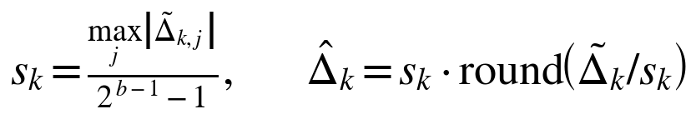 (5)
Secure upload:- Every pair of clients (k, j) with k < j shares a random mask m_{kj}. Client k adds the mask and client j subtracts it from its weighted update, where p_{k} = n_{k}/n (Eq. 6), in the manner of secure aggregation [10]. The server sees only masked vectors, but the masks cancel in the sum. Our implementation simulates this cancellation with a pseudo-random generator and omits the key agreement, dropout handling and cryptographic protocol of the full scheme.
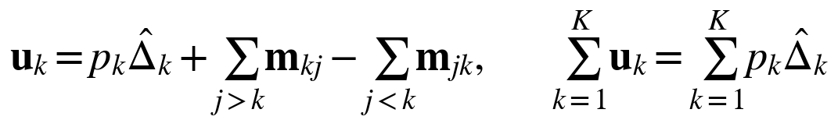 (6)
Differential privacy:- The server adds Gaussian noise to the summed update, following the central model of differentially private federated averaging [26], [11] (Eq. 7). The noise scale uses the sensitivity C p_{max}, where p_{max} is the largest client weight, with δ = 10⁻⁵. The noise is assumed to be added by a trusted secure aggregator after unmasking.
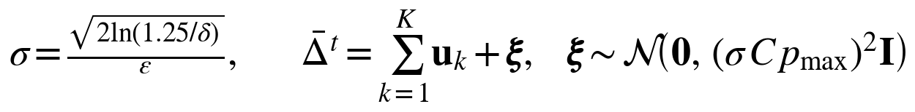 (7)
The multiplier σ follows the classical Gaussian mechanism formula [11], which was derived for ε ≤ 1. Since larger values of ε were used, ε here describes the noise scale of a single round and is not a formal end-to-end guarantee. No privacy accountant was applied to compose the budget over the 40 rounds. The main experiments use ε = 10 per round, and ε was varied from 1 to 50 to expose the trade-off between privacy and utility.
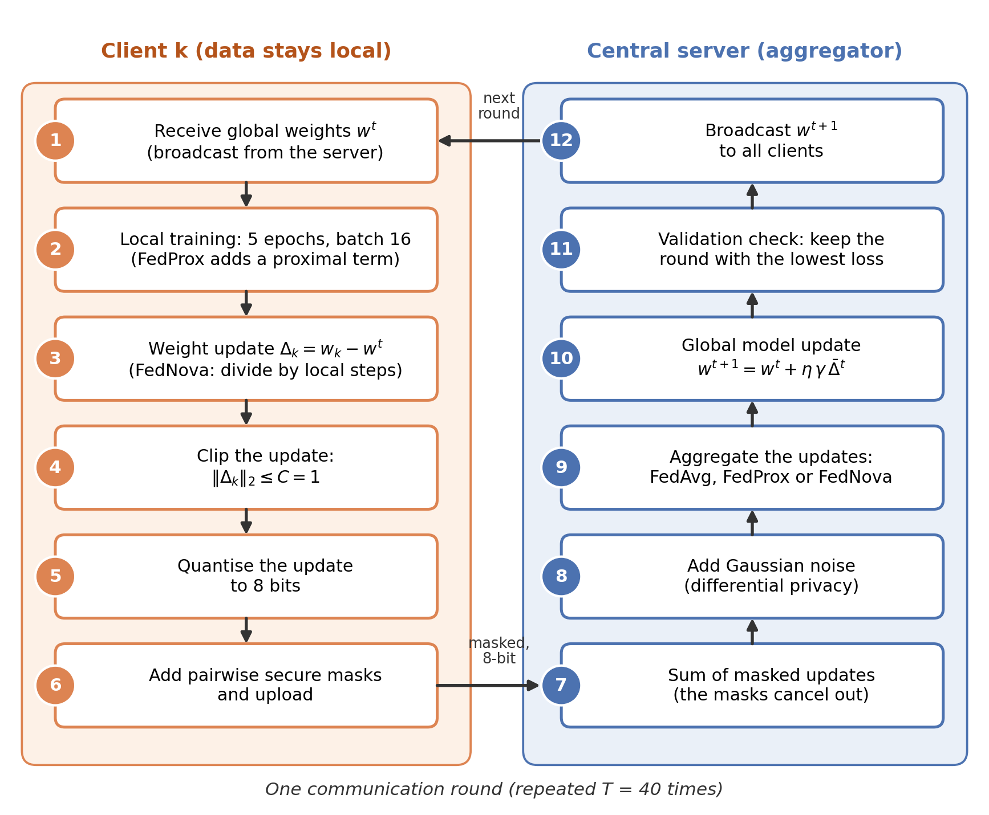
Fig. 6. One communication round. Client side (boxes 1 to 6): receive the global weights, train locally, form the update, clip, quantise and mask it. Server side (boxes 7 to 12): sum the masked updates, add noise, aggregate, update the global model, check the validation loss and broadcast.

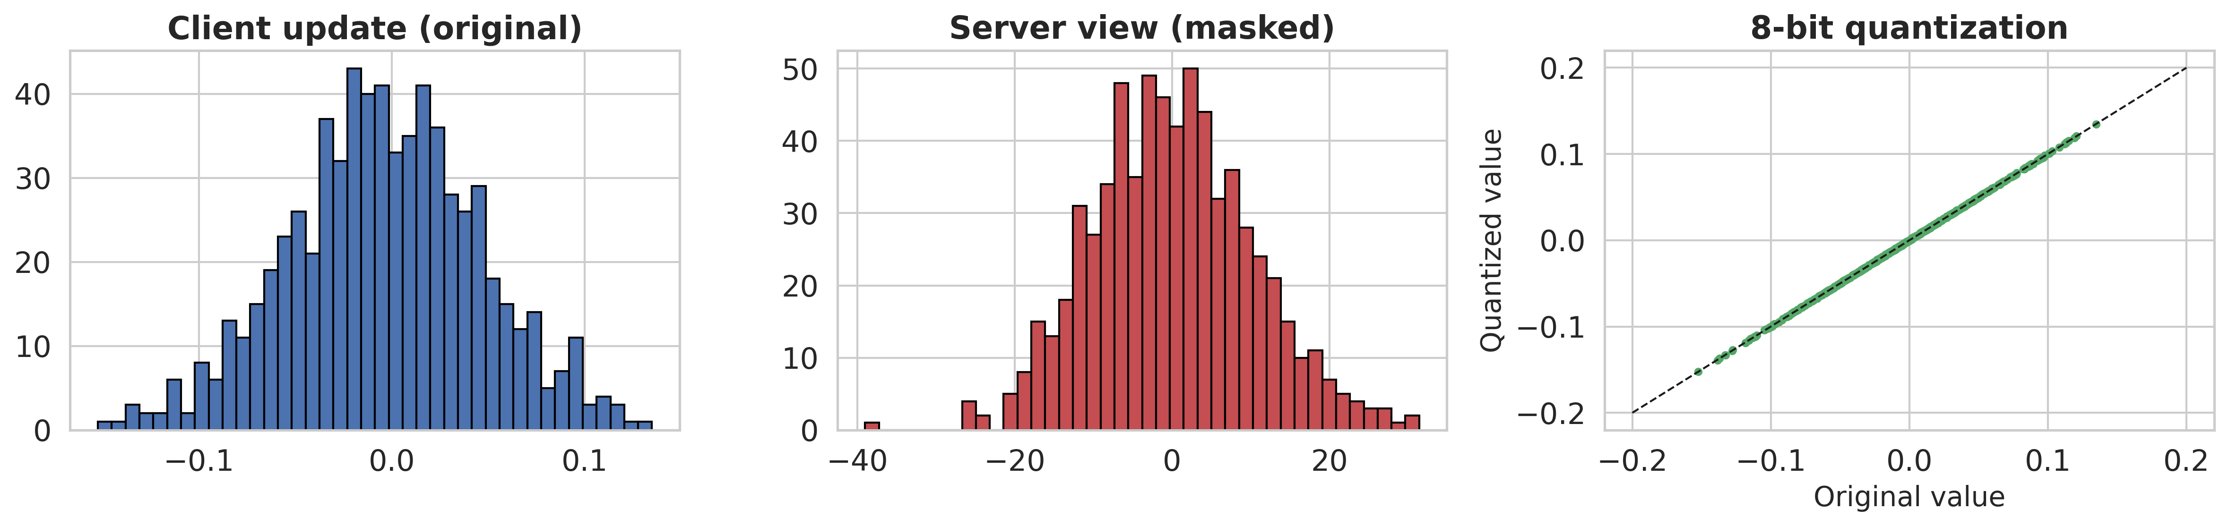
Fig. 7. Illustration of the protection layers on synthetic update vectors (standard deviation 0.05): original update (left), the masked vector seen by the server (middle), and original against 8-bit quantised values (right).

3.9 Communication rounds and aggregation
Training runs for T = 40 communication rounds, and all clients take part in every round. In each round the server broadcasts the current global weights, each client trains locally and uploads its protected update, the server aggregates the updates, and the global model is updated (Algorithm 1).
Algorithm 1. Privacy-preserving federated training of the global model.
Input: K clients with private training data; rounds T, local epochs E, clipping norm C, bit width b, privacy parameters (ε, δ), aggregation rule (FedAvg, FedProx or FedNova)
Output: global model w^{t*} with the lowest validation loss
1: Clients and server run federated preprocessing (medians, mean, standard deviation)
2: Server initialises w⁰
3: for t = 1 to T do
4: Server broadcasts w^{t} to all clients
5: for each client k in parallel do
6: w_{k} ← w^{t}; train for E epochs on local data (FedProx: with proximal term)
7: Δ_{k} ← w_{k} − w^{t} (FedNova: Δ_{k} ← τ_{ref} Δ_{k} / τ_{k})
8: Clip Δ_{k} to norm C; quantise to b bits; add pairwise masks to p_{k}Δ_{k}; upload
9: end for
10: Server sums the masked updates and adds noise N(0, (σCp_{max})²I)
11: Server sets w^{t+1} ← w^{t} + η γ Δ̄^{t}
12: Server computes the validation loss of w^{t+1}
13: end for
14: return the weights of the round with the lowest validation loss

Three aggregation rules were compared. FedAvg [4] averages the updates with weights p_{k}. FedProx [15] uses the proximal objective of Eq. 3, which keeps local weights near the global weights when client data differ. FedNova [24] corrects for clients that perform different numbers of local steps τ_{k}: each update is multiplied by τ_{ref}/τ_{k}, where τ_{ref} is the mean number of local steps, before clipping, and the aggregate is rescaled afterwards. The global update is given in Eq. 8 with server step η = 1, where γ = 1 for FedAvg and FedProx, and γ = Σ_{k} p_{k}τ_{k}/τ_{ref} for FedNova.
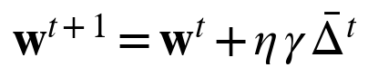 (8)
The server records the validation loss after every round. The final global model is the one from the round with the lowest validation loss (Eq. 9), so the test subset plays no part in stopping the training. Convergence speed is reported as the first round in which the validation accuracy reaches 99% of its maximum.
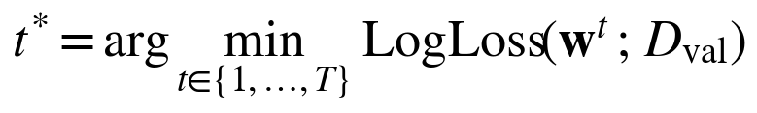 (9)
Table 2. Settings used in all experiments.
Group | Setting | Value
Data | Features, classes | 18 features, 2 classes (survived, died)
Data | Holdout split | 70% / 15% / 15%, stratified
Data | Random seeds | 42, 43, 44, 45, 46
Federation | Clients K | 5
Federation | Dirichlet α | 0.5 (IID also tested)
Federation | Minimum patients per client | 20
Federation | Communication rounds T | 40, all clients in every round
Model | Architecture | 18-16-2, ReLU and softmax, 338 weights
Model | Initialisation | He normal
Model | Loss | Class-weighted cross-entropy, L2 λ = 0.001
Local training | Optimiser | Mini-batch gradient descent
Local training | Local epochs E, batch size | 5, 16
Local training | Learning rate | 0.05
Aggregation | FedProx μ, server step η | 0.05, 1.0
Privacy | Clipping norm C | 1.0
Privacy | Quantisation | 8 bits
Privacy | Differential privacy | Gaussian noise, ε = 10 per round (1 to 50 tested), δ = 10⁻⁵
Privacy | Secure upload | Pairwise additive masks
Explainability | SHAP | Kernel explainer, 15 background centres, 300 samples
Explainability | LIME | 2000 perturbations (1000 each for 25 patients)
Explainability | Permutation importance | 30 repeats per feature

3.10 Evaluation protocol
The selected global model was evaluated once on the test subset. The reported metrics are accuracy, weighted precision, weighted recall, weighted F1-score and the area under the ROC curve (AUC), together with the confusion matrix, the ROC curve and a per-class report. The test subset contains only 63 patients, so a single split gives unstable estimates. Every experiment was therefore repeated with five random seeds (42 to 46). A seed changes the holdout split, the Dirichlet partition, the weight initialisation and the privacy noise, and results are given as mean and standard deviation.
The experiments cover five comparisons. First, FedAvg, FedProx and FedNova were run under IID and non-IID data, with quantisation, secure upload and differential privacy all switched on. Second, centralised reference models were trained on the pooled training data: the same neural network with early stopping on validation loss, a random forest with 300 trees [28] and logistic regression from scikit-learn [33], both with balanced class weights. Third, an ablation added quantisation, secure upload and differential privacy one at a time and all together. Fourth, ε was swept over 1, 2, 5, 10, 20 and 50, and compared with training without noise. Fifth, the bit width b of the quantiser was varied over 2, 4, 6, 8 and 16 bits and compared with full 32-bit updates, with differential privacy and secure upload switched off so that only the effect of quantisation is measured. The aggregation rule used in the ablation and the sweep was the one with the highest mean validation accuracy under non-IID data. The hidden-layer size was chosen among a few candidates by validation accuracy, and the other settings stayed at the values in Table 2.

3.11 Explainability
Explanations were generated for the final global model and describe its predicted probability of death. The model takes standardised inputs, so attributions are expressed in standardised units. Three complementary methods were used (Fig. 8).
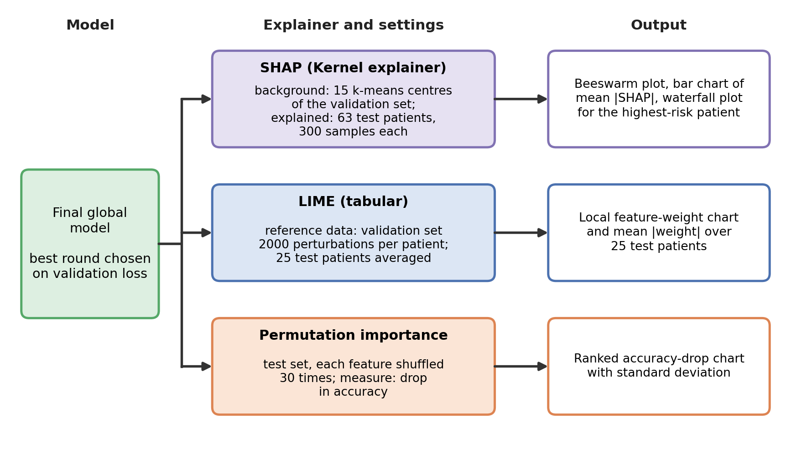
Fig. 8. Explainability workflow applied to the final global model. Each method is shown with its data source, its main settings and the outputs it produces.

SHAP:- SHAP assigns each feature j a Shapley value (Eq. 10), the weighted average of its marginal contribution over subsets S of the full feature set F [18]. The model-agnostic Kernel explainer was used with a background of 15 k-means centres of the validation subset, and all 63 test patients were explained with 300 sampled coalitions each. The outputs are a beeswarm summary plot, a bar chart of the mean absolute SHAP value, and a waterfall plot for the test patient with the highest predicted risk.
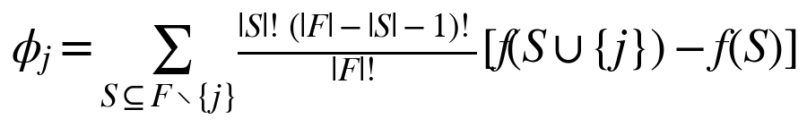 (10)
LIME:- LIME fits a sparse linear surrogate on perturbed copies of one patient [19]. The tabular explainer used the validation subset as reference data and 2000 perturbations for the case-study patient. For a global view, the absolute LIME weights were also averaged over 25 test patients, with 1000 perturbations each.
Permutation Importance:- This method measures the drop in test accuracy when one feature is randomly shuffled [28]. Each feature was shuffled 30 times, and the mean and standard deviation of the drop are reported.
The three methods were finally compared by ranking the features under each method and averaging the three ranks. Agreement between methods raises confidence that a feature influences the model. All three methods explain the behaviour of the model, which is not the same as explaining the biology of the disease.

3.12 Implementation details
The pipeline was written in Python 3 with NumPy [32], pandas, scikit-learn [33], SHAP, LIME, matplotlib and seaborn, and is supplied as two notebooks, one for Google Colab and one for Kaggle. All random seeds are fixed. The full set of experiments finishes within a few minutes on a standard CPU runtime, and every figure and table is saved automatically.

4. Results

4.1 Client data under the IID and non-IID partitions
With seed 42, the training subset of 292 patients was divided among five clients. In the IID partition every client held 58 or 59 patients, of whom 22 or 23 died (Fig. 4b). In the non-IID partition with α = 0.5 the clients held 33, 28, 39, 158 and 34 patients (Fig. 4c). Client 4 held 146 of the 180 training survivors, while clients 1, 2 and 5 held mostly patients who died (29 of 33, 24 of 28 and 31 of 34). Fig. 5 shows how α changes the picture: at α = 0.1 most clients contain a single class, and at α = 10 the partition is close to IID.

4.2 Overall performance
Table 3 and Fig. 9 give the global test performance averaged over five seeds. All federated results use quantisation, secure upload and differential privacy with ε = 10 per round. Under IID data, FedAvg and FedNova reached an accuracy of 0.730 ± 0.045 and an AUC of 0.784 ± 0.045, and FedProx reached 0.724 ± 0.053. Under non-IID data, FedNova gave the best accuracy of 0.689 ± 0.044 with an AUC of 0.688 ± 0.054, while FedAvg and FedProx both gave 0.667 ± 0.076 with AUC values near 0.70. The centralised reference models trained on the pooled training data were better: logistic regression reached 0.787 ± 0.029 (AUC 0.845), the random forest 0.781 ± 0.028 (AUC 0.840) and the same neural network 0.775 ± 0.031 (AUC 0.818).
The federated models therefore lost about 4.5 to 5.7 accuracy points under IID data and about 8.6 to 12 points under non-IID data, compared with the centralised models. The spread between seeds was large. For example, the accuracy of FedAvg under non-IID data ranged from 0.587 to 0.746 across the five seeds, and the test subset contains only 63 patients. Differences between the three aggregation rules are smaller than this spread, so the data do not show that one rule is better than another.
Table 3. Global test performance, mean ± standard deviation over five seeds. Federated rows use quantisation, secure upload and differential privacy (ε = 10 per round).
Setting | Method | Accuracy | Precision | Recall | F1-score | AUC
IID | FedAvg | 0.730 ± 0.045 | 0.733 ± 0.049 | 0.730 ± 0.045 | 0.728 ± 0.046 | 0.784 ± 0.045
IID | FedProx | 0.724 ± 0.053 | 0.726 ± 0.058 | 0.724 ± 0.053 | 0.722 ± 0.054 | 0.783 ± 0.045
IID | FedNova | 0.730 ± 0.045 | 0.733 ± 0.049 | 0.730 ± 0.045 | 0.728 ± 0.046 | 0.784 ± 0.045
Non-IID | FedAvg | 0.667 ± 0.076 | 0.699 ± 0.078 | 0.667 ± 0.076 | 0.648 ± 0.081 | 0.702 ± 0.054
Non-IID | FedProx | 0.667 ± 0.076 | 0.699 ± 0.078 | 0.667 ± 0.076 | 0.648 ± 0.081 | 0.702 ± 0.055
Non-IID | FedNova | 0.689 ± 0.044 | 0.691 ± 0.040 | 0.689 ± 0.044 | 0.685 ± 0.042 | 0.688 ± 0.054
Centralised | MLP | 0.775 ± 0.031 | 0.777 ± 0.033 | 0.775 ± 0.031 | 0.773 ± 0.031 | 0.818 ± 0.024
Centralised | Random forest | 0.781 ± 0.028 | 0.780 ± 0.029 | 0.781 ± 0.028 | 0.777 ± 0.029 | 0.840 ± 0.033
Centralised | Logistic regression | 0.787 ± 0.029 | 0.790 ± 0.031 | 0.787 ± 0.029 | 0.788 ± 0.029 | 0.845 ± 0.025

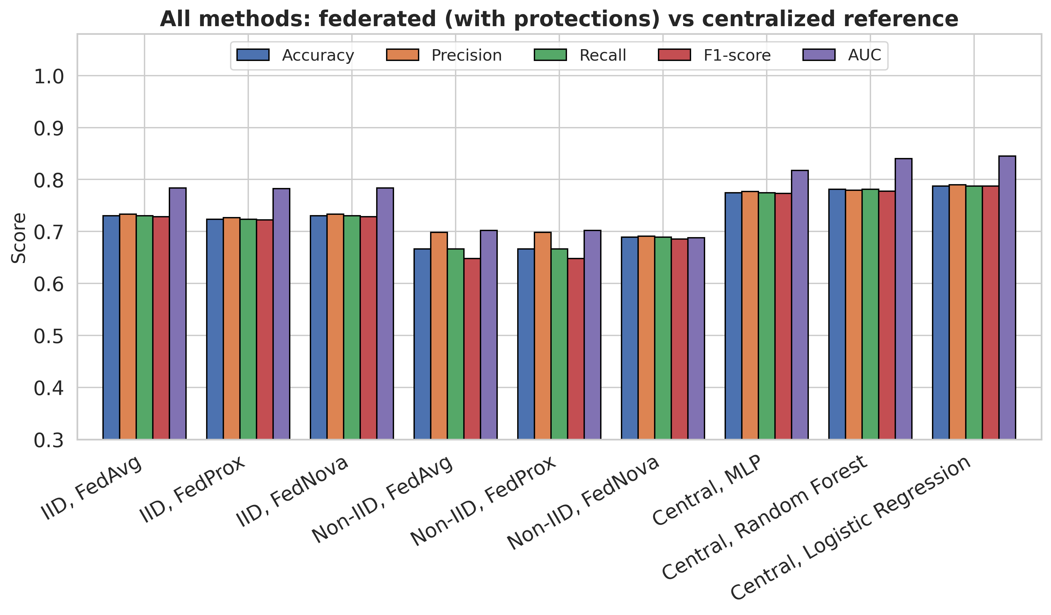
Fig. 9. Federated methods and centralised reference models compared on five metrics (mean over five seeds).

4.3 Effect of data heterogeneity and aggregation rule
Moving from IID to non-IID data lowered the accuracy of FedAvg by 6.3 points, that of FedProx by 5.7 points and that of FedNova by 4.1 points (Fig. 10). FedNova also had the smallest spread under non-IID data (0.044 against 0.076 for the other two rules) and the highest mean validation accuracy (0.727 against 0.708 for FedAvg and 0.702 for FedProx), which is why it was chosen for the ablation, the privacy sweep and the explanations. With five seeds this ranking is suggestive and not conclusive. Under IID data FedNova and FedAvg gave identical results. The reason is that the five IID clients each had 58 or 59 patients and so performed the same number of local steps per epoch (four batches), in which case the FedNova correction has no effect.
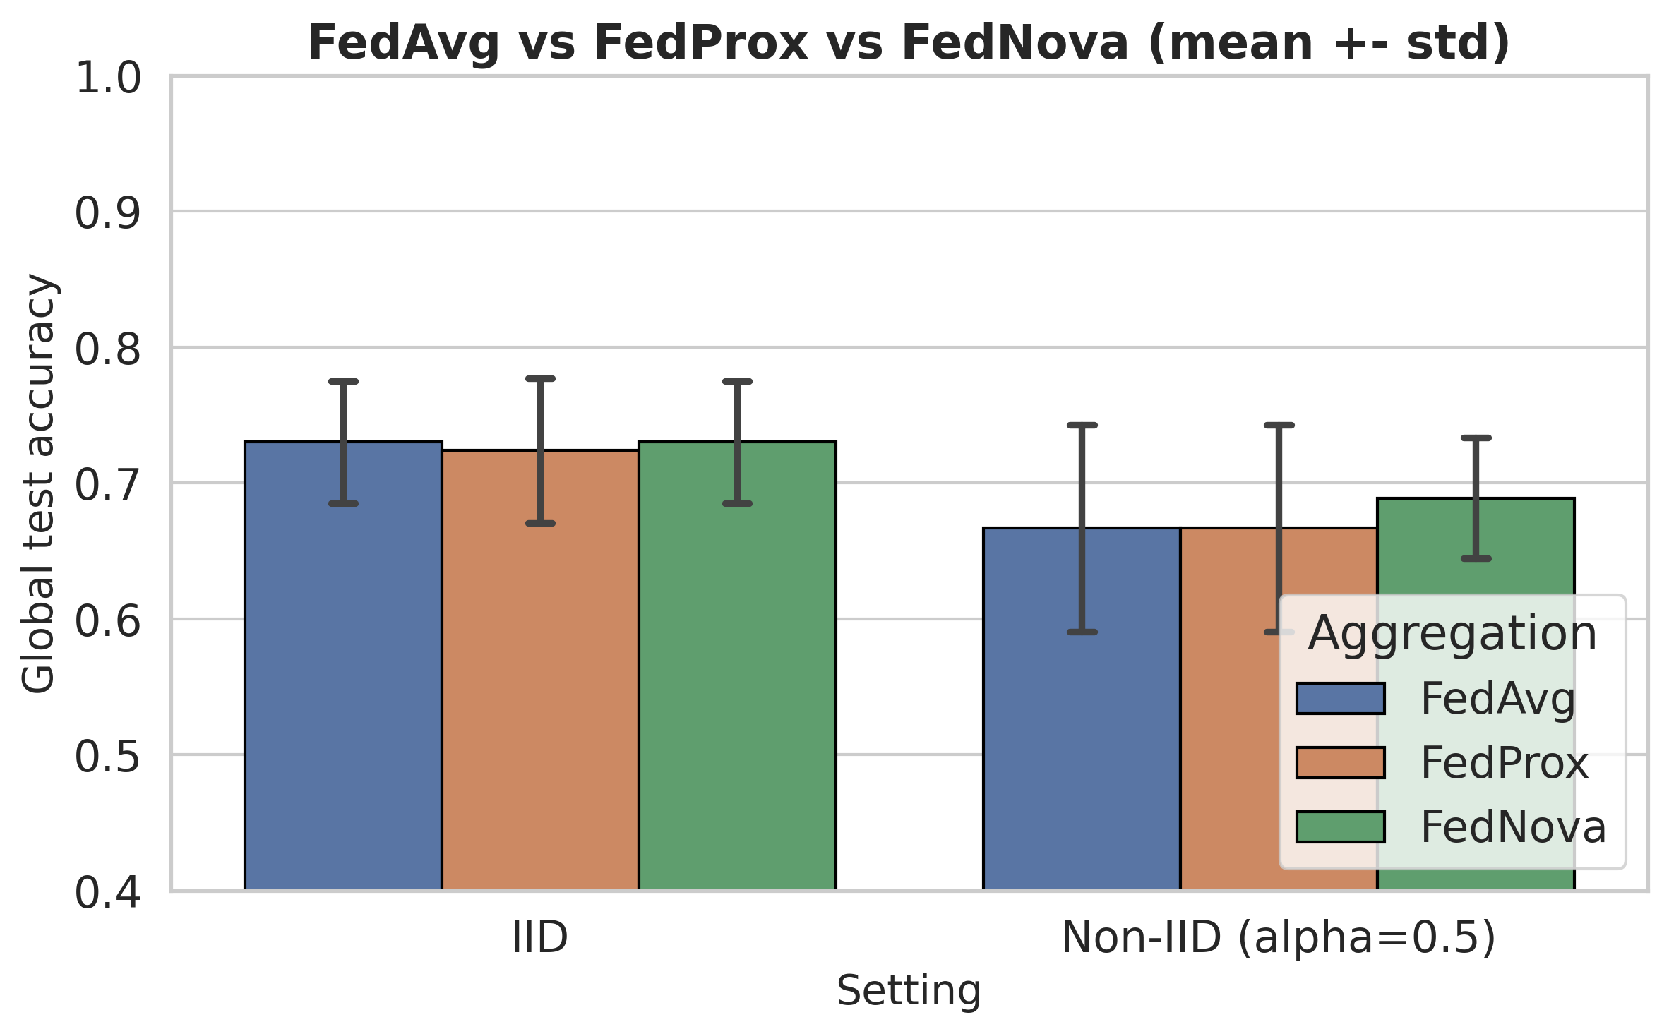
Fig. 10. Test accuracy of FedAvg, FedProx and FedNova (mean ± standard deviation over five seeds), with quantisation, secure upload and differential privacy active.

4.4 Convergence
Fig. 11 shows the progress of the global model for seed 42, and Table 4 gives the number of rounds needed to reach 99% of the best validation accuracy. Under IID data the three rules needed about 22 to 23 rounds on average. Under non-IID data FedAvg and FedProx reached that level after about 13 to 14 rounds and FedNova after 28 rounds. The curves are not smooth. In the non-IID runs of seed 42 the global test accuracy moved between roughly 0.5 and 0.8 from one round to the next, and the validation loss of FedNova rose during training while that of FedAvg and FedProx stayed lower. We expect that conflicting local updates and the privacy noise both contribute to this behaviour, but we did not test the two causes separately. Because of these fluctuations, choosing the final round by validation loss, and never by test results, is an important part of the protocol.
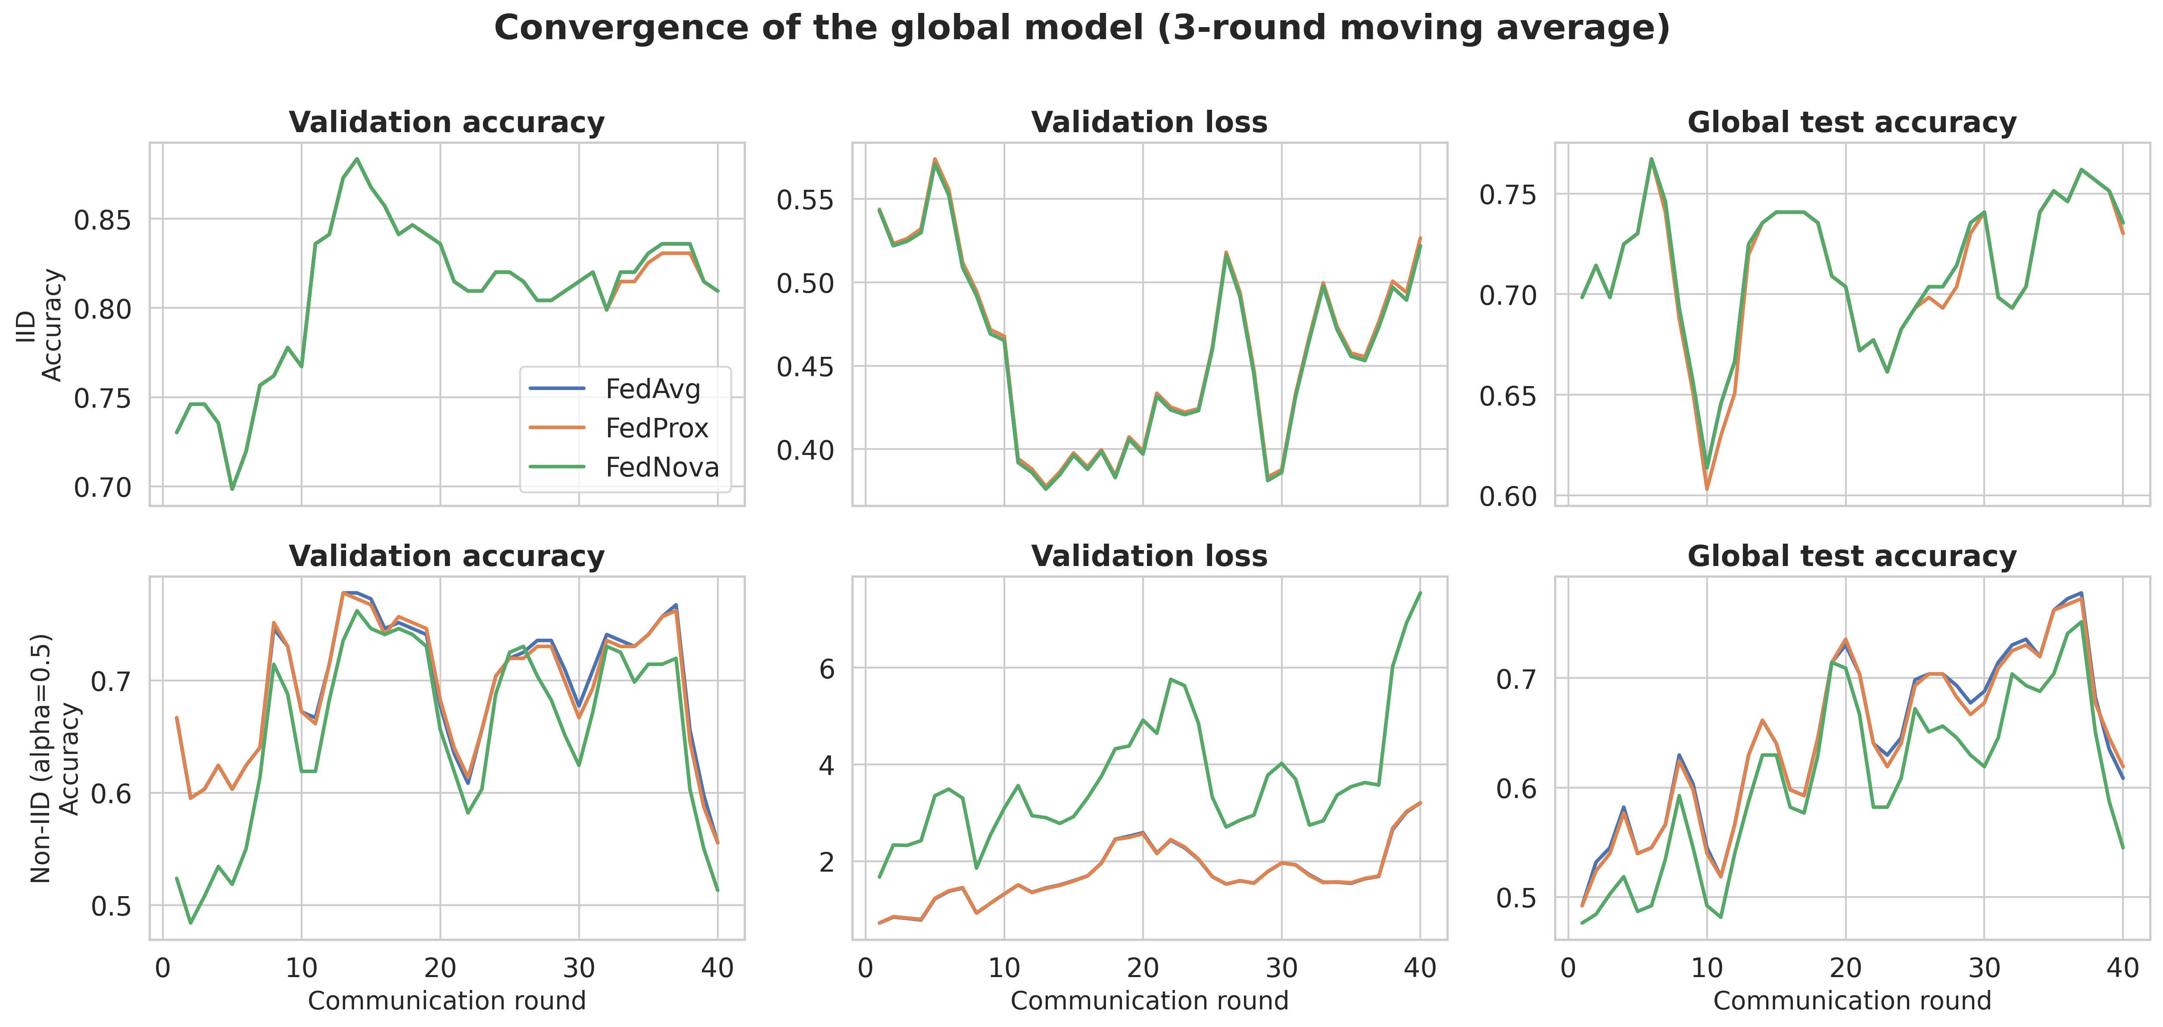
Fig. 11. Convergence of the global model for seed 42 under IID (top) and non-IID (bottom) data: validation accuracy, validation loss and global test accuracy in every communication round (3-round moving average).
Table 4. Convergence of the aggregation rules, mean over five seeds.
Setting | Method | Mean validation accuracy | Mean rounds to converge
IID | FedAvg | 0.790 | 22.6
IID | FedProx | 0.790 | 22.6
IID | FedNova | 0.790 | 22.6
Non-IID | FedAvg | 0.708 | 13.0
Non-IID | FedProx | 0.702 | 13.8
Non-IID | FedNova | 0.727 | 28.0

4.5 Effect of the protection layers
Table 5 and Fig. 12 show the effect of adding each layer to FedNova under non-IID data. Plain federated training reached an accuracy of 0.743 ± 0.044. Adding quantisation (0.756 ± 0.043) or secure upload (0.749 ± 0.052) did not change it beyond the spread between seeds, as expected for secure upload, whose masks cancel exactly in the sum. Differential privacy alone lowered the accuracy to 0.638 ± 0.080, and the combination of all three layers reached 0.689 ± 0.044. The two differential privacy variants differ by less than one standard deviation, so their ordering should not be interpreted.
Table 5. Ablation of the protection layers (FedNova, non-IID, mean ± standard deviation over five seeds).
Variant | Accuracy | F1-score | AUC
Plain FL (no protection) | 0.743 ± 0.044 | 0.743 ± 0.041 | 0.802 ± 0.020
+ Quantization | 0.756 ± 0.043 | 0.756 ± 0.040 | 0.803 ± 0.022
+ Secure upload | 0.749 ± 0.052 | 0.749 ± 0.049 | 0.796 ± 0.023
+ Differential privacy | 0.638 ± 0.080 | 0.633 ± 0.075 | 0.667 ± 0.088
All protections | 0.689 ± 0.044 | 0.685 ± 0.042 | 0.688 ± 0.054

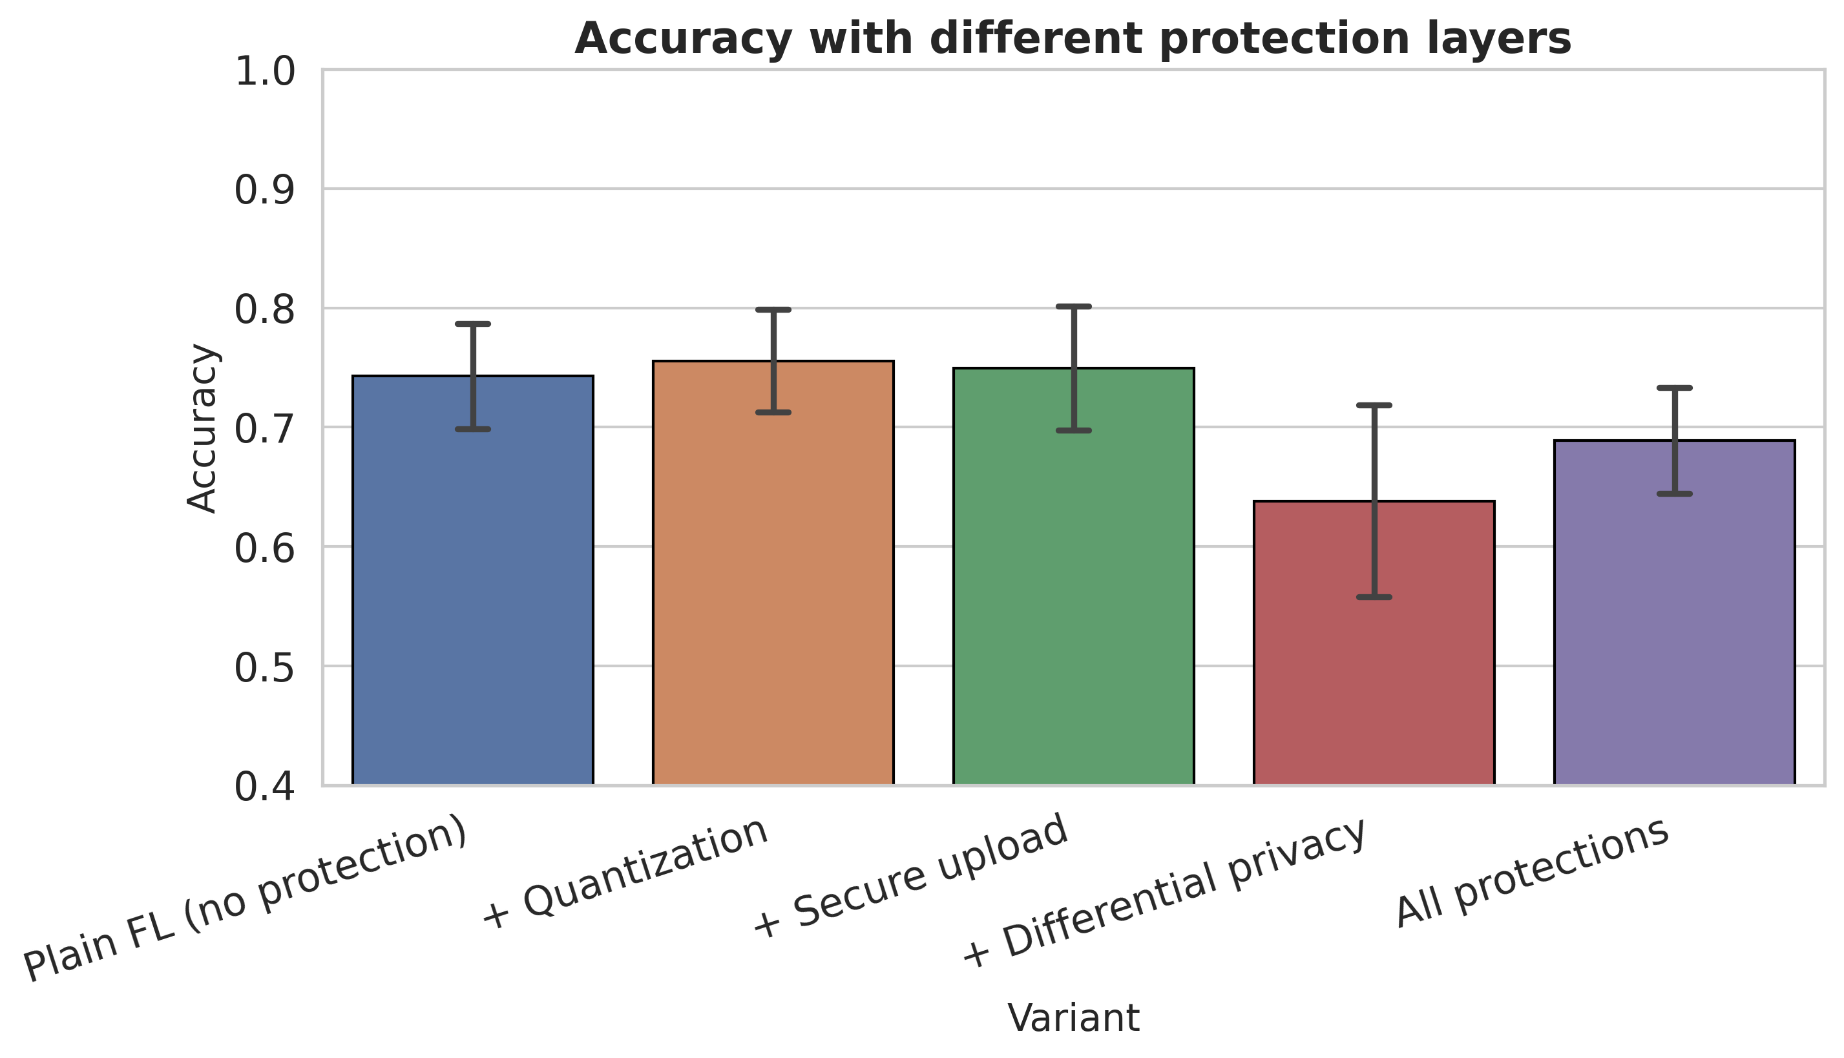
Fig. 12. Accuracy for the protection variants (FedNova, non-IID, mean ± standard deviation over five seeds).
The sweep over ε (Table 6 and Fig. 13) shows the price of stronger privacy. At ε of 20 the accuracy was 0.724 ± 0.072, and at ε of 50 it was 0.749 ± 0.034, equal to training without noise (0.749 ± 0.052). At ε of 10 it was 0.689 ± 0.044. At ε of 5 or below the accuracy fell to between 0.58 and 0.64, which is close to the 0.62 share of survivors in the data, and the AUC fell to between 0.64 and 0.67. The standard deviations at small ε are large (up to 0.12), and the ordering of ε = 1, 2 and 5 is not monotonic, which indicates that noise dominates the result at these levels. Since ε is a per-round noise parameter here and not an accounted total budget, these values show the noise scale and not a formal guarantee.
Table 6. Privacy-utility trade-off: test scores against ε per round (FedNova, non-IID, mean ± standard deviation over five seeds). The last row uses quantisation and secure upload without noise.
ε per round | Accuracy | F1-score | AUC
1 | 0.641 ± 0.123 | 0.632 ± 0.121 | 0.646 ± 0.119
2 | 0.578 ± 0.115 | 0.552 ± 0.142 | 0.636 ± 0.072
5 | 0.594 ± 0.107 | 0.565 ± 0.122 | 0.665 ± 0.065
10 | 0.689 ± 0.044 | 0.685 ± 0.042 | 0.688 ± 0.054
20 | 0.724 ± 0.072 | 0.720 ± 0.073 | 0.786 ± 0.019
50 | 0.749 ± 0.034 | 0.749 ± 0.030 | 0.805 ± 0.023
no noise | 0.749 ± 0.052 | 0.749 ± 0.049 | 0.796 ± 0.023

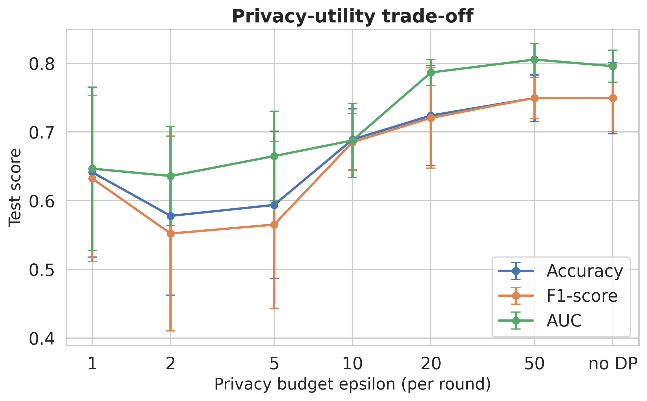
Fig. 13. Privacy-utility trade-off: test scores against ε per round (mean ± standard deviation over five seeds). The point at the right is training without noise.

4.6 Quantisation and communication cost
The network has 338 weights, so a full-precision upload is 1.32 KB per client and round. With 8-bit quantisation it is 0.33 KB, which reduces the upload of five clients over 40 rounds from about 0.26 MB to about 0.06 MB, a factor of four. Fig. 7 illustrates the quantiser and the secure masks on synthetic update vectors: the 8-bit values lie on the diagonal against the original values, and the masked vector that the server sees is spread over a range about two orders of magnitude wider than the original update.
The bit-width study (Table 7 and Fig. 14) was run without differential privacy and secure upload. Accuracy stayed between 0.733 and 0.756 for all bit widths from 2 to 16, and full-precision updates gave 0.743 ± 0.044. All differences are well within one standard deviation, so even 2-bit updates, which are 16 times smaller than full-precision updates (0.08 KB), caused no measurable loss in this setting. This result holds for a very small network trained on a small table, and larger models may behave differently.

Table 7. Effect of the quantisation bit width (FedNova, non-IID, no differential privacy, no secure upload; mean ± standard deviation over five seeds). A width of 32 bits means no quantisation.
Bits | Accuracy | F1-score | AUC | Upload (KB)
2 | 0.733 ± 0.043 | 0.734 ± 0.041 | 0.779 ± 0.032 | 0.08
4 | 0.752 ± 0.043 | 0.753 ± 0.040 | 0.801 ± 0.023 | 0.17
6 | 0.743 ± 0.044 | 0.743 ± 0.041 | 0.802 ± 0.020 | 0.25
8 | 0.756 ± 0.043 | 0.756 ± 0.040 | 0.803 ± 0.022 | 0.33
16 | 0.743 ± 0.044 | 0.743 ± 0.041 | 0.802 ± 0.020 | 0.66
32 | 0.743 ± 0.044 | 0.743 ± 0.041 | 0.802 ± 0.020 | 1.32

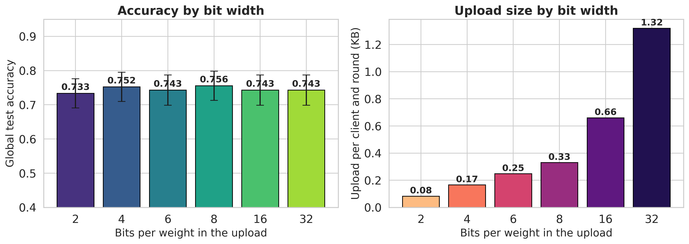
Fig. 14. Effect of the quantisation bit width. Left: test accuracy (mean ± standard deviation over five seeds). Right: upload size per client and round. A width of 32 bits means no quantisation.

4.7 Final global model
The final model was FedNova trained on the non-IID partition of seed 42, with the round chosen by validation loss (round 7). On the validation subset it reached an accuracy of 0.794 and an AUC of 0.856. On the test subset it reached an accuracy of 0.651, a weighted precision of 0.682, a weighted recall of 0.651, a weighted F1-score of 0.656 and an AUC of 0.707. This test accuracy is lower than the five-seed mean of 0.689, and the gap between validation and test results shows how unstable estimates from subsets of 63 patients are.
The confusion matrix (Fig. 15) shows 24 survivors and 17 deaths classified correctly, 15 survivors classified as deaths and 7 deaths classified as survivors. The model found 70.8% of the deaths (recall of the death class) and 61.5% of the survivors, and only 53.1% of the patients it flagged as deaths actually died (Table 8). The ROC curve (Fig. 16) stays above the diagonal but is far from the top-left corner.
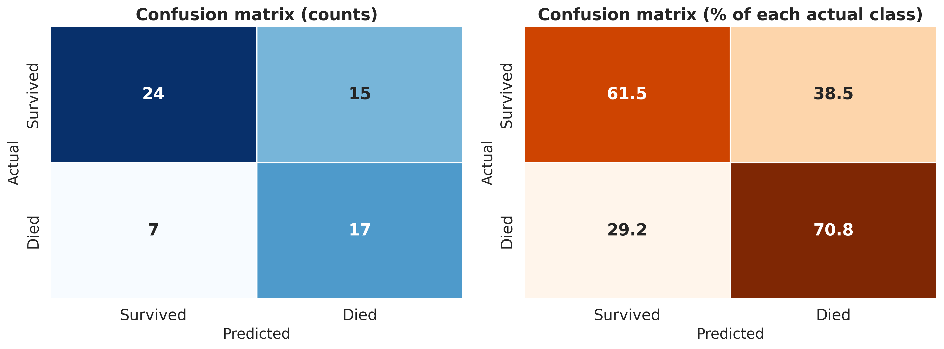
Fig. 15. Confusion matrix of the final global model on the test subset (seed 42): counts (left) and percentage of each actual class (right).
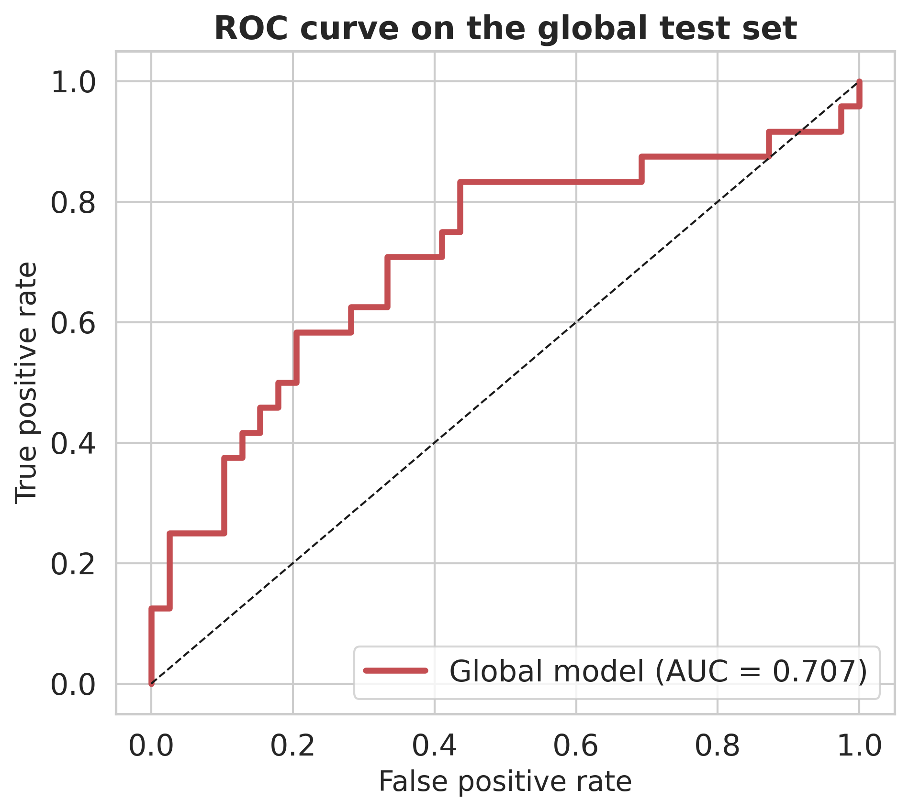
Fig. 16. ROC curve of the final global model on the test subset (AUC = 0.707).
Table 8. Per-class report of the final global model on the test subset (seed 42).
Class | Precision | Recall | F1-score | Support
Survived | 0.774 | 0.615 | 0.686 | 39
Died | 0.531 | 0.708 | 0.607 | 24
macro avg | 0.653 | 0.662 | 0.646 | 63
weighted avg | 0.682 | 0.651 | 0.656 | 63

4.8 Explanations of the final model
The SHAP summary plot (Fig. 17) and the bar chart of mean absolute SHAP values (Fig. 18) show that three features stand out: age (mean absolute SHAP value of 0.165), alkaline phosphatase (0.151) and the missing-treatment indicator (0.132). The next features, hepatomegaly, histologic stage, platelets, prothrombin time, copper, ascites and sex, all lie between 0.03 and 0.05. Older age, higher alkaline phosphatase and a missing treatment label (a patient outside the randomised trial) all push the predicted risk of death upward.
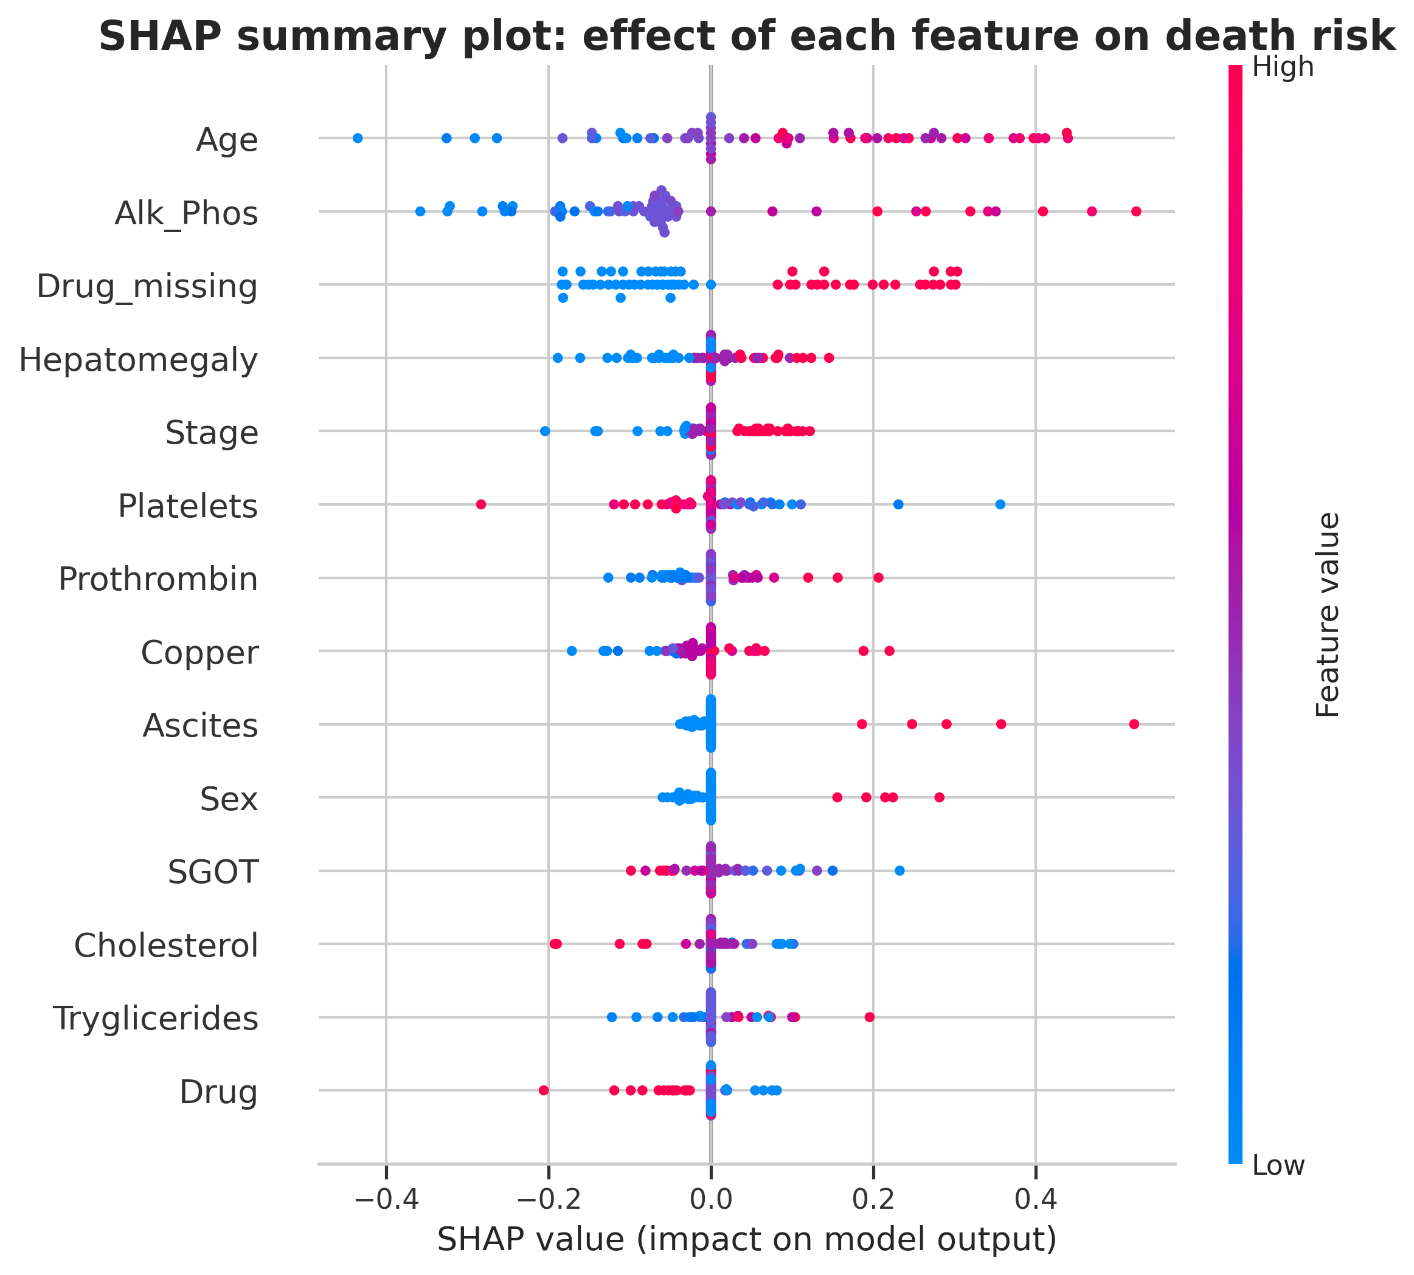
Fig. 17. SHAP summary plot of the final global model for the 63 test patients. Each point is one patient; colour shows the feature value and the horizontal position shows the effect on the predicted risk of death.
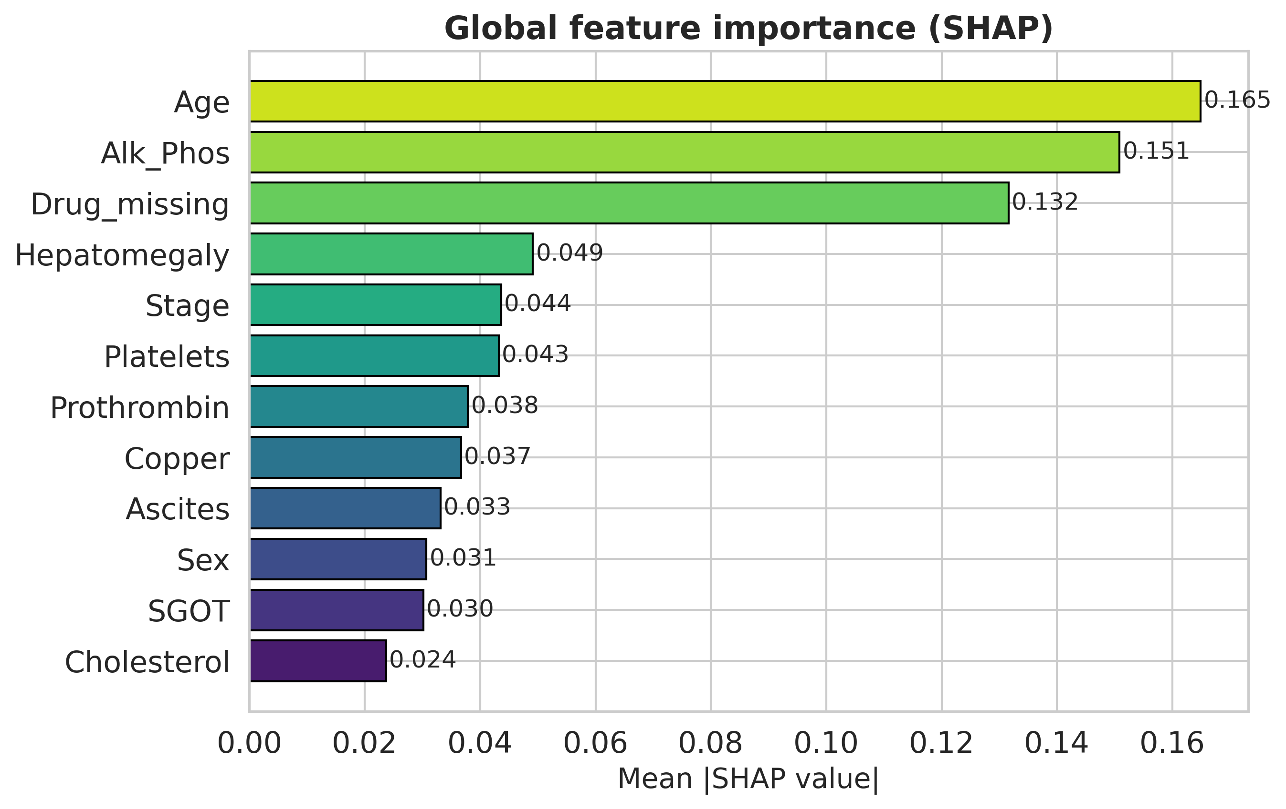
Fig. 18. Mean absolute SHAP value of the leading features.
Fig. 19 explains the test patient with the highest predicted risk. The baseline risk is 0.42, and the predicted risk reaches about 1.00. Alkaline phosphatase (+0.26) and age (+0.17) make the largest contributions, followed by SGOT (+0.09) and hepatomegaly (+0.08), while the missing-treatment indicator (−0.08) and the treatment variable (−0.05) lower the risk. LIME gives the same two leading contributions for this patient (Fig. 20) and adds that the absence of ascites pushes the prediction away from death.
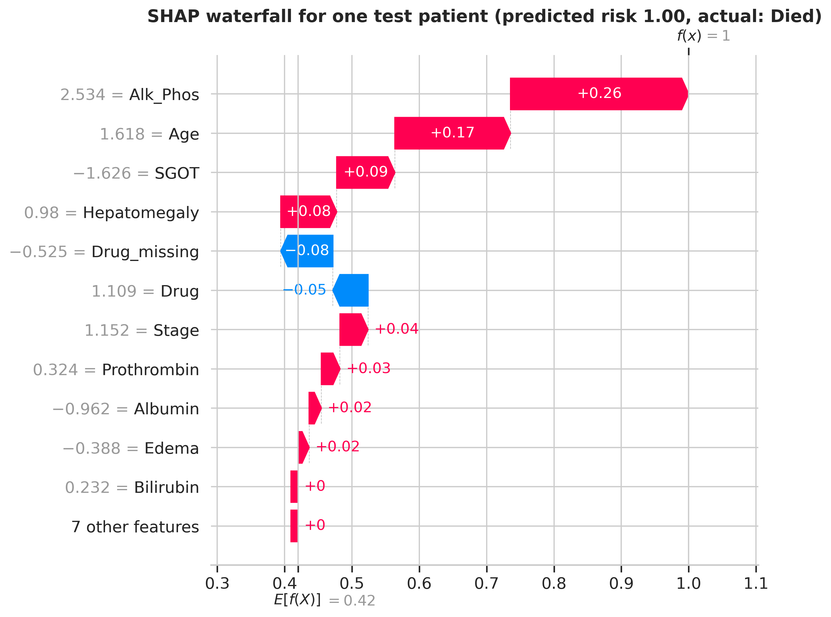
Fig. 19. SHAP waterfall plot for the test patient with the highest predicted risk of death. Feature values are standardised.
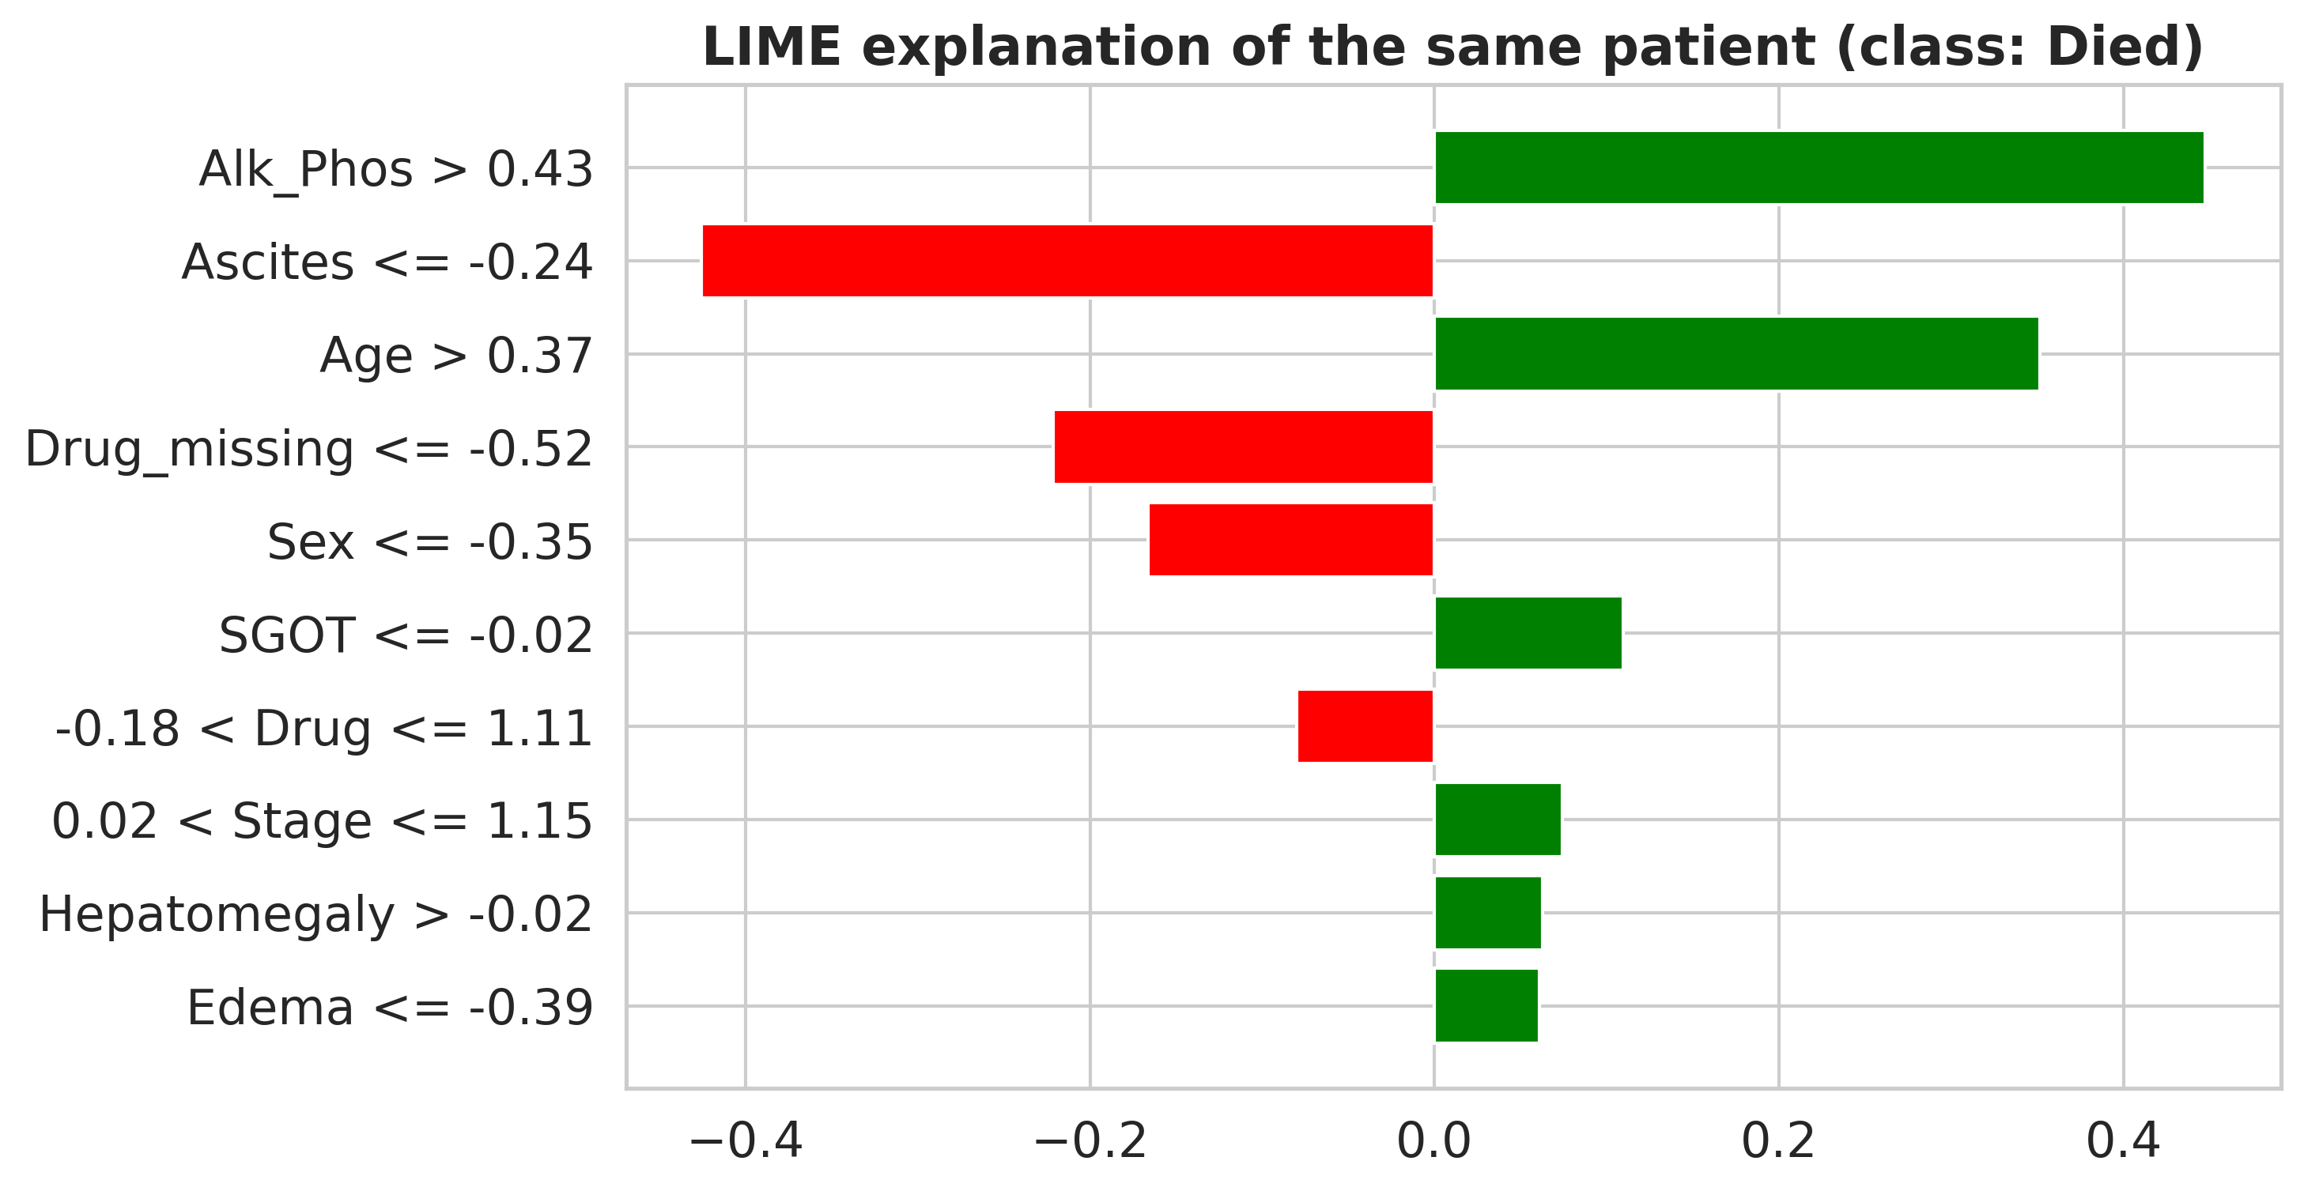
Fig. 20. LIME explanation of the same patient. Green bars push towards death and red bars push away from it.
Permutation importance (Fig. 21) ranks ascites first (accuracy drop of 0.048), then age (0.041) and alkaline phosphatase (0.029). Many of the error bars cross zero, so only the top few features are clearly separated from noise. Table 9 combines the three methods. Age has the best average rank (1.7), followed by alkaline phosphatase (2.7), and ascites and the missing-treatment indicator share the third place (3.7). Ascites ranks first in LIME and permutation importance but ninth in SHAP, which fits the fact that it is a rare finding: it matters a great deal for the few patients who have it, but contributes little on average over all patients. We did not verify this explanation with a separate analysis.
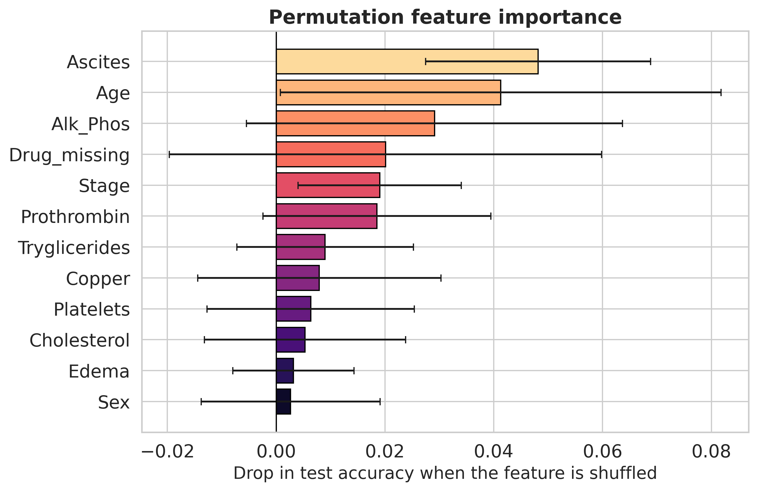
Fig. 21. Permutation importance on the test subset: mean drop in accuracy (± standard deviation over 30 shuffles) when a feature is shuffled.

Table 9. Top ten features under the three explanation methods and their average rank.
Feature | SHAP | LIME | Permutation | SHAP rank | LIME rank | Perm. rank | Average rank
Age | 0.165 | 0.259 | 0.041 | 1 | 2 | 2 | 1.7
Alk_Phos | 0.151 | 0.227 | 0.029 | 2 | 3 | 3 | 2.7
Ascites | 0.033 | 0.383 | 0.048 | 9 | 1 | 1 | 3.7
Drug_missing | 0.132 | 0.223 | 0.020 | 3 | 4 | 4 | 3.7
Stage | 0.044 | 0.104 | 0.019 | 5 | 6 | 5 | 5.3
Prothrombin | 0.038 | 0.077 | 0.019 | 7 | 9 | 6 | 7.3
Platelets | 0.043 | 0.068 | 0.006 | 6 | 10 | 9 | 8.3
Tryglicerides | 0.021 | 0.088 | 0.009 | 13 | 7 | 7 | 9.0
Sex | 0.031 | 0.139 | 0.003 | 10 | 5 | 12 | 9.0
Cholesterol | 0.024 | 0.085 | 0.005 | 12 | 8 | 10 | 10.0

5. Discussion
Accuracy and what limits it:- The best centralised model reached an accuracy of about 0.79, and the federated models stayed below it. The ceiling is probably set by the data and not by the training method: the table has 418 patients, a quarter of them without treatment and several laboratory values, and a test subset of 63 patients. Accuracies far above this level on the same table would call for a check of the evaluation design for leakage [20]. We chose to keep the evaluation strict and to report the lower numbers.
Cost of federation, heterogeneity and privacy:- With all protections active, the federated models lost about 5 accuracy points against the centralised models under IID data and about 9 to 12 points under non-IID data. The ablation on non-IID data separates the causes. Federated training without any protection reached 0.743, only 3 to 4 points below the centralised models, and adding quantisation and secure upload left it unchanged, whereas differential privacy at ε = 10 per round accounted for most of the drop to 0.689. Under non-IID data, FedNova was the most stable of the three rules, which agrees with its purpose of correcting for unequal local work [24], but five seeds are too few to call this a firm advantage. The convergence curves show that training under skewed data and noise is erratic, and that selecting the final round on a validation subset is needed.
Quantisation is cheap here:- Quantising the clipped updates to 8 bits, or even to 2 bits, left the accuracy unchanged within the seed-to-seed spread while shrinking the upload by a factor of 4 to 16. Part of the reason may be that the network is very small and that clipping bounds the range of each update, so a uniform quantiser covers it well. This result should be repeated with larger models before it is generalised, and we did not test quantisation together with stronger noise at every bit width.
Reading the explanations:- The three methods agree on age and alkaline phosphatase, and the model uses age in the direction one would expect, with older patients receiving higher risk. The original Mayo risk model uses age, bilirubin, albumin, prothrombin time and oedema [3]. In our model age and prothrombin time appear among the top ten features, but bilirubin, albumin and oedema do not. Together with the moderate accuracy, this suggests that the federated model has not fully recovered the known prognostic structure, and the explanations should be read as descriptions of this model and not as clinical findings [17]. The missing-treatment indicator deserves particular attention. It marks patients outside the randomised trial, so its strong effect reflects how the data were collected and not a property of the disease. A robustness check without this variable would be a sensible next step.
Practical meaning of the privacy parameter:- The noise multiplier follows the classical Gaussian mechanism formula, which was derived for ε at most 1, and we did not account for the composition over rounds. The values of ε in this paper therefore describe the amount of noise per round. They show how accuracy changes with the noise level, and they do not certify a particular privacy guarantee. A formal claim would need a privacy accountant and an analysis that also covers the shared preprocessing statistics.

6. Limitations and Future Work
The study has several limits. The data set is small, comes from one trial and has no external validation set, and the test subset holds only 63 patients, so confidence intervals are wide. The federation is simulated on one machine, and the heterogeneity was created by a Dirichlet split on the outcome, which is only one of the ways in which real hospitals differ. Secure upload was simulated with pairwise masks and without the key agreement and dropout handling of a real protocol. The privacy parameter is per round and not accounted, and the medians, sums and sums of squares shared during preprocessing are sent without noise. The outcome was reduced to a binary variable, which ignores the time of death and the censoring of patients, and survival models would use that information. The network is small, only a few hidden-layer sizes were tried, and the choice among them used validation accuracy averaged over the same five seeds as the final results. Because the validation subset of one seed can overlap the test subset of another, this choice may make the reported means slightly optimistic.
Future work should test the pipeline on data from several real sites, add a privacy accountant, and compare it with survival models that use follow-up time. It should also repeat the explanation analysis without the missing-treatment indicator, test partitions that skew features and not only labels, and examine whether stronger noise changes the quantisation results.

7. Conclusion
We built and evaluated a leakage-aware federated learning pipeline for predicting death or survival in primary biliary cirrhosis, with clipping, quantisation, secure upload and differential privacy, and with SHAP, LIME and permutation explanations of the final model. With all protections active, the federated model reached a mean test accuracy of 0.689 on non-IID data and 0.730 on IID data, below the 0.78 to 0.79 of centralised models. Differential privacy was the main source of accuracy loss, whereas quantisation to 8 bits, and even to 2 bits, and secure upload had no measurable effect and reduced communication by a factor of 4 to 16. The explanations agreed on age and alkaline phosphatase and revealed a dataset artefact among the strongest predictors. The results describe the cost of private federated training on a small clinical table, and external validation is required before any clinical use.

References
[1] Lindor KD, Bowlus CL, Boyer J, Levy C, Mayo M. Primary biliary cholangitis: 2018 practice guidance from the American Association for the Study of Liver Diseases. Hepatology 2019;69(1):394-419.
[2] European Association for the Study of the Liver. EASL Clinical Practice Guidelines: the diagnosis and management of patients with primary biliary cholangitis. Journal of Hepatology 2017;67(1):145-172.
[3] Dickson ER, Grambsch PM, Fleming TR, Fisher LD, Langworthy A. Prognosis in primary biliary cirrhosis: model for decision making. Hepatology 1989;10(1):1-7.
[4] McMahan B, Moore E, Ramage D, Hampson S, Arcas BA. Communication-efficient learning of deep networks from decentralized data. In: Proceedings of the International Conference on Artificial Intelligence and Statistics (PMLR 54); 2017. p. 1273-1282.
[5] Kairouz P, McMahan HB, Avent B, et al. Advances and open problems in federated learning. Foundations and Trends in Machine Learning 2021;14(1-2):1-210.
[6] Rieke N, Hancox J, Li W, et al. The future of digital health with federated learning. npj Digital Medicine 2020;3:119.
[7] Sheller MJ, Edwards B, Reina GA, et al. Federated learning in medicine: facilitating multi-institutional collaborations without sharing patient data. Scientific Reports 2020;10:12598.
[8] Kaissis GA, Makowski MR, Rueckert D, Braren RF. Secure, privacy-preserving and federated machine learning in medical imaging. Nature Machine Intelligence 2020;2:305-311.
[9] Geyer RC, Klein T, Nabi M. Differentially private federated learning: a client level perspective. arXiv:1712.07557; 2017.
[10] Bonawitz K, Ivanov V, Kreuter B, et al. Practical secure aggregation for privacy-preserving machine learning. In: Proceedings of the ACM SIGSAC Conference on Computer and Communications Security; 2017. p. 1175-1191.
[11] Dwork C, Roth A. The algorithmic foundations of differential privacy. Foundations and Trends in Theoretical Computer Science 2014;9(3-4):211-407.
[12] Konecny J, McMahan HB, Yu FX, Richtarik P, Suresh AT, Bacon D. Federated learning: strategies for improving communication efficiency. arXiv:1610.05492; 2016.
[13] Reisizadeh A, Mokhtari A, Hassani H, Jadbabaie A, Pedarsani R. FedPAQ: a communication-efficient federated learning method with periodic averaging and quantization. In: Proceedings of the International Conference on Artificial Intelligence and Statistics (PMLR 108); 2020. p. 2021-2031.
[14] Zhao Y, Li M, Lai L, Suda N, Civin D, Chandra V. Federated learning with non-IID data. arXiv:1806.00582; 2018.
[15] Li T, Sahu AK, Zaheer M, Sanjabi M, Talwalkar A, Smith V. Federated optimization in heterogeneous networks. In: Proceedings of Machine Learning and Systems; 2020;2:429-450.
[16] Hsu TMH, Qi H, Brown M. Measuring the effects of non-identical data distribution for federated visual classification. arXiv:1909.06335; 2019.
[17] Rudin C. Stop explaining black box machine learning models for high stakes decisions and use interpretable models instead. Nature Machine Intelligence 2019;1:206-215.
[18] Lundberg SM, Lee SI. A unified approach to interpreting model predictions. In: Advances in Neural Information Processing Systems; 2017;30.
[19] Ribeiro MT, Singh S, Guestrin C. "Why should I trust you?": explaining the predictions of any classifier. In: Proceedings of the ACM SIGKDD International Conference on Knowledge Discovery and Data Mining; 2016. p. 1135-1144.
[20] Kapoor S, Narayanan A. Leakage and the reproducibility crisis in machine-learning-based science. Patterns 2023;4(9):100804.
[21] Varoquaux G, Cheplygina V. Machine learning for medical imaging: methodological failures and recommendations for the future. npj Digital Medicine 2022;5:48.
[22] Li T, Sahu AK, Talwalkar A, Smith V. Federated learning: challenges, methods, and future directions. IEEE Signal Processing Magazine 2020;37(3):50-60.
[23] Yang Q, Liu Y, Chen T, Tong Y. Federated machine learning: concept and applications. ACM Transactions on Intelligent Systems and Technology 2019;10(2):12.
[24] Wang J, Liu Q, Liang H, Joshi G, Poor HV. Tackling the objective inconsistency problem in heterogeneous federated optimization. In: Advances in Neural Information Processing Systems; 2020;33:7611-7623.
[25] Abadi M, Chu A, Goodfellow I, McMahan HB, Mironov I, Talwar K, Zhang L. Deep learning with differential privacy. In: Proceedings of the ACM SIGSAC Conference on Computer and Communications Security; 2016. p. 308-318.
[26] McMahan HB, Ramage D, Talwar K, Zhang L. Learning differentially private recurrent language models. In: International Conference on Learning Representations; 2018.
[27] Alistarh D, Grubic D, Li J, Tomioka R, Vojnovic M. QSGD: communication-efficient SGD via gradient quantization and encoding. In: Advances in Neural Information Processing Systems; 2017;30.
[28] Breiman L. Random forests. Machine Learning 2001;45(1):5-32.
[29] He H, Garcia EA. Learning from imbalanced data. IEEE Transactions on Knowledge and Data Engineering 2009;21(9):1263-1284.
[30] Fleming TR, Harrington DP. Counting Processes and Survival Analysis. New York: Wiley; 1991.
[31] He K, Zhang X, Ren S, Sun J. Delving deep into rectifiers: surpassing human-level performance on ImageNet classification. In: Proceedings of the IEEE International Conference on Computer Vision; 2015. p. 1026-1034.
[32] Harris CR, Millman KJ, van der Walt SJ, et al. Array programming with NumPy. Nature 2020;585:357-362.
[33] Pedregosa F, Varoquaux G, Gramfort A, et al. Scikit-learn: machine learning in Python. Journal of Machine Learning Research 2011;12:2825-2830.
[34] https://www.kaggle.com/datasets/fedesoriano/cirrhosis-prediction-dataset

