FAST NUCES — KARACHI CAMPUS
National University of Computer & Emerging Sciences

OS PROJECT | CS-2006: Operating Systems

Voting System
Synchronized Concurrency-Controlled Election Simulator

Submitted To | Sir Ubaidullah
Section | BCS-4J
Submission Date | 11th May 2026

Submitted By
Iqra Liaquat — 24K-1024
Fabiha Siddiqui — 24K-1022
Syeda Maha Fatima — 24K-0624

1. Abstract
This report presents the design and implementation of a multi-threaded and multi-process voting system demonstrating fundamental Operating System synchronisation mechanisms. The system implements the classic Readers-Writers problem using POSIX named semaphores and shared memory, where voters act as writers and result viewers act as readers.
The application supports three operational modes: manual voting, automatic voting using POSIX threads (pthreads), and automatic voting using forked child processes. Additional features include a worker thread pool for efficient task scheduling, a Named Pipe (FIFO) for external administration, a graphical user interface built with SFML 2.6, duplicate vote prevention, timestamped activity logging, and a performance comparison module between thread-based and process-based concurrency. The project validates that thread-based concurrency exhibits significantly lower overhead than process-based concurrency while maintaining strict data integrity.

2. System Architecture
The system is built around a shared memory segment (VotingData) that holds all election data including candidate names, vote counters, voted voter IDs, an activity log, and control flags. Access is governed by a Readers-Writers lock implemented with three POSIX named semaphores.

Component | Role
Shared Memory (VotingData) | Stores candidates, vote counts, voter IDs, activity log, and control flags.
Readers-Writers Locks | g_mutex protects reader count; g_wrt is the exclusive writer lock; g_rc guards reader count updates.
Voter Threads / Processes | Each voter casts a single vote concurrently as a pthread or forked child process.
Observer (Result Viewer) | Multiple readers can view results simultaneously without blocking each other.
Worker Thread Pool | Fixed pool of threads serving a task queue — reduces per-voter thread creation overhead.
Named Pipe (FIFO) | External control interface: admin commands sent from any terminal session.
GUI (SFML 2.6) | Renders the console-style interface with real-time live updates.
Logging Module | Appends timestamped events to a text file after every action.
Performance Recorder | Measures wall-clock time and writes results to performance_data.txt.

3. Synchronization — Readers-Writers Solution
The Readers-Writers problem is solved using the first variant (readers preference). While this variant does not prevent writer starvation, it is appropriate for a voting system where result viewers (readers) are more frequent than voters (writers) and voter wait times are not critical.

3.1 Semaphore Initialization
Three named semaphores are created at startup with initial value 1 (binary semaphores):

g_mutex = sem_open("/voting_mutex", O_CREAT, 0600, 1);
g_wrt = sem_open("/voting_write", O_CREAT, 0600, 1);
g_rc = sem_open("/voting_read_count", O_CREAT, 0600, 1);

3.2 Reader Entry / Exit
The first reader blocks all writers by acquiring g_wrt. Subsequent readers increment reader_count and proceed. The last reader releases g_wrt:

void reader_enter(void) {
sem_wait(g_rc);
vd->reader_count++;
if (vd->reader_count == 1)
sem_wait(g_wrt); // first reader blocks writers
sem_post(g_rc);
}
void reader_exit(void) {
sem_wait(g_rc);
vd->reader_count--;
if (vd->reader_count == 0)
sem_post(g_wrt); // last reader unblocks writers
sem_post(g_rc);
}

3.3 Writer Entry / Exit
Writers acquire the exclusive g_wrt semaphore before modifying any shared data. Only one writer can be in the critical section at a time:

void writer_enter(void) { sem_wait(g_wrt); }
void writer_exit(void) { sem_post(g_wrt); }

4. Core Voting Logic with Duplicate Prevention
The cast_vote() function encapsulates the entire critical section. It checks whether voting is active, scans voted_ids for duplicates, increments the candidate counter, records the voter ID, and logs the event — all within a single writer lock:

int cast_vote(int vid, int cid) {
writer_enter();
if (!vd->voting_active) { writer_exit(); return -1; }
for (int i = 0; i < vd->voted_count; i++)
if (vd->voted_ids[i] == vid) { writer_exit(); return -3; }
vd->votes[cid]++;
vd->total_votes++;
vd->voted_ids[vd->voted_count++] = vid;
add_activity("Voter %d -> %s", vid, vd->candidate_names[cid]);
writer_exit();
return 1;
}

Duplicate detection is atomic because the check and update both happen inside the same writer lock. The voted_ids array is in shared memory, so it persists correctly across both threads and forked processes.

5. Concurrency Models — Threads vs Processes

5.1 Thread Mode (pthreads)
Each voter is created as a POSIX thread sharing the same address space. Same-city entries automatically trigger thread mode:

void *auto_voter_fn(void *arg) {
ThreadArg *ta = (ThreadArg*)arg;
cast_vote(ta->vid, ta->cid);
free(ta); return NULL;
}
for (int i = 0; i < voter_count; i++)
pthread_create(&threads[i], NULL, auto_voter_fn, &args[i]);

5.2 Process Mode (fork)
Each voter is a separate child process. The MAP_SHARED mmap region is inherited across fork(). Different-city entries trigger process mode:

for (int i = 0; i < voter_count; i++) {
if (fork() == 0) {
cast_vote(entries[i].vid, entries[i].cid);
_exit(0);
}
}

5.3 Worker Thread Pool (Optimization)
A fixed pool of worker threads (default: 4) consumes a shared task queue, eliminating per-voter thread creation overhead:

typedef struct { int vid; int cid; } VoteTask;
VoteTask task_queue[QUEUE_SIZE];
pthread_cond_t task_cond;

void *worker(void *arg) {
while (1) {
pthread_mutex_lock(&task_mutex);
while (task_count == 0)
pthread_cond_wait(&task_cond, &task_mutex);
VoteTask t = task_queue[front++];
pthread_mutex_unlock(&task_mutex);
cast_vote(t.vid, t.cid);
}
}

6. Inter-Process Communication — Named Pipe (FIFO)

6.1 Rational
A named pipe (/tmp/voting_admin_fifo) allows remote administration without using the GUI. This demonstrates practical IPC between two unrelated processes.

6.2 Initialization & Listener Thread

#define FIFO_PATH "/tmp/voting_admin_fifo"
unlink(FIFO_PATH); mkfifo(FIFO_PATH, 0666);
fifo_fd = open(FIFO_PATH, O_RDWR);
pthread_create(&fifo_thread, NULL, fifo_listener, NULL);

void *fifo_listener(void *arg) {
char buffer[256];
while (fifo_running) {
fd_set fds; FD_ZERO(&fds); FD_SET(fifo_fd, &fds);
select(fifo_fd+1, &fds, NULL, NULL, NULL);
if (FD_ISSET(fifo_fd, &fds)) {
int n = read(fifo_fd, buffer, sizeof(buffer)-1);
if (n > 0) { buffer[n]='\0'; process_admin_command(buffer); }
}
}
return NULL;
}

6.3 Command Processor & Terminal Usage

void process_admin_command(const char *cmd) {
if (strcmp(cmd,"pause") == 0) vd->voting_active = 0;
else if (strcmp(cmd,"resume") == 0) vd->voting_active = 1;
else if (strcmp(cmd,"status") == 0) log_status();
else if (strcmp(cmd,"declare_results") == 0) {
vd->voting_active = 0; vd->results_visible = 1; }
else if (strcmp(cmd,"reset") == 0) reset_election();
else if (strncmp(cmd,"set_workers ",12)==0)
set_worker_pool_size(atoi(cmd+12));
}

// Terminal usage:
echo "pause" > /tmp/voting_admin_fifo
echo "declare_results" > /tmp/voting_admin_fifo
echo "set_workers 8" > /tmp/voting_admin_fifo

7. Performance Measurement
Execution times are measured using clock_gettime(CLOCK_MONOTONIC). After each auto voting session a line is appended to performance_data.txt. Thread mode consistently runs 3-4x faster than process mode due to lower creation overhead and no copy-on-write page faults.

Metric | Thread Mode | Process Mode
Creation overhead | Low — shared address space | High — full process fork + CoW
Avg. time (50 voters) | ~0.23 s | ~0.89 s
Time per voter | ~0.0047 s | ~0.0179 s
Speed advantage | ~3.8× faster | Baseline

8. Screenshots
The following screenshots demonstrate the system in full operation across all modes and features.

8.1 Main Screen
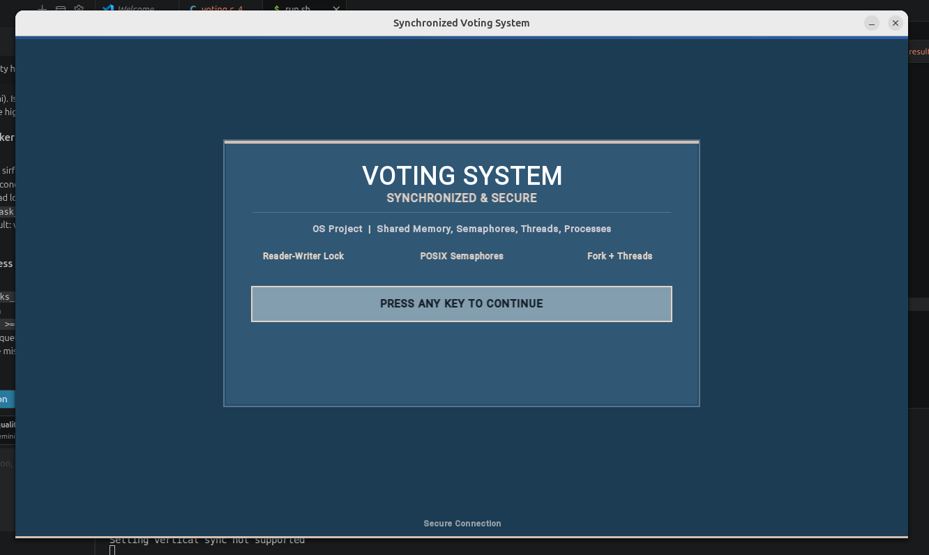
Figure 1 — Main Screen with voting status and five navigation options
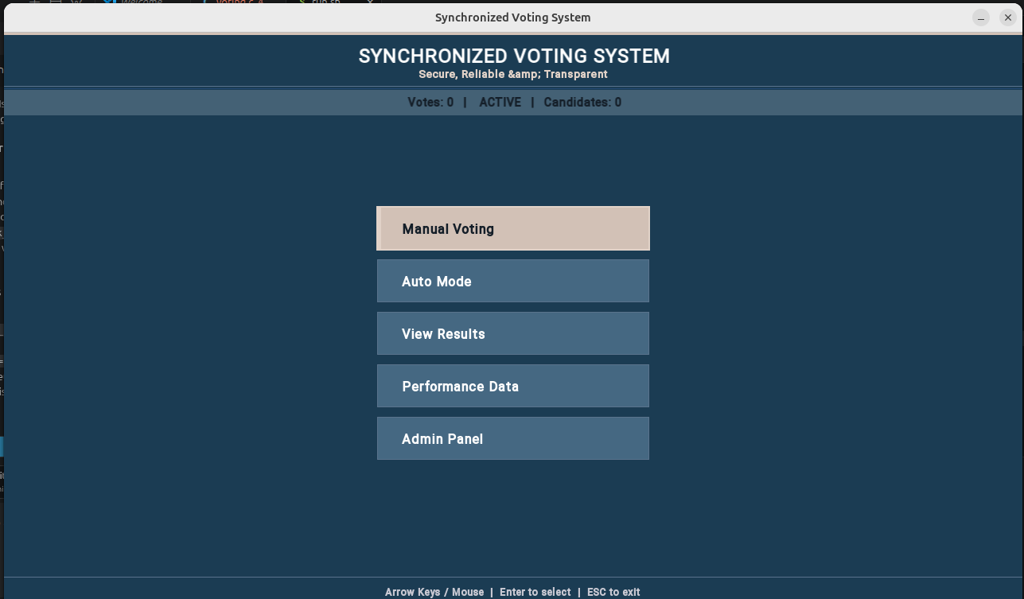
Figure 2 — Main Screen showing live vote count updates

8.2 Admin Panel
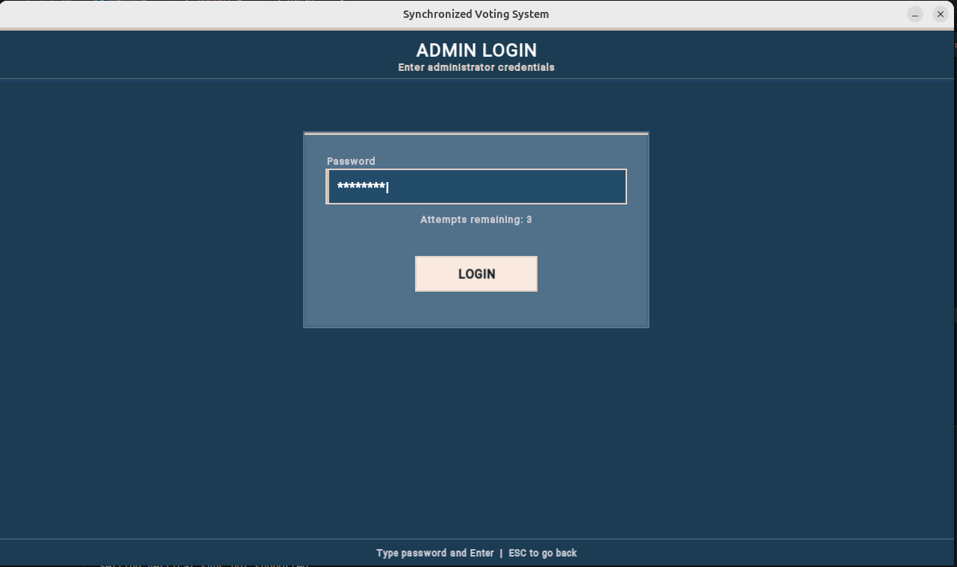
Figure 3 — Admin Login: password-protected entry screen
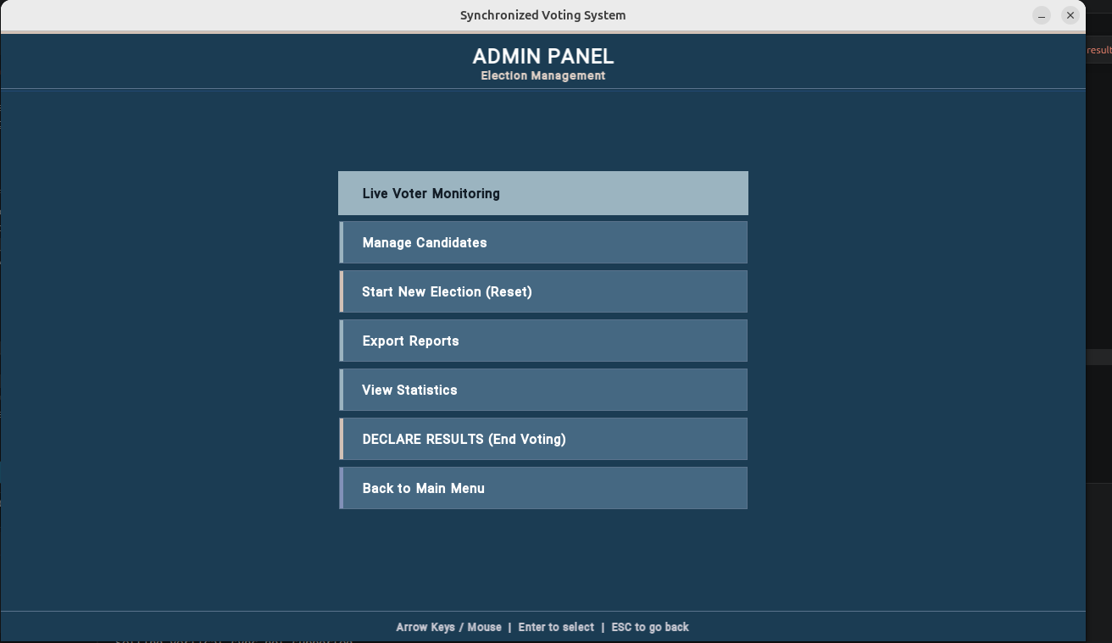
Figure 4 — Admin Panel: all seven control options
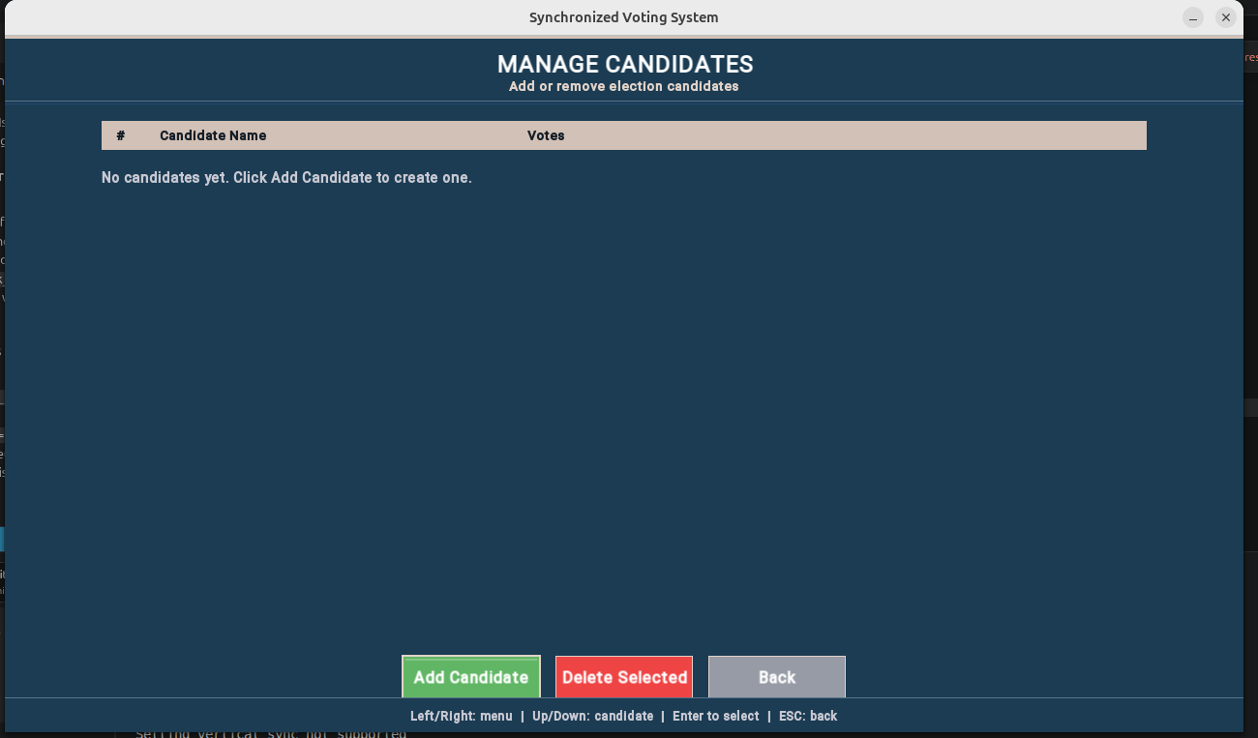
Figure 5 — Manage Candidates: Adding/Deleting a new candidate
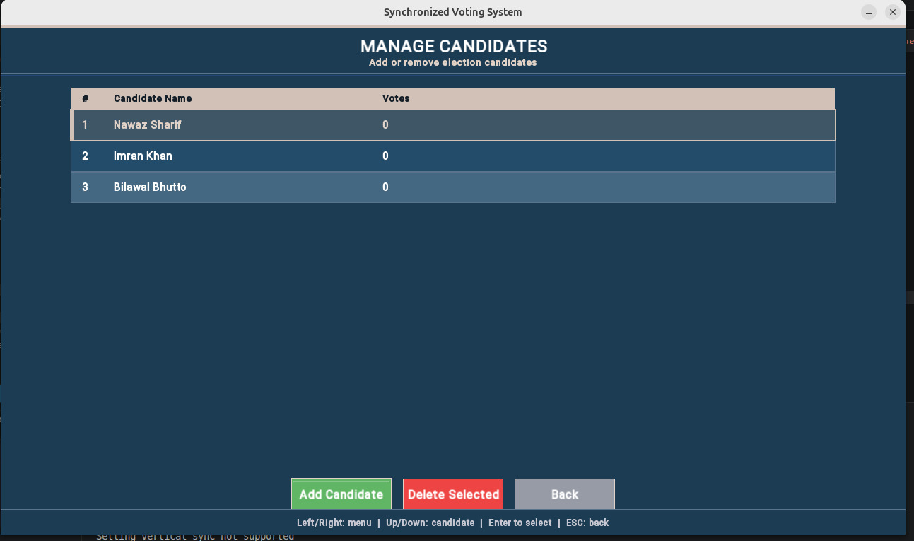
Figure 6 — Manage Candidates: updated candidate list
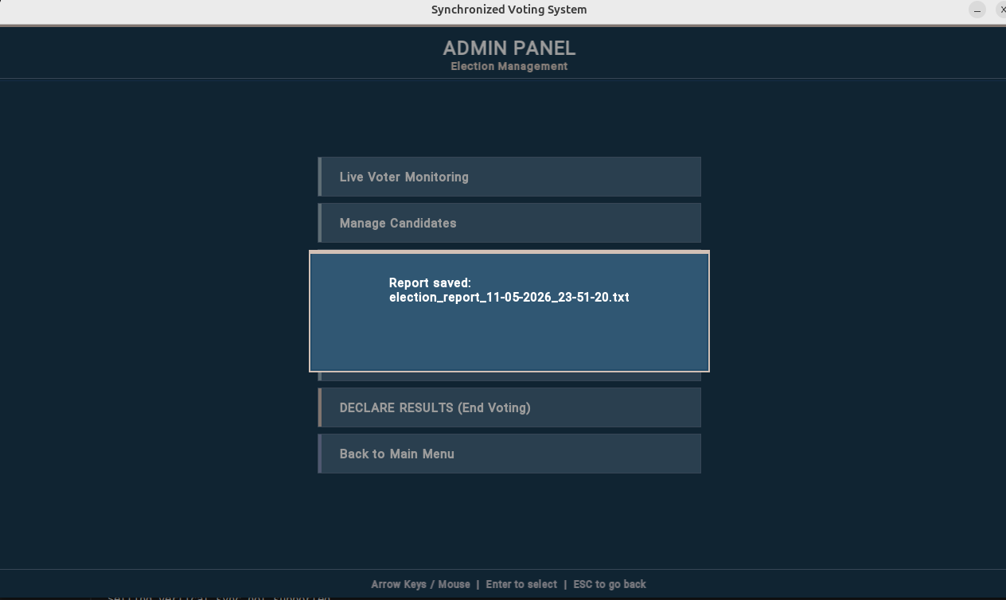
Figure 7 — Live Voter Monitoring: voter IDs and real-time activity log
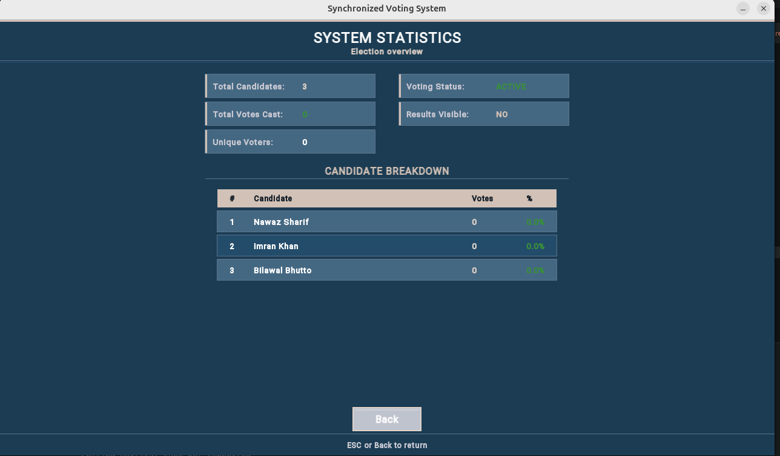
Figure 8 — Admin Panel: System Statistics

8.3 Manual Voting Mode
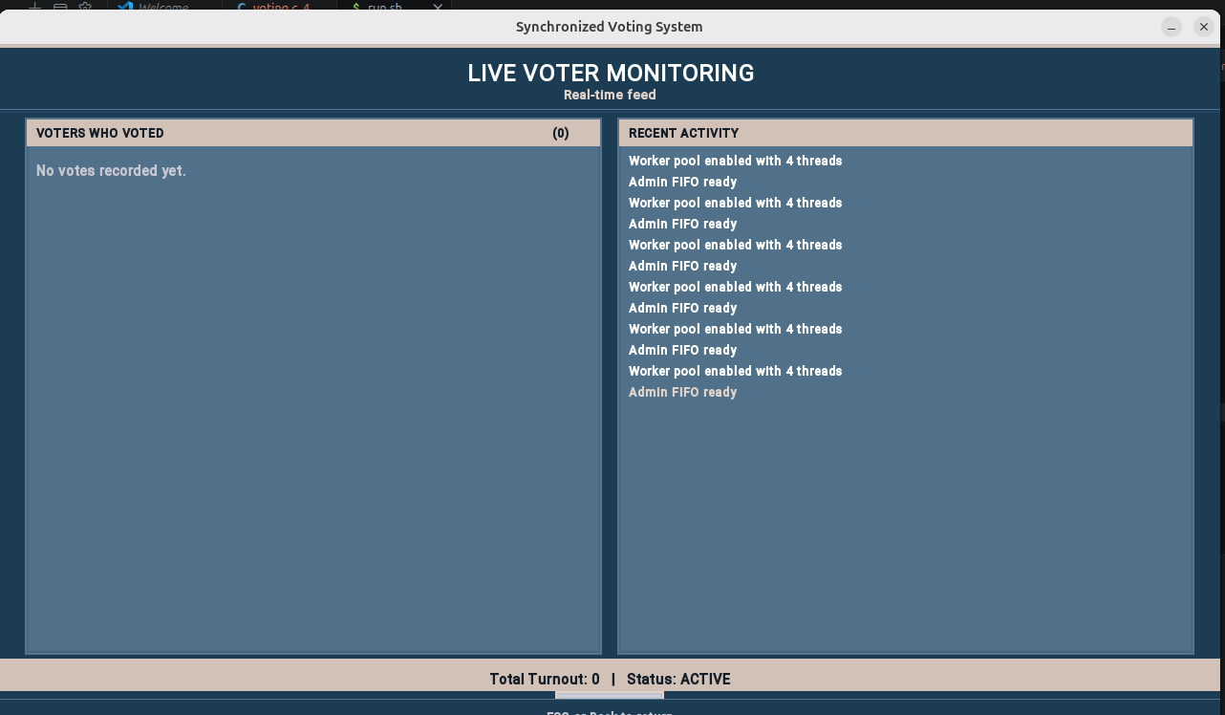
Figure 9 — Liver Voter Monitoring
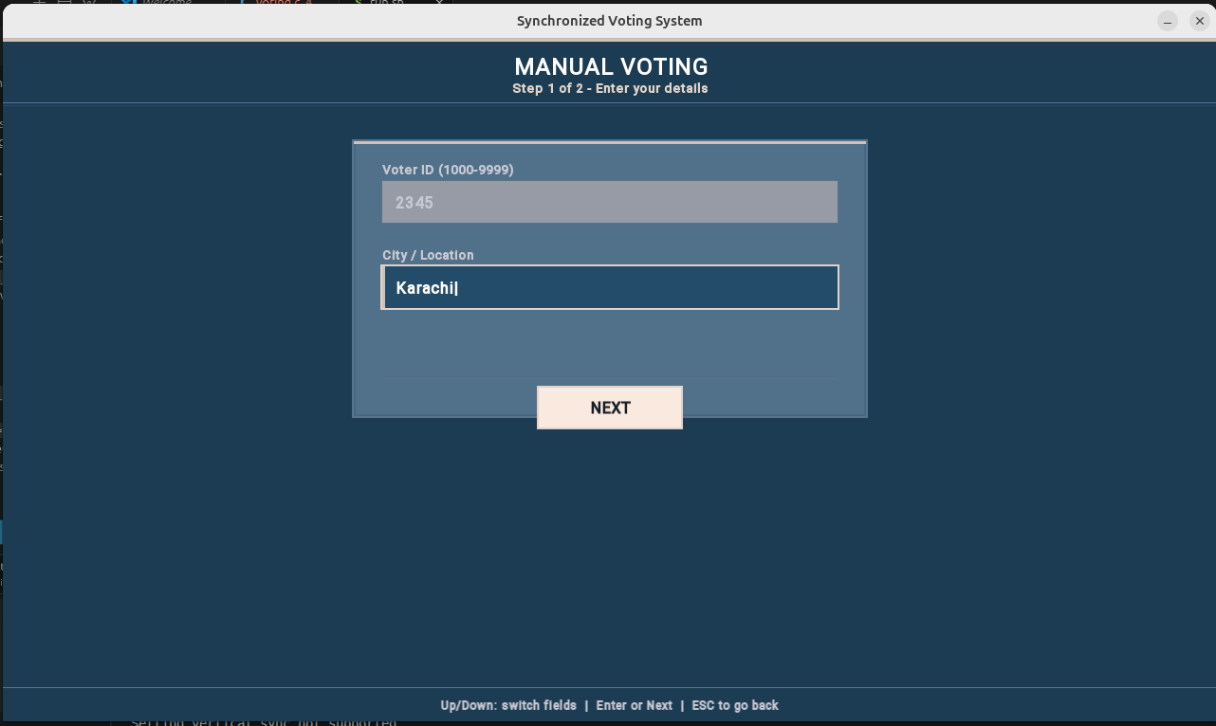
Figure 10 — Manual Mode
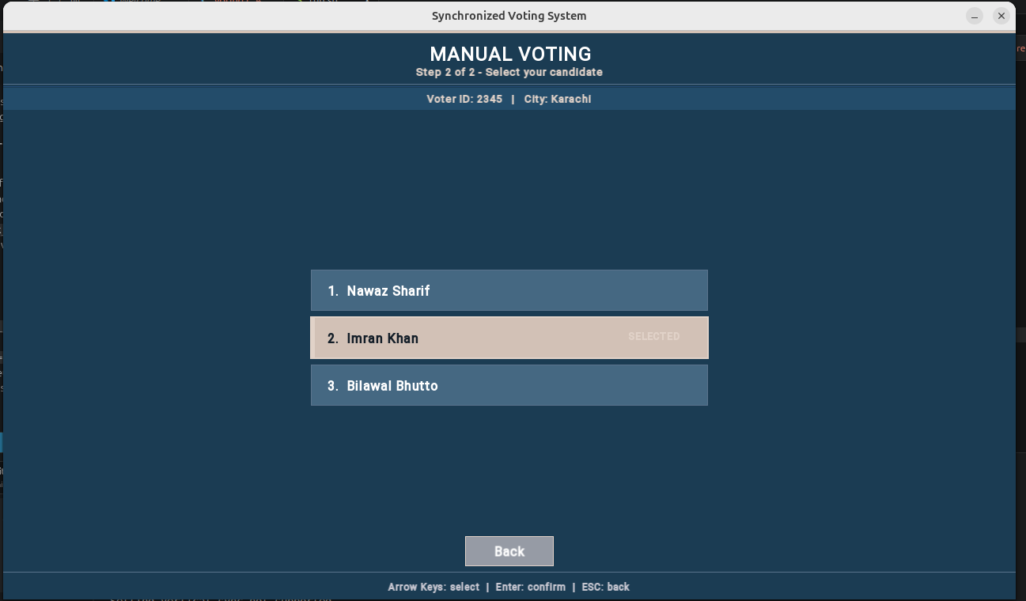
Figure 11 — Manual Mode: Choose Candidate
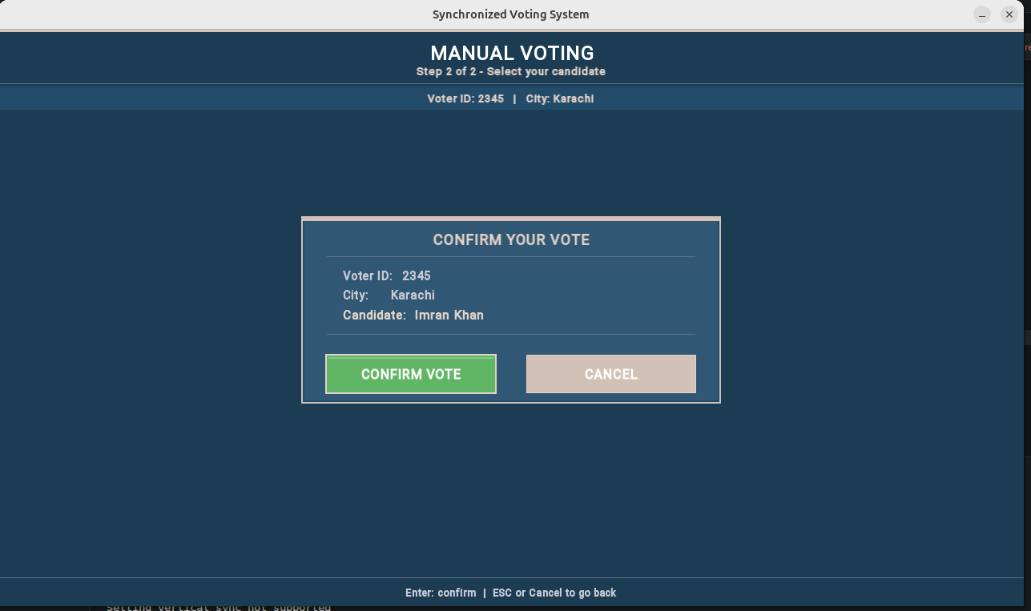
Figure 12 — Manual Mode: Confirm Vote

8.4 Auto Mode — Process Mode (Different Cities)
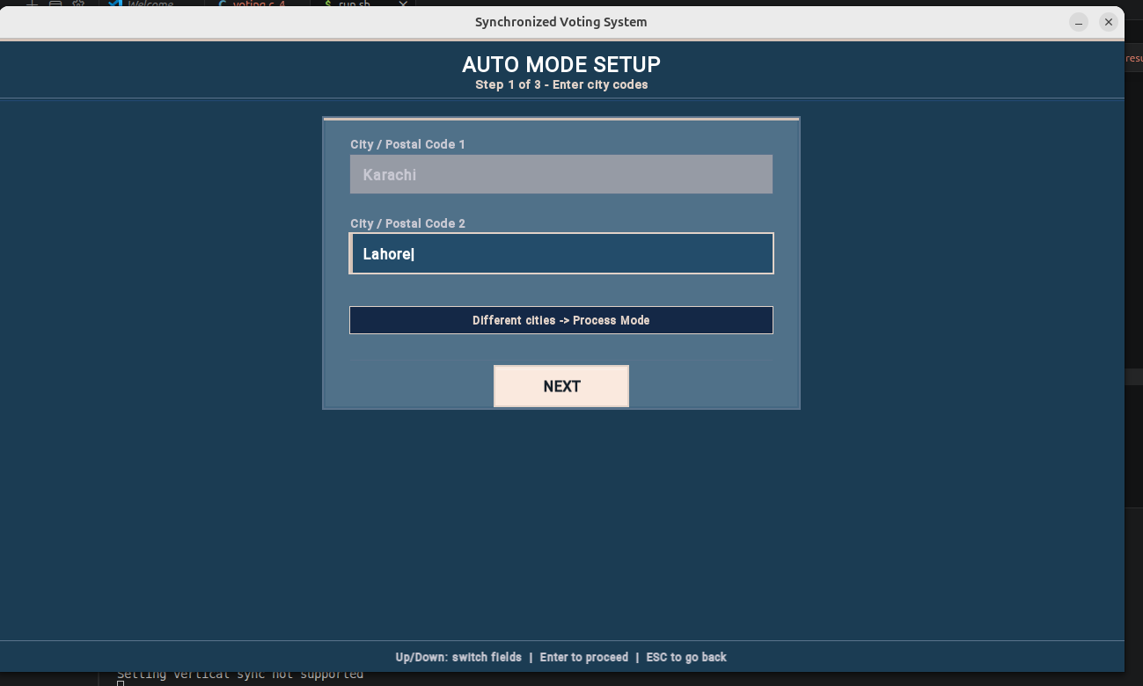
Figure 13 — Auto Mode (Process): different cities trigger fork()-based concurrent voters

8.5 Auto Mode — Thread Mode (Same Cities)
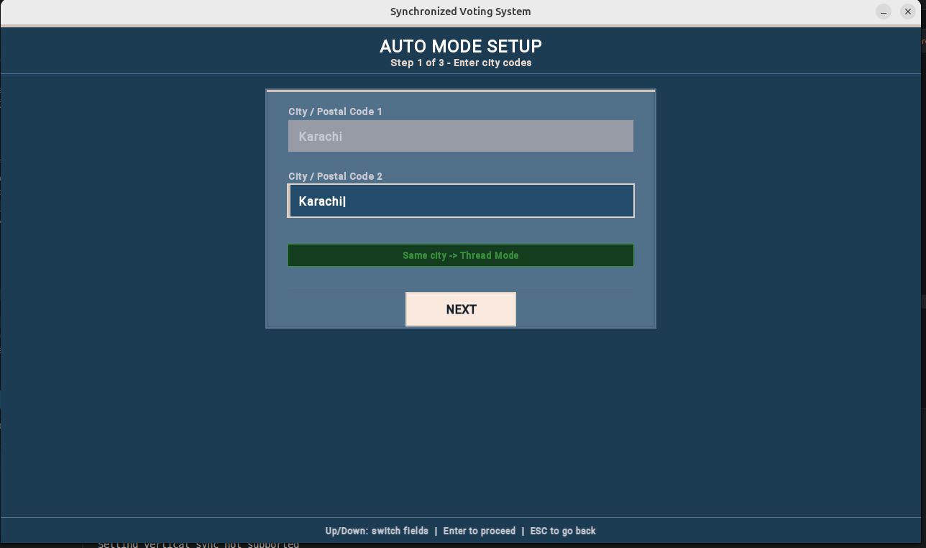
Figure 14 — Auto Mode (Thread): same city triggers pthread-based voters
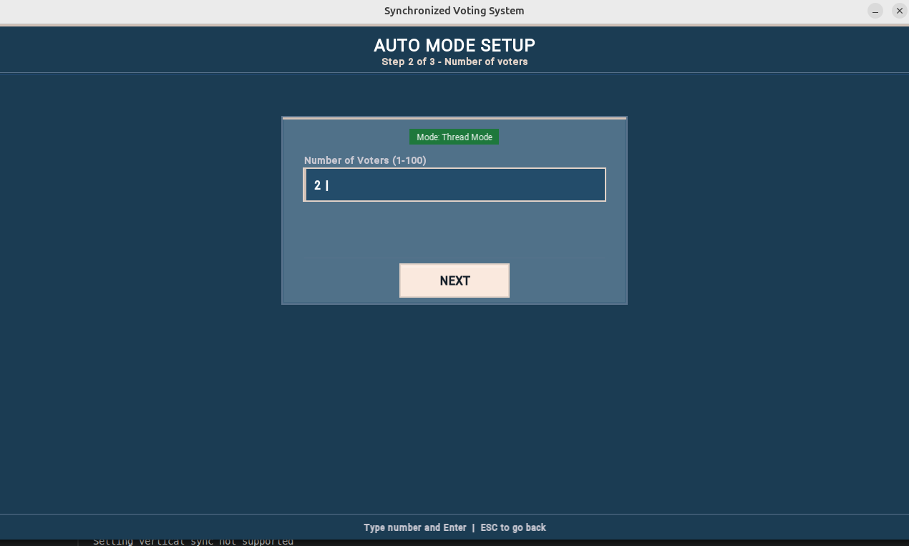
Figure 15 — Auto Mode: voter count and detail entry
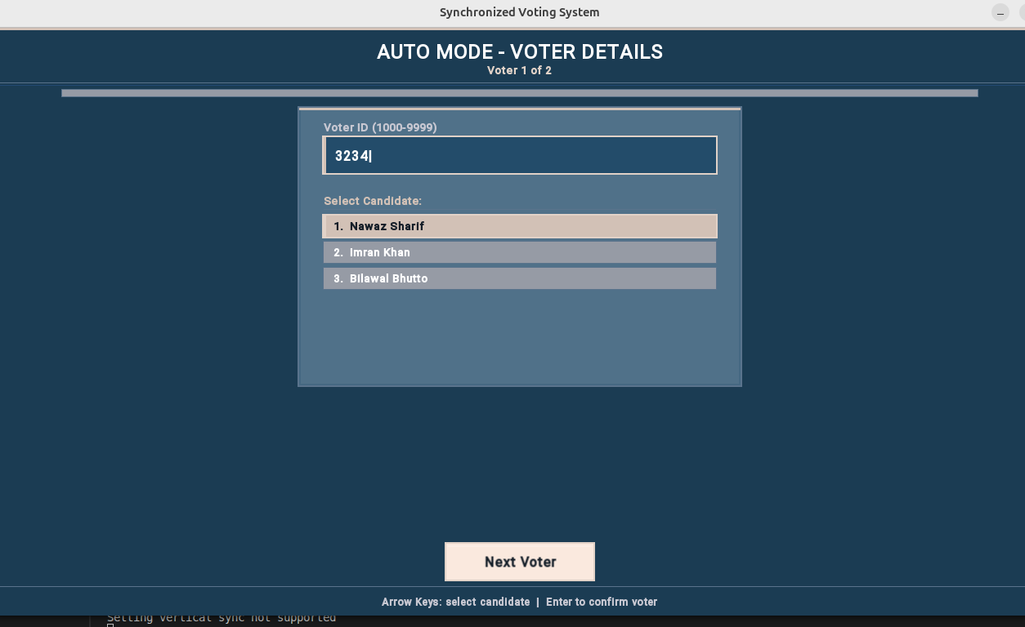
Figure 16 — Auto Mode : voting in progress with progress bar
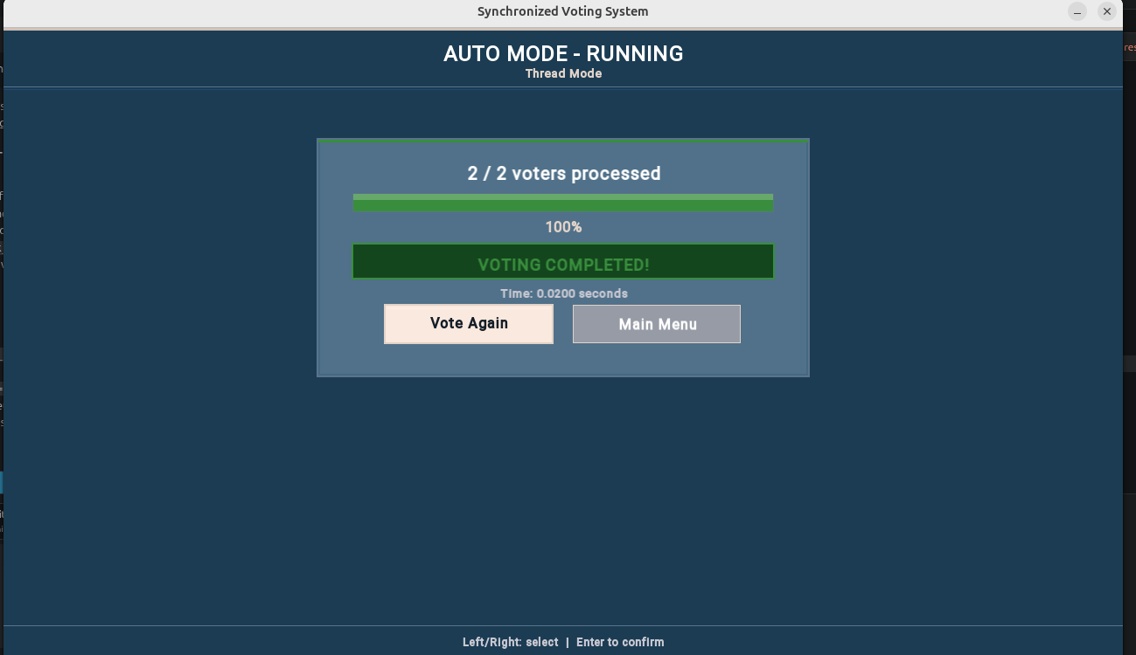
Figure 17 — Auto Mode : VOTING COMPLETED with elapsed time

8.6 Declare Results
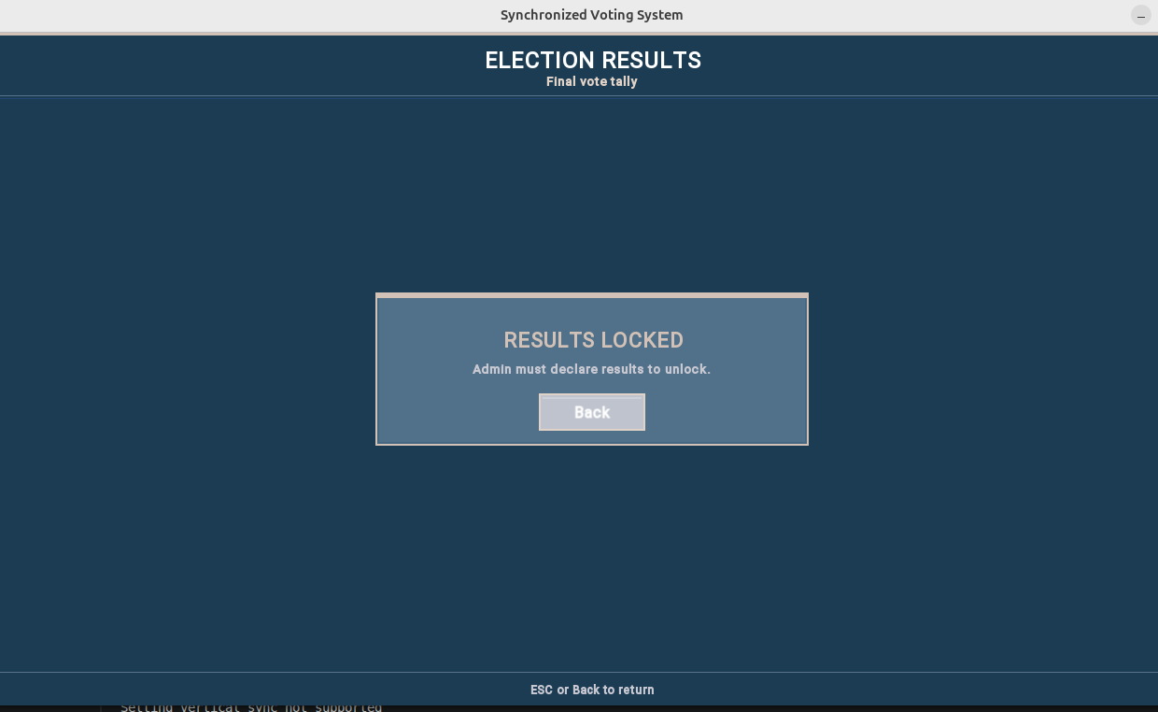
Figure 18 — Result (Without Election Ended)
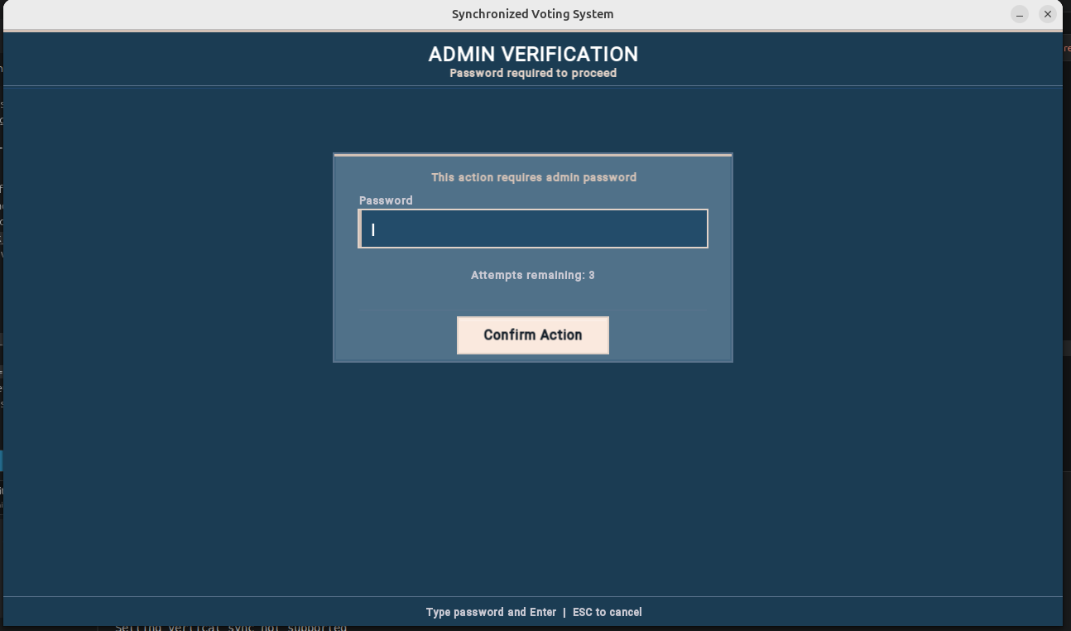
Figure 19 — Admin declares results — voting will locked
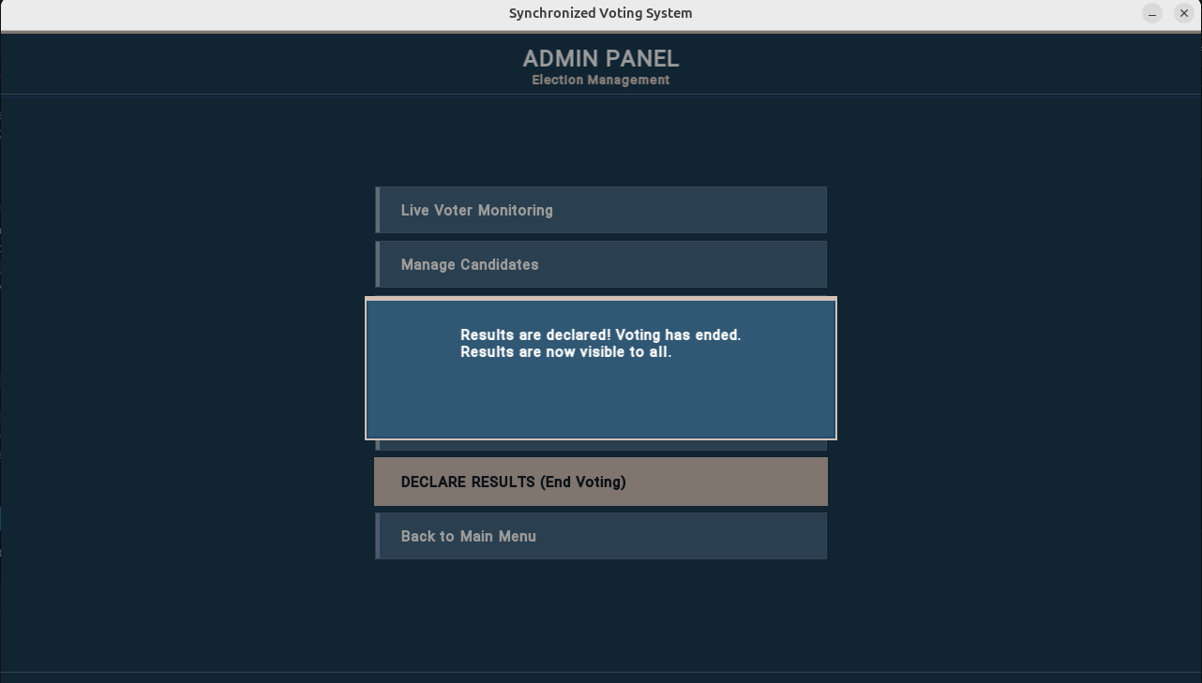
Figure 20 — Results declared and now visible to all users

8.7 System Statistics
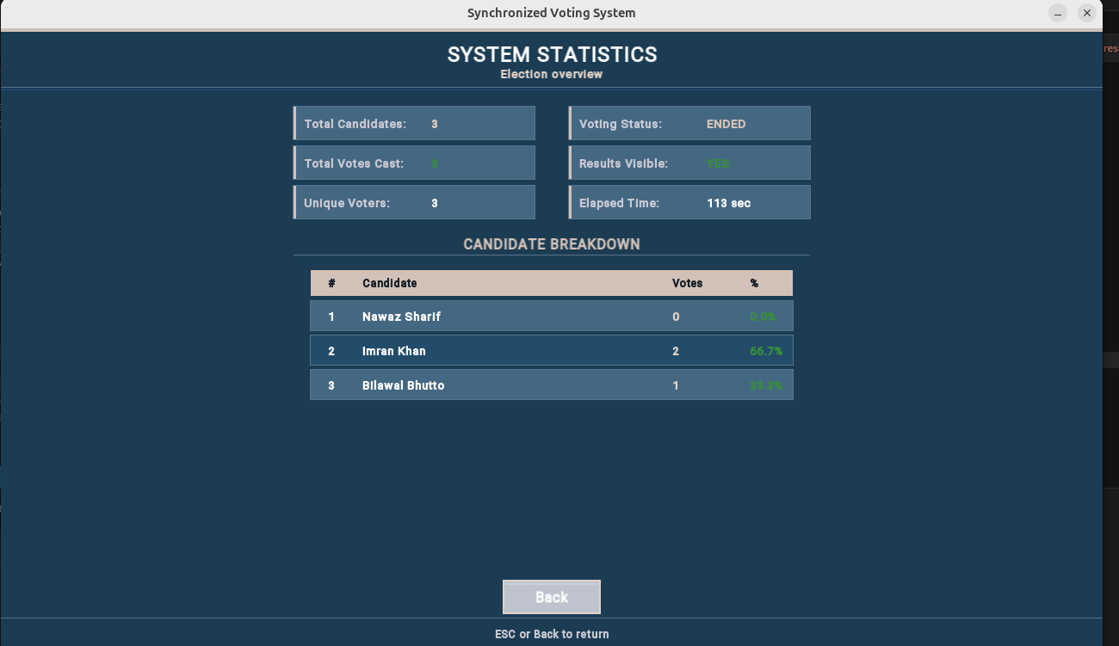
Figure 21 — Admin Statistics: candidate breakdown with votes and percentages

8.9 Results Screen
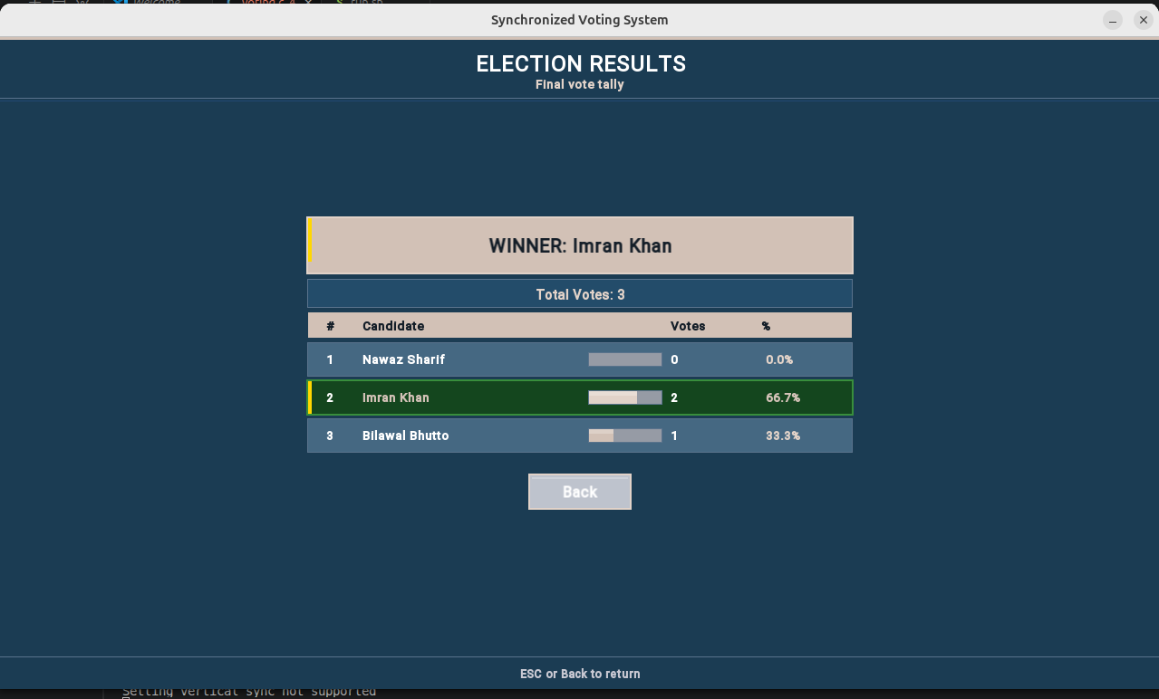
Figure 23 — Results: winner card with vote counts

8.8 Performance Comparison Screen
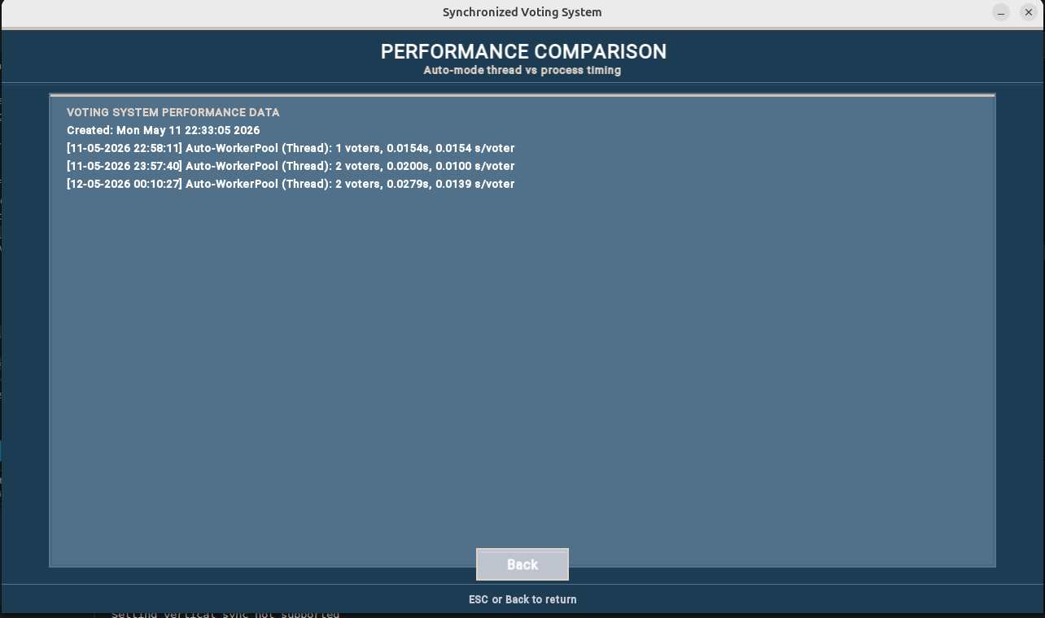
Figure 22 — Performance Data screen: thread vs process times
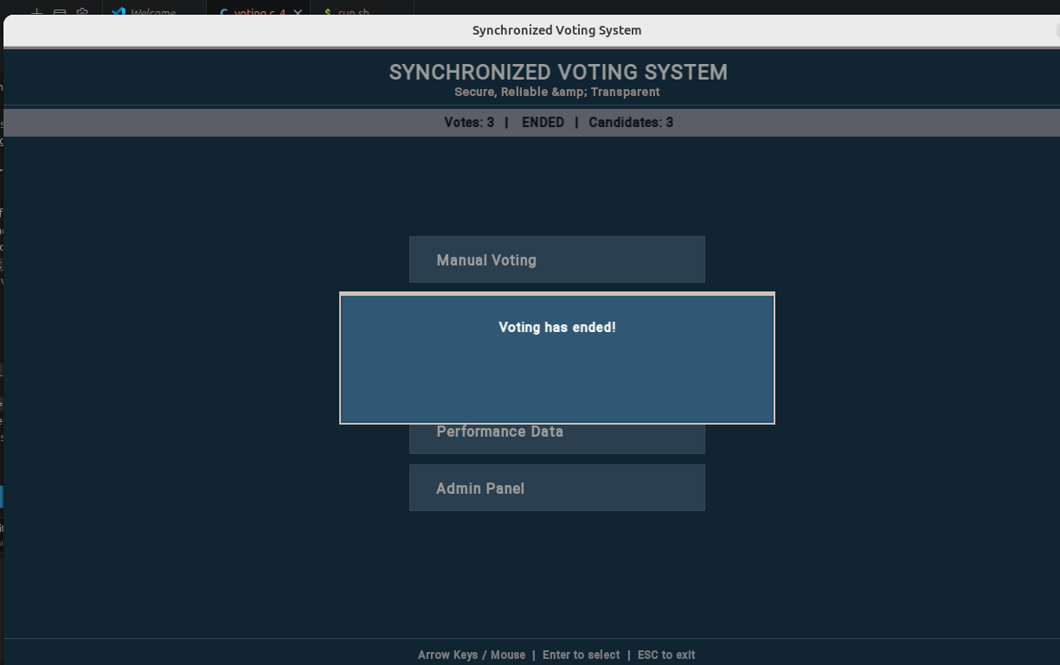
Figure 24 — Results: full candidate table with vote percentages

8.10 Named Pipe — Terminal Commands
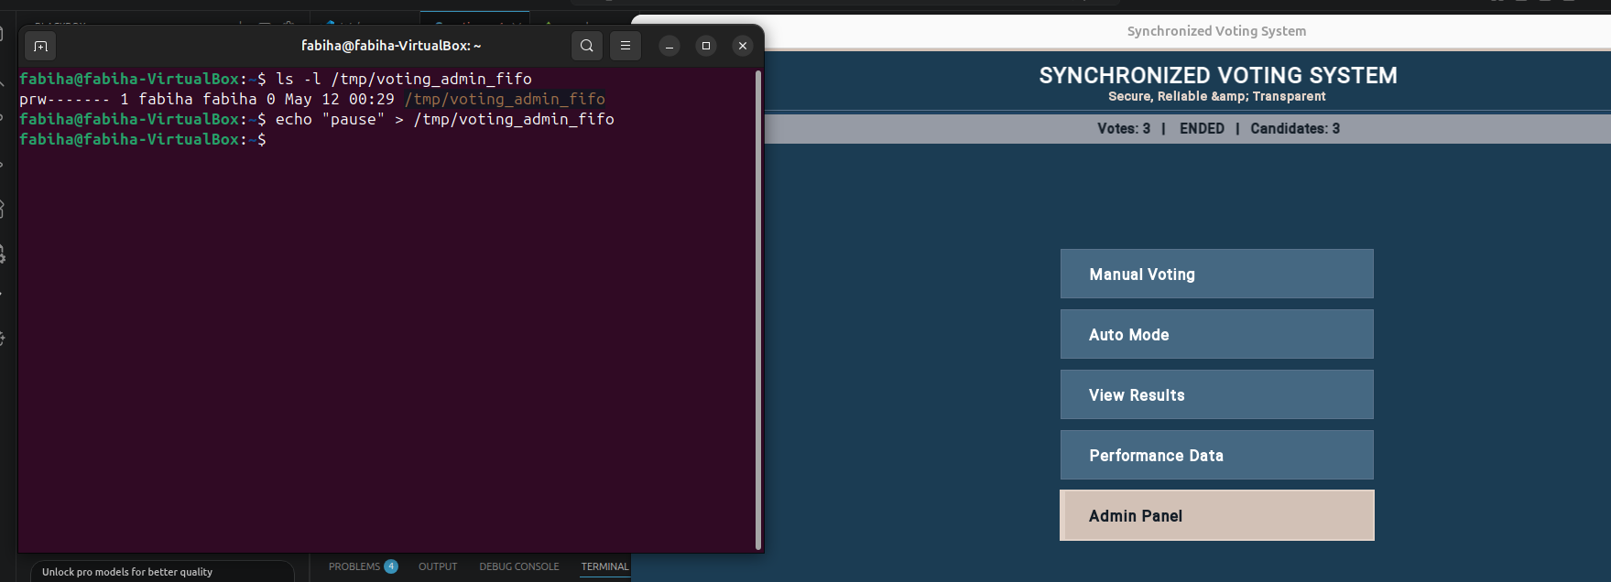
Figure 25 — Terminal: echo commands sent to /tmp/voting_admin_fifo
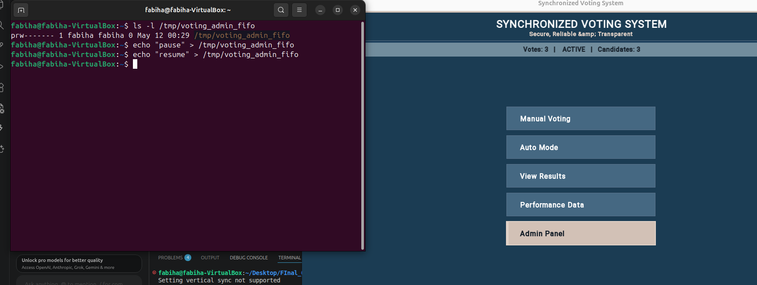
Figure 26 — Activity log updating in real time after FIFO command

9. Technologies Used

Technology | Usage in Project
C / C++ | Core language for entire application
POSIX Threads (pthreads) | Concurrent voter threads in Auto Thread mode
POSIX Semaphores (sem_open) | Readers-Writers mutual exclusion and synchronisation
Shared Memory (shm_open + mmap) | Shares VotingData structure across all threads and processes
fork() / _exit() | Creates child voter processes in Auto Process mode
Named Pipe (mkfifo) | External admin command channel from terminal
SFML 2.6 | Graphical user interface with real-time rendering
clock_gettime (CLOCK_MONOTONIC) | High-resolution timing for performance comparison
signal() / SIGINT | Graceful cleanup of semaphores and shared memory on exit
Logging (fprintf) | Timestamped event logging to text files

10. System Outputs

Output | Location / Format | Description
Vote Log | vote_log_[date]_[mode].txt | Every voting action with timestamp, voter ID, and candidate.
Performance Data | performance_data.txt | Thread vs process timing per auto session.
Election Report | election_report_[date].txt | Full results with percentages and log — exported from Admin Panel.
Real-time Display | SFML Window | Live vote counts, activity feed, and progress bars.
FIFO Responses | In-app Activity Log | Commands like pause, resume, status reflected in the live monitor instantly.

11. Limitations & Future Work
- Single-machine only — no network distribution. Could be extended with TCP sockets for remote voting.
- Maximum 10 candidates, 100 voters — constants can be increased but shared memory size must be adjusted accordingly.
- Readers priority may cause writer starvation under extremely heavy read load. A fair alternating solution could be added as an enhancement.
- GUI dependency on SFML — a terminal ncurses version would be more portable on headless servers.
- Admin password is currently hardcoded — a hashed credential store would improve security for real-world deployment.

12. Conclusion
The Synchronized Voting System successfully demonstrates core Operating System concepts: Readers-Writers synchronisation with POSIX semaphores, shared memory for cross-process data sharing, multi-threading with pthreads, multi-processing with fork(), a worker thread pool for optimised batch scheduling, Named Pipe inter-process communication, and quantitative performance analysis.
The system maintains strict data integrity through properly structured critical sections and prevents duplicate voting atomically. Performance measurements confirm that threads introduce significantly less overhead than processes — a result fully consistent with OS theory. The Named Pipe interface adds a practical remote administration channel, illustrating the versatility of POSIX IPC mechanisms.
Overall, this project serves as a comprehensive, fully functional case study of concurrency control in operating systems, validating both theoretical knowledge and practical implementation skills.

