PIZZA SALES SQL QUERIES

- KPI’s

- Total Revenue:
SELECT ROUND(SUM(pizza_sales.total_price), 2) AS 'Total Revanue'
FROM pizza_sales
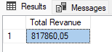

- Average Order Value:
SELECT ROUND(SUM(total_price) / COUNT(DISTINCT order_id), 2) AS 'Average Order Value'
FROM pizza_sales
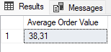

- Total Pizzas Sold:
SELECT SUM(quantity) AS 'Total Pizza Sold'
FROM pizza_sales
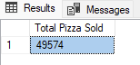

- Total Orders:
SELECT COUNT(DISTINCT order_id) AS 'Total Orders'
FROM pizza_sales
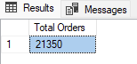

- Average Pizzas Per Order:
SELECT CAST(CAST(SUM(quantity) AS DECIMAL(10,2))/ CAST(COUNT(DISTINCT order_id) AS DECIMAL(10, 2)) AS DECIMAL(10, 2)) AS 'Average Pizzas Per Order'
FROM pizza_sales
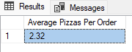

- Chart’s

- Daily Trend for Total Orders:
SELECT
DATENAME(DW, order_date) AS 'Order Day',
COUNT(DISTINCT order_id) AS 'Total Orders'
FROM pizza_sales
GROUP BY DATENAME(DW, order_date
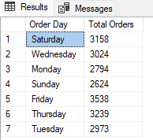

- Monthly Trend for Total Orders:
SELECT
DATENAME(MONTH, order_date) AS 'Month Name',
COUNT(DISTINCT order_id) AS 'Total Orders'
FROM pizza_sales
GROUP BY DATENAME(MONTH, order_date)

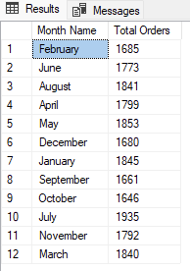

- Percentage of Sales by Pizza Category:
SELECT
pizza_category,
ROUND(SUM(total_price) * 100 / (SELECT SUM(total_price) FROM pizza_sales), 2) AS 'Percentage of Sales'
FROM pizza_sales
GROUP BY pizza_category
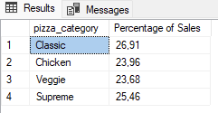

- Percentage of Sales by Pizza Size:
SELECT
pizza_size,
ROUND(SUM(total_price) * 100 / (SELECT SUM(total_price) FROM pizza_sales),2) AS 'Percentage of Sales'
FROM pizza_sales
GROUP BY pizza_size
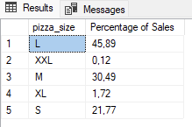

- Total Pizzas Sold by Pizza Category:
SELECT
pizza_category,
SUM(quantity) AS 'Total Pizzas Sold'
FROM pizza_sales
GROUP BY pizza_category
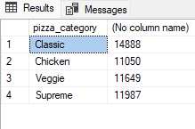

- Top 5 Best Sellers by Revenue, Total Quantity and Total Orders:
SELECT TOP 5
pizza_name,
ROUND(SUM(total_price), 2) AS 'Total Revenue'
FROM pizza_sales
GROUP BY pizza_name
ORDER BY 'Total Revenue' DESC

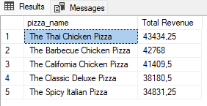

SELECT TOP 5
pizza_name,
ROUND(SUM(quantity), 2) AS 'Total Quantity'
FROM pizza_sales
GROUP BY pizza_name
ORDER BY 'Total Quantity' DESC

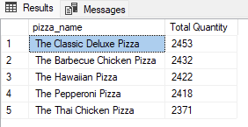

SELECT TOP 5
pizza_name,
ROUND(COUNT(DISTINCT order_id), 2) AS 'Total Orders'
FROM pizza_sales
GROUP BY pizza_name
ORDER BY 'Total Orders' DESC

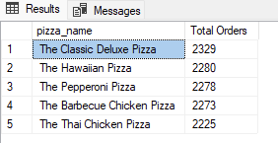

- Bottom 5 Sellers by Revenue, Total Quantity and Total Orders:
SELECT TOP 5
pizza_name,
ROUND(SUM(total_price), 2) AS 'Total Revenue'
FROM pizza_sales
GROUP BY pizza_name
ORDER BY 'Total Revenue' ASC

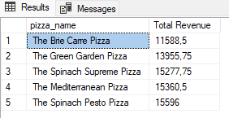

SELECT TOP 5
pizza_name,
ROUND(SUM(quantity), 2) AS 'Total Quantity'
FROM pizza_sales
GROUP BY pizza_name
ORDER BY 'Total Quantity' ASC

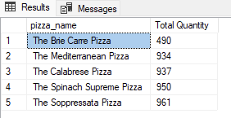

SELECT TOP 5
pizza_name,
ROUND(COUNT(DISTINCT order_id), 2) AS 'Total Orders'
FROM pizza_sales
GROUP BY pizza_name
ORDER BY 'Total Orders' ASC

