BUILDING STARTUP SYSTEMS - MILESTONE 2

- a link to a shareable, publicly viewable link to your copy of the Figma Wireframes
https://www.figma.com/file/vtl5Y4PzhSAak2ZVzvnW5E/CS-5356-Prototype-%232-(Copy)?node-id=77-432

a link to your Feedback pull request in Github Classroom.
https://github.com/2023-ctech-cs5356/milestone-2-Fabio752/pull/1

- Your public URL to your working website, something like https://your-project-id.web.appLinks to an external site.
https://bss-ms2.web.app/

- Screenshots of metrics and logs to answer the questions
  - How many API calls are made to your application? Hint: Some of the requests to your app are for HTML pages, others are to send/receive data.

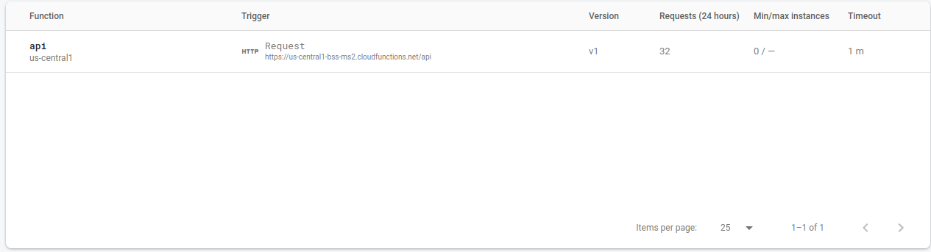
We can find how many API calls have been executed by filtering the entries in the logs explorer, but an easy way to do it is directly from the firebase console, from the Build > Functions tab. In my case, I make 32 api calls to load the app, log in, create a class and a question, and play a bit more with upvotes.

  - Create some traffic that results in a 401 Unauthorized Status Code, and then find it in logs

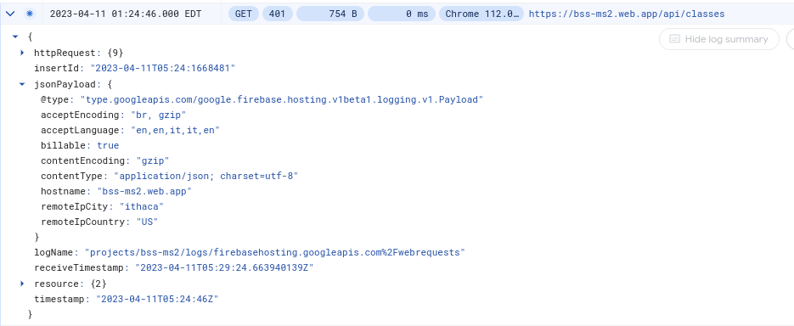
The 401 response above was generated when trying to get the classes for the instructor-home page when not signed in.

  - What is the latency on one of the requests to post a question?
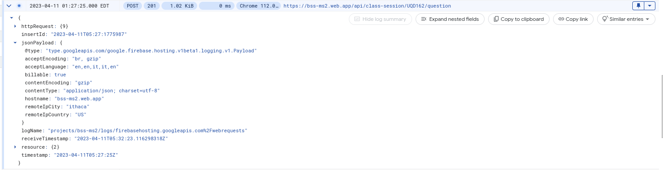
The request is really fast, with a latency of 0ms (we would need higher sensitivity to show the real latency in microseconds) as shown in the screenshot above.

