Databricks
FXb6gFFYYqgLHaKFrsnt3Gfk
Bernardeschi93#

Get Started

Databricks Lakehouse platform is a commercial grade, cloud native implementation of the lake house model. Data storage layer resides on top of the data lake: it provides the performance, reliability of a data warehouse combined with the flexibility, cost efficiency and scale of a data lake all in once simple, open collaborative platform. This diagram illustrates the Databricks architecture. 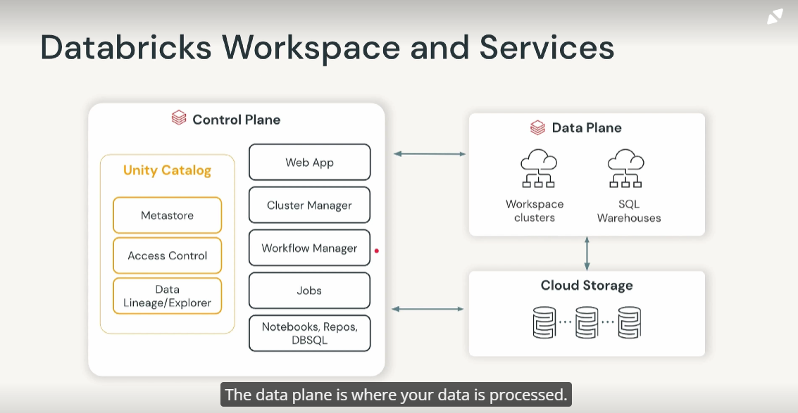

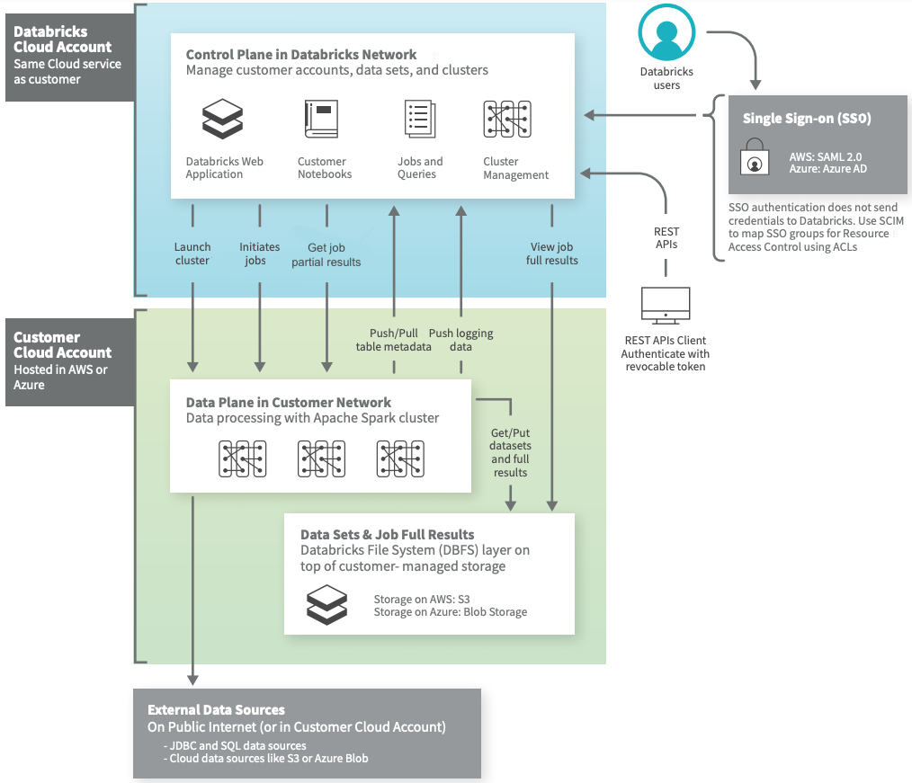

Notebook commands and Job scheduler reside in the control plane

The control plane consists of the backend services that Databricks manages in its own cloud account, aligned with the Cloud service in use by the customer (AWS, Azure, or GCP). Though the majority of your data does not live here, some elements such as Notebook commands and workspace configurations are stored in the control plane, and encrypted at rest. Through the control plane and the associated UI/APIs it provides, one can: launch clusters, start jobs and get results, interact with table metadata.
Control plane has several services:
- Web App which serves Databricks UI for you, the customer to access Databricks.
- A workflow manager that provides jobs or flows and DLT to orchestrate tasks in a manner of ways.
- A cluster manager which helps to configure Spark cluster.
- Jobs which schedule tasks,
- Unity catalog that provide Data Governance around access control, metadata management and data lineage and data discovery.
The data plane is where your data is processed. All your compute resources reside in your cloud account. Data plane: hosts compute resources(clusters), connect to the data store(s) backing DBFS. Optionally provides connections to external data sources, either within the same customer cloud account or elsewhere on the internet. For example: JDBC and SQL data sources or a data lake stored on S3, Azure Blob Storage, or GCS.
A Databricks cluster is a set of computation resources and configurations on which you run data engineering, data science and data analytics workloads. You run these workloads as a set of commands in a notebook or as a job. Typical applications include production ETL pipelines, streaming analytics, ad-hoc analytics and machine learning. The clusters live in the data plane within your organization’s cloud account, although cluster management is a function of the control plane that is part of the services offered by the Databricks platform.

Which of the following are data objects that can be created in the Databricks Data Science and Engineering workspace?
- Tables
- Functions

A data engineer needs to develop an interactive dashboard that displays the results of a query. Which of the following services can they employ to accomplish this?
- Databricks SQL

Databricks UI
Workspace ->users ->username to clone, import, export, permissions, create
To add a repo just insert the git url.
On top the cloud provider and the search bar. The username where I can see user settings (git integration, access token, editor setting), admin settings.
Three option on the side bar: Data science and engineering, Machine Learning and SQL: three persona.
Compute Resources
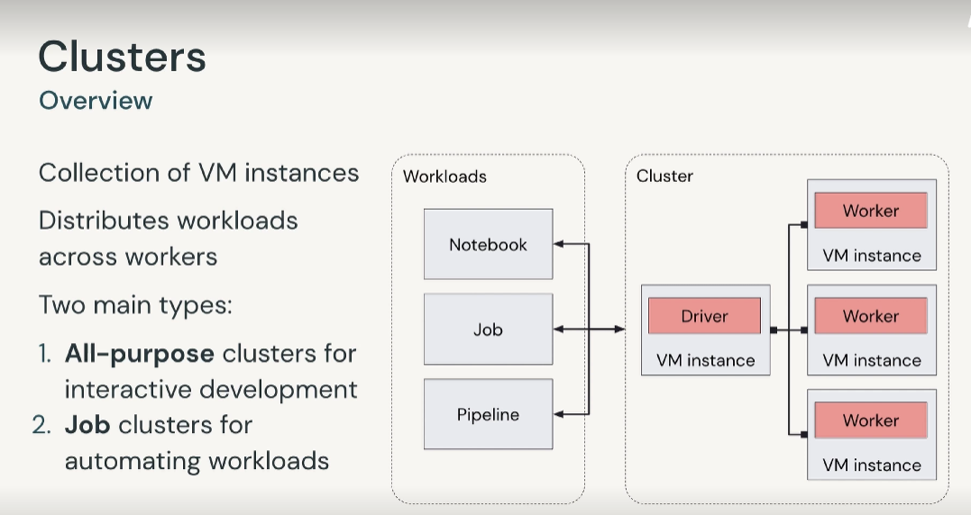
Clusters consist of a set of one or more VM instances, over which computation workloads are distributed. In the typical case, a cluster has a driver node alongside one or more worker nodes, although Databricks provides a single node model as well (typical limited to development or testing with small workloads). Workloads are distributed across available worker nodes by the driver. Databricks makes a distinction between all-purpose and job clusters.
- All-purpose clusters analyze data collaboratively using interactive notebooks (interactive and collaborative development). Multiple users can share all-purpose clusters to do collaborative interactive analysis
- Job cluster for automated jobs and pipelines in an expeditious and robust way.
You can create an all-purpose cluster using the workspace or programmatically using the command-line interface or REST API. You can manually terminate and restart an all-purpose cluster. Job clusters automated jobs in an expeditious and robust way.
The Databricks job scheduler creates a job cluster when you run a job on a new job cluster and terminates the cluster when the job is complete. You cannot restart a job cluster.
- Job clusters: configuration information retained for up to 30 clusters recently terminated by the job scheduler.
- All-purpose clusters: configuration information is retained for up to 70 clusters terminated within the last 30 days. To retain information beyond this period, the administrator must pin the cluster.

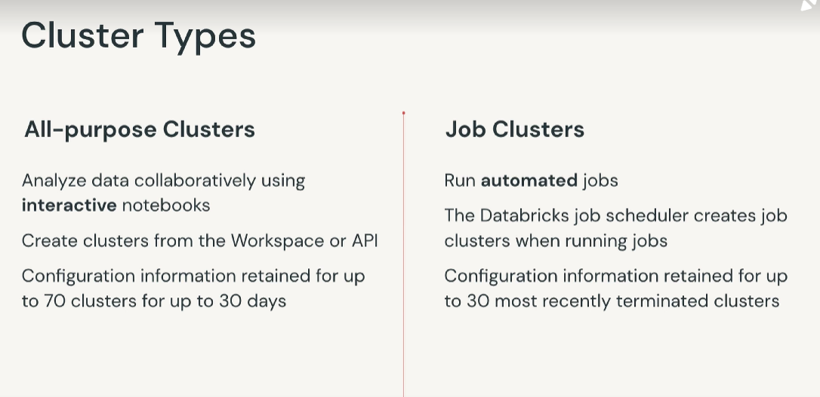

Cluster Configuration
Cluster mode is an operating mode on which there are two options.
- Single node cluster which need only one VM instance hosting driver. There are no worker instance in this configuration. Low cost configuration useful for single node machine learning workload that use spark to load and save data.
- A standard cluster is a general purpose configuration and it consists of VM instances and it hosts the driver and at least one additional instance for the worker
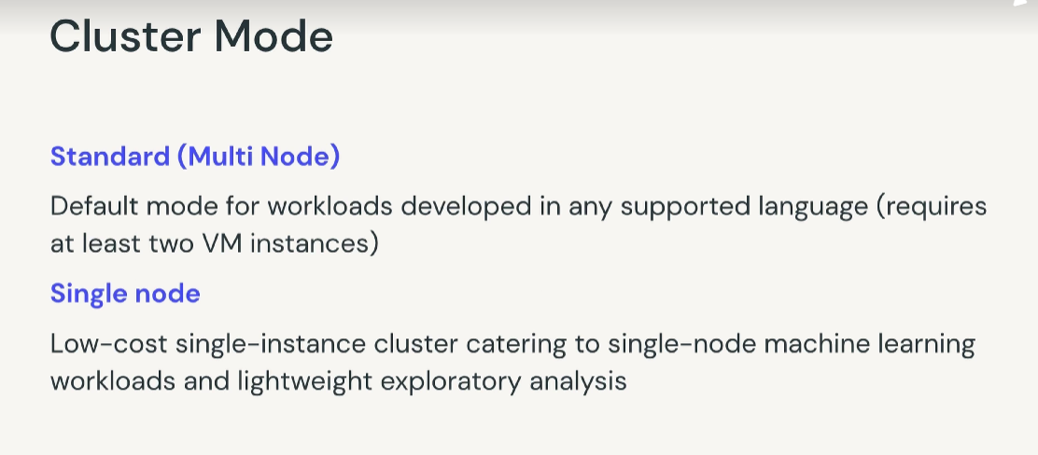
Databricks runtime is a collection of courseware components running on the cluster including Apache Spark and many others and updates which improves usability and security of data analytics. Photon is used to optimize the performance and cost of sql workloads. Databricks also offer automatic runtime for machine learning workload: select the most recent version that you can. For unity catalog the minimum version 10.1
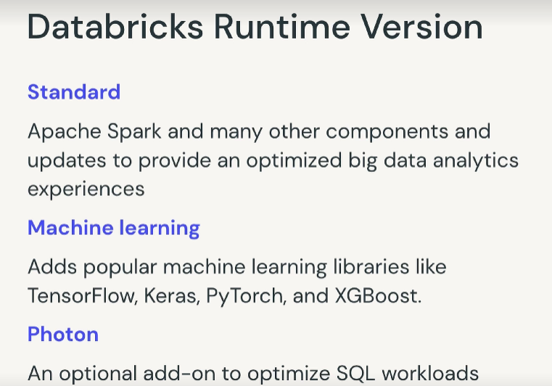

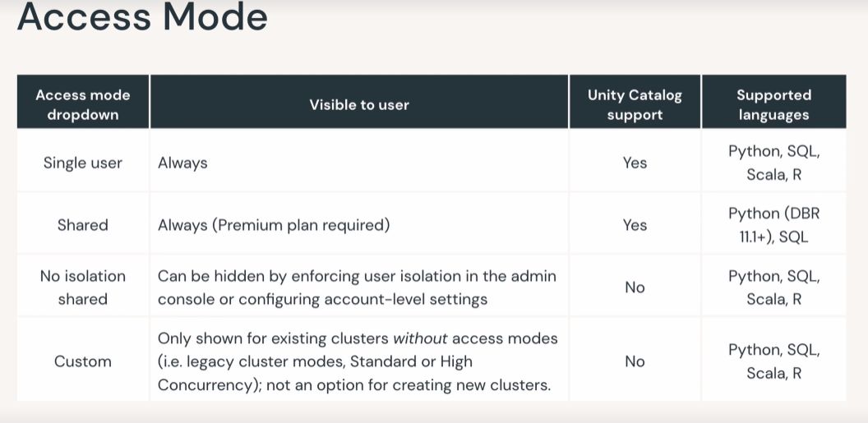
Access mode dropdown replace the security mode dropdown. The access mode replace the overall security model of the cluster. Other people cannot be attached to single user cluster (in shared yes, but in shared library isolation and dbfs are prohibited). It support library isolation and dbfs.

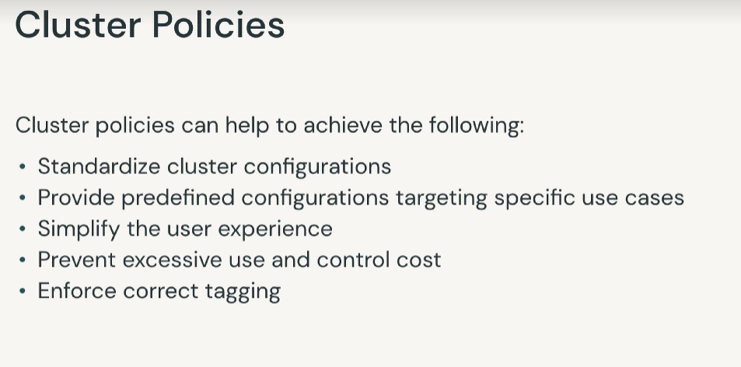

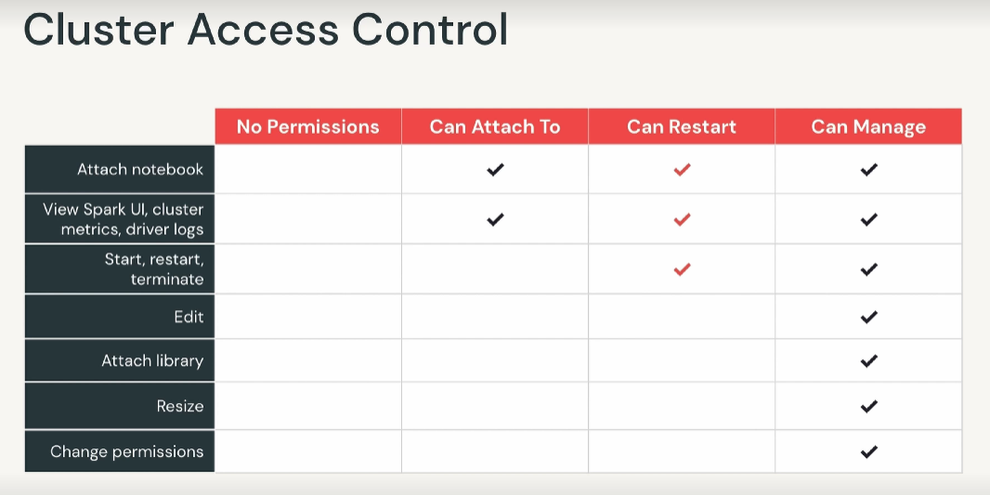
To create cluster click on compute on the side bar or on new.

A data engineer has a long-running cluster for an ETL workload. Before the next time the workload runs, they need to ensure that the image for the compute resources is up-to-date with the latest image version. Which of the following cluster operations can be used in this situation?
- Restart

Which of the following cluster configuration options can be customized at the time of cluster creation? Select all that apply.
- Databricks Runtime version
- Cluster mode
- Maximum number of worker nodes

Databricks Notebook
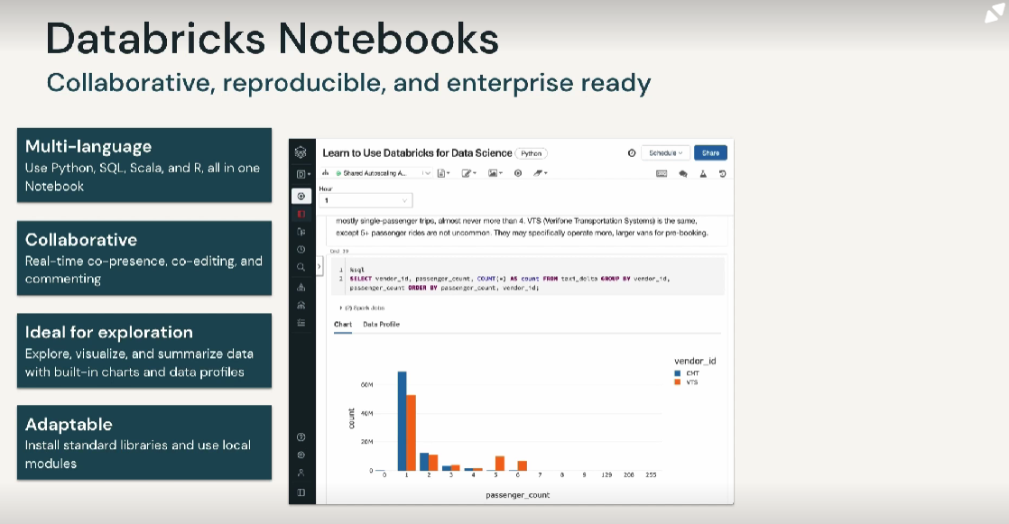
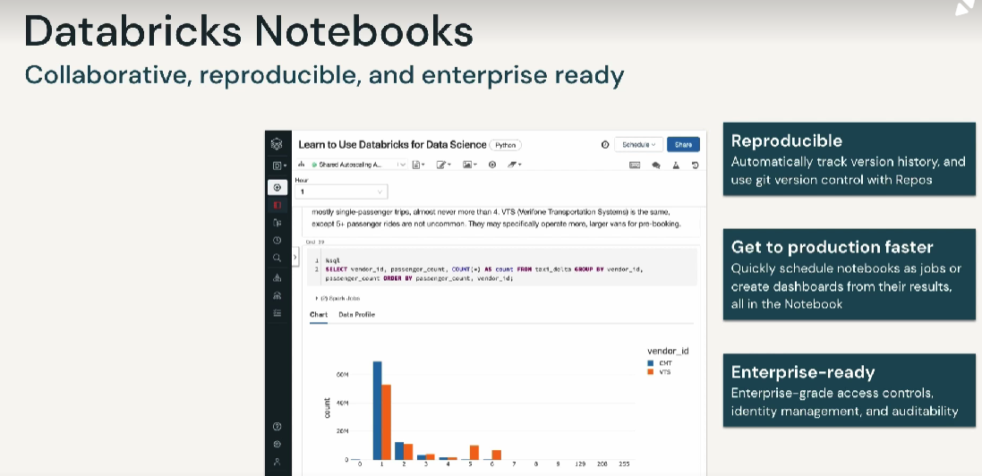

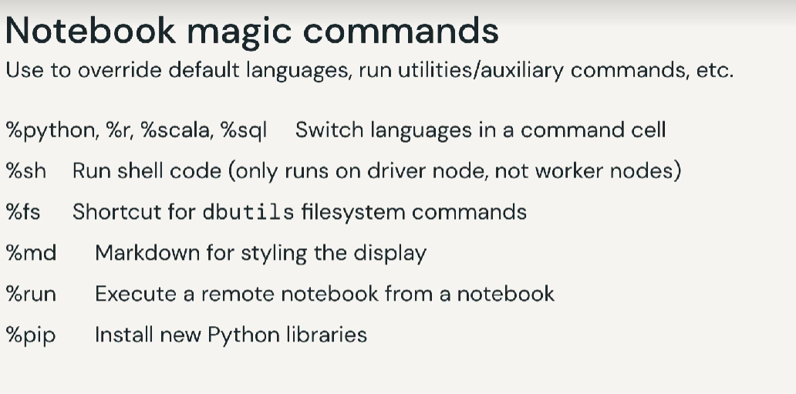

Databricks Repos

Databricks Repo is a feature of Databricks that takes all the practices involved in a managing workspace assets and applies them to a similar environment that is backed by revision control using Git.
The Repos REST API enables you to integrate data projects into CI/CD pipelines
Databricks Repos supports the use of multiple branches (advantage respect to Databricks Notebook versioning)
Notebooks has some basic revision control built-in, these features are fairly basic a do not support the requirments of a full-fledged software development lifecycle. There is no centralized, immutable history maintained. The history is attached to a single instance of a Notebook. If you export the notebook or create a copy of it, the history is lost. The history can also easily be manipulated or deleted by users. You cannot merge changes, create branches or named tags. No external integration points to supports a CI/CD pipeline. Databricks Repos, through its Git integration satisfies the first of these requirements, and addresses the third with its provided API. Databricks supports Azure DevOps, Bitbucket, GitHub and GitLab. Databricks currently does not support private Git servers. Supported operations include:
- Clone repository, which creates a local working copy of a remote Git repository,
- pulling, which synchronizes upstream (remote) changes with your local copy, adding new items, like folder or notebooks,
- pushing, which is the opposite of pulling, and lastly creating a branch. This operation resets your current notebook state without impacting other branches in the repository. Creating branches for your own development is a good practice to adopt, since your changes, even if you push them upstream, will not be interfering with the production environment or others who are following the same practice.
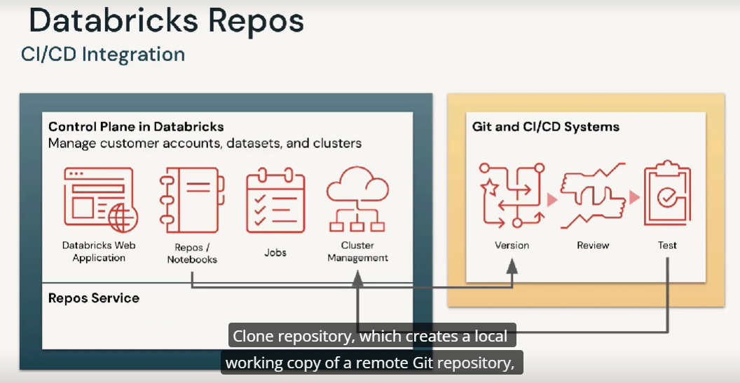
This diagram provides an high level overview of recommended best practices to follow when developing with Repos. In short: 1. Clone the target repository. 2. Create a new development branch, orselect an existing branch agreed upon by your team in which development work will be conducted. It’s considered best practice to not develop directly on the main branch. 3. Make changes (add items, modify code) and test. 4. Commit and push to your branch. 5. Merge changes into main (in accordance with your organization’s code review and release processed)
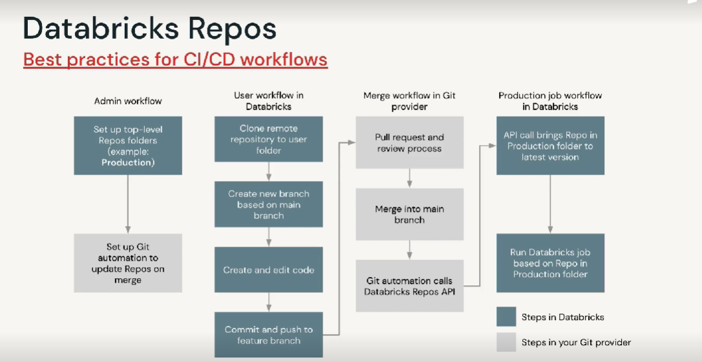
Two piece of information are required to connect Databricks to a Git service: the username to log into your Git service account and a personal access token. In user settings there is the Git integration. Each Databricks repo maps to a Git repository. Any changes you make within a repo are tracked and can be synchronized with a remote repository. When a repo is created the underlying Git repository will be cloned into the repo that is your new repo will contain a local copy of the upstream repository.
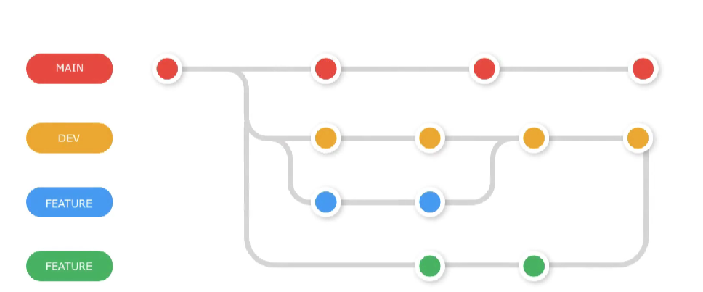
It is considered best practice to keep changes contained within a dev branch, particularly when working on features that are not tied tightly to development work being carried out by others in your team following this model. Once you complete the changes and they have been tested and approved, then merging with feature branches or the main branch can be handled in a more controlled manner. To create a branch Dev, we use Repos dialog, which we can access from the Repos page or from any notebook inside the repo. To push upstream a notebook to our remote repository we use Repos dialog. Dialog allows us to see what has changed in each file, commit changes at once or each change individually or any number of changes together. For each commit, provide a descriptive and concise summary. When multiple developers are collaborating on the same branch: if someone else pushed changes to the repo that conflict with your changes then you won’t be able to push these changes. You will have to pull first and potentially deal with any merge conflicts that can sometimes happen when conflicting changes are detcted. Therefore pulling regularly is important particularly when multiple developers are developing on the same branch.
A data engineering team is working on a shared repository. Each member of the team has cloned the target repository and is working in a separate branch. Which of the following is considered best practice for the team members to commit their changes to the centralized repository?
The data engineers can each create a pull request to be reviewed by other members of the team before merging the code changes into the main branch.

Three data engineers are collaborating on a project using a Databricks Repo. They are working on the notebook at separate times of the day. Which of the following is considered best practice for collaborating in this way?
The engineers can each work in their own branch for development to avoid interfering with each other.

Databricks

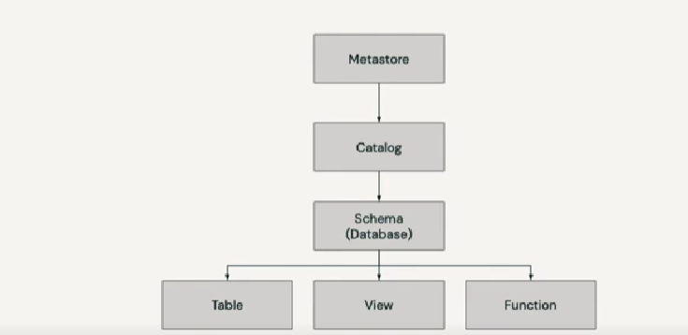
Databricks Lakehouse architecture combines data stored with the Delta Lake protocol in cloud object storage with metadata registered to a metastore.
5 primary objects in the Lakehouse:
- Catalog: group of db
- Db or schema which is a grouping of objects in a catalog. Db contains tables, view and functions. Table is a collection of rows, columns stored as data files in object storage. View is a saved query. Function is saved logic that returns a scalar value or set of rows
- Managed tables are based on files which are stored in the managed storage location that is configured into the metastore. When you drop a managed table, this will delete the table and it’s underlying data
- External tables are tables whose data files are stored in a cloud storage location outside of the managed storage location, so only the table metadata is managed. When you drop an external table the underlying data is retained while only the table itself is dropped. External and Managed table are the same from an access control point of view 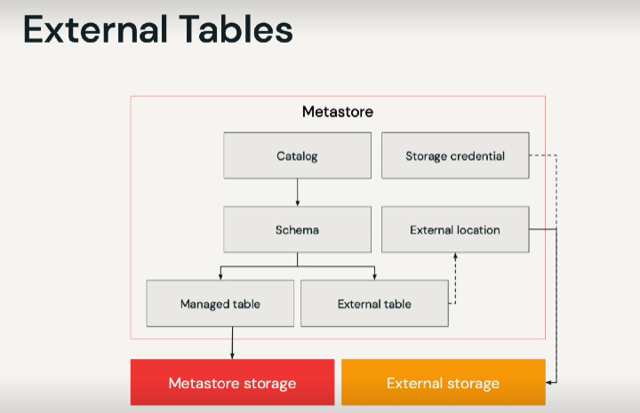

Which of the following statements about the difference between views and temporary views are correct? Select two responses.
- Temporary views skip persisting the definition in the underlying metastore. Views have metadata that can be accessed in the view's directory.
- Temporary views are session-scoped and dropped when the Spark session ends. Views can be accessed after the session ends.

Which of the following identifies a performance challenge associated with Python UDFs? Select three responses
- Python UDFs have interprocess communication overhead between the executor and a Python interpreter running on each worker node.
- Python UDFs have to deserialize row data from Spark's native binary format to pass to the UDF, and the results are serialized back into Spark's native format.
- Python UDFs cannot be optimized by the Catalyst Optimizer.
A data engineer needs to create and register a user-defined function (UDF) CREATE_USER using the Python function createUser and apply it to array column username in the table users. They have the following lines of code. In what order do the lines of code above need to be run in a Python session in order to accomplish this? Select one response.
- spark.udf.register("CREATE_USER", createUser)
- spark.sql("SELECT CREATE_USER(username) AS user FROM users")

ETL with Spark

DESCRIBED EXTENDED: will show all of the metadata associated with the table definition.

Common Table Expression
A CTE can hold temporary result set that is defined within the execution scope of a single SELECT, INSERT, UPDATE, DELETE. You cannot have another SELECT outside the scope of CTE

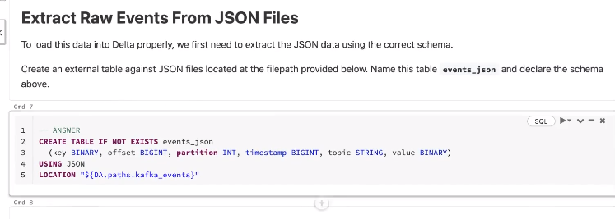

A data engineer has created a custom Python function that returns an input variable of type double after it has been incremented by 1. Which of the following identifies the most efficient type of UDF the engineer can use in terms of complexity, as well as the correct method to specify the type of UDF? Select one response.

- The data engineer can specify that the UDF has row-at-a-time execution using @pandas_udf( " double " , PandasUDFType.SCALAR) syntax.

A data engineer is using the following code block to create a table using an external CSV file as its source. They need to specify that the fields are separated by | and that there is a header.

Code blocks:

CREATE TABLE IF NOT EXISTS sales_csv

(order_id LONG, email STRING, transactions_timestamp LONG, total_item_quantity INTEGER, purchase_revenue_in_usd DOUBLE, unique_items INTEGER, items STRING)

USING CSV

_____

LOCATION "${dbfs:/mnt/datasets}"

Which of the following correctly fills in the blank for the table options? Select one response.

OPTIONS (
header = "true",
delimiter = "|"
)

A senior data engineer has registered the Python function create_users to be used by the rest of their team. They have written the function in Python 3.6. Another data engineer wants to know what the expected inputs are. Which of the following is considered a best practice to do this? Select one response.

- The data engineer can declare the function with @udf("string") syntax to specify the input and return types of the function.

Manage Data with Delta Lake
Delta Lake is an open-source project that enables building a data lakehouse on top of existing storage systems.
Delta Lake is not a storage format, a storage medium or a database service or data warehouse.
- Delta Lake is open-source: it leverages open formats, stores data in the customer’s cloud-based object storage, and is designed for infinite scalability
- Delta Lake builds upon standard data formats (is powered primarily by data stored in the Parquet formats. Parquet gives you additional metadata leverage over the open-source formats such as JSON),
- it is optimized for cloud object storage (it can be run on a number of different storage medium. Object storage is cheap, durable, highly available, and effectively infinitely scalable)
- it’s built for scalable metadata handling.
A primary objective in designing Delta Lake was to solve the problem of quickly returning point queries in some of the world’s largest and most rapidly changing datasets. Delta Lake decouples compute and storage costs and provides optimized performance on data regardless of scale.
Data Lakehouse is built upon this foundation with the vision of powering applications queries throughout your organization from a single copy of your data.
Delta Lake provides ACID transactional guarantees, scoped at the table level to data stored in cloud-based object storage
- Atomicity: all transactions either succeed or fail completely
- Consistency: guarantees relate to how a given state of data is observed by simultaneous operations
- Isolation: refers to how simultaneous operations conflict with one another
- Durability: committed changes are permanent
Problems solved by ACID:
- Appends won’t fail due to conflict, even when writing from many sources simultaneously.
- Modification of existing data difficult: now changes are not committed until a job has succeeded, single transaction
- Jobs will either fail or succeed completely
- Real -time operations hard: Delta Lake allows atomic microbatch transaction processing in near real-time through a tight integration with structured streaming.
- Costly to keep historical data version: Transaction logs guarantees atomicity, consistency and isolation allow snapshot queries, easily enabling time travel.
Delta Lake is the default for all tables created in Databricks.
Hive Metastore is by default what we use to register databases, tables, and views.
An organization’s data warehouse team is using a change data capture (CDC) feed that needs to meet the CCPA compliance standards. They are worried that their current architecture will not support this workload. Which of the following explains how employing Delta Lake in a data lakehouse architecture addresses these concerns?
- Delta Lake supports merge, update and delete operations to enable complex use cases.
Build Data Pipelines with Delta Live Tables

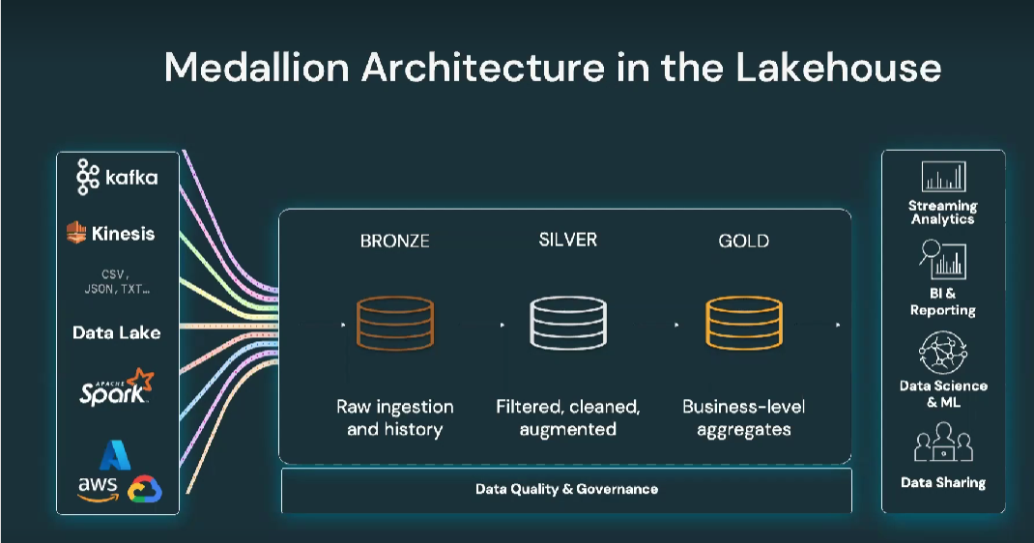
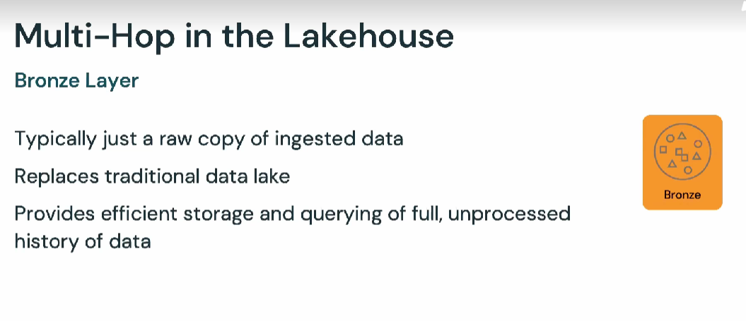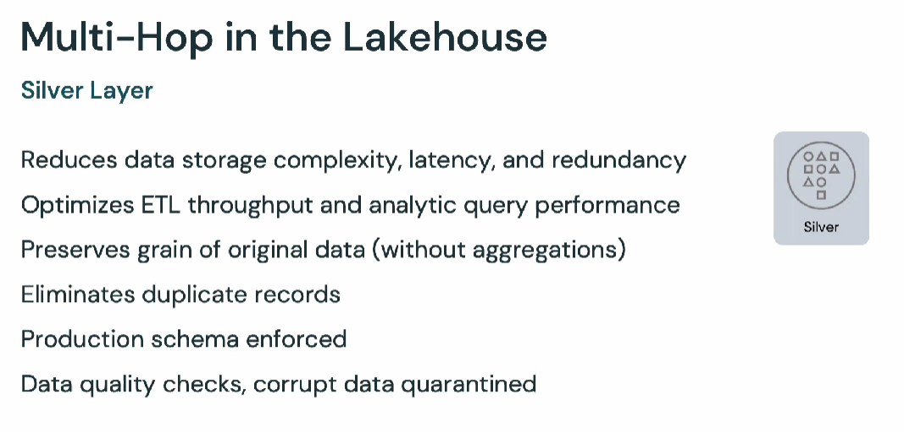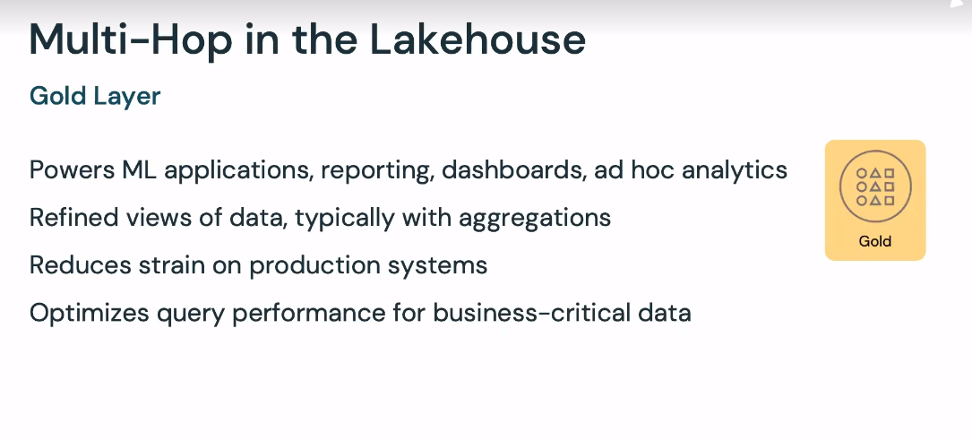

Within the Lakehouse, most ETL pipelines follow a multi-hop architecture. Data enters Databricks from a variety of sources, initially being stored in a raw data lake. As data is clean, validated, enriched and joined with other sources, it is stored in a series of incremental tables, each providing potential value for other operations, organization-wide querying or auditing needs.
Finally, highly refined views of the data are used for data analytics, including ad-hoc queries, dashboarding and machine learning.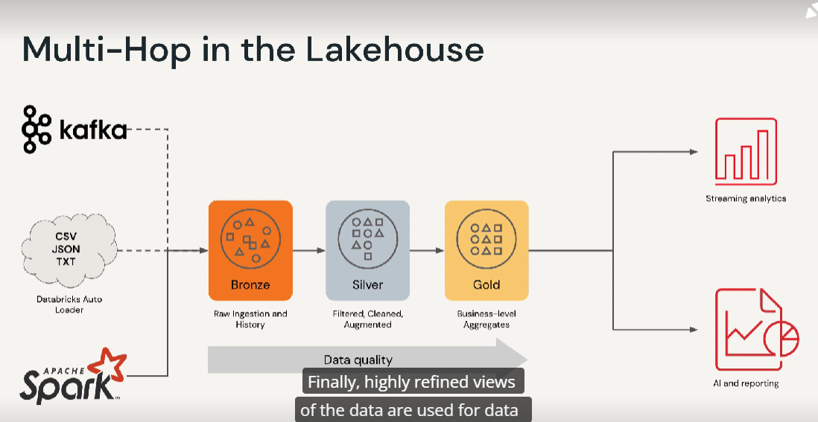
Maintaing data quality and reliability at scale is complex and brittle. Not all dependencies are easily expressed in such a linear fashion.
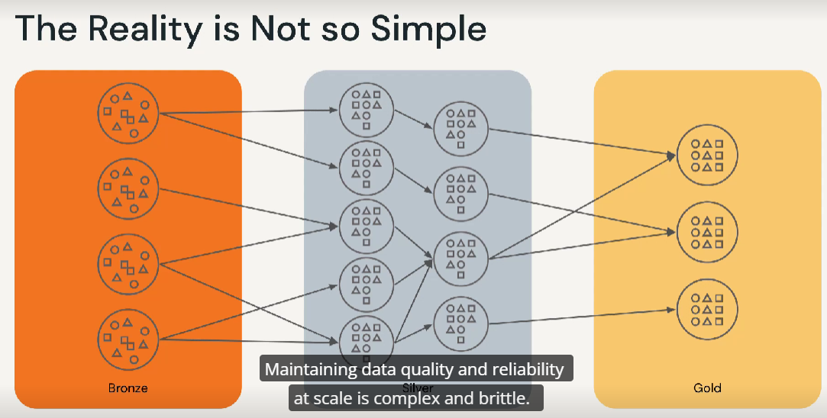

Databricks has always sought to make enterprise ETL easy, we’ve still seen our customers hitting the same roadblocks:
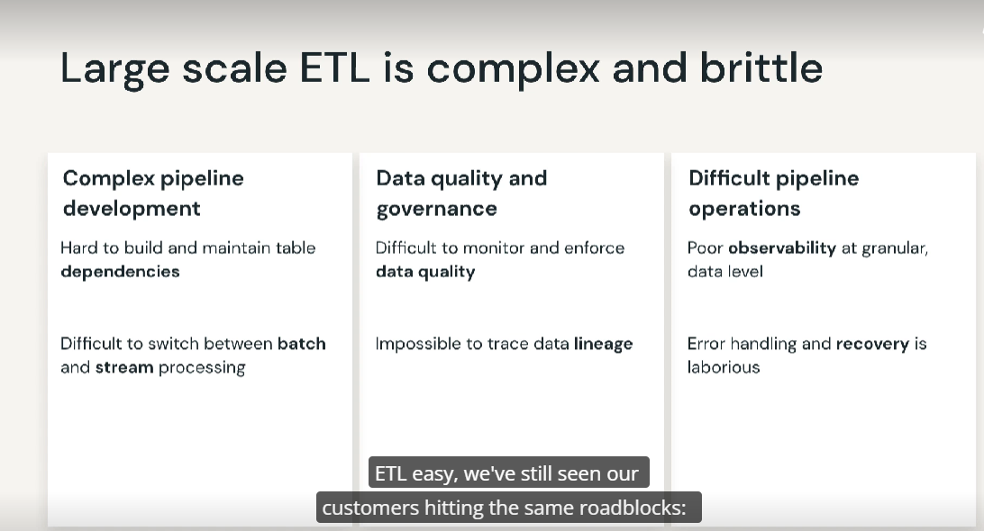
Delta Live Tables is designed to allow users to easily declare batch and/or streaming pipelines using Python or SQL. Because Python and SQL can be combined within a pipeline it’s easier to share code and collaboration on production pipelines. Delta Live Tables has built-in quality controls and data quality monitoring that ensure accurate and useful BI, data science and ML built on top of quality data. DLT is designed to scale with rapidly growing companies and provides clear observability into pipeline operations and automatic error handling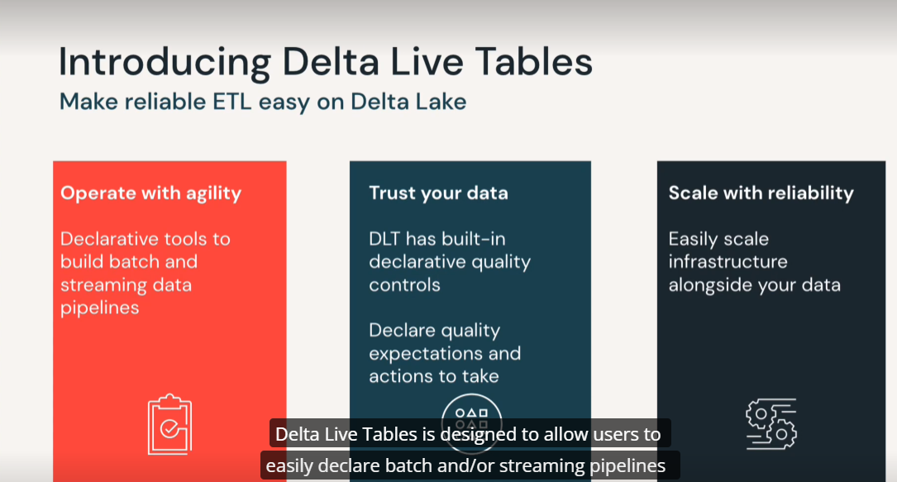

What is a Live Table?
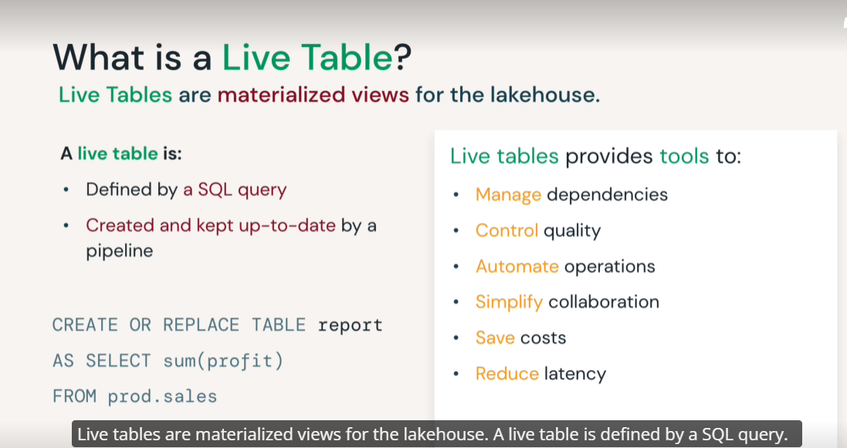
Live tables are materialized views for the lakehouse. A live table is defined by a sql query. It is created and kept up-to-date by a pipeline. We will create or replace a LIVE table.
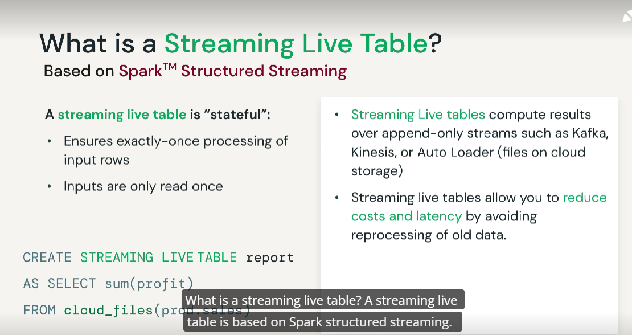
How do I use DLT?
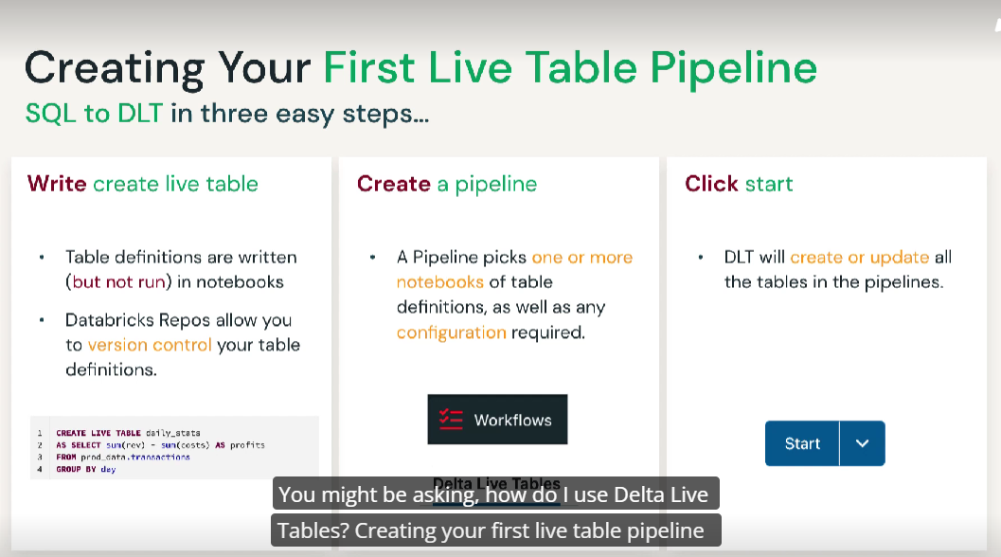
Creating your first live table pipeline is easy: just three steps.
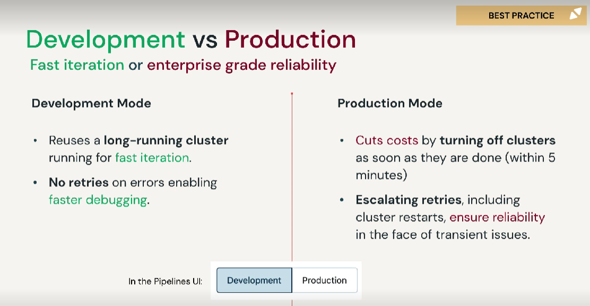
We can switch between Development and Production.
What if I have many tables?
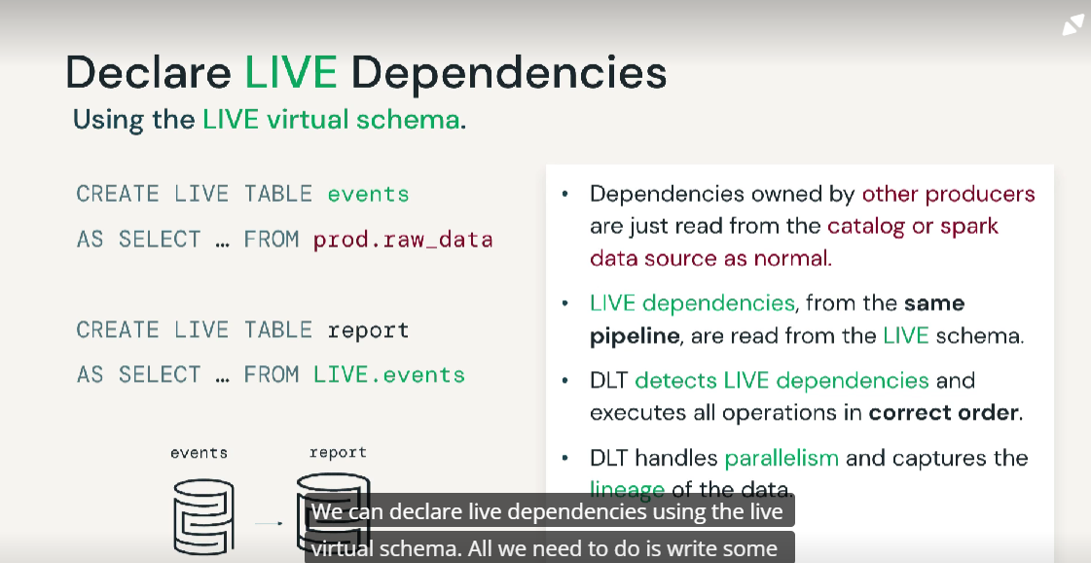
We can declare live dependencies using the live virtual schema. All we need to do is write some SQL statement (il primo). Live table are created and maintained by the delta live pipeline,
How do I know my results are correct?
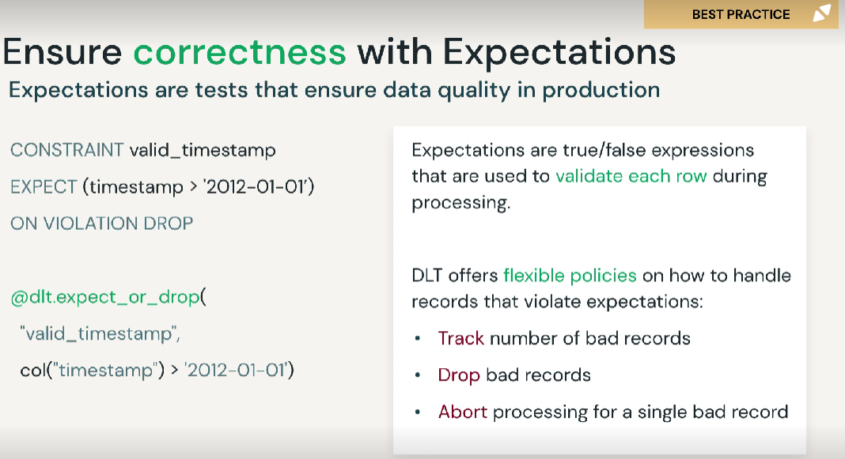
We can ensure correctness with expectations. Expectations are tests that ensure data quality in production. We can place constraints like making sure that we have a valid timestamp, on violation drop any record. We can also declare this in Python using a decorator.
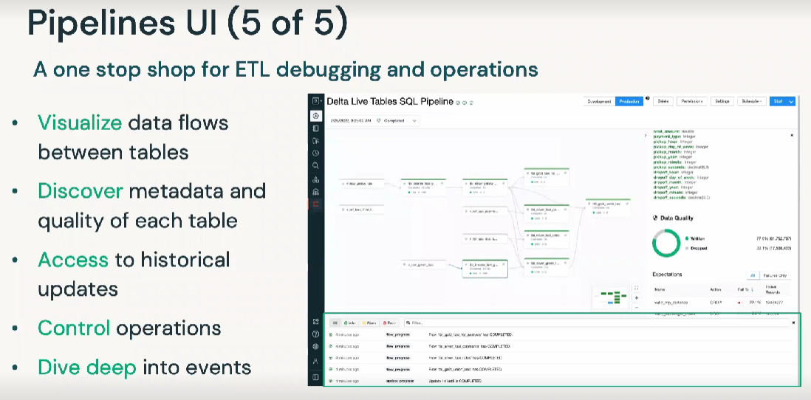
What about operations?
The pipelines UI offers a one-stop shop for ETL debugging and operations. We can visualize data flows between tables. We can discover metadata and quality of each table. We can access historical updates. We can control operations, and we can dive deep into events.
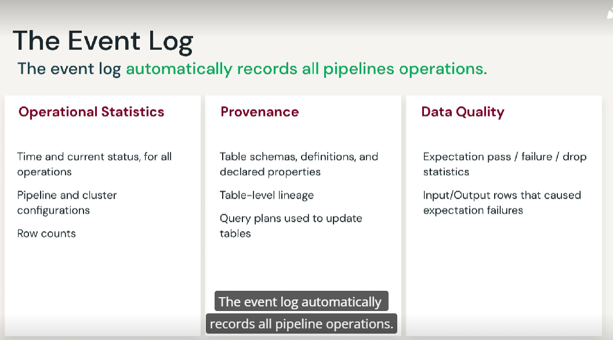
The event log automatically records all pipeline operations. We can get operational statistics, like the time and current status for all operations, or pipeline and cluster configurations, or row counts. It also provides us provenance. We can look at table schemas, definitions and declare properties. We also have table-level lineage. We can look at the query plans used to update tables. And it also offers data quality. We have expectation pass/failure/drop statistics and input output rows that caused expectations failures.
When should I use streaming?
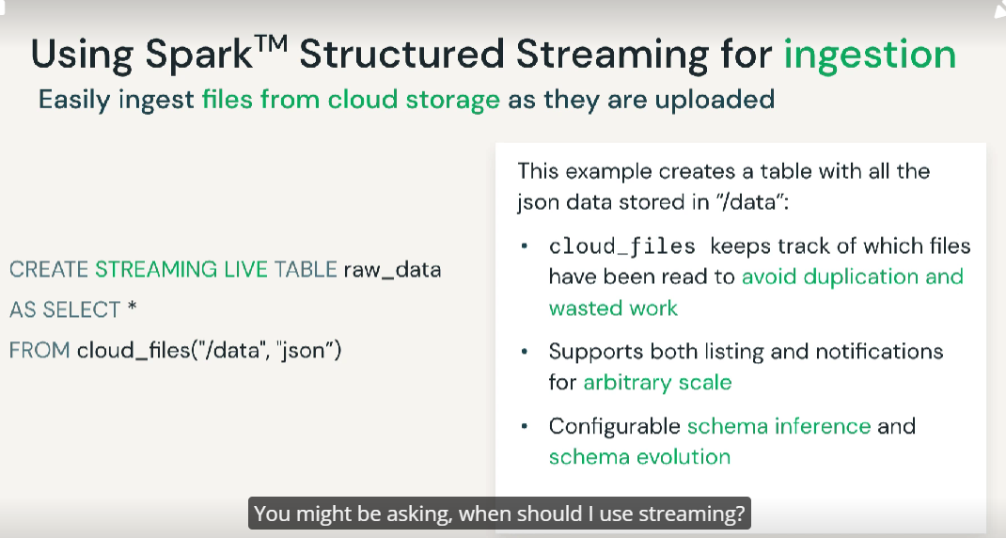
We can easily ingest files from cloud storage as they are uploaded using Park structured streaming for ingestion.
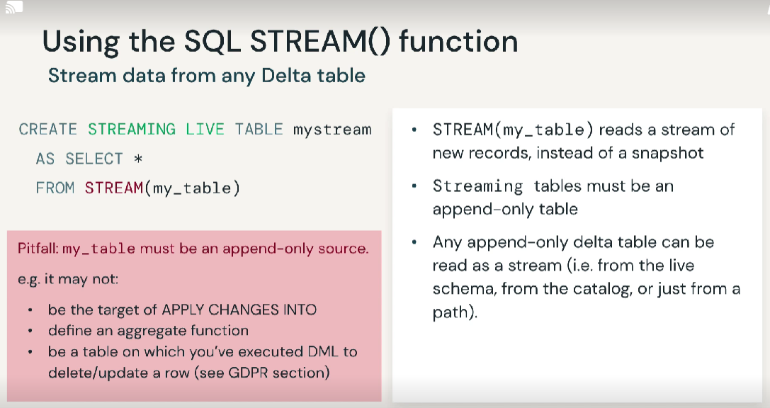
The SQL stream function to stream data from any Delta table
How can I use parameters in DLT?
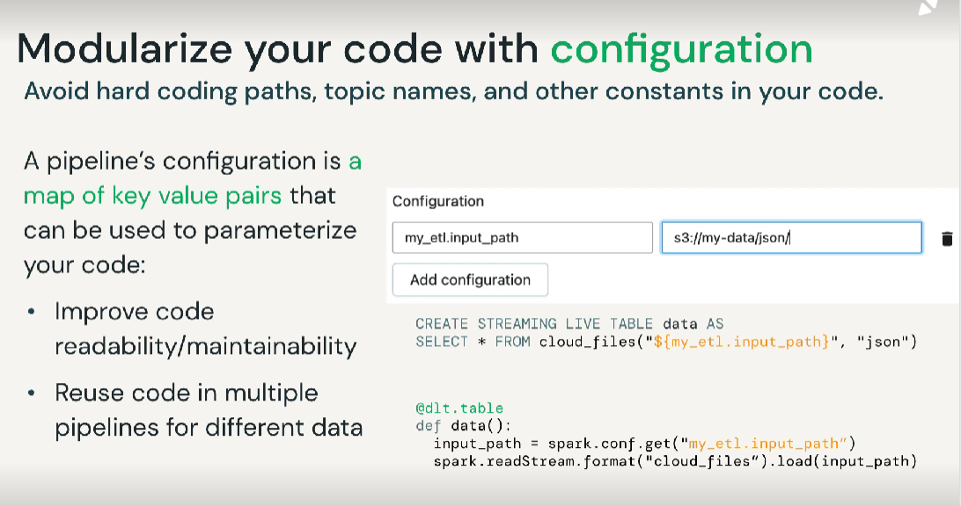
We can modularize or code with configuration. That means we can avoid hard-coding paths, topic names, and other constants in our code.
How can I do change data capture (CDC)?
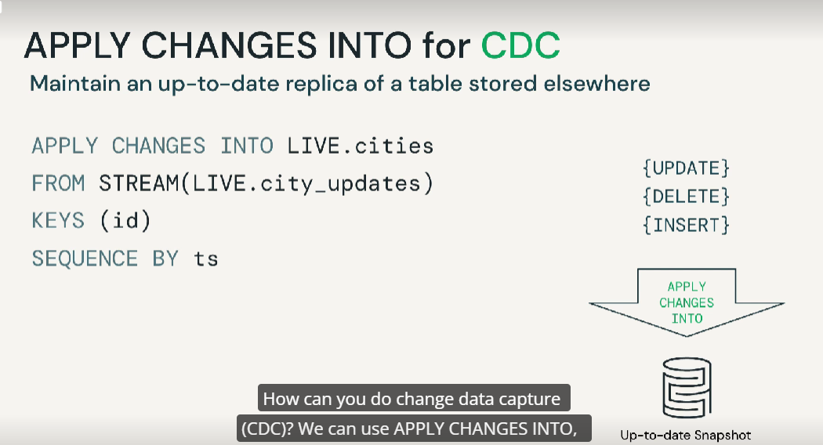
We can use APPLY CHANGES INTO for CDC which maintains an update replica of a table stored elsewhere. LIVE.cities has updates, ts=timestamp. This would give us an up-to-date snapshot on the most recent changes.
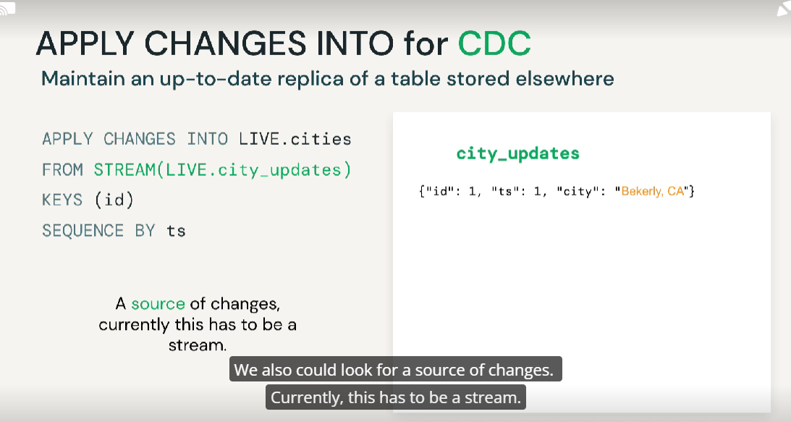
We could look for a source of changes. Currently, this has to be a stream. Then we would apply this to a target for the changes to be applied to. We need a unique key that can be used to identify a given row, and then we need a sequence that can be used to order changes. We are looking for a sequence number, a timestamp, or an ingestion time.
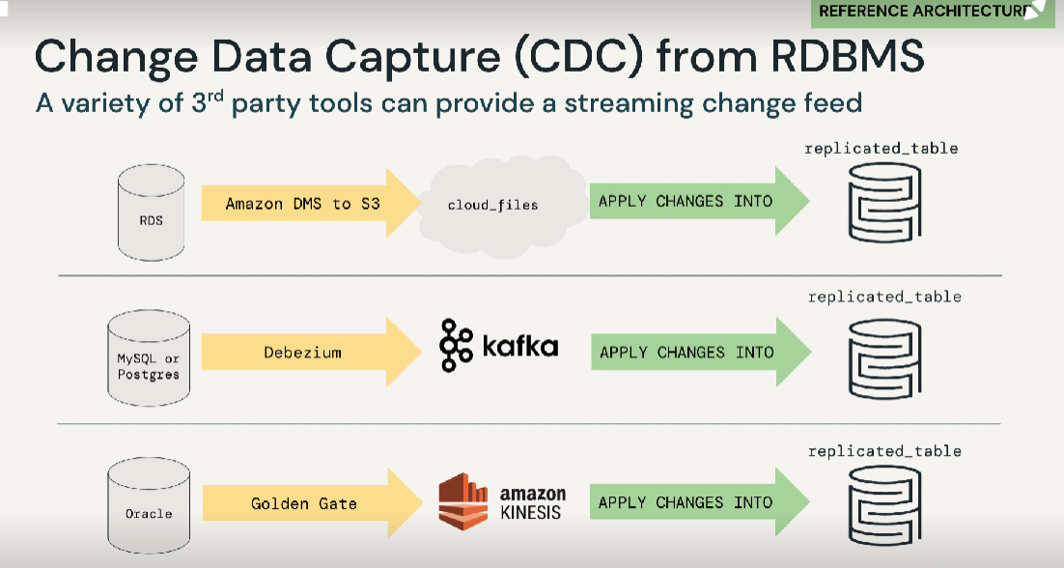
A variety of 3rd party tools can provide streaming change feed
What do I no longer need to manage with DLT?
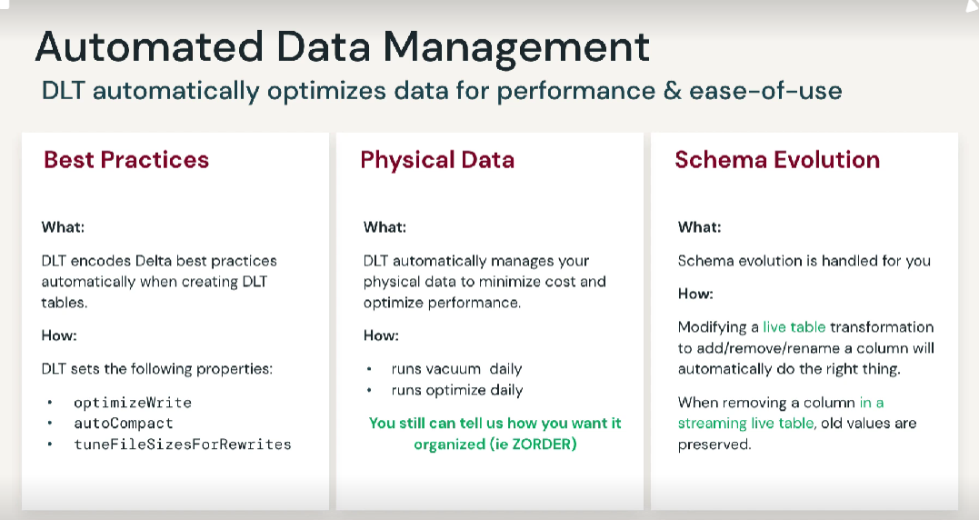
DLT encodes Delta best practices automatically when creating DLT tables. How it does this is it sets the following properties.
When you create a pipe in product edition you can select core-pro-advanced.
Pipeline Mode:
Triggered pipelines run once and then shut down until the next manual or scheduled update. Continuous pipelines, though, run continuously, ingesting new data as it arrives.
Cluster mode: Legacy autoscaling, fixed size (the number of workers is fixed) and enhanced autoscaling.
Development environment provides more expeditious, iterative development disables retry so that you can readily identify and fix errors.
With each triggered update, all newly arriving data will be processed through your pipeline
Solution:
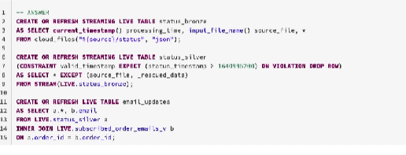

Workflows
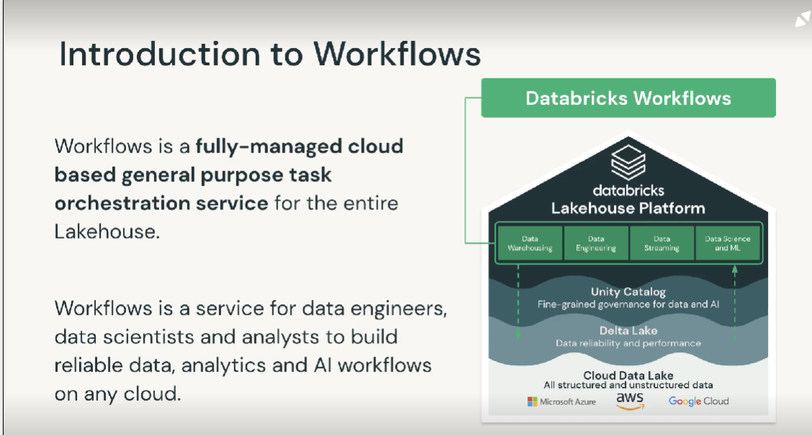
Workflows enables all data teams to orchestrate any combination of tasks, such as notebooks, SQL, ML models and Python code. Workflows sits on top of the Databricks platform, it can be fully integrated with other services. This allows data teams to use data governance and monitoring service.
With Workflows, your team can easily create, run, monitor and repair data pipelines without managing any infrastructure data.
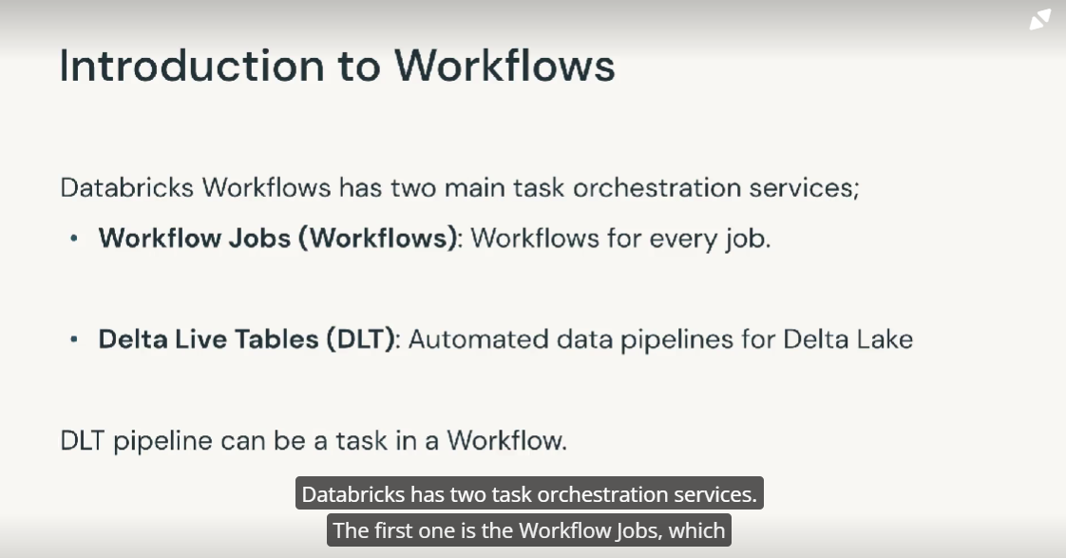
Workflows is the service for orchestrating all types of tasks: it can orchestrate any combination of notebooks, SQL, Spark, ML model and Delta Live Tables.
Delta Live Tables is designed for data teams to easily create batch and streaming data pipelines using Python or SQL. DLT has built-in quality control and data quality monitoring, which ensures accurate and useful business intelligence, data science, and machine learning built on top of quality.
These two services serve different purposes, they can easily be integrated. A DLT pipeline can be executed as a task in a workflow.
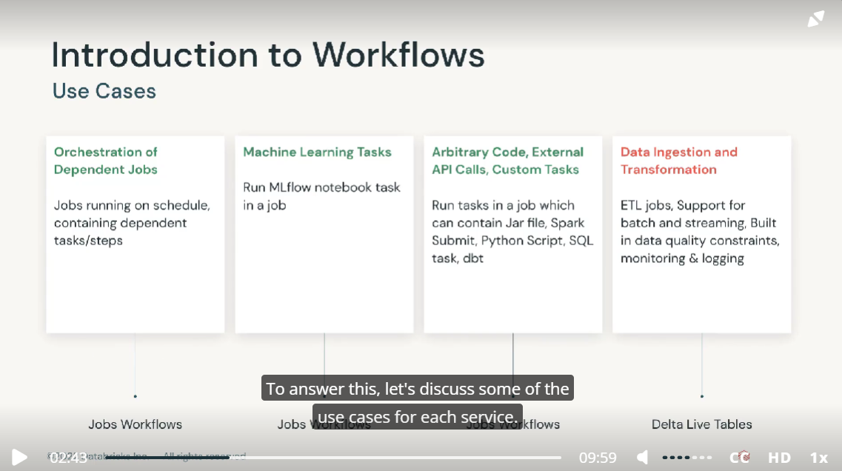
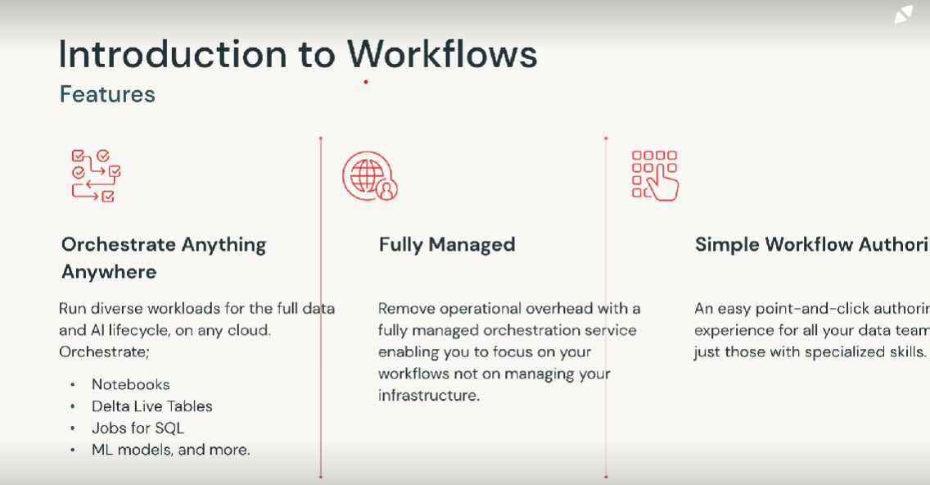
Workflow is cloud native and it is available on GCP, AWS and Azure.
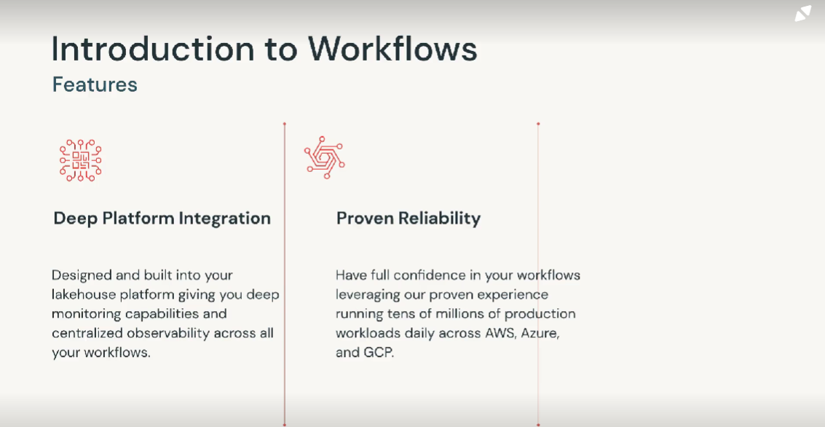
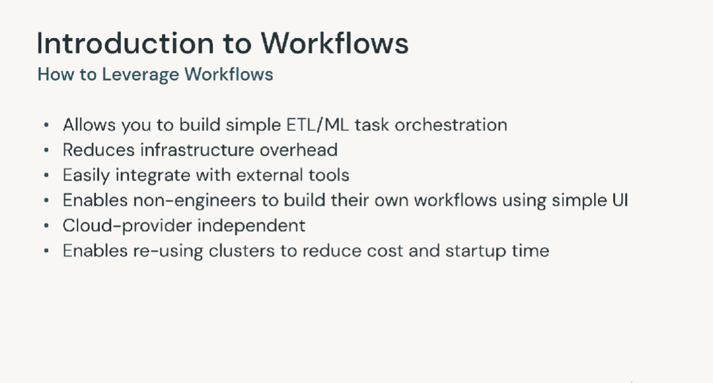
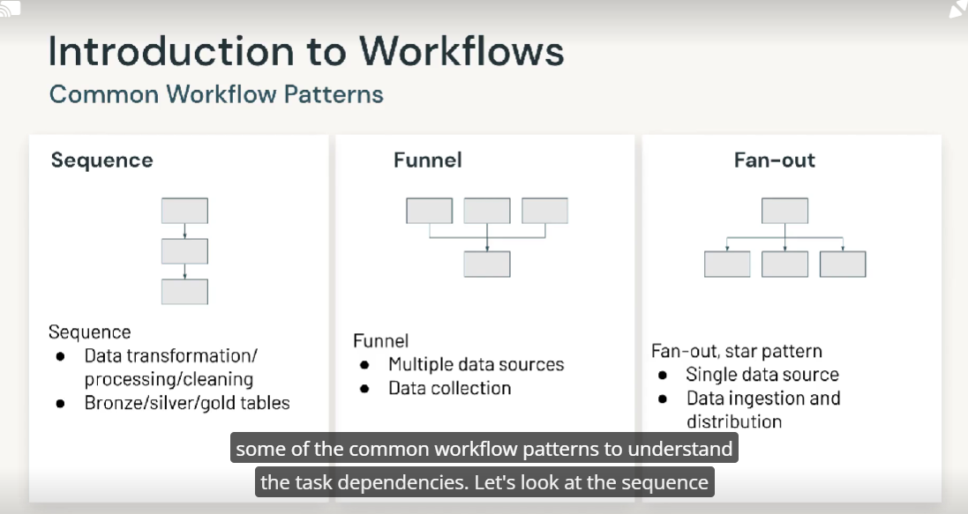
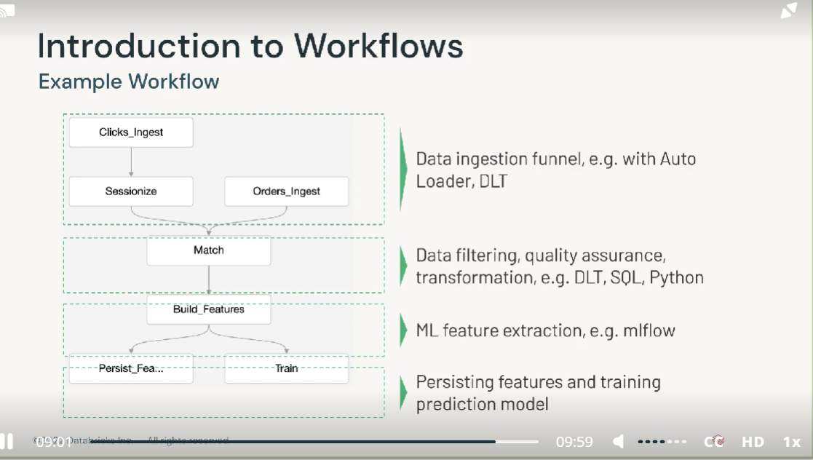
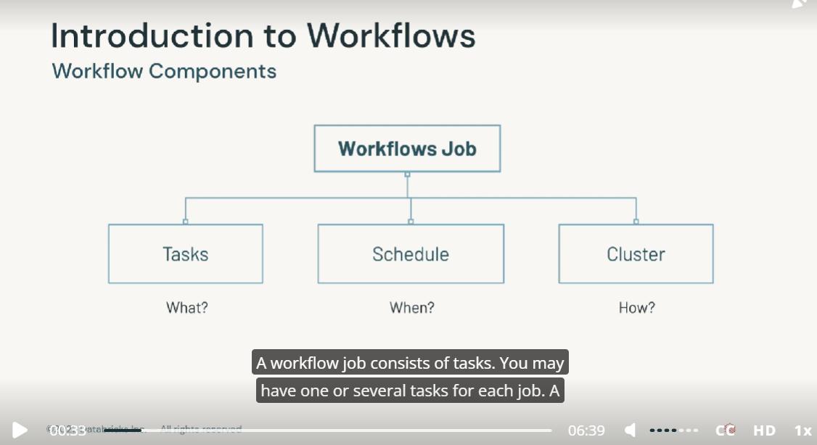
A workflow job consists of tasks. You may have one or several tasks for each job. A task can be a notebook, a delta live table pipeline, a jar file, a python script. Depending on the task execution logic, there might be a dependency between some of. In workflows you can easily define your tasks and define dependencies for each one using the simple authoring interface. Next we have triggering instructions for the job. The simplest way of running a job is to trigger it manually. Workflows also allows you to define our running schedule. After defining the schedule, workflows takes care of the rest and automatically triggers a job execution in a specified date and time. With alerts, you can monitor the execution of your workflow. For example, if you’d like to be notified of when a task fails, you can set up alert and receive an email notification. The final component of the workflow’s job is the cluster. Depending on the job requirements you can create a new cluster or use an existing cluster. Workflow supports all purpose compute clusters and shared job cluster. For running workflow jobs in production environment it is recommended to use shared job clusters. Shared job clusters provide flexibility of using the same cluster for more than one task. This allows you to use active clusters for a job run, which is great as it will reduce the cost and reduce the initial startup time.
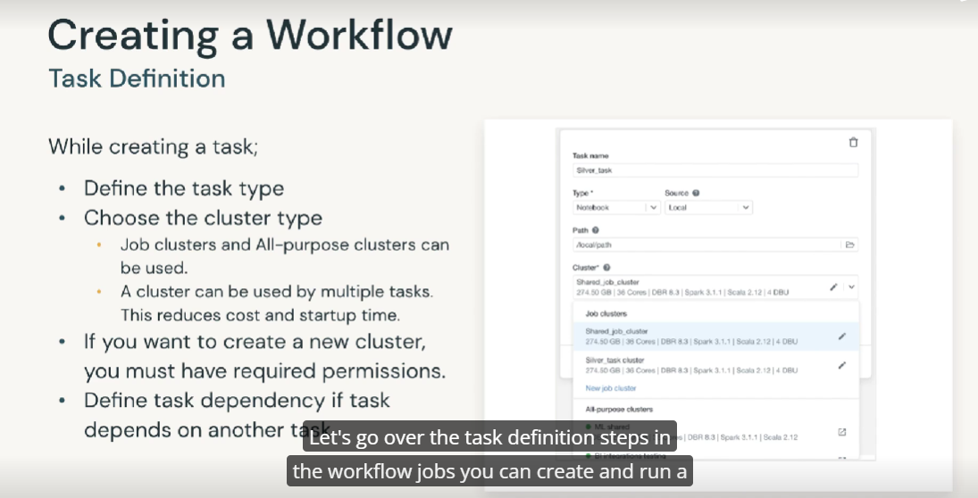
In the workflow jobs you can create and run a job using the UI, CLI or job API. When creating a task in workflow jobs, we first need to select the task type. Databrick supports a wide range of task (notebooks and dlt pipelines). The next steps is to attach a cluster to the task. We can use all purpose clusters and job clusters for running the task in production to optimize resource usage. It is recommended to use shared job clusters, which allows multiple tasks in the same job run. To reuse the cluster, we have the option of selecting an existing cluster or create a new one. You must have cluster creation permissions to create new job clusters. You can configure tasks to run in sequence or in parallel.
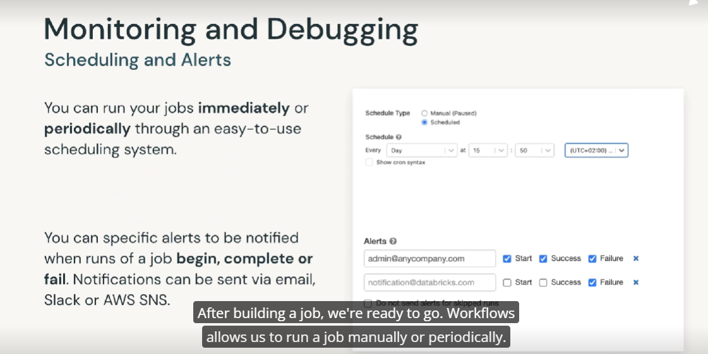
After building a job, we are ready to go. Workflows allows us to run a job manually or periodically. We can define a scheduling period using the UI. We just need to specify the period, the starting time and time zone, and workflows takes care of the rest while running a job. Most of the time we need to monitor it for state changes such as when the job completes or fails. Alerts are great for monitoring job. We can add one or more email addresses to be notified when jobs start complete or fail.
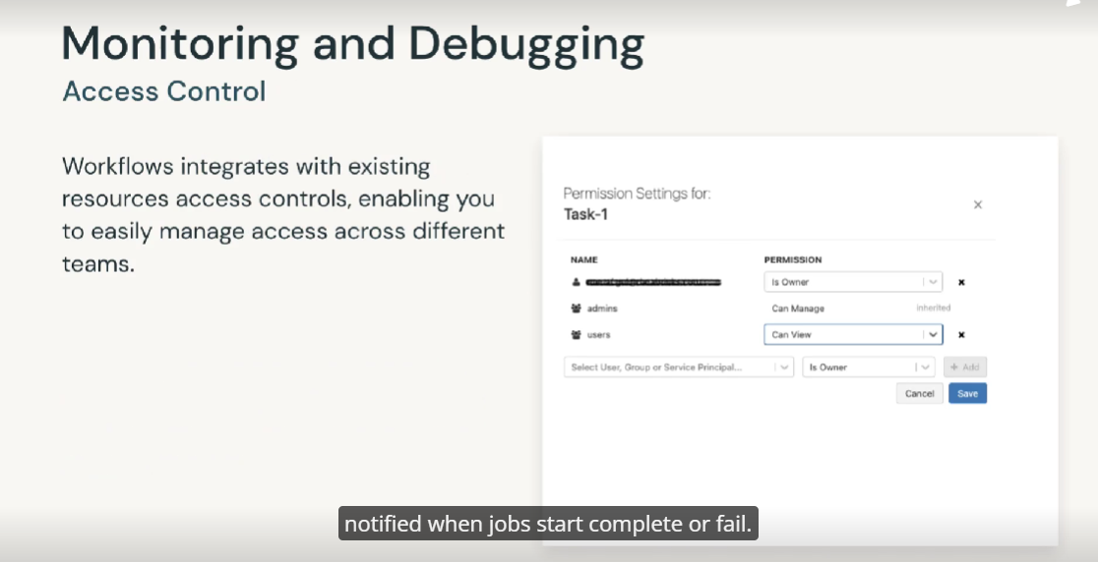
Access control lists allow job owners and administrators to grant fine grain permissions on their job. With access control, we can set permissions at the user level or group level to control who can view job results or manage runs of a job.
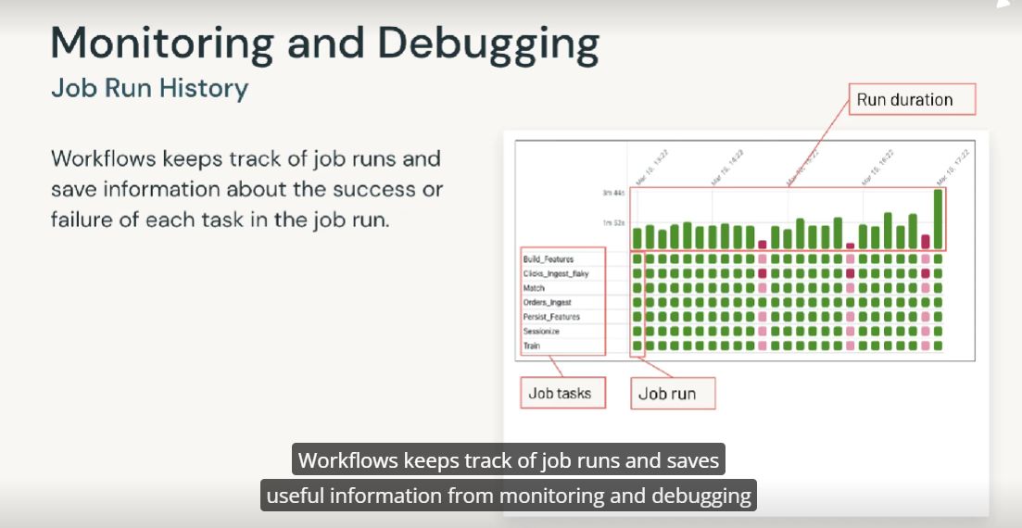
The job runs history contains job output and links to logs for currently running jobs and completed jobs, including information about the success or failure of each tasks in the job. The image shows a matrix view of job. With Matrix view, we can quickly inspect the total duration and state of each task run. Also, the job run and task run bars are color coded to indicate the status of the run. Successful runs are green, unsuccessful runs are red and skipped. Runs are pinked. The height of the bars in the first row of each column provides a visual indication of the execution duration.
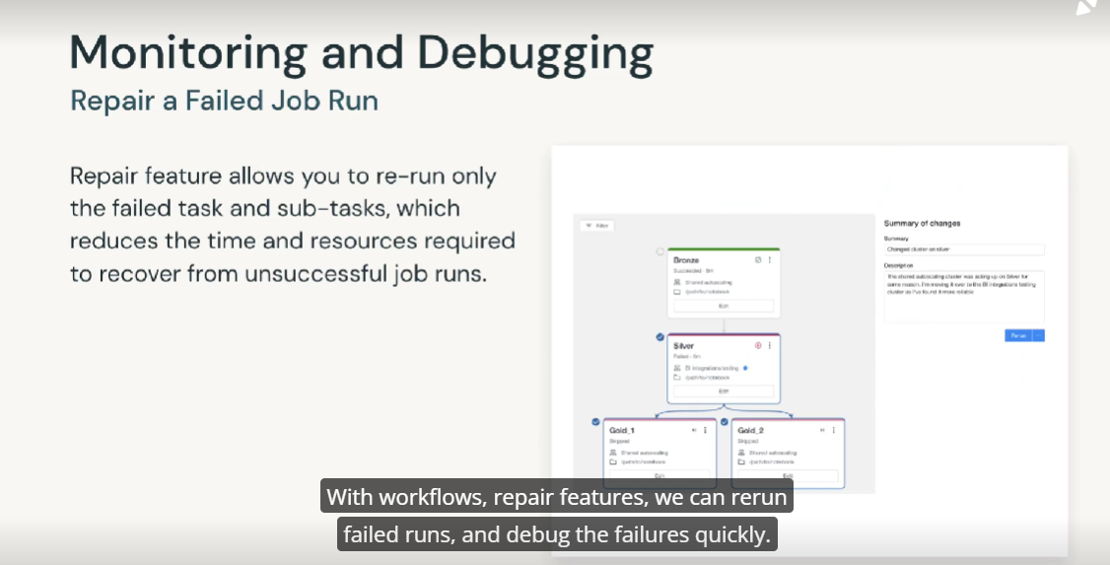
With workflows, repair features, we can rerun failed runs, and debug the failures quickly. The repair feature enables us to repair, failed or canceled jobs by running only the subset of failed tasks and any dependent asks. Because successful tasks and any tasks that depend on them are not rerun. This feature reduces the time and resources required to recover from unsuccessful job runs. In the example shown on the right, the Silver Table task was unsuccessful. After fixing the cause of the failure, if you would like to rerun the workflow, instead of running all f the tasks, in this case, including the bronze table, we could rerun the job starting from the silver. The repair would run only the silver task and its sub-tasks. This might sound like a very small gain. However, imagine if the bronze task were taking one hour to run would save an hour of time and compute resource consumption.
Production job should always be scheduled against new job clusters, appropriately sized for the workload, as this is billed at a much lower rate

Unity Catalog is a unified layer that manage governance for data and ai assets
NOTE:
- GENERATED ALWAYS AS (CAST(nomeColonna AS DATE) per creare una nuova Colonna in formato date.

